* Write sql query to find the items whose prices are higher than or equal 250rs. Order the result by product price in descending, then product name in ascending. Return pro_name and pro_price ?

**QUERY :**  - SELECT PRO_NAME,PRO_PRICE FROM product WHERE PRO_PRICE >= 250 ORDER by PRO_PRICE DESC ,PRO_NAME ASC;

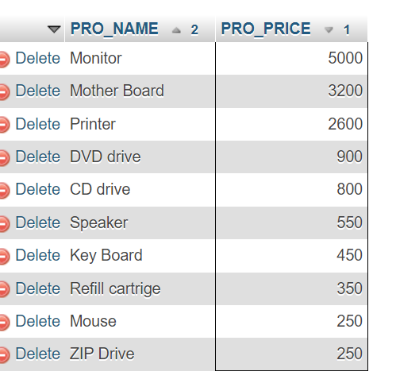

* Write a sql query to find the cheapest item. Return pro_name and pro_price?

**QUERY:- SELECT PRO_NAME,PRO_PRICE FROM product WHERE PRO_PRICE =**  **(SELECT MIN(pro_price) FROM product);**

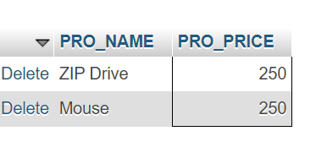

* Write the sql query to calculate the average price of the items for each company. Return average price and company code.

**QUERY:- SELECT AVG(PRO_PRICE), PRO_COM FROM product GROUP BY PRO_COM;**

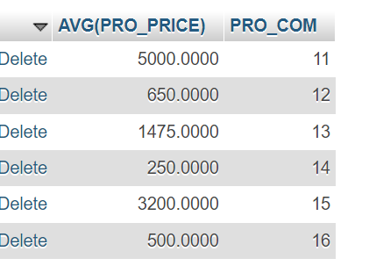

* Write the sql query to find the average total for all the product mention in the table

**QUERY:- SELECT AVG(PRO_PRICE) FROM product;**

