- Define the terms: Website, Webpage, Web browser, Web server, HTML, CSS?

- Website: collection of files we can refer with the help of website URL
- Webpages: A document written in HTML that you can see online, using a web browser
- Web browser: where we can search any website of any things that we want is called Web Browser.
- Web server: A web server is software and hardware that uses HTTP/HTTPS and other protocols to respond to client requests made over the World Wide Web.
- HTML: Hyper Text Mark-up Language. Use to create structure of web-pages.
- CSS: Cascading style sheets. Use to give style to the html structure/web-pages.

- Create a webpage to show “This is my first HTML page”?

  - <h1>This is my first HTML page</h1>

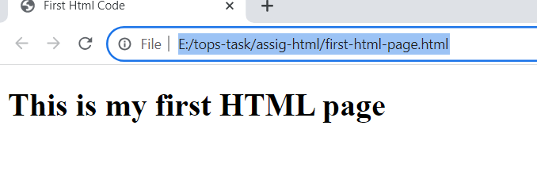
- Display top 10 IT companies list in html webpage?

<ol>
<li>MicroSoft</li>
<li>Tos </li>
<li>Infosys</li>
<li>HCL Technologies</li>
<li>Wipro Limited</li>
<li>LTIMindtree Ltd.</li>
<li>Tech Mahindra Ltd.</li>
<li>MphasiS Ltd.</li>
<li>Persistent</li>
<li>Oracle Fin Serv</li>
</ol>
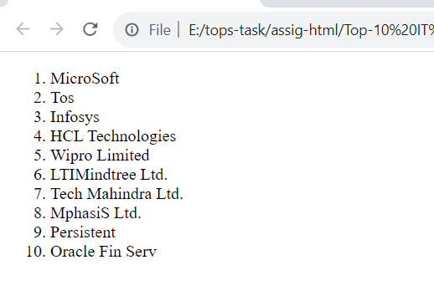
- Create a dropdown list?

<label for="Hobbies" id="Hobbie">Choose Hobbie:</label>

<select id="Hobbies">
<option value="select" selected disabled>Select Hobbie</option>
<option value="playing">playing</option>
<option value="Reading">Reading</option>
<option value="Dancing">Dancing</option>
<option value="music">music</option>
</select>

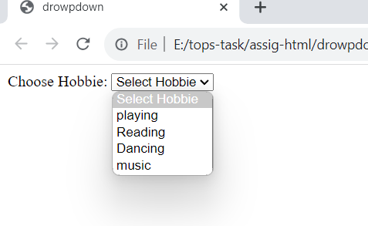

- Create a Table Of college Management system using row span & col span?
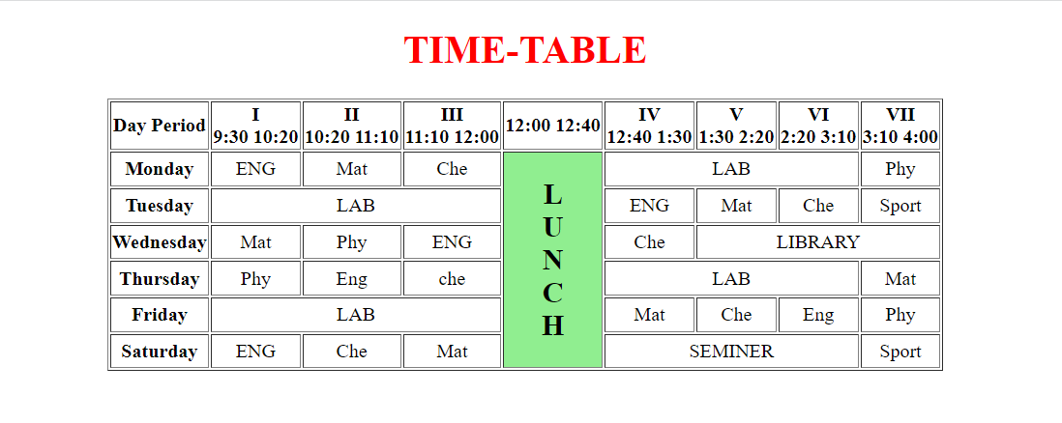
- Create below table using HTML table tags?
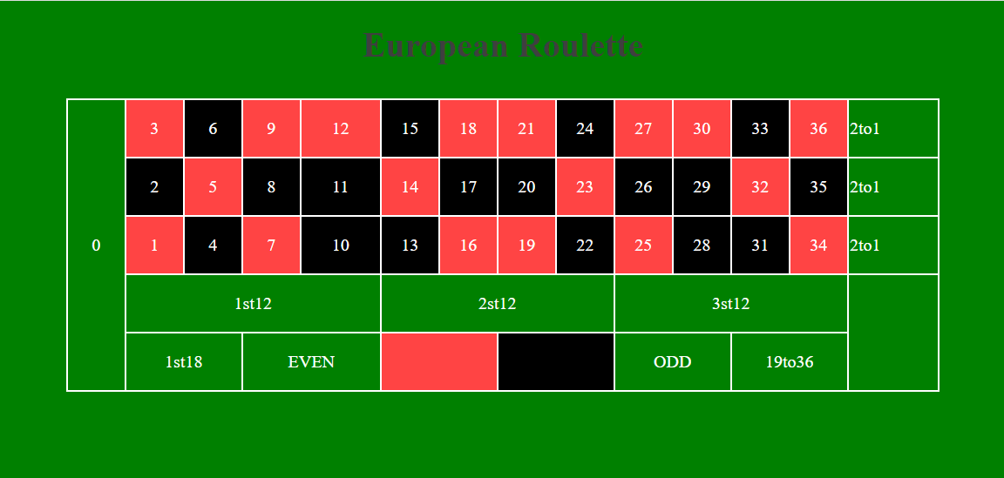

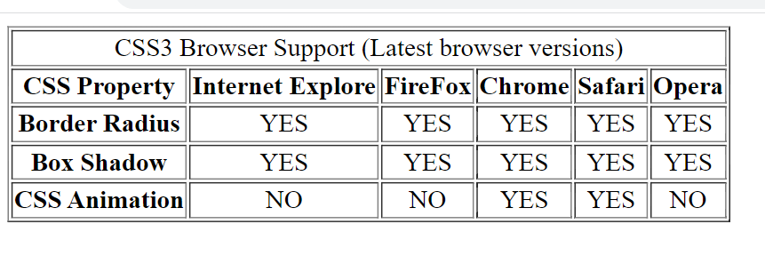

- Create Registration form using HTML, CSS?
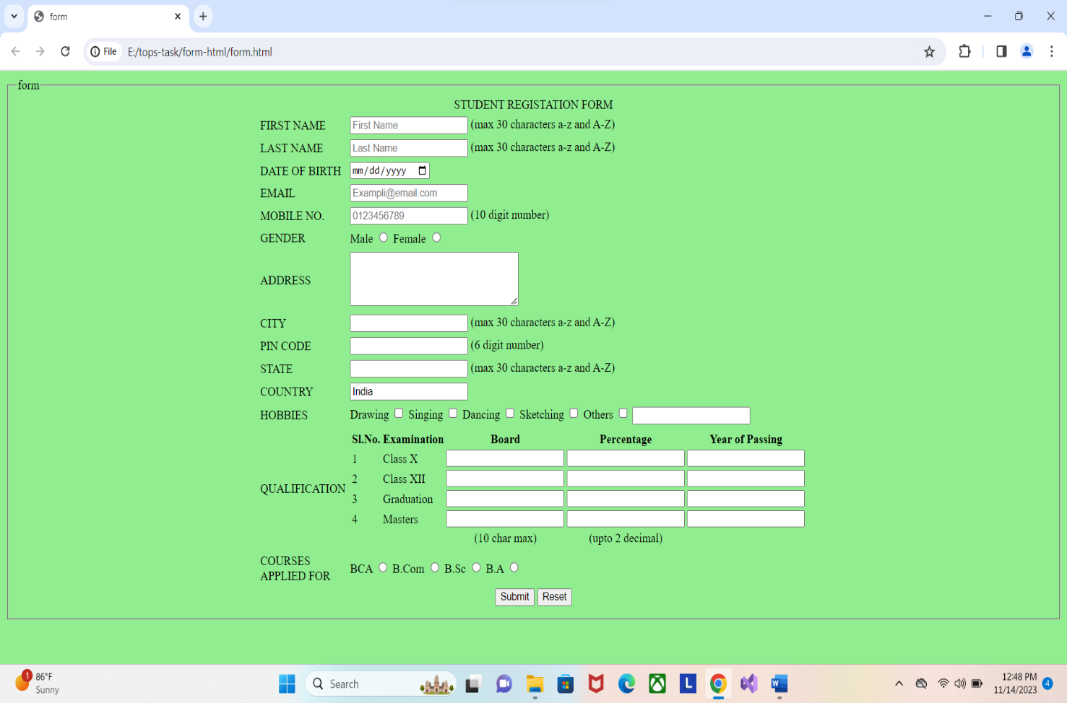

- In how many ways can a CSS be integrated as a web page?

- There are three ways to integrate CSS on web page
- Inline: Inside the html tag using style tag
- Internal: Create style tag inside the header position
- External: Create page for CSS and link that page to html page.

- Create simple three pages using External CSS, Internal CSS, and Inline CSS?

- Inline CSS: Inside the html tag using style tag
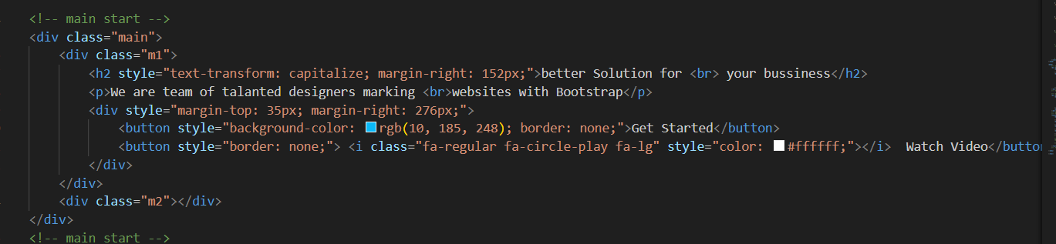
- Internal CSS: Create style tag inside the header position
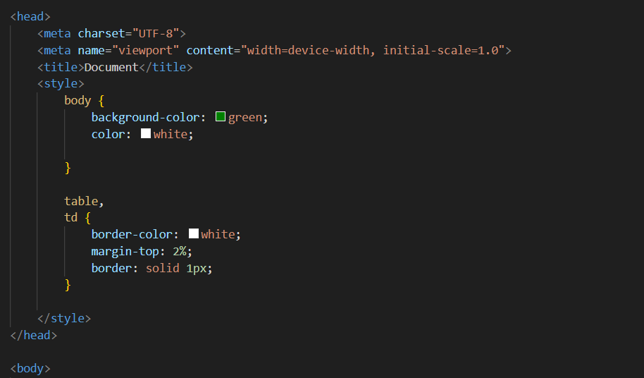
- External CSS: Create page for CSS and link that page to html page.
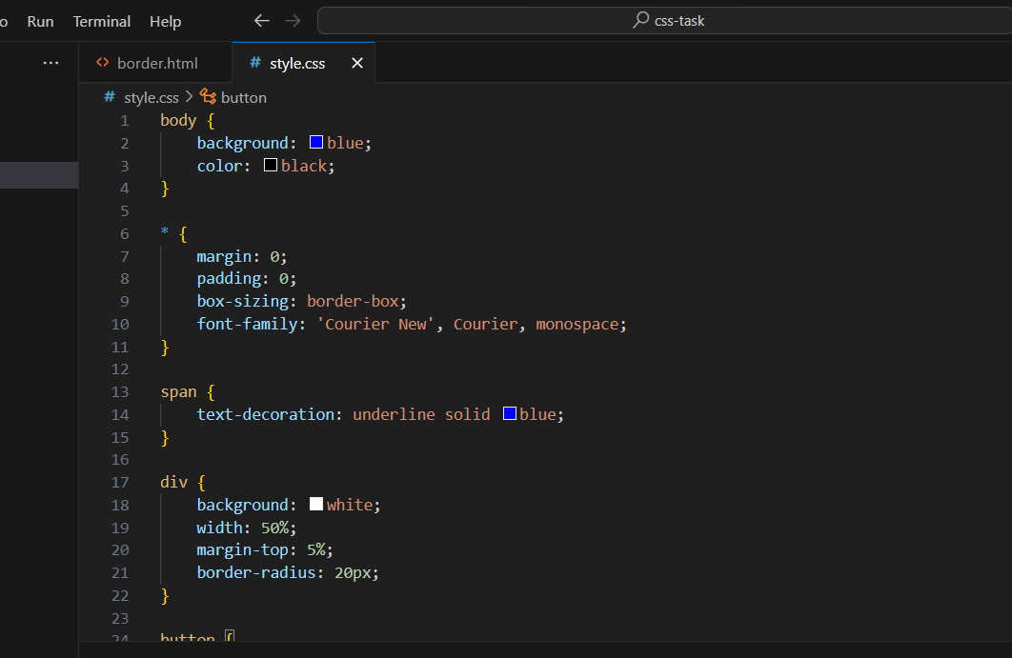
- Link give in html header position
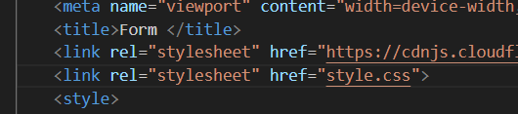

- Create below page using HTML CSS?
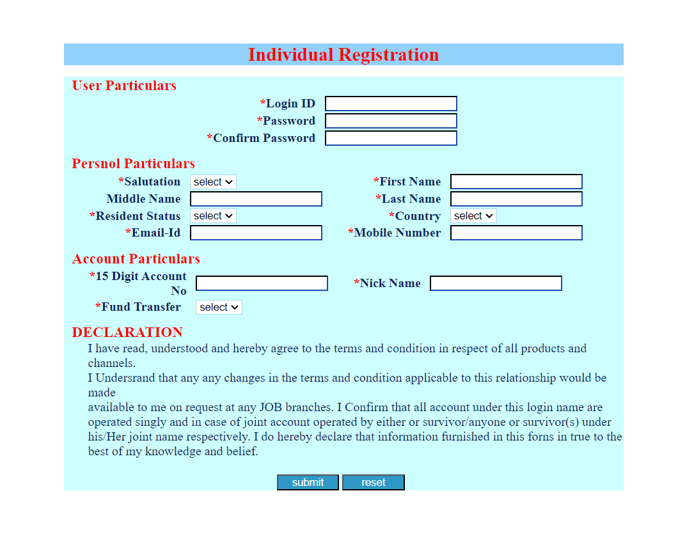
- Create link-pseudo classes using external CSS, to format links on the pages.
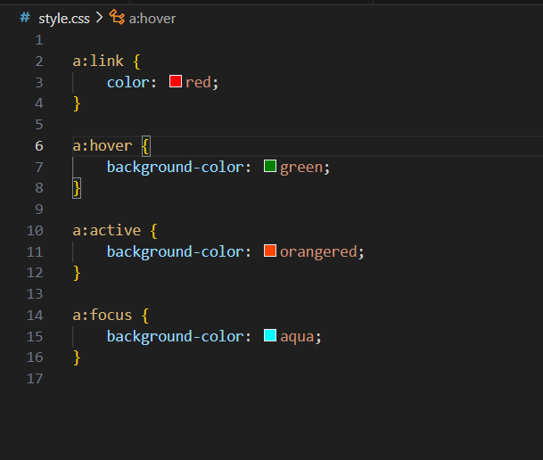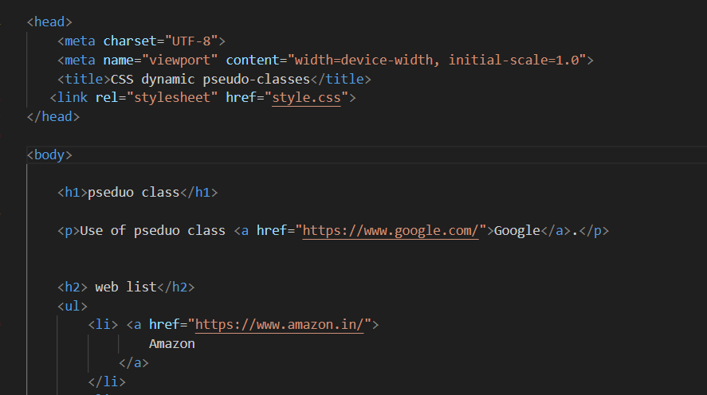
- Output:
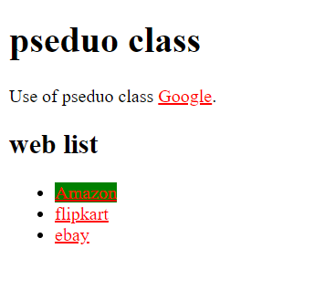

- . Create a dynamic pseudo class using HTML, CSS
- A pseudo-class is used to define a special state of an element.
- The single (:) colon is used for pseudo class.
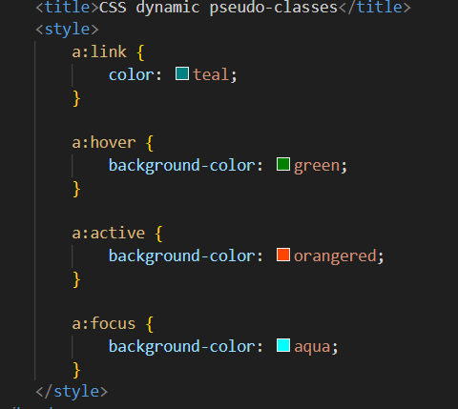

------------------------------------------------------------------END-------------------------------------------------------------

