FTC-WBSQLFRM703

ftc-wbsndbox242 -- new PS1 executed with Dell w/o local ID

ftc-wbsndbox238 – NT6.2 (windows server 2016 ) installed SQL 2019 silent by Rohit  
ftc-wbsndbox314 – NT6.2 (windows server 2016 )  
ftc-wbsndbox327 – NT6.2 (windows server 2016 ) 8/25/2020)

ftc-wbsndbox329 – NT6.2 (windows server 2016 ) 8/25/2020)

ftc-wbsndbox332 – NT6.2 (windows server 2016 ) 9/2/2020)

334 9/3/2020 for SQL2017 defaut

VRA stuff for pre-requisites:

1. Copy Ps1 to local drive from \\ftcfiler03\DBMW_CAS_Share\Ansible

Execute as per readme

1. Enable / add trust site in IE

<http://ftc-lbcmsnfs501/mssql_binaries/>

1. add SQLserveradmins in local Administrator group

**then only tower can connect to node with Ansible**

sudo apt-get install gcc python-dev libkrb5-dev  
sudo apt-get install python-pip  
sudo pip install -–upgrade pip  
sudo pip install -–upgrade virtualenv  
sudo pip install pywinrm[kerberos]  
sudo apt install krb5-user  
sudo pip install pywinrm  
sudo pip install ansible

--

sudo pip3 install -–upgrade pip  
sudo pip3 install -–upgrade virtualenv  
sudo pip3 install pywinrm[kerberos]  
sudo pip3 install pywinrm  
sudo pip3 install ansible

**on New node**

./ConfigureRemotingForAnsible.ps1 -CertValidityDays 3650 -DisableBasicAuth

Winrm enumerate winrm/config/listener

Add in nphosts inventory on root in vscode with FQDN

ansible-playbook -i nphosts "/home/patelnil/mss_dbmw_sql_install/tests/test_ldap.yml" -k

if token error

kinit <user>@AD.MOODYS.NET

apt list –installed

pip list

ansible -i nphosts win_ldap -m 'win_sql' -vvvvv

ansible-playbook -i nphosts "/home/patelnil/mss_dbmw_sql_install/tests/test_ldap.yml"

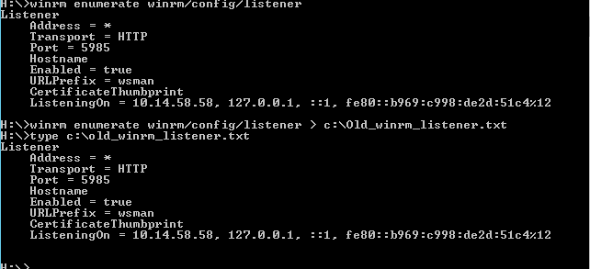

Winrm enumerate winrm/config/listener

Executed script as is from \\ftcfiler03\DBMW_CAS_Share\Ansible

On FTC-WBSQLFRM703

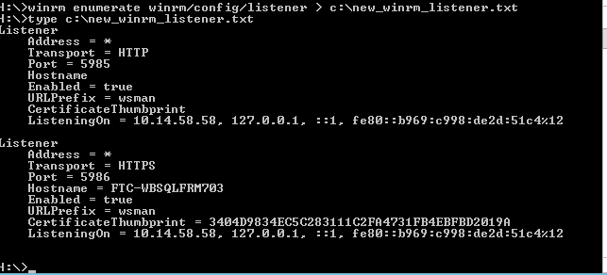

link found

http://mdpconfluence.ad.moodys.net:8090/pages/viewpage.action?spaceKey=AUTOGUILD&title=7.+Windows+WINRM+Setup

on 7/22/ by Dell **sudo apt-get install krb5-user**

on VScode terminal –

**sudo apt-get install krb5-user**

**password for my WSL - wood3390**

then krb5.conf as sudo vi updated with site info

sudo apt-get install python-kerberos

sudo apt-get update

ansible-playbook -i nphosts "/home/patelnil/mss_dbmw_sql_install/tests/test_runas.yml"

--not with patelnil

patelnil@patelnil-10w:~$ ansible-playbook -i ~/mss_dbmw_sql_install/tests/inventory ~/mss_dbmw_sql_install/tests/test.yml -k

--working with ansible

patelnil@patelnil-10w:~$ ansible-playbook -i ~/nphosts ~/mss_dbmw_sql_install/tests/test.yml

on 694

yum install krb5-workstation  
  
yum install krb5-devel  
  
yum install krb5-libs

installed 6/17 5:13 pm

[root@ftc-lbsndbox694 nilesh]# scl enable rh-python36 bash

[root@ftc-lbsndbox694 nilesh]# ansible np_win -i nphosts -m 'win_ping'

FTC-WBSQLFRM703.AD.MOODYS.NET | SUCCESS => {

"changed": false,

"ping": "pong"

}

10.14.58.58 | SUCCESS => {

"changed": false,

"ping": "pong"

}

[root@ftc-lbsndbox694 nilesh]# ansible np_win -i nphostsldap -m 'win_ping'

FTC-WBSQLFRM703.AD.MOODYS.NET | UNREACHABLE! => {

"changed": false,

"msg": "kerberos: the python kerberos library is not installed",

"unreachable": true

}

10.14.58.58 | UNREACHABLE! => {

"changed": false,

"msg": "kerberos: the python kerberos library is not installed",

"unreachable": true

}

patelnil@patelnil-10w:~$ ansible-playbook -i nphosts "/home/patelnil/mss_dbmw_sql_install/tests/test_runas.yml"

---

- hosts: win_sql

 # remote_user: root

  gather_facts: yes

#  become_user: true

  vars_files:

    - ~/mss_dbmw_sql_install/vars/main.yml

  tasks:

  - name: "win command whoami"

    win_command: "whoami"

    register: output1

    become: yes

    become_method: runas

  - name: "print output1"

    debug:

      msg: "{{ output1 }}"

  - name: "print ansible_become_user"

    debug:

      msg: "{{ ansible_become_user }} {{ ansible_become_password }}"