**HACKATHON PROJECT**

PROJECT TEAM NAME :- Team Automation

Project NO. 06 -> Identify NewBikes

**Project Member Names :**

1. Dakshita Sudhir Chaubey
2. Poonam Madhav Mamankar
3. Nikita Rajeshwar Modak
4. Aishwarya Ganesh Kawade

**Project Module:**

1. Display "Upcoming" bikes details like bike name, price and expected launch date in India, for manufacturer 'Honda' & Bike price should be less than 4Lac.  
2. For Used cars in Chennai, extract all the popular models in a List; Display the same  
3. Try to 'Login' with google, give invalid account details & capture the error message

**Prerequisites**

Steps to automate:

1. Initially we need to create a Maven Project.
2. In that project we have to create test scenarios and test classes
3. According to this project we need to create methods in that pages
4. We have to use Base Class for driver setup and others utilities
5. Data driven concept is used for the pages to read data and write data
6. This are the basic requirements of this project.

**Once everything is set up:**

1. Right click on the “Test.java” >> “Run” >> “Run as” >> “TestNG Test”

2. Then we are navigated to the Zigwheels website:

https://www.zigwheels.com/

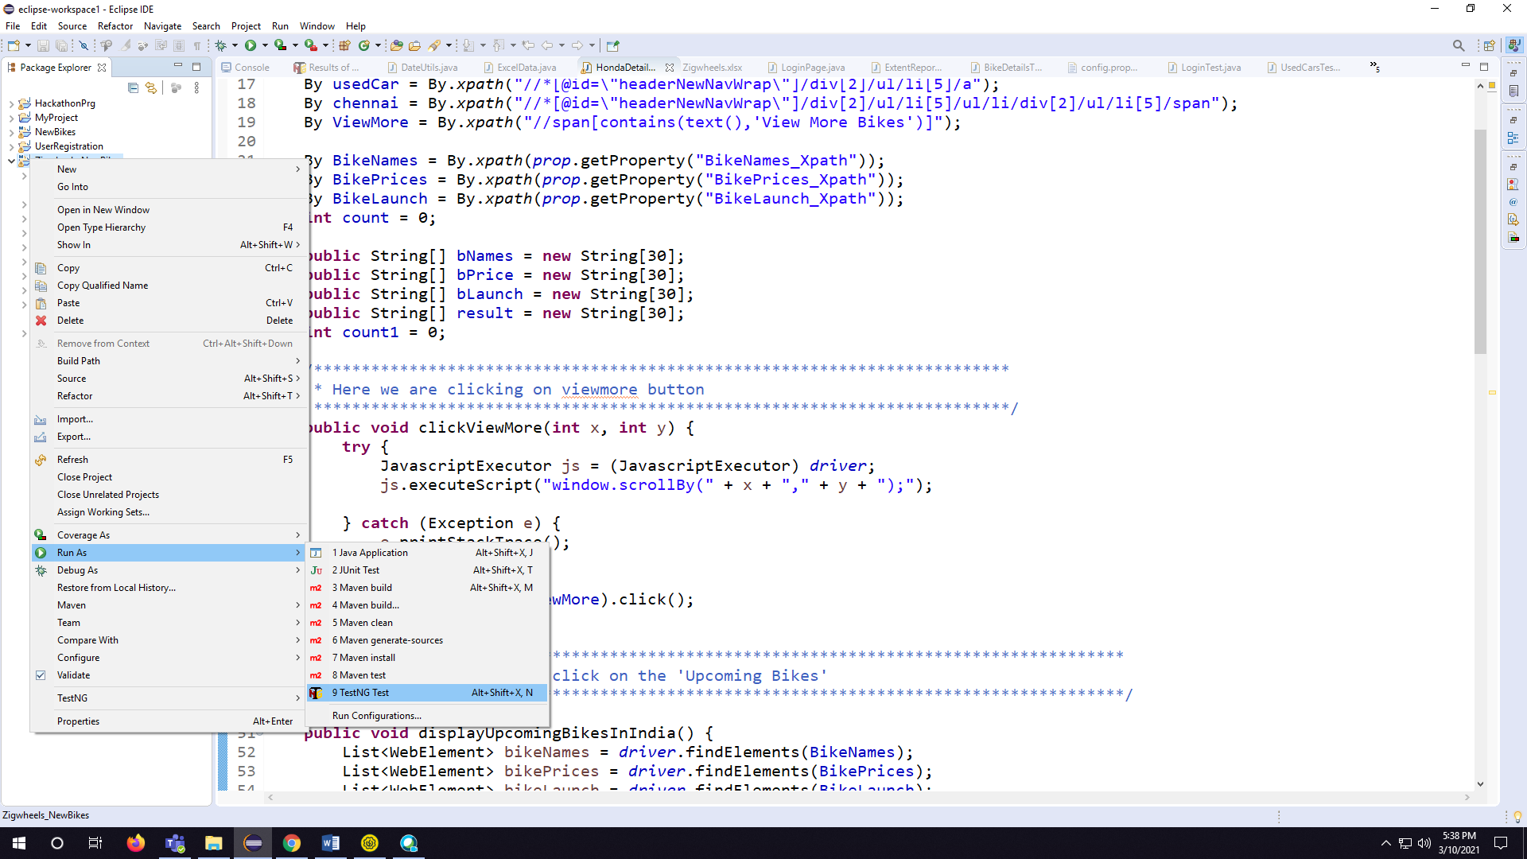

**Steps to view the Screen Shots**

(After automation steps):

1. Click on “src/test/resources” source-folder (expand the view) of “Package Zigwheels_NewBikes ”

2. Left-click on “Screenshot” folder and expand the view

3. Click on that file to view the Screen Shot.

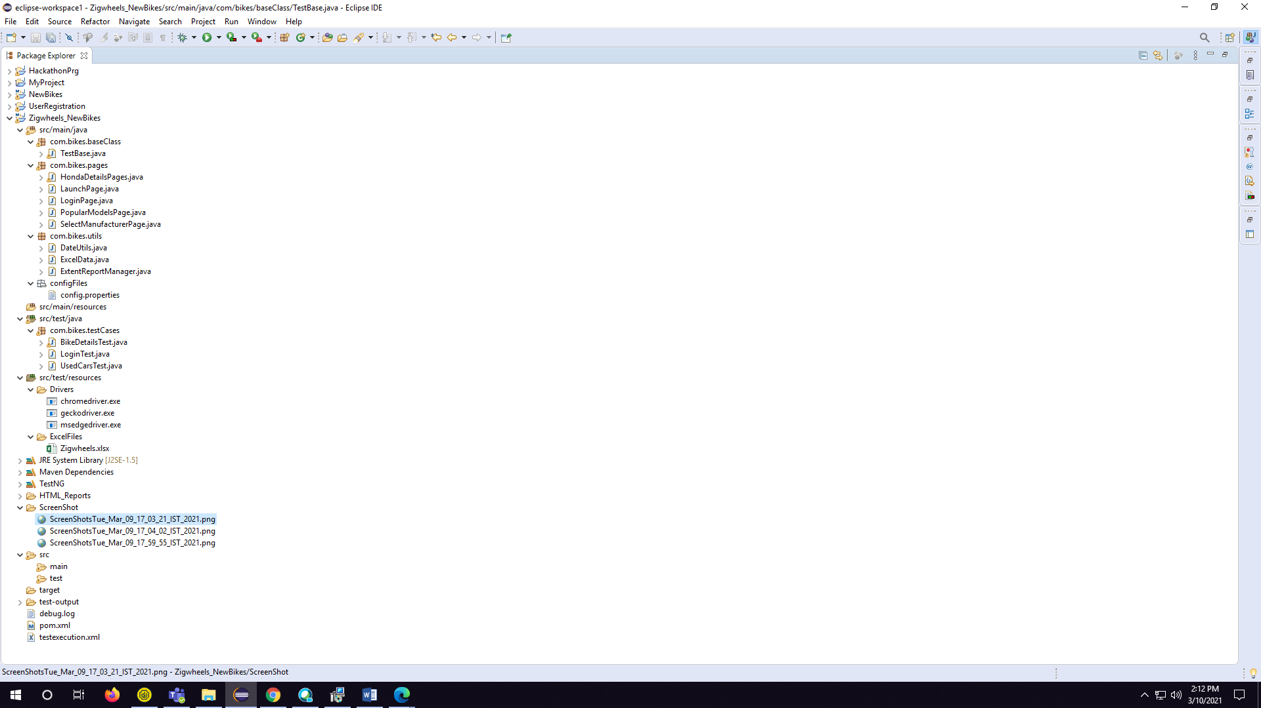

4.Select one screenshot report from that file and Right-click on that file and click on “properties”

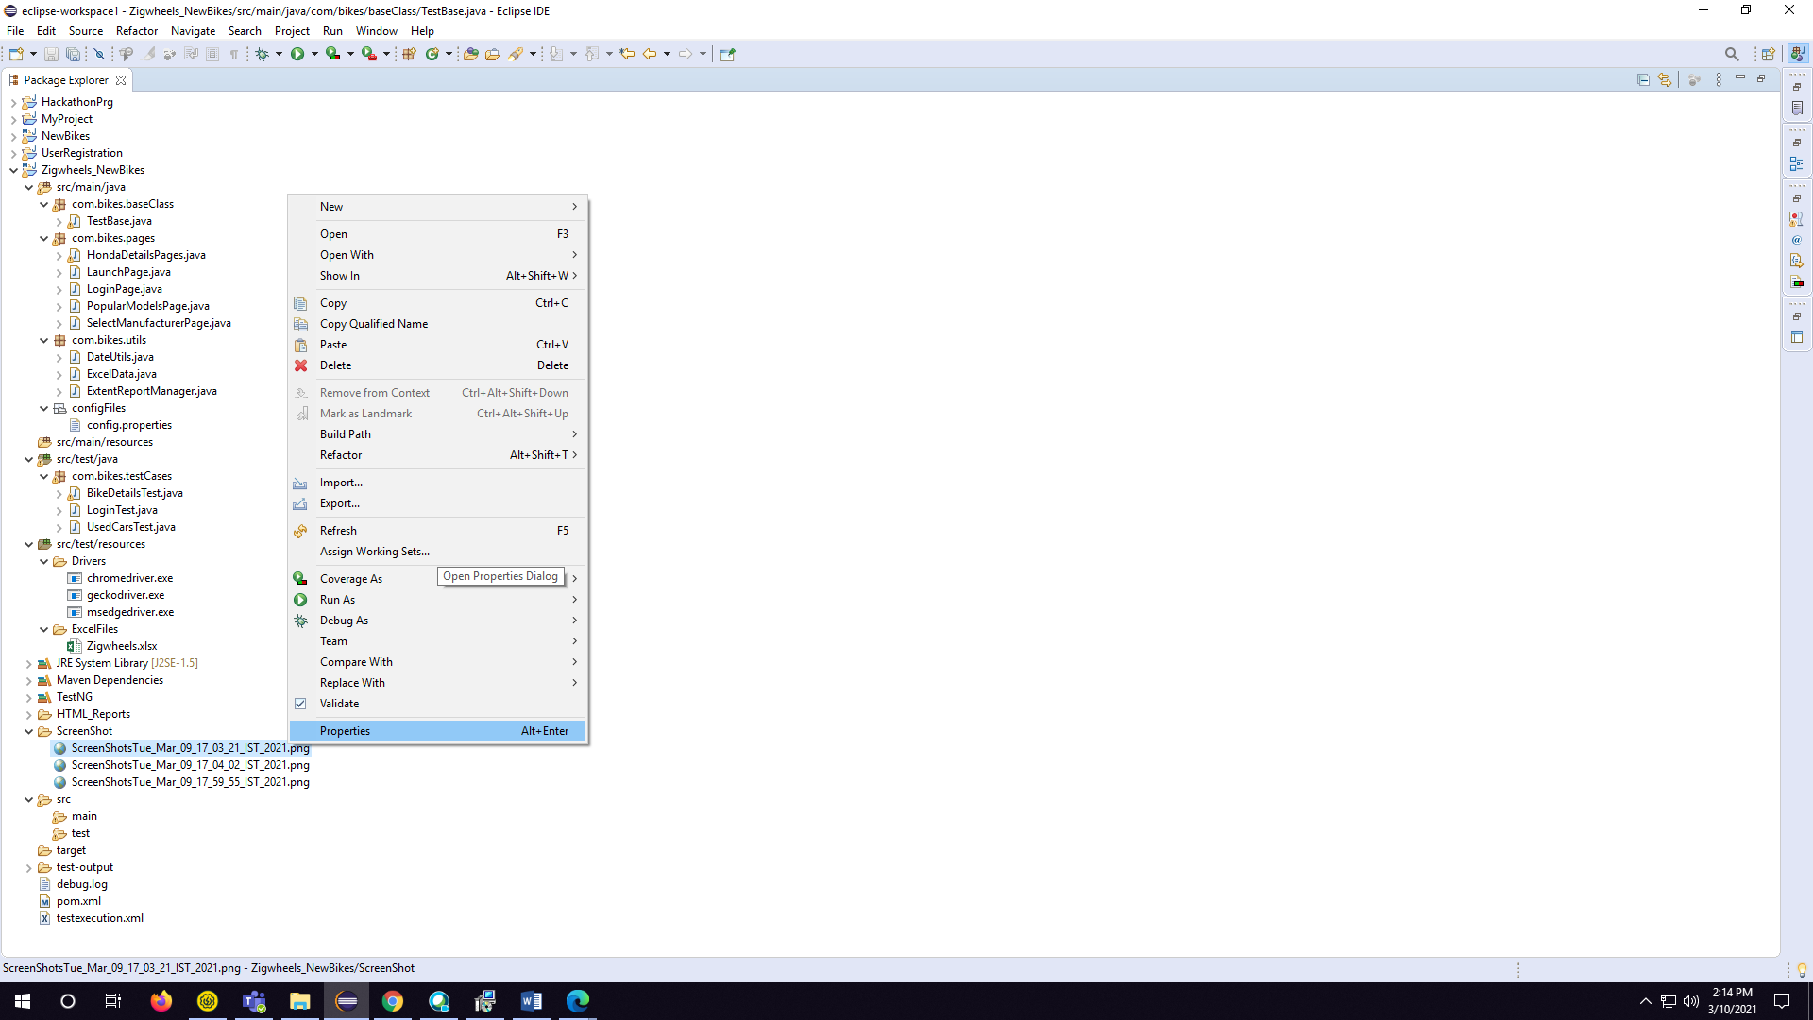

5. Copy the path of the file.

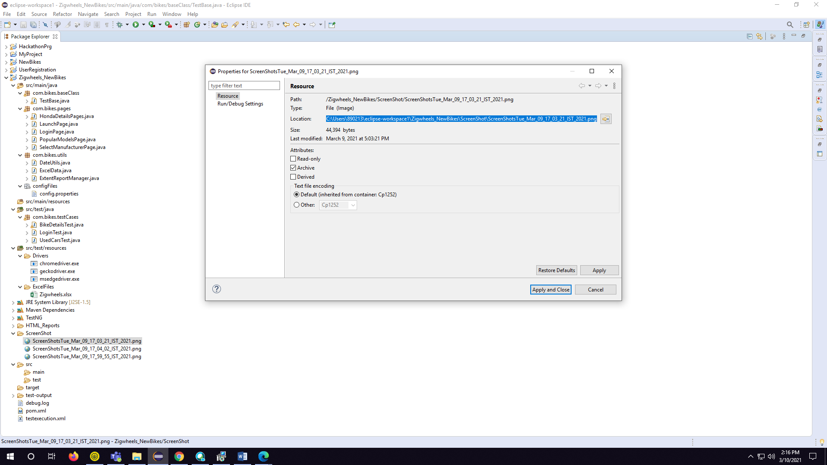

6. Then paste the path on any browser, in your device:

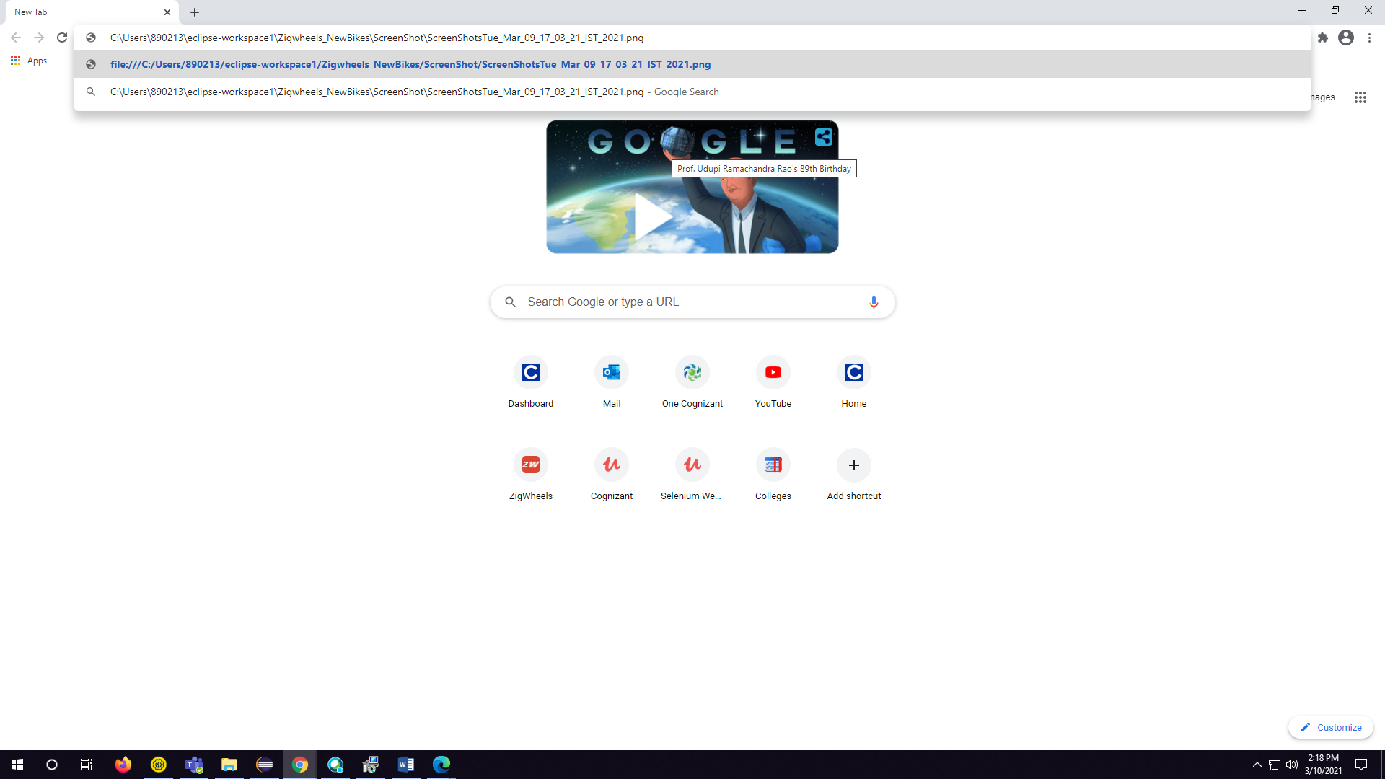

7. Hit “Enter” Key a Screen Shot report is generated.

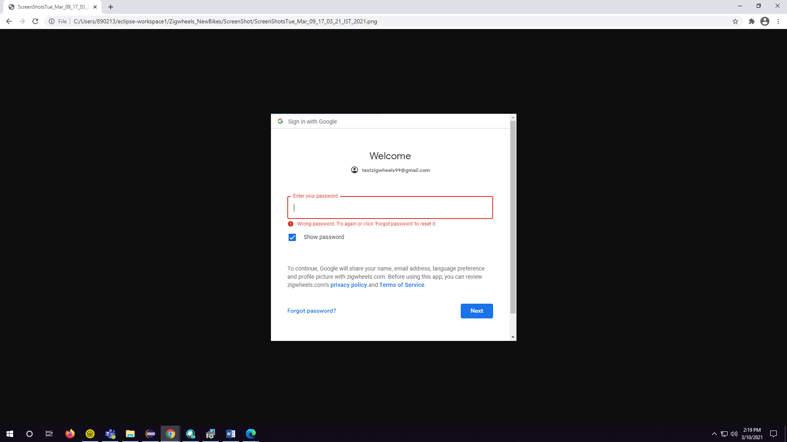

**Steps to view the Excel-Reports -**

**(After automation steps):**

1. Click on “src/test/resources” source-folder (expand the view) of “Package Zigwheels_NewBikes”

2. Left-click on “ExcelFiles” folder and expand the view

3. Click on “Zigwheels.xlsx” file to view the automation report.

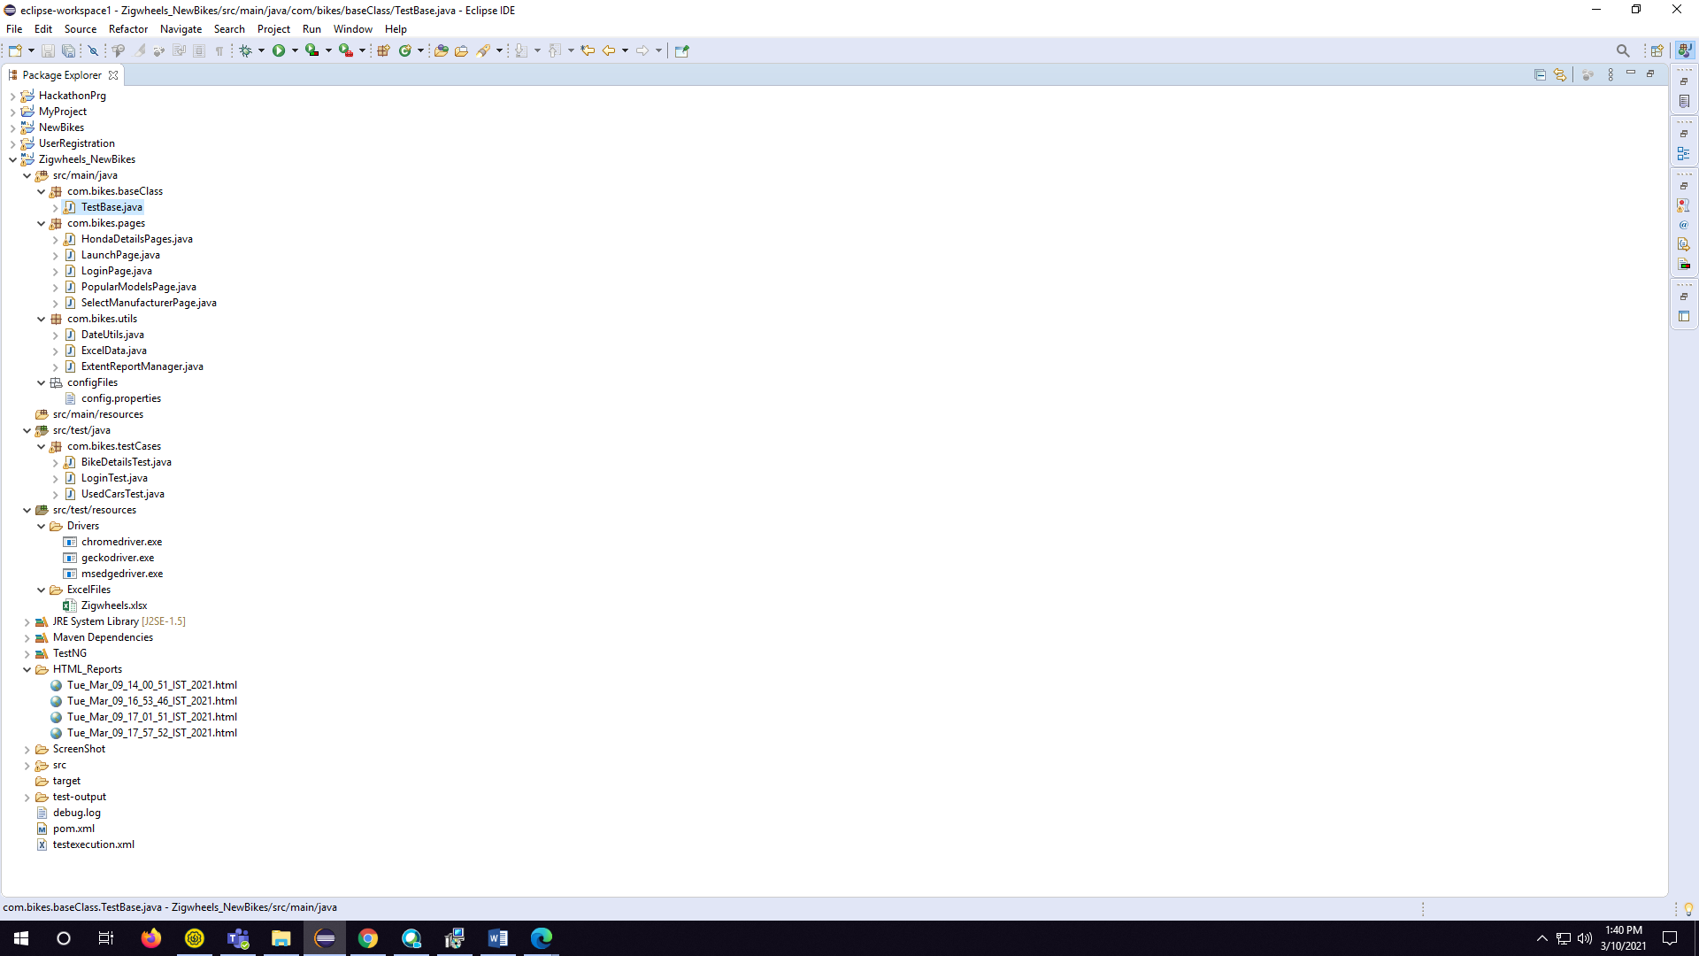

**Steps to view the HTML-Reports**

**(After automation steps):**

1. Click on “html report” folder and expand the view in your “Package Zigwheels_NewBikes”

2. We can see an html file with “Date and Time” stamp is present.

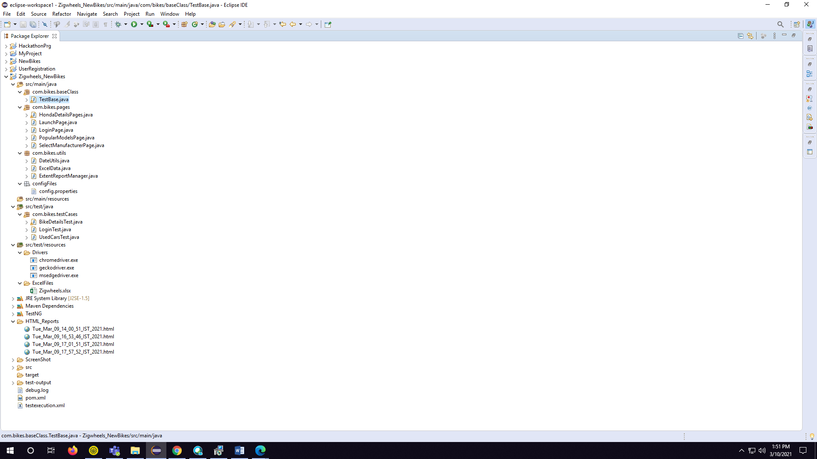

3.Select one report from that file and Right-click on that file and click on “properties”

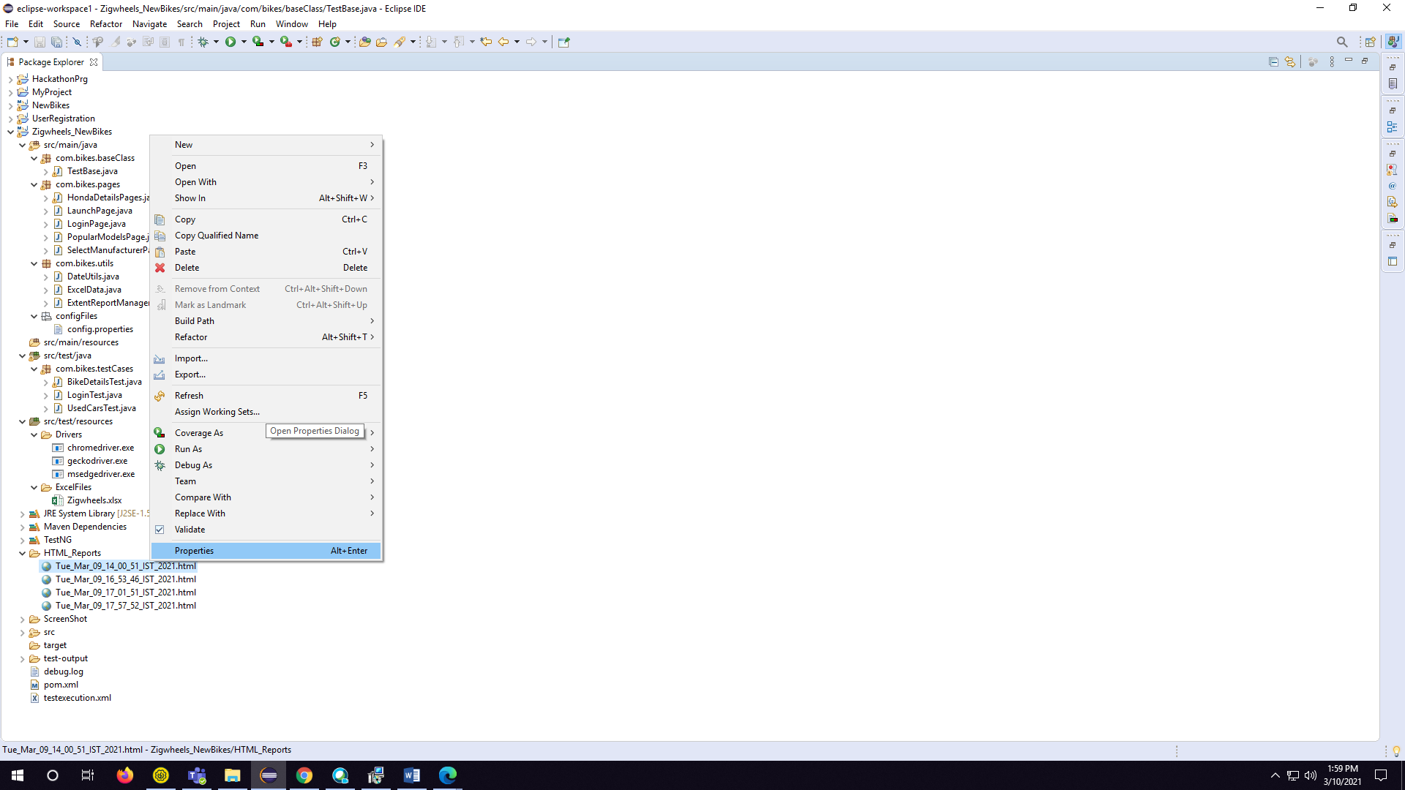

4. Copy the path of the file.

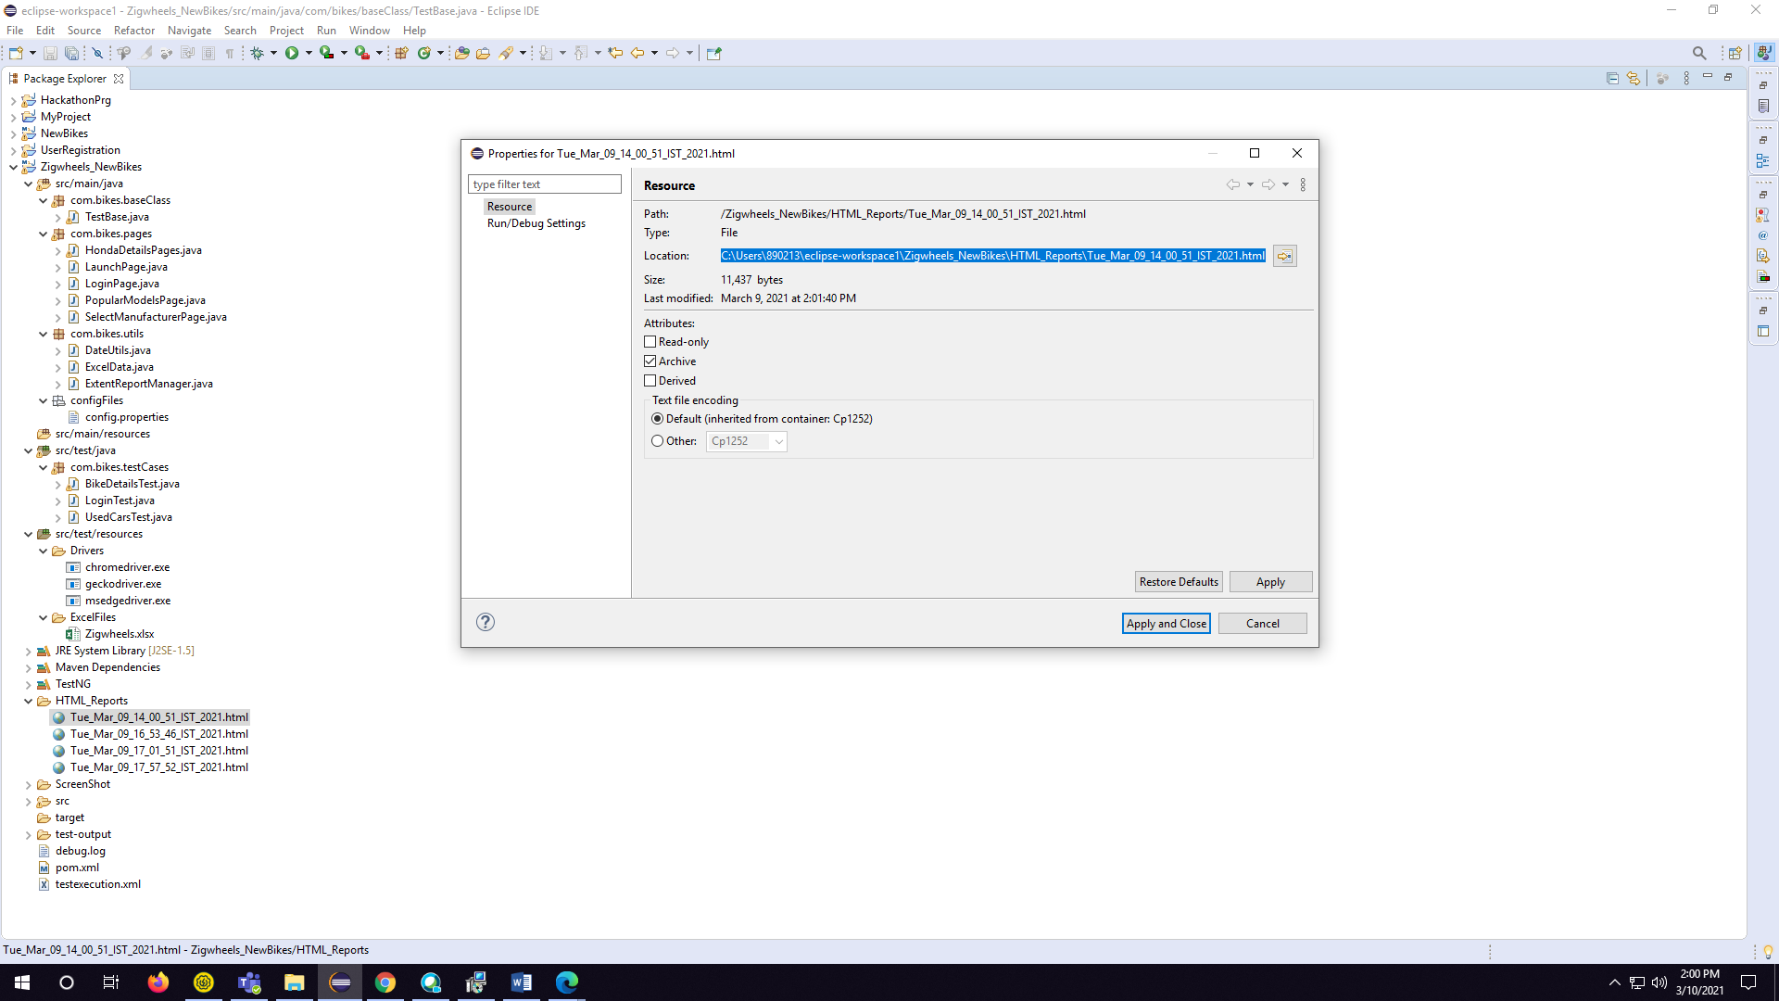

5. Then paste the path on any browser, in your device:

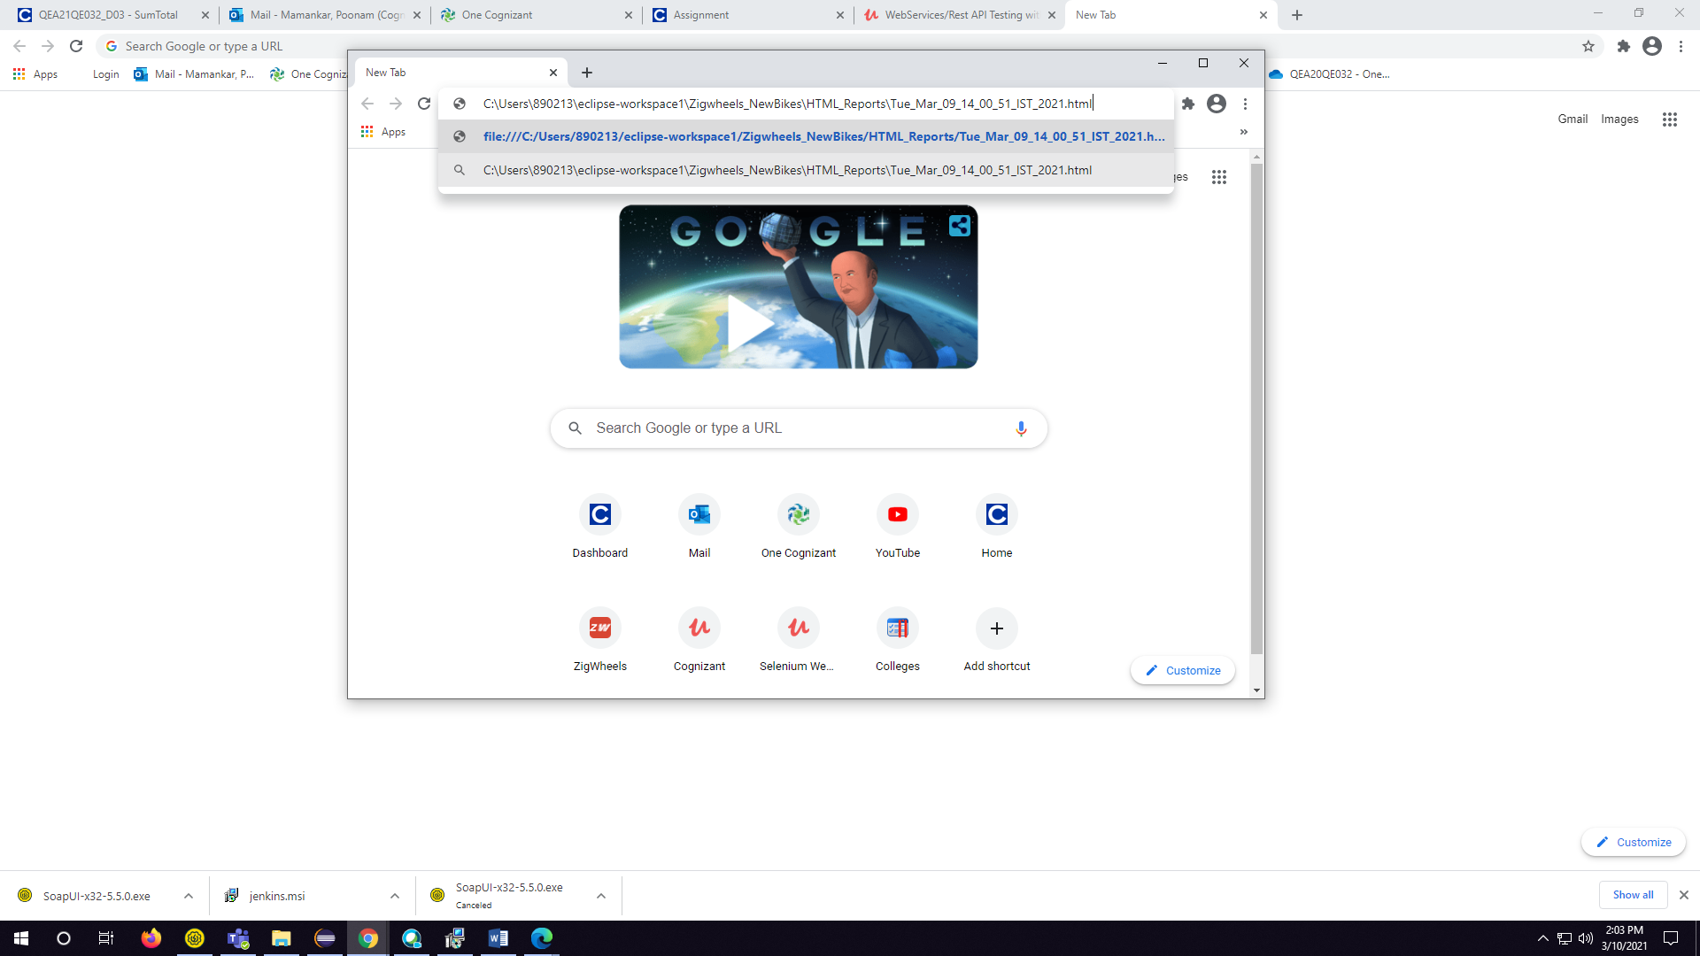

6. Hit “Enter” Key an HTML report is generated.

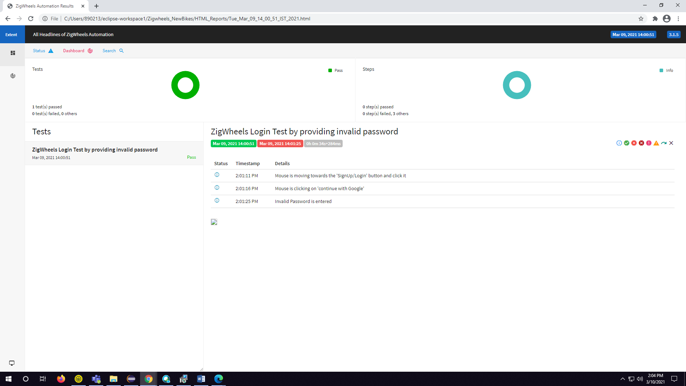

**What contains in:**

(Script details)

1. The project follows maven standards with a hybrid framework i.e., the mixture of Data-driven and POM.

2. There are 3 source files - "src/main/java", "src/test/java", "src/test/resources".

3. "src/main/java" consists of 5 packages – baseclass, pageClasses, utilities, Object Repository, testcases, pom.

· In baseclasss package, we have 3 classes- baseUI, DriverSetup and PageBaseClass

* In baseUI- holds up all the reusable methods in it.
* In DriverSetup- It consists of browser drivers used in automation.
* In PageBaseClass- It has the instances of the Landing Page during the execution of the website.

· The PageBaseClass consists of instances of other pages of the website.

· The utilities package consists of Excel and Report generation classes.

· The pom file consists of Excel write methods.

4. "src/test/java" consists of only 1 package i.e., testCases

· The testCases package have the test class of the project.

5. "src/test/resources" consists of 3 folders- drivers, Object Repository And ExcelFiles.

· The purpose of the resources source folder is to hold the necessary resources to run the project in various systems. User needs to change the versions of web drivers which are compatible in their machines.