CET6
一·替换
- 词组：
- people&persons = individuals/characters/folk
- good=positive/favorable/rosy/promising/pleasurable/excellent/outstanding/superior
- bad=dreadful/poor/adverse/ill/terrible/awful
- many=an army of/an ocean of/a sea of/a multitude of/a host of/an abundance of/ample/numerous/enormous/chunks of/various/diverse
- some=a slice of/quite a few/several/a handful of
- think=harbor the idea that/take the attitude that/hold the view that/it’s universally acknowledged that/it’s widely shared that/reckon/deem/consider/perceive/advocate/claim/assert
- thing=matter/affair/business
- common=shared/universal
- get many benefits=reap huge fruits
- in my opinion=from my perspective
- more=an increasing number of/mounting/growing
- helpful=rewarding/beneficial
- customer=client/purchaser
- very=exceedingly/extremely/intensely
- unavoidable=inevitable
- sb take interest in=sth appeals to sb/sth exerts a tremendous fascination on sb
- attract one’s attention=capture
- side=aspect/facet/dimension/sphere
- cause=give rise to/lead to/contribute to/result in/trigger
- reasons for=there are several factors behind sth
- want=long for/desire/be thirsty for
- pay attention to=pour attention into/immense in/lost in/focus on/lock one’s eyes on
- remember=bear sth in mind
- have=possess/enjoy/own
- enjoy=relish
- disagree with=frown on
- for example=for instance/to name only a few
- effective=constructive/feasible
- because=account for/on account of
- prevent sb from=impede/hinder/hamper/shield sb against
- should=be expected to/be well-advised to do
- sure=convinced
- show=showcase/illustrate/demonstrate/indicate/imply/shed light on/display/exhibit
- improve=enhance/boom/thrive
- ignore=neglect/hold…in contempt
- change=transform/convert/alter
- be made of=be composed of/constitute
- constantly=consistently
- empathy=sympathy/compassion/commiseration
- dislike=disgust/despise/hatred/resentment/abhorrence
- convenient=facilitate

(二)句子
1.sb says=it’s said that
2.I suggest that=effective measures should be taken before things get worse
3.thanks you=your prompt attention to my enquiry would be highly appreciated

二．句式
（一）倒装句：
1.否定never will I agree
2.only in this way, can we…
3.simple as it is
4.in front of me was ..
5.hardly had I done when…

三．表达
（一）逻辑关系过渡词：
1.to begin with/first and foremost
2.additional/in addition/afterword/next/plus/what’s more/moreover/furthermore
3.meanwhile/simultaneously/immediately
4.eventually/therefore/since then/last but not least/thus
5.in a word/in brief/in a nutshell/to sum up/in conclusion
6.Accordingly/consequently
7.due to/in the light of/considering/regardless of/as a result of/in this way
8.in contrast with/on the contrary/different from/otherwise/whereas
9.likewise/equally important/similarily
10.indeed/naturally/actually/in particular

四．AI
1.the transition of… marks a profound shift in…(reflect/reveal)
2.strike a similarity in…
3.transition/evolution/shift
4.compel sb to do…/push/drive/inspire
5.beneath sth lies …
6.diverge significantly
7.brim with
8.plunge sb into a whirlpool of…
9.cast a shadow over
10.adhere to
11. The issue of... has sparked heated debate/Nowadays, it is widely believed that...(universally acknowledged)/the phenomenon of …has captured widespread attention
12. There is no denying that
13. Some people argue that..., while others maintain that...
14. play a pivotal role in...
15. a double-edged sword
16.abundant/numerous/a multitude of/countless
17.cast intense light on
18.this is a recipe for…,and you’ll yield fruitful results.

1.considering/with regard to…/as for
2.in contrast/conversely
3.nevertheless

1.deteriorate
2.embrace
3.navigate
4.threaten
5.transcend
6.approach

- 倒装句
- 强调句
- 虚拟语气

- "Social media, **which has permeated every facet of modern life**, reshapes interpersonal dynamics."
- Were we to neglect this issue**, future generations **would bear the brunt
- The advent of artificial intelligence **has irrevocably altered the trajectory of human progress

翻译：
- the Yangtze River
- the Zhujiang Delta
- the third longest river in Asia
- one-fifth of the land/two-fifths
- 20世纪70年代 the 1970s/in the late 1970s
- Have a total population of/cover/be located in/originate in /place of origin
- 流域river basin
- 注入empty into/流经flow through, run through
- Be renowned for/享誉世界world-renowned/被誉为 be hailed/credited as
- Be essential for sb’s existence
- The birthplace of ancient civilization
- Play a prominent part in
- Hydroelectric power station
- Flood prevention
- Irrigate the land
- Trigger multiple disasters
- Keep disasters at bay

作文：
理由：CHEMIST
- convenience:
be tremendously/exceedingly convenient(very)
be by no means convenient(not)
- health:
enhance/boost/promote physical and mental well-being
impair/jeopardize/be detrimental to
- environment:
safeguard/preserve the environment
aggravate/wreck havoc on
- money:
economical/cost-effective
pricey
- interpersonal relationship&relax
enlarge social circle/build an intimate bond
relax=loosen up
- success:
achieve academic/career success
boost …performance
- technology:
foster valuable qualities(teamwork/communication skills, persistence, diligence, self-discipline, ego, innovation, independence))
- 从背景入手，引出当前社会广泛关注的话题，随后指出核心问题和潜在担忧
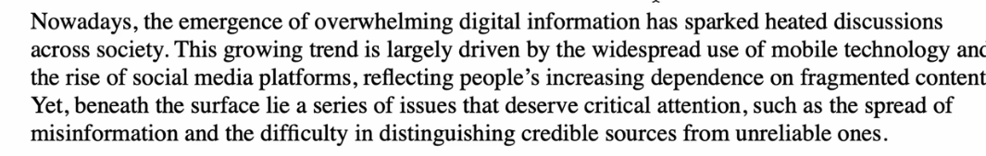
分析原因、争议或后果
Several key factors account for the rise of this trend
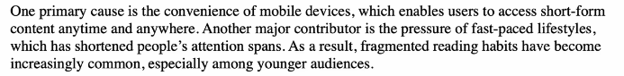
表达立场+对策+升华总结
