**DCO Usage Status Report**

**January 04, 2016**

The following is a report of usage of the DCO Portal for the last 30 days. The report includes the number of new entities added to the DCO data portal of types of interest, e.g. as number of publications added, number of datasets added. Below that number is a breakdown the DCO Community that the entities are associated with. The report also includes the number of DCO members who have logged in to the community portal in the last 30 days followed by the communities that those members are associated with.

## ***New Individuals***

### **DataSets**

number of new individuals = 1

### **Field Studies**

number of new individuals = 0

### **Instruments**

number of new individuals = 0

### **People**

number of new individuals = 32

Number of new members: 7

Extreme Physics and Chemistry Community 1

Data Science Team 1

Reservoirs and Fluxes Community 3

Deep Energy Community 1

Deep Life Community 2

### **Projects**

number of new individuals = 0

### **Project Updates**

number of new individuals = 0

### **Publications**

number of new individuals = 15

Reservoirs and Fluxes Community 2

Extreme Physics and Chemistry Community 3

## **Portal Usage**

1. Number of users logged in in last 30 days: 45
2. DCO Secretariat 5
3. Reservoirs and Fluxes Community 8
4. Deep Life Community 13
5. Data Science Team 4
6. Deep Energy Community 4
7. Engagement Team 6
8. Extreme Physics and Chemistry Community 9
9. Number of users logged in to Data Portal in last 30 days: 14
10. Data Science Team 7
11. Deep Life Community 1
12. DCO Secretariat 1
13. Reservoirs and Fluxes Community 1
14. Engagement Team 3

### ***Google Analytics – Community Portal – last 30 days***

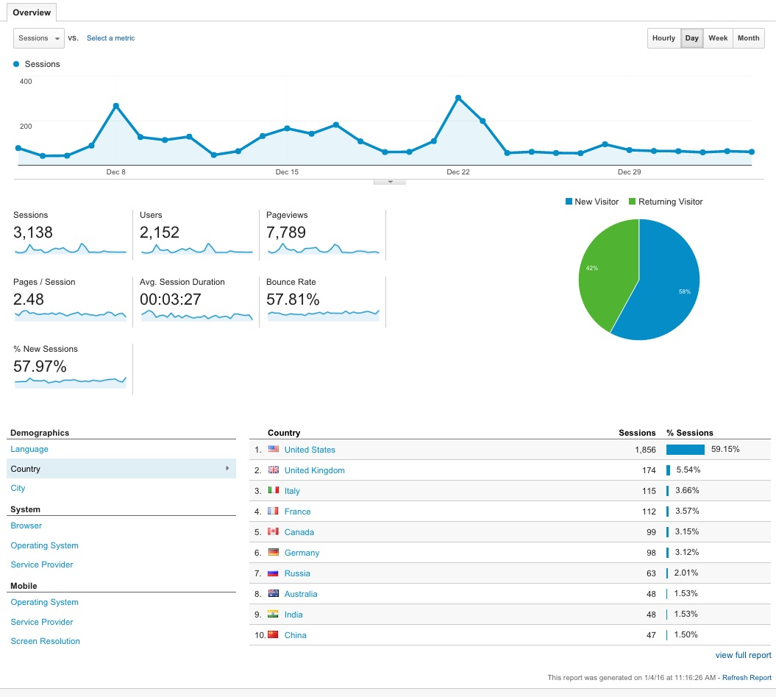

### ***Google Analytics – Data Portal – last 30 days***

