I. Use Case Description
Use Case Name | Reasoning About Action Feasibility from Physical Properties
Use Case Identifier | UC-ActionFeasibility-01
Source | LACAI Lab, Department of Computer Science, Rensselaer Polytechnic Institute
Point of Contact | Hyejin Park, Department of Computer Science, Rensselaer Polytechnic Institute, parkh12@rpi.edu  Xiye Fan, Department of Cognitive Science, Rensselaer Polytechnic Institute, fanx4@rpi.edu  Liangliang Zhang, Department of Computer Science, Rensselaer Polytechnic Institute Zhangl41@rpi.edu  Alex Clark, Department of Electrical, Computer & Systems Engineering, Rensselaer Polytechnic Institute, clarka14@rpi.edu
Creation / Revision Date | September 18, 2026
Associated Documents | Nothing at this stage

II. Use Case Summary
Goal | Develop an ontology that represents how relevant object parts and their physical properties relate to the physical requirements of the action Cut, enabling a system to determine and explain whether an everyday object can support cutting by an ordinary human actor. The ontology should also support identifying alternative objects whose represented properties satisfy the requirements for cutting.
Requirements | The ontology should represent Object, ObjectPart, Action, PhysicalProperty, and ActionRequirement, together with the relations needed to connect these concepts. In particular, it should represent how an object is connected to its relevant parts, how those parts are characterized by physical properties, how the action Cut is associated with physical requirements, and how the properties of an object part satisfy or fail to satisfy those requirements. The ontology should support reasoning over these relations to determine whether a represented object can support cutting, distinguish explicit incompatibility from insufficient property information, and provide a property-based explanation for the result. It should also support retrieving candidate objects whose relevant parts satisfy the represented requirements for cutting, rather than relying only on conventional object categories or functions.
Scope | This use case focuses on ontology-based reasoning about the physical feasibility of the action Cut in a kitchen environment. The system is queried by a researcher, while feasibility is evaluated with respect to whether an ordinary human actor could use an everyday manipulable object to perform the action. The initial ontology represents only the object parts, physical properties, and action requirements that are directly relevant to cutting feasibility. Other manipulation actions, including Open, Pour, and Squeeze, as well as broader environments, non-human actors, specialized industrial tools, and properties unrelated to cutting feasibility, are outside the scope of the initial course project and may be considered in future extensions.
Priority | High — representing action feasibility from physical properties is central to the intended reasoning task and provides the foundation for later extensions of the ontology.
Stakeholders | Primary stakeholders are researchers in knowledge representation, affordance reasoning, robotics, and embodied AI who study how physical properties support action feasibility. Secondary stakeholders include developers of intelligent systems that require explainable reasoning about non-conventional object use.
Description | This use case considers a researcher who uses an ontology-based reasoning system to evaluate whether an everyday object could physically support the action Cut when used by an ordinary human actor in a kitchen environment. Rather than relying only on an object's conventional name, category, or typical function, the system reasons over relevant object parts, their physical properties, and the physical requirements associated with cutting.  The use case supports two complementary types of interaction. First, the researcher can provide a specific object and ask whether it could support cutting under the represented conditions and why. Second, when a conventional cutting tool is unavailable or unusable, the researcher can provide a set of available objects and ask which of them satisfy the represented physical requirements for cutting. In both cases, the system returns a property-based explanation and distinguishes explicit incompatibility from cases where the available property information is insufficient to support a conclusion.
Actors / Interfaces | Primary Actor – Researcher:  Submits queries to the ontology-based reasoning system about whether a specific object can support the action Cut, or which available objects could satisfy the physical requirements for cutting. The researcher receives the resulting feasibility judgment, candidate objects, and property-based explanations.  Reference Actor – Ordinary Human Actor:  Represents the assumed physical capabilities of the person who would perform the action. Feasibility judgments are made with respect to whether an ordinary human actor could manipulate the represented object and use its relevant part to perform cutting. This actor does not directly interact with the reasoning system.  System – Ontology-Based Reasoning System:  Uses the ontology to retrieve the requirements associated with Cut, identify relevant object parts and their represented physical properties, and reason about whether those properties satisfy or conflict with the action requirements.  Secondary Actor / Interface – Knowledge Base / Data Sources:  Supplies structured information used to populate or support the ontology, including objects, object parts, physical properties, and evidence used to define or refine cutting requirements.
Pre-conditions | The ontology contains a representation of the action Cut, the physical requirements associated with cutting, and relevant objects, object parts, and physical properties. The specific object or candidate objects being evaluated must have sufficient information about their relevant parts and properties for the system to compare them with the represented cutting requirements. If such information is unavailable, the system follows the insufficient-information alternate flow rather than assuming infeasibility.
Post-conditions | The system returns either (1) a feasibility judgment for the specified object or (2) a set of candidate objects whose relevant parts satisfy the represented requirements for cutting. The result is accompanied by a property-based explanation identifying the relevant object part, physical properties, and action requirements involved in the judgment. If the available knowledge is insufficient, the system returns an insufficient-information result and identifies the missing information instead of forcing a feasible or infeasible conclusion.
Triggers | The use case is triggered when a researcher submits either (1) a query asking whether a specific object can support Cut under the represented conditions, or (2) a query asking which objects from a provided set of available objects satisfy the represented physical requirements for cutting.
Performance Requirements | No specific runtime performance requirement is imposed for the course prototype. Priority is given to correctness, traceability, and explainability of ontology-based reasoning rather than response speed.
Assumptions | Feasibility judgments assume an ordinary human actor operating in a kitchen environment. For the initial course ontology and competency questions, cutting feasibility is evaluated under a fixed target context involving a carrot unless otherwise specified.
Open Issues | The main ontology-design issue is how to formalize the relations between ObjectPart / PhysicalProperty and ActionRequirement, including which existing ontology relations can be reused and which project-specific relations need to be introduced.

III. Usage Scenarios

Scenario 1: Feasibility Verification and Explanation
A researcher studying physical affordances wants to determine whether a specific everyday object could be used by an ordinary human actor to perform Cut in a kitchen setting. For example, the researcher may ask whether a rigid plastic card could be used to cut a carrot. The system uses the ontology to retrieve the physical requirements represented for cutting, identify the relevant part of the card, and retrieve the physical properties associated with that part. It then determines whether those represented properties satisfy or conflict with the cutting requirements. The desired outcome is a feasible, infeasible, or insufficient-information judgment together with an explanation identifying the relevant object part, physical properties, and requirements that support the result.
Scenario 2 — Goal-Driven Alternative Object Discovery Under Constraints
A researcher studying alternative object use wants to identify which objects from a known set of available kitchen items could support Cut when a conventional cutting tool is unavailable or unusable. For example, the available objects may include a rigid plastic card, a rolling pin, and a kitchen sponge. Rather than searching for objects conventionally categorized as cutting tools, the system starts from the physical requirements represented for cutting and uses the ontology to examine the relevant parts and properties of each available object. Objects whose represented properties satisfy the cutting requirements are returned as candidates, while objects with explicitly incompatible properties are excluded. The desired outcome is a set of physically plausible alternative objects together with property-based explanations for why each candidate satisfies the represented cutting requirements.

IV. Basic Flow of Events

Basic Flow Narrative:
The researcher submits a query involving the action Cut and either (1) a specific object to evaluate or (2) a known set of available objects to search for alternatives. The reasoning system first queries the ontology for the ActionRequirement instances associated with Cut. It then uses the represented relations among Object, ObjectPart, and PhysicalProperty to identify the relevant parts and properties of the object or candidate objects. The system evaluates whether those represented properties satisfy or conflict with the cutting requirements. For a feasibility-verification query, the system derives a feasible, infeasible, or insufficient-information result for the specified object. For an alternative-object query, it identifies the objects whose relevant parts satisfy the represented cutting requirements. Finally, the system returns the result together with a property-based explanation showing the relevant object part, physical properties, and action requirements used in the reasoning process.

Basic / Normal Flow of Events
Step | Actor (Person) | Actor (System) | Description
1 | Researcher |  | Submits a query involving Cut and specifies either a particular object to evaluate or a known set of available objects to search.
2 |  | Ontology-Based Reasoning System | Identifies whether the query is a feasibility-verification query or an alternative-object search query.
3 |  | Ontology-Based Reasoning System | Queries the ontology for the ActionRequirement instances associated with Cut and retrieves the represented physical requirements for cutting.
4 |  | Ontology-Based Reasoning System | Uses ontology relations linking Object, ObjectPart, and PhysicalProperty to identify the relevant part(s) of the specified or candidate objects and retrieve their represented physical properties.
5 |  | Ontology-Based Reasoning System | Evaluates whether the represented properties of each relevant object part satisfy, conflict with, or provide insufficient information for the cutting requirements.
6 |  | Ontology-Based Reasoning System | For a feasibility-verification query, derives a feasible, infeasible, or insufficient-information result for the specified object.
7 |  | Ontology-Based Reasoning System | For an alternative-object search query, retains objects whose relevant parts satisfy the represented cutting requirements and excludes objects with explicitly incompatible properties. Objects with missing required information are treated as unresolved rather than infeasible.
8 |  | Ontology-Based Reasoning System | Generates a property-based explanation identifying the relevant ObjectPart, PhysicalProperty, and ActionRequirement information used to derive the result.
9 | Researcher | System | Receives the feasibility judgment or candidate-object set together with the explanation.

V. Alternate Flow of Events

Alternate Flow Narrative — Insufficient Property Information
This alternate flow begins during Step 5 of the Basic Flow when the reasoning system determines that one or more physical properties required to evaluate a cutting requirement are not represented for the relevant object part. Missing information is not treated as evidence that the object is infeasible. For a feasibility-verification query, the system returns an insufficient-information result and identifies the missing property information. For an alternative-object search query, the affected object is marked as unresolved rather than excluded as infeasible, and the system continues evaluating the remaining candidate objects. If the researcher later provides sufficient additional information, the system updates or retrieves the relevant property information and resumes the Basic Flow.

Alternate Flow of Events
Step | Actor (Person) | Actor (System) | Description
A1 |  | Ontology-Based Reasoning System | During Basic Flow Step 5, detects that one or more physical properties needed to evaluate a represented cutting requirement are missing for the relevant object part.
A2 |  | Ontology-Based Reasoning System | Identifies the missing property information and does not interpret the absence of that information as evidence of infeasibility.
A3 |  | Ontology-Based Reasoning System | For a feasibility-verification query, returns an insufficient-information result and identifies which property information is required to complete the judgment.
A4 |  | Ontology-Based Reasoning System | For an alternative-object search query, marks the affected candidate as unresolved and continues evaluating the remaining available objects.
A5 | Researcher |  | May provide additional property information, choose another object for evaluation, or end the query.
A6 |  | Ontology-Based Reasoning System | If sufficient new information becomes available, updates or retrieves the relevant property representation and resumes the Basic Flow at Step 4, followed by reevaluation at Step 5.

VI. Use Case and Activity Diagram(s)

The following diagrams illustrate the actors, system components, and reasoning activities involved in the two usage scenarios. The use case diagram summarizes the primary interactions with the ontology-based reasoning system, while the architecture diagram shows where the ontology is used within the overall system. Two activity diagrams then show the detailed flows for (1) feasibility verification and explanation and (2) goal-driven alternative object discovery.

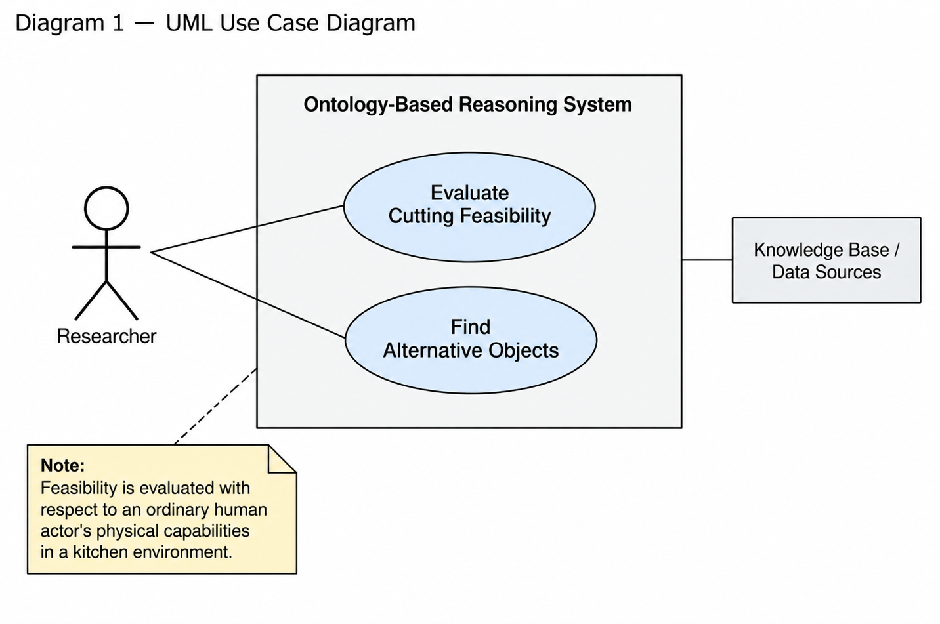
Diagram 1 — UML Use Case Diagram

Diagram 2 — High-Level Architecture / Overview
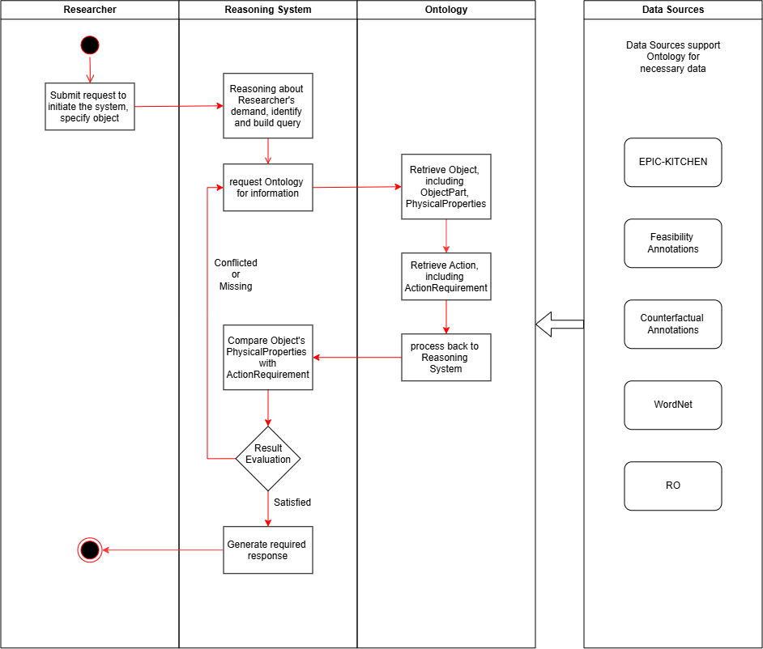

Diagram 3 — Activity Diagram: Scenario 1
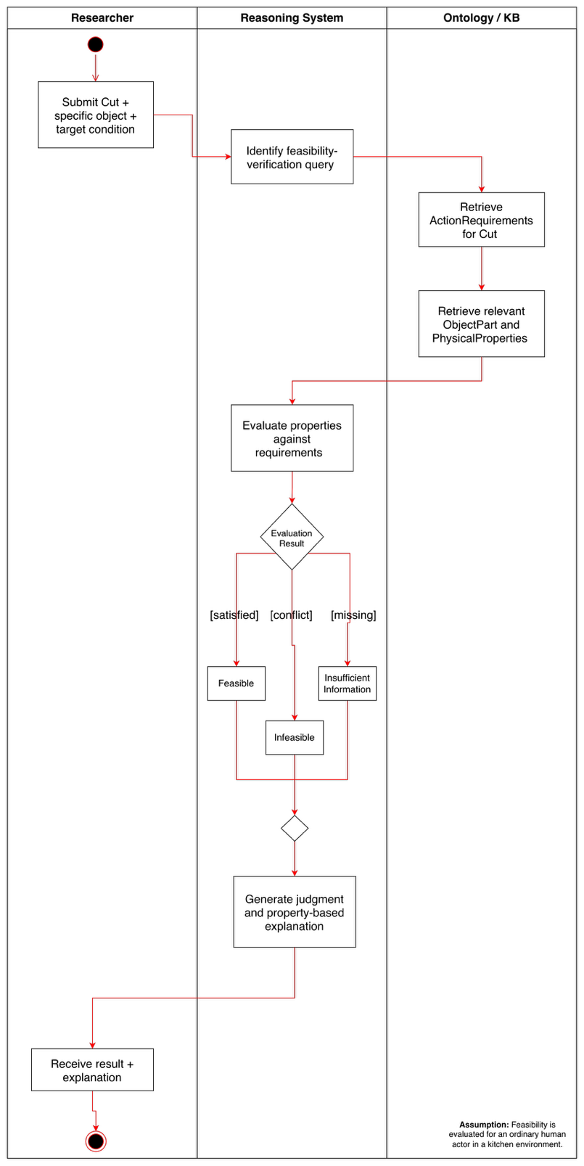

Diagram 4 — Activity Diagram: Scenario 2 (Lia working on this)
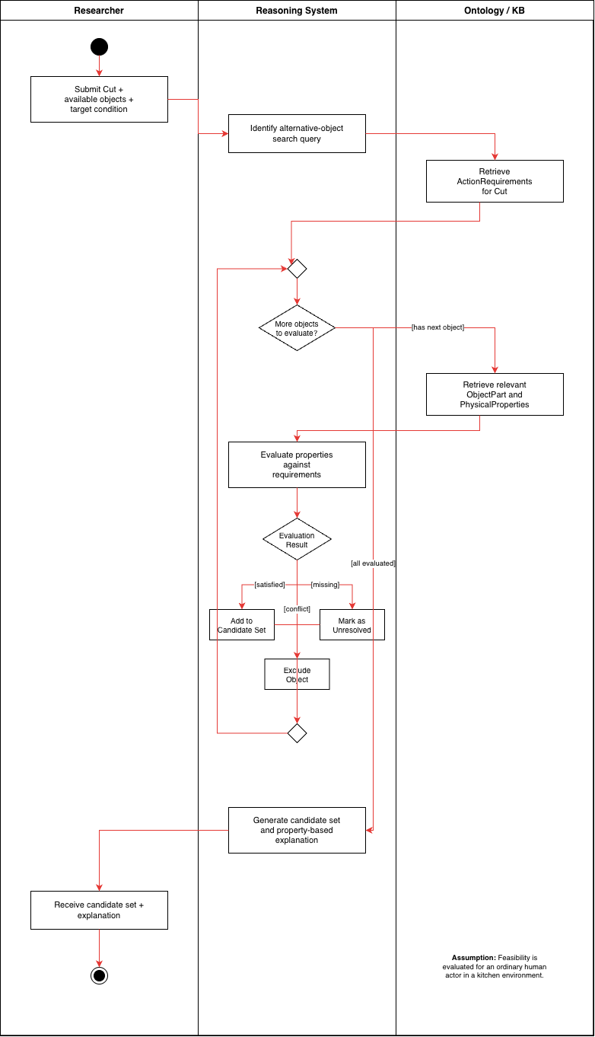

VII. Competency Questions

Scenario 1 — Feasibility Verification and Explanation
CQ1.1 — Can a rigid plastic card be used by an ordinary human actor to cut a carrot, and why?

Example Answer: Yes, under the represented conditions. A rigid plastic card may support cutting a carrot when its edge has sufficiently thin geometry and sufficient rigidity to satisfy the relevant cutting requirements.
Ontology Approach: The ontology represents the plastic card as an Object and its edge as a relevant ObjectPart. The edge is associated with represented PhysicalProperties, while Cut is associated with corresponding ActionRequirements. The reasoning system compares the represented properties of the card edge with those requirements and derives a feasible result when the required conditions are satisfied.
Resource Note: The relevant object-part, property, and feasibility examples are supported by the Derived Feasibility Scenario Annotations described in Section VIII. Resources. Counterfactual examples may additionally support refinement of which properties are relevant to the cutting requirements.
CQ1.2 — Can a typical kitchen sponge be used to cut a carrot, and why or why not?
Example Answer: No. A typical kitchen sponge does not provide a sufficiently rigid and appropriately shaped edge to satisfy the represented requirements for cutting the carrot.
Ontology Approach: The system retrieves the ActionRequirements represented for Cut and the relevant PhysicalProperties of the sponge or its candidate cutting part. If the represented properties explicitly conflict with one or more required conditions, the system derives an infeasible result and identifies the unmet requirement.
Resource Note: Examples of feasible and infeasible object-action combinations are provided by the Derived Feasibility Scenario Annotations in Section VIII. Resources.

Scenario 2 — Goal-Driven Alternative Object Discovery Under Constraints
CQ2.1 — If a conventional cutting tool is unavailable, which of the following available objects could satisfy the represented physical requirements for cutting a carrot: a rigid plastic card, a rolling pin, or a kitchen sponge?
Example Answer: The rigid plastic card may be returned as a candidate. Its relevant edge can provide the thin geometry and rigidity represented as necessary for cutting the carrot. Based on the represented properties, the rolling pin and kitchen sponge do not satisfy the same cutting requirements.
Ontology Approach: The system begins with Cut and retrieves its associated ActionRequirements. It then examines the available Object instances, follows their relations to relevant ObjectParts and PhysicalProperties, and identifies those whose represented properties satisfy the cutting requirements. Candidates are therefore retrieved from physical compatibility rather than from membership in a conventional cutting-tool category.
Resource Note: Candidate objects and their relevant properties are drawn from the Derived Feasibility Scenario Annotations, while the kitchen-domain vocabulary is informed by EPIC-KITCHENS-100. See Section VIII. Resources.

CQ2.2 — Why can a rigid plastic card be returned as a candidate for cutting a carrot while a kitchen sponge is excluded?
Example Answer: The rigid plastic card may be returned because its relevant edge has represented properties that satisfy the cutting requirements, including sufficient rigidity and suitable edge geometry. The kitchen sponge is excluded because its represented properties do not satisfy those same requirements, particularly the rigidity and edge characteristics needed for cutting.
Ontology Approach: The ontology enables the system to compare the relevant ObjectPart–PhysicalProperty descriptions of the two objects against the same ActionRequirements for Cut. The difference in how their represented properties satisfy or conflict with those requirements explains why one object is retrieved as a candidate while the other is not.
Resource Note: The Derived Feasibility Scenario Annotations provide object-property and outcome examples, while the Derived Counterfactual Contrast Annotations in Section VIII. Resources can support identification of properties whose change is associated with a change in cutting feasibility.

VIII. Resources

Data Availability
EPIC-KITCHENS-100 is publicly available and provides the source kitchen-domain action vocabulary from which Cut was selected for the initial ontology scope. However, EPIC-KITCHENS does not directly provide the physical properties, object-part descriptions, or action-requirement relations needed for the proposed feasibility reasoning. These are supplied by a small curated subset of feasibility and counterfactual annotations generated as part of ongoing affordance-reasoning research. For the course project, only data relevant to Cut and the competency questions defined in Section VII will be used.

Knowledge Bases, Repositories, or other Data Sources
Data | Type | Characteristics | Description | Owner | Source | Access Policies & Usage
EPIC-KITCHENS-100 | Remote dataset / repository | Egocentric kitchen videos with annotated manipulation actions and object interactions | Provides the source kitchen-domain action vocabulary and human-object interaction context from which Cut is selected for the initial ontology scope. It does not directly provide the physical-property or action-requirement knowledge used for feasibility reasoning. | EPIC-KITCHENS / University of Bristol and collaborators | EPIC-KITCHENS dataset website / annotation repository  Link (full dataset): https://epic-kitchens.github.io/  Link (annotation dataset): https://github.com/epic-kitchens/epic-kitchens-100-annotations | Publicly available; Required for establishing the action vocabulary and provenance of the selected kitchen action, but not queried directly during ontology reasoning.
Derived Feasibility Scenario Annotations | Local / experimentally generated dataset | A curated set of feasible and infeasible examples for the action Cut, including the relevant object, object part, physical properties, target context, and feasibility outcome. The resource provides instance-level evidence used to populate and test the course ontology and to support the competency questions in Section VII. | Provides the instance-level evidence used to populate the course ontology with examples of objects, object parts, relevant physical properties, and feasible or infeasible outcomes. Only the Cut-specific subset will be used for this course project. | Hyejin Park / LACAI Lab | nternal project resource; no public URL available at this stage. | Internal and under development; a curated Cut-specific subset will be available to the course team. Required.
Derived Counterfactual Contrast Annotations | Local / experimentally generated dataset | Paired examples in which changes to an object property or relevant part are associated with changes in action feasibility | Paired or contrastive examples in which a change to a relevant object part or physical property is associated with a change in cutting feasibility. The resource is used as supporting evidence when identifying or refining which properties are relevant to the ActionRequirements for Cut | Hyejin Park / LACAI Lab | Generated through ongoing affordance-reasoning experiments | Internal and under development; a limited Cut-specific subset will be available for the course project. Supporting / Optional

External Ontologies, Vocabularies, or other Model Services
Resource | Language | Description | Owner | Source | Describes/Uses | Access Policies & Usage
WordNet | English | Supports terminology normalization and sense distinction for action and object terms used in the ontology. It is not used to determine physical feasibility. | Princeton University | Princeton WordNet  Link: https://wordnet.princeton.edu/ | Action and object terminology derived from EPIC-KITCHENS and the experimental annotations | Freely available; Supporting / Optional
Relations Ontology (RO) | OWL / OBO | Provides standardized relation types intended for reuse across ontologies. It will be reviewed to determine whether general relations needed in this project, such as part-whole relations, can reuse existing semantics before new project-specific relations are introduced. | OBO Relations Ontology community / OBO Foundry | Official Website Link: https://obofoundry.org/ontology/ro.html | Relations among ontology entities, particularly reusable general-purpose relations such as part-whole relations. | Publicly available; Supporting / Optional. Used as a reference for relation reuse and ontology-design decisions rather than as a required source of instance data.

Other Resources, Service, or Triggers (e.g., event notification services, application services, etc.)
Resource | Type | Description | Owner | Source | Access Policies & Usage
(sensor or external service name) |  | Include a description of the resource as well as availability, if applicable | Primary owner of the service | Application or service URL; if subscription based, include subscription and any subscription owner

IX. References and Bibliography

- EPIC-KITCHENS-100. Egocentric kitchen video dataset and action annotation repository. https://epic-kitchens.github.io/
- EPIC-KITCHENS-100 Annotations. https://github.com/epic-kitchens/epic-kitchens-100-annotations
- Princeton WordNet. Princeton University. https://wordnet.princeton.edu/
- Relations Ontology (RO). OBO Foundry. https://obofoundry.org/ontology/ro.html
- Object Management Group (OMG). Unified Modeling Language (UML), Version 2.5.1. https://www.omg.org/spec/UML/2.5.1/

X. Notes

There is always some piece of information that is required that has no other place to go. This is the place for that information.

