Provenance Diagram:

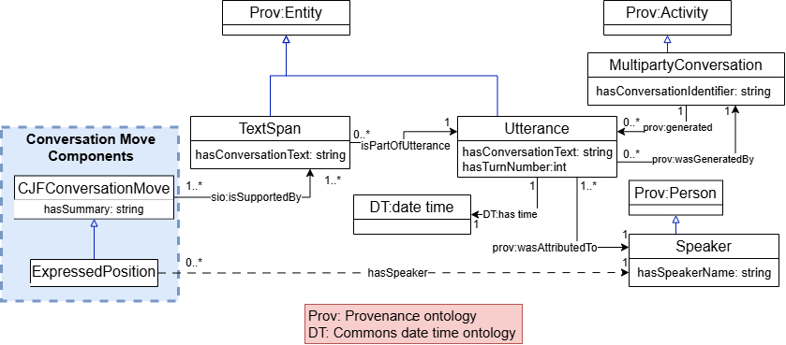
Description: The diagram is responsible for depicting how the underlying text is connected to our model where each CFJConversationMove is connected to an evidence TextSpan. The property chain represented in the diagram supports the inference of the associatedWithSpeaker relationship, which is used to answer CQ5 and CQ6. The supporting TextSpan and turn number can also be retrieved to answer CQ5, CQ6, and CQ7.

-----------------

Diagram of CJF Conversation Moves that have states:

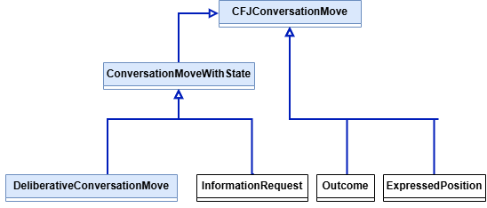
Description: The diagram shows how the conversation move classes are grouped under the general CJFConversationMove class. DeliberativeConversationMove and InformationRequest are grouped under ConversationMoveWithState because they represent conversation moves that have states that change during a conversation. Outcome and ExpressedPosition are directly under CJFConversationMove since they do not have states. This distinction relates to CQ1, which asks which conversation moves occurred and what state information is known for the conversation moves where a state applies.
-----------------

A Deliberative CJF Conversation Move:

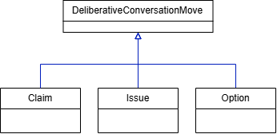

Description: This diagram expands the DeliberativeConversationMove class from the previous diagram into three subclasses: Claim, Issue, and Option. Each is a type of DeliberativeConversationMove and therefore also belongs to Conversation MoveWithState. This grouping supports CQ1 by identifying conversation move types the ontology represents state information for.
-----------------

CJF Conversation Moves state taxonomy:

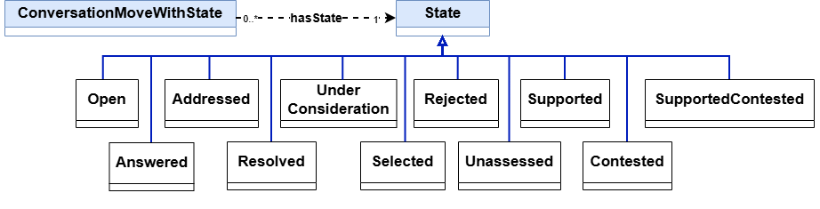

Description: This diagram shows the state taxonomy linked to each conversation move type through hasState. These states relate to CQ1 about conversation move state information and CQs 2 and 4 about whether Issues are Addressed or Resolved. Each conversation moveWithState has exactly one current State. A State can be shared by any number of conversation moves.
-----------------

Previous State Assignment Diagram:

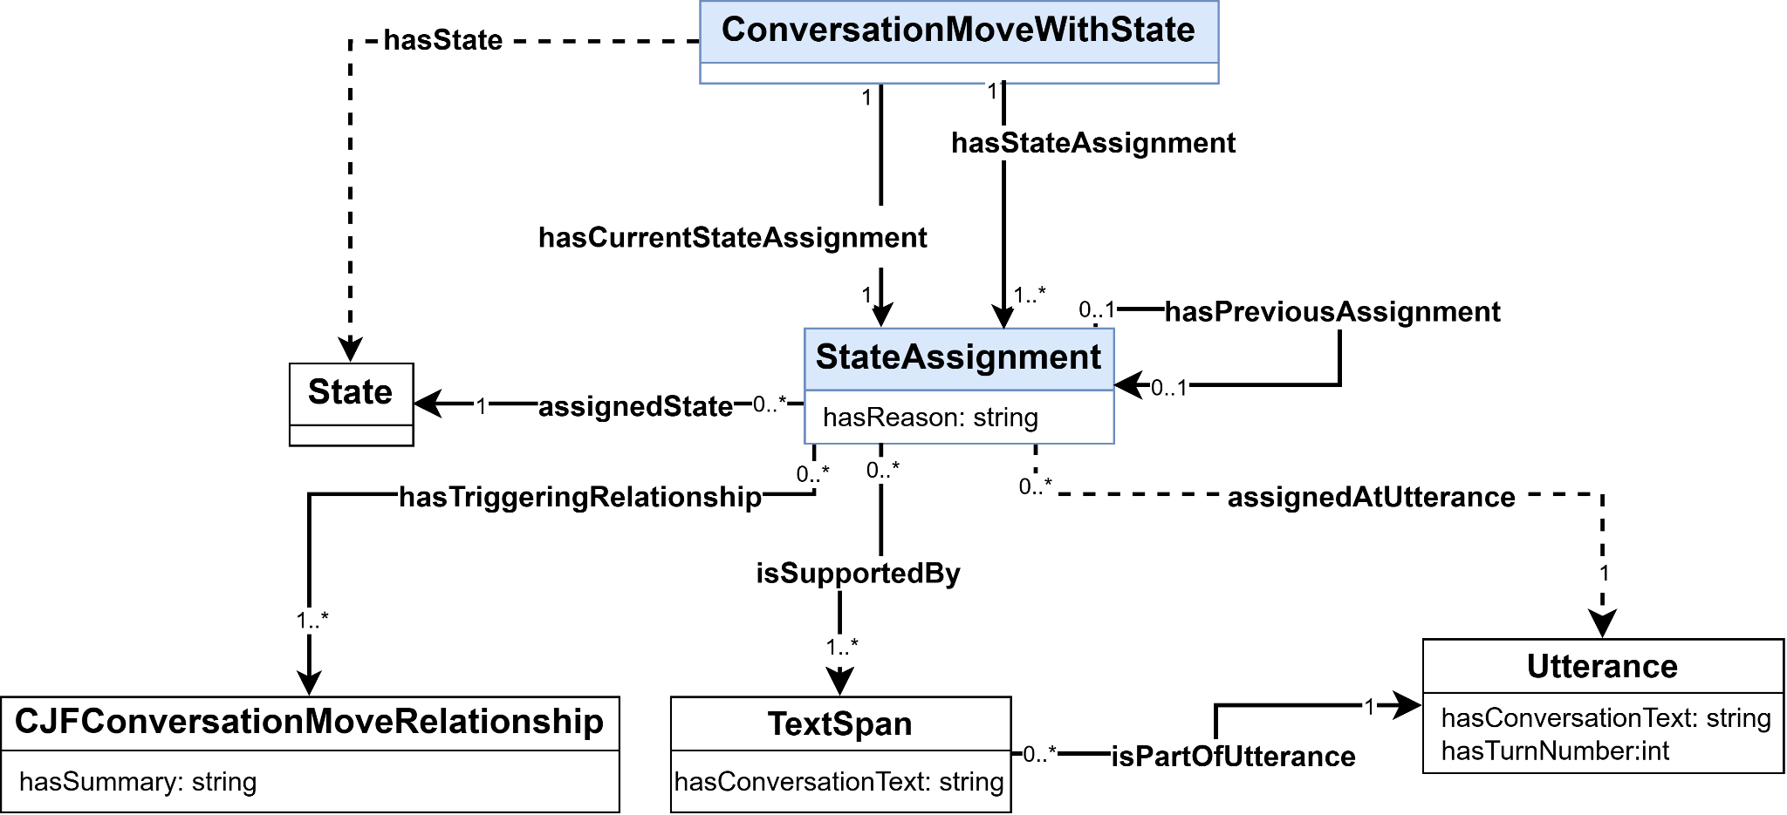

Description: This diagram shows how conversation moves with states retain their state history as the current State updates. Each conversation move has one current State and one or more StateAssignment records (including current and historical states). Each StateAssignment identifies the recorded State, the Utterance at which it became applicable, and the Text Span evidence supporting it. A StateAssignment may link to the preceding StateAssignment for the same conversation move, allowing changes to be traced through the conversation. This is needed to provide supporting evidence of states in our CQs through hasStateEvidence and assignedAtUtterance. We also have a connection to the triggering relationship of the state change. Which further assists in the inference
—---------------

Expressed Position Subdiagram:
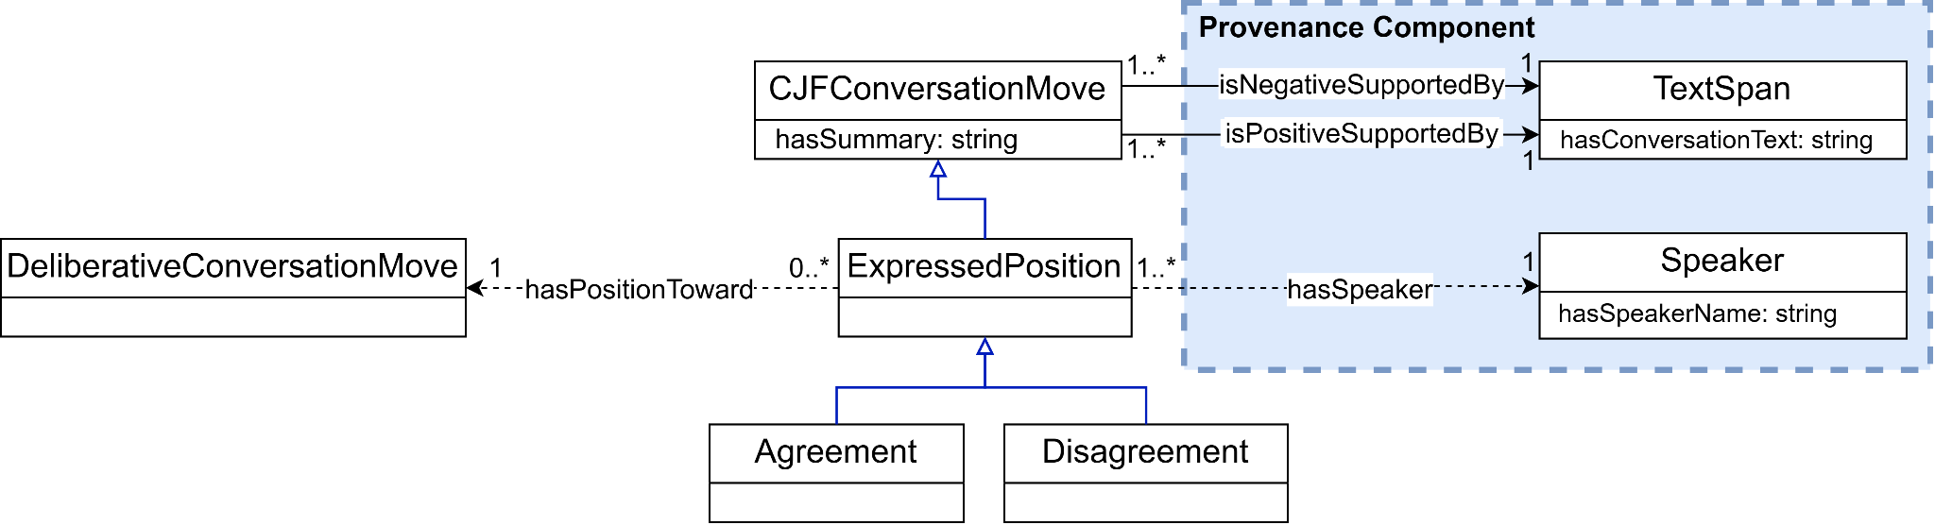
Description: The diagram models Agreement and Disagreement as subclasses of ExpressedPosition, which is itself a subclass of CFJConversationMove. The appropriate subclass is inferred from the supporting textual evidence: isPositiveSupportedBy indicates Agreement, whereas isNegativeSupportedBy indicates Disagreement. Together with conversation turn information, these relationships support CQs 5, 6 and 7.
-----------------

Relationships between CJF Conversation Moves:

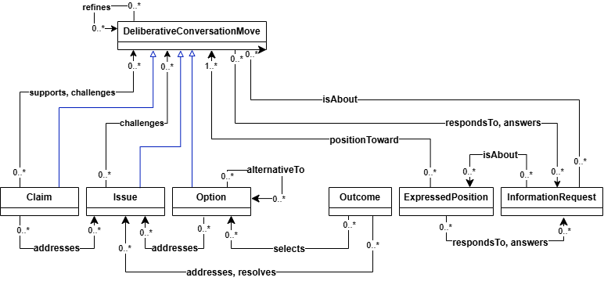

Description: This diagram shows how the conversation move types can be connected in the conversation. These relationships help retrieve related contributions and provide evidence for determining conversation move states. Together with the state information and links to speakers and turns, they support all the competency questions.
-----------------

Diagram of Property Hierarchy:

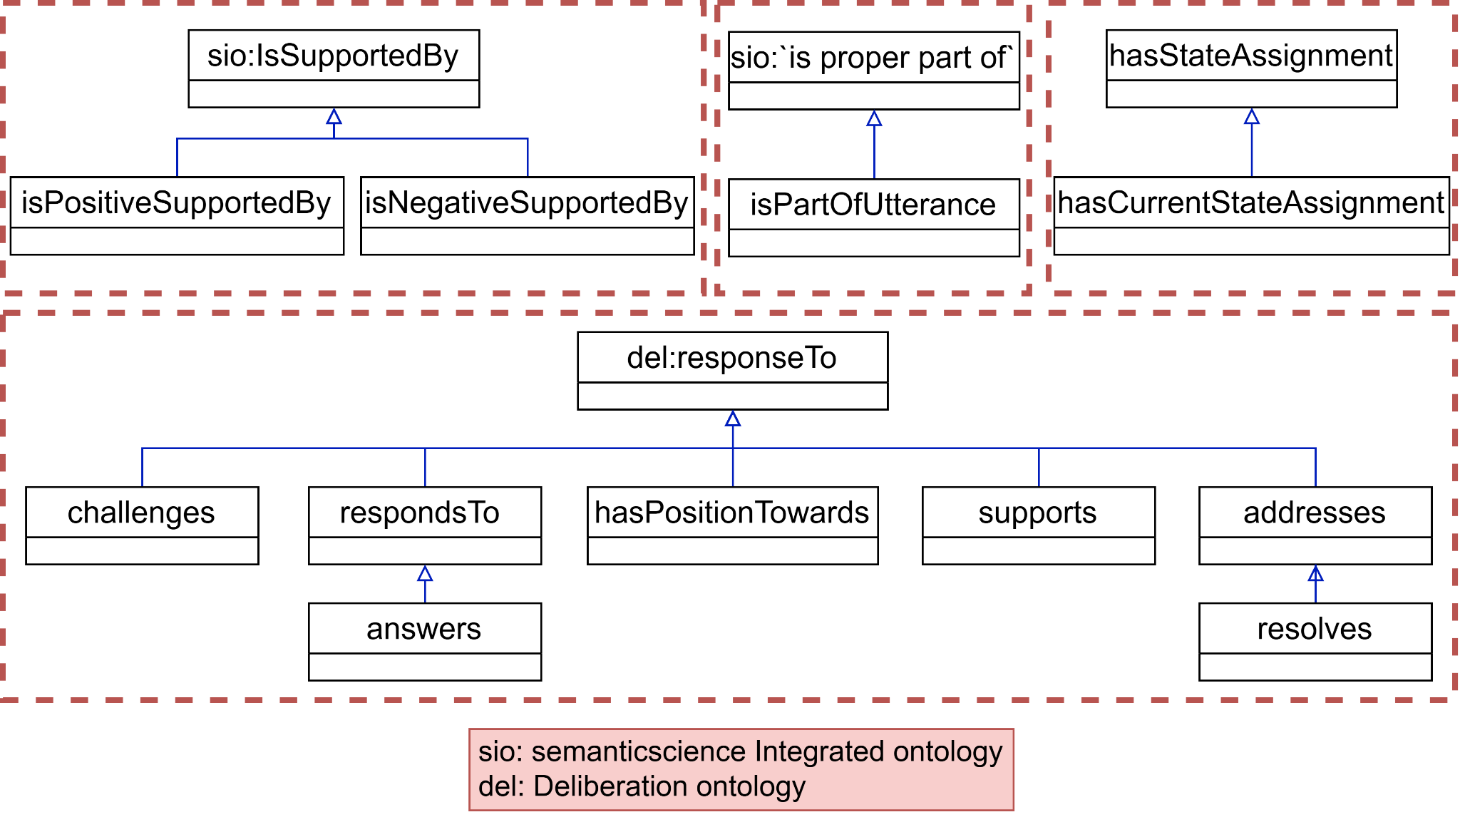

Description: The diagram shows the subproperty relationships of properties in our ontology, This contains 4 segments of properties and imports properties from SIO [1] and deliberation ontology [2]
------------

Reification CJF Relationship Class Taxonomy

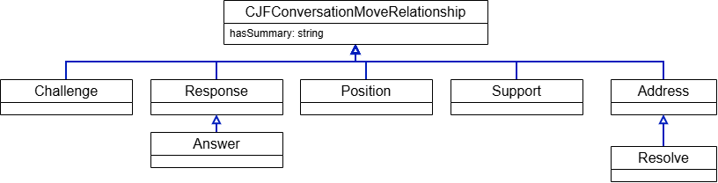
Description:
The diagram shows the class hierarchy used to reify relationships between conversation moves. CJFConversationMoveRelationship is the superclass of Challenge, Response, Position, Support, and Address. Answer specializes Response, while Resolve specializes Address.

Reification Diagram:

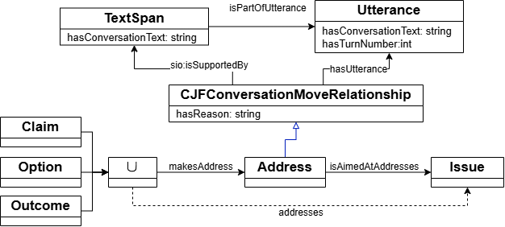
Description: The diagram illustrates how relationships between conversation moves are represented through reification. Each relationship is modeled as an individual that connects a source conversation move to a target conversation move. This allows supporting evidence and other contextual information to be attached to the relationship itself, recording both how the moves are connected and what justifies that connection. The reasoner can infer from the property chain the actual relationship. In this example, addresses are inferred through the property chain of makesAddress and isAimedAtAddresses. The same reification pattern applies to supports, challenges, respondsTo, answers, resolves, and hasPositionTowards: each is represented by a relationship individual with supporting evidence, and its direct relationship can be inferred through the corresponding property chain.

-----------------
References

[1] M. Dumontier et al., “The Semanticscience Integrated Ontology (SIO) for biomedical research and knowledge discovery,” Journal of Biomedical Semantics, vol. 5, no. 1, Art. no. 14, 2014, doi: 10.1186/2041-1480-5-14. [Online]. Available: https://doi.org/10.1186/2041-1480-5-14.

[2] S. Vagnoni, “Deliberation Knowledge Graph.” Accessed: Oct. 13, 2026. [Online]. Available: https://dkg.svagnoni.linkeddata.es/

[3] M. Dumontier et al., “The Semanticscience Integrated Ontology (SIO) for biomedical research and knowledge discovery,” Journal of Biomedical Semantics, vol. 5, no. 1, Art. no. 14, 2014, doi: 10.1186/2041-1480-5-14. [Online]. Available: https://doi.org/10.1186/2041-1480-5-14.

[4] T. Lebo, S. Sahoo, and D. McGuinness, Eds., “PROV-O: The PROV Ontology,” W3C Recommendation, Apr. 30, 2013. [Online]. Available: https://www.w3.org/TR/prov-o/

[5] S. Vagnoni, “Deliberation Knowledge Graph.” Accessed: Oct. 13, 2026. [Online]. Available: https://dkg.svagnoni.linkeddata.es/

