I. Use Case Description
Use Case Name | When To Go Where
Use Case Identifier | NP-001
Source | Student In CSCI 4340
Point of Contact | Benjamin Rodgers, Tyler Layton, Annabelle Choi, Samyuth Sagi
Creation / Revision Date | September 2024
Associated Documents | Requirements documentation, traceability matrix if applicable

II. Use Case Summary
Goal | To help explorers and adventurers decide on a national park they wish to go to based on their preferences
Requirements | Recommendations will take into consideration a National Park’s typical weather, terrain, visitation statistics, hike statistics, etc. to make a correct recommendation based on a user's request. These statistics are my required data points.
Scope | The scope would contain all the national parks in the United States. Based on whatever settings the user would want, this would be a recommender for your novice to experienced adventurer who requires specifics on their hike/camp. The scope should remain national parks and not national forests or sites, this keeps the data within a doable nature.
Priority | N/A
Stakeholders | Stakeholders would be novice to experienced adventurers/campers looking to checkout national parks
Description | Many campers/explorers have experienced quite a bit of nature. I, for example, have seen 40+ states within this beautiful country. When you do such a thing for so long, you develop preferences and desires for what you want to see and experience. When you develop these preferences, they tend to revolve around the people you are hiking with, the temperature to hike in, and the terrain you wish to climb. For example, in 2023 I was at Yellowstone National Park. I experienced the beauty of the park and the great hiking trails. The only problem was the tourists ruining the views. Taking the cheap hiking routes just to get to the bigger picture, clogging up scenic views, and getting in the way. I would like a way to easily pick out when to go to avoid this and so would many others.
Actors / Interfaces | Actors would mainly include hikers and campers willing to see more with more preferences. Campers who seek to hike and camp when nobody is around at a certain temperature. Anyone who wants specifics influencing their planning. Databases would include weather forecasting data, National Park visitation statistics, and map terrain data.
Pre-conditions | Ability to access weather forecasting data, National Park visitation statistics, map terrain data, or any other needed source.
Post-conditions | None, hopefully the actor will be satisfied.
Triggers | An actor looking for specifics and needing a recommendation.
Performance Requirements
Assumptions | The data is acquirable and there is a market for this
Open Issues

III. Usage Scenarios

Provide at least two usage scenarios that flesh out the requirements outlined in the summary, including identification of requirements specific to any envisioned ontology or semantically-driven service or application. Scenarios should be described as narrative, with supporting diagrams as appropriate. In an Agile process, every user story relevant to the use case should be included and elaborated/rolled up into one or more usage scenarios, with a clear mapping from the user story to the scenario it is integrated in or mapped to.

- John, an experienced hiker, is looking for something new. He has never been to the true midwest of the United States. He is looking for someplace in South Dakota where the weather is typically around 50 degrees in the Fall, is mostly flat land, and where no people show up. He has looked around but can’t seem to find the correct data to point him where he needs to go. He needs specifics in order to satisfy his quench for adventure.
- Jeb is fairly new to hiking, his legs are very weak and he can’t go for long distances. He correctly assumes that National Parks with more visitation tend to have easier trails and sights to see, but he also wants something warm, dry, yet mountainous. Jeb also just wants to take pictures for Instagram and Hinge, he figures that seeming like he loves nature is a good way to seem likeable. He needs to find that easy popular place, he wants to follow the people trail.

IV. Basic Flow of Events
Narrative: Often referred to as the primary scenario or course of events, the basic flow defines the process/data/work flow that would be followed if the use case were to follow its main plot from start to end. Error states or alternate states that might occur as a matter of course in fulfilling the use case should be included under Alternate Flow of Events, below. The basic flow should provide any reviewer a quick overview of how an implementation is intended to work. A summary paragraph should be included that provides such an overview (which can include lists, conversational analysis that captures stakeholder interview information, etc.), followed by more detail expressed via the table structure.

In cases where the user scenarios are sufficiently different from one another, it may be helpful to describe the flow for each scenario independently, and then merge them together in a composite flow.

Summary: In the basic flow of events the user would reach out, through a UI, and declare what they’re looking for. For the basis of scope, the plan is to have the user decide what they want based on, selection of states, temperature/weather required, and visitation/population in the park at a given time. Once this selection is made, the computer will take a look at the ontology and pick places that fit all the descriptions needed. Lastly, the computer will return the data to the user and the normal flow.

Basic / Normal Flow of Events
Step | Actor (Person) | Actor (System) | Description
Search | Hiker | UI | The actor is looking for a place to go, he puts in specifics for his search based on descriptions provided by the system
Find | Hiker | System | The system will take the queries desire by the hiker and look within its ontology to find characteristics that contain the characteristics and stats the hiker is looking for
Finish | Hiker | System | After gathering all the statistics and characteristics within the given queries and ontologies, the computer narrows down the parks to its top three and reveals them to the hiker along with their statistics that match the queries.

V. Alternate Flow of Events
Narrative: The alternate flow defines the process/data/work flow that would be followed if the use case enters an error or alternate state from the basic flow defined, above. A summary paragraph should be included that provides an overview of each alternate flow, followed by more detail expressed via the table structure.

Summary: The only difference between this flow and the basic flow is that the computer is/was not able to find a selection of places that fit the required description. In this case, the system would inform the user what part of the query went wrong/causes the issue.

Alternate Flow of Events
Step | Actor (Person) | Actor (System) | Description
Search | Hiker | UI | The actor is looking for a place to go, he puts in specifics for his search based on descriptions provided by the system
Find | Hiker | System | The system will take the queries desire by the hiker and look within its ontology to find characteristics that contain the characteristics and stats the hiker is looking for
Fail Find | Hiker | System | The system is unable to find a good result/ no result that fits the user’s request.
Finish | Hiker | System | The system informs the hiker that what he is looking for doesn’t exist/ can’t be done. It will let the user know what certain part of its request led to no results.

VI. Use Case and Activity Diagram(s)

Provide the primary use case diagram, including actors, and a high-level activity diagram to show the flow of primary events that include/surround the use case. Subordinate diagrams that map the flow for each usage scenario should be included as appropriate

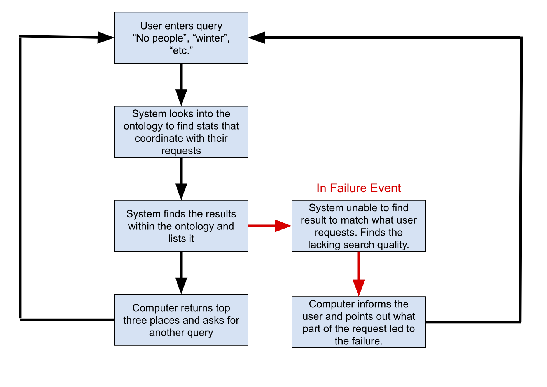

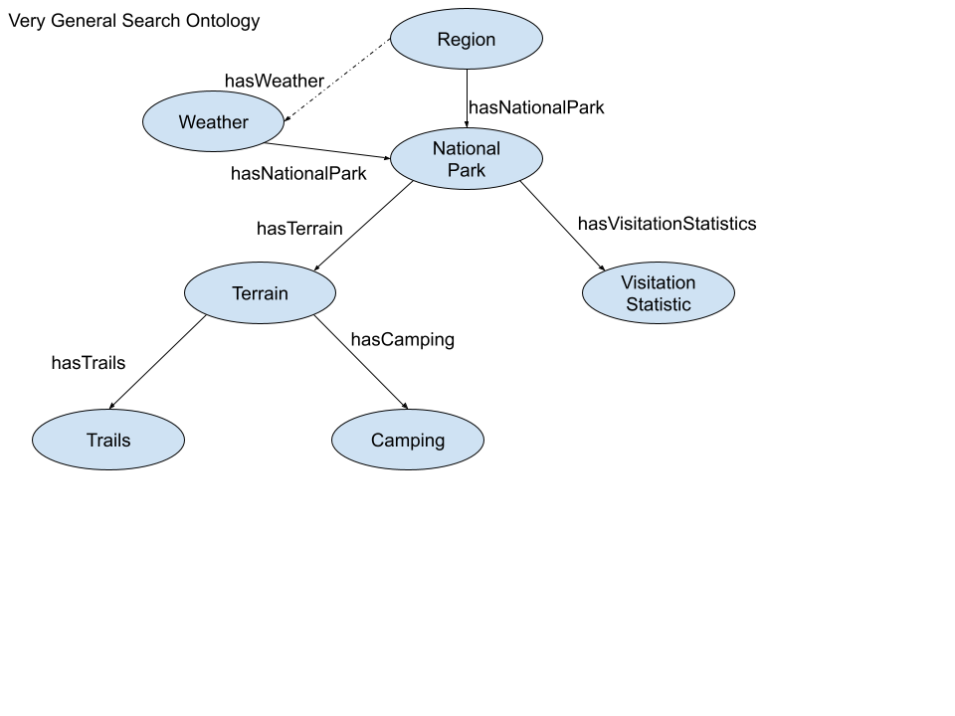
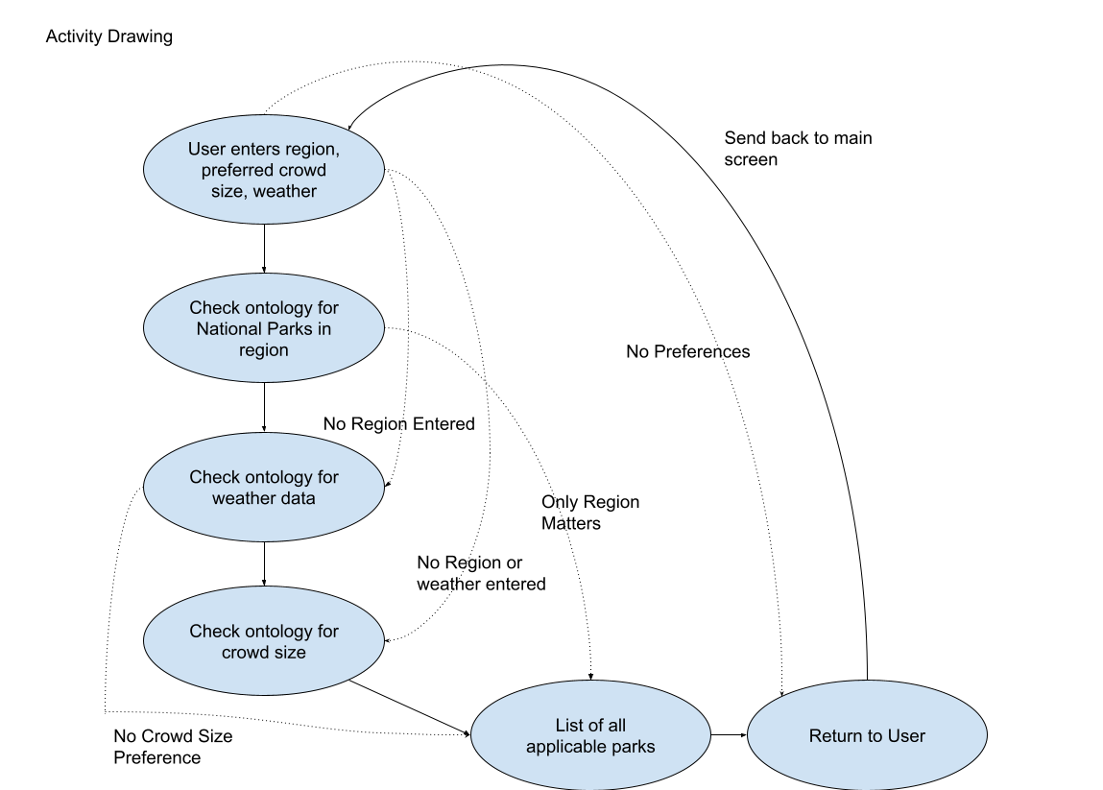

VII. Competency Questions

Provide at least 2 competency questions that you will ask of the vocabulary/ontology/knowledge base to implement this use case, including example answers to the questions.

Describe at least one way you expect to use the semantics and/or provenance to propose an answer to the questions. Include an initial description of why the semantics and/or provenance representation and reasoning provides an advantage over other obvious approaches to the problem. (optional – depending on the use case and need for supporting business case).

One way to use semantics etc.:

Importance: I would need to use provenance and semantics to ensure that my data is reliable and my answers are as well. With semantics, this representation allows me to be specific with data related to whatever the user desires.

For Visitation Stats: Knowing visitation statistics and using provenance allows us to assume that all the data of people coming to the park is accurate, thus my recommendation to the user is accurate.

For Weather Data: Similar to visitation statistics, provenance allows the user to assume that the climate and the source I am getting the information from is accurate and thus my response is accurate.

Question 1: If I want to go to the northernmost park in the United States that is the least visited in Winter, where should I go?

Answer 1: “In order to avoid crowds, visiting Arctic Gates National Park in the winter is the optimal solution.”

How was this determined?: The user input their own desires into the system and then the system is able to compare the specific places through a query. Ideally the computer finds the location of the northernmost parks in the United States, once this is done, the computer can compare the visitation statistics for the winter months. The ontology, containing the national parks, is able to easily compare the visitation statistics/month and weather/month, as they will be characteristics attached to the park object.

Question 2: “If I want the coldest temperature park in the midwest during summer, what park should I go to that fits my comfort level?”

Answer 2: “The coldest park during summer in the midwest would be Theodore Roosevelt National Park located in North Dakota”

How was this determined?: Similar to the first question, the computer would need to find the locations of all the midwest parks in the United States. After it found these parks, it would then need to access the weather data for the Summer months for those states. Once it finds the lowest overall temperature it can narrow it down to a list of parks that work for the user.

VIII. Resources

In order to support the capabilities described in this Use Case, a set of resources must be available and/or configured. These resources include the set of actors listed above, with additional detail, and any other ancillary systems, sensors, or services that are relevant to the problem/use case.

Knowledge Bases, Repositories, or other Data Sources
Data | Type | Characteristics | Description | Owner | Source | Access Policies & Usage
(dataset or repository name) | (remote, local/in situ, etc.) | e.g. – no cloud cover | Short description of the dataset, possibly including rationale of the usage characteristics |  | Source (possibly a system, or remote site) for discovery and access
National Park Service Visitation Statistics | Potentially downloadable | List of all the national parks and their visitation statistics by year by month | This can give the visitation statistics of all the national parks. | US Government | https://irma.nps.gov/Stats/SSRSReports/Park%20Specific%20Reports/Summary%20of%20Visitor%20Use%20By%20Month%20and%20Year%20(1979%20-%20Last%20Calendar%20Year)?Park=KNRI | Public Access
Weather in North Dakota by Month | Potentially downloadable | This will list the weather in a given state by month | This will list the weather in a given state by month. The goal would be to find one of these per state or region. | Associated Weather Websites | https://weatherspark.com/countries/US/ND | Public
US Topo: Maps for America | Downloadable | Terrain mappage for United States | This is a topological map of the United States that can be used to get terrain data for a state/area | US Government | https://www.usgs.gov/programs/national-geospatial-program/us-topo-maps-america | Public

External Ontologies, Vocabularies, or other Model Services
Resource | Language | Description | Owner | Source | Describes/Uses | Access Policies & Usage
(ontology, vocabulary, or model name) | (ontology language and syntactic form, e.g., RDFS - N3) | If the service is one that runs a given ontology or model-based application at a given frequency, state that in addition to the basic description |  | Source (link to the registry or directly to the ontology, vocabulary, or model where that model is maintained, if available) | List of one or more data sources described by and/or used by the model
Bioregistry |  | “An ontology and inventory of geopolitical entities such as nations and their components (states, provinces, districts, counties) and the actual physical territories over which they have jurisdiction. We thus distinguish and assign different identifiers to the US in "The US declared war on Germany" vs. the US in "The plane entered US airspace".” - From Website | geogeo | https://bioregistry.io/registry/geogeo | Would use this to register states. | Public
Ontological analysis of terrain data |  | “ we formalize the properties of each piece of data and its processing history in a geographic ontology, and use declarative Semantic Web Rule Language (SWRL) rules to calculate the errors relative to the real world or to other data. Since the impact of these errors depends on the purpose for which the data is to be used, purpose-dependent requirements are described using an additional task ontology and evaluated by our task analyzer software. The geographic ontology combines knowledge from different areas of expertise, and makes it available for the community to use, critique, and augment.”- From Website | Susanne Riehemann, Daniel Elenius | https://dl.acm.org/doi/10.1145/1999320.1999330 | This might have the same use as the previous source, but I believe this can get terrain data. | Need to Purchase - $15

Other Resources, Service, or Triggers (e.g., event notification services, application services, etc.)
Resource | Type | Description | Owner | Source | Access Policies & Usage
(sensor or external service name) |  | Include a description of the resource as well as availability, if applicable | Primary owner of the service | Application or service URL; if subscription based, include subscription and any subscription owner

IX. References and Bibliography

List all reference documents – policy documents, regulations, standards, de-facto standards, glossaries, dictionaries and thesauri, taxonomies, and any other reference materials considered relevant to the use case
All needed elements, sourced in previous tables

