Diagram 1
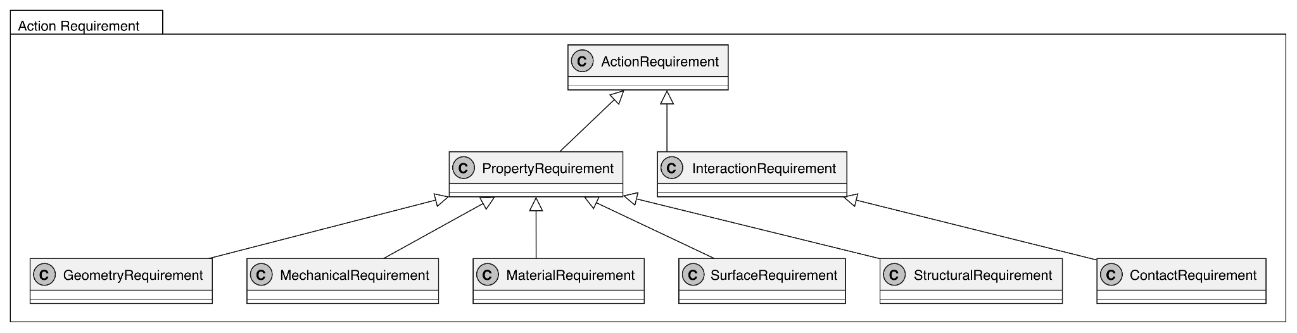
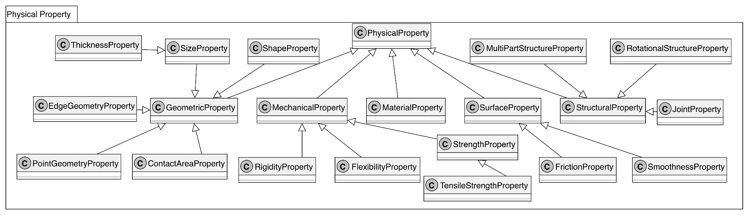
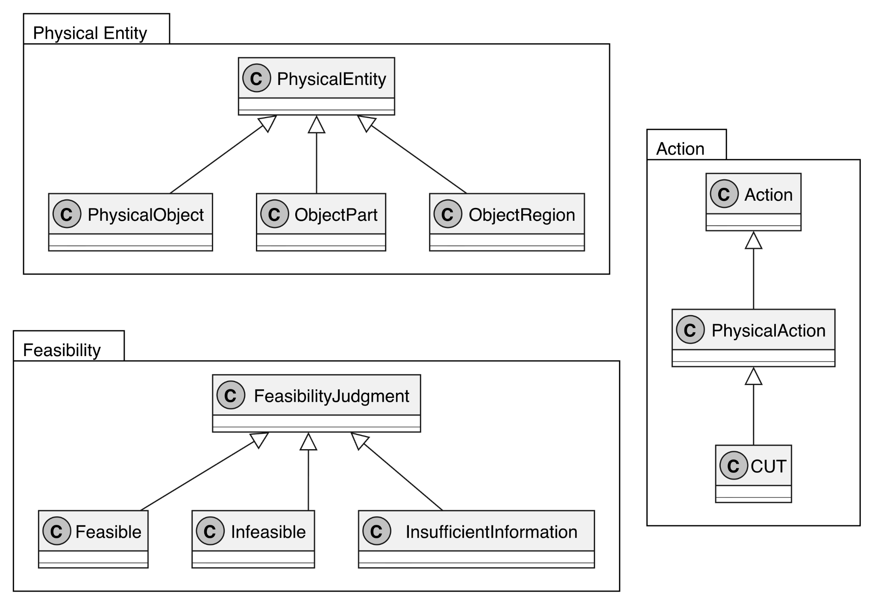

This diagram presents the core class hierarchy for representing the physical feasibility of the CUT action. The model is organized into five main areas: Action, Physical Entity, Physical Property, Action Requirement, and Feasibility. Action is specialized into PhysicalAction and then into CUT, which represents the current implementation scope. PhysicalEntity is specialized into PhysicalObject, ObjectPart, and ObjectRegion, providing concepts for representing physical objects and their structural components.
The PhysicalProperty hierarchy represents different categories of physical properties relevant to CUT feasibility, including geometric, mechanical, material, surface, and structural properties. These categories are further specialized into concepts such as thickness, rigidity, flexibility, strength, friction, joints, and rotational structures.
The ActionRequirement hierarchy represents different types of requirements associated with physical actions. PropertyRequirement is specialized into geometry, mechanical, material, surface, and structural requirements, while InteractionRequirement and ContactRequirement represent requirements related to interactions and contact.
Together, these class hierarchies provide the conceptual foundation for the competency questions by supporting the representation of physical entities, their properties, and the requirements relevant to CUT. The model intentionally does not introduce a separate PhysicalConfiguration class. Semantic relationships among these classes, such as relationships between physical entities, properties, actions, and requirements, are represented separately in the relationship view of the conceptual model. The hierarchy supports the competency questions by representing the physical entities and properties evaluated in Scenarios 1 and 2, as well as the part structures and interaction-related requirements needed to represent the alternative structures considered in Scenario 3.

Diagram 2

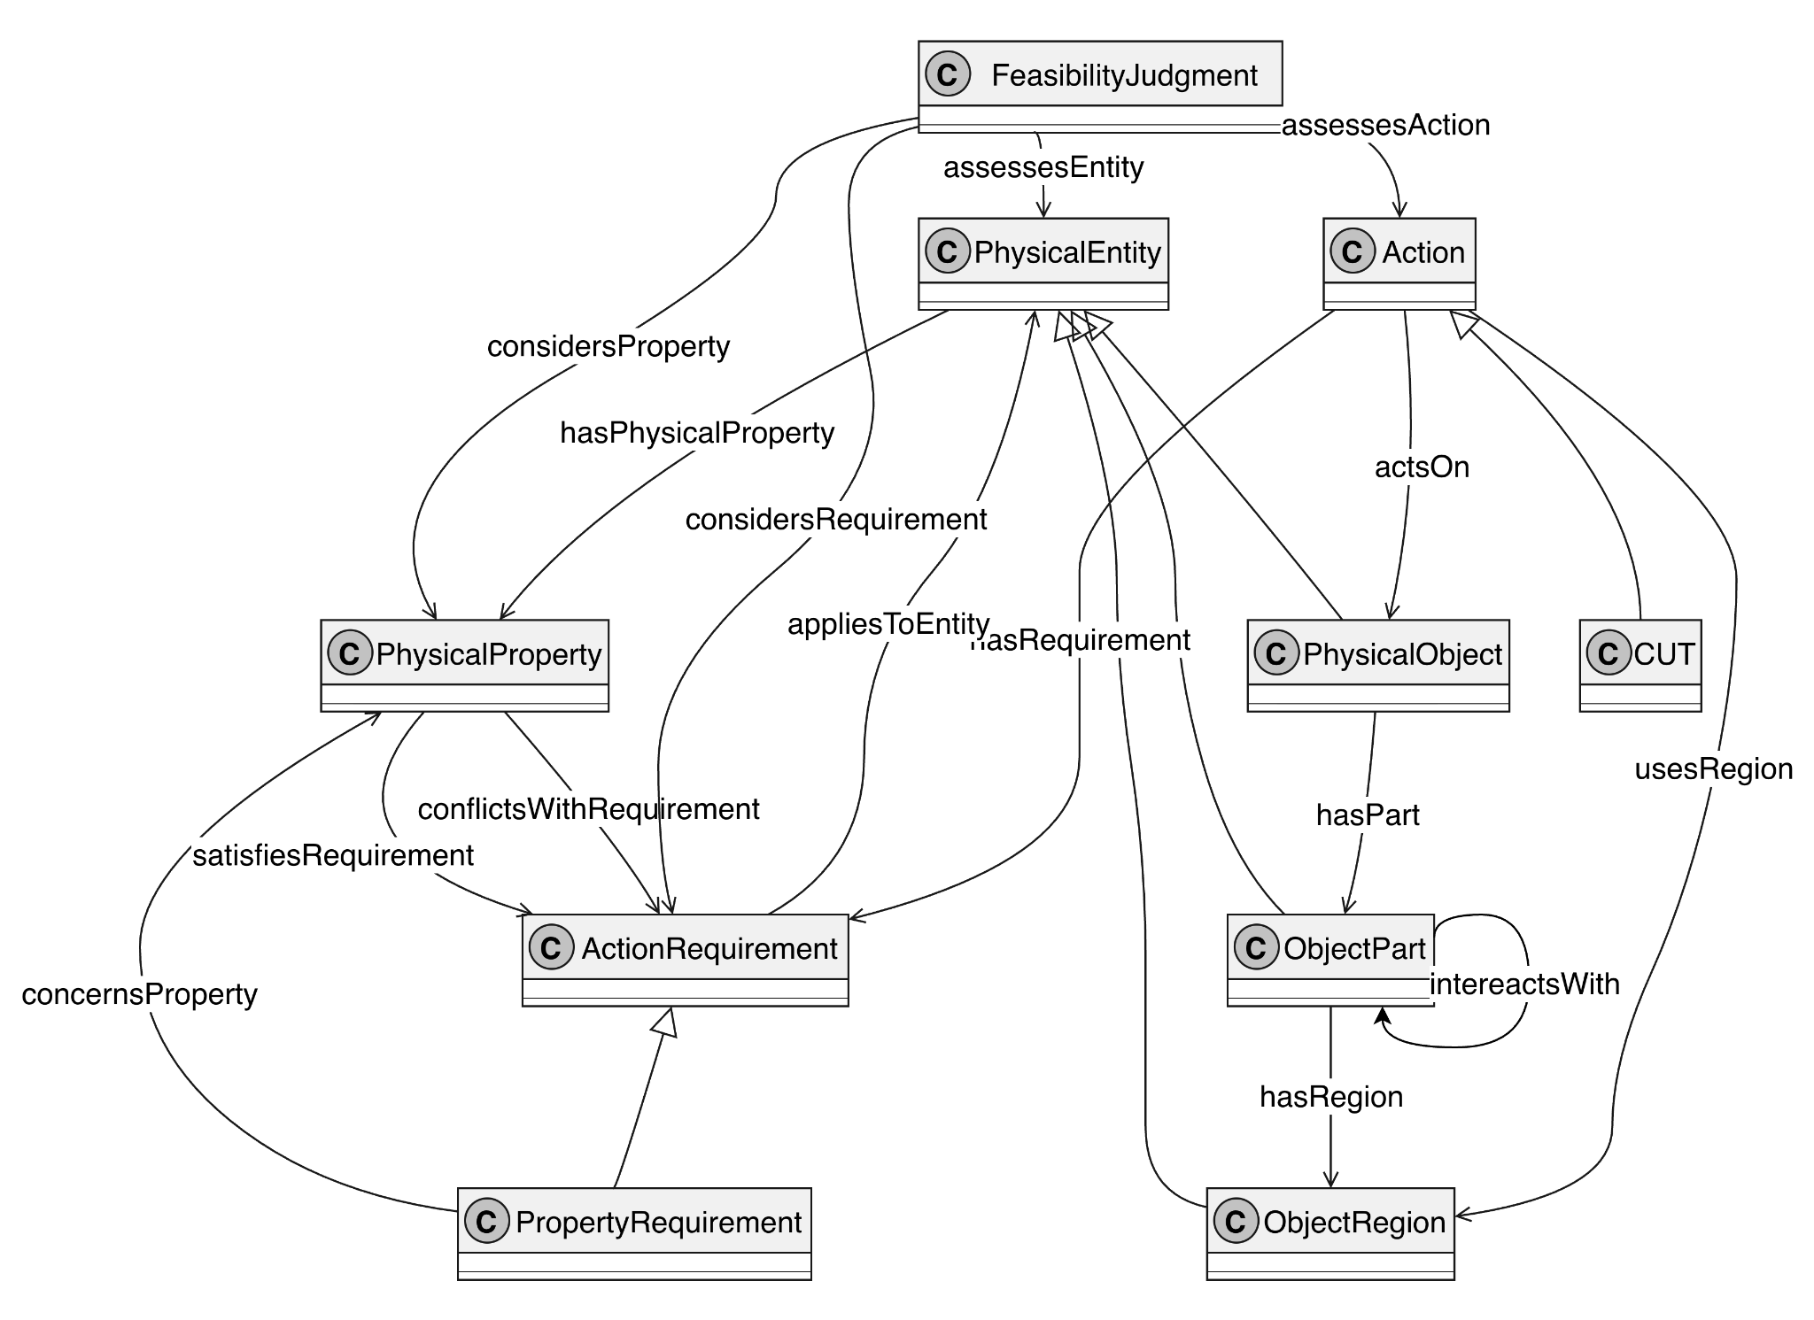
This diagram shows the core semantic relationships among the classes used to represent CUT feasibility. PhysicalObject, ObjectPart, and ObjectRegion are connected through hasPart and hasRegion to represent physical structure, while PhysicalEntity is linked to PhysicalProperty through hasPhysicalProperty. Action is connected to PhysicalObject, ObjectRegion, and ActionRequirement through actsOn, usesRegion, and hasRequirement. ActionRequirement can be related to other requirements through hasSubRequirement and to physical entities through appliesToEntity, while PropertyRequirement is connected to PhysicalProperty through concernsProperty. PhysicalProperty is related to ActionRequirement through satisfiesRequirement and conflictsWithRequirement. The diagram also represents relationships between object parts through interactsWith.
Finally, FeasibilityJudgement is connected to the entity and action being assessed, as well as the physical properties and action requirements considered in the assessment. Together, these relationships show how the core concepts in the model are connected for CUT feasibility assessment. These relationships support the competency questions by enabling the model to compare supplied physical properties and part structures with CUT requirements, explain supporting or conflicting evidence, and represent interactions between object parts.

