I. Use Case Description
Use Case Name | Reasoning About Action Feasibility from Physical Properties
Use Case Identifier | UC-ActionFeasibility-01
Source | LACAI Lab, Department of Computer Science, Rensselaer Polytechnic Institute
Point of Contact | Hyejin Park, Department of Computer Science, Rensselaer Polytechnic Institute, parkh12@rpi.edu  Xiye Fan, Department of Cognitive Science, Rensselaer Polytechnic Institute, fanx4@rpi.edu  Liangliang Zhang, Department of Computer Science, Rensselaer Polytechnic Institute Zhangl41@rpi.edu  Alex Clark, Department of Electrical, Computer & Systems Engineering, Rensselaer Polytechnic Institute, clarka14@rpi.edu
Creation / Revision Date | September 18, 2026
Associated Documents | Nothing at this stage

II. Use Case Summary
Goal | Develop an extensible ontology that represents how physical properties of objects and object parts, individually or in combination, satisfy or conflict with the physical requirements of actions. Given an object's known physical properties, an ontology-based reasoning system will use the represented property relationships and action requirements to infer and explain action feasibility independently of the object's name or conventional function. The initial course implementation focuses on CUT, providing a foundation for future extensions to additional actions.
Requirements | The ontology should represent Action, ObjectPart, PhysicalProperty, and ActionRequirement, together with the relations connecting them. Object may also be represented as a structural entity, but object identity or conventional function is not used as reasoning evidence. The ontology should represent relationships among object parts, physical properties, and relationships between parts, including combinations of properties that may jointly satisfy an action requirement and alternative part structures that may support the same action.  An ontology-based reasoning system should compare the known properties of an object or object part, together with relevant part relationships, with these represented requirements to infer whether a specified action is physically feasible under the given conditions. It should also support property-based explanations and the retrieval of alternative objects that satisfy the relevant requirements. The system must distinguish explicitly incompatible properties from insufficient information.  Physical properties are assumed to be known and provided as structured input. The system does not recognize objects, estimate properties from images, or infer properties from object names or conventional functions.
Scope | CUT is treated as a physical action that may be supported by different combinations of relevant object parts, physical properties, and relationships between parts, rather than as an action associated exclusively with knives or a single cutting method. The initial ontology will represent a limited set of CUT-relevant object parts, physical properties, part relationships, and action requirements, while its structure is intended to accommodate additional mechanisms, actions, and target-specific modeling in future extensions.  The system assumes that physical properties are already known and provided as structured data. Object recognition, visual property estimation, safety, convenience, and social appropriateness are outside the scope of the project. Object identities or conventional categories may be used only as human-readable labels in examples; they are not used as reasoning evidence. The ontology reasons from supplied physical properties, relevant part structure, and represented relationships between parts in relation to the ActionRequirements for CUT.
Priority | High — representing action feasibility from physical properties is central to the intended reasoning task and provides the foundation for later extensions of the ontology.
Stakeholders | Primary stakeholders are researchers in knowledge representation, affordance reasoning, robotics, and embodied AI who study how physical properties support action feasibility. Secondary stakeholders include developers of intelligent systems that require explainable reasoning about non-conventional object use.
Description | The broader ontology is intended to represent property–action relationships across different physical actions. For the initial course implementation, the scope is limited to CUT in everyday kitchen contexts, assuming an ordinary human actor. Familiar object names and kitchen examples may be used to make the scenarios understandable to human readers, but they are not used as reasoning evidence.  CUT is treated as a physical action that may be supported by different combinations of relevant object parts, physical properties, and relationships between parts, rather than as an action associated exclusively with knives or a single cutting method. The current model focuses on how supplied physical properties, relevant parts, and represented relationships between parts relate to the ActionRequirements for CUT. Target-specific physical states and thresholds are outside the current modeling scope.  The system assumes that physical properties are already known and provided as structured data. Object recognition, visual property estimation, safety, convenience, and social appropriateness are outside the scope of the project.
Actors / Interfaces | Primary Actor – Researcher:  Submits queries to the ontology-based reasoning system using supplied physical descriptions of one or more candidate physical descriptions, including known physical properties and relevant part information. The researcher may ask whether a supplied configuration supports CUT or which of several candidate physical descriptions satisfy the represented physical requirements for CUT. Human-readable object labels may be included for clarity, but they are not used as reasoning evidence. The researcher receives the resulting feasibility judgment, and property-based explanations.  Reference Actor – Ordinary Human Actor:  Represents the assumed physical capabilities of the person who would perform the action. Feasibility judgments are made with respect to whether an ordinary human actor could use the supplied physical description and its relevant parts to perform CUT. This actor does not directly interact with the reasoning system.  System – Ontology-Based Reasoning System:  Uses the ontology to retrieve the requirements associated with Cut, identify relevant object parts and their represented physical properties, and reason about whether those properties satisfy or conflict with the action requirements.  Secondary Actor / Interface – Knowledge Base / Data Sources:  Supplies structured physical-property descriptions, relevant part structure, part relationships where applicable, and evidence used to define or refine CUT requirements.
Pre-conditions | The CUT ontology and its associated knowledge base have been loaded, and the query and reasoning functions are available. The knowledge base contains the represented ActionRequirements for CUT and structured descriptions of the supplied physical properties and relevant part information used for reasoning. Physical properties are supplied as input data; the system does not estimate them.
Post-conditions | The system returns the appropriate response to the query. The query does not add, remove, or modify information in the underlying knowledge base, and the system remains available for subsequent queries.  I
Triggers | The use case is triggered when a researcher submits either (1) a query asking whether a supplied candidate physical description satisfies the represented requirements for CUT, or (2) a query asking which candidate descriptions from a provided set satisfy those requirements.
Performance Requirements | No specific runtime performance requirement is imposed for the course prototype. Priority is given to correctness, traceability, and explainability of ontology-based reasoning rather than response speed.
Assumptions | Feasibility judgments assume an ordinary human actor operating in an everyday kitchen environment. Known physical properties and relevant part information are assumed to be provided as input. The ontology does not recognize objects or estimate physical properties from images, object names, or conventional functions. Target-specific physical states, material thresholds, and target-dependent requirements are outside the scope of the current model.
Open Issues | The main open issue is how to formally represent relationships among physical properties and between those properties and action requirements. This includes determining how combinations of properties satisfy or conflict with the requirements for CUT, which existing ontology relations can be reused, and which project-specific relations need to be introduced. Another issue is how to distinguish explicit physical incompatibility from insufficient information without assuming that missing properties indicate infeasibility.  A further issue is how to represent alternative combinations of relevant object parts, physical properties, and relationships between parts without treating provisional relationships as universally necessary or sufficient conditions for CUT.

III. Usage Scenarios

Scenario 1— Feasibility Verification and Explanation
A researcher studying physical affordance reasoning wants to evaluate whether an ontology-based system can infer action feasibility from known physical properties and their relationships to action requirements. The researcher is interested in whether this approach can account for unconventional objects and different ways of performing an action without relying on conventional object–function associations.
For an initial CUT evaluation, the researcher selects a kitchen scenario involving a rigid plastic card and a carrot. For an initial CUT evaluation, the researcher selects a kitchen scenario involving a rigid plastic card and a carrot. The identity of the object as a “plastic card” is not itself used as reasoning evidence. Instead, the supplied physical description provides the known physical properties of its relevant part, such as the geometry and rigidity of its edge. The researcher queries whether this supplied physical description can support CUT. The system compares the supplied properties and part structure with the represented physical requirements for CUT, rather than relying on a conventional card–function association, and derives a feasible, infeasible, or insufficient-information judgment with a property-based explanation.
Scenario 2 — Goal-Driven Alternative Object Discovery Under Constraints
A researcher investigating unconventional object use wants to determine which available candidates could support CUT when a conventional cutting tool is unavailable. A rigid plastic card, a rolling pin, and a kitchen sponge are used as illustrative candidates. Their object identities are not used as reasoning evidence; instead, physical property description provides the relevant part structure and known physical properties of each candidate.
The researcher asks which of these candidate physical descriptions can satisfy the represented requirements for CUT. The system compares the supplied properties and part structure of each candidate against the same CUT requirements, identifies candidates whose supplied physical properties, relevant part structure, and represented part relationships satisfy those requirements distinguishes candidates with explicitly incompatible properties, and marks candidates with insufficient information as unresolved. It then returns the qualifying candidates together with property-based explanations for each result.
Scenario 3 — Comparing Alternative Part Structures for the Same Action
A researcher wants to determine whether objects with different relevant part structures can support the same CUT action. As illustrative examples, the researcher compares a knife with a single cutting edge and a pair of scissors with two interacting blades. The object identities “knife” and “scissors” are not used as reasoning evidence. Instead, each candidate is described by its relevant parts, the known physical properties of those parts, and, where applicable, represented relationships between parts.
The researcher asks whether each candidate can satisfy the applicable CUT requirements. The system evaluates the supplied physical properties, relevant part structure, and represented part relationships against the CUT requirements. This allows different arrangements of parts and properties to support the same action without requiring each arrangement to be represented as a separate configuration entity. The system then explains which property–requirement relationships and part relationships support each feasibility judgment.

IV. Basic Flow of Events
Shared evaluation rule
The system evaluates each relevant modeled configuration separately. A configuration is supported when supplied properties and part relations jointly satisfy all its represented requirements; it is blocked when known evidence explicitly conflicts with a required condition; otherwise it is unresolved. A candidate is feasible if at least one configuration is supported. It is infeasible within the evaluated configurations only when that set is nonempty and every configuration is explicitly blocked. All other cases, including missing model coverage, return insufficient information. Failure of one configuration does not rule out an alternative.

Basic Flow Narrative — Scenario 1: Feasibility Verification and Explanation
The researcher submits a query about whether a candidate object described by supplied physical properties and relevant part information can support CUT. A rigid plastic card and carrot are used as illustrative examples, but the object's identity is not used as reasoning evidence. The reasoning system retrieves the applicable CUT requirements and compares them with the supplied physical properties and part structure of the candidate. It then determines whether the represented information satisfies a supported cutting configuration, explicitly conflicts with the applicable requirements, or is insufficient for a judgment. The system returns a feasibility result together with a property-based explanation identifying the relationships that support the inference.
Basic / Normal Flow of Events
Step | Actor (Person) | Actor (System) | Description
1 | Researcher |  | Submits a query asking whether a candidate physical description, illustrated by a rigid plastic card and carrot example, can support CUT.
2 |  | Ontology-Based Reasoning System | Retrieves the applicable ActionRequirements and represented property relationships for CUT.
3 |  | Ontology-Based Reasoning System | Retrieves the supplied physical properties, relevant part structure, and any represented part relationships for the candidate description.
4 |  | Ontology-Based Reasoning System | Compares the supplied properties and part structure against the applicable CUT requirements, including relevant property combinations and supported alternative candidates .
5 |  | Ontology-Based Reasoning System | Derives a feasible or explicitly infeasible judgment when supported by the represented information; otherwise, follows the insufficient-information alternate flow.
6 |  | Ontology-Based Reasoning System | Generates an explanation identifying the physical properties, part relationships, and requirement relationships supporting the judgment.
7 | Researcher |  | Receives the judgment and explanation.

Basic Flow Narrative — Scenario 2: Goal-Driven Alternative Object Discovery Under Constraints
The researcher submits a query asking which candidates from a supplied set of physical descriptions can support CUT. A rigid plastic card, rolling pin, and kitchen sponge are used as illustrative labels for the candidates, but their object identities are not used as reasoning evidence. For each candidate, the supplied physical description includes the relevant part structure, known physical properties, and any represented part relationships. The reasoning system retrieves the applicable CUT requirements and evaluates each candidate description against the same requirements. It identifies candidates whose supplied physical properties, relevant part structure, and represented part relationships satisfy the applicable CUT requirements, distinguishes candidates with explicitly incompatible properties, and marks candidates with insufficient information as unresolved. The system returns the qualifying candidates together with property-based explanations for the resulting judgments.

Step | Actor (Person) | Actor (System) | Description
1 | Researcher |  | Submits a set of candidate physical descriptions, illustrated by a rigid plastic card, rolling pin, and kitchen sponge, and asks which candidates can support CUT.
2 |  | Ontology-Based Reasoning System | Retrieves the applicable ActionRequirements and represented property relationships for CUT.
3 |  | Ontology-Based Reasoning System | Retrieves the supplied part structure, known PhysicalProperties, and any represented part relationships for each candidate description.
4 |  | Ontology-Based Reasoning System | Evaluates each candidate description against the same CUT requirements, including relevant property combinations and supported alternative candidates..
5 |  | Ontology-Based Reasoning System | Identifies candidates whose supplied physical descriptions satisfy a supported set of CUT requirements, distinguishes candidates with explicitly incompatible properties, and marks candidates with insufficient information as unresolved.
6 |  | Ontology-Based Reasoning System | generates property-based explanations identifying the physical properties, part relationships, and requirement relationships supporting each judgment, and returns the qualifying candidate set to the researcher.
7 | Researcher |  | Receives the qualifying candidates and their associated property-based explanations.

Basic Flow Narrative — Scenario 3: Comparing Alternative Part Structures for the Same Action
The researcher submits a query asking whether two candidates with different relevant part structures can each support CUT. A knife with a single cutting edge and a pair of scissors with two interacting blades are used as illustrative examples, but their object identities are not used as reasoning evidence. For each candidate description, the physical property descriptionprovides the relevant part structure, known physical properties, and any required relationships between parts. The reasoning system retrieves the applicable CUT requirements and evaluates each candidate description independently. It determines whether the supplied properties and part relationships for each candidate description satisfy a supported set of CUT requirements, and then compares how the two candidate descriptions support the same action through different physical structures. The system returns a feasibility judgment and property-based explanation for each candidate description.

Step | Actor (Person) | Actor (System) | Description
1 | Researcher |  | Submits two supplied physical candidate descriptions, illustrated by a knife and scissors, and asks whether each can support CUT.
2 |  | Ontology-Based Reasoning System | Retrieves the applicable ActionRequirements and represented property relationships for CUT.
3 |  | Ontology-Based Reasoning System | etrieves the supplied part structure, known PhysicalProperties, and any represented relationships between parts for each candidate description.
4 |  | Ontology-Based Reasoning System | Evaluates the first physical candidate description against the applicable CUT requirements.
5 |  | Ontology-Based Reasoning System | Evaluates the second physical candidate description against the applicable CUT requirements, including any required interaction between multiple parts.
6 |  | Ontology-Based Reasoning System | Compares how the two supplied candidate descriptions satisfy CUT through different property combinations, part structures, or part interactions
7 |  | Ontology-Based Reasoning System | Generates a feasibility judgment and property-based explanation for each candidate description.
8 | Researcher |  | Receives the judgments and explanations for both candidate descriptions.

V. Alternate Flow of Events
Alternate Flow Narrative — Insufficient Property or candidate description Information
This alternate flow may occur during any of the three Basic Flows when the reasoning system determines that one or more pieces of information required to evaluate an applicable CUT requirement are not available in the supplied candidate description or represented knowledge. The missing information may concern a relevant physical property, part structure, or relationship between parts. Missing information is not treated as evidence of infeasibility. For a feasibility-verification query, the system returns an insufficient-information result and identifies the missing information. For an alternative-candidate query, the affected candidate is marked as unresolved rather than excluded as infeasible, and the system continues evaluating the remaining candidates. For a comparison of alternative physical candidate description, the affected configuration is marked as unresolved while any configuration with sufficient information may still be evaluated. If sufficient additional information is later provided, the system resumes evaluation.

Alternate Flow of Events
Step | Actor (Person) | Actor (System) | Description
A1 |  | Ontology-Based Reasoning System | Detects that information required to evaluate an applicable CUT requirement is missing from the supplied candidate description or represented knowledge..
A2 |  | Ontology-Based Reasoning System | Identifies the missing physical property, part structure, or part relationship and does not treat its absence as evidence of infeasibility. .
A3 |  | Ontology-Based Reasoning System | For Scenario 1, returns an insufficient-information result and identifies what information is needed.
A4 |  | Ontology-Based Reasoning System | For Scenario 2, marks the affected candidate as unresolved and continues evaluating the remaining candidates.
A5 |  | Ontology-Based Reasoning System | For Scenario 3, marks the affected configuration as unresolved and continues evaluating any configuration with sufficient information.
A6 | Researcher |  | May provide additional physical-property or part information, select another candidate, or end the query..
A7 |  | Ontology-Based Reasoning System | If sufficient information becomes available, resumes evaluation at the appropriate step of the corresponding Basic Flow.

VI. Use Case and Activity Diagram(s)

The following diagrams illustrate the actors, system components, and reasoning activities involved in the three usage scenarios. The use case diagram summarizes the primary interactions with the ontology-based reasoning system, while the architecture diagram shows where the ontology is used within the overall system.Three activity diagrams then show the detailed flows for (1) feasibility verification and explanation, (2) goal-driven alternative candidate identification, and (3) comparison of alternative part structures and property relationships.

Diagram 1 — High-Level Architecture / Overview
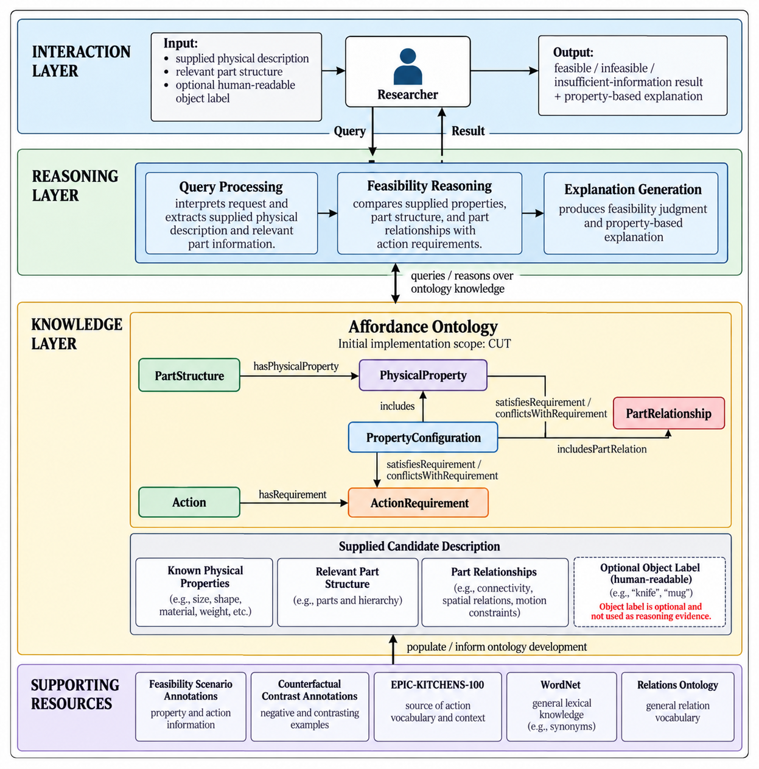

Diagram 2 — Use Case Diagram
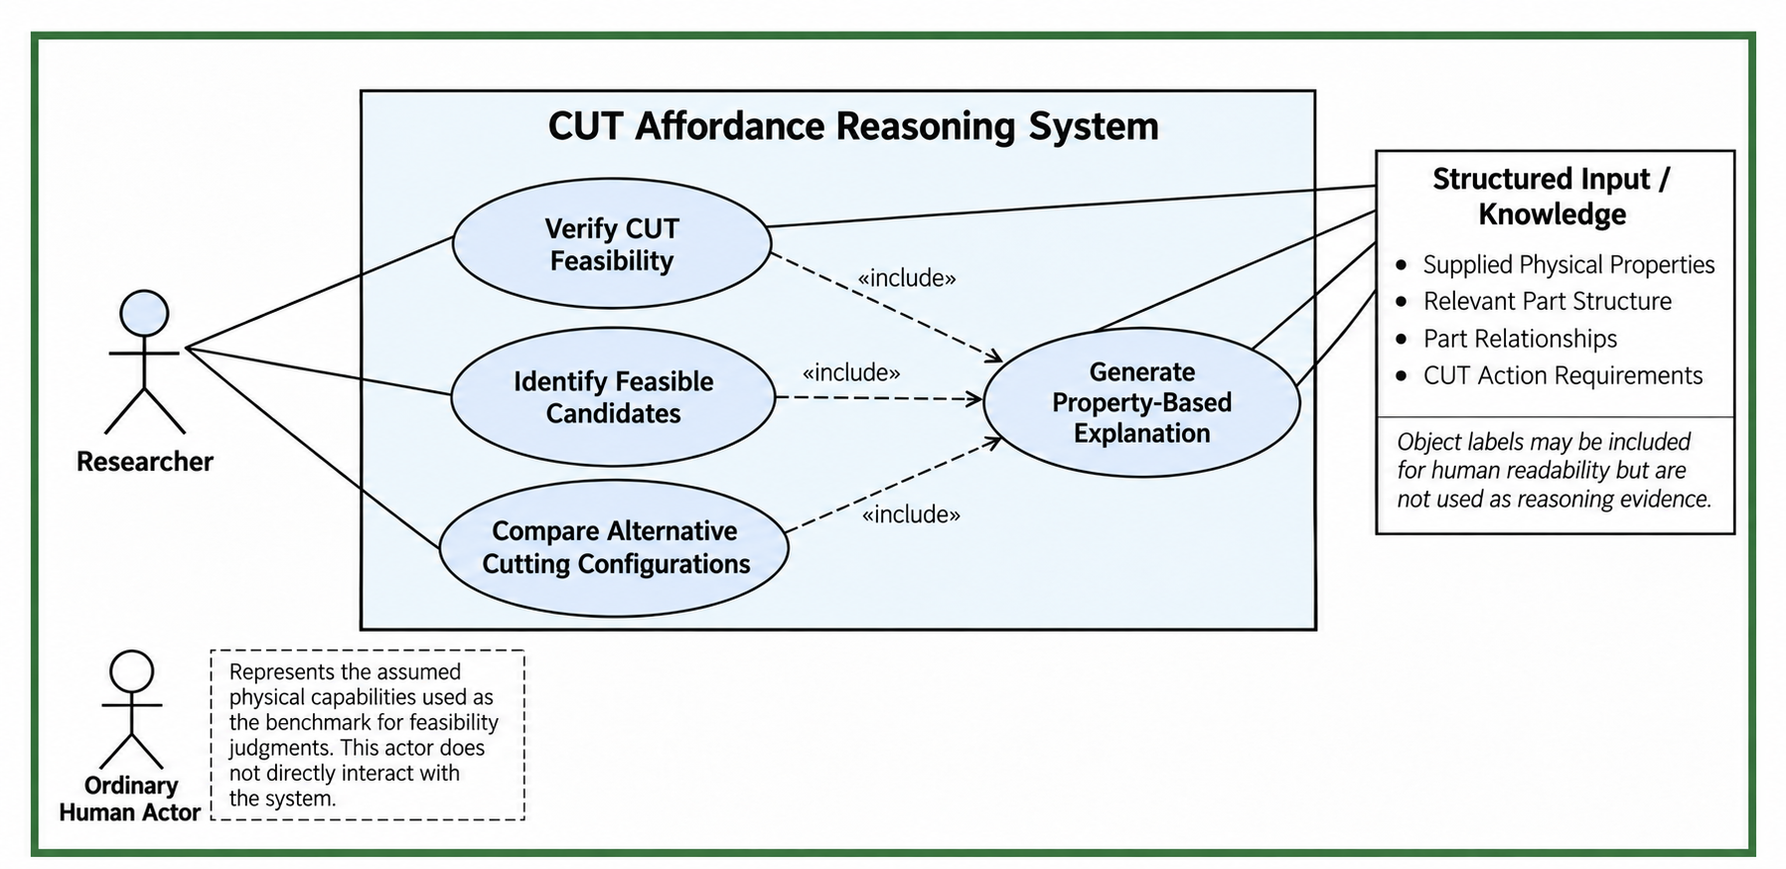
Diagram 3 — Activity Diagram: Scenario 1
Scenario 1 branches according to the shared evaluation rule in Section IV. Support for one configuration is sufficient for a feasible result. An infeasible result requires a nonempty evaluated set in which every configuration is explicitly blocked. Otherwise the result is insufficient information. The merge joins alternative outcomes before the explanation is returned. This flow supports CQ1.1–CQ1.3.

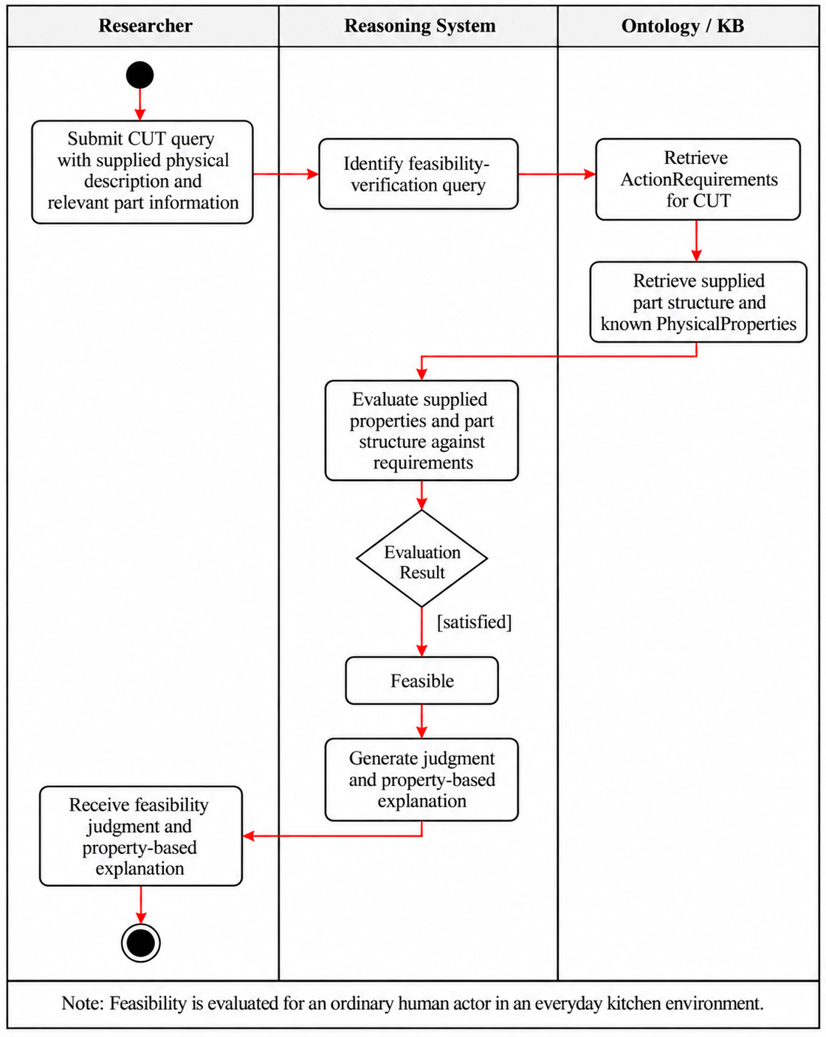

Diagram 4 — Activity Diagram: Scenario 2
Scenario 2 evaluates every supplied candidate and records its judgment before continuing the loop. An unresolved candidate does not stop the search and is not placed in the infeasible group. The shared evaluation behavior is the system-side requirement evaluation and classification shown in Diagram 3. This flow supports CQ2.1–CQ2.3.

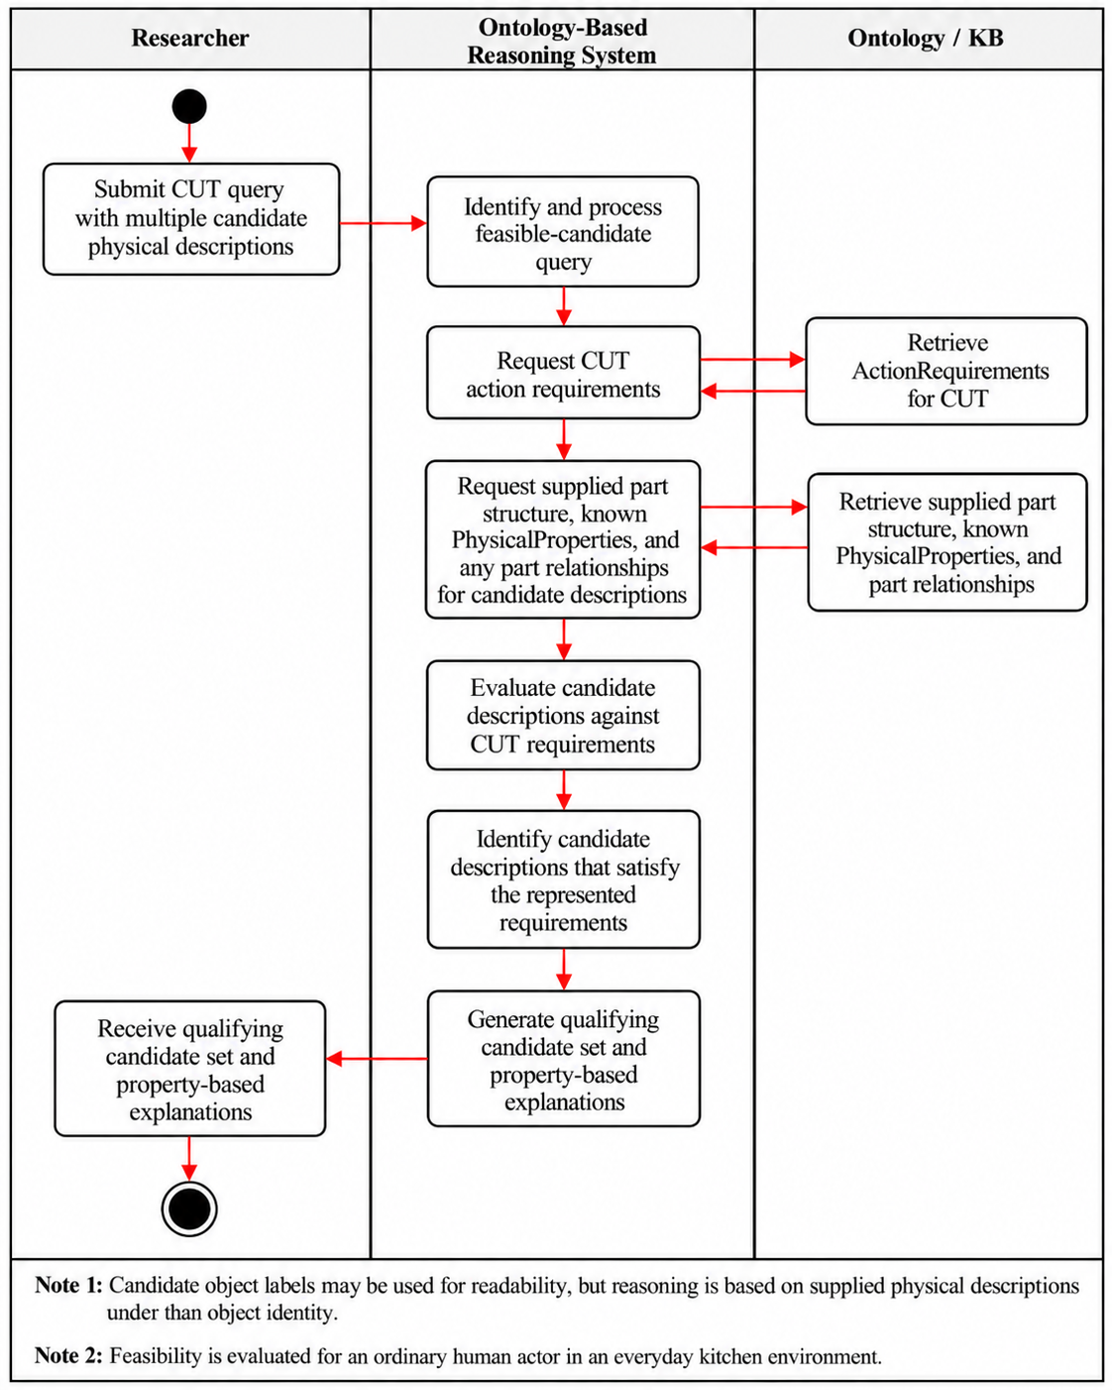
Diagram 5 — Activity Diagram: Scenario 3

Scenario 3 uses the same evaluation behavior for each configuration independently. It compares the resulting evidence, including any interaction required between parts, and preserves uncertainty for either configuration. The comparison does not assume both configurations are feasible. This flow supports CQ3.1–CQ3.2.

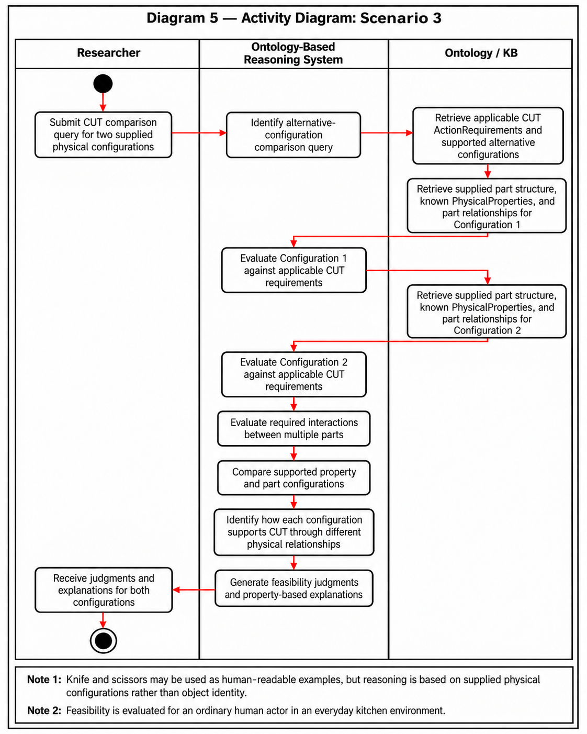

VII. Competency Questions

These questions test whether the ontology can explain CUT judgments from supplied properties and part relations. The examples are proposed test cases, not verified experimental outcomes. Object names are labels only, and a carrot is an illustrative target rather than a source of target-specific constraints. “Feasible” and “infeasible” refer to the modeled configurations defined in Section IV.
The CUT-specific feasibility and counterfactual annotations listed in Section VIII are intended to supply instance facts and help refine the requirement mappings. Expected outcomes should be checked against those annotations before being treated as validated results. EPIC-KITCHENS-100 supplies action vocabulary, not the physical-property evidence needed to answer these questions.

Resource Note: The competency questions use the CUT-specific Derived Feasibility Scenario Annotations and, where relevant, the Derived Counterfactual Contrast Annotations described in Section VIII. These resources provide structured examples containing relevant part structure, known physical properties, part relationships where applicable, and feasibility outcomes. Object names may appear in these examples as human-readable labels, but they are not used as reasoning evidence. EPIC-KITCHENS-100 informs the kitchen-domain action vocabulary but does not directly provide the physical-property or action-requirement relationships used in feasibility reasoning. The combinations of relevant part structure, physical properties, and part relationships described below are illustrative, context-specific modeling candidates for the initial CUT ontology. They will be refined using the available annotations and should not be interpreted as a complete or universally sufficient definition of CUT.

Scenario 1 — Feasibility Verification and Explanation
CQ1.1 — Can a rigid plastic card be used by an ordinary human actor to cut a carrot, and why?

Example Answer: Yes, if its supplied edge geometry and structural support jointly satisfy every requirement of the represented single-edge configuration.
Ontology Approach: The candidate in this example is described by its known PhysicalProperties and relevant part information, including thin edge geometry and sufficient rigidity. The label “rigid plastic card” is retained only to make the example understandable to human readers and is not used as reasoning evidence. The ontology represents the applicable ActionRequirements for CUT, including requirements related to suitable edge geometry and sufficient structural support. The reasoning system compares the supplied physical properties and relevant part structure with these modeled requirements. If the represented information satisfies the modeled requirements, the system returns a feasible judgment and identifies the specific property–requirement relationships that support the result.

CQ1.2 — Can a typical kitchen sponge be used to cut a carrot, and why or why not?
Example Answer: No, under the represented conditions. The sponge's deformable contact edge does not provide the rigidity required to cut the carrot. Its explicitly represented deformability conflicts with the modeled requirement to maintain an effective cutting region under applied force.
Ontology Approach:The candidate in this example is described by its known PhysicalProperties and relevant part information. The label “kitchen sponge” is retained only to make the example understandable to human readers and is not used as reasoning evidence. The ontology represents the applicable ActionRequirements for CUT, including a requirement for sufficient structural support to maintain an effective cutting region under applied force. The reasoning system compares the supplied physical properties and relevant part structure with these modeled requirements. Because the represented properties explicitly conflict with the applicable requirement, the system returns an infeasible judgment and identifies the specific property–requirement relationship supporting that result.

Scenario 2 — Goal-Driven Alternative Candidate Identification Under Constraints
CQ2.1 — If a conventional cutting tool is unavailable, which of the following available objects could satisfy the represented physical requirements for cutting a carrot: a rigid plastic card, a rolling pin, or a kitchen sponge?
Example Answer: Under the represented conditions, the rigid plastic card is returned as a candidate because its edge satisfies the modeled geometry and rigidity requirements. The rolling pin and kitchen sponge are excluded because their represented properties conflict with different cutting requirements.
Ontology Approach: The labels “rigid plastic card,” “rolling pin,” and “kitchen sponge” are retained only to make the example understandable to human readers and are not used as reasoning evidence. The ontology represents the applicable ActionRequirements for CUT. The reasoning system evaluates each candidate description against the same modeled requirements. The card candidate includes a relevant edge with thin geometry and sufficient rigidity that satisfies the modeled requirements. The rolling-pin candidate lacks a relevant part configuration with suitable cutting-edge geometry, while the sponge candidate includes a deformable contact region whose low rigidity conflicts with the structural-support requirement. The system therefore returns the card candidate, excludes the candidates with explicitly incompatible properties, and provides a property-based explanation for each judgment.

CQ2.2 — Why can a rigid plastic card be returned as a candidate for cutting a carrot while a kitchen sponge is excluded?
Example Answer: The card's edge satisfies the represented edge-geometry and rigidity requirements, whereas the sponge's deformable contact edge fails to meet the rigidity requirement for cutting the carrot.
Ontology Approach: The two candidates are described by their known PhysicalProperties and relevant part information. The labels “rigid plastic card” and “kitchen sponge” are retained only for human readability and are not used as reasoning evidence. The reasoning system compares both candidate descriptions against the same applicable ActionRequirements for CUT. The card candidate includes a relevant edge whose geometry and rigidity satisfy the applicable CUT requirements, while the sponge candidate includes a deformable contact region whose low rigidity explicitly conflicts with the structural-support requirement. The system traces these different property–requirement relationships to explain why the card is returned as a qualifying candidate and the sponge is excluded.

Scenario 3 — Comparing Alternative Part Structures for the Same Action
CQ3.1 — Can a knife and a pair of scissors both support CUT despite having different relevant part structures and part relationships?
Example Answer: Yes. Both may support CUT through different combinations of relevant physical properties and part relationships. A knife may rely on a single relevant edge with suitable geometry and structural support, while scissors may rely on two relevant parts whose properties and interaction jointly satisfy the applicable CUT requirements.
Ontology Approach: The two examples are described by their relevant ObjectParts, the PhysicalProperties of those parts, and any represented relationships between parts. The labels “knife” and “scissors” are retained only for human readability and are not used as reasoning evidence. The ontology does not represent each candidate as a predefined physical configuration. Instead, the reasoning system evaluates the relevant parts, their physical properties, and their relationships against the applicable ActionRequirements for CUT. This allows different part structures and property combinations to satisfy the same action requirements.

VIII. Resources

Data Availability
EPIC-KITCHENS-100 is publicly available and provides the source kitchen-domain action vocabulary from which Cut was selected for the initial ontology scope. However, EPIC-KITCHENS does not directly provide the physical properties, object-part descriptions, or action-requirement relations needed for the proposed feasibility reasoning. These are supplied by a small curated subset of feasibility and counterfactual annotations generated as part of ongoing affordance-reasoning research. For the course project, only data relevant to Cut and the competency questions defined in Section VII will be used.

Knowledge Bases, Repositories, or other Data Sources
Data | Type | Characteristics | Description | Owner | Source | Access Policies & Usage
EPIC-KITCHENS-100 | Remote dataset / repository | Egocentric kitchen videos with annotated manipulation actions and object interactions | Provides the source kitchen-domain action vocabulary and human-object interaction context from which Cut is selected for the initial ontology scope. It does not directly provide the physical-property or action-requirement knowledge used for feasibility reasoning. | EPIC-KITCHENS / University of Bristol and collaborators | EPIC-KITCHENS dataset website / annotation repository  Link (full dataset): https://epic-kitchens.github.io/  Link (annotation dataset): https://github.com/epic-kitchens/epic-kitchens-100-annotations | CC BY-NC 4.0. Non-commercial use is permitted with appropriate attribution, a link to the license, and an indication of any changes. The dataset is used to establish the source action vocabulary and is not queried directly during ontology reasoning.  License: https://github.com/epic-kitchens/epic-kitchens-100-annotations/blob/master/license.txt
Derived Feasibility Scenario Annotations | Local / experimentally generated dataset | A curated set of feasible and infeasible examples for the action Cut, including the relevant object, object part, physical properties, target context, and feasibility outcome. The resource provides instance-level evidence used to populate and test the course ontology and to support the competency questions in Section VII. | Provides the instance-level evidence used to populate the course ontology with examples of objects, object parts, relevant physical properties, and feasible or infeasible outcomes. Only the Cut-specific subset will be used for this course project. | Hyejin Park / LACAI Lab | nternal project resource; no public URL available at this stage. | Internal research resource; not publicly available. A curated CUT-specific subset will be shared with the course team for ontology development and evaluation. Redistribution outside the project is not authorized at this stage. No public license has been assigned.
Derived Counterfactual Contrast Annotations | Local / experimentally generated dataset | Paired examples in which changes to an object property or relevant part are associated with changes in action feasibility | Paired or contrastive examples in which a change to a relevant object part or physical property is associated with a change in cutting feasibility. The resource is used as supporting evidence when identifying or refining which properties are relevant to the ActionRequirements for Cut | Hyejin Park / LACAI Lab | Generated through ongoing affordance-reasoning experiments | Internal research resource; not publicly available. A limited CUT-specific subset may be shared with the course team as supporting evidence for identifying and refining property–requirement relationships. No public license has been assigned. Any further sharing is subject to the research project's data-use policy.

External Ontologies, Vocabularies, or other Model Services
Resource | Language | Description | Owner | Source | Describes/Uses | Access Policies & Usage
WordNet | English | Supports terminology normalization and sense distinction for action and object terms used in the ontology. It is not used to determine physical feasibility. | Princeton University | Princeton WordNet  Link: https://wordnet.princeton.edu/ | Action and object terminology derived from EPIC-KITCHENS and the experimental annotations | Princeton WordNet License. Use, modification, and distribution are permitted without a fee, subject to retaining the required copyright notice and license statements. Used as an optional terminology resource, not for determining physical feasibility.  License: https://wordnet.princeton.edu/license-and-commercial-use
Relations Ontology (RO) | OWL / OBO | Provides standardized relation types intended for reuse across ontologies. It will be reviewed to determine whether general relations needed in this project, such as part-whole relations, can reuse existing semantics before new project-specific relations are introduced. | OBO Relations Ontology community / OBO Foundry | Official Website Link: https://obofoundry.org/ontology/ro.html | Relations among ontology entities, particularly reusable general-purpose relations such as part-whole relations. | CC0 1.0 Universal (Public Domain Dedication). RO is available for reuse and adaptation. The original ontology and term identifiers should be retained when reusing existing relations, and the source should be cited. Used as an optional reference for relation reuse and ontology-design decisions.  License: https://github.com/oborel/obo-relations/blob/master/LICENSE.txt

Other Resources, Service, or Triggers (e.g., event notification services, application services, etc.)
Resource | Type | Description | Owner | Source | Access Policies & Usage
(sensor or external service name) |  | Include a description of the resource as well as availability, if applicable | Primary owner of the service | Application or service URL; if subscription based, include subscription and any subscription owner

IX. References and Bibliography

- EPIC-KITCHENS-100. Egocentric kitchen video dataset and action annotation repository. https://epic-kitchens.github.io/
- EPIC-KITCHENS-100 Annotations. https://github.com/epic-kitchens/epic-kitchens-100-annotations
- Princeton WordNet. Princeton University. https://wordnet.princeton.edu/
- Relations Ontology (RO). OBO Foundry. https://obofoundry.org/ontology/ro.html
- Object Management Group (OMG). Unified Modeling Language (UML), Version 2.5.1. https://www.omg.org/spec/UML/2.5.1/
- Chemero, A. (2003), An Outline of a Theory of Affordances
- Jiang, Y., Yang, M., Li, Z., & Pujara, J. (2026). AFFORDANCE20Q: Evaluating Affordance Reasoning from Physical Properties. arXiv:2606.14240v2.
- Wang et al., Affordance-R1 (2026), p. 1, Introduction; p. 2, §2.1; Xie et al., RelationLMM (2025), p. 3515, Introduction; p. 3519, §IV-A/Table II
- Xie et al., RelationLMM (2025), p. 3515, Introduction; p. 3519, §IV-A
- "B. Barati and E. Karana, ""Affordances as Materials Potential: What Design Can Do for Materials Development,"" International Journal of Design, vol. 13, no. 3, pp. 105–123, 2019.
- M. Qu et al., ""RIO: A Benchmark for Reasoning Intention-Oriented Objects in Open Environments,"" in Advances in Neural Information Processing Systems (NeurIPS), Datasets and Benchmarks Track, 2023.
- Z. Wang, Y. Zhong, J. Fu, H. I. Christensen, and J. Gao, ""AFUN: Towards an Affordance Foundation Model for Functionality Understanding,"" arXiv:2606.02551, 2026. https://arxiv.org/abs/2606.02551"
- J. Mccusker et al., ‘ARCLIGHT: Automated Clustering and Curriculum Learning Guided by Human Training’. Accessed: Sep. 22, 2026. [Online]. Available: https://dspace.rpi.edu/server/api/core/bitstreams/793857db-ca6a-46a6-af17-045c00505de2/content
- "A. Myers, C. L. Teo, C. Fermüller and Y. Aloimonos, ""Affordance detection of tool parts from geometric features,"" 2015 IEEE International Conference on Robotics and Automation (ICRA), Seattle, WA, USA, 2015, pp. 1374-1381, doi: 10.1109/ICRA.2015.7139369.

X. Notes

There is always some piece of information that is required that has no other place to go. This is the place for that information.

