I. Use Case Description
Use Case Name | Ontology-Guided Agentic Capabilities Orchestration
Use Case Identifier | AC-001
Source | CSCI 6340 - Ontologies
Point of Contact | Gia Oriana Santos (santog@rpi.edu), Barbara Kotlan (kotlab@rpi.edu), Jiaying(Michael) Wang (wangj63@rpi.edu), Jialin (Gary) Fang (fangj6@rpi.edu), Eli (guedee@rpi.edu)
Creation / Revision Date | 9/18/2026
Associated Documents

II. Use Case Summary
Goal | To govern which agent skills and tools to invoke, as well as determine the most optimal orchestration plan an LLM should follow given the user’s request and constraints
Requirements | This use case must accomplish the following capabilities  - Skill and tool discovery  - Orchestration plan generation  - Dependency checking with skills and tools  - Constraint-Aware orchestration plan selection  - Explanability and provenance of selected orchestration plan  - Parallel Execution Planning
Scope | - LLM agent retrieves scholarly articles and answers questions for a specific domain  - External servers available to the LLM  - PubMed MCP  - Supplement Advisor MCP  - OpenFDA MCP  - iHerb-CLI  - Specific domain: personalized supplement recommendation  - Not considering “common knowledge” questions. Only questions related to personalized supplement recommendations
Priority | N/A
Stakeholders | - LLM users  - LLM agent developers  - External server providers
Description | The emergence of the MCP has enabled LLMs to access external tools and data sources through standardized interfaces, allowing AI agents to perform complex retrieval, reasoning, and decision-making tasks. As AI agents become increasingly modular, they must not only determine which external servers and tools to invoke, but also decide when specialized agentic skills should be executed to accomplish subtasks for an overall goal. As the number of available skills and tools continues to grow, LLM agents face increasingly difficult orchestration problems, including determining which skills and tools should be executed, dependencies between skills and tools in orchestration, choosing the best valid orchestration plan given the particular user and situation, and explaining why the orchestration plan should be preferred over another. Current LLMs typically make these decisions implicitly through prompting or learned behavior, making the orchestration process difficult to explain, reproduce, validate, and optimize.  This use case addresses the ambiguity of agentic skill and tool orchestration by incorporating an ontology as a layer between the user and agent to explicitly represent the capabilities, inputs, outputs, dependencies, execution requirements, and characteristics of available skills, external servers, and their associated tools. Given a user's request, the ontology guides the LLM agent in selecting the appropriate skills, identifying the relevant external servers and tools, determining the optimal sequence of skill executions and tool invocations, and selecting the orchestration plan that best satisfies the task requirements. The use case’s scope focuses on generating evidence-based, personalized supplement recommendations by integrating information from a user's health profile and preferred execution settings to act as constraints on orchestration plan selection. This use case also incorporates external servers to support retrieval from scientific literature, safety screening, and an existing product catalog. By grounding orchestration decisions in explicit ontological knowledge, the framework enables transparent, explainable, reusable, and repeatable agent workflows while ensuring that supplement recommendations are supported by user-specified constraints for semantic orchestration plan generation
Actors / Interfaces | Primary actors  - LLM User  - LLM Agent  Secondary actors (resources)  - External Servers  - PubMed MCP  - Supplement Advisor MCP  - OpenFDA MCP  - iHerb-CLI  - NLP Tool  - Agent Harness (ie. Claude Code, Codex CLI, OpenClaw, etc.)  - Reasoner  - Knowledge Graph (KG)
Pre-conditions | - Ontology is loaded into the system  - LLM agent model must be able to use skills and tools (including MCP and CLI).  - LLM agent must have the following skills  - Supplement Recommendation  - Safety Screening  - Evidence Verification  - Product Selection  - LLM agent is connected to the following external servers  - PubMed MCP  - Supplement Advisor MCP  - OpenFDA MCP  - iHerb-CLI  - LLM agents must also have access to the following to facilitate constraint-aware selection  - User health profile  - User’s execution settings
Post-conditions | - LLM agent provides an answer to the user’s request
Triggers | - User sends a request to the LLM agent.
Performance Requirements
Assumptions
Open Issues

III. Usage Scenarios

Provide at least two usage scenarios that flesh out the requirements outlined in the summary, including identification of requirements specific to any envisioned ontology or semantically-driven service or application. Scenarios should be described as narrative, with supporting diagrams as appropriate. In an Agile process, every user story relevant to the use case should be included and elaborated/rolled up into one or more usage scenarios, with a clear mapping from the user story to the scenario it is integrated in or mapped to.

- Ken is a 21-year-old male college student who exercises 5–6 days per week, combining resistance training with cardiovascular training as he prepares to become a hybrid athlete. His primary goals are to build lean muscle while supporting long-term health, particularly bone strength and cellular support, so he can maintain an active lifestyle for years to come. He follows a Mediterranean diet, has no known medical conditions or injuries, and does not take any prescription medications.
Ken uses the Supplement Recommender agent through his LLM. Although he has a paid LLM subscription, he prefers to minimize token usage and external tool calls whenever possible. As a college student on a budget, he is looking for affordable supplements with strong customer reviews and good value. He wants recommendations that are supported by scientific evidence but is willing to accept slightly less comprehensive analysis if it reduces cost. He also wants to avoid purchasing unnecessary or overlapping supplements that provide redundant benefits.
- Jessica is a woman in her late 60s with osteoarthritis who has begun experiencing age-related declines in bone density. She remains active through low-impact activities such as walking, yoga, and tai chi but avoids strenuous exercise because of joint pain. She takes 200 mg of celecoxib (Celebrex) daily to manage her arthritis symptoms. Jessica's primary goal is to improve her bone health while supporting overall longevity, including maintaining cardiovascular health, mobility, and healthy aging.
She uses the Supplement Recommender agent through her LLM and also has a paid LLM subscription. She is not concerned about the cost of LLM usage or supplement prices. Instead, she prioritizes recommendations that are supported by high-quality scientific evidence and thoroughly evaluated for safety. She wants high-quality supplements with minimal risk of adverse effects and expects the system to screen for potential interactions with her prescription medication before making any recommendations.
- Ken is able to view the candidate orchestration plans considered by the agent through the system's harness. He knows that he constrained the execution settings to minimize token usage and external tool calls while prioritizing recommendations supported by scientific evidence and affordable supplements with strong customer reviews. He also understands that these constraints may conflict with one another and wants to understand why a particular orchestration plan was selected. He wants the system to provide an explanation of the plan-selection process, identifying the decision criteria used to evaluate the candidate plans, the precedence assigned to each criterion, and how each candidate plan was eliminated from consideration.
- Jessica has received a supplement recommendation from the agent but remains cautious about how the recommendation was produced. Through the system's harness, she is able to view the orchestration plan selected and executed by the agent. However, she is unfamiliar with what each capability did, the servers the tools were invoked from, and the intermediate outputs produced by each step in the orchestration. She wants the system to give an explanation as to why each capability was called and the reason they were invoked in their particular sequence.
IV. Basic Flow of Events
Narrative: Often referred to as the primary scenario or course of events, the basic flow defines the process/data/work flow that would be followed if the use case were to follow its main plot from start to end. Error states or alternate states that might occur as a matter of course in fulfilling the use case should be included under Alternate Flow of Events, below. The basic flow should provide any reviewer a quick overview of how an implementation is intended to work. A summary paragraph should be included that provides such an overview (which can include lists, conversational analysis that captures stakeholder interview information, etc.), followed by more detail expressed via the table structure.

In cases where the user scenarios are sufficiently different from one another, it may be helpful to describe the flow for each scenario independently, and then merge them together in a composite flow.

Basic / Normal Flow of Events
Step | Actor (Person) | Actor (System) | Description
1 | user |  | Submits a request
2 | - | NLP Tool | Parses request, extracting goals, constraints, and information requirements
3 | - | Harness | Retrieves user’s health profile and execution settings to identify orchestration constraints
4 | - | Reasoner | Identifies candidate agent tools and skills from the information requirements
5 | - | Reasoner | Determines candidate orchestration plans based on a combination of required agent tools and skills that satisfy the information requirements
6 | - | Reasoner | Evaluates candidate orchestration plans by applying constraints (user constraints and planning constraints) and ranking them based off various decision criteria
7 | - | Reasoner | Selects orchestration plan
8 | - | Harness | Derives orchestration dependencies from the input/outputs of orchestration steps into a dependency graph
9 | agent | - | Executes orchestration plan by invoking agent tools and skills according to the plan
10 | agent |  | Generates answer to user’s request
11 |  | KG | Records skill and tool invocations from the orchestration as well as decision criteria as provenance

Summary: The User submits a request, after which the NLP Tool parses the request to extract goals, constraints, and preferences. The Harness retrieves the user’s health profile and execution settings to identify orchestration constraints. The Reasoner identifies candidate tools and skills to satisfy the information requirements, as well as candidate orchestration plans that collectively satisfy those requirements. The Reasoner then evaluates and ranks the candidate plans according to user and planning constraints and relevant decision criteria before selecting an orchestration plan. The Harness derives dependencies between orchestration steps from their inputs and outputs to form a dependency graph, and the Agent executes the selected plan by invoking the required tools and skills in the appropriate order. The Agent then generates an answer to the user’s request, while the KG records the tool and skill invocations and associated decision criteria as provenance for the resulting orchestration.

V. Alternate Flow of Events
Narrative: The alternate flow defines the process/data/work flow that would be followed if the use case enters an error or alternate state from the basic flow defined, above. A summary paragraph should be included that provides an overview of each alternate flow, followed by more detail expressed via the table structure.

Alternate Flow of Events: current agentic capabilities cannot satisfy the user’s request
Step | Actor (Person) | Actor (System) | Description
1 | user |  | Submits a request
2 | - | NLP Tool | Parses request, extracting goals, constraints, and information requirements
3 | - | Harness | Retrieves user’s health profile and execution settings to identify orchestration constraints
4 |  | Reasoner | Determines there are no agentic capabilities that satisfy one or more information requirements
5 |  | Reasoner | Identifies unsatisfied information requirements
6 | - | Harness | Returns unsatisfied information requirements
7 | agent | - | Informs the users that the available agent capabilities cannot satisfy the user’s request, highlighting the unsatisfied information requirements needed to answer the query

Summary: The User submits a request. The NLP Tool parses the request to extract goals, constraints, and information requirements. The Harness retrieves the user’s health profile and execution settings to identify relevant orchestration constraints. The Reasoner determines that the available agentic capabilities cannot satisfy one or more of those requirements. It identifies the unsatisfied information requirements, which the Harness returns to the Agent. The Agent then informs the user that the currently available tools and skills cannot fully satisfy the request, explicitly highlighting the information requirements that cannot be fulfilled and aruie therefore needed to answer the query.

VI. Use Case and Activity Diagram(s)

Provide the primary use case diagram, including actors, and a high-level activity diagram to show the flow of primary events that include/surround the use case. Subordinate diagrams that map the flow for each usage scenario should be included as appropriate

Use case diagram of overall system architecture
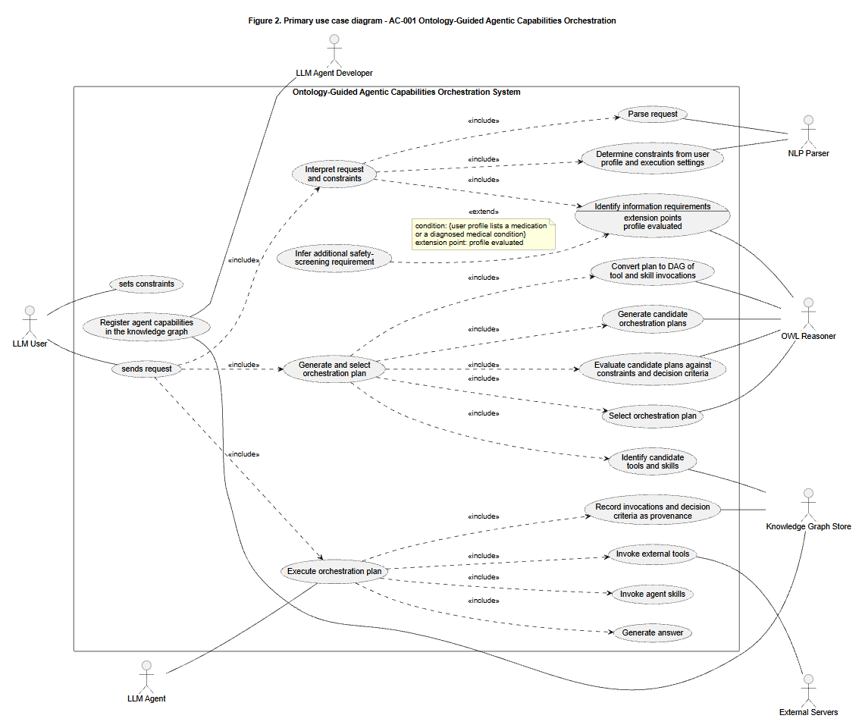
Basic flow Activity Diagram
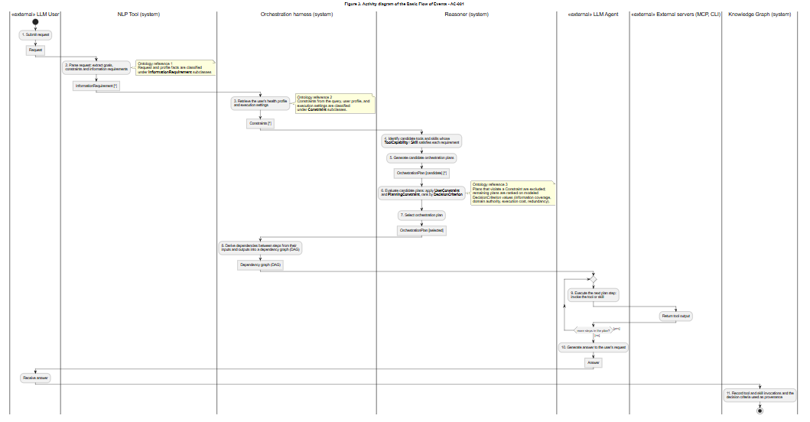

Alternate Flow Activity Diagram: Current agentic capabilities cannot satisfy the user’s request
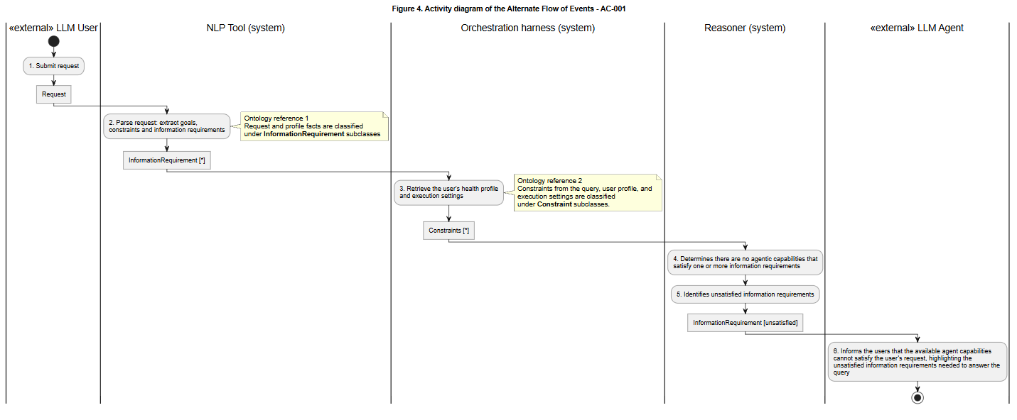

VII. Competency Questions

Provide at least 2 competency questions that you will ask of the vocabulary/ontology/knowledge base to implement this use case, including example answers to the questions.

Describe at least one way you expect to use the semantics and/or provenance to propose an answer to the questions. Include an initial description of why the semantics and/or provenance representation and reasoning provides an advantage over other obvious approaches to the problem. (optional – depending on the use case and need for supporting business case).

- What external servers are need to be called to collectively satisfy all information requirements needed to answer the user's request?
Ex. provide me with supplement recommendations that suits my health profile

Usage Scenario 1 (Ken) Answers:
- Supplement Advisor MCP
  - Identifies candidate supplements based on the user’s health goals, medical conditions, and medical interactions with other supplements and medications the user takes
  - Provides initial set of supplement recommendations before downstream analysis
- PubMed MCP
  - Retrieves peer-reviewed biomedical evidence to support the effectiveness of the recommended supplements
  - 2nd priority but still useful in Ken’s case
- iHerb-CLI
  - Retrieves live supplement products with prices
  - Useful in Ken’s case since his top priority is affordable supplements

Usage Scenario 2 (Jessica) Answers:
- Supplement Advisor MCP
  - Identifies candidate supplements based on the user’s health goals, medical conditions, and medical interactions with other supplements and medications the user takes
  - Provides initial set of supplement recommendations before downstream analysis
- PubMed MCP
  - Retrieves peer-reviewed biomedical evidence to support the effectiveness of the recommended supplements
  - Top priority: supplements backed up by evidence
- Open FDA MCP
  - Screens supplements for potential drug interactions, adverse effects, contraindications, recalls, and other regulatory safety information
  - Required since Jessica is taking medication or has medical conditions that could introduce safety concern
- iHerb-CLI
  - Retrieves live supplement products with ratings
  - Useful in Jessica’s case since she want’s high-quality supplements

Why an ontology would be useful
- underlying information requirements implied by the user’s request (scientific evidence retrieval, medication interaction, safety screening)
- Maps information requirements to external servers capable of satisfying them
  - Supplement Advisor MCP =>personalized supplement recommendations
  - PubMed MCP => Evidence-based biomedical literature
  - OpenFDA=> drug interactions, adverse events, contraindications, recalls
  - iHerb-CLI => live supplement product prices and ratings
- Reasons over whether certain information requirements are necessary
  - User not taking medication may not require safety screening
  - Users taking medication require additional safety screening check
- Avoids unnecessary tool invocations

How to use the ontology
- System parses the user’s request and retrieves any Constraints and InformationRequirements
- System extracts the Constraints from the user’s profile (ie., diagnosis, medication, health goals, etc.) and execution settings (ie.high-quality evidence, reduce supplement cost, minimize execution cost, maximize safety screening, etc.)
- System queries the KG to identify which external Servers satisfy each Information Requirement (ie. supplement recommendation => Supplement Advisor, evidence retrieval => PubMed)
- Ontology reasons over the Constraints to determine whether additional InformationRequirements are implied by the user’s profile (ex. Jessica’s current medication implies her agent orchestration needs to perform safety screening)
- If multiple external server combinations satisfy the user’s request, the ontology evaluates them according to the modeled DecisionCriteria (ie., information coverage, domain authority, execution cost, etc.)
  - Ex. Data from Supplement Advisor is grounded on PubMed but the evidence is static. PubMed MCP enables dynamic biomedical literature retrieval. PubMed has higher information coverage and domain authority compared to Supplement Advisor that its server should be invoked if evidence retrieval is one of the information requirements, even if Ken wants to minimize execution cost.
- The system selects the minimal set of external Servers that collectively satisfies all Information Requirements while satisfying the user’s Constraints
- System records the DecisionCriterion as provenance in the KG

- What execution orchestration should the agent follow to answer a user's request?
Ex. provide me with supplement recommendations that suit my health profile

Candidate Answers:

Usage scenario 1 (Ken) orchestration plan:
- Get user profile
- Get candidate supplements
  - Supplement_advisor: recommend_supplement(search_query) => supplement recommendations
- Remove redundant supplements
- Get supplement products
  - iHerb-CLI: search(supplement, sort=[price]) => list of supplement products
- Rank supplement products by cost
- Verify evidence
  - PubMed: search_articles(search_query) => PMIDs
  - PubMed: download_articles_batch(PMIDs) => article abstracts
  - summarize_evidence()
- Rank supplement products by evidence
- Select supplement product
- Produce recommendations

Usage scenario 2 (Jessica) orchestration plan:
- Get user profile
- Get candidate supplements
  - Supplement_advisor: recommend_supplement() => supplement recommendations
- Screen interactions
  - OpenFDA: search_drug_adverse_events(medication/supplement)
  - OpenFDA: search_drug_labels(supplement)
  - OpenFDA: search_drug_recalls(supplement)
- Rank by screening
- Verify evidence
  - PubMed: search_articles(search_query) => PMIDs
  - PubMed: download_articles_batch(PMIDs) => article abstracts
  - summarize_evidence()
- Rank by evidence
- Get supplement products
  - iHerb-CLI: search(supplement, sort=[rating]) => list of supplement products
- Rank supplement products by rating
- Select supplement product
- Produce recommendations

How to solve with ontology
- System parses the user’s request and retrieves any Constraints and InformationRequirements
- System extracts the Constraints from the user’s profile (ie., diagnosis, medication, health goals, etc.) and execution settings (ie.high-quality evidence, reduce supplement cost, minimize execution cost, maximize safety screening, etc.)
- System queries the KG to identify Tools and Skills that can satisfy each InformationRequirement
- Ontology reasons over Tool and Skill dependencies, modeled by their expected inputs and outputs
  - Which tools and skills are needed?
  - What order they should execute in?
  - Which orchestration plan best satisfies the user’s constraints?
- System creates the Orchestration Plan as a DAG workflow graph of the Skills and Tools to execute in order
- Orchestration Plan and related metadata are stored in KG for provenance
- The system selects that orchestration plan for the agent to follow

3. Which workflow steps of a given orchestration should be executed in parallel while satisfying both workflow dependencies and the user’s execution preferences?

Usage scenario 1 (Ken) orchestration plan:
- Get user profile
- Get candidate supplements
  - Supplement_advisor: recommend_supplement(search_query) => supplement recommendations
- Remove redundant supplements
- Get supplement products
  - iHerb-CLI: search(supplement, sort=[price]) => list of supplement products
- Rank supplement products by cost
- Verify evidence
  - PubMed: search_articles(search_query) => PMIDs
  - PubMed: download_articles_batch(PMIDs) => article abstracts
  - summarize_evidence()
- Rank supplement products by evidence
- Select supplement product
- Produce recommendations

Candidate Answer:
- Get supplement products
  - iHerb-CLI: search(supplement, sort=[price]) => list of supplement products
- Verify evidence
  - PubMed: search_articles(search_query) => PMIDs
  - PubMed: download_articles_batch(PMIDs) => article abstracts
  - summarize_evidence()

Usage scenario 2 (Jessica) orchestration plan:
- Get user profile
- Get candidate supplements
  - Supplement_advisor: recommend_supplement() => supplement recommendations
- Screen interactions
  - OpenFDA: search_drug_adverse_events(medication/supplement)
  - OpenFDA: search_drug_labels(supplement)
  - OpenFDA: search_drug_recalls(supplement)
- Rank by screening
- Verify evidence
  - PubMed: search_articles(search_query) => PMIDs
  - PubMed: download_articles_batch(PMIDs) => article abstracts
  - summarize_evidence()
- Rank by evidence
- Get supplement products
  - iHerb-CLI: search(supplement, sort=[rating]) => list of supplement products
- Rank supplement products by rating
- Select supplement product
- Produce recommendations

Candidate Answer:
- Screen interactions
  - OpenFDA: search_drug_adverse_events(medication/supplement)
  - OpenFDA: search_drug_labels(supplement)
  - OpenFDA: search_drug_recalls(supplement)
- Get supplement products
  - iHerb-CLI: search(supplement, sort=[price]) => list of supplement products
- Verify evidence
  - PubMed: search_articles(search_query) => PMIDs
  - PubMed: download_articles_batch(PMIDs) => article abstracts
  - summarize_evidence()

How to solve with ontology:
- The system retrieves the user's Orchestration Plan from the ontology-grounded knowledge graph.
- The system constructs a workflow dependency graph by reasoning over the semantic relationships between workflow steps. Each Skill and Tool Invocation is linked to the Information Artifacts it consumes and produces (e.g., HealthProfile, CandidateSupplement, PMID, ArticleAbstract, ProductList, SafetyAssessment).
- The ontology infers dependency relationships between workflow steps. A workflow step is dependent on another if it consumes an Information Artifact produced by that step.
- The system identifies independent workflow branches by finding workflow steps whose required Information Artifacts have already been satisfied and that do not consume outputs produced by one another.
- The system returns the set of workflow steps eligible for concurrent execution, allowing the agent to execute those steps in parallel while preserving all semantic dependencies.

4. Why were the MCP servers for a given orchestration invoked in this order?
Example query: provide me with supplement recommendations that suits my health profile

Usage Scenario 1 (Ken): Supplement Advisor => PubMed
Usace Scenario 2 (Jessica): Supplement Advisor => OpenFDA => PubMed

Candidate Answers:
- Tool dependency: Both orchestrations call Supplement Advisor MCP first
  - Cannot check for evidence or screening information for a supplement without the supplement itself
- Prioritization of user-specified planning constraints
  - Ken: minimizing execution cost > exhaustive search
    - Is taking no medication and is not concerned with adverse effects as much as Jessica, therefore, his plan doesn’t invoke OpenFDA
  - Jessica: maximize evidence quality, check medication interactions
    - Must call OpenFDA for adverse side effects or contraindications
    - Safety > evidence is probably a prioritization we should assume

Why it’s hard without an ontology:
- There are multiple criteria when selecting the first MCP server (data dependency, information coverage, domain authority, required output format, execution constraints)
- Execution logs and relational databases may tell you the order of MCP servers being called
  - This question asks for an explanation (difficult for relational databases)
  - Requires explicit semantics of an ontology

How to get the answer:
- System extracts all information requirements implied by the user’s request
- System queries the ontology-grounded KG of candidate MCP servers that satisfy the information requirements of the user’s query
- System uses ontology to reason over server and tool dependencies to determine whether server B needs to be invoked before server A (ie. produces outputs required by other servers)
- If multiple valid servers can be invoked first, the system uses the ontology to evaluate them according to modeled decision criteria (ie. domain authority, information coverage, execution cost, redundant tool invocations, etc)
- The system chooses the best server to invoke first based on the decision criteria modeled by the ontology

5. Why was orchestration plan B selected over orchestration plan A? (mostly planning constraint-based)
Example query: provide me with supplement recommendations that suits my health profile

Usage scenario 1 (Ken) orchestration plan:
- Get user profile
- Get candidate supplements
  - Supplement_advisor: recommend_supplement(search_query) => supplement recommendations
- Remove redundant supplements
- Get supplement products
  - iHerb-CLI: search(supplement, sort=[price]) => list of supplement products
- Rank supplement products by cost
- Verify evidence
  - PubMed: search_articles(search_query) => PMIDs
  - PubMed: download_articles_batch(PMIDs) => article abstracts
  - summarize_evidence()
- Rank supplement products by evidence
- Select supplement product
- Produce recommendations

Usage scenario 2 (Jessica) orchestration plan:
- Get user profile
- Get candidate supplements
  - Supplement_advisor: recommend_supplement() => supplement recommendations
- Screen interactions
  - OpenFDA: search_drug_adverse_events(medication/supplement)
  - OpenFDA: search_drug_labels(supplement)
  - OpenFDA: search_drug_recalls(supplement)
- Rank by screening
- Verify evidence
  - PubMed: search_articles(search_query) => PMIDs
  - PubMed: download_articles_batch(PMIDs) => article abstracts
  - summarize_evidence()
- Rank by evidence
- Get supplement products
  - iHerb-CLI: search(supplement, sort=[rating]) => list of supplement products
- Rank supplement products by rating
- Select supplement product
- Produce recommendations

Candidate Answers:
- Ken: minimizes execution cost
  - Less tool calls than Jessica’s
  - Is already healthy and is taking no medications, so he skips the screening (OpenFDA MCP)
- Ken: cost efficiency > exhaustive analysis
  - Removes redundant supplements and ranks by cost first before checking evidence
  - Minimizing search scope for literature retrieval
- Jessica: safety check > evidence-based > cost efficiency
  - Performs screening interactions before evidence-based retrieval because she wants to minimize risks of adverse effects of the supplements
  - Doesn’t mind the cost so her recommendations don’t rank by cost
  - Must call OpenFDA since she’s on medication
- Jessica: performs comprehensive analysis
  - Prioritizes high-quality evidence and safety so the Recommender invokes tools from OpenFDA and PubMed
  - Invokes MPC of high domain authority
  - Doesn’t try to minimize the search scope
- Rankings of Kent and Jessica’s supplements are different
  - Ken: cost, evidence
  - Jessica: safety, evidence
- Different user-specified planning constraints (preferences of the user)
  - Ken: minimizing execution cost, recommending affordable supplements, avoiding unnecessary and redundant supplements
  - Jessica: maximize evidence quality, check medication interactions, prioritize supplement quality over price
- Different information requirements (information supplied to support recommendation)
  - Ken is young, has no medical conditions, and is not currently taking any medication
    - Calling OpenFDA is unnecessary for him since he’s not taking any other medication
  - Jessica is older, diagnosed with osteoarthritis, and is taking medication
    - Safety screening is required. More emphasis on invoking OpenFDA and PubMed MCPs for safety and evidence-based retrieval

Why it’s hard without an ontology:
- Multiple criteria in choosing the most optimal orchestration plan (information requirements, tool capabilities, domain authority, dependency constraints, execution cost, and user constraints)
- Can traverse to find multiple candidate orchestration plans that satisfy the user's request
  - difficult to systematically compare and rank them without explicit semantic representations
- Explanations require traceable relationships between requirements, tool capabilities, planning objectives, and constraints.

How to get the answer:
- System traverses through the ontology-grounded KG of available MCP servers, tools, inputs, outputs, and dependency relationships to retrieves all candidate orchestration plans that satisfy the information requirements of the user’s query.
- System uses the ontology to reason over discovered candidate orchestration plans and determine which plans satisfy all semantic constraints (ie. tool dependencies, required information coverage, user constraints, etc)
- If multiple valid plans exist, the system uses the ontology to evaluate them according to modeled decision criteria (ie. domain authority, information coverage, execution cost, redundant tool invocations, etc)
- System chooses the preferred orchestration plan based on the decision criteria modeled by the ontology
- System records the preferred orchestration plan, the decision criteria supporting its selection, and all alternative orchestration plans as instances in the KG for provenance-awareness

6. What skills are required to satisfy the user's request?
Example query: Provide me with supplement recommendations that suit my health profile.

Usage scenario 1 (Ken):
- Personalized Supplement Recommendation Skill
- Evidence Verification Skill
- Product Selection Skill

Usage scenario 2 (Jessica):
- Personalized Supplement Recommendation Skill
- Supplement Safety Screening Skill (due to her current medication and diagnosed health condition)
- Evidence Verification Skill
- Product Selection Skill

Example query: Are there any safety concerns with taking magnesium while I’m taking my current medications?
Usage scenario 2 (Jessica):
- Supplement Safety Screening Skill
- Evidence Verification Skill

How to get the answer:
- System processes the user query with NLP to extract InformationRequirements to satisfy the user’s request
- System processes the user’s health profile and preferred execution settings to determine constraints and additional InformationRequirements the user’s OrchestrationPlan must follow (ex. Jessica’s current medication and diagnosed health condition means the OrchestrationPlan must include safety screening for contraindications)
- System uses the KG to map what Capabilities satisfy the InformationRequirements and the Skills that perform those Capabilities.
- System returns the Skills required to satisfy the user’s request

7. What skills depend on other skills?
The Evidence Verification Skill, Supplement Safety Screening Skill, and Product Selection Skill all depend the Personalized Supplement Recommendation Skill in order to execute. All of those skills require a CandidateSupplement as input, which is only returned by the Personalized Supplement Recommendation Skill as output.

How to get the answer:
- System traverses the ontology-grounded KG and identifies all available Skills
- The system retrieved produced and consumed InformaionArtifacts for each Skill. Ex.
  - Personalized Supplement Recommendation Skill → produces CandidateSupplement
  - Evidence Verification Skill → consumes CandidateSupplement, produces EvidenceAssessment
  - Safety Screening Skill → consumes CandidateSupplement, produces SafetyAssessment
  - Product Selection Skill → consumes EvidenceAssessment, SafetyAssessment, and ProductList
- Ontology reasons over semantic relationships between Skills and InformationArtfacts to infer skill dependencies. Skill B is dependent on Skill A if B consumes an Information Artifact produced by A.
- The system constructs a Skill dependency graph of inferred relationships
- The system returns the set of Skills that must be executed sequentially from the dependency graph.

8. Are all the prerequisites satisfied before executing this Skill given the agent's current phase in orchestration?
Example: about to execute Evidence Verification Skill when:
- HealthProfile ✓
- CandidateSupplement ✗
- SearchQuery ✓

No, the agent cannot execute the Evidence Verification Skill because not all the prerequisites have been satisfied (namely CandidateSupplement). The agent must call the Personalized Supplement Recommendation Skill, which returns a CandidateSupplement before executing the Evidence Verification Skill.

How to get the answer:
- System retrieves the agent’s its current phase in the orchestration plan and identifies the Skill it’s trying to execute.
- System retrieves the Skill’s prerequisites by querying the Skill dependency graph mentioned in CQ 8.
- System checks off which prerequisites have been satisfied based on the agent’s current orchestration state. Prerequisites are InformationArtifacts that are required as input for the Skill
- If any unsatisfied prerequisite InformationArtifacts are detected, the system traces those artifacts to their producing Skills
- The system returns one of the following two states:
  - Executable: all prerequisites are satisfied
  - Blocked: one or more prerequisites are missing but can be satisfied by calling another Skill

VIII. Resources

In order to support the capabilities described in this Use Case, a set of resources must be available and/or configured. These resources include the set of actors listed above, with additional detail, and any other ancillary systems, sensors, or services that are relevant to the problem/use case.

Knowledge Bases, Repositories, or other Data Sources
Data | Type | Characteristics | Description | Owner | Source | Access Policies & Usage
(dataset or repository name) | (remote, local/in situ, etc.) | e.g. – no cloud cover | Short description of the dataset, possibly including rationale of the usage characteristics |  | Source (possibly a system, or remote site) for discovery and access
PubMed MCP Server | remote | Third-party MCP server | Connects to research repository for retrieving biomedical-related papers | aeghnnsw | https://github.com/aeghnnsw/pubmed-mcp | Open-source  Github  License - must comply with PubMed's terms of service for API usage guidelines
Supplement Advisor MCP Server | remote | Third-party MCP server | Recommends supplements based on user’s needs | erinheit451 | https://github.com/erinheit451/supplement-advisor-mcp | Open-source  Github  MIT license
OpenFDA MCP Server | remote | Third-party MCP server | Provides safety and regulatory information on FDA-regulated products (recalls, adverse effects, shortages) | Augmented Nature | https://github.com/Augmented-Nature/OpenFDA-MCP-Server | Open-source  Github  license
iHerb-CLI | remote | Third-party Client | Provides pricing and reviews for supplements from iHerb | SeverinAlexB | https://github.com/SeverinAlexB/iherb-cli | Open-source github  MIT license

External Ontologies, Vocabularies, or other Model Services
Resource | Language | Description | Owner | Source | Describes/Uses | Access Policies & Usage
(ontology, vocabulary, or model name) | (ontology language and syntactic form, e.g., RDFS - N3) | If the service is one that runs a given ontology or model-based application at a given frequency, state that in addition to the basic description |  | Source (link to the registry or directly to the ontology, vocabulary, or model where that model is maintained, if available) | List of one or more data sources described by and/or used by the model
Representing Agentic Tools in Knowledge Graphs for Structure-Aware Tool Discovery Under Tool Overload | Paper that proposes high-level ontology (core classes, relationships, taxonomies)  No access to github or owl/rdf file | Proposes ontology and KG as layer for tool discovery | Isaiah Onando Mulang'  ~Isaiah_Onando_Mulang'1  , Johannes Thaller, Tushar Trivedi, Lars Heling, Felix Sasaki | https://openreview.net/forum?id=7MVoH9Y3mi&noteId=LGfMuSRiu6 | Use cases:  Discovering tools | Creative Commons License Attribution 4.0 International (CC BY 4.0).
AgentO | Ontology file (RDF/OWL) | Formalizes core concepts, roles, and relationships necessary to describe contemporary agent-based and workflow-oriented AI systems, with particular emphasis on LLM-driven agent frameworks | Kabul Kurniawan, Fajar J. Ekaputra | https://sepses.ifs.tuwien.ac.at/onto/index-en.html | Use cases:  Workflow reconstruction  Workflow reuse  Workflow auditing  Captured classes: Agent, Task, Tool, Goal, Role, Capability, Workflow Pattern, Workflow Step | Creative Commons License Attribution 4.0 International (CC BY 4.0).

Other Resources, Service, or Triggers (e.g., event notification services, application services, etc.)
Resource | Type | Description | Owner | Source | Access Policies & Usage
(sensor or external service name) |  | Include a description of the resource as well as availability, if applicable | Primary owner of the service | Application or service URL; if subscription based, include subscription and any subscription owner
Open WebUI | Agent Harness | Web interface to connect AI models  Supports MCP and Agent Skills | Tim J. Baek and team | https://knowledge.exlibrisgroup.com/Ulrich's/Product_Documentation/Configuring/Ulrichsweb_API/Ulrichsweb%3A_Using_the_Ulrichsweb_API | Open WebUI License

IX. References and Bibliography

List all reference documents – policy documents, regulations, standards, de-facto standards, glossaries, dictionaries and thesauri, taxonomies, and any other reference materials considered relevant to the use case

X. Notes

There is always some piece of information that is required that has no other place to go. This is the place for that information.

Concept of Operations

For a general ontology-guided agentic orchestration use case
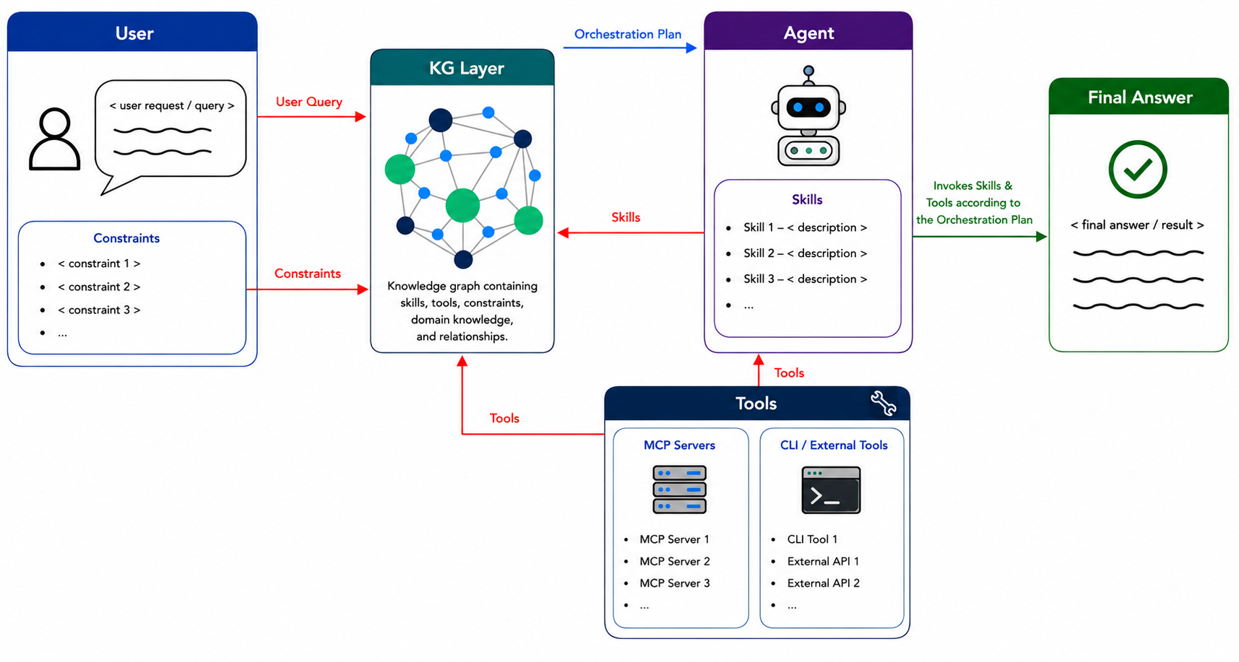
For a specific scope: personalized supplement recommendation

