I. Use Case Description
Use Case Name | Ontology-Guided Agentic Capabilities Orchestration
Use Case Identifier | AC-001
Source | CSCI 6340 - Ontologies
Point of Contact | Gia Oriana Santos (santog@rpi.edu), Barbara Kotlan (kotlab@rpi.edu), Jiaying(Michael) Wang (wangj63@rpi.edu), Jialin (Gary) Fang (fangj6@rpi.edu), Eli (guedee@rpi.edu)
Creation / Revision Date | 9/25/2026
Associated Documents

II. Use Case Summary
Goal | To govern which agent skills and tools to invoke, as well as determine the most optimal orchestration plan an LLM should follow given the user’s request and constraints
Requirements | This use case must accomplish the following tasks  - Identify agent capabilities that can fulfill the information requirements or goals expressed in a user request  - Construct one or more candidate orchestration plans by sequencing agent capabilities to satisfy the information requirements of a user request.  - Determine whether capabilities in a candidate plan have their required inputs, outputs, preconditions, and dependencies satisfied, and identify missing or incompatible dependencies before execution  - Select an orchestration plan that satisfies all or most of the constraints specified in the user’s preferences  - Explain why an orchestration plan is selected by mapping candidate plans to decision criteria  - Plan independent capabilities in a given orchestration plan that can run in parallel
Scope | - These are the external servers available to the LLM  - PubMed MCP  - Supplement Advisor MCP  - OpenFDA MCP  - iHerb-CLI  - External servers are exclusively MCP and CLI  - The LLM cannot use RAG or GraphRAG  - Specific domain: personalized supplement recommendation  - Not considering “common knowledge” questions. Only questions related to personalized supplement recommendations
Priority | N/A
Stakeholders | - LLM users  - LLM agent developers  - External server providers
Description | The emergence of the MCP has enabled LLMs to access external tools and data sources through standardized interfaces, allowing AI agents to perform complex retrieval, reasoning, and decision-making tasks. As AI agents become increasingly modular, they must not only determine which external servers and tools to invoke, but also decide when specialized agentic skills should be executed to accomplish subtasks for an overall goal. As the number of available skills and tools continues to grow, LLM agents face increasingly difficult orchestration problems, including determining which skills and tools should be executed, dependencies between skills and tools in orchestration, choosing the best valid orchestration plan given the particular user and situation, and explaining why the orchestration plan should be preferred over another. Current LLMs typically make these decisions implicitly through prompting or learned behavior, making the orchestration process difficult to explain, reproduce, validate, and optimize.  This use case addresses the ambiguity of agentic skill and tool orchestration by incorporating an ontology as a layer between the user and agent to explicitly represent the capabilities, inputs, outputs, dependencies, execution requirements, and characteristics of available skills, external servers, and their associated tools. Given a user's request, the ontology guides the LLM agent in selecting the appropriate skills, identifying the relevant external servers and tools, determining the optimal sequence of skill executions and tool invocations, and selecting the orchestration plan that best satisfies the task requirements. The use case’s scope focuses on generating evidence-based, personalized supplement recommendations by integrating information from a user's health profile and preferred execution settings to act as constraints on orchestration plan selection. This use case also incorporates external servers to support retrieval from scientific literature, safety screening, and an existing product catalog. By grounding orchestration decisions in explicit ontological knowledge, the framework enables transparent, explainable, reusable, and repeatable agent workflows while ensuring that supplement recommendations are supported by user-specified constraints for semantic orchestration plan generation
Actors / Interfaces | Primary actors  - LLM User  - LLM Agent  Secondary actors (resources)  - External Servers  - PubMed MCP  - Supplement Advisor MCP  - OpenFDA MCP  - iHerb-CLI  - NLP Tool  - Agent Harness (ie. Claude Code, Codex CLI, OpenClaw, etc.)  - Reasoner  - Knowledge Graph (KG)
Pre-conditions | - Ontology is loaded into the system  - LLM agent model must be able to use skills and tools (including MCP and CLI).  - LLM agent must have the following skills  - Supplement Recommendation  - Safety Screening  - Evidence Verification  - Product Selection  - LLM agent is connected to the following external servers  - PubMed MCP  - Supplement Advisor MCP  - OpenFDA MCP  - iHerb-CLI  - LLM agents must also have access to the user’s preference settings to facilitate constraint-aware selection
Post-conditions | - Harness provides ontology-aligned orchestration plan to the LLM  - LLM agent follows the plan  - LLM agent provides an answer to the user’s request  - Orchestration plan is recorded to the KG for provenance
Triggers | - User sends a request to the LLM agent.
Performance Requirements
Assumptions
Open Issues

III. Usage Scenarios

Provide at least two usage scenarios that flesh out the requirements outlined in the summary, including identification of requirements specific to any envisioned ontology or semantically-driven service or application. Scenarios should be described as narrative, with supporting diagrams as appropriate. In an Agile process, every user story relevant to the use case should be included and elaborated/rolled up into one or more usage scenarios, with a clear mapping from the user story to the scenario it is integrated in or mapped to.

- Ken is a college student training to be a hybrid athlete in search of supplements while on a budget. Jessica is also looking for supplements, but is diagnosed with osteoarthritis and taking prior medication. Both use the Supplement Recommender agent through their LLMs, but they each have different user preferences in terms of agent orchestration.
Ken prefers to minimize token usage and external tool calls whenever possible. As a college student on a budget, he is looking for affordable supplements with strong customer reviews and good value. He wants recommendations that are supported by scientific evidence but is willing to accept slightly less comprehensive analysis if it reduces cost. Jessica, on the other hand, prioritizes recommendations that are supported by high-quality scientific evidence. She also expects the system to screen for potential interactions with her prescription medication before making any recommendations.
- Dante uses the Supplement Recommender agent and can view the candidate orchestration plans considered by the agent through the system's harness. Although he can see the plans, he is unfamiliar with what each capability does, which servers provide the invoked tools, what intermediate information artifacts are produced at each step of the orchestration, and why each agent capability was invoked in a particular order. He wants to understand why the agent selected one orchestration plan over the other candidate plans.
- Olivia wants to find the best heart-health supplement. She explicitly tells the Supplement Recommender agent to find strong scientific evidence while also requiring the response to use as few external tool calls as possible. The agent identifies that these preferences can be conflicting constraints. Regardless, the agent generates candidate plans with different trade-offs between evidence coverage and execution cost. The agent determines which orchestration plan to choose based on Olivia’s user preferences and goes ahead to execute that orchestration plan.
IV. Basic Flow of Events
Narrative: Often referred to as the primary scenario or course of events, the basic flow defines the process/data/work flow that would be followed if the use case were to follow its main plot from start to end. Error states or alternate states that might occur as a matter of course in fulfilling the use case should be included under Alternate Flow of Events, below. The basic flow should provide any reviewer a quick overview of how an implementation is intended to work. A summary paragraph should be included that provides such an overview (which can include lists, conversational analysis that captures stakeholder interview information, etc.), followed by more detail expressed via the table structure.

In cases where the user scenarios are sufficiently different from one another, it may be helpful to describe the flow for each scenario independently, and then merge them together in a composite flow.

Usage Scenario 1 - Basic / Normal Flow of Events
Step | Actor (Person) | Actor (System) | Description
1 | user |  | Submits a request
2 | - | NLP Tool | Parses request, extracting goals, constraints, and information requirements
3 | - | Harness | Retrieves user’s preference settings to identify orchestration constraints
4 | - | Reasoner | Identifies candidate agent tools and skills from the information requirements
5 | - | Reasoner | Determines candidate orchestration plans based on a combination of required agent tools and skills that satisfy the information requirements
6 | - | Reasoner | Evaluates candidate orchestration plans by applying constraints (user constraints and planning constraints) and ranking them on the modeled decision criteria
7 | - | Reasoner | Selects orchestration plan
8 | - | Harness | Derives orchestration dependencies from the input/outputs of orchestration steps into a dependency graph
9 | agent | - | Executes orchestration plan by invoking agent tools and skills according to the plan
10 | agent |  | Generates answer to user’s request
11 |  | KG | Records skill and tool invocations from the orchestration as well as decision criteria as provenance

Summary: The User submits a request, after which the NLP Tool parses the request to extract goals, constraints, and preferences. The Harness retrieves the user’s health profile and execution settings to identify orchestration constraints. The Reasoner identifies candidate tools and skills to satisfy the information requirements, as well as candidate orchestration plans that collectively satisfy those requirements. The Reasoner then evaluates and ranks the candidate plans according to user and planning constraints and relevant decision criteria before selecting an orchestration plan. The Harness derives dependencies between orchestration steps from their inputs and outputs to form a dependency graph, and the Agent executes the selected plan by invoking the required tools and skills in the appropriate order. The Agent then generates an answer to the user’s request, while the KG records the tool and skill invocations and associated decision criteria as provenance for the resulting orchestration.

Usage Scenario 2 - Basic / Normal Flow of Events
Step | Actor (Person) | Actor (System) | Description
1 | user |  | Submits a request
2 | - | Reasoner | Generates candidate orchestration plans and selects one based on DecisionCriteria
3 |  | KG | Records candidate orchestration plans and selected plan with corresponding DecisionCriteria as provenance
4 | Agent | - | Executes orchestration plan by invoking agent tools and skills according to the plan
5 | user |  | Requests an explanation of the selected orchestration plan through the system’s Harness
6 |  | Reasoner | Identifies DecisionCriteria of corresponding selected orchestration plan
7 | - | Reasoner | Maps each ToolInvocation and SkillInvocation to the Capability it provides and to the InformationRequirements and Constraints that Capability satisfies
8 | - | Harness | Displays the DecisionCriteria and mapped InformationRequirements & Constraints to each agent capability in the orchestration plan
9 | User | - | Views the explanation of the orchestration plan via the system’s Harness
Summary: The User submits a request to the Supplement Recommender Agent. The Reasoner generates candidate orchestration plans and selects an orchestration plan based on applicable Decision Criteria, while the Knowledge Graph records the candidate plans, selected plan, and corresponding Decision Criteria as provenance. The Agent then executes the selected orchestration plan by invoking the required tools and skills according to the plan. Following execution, the Reasoner identifies the Decision Criteria associated with the selected plan and maps each Tool Invocation and Skill Invocation to the Capabilities they provide, as well as the Information Requirements and Constraints satisfied by those capabilities. The Harness then displays the Decision Criteria and the mapped Information Requirements and Constraints associated with each agent capability in the orchestration plan, allowing the User to view an explanation of why the selected orchestration plan was chosen.

Usage Scenario 3 - Basic / Normal Flow of Events
Step | Actor (Person) | Actor (System) | Description
1 | user |  | Submits a request
2 | - | NLP Tool | Parses request, extracting goals, constraints, and information requirements
3 | - | Harness | Retrieves user’s preference settings to identify orchestration constraints (ie. high evidence coverage, low external tool calls)
4 | - | Reasoner | Identifies candidate orchestration plans whose Capabilities satisfy the InformationRequirements
5 | - | Reasoner | Selects “Evidence Coverage” and “External Tool Calls” as DecisionCriteria to select orchestration plan
6 | - | Harness | Calculates evidence coverage and external tool call scores for each candidate plan
7 |  | KG | Records the evidence coverage and external tool call scores of each candidate plan
8 | - | Reasoner | Ranks each candidate plan by evidence coverage and external tool call scores
9 |  | Reasoner | Selects orchestration plan based on highest DecisionCriteria score
10 | - | Harness | Derives orchestration dependencies from the input/outputs of orchestration steps into a dependency graph
11 | agent | - | Executes orchestration plan by invoking agent tools and skills according to the plan
12 | agent | - | Generates answer to user’s request
13 |  | KG | Records candidate orchestration plans and selected plan with corresponding DecisionCriteria as provenance

Summary: The User submits a request to the Supplement Recommender Agent. The NLP Tool parses the request to extract the user’s goals, constraints, and information requirements, while the Harness retrieves the user’s preference settings to identify relevant orchestration constraints, such as high evidence coverage and minimizing external tool calls. The Reasoner identifies candidate orchestration plans whose Capabilities satisfy the extracted Information Requirements and selects Evidence Coverage and External Tool Calls as the Decision Criteria for evaluating the plans. The Harness calculates the evidence coverage and external tool call scores for each candidate plan, and the Knowledge Graph records these scores as provenance. The Reasoner evaluates the candidate plans based on the Decision Criteria and selects an orchestration plan. The Harness then derives the dependencies among the orchestration steps from their inputs and outputs to construct a dependency graph. The Agent executes the selected orchestration plan by invoking the required tools and skills according to the derived dependencies, generates an answer to the user’s request, and the Knowledge Graph records the candidate plans, selected plan, Decision Criteria, and associated evaluation information as provenance.

V. Alternate Flow of Events
Narrative: The alternate flow defines the process/data/work flow that would be followed if the use case enters an error or alternate state from the basic flow defined, above. A summary paragraph should be included that provides an overview of each alternate flow, followed by more detail expressed via the table structure.

Usage Scenario 1 - Alternate Flow of Events: current agentic capabilities cannot satisfy the user’s request
Step | Actor (Person) | Actor (System) | Description
1 | user |  | Submits a request
2 | - | NLP Tool | Parses request, extracting goals, constraints, and information requirements
3 | - | Harness | Retrieves user’s health profile and execution settings to identify orchestration constraints
4 |  | Reasoner | Determines there are no agentic capabilities that satisfy one or more information requirements
5 |  | Reasoner | Identifies unsatisfied information requirements
6 | - | Harness | Returns unsatisfied information requirements
7 | agent | - | Informs the users that the available agent capabilities cannot satisfy the user’s request, highlighting the unsatisfied information requirements needed to answer the query

Summary: The User submits a request. The NLP Tool parses the request to extract goals, constraints, and information requirements. The Harness retrieves the user’s health profile and execution settings to identify relevant orchestration constraints. The Reasoner determines that the available agentic capabilities cannot satisfy one or more of those requirements. It identifies the unsatisfied information requirements, which the Harness returns to the Agent. The Agent then informs the user that the currently available tools and skills cannot fully satisfy the request, explicitly highlighting the information requirements that cannot be fulfilled and are therefore needed to answer the query.

Usage Scenario 2 - Alternate Flow of Events: current agentic capabilities cannot satisfy the user’s request (requires explanation)
Step | Actor (Person) | Actor (System) | Description
1 | user |  | Submits a request
2 | agent | - | Informs the users that the available agent capabilities cannot satisfy the user’s request, highlighting the unsatisfied information requirements needed to answer the query
3 | - | Reasoner | Retrieves the InformationRequirements the system was trying to satisfy in the previous query
4 |  | Reasoner | Retrieve all the Tools and Skills available to the agent
5 |  | Reasoner | Map those Tools and Skills to their Capabilities and the InformationRequirements they satisfy
6 |  | Reasoner | Identifies unsatisfied InformationRequirements
7 | - | Harness | Display the Tools and Skills with the InformationRequirements they satisfy, as well as the unsatisfied InformationRequirements
8 | User | - | Views the explanation as to why the agent failed to execute the task via the system’s Harness
Summary: When the available agentic capabilities cannot satisfy the User’s request, the Agent informs the user that the request cannot be fulfilled and identifies the Information Requirements that remain unsatisfied. The Reasoner retrieves the Information Requirements associated with the request, as well as all Tools and Skills currently available to the agent. It then maps the available Tools and Skills to their corresponding Capabilities and determines which Information Requirements those Capabilities can satisfy, allowing the system to identify the Information Requirements that remain unsatisfied. The Harness displays the available Tools and Skills, the Information Requirements they can satisfy, and the unsatisfied Information Requirements. The User can then view this explanation through the system Harness to understand why the Agent was unable to execute the task.

Usage Scenario 3 - Alternate Flow of Events: identifes directl conflicting constraints (ex. Maximize tool use and minimize tool use)
Step | Actor (Person) | Actor (System) | Description
1 | user |  | Submits a request
2 |  | NLP Tool | Parses request, extracting goals, constraints, and information requirements
3 | - | Harness | Retrieves user’s preference settings to identify orchestration constraints (ie. maximize tool use, minimize tool use)
4 | - | Reasoner | Identifies that the constraints directly conflict with each other
5 | - | Harness | Returns conflicting constraints
6 | agent | - | Informs the user that it cannot execute the request because the constraints conflict, names the conflicting constraints, and asks the user to revise them
Summary: The User submits a request, and the NLP Tool parses the request to extract the user’s goals, constraints, and Information Requirements. The Harness retrieves the user’s preference settings to identify the orchestration constraints associated with the request, while the Reasoner evaluates these constraints and identifies a direct conflict between them, such as simultaneously maximizing and minimizing tool use. The Harness returns the conflicting constraints, and the Agent informs the user that it cannot execute the task because the specified constraints are incompatible. The User is then prompted to resolve or modify the conflicting constraints before the request can be executed.

VI. Use Case and Activity Diagram(s)

Provide the primary use case diagram, including actors, and a high-level activity diagram to show the flow of primary events that include/surround the use case. Subordinate diagrams that map the flow for each usage scenario should be included as appropriate

Sructural Diagram of System Architecture
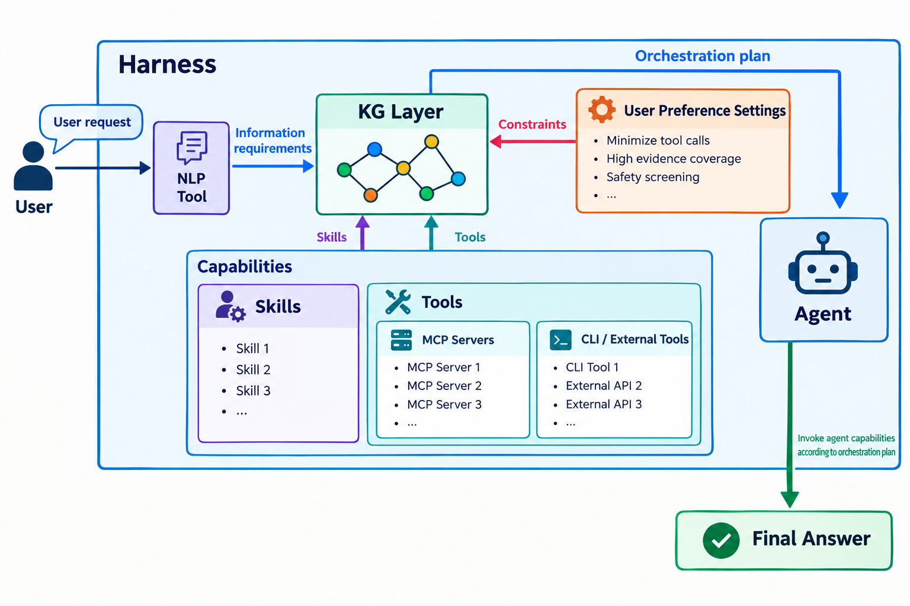

Use case diagram: LLM User and Agent Developer Side
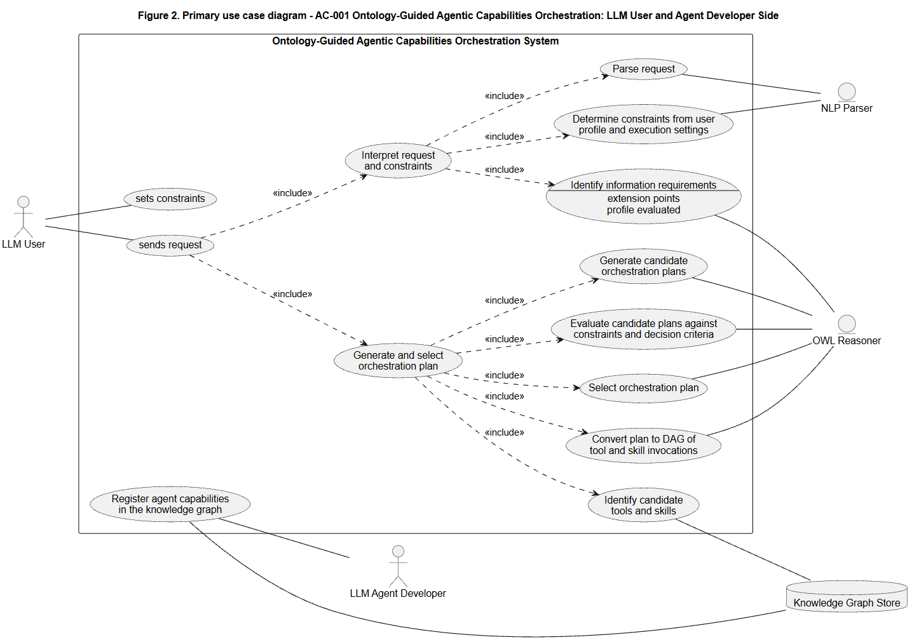

Use case diagram: Agent Side
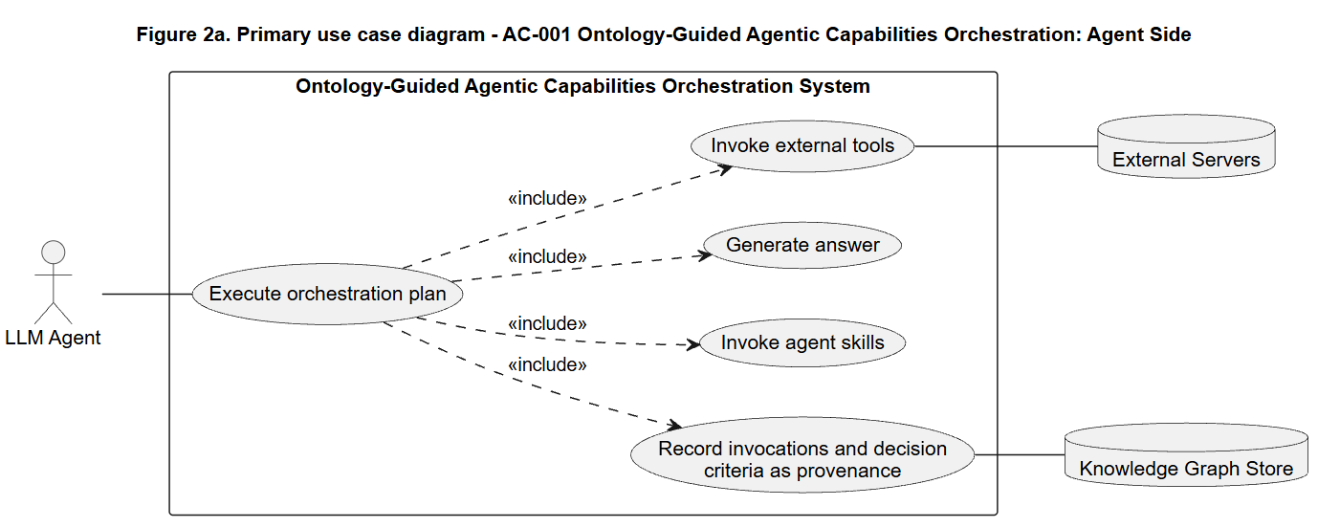

Basic flow Activity Diagram
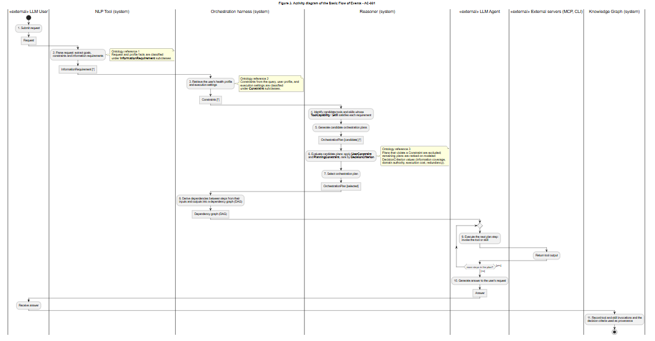

Alternate Flow Activity Diagram: Current agentic capabilities cannot satisfy the user’s request
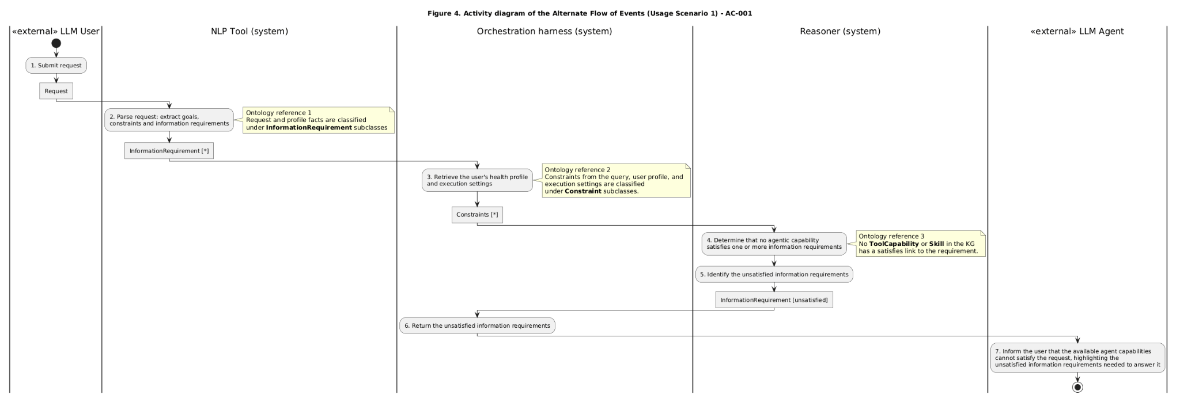

VII. Competency Questions

Provide at least 2 competency questions that you will ask of the vocabulary/ontology/knowledge base to implement this use case, including example answers to the questions.

Describe at least one way you expect to use the semantics and/or provenance to propose an answer to the questions. Include an initial description of why the semantics and/or provenance representation and reasoning provides an advantage over other obvious approaches to the problem. (optional – depending on the use case and need for supporting business case).

- What execution orchestration should the agent follow to answer a user's request?
Refer to usage scenario 1 (Ken)
Ex. provide me with supplement recommendations that suit my health profile

Candidate Answers:

Usage scenario 1 (Ken) orchestration plan:
- Get user profile
- Get candidate supplements
  - Supplement_advisor: recommend_supplement(search_query) => supplement recommendations
- Remove redundant supplements
- Get supplement products
  - iHerb-CLI: search(supplement, sort=[price]) => list of supplement products
- Rank supplement products by cost
- Verify evidence
  - PubMed: search_articles(search_query) => PMIDs
  - PubMed: download_articles_batch(PMIDs) => article abstracts
  - summarize_evidence()
- Rank supplement products by evidence
- Select supplement product
- Produce recommendations

How to solve with ontology
- System parses the user’s request and retrieves any Constraints and InformationRequirements
- System extracts the Constraints from the user’s profile (ie., diagnosis, medication, health goals, etc.) and execution settings (ie.high-quality evidence, reduce supplement cost, minimize execution cost, maximize safety screening, etc.)
- System queries the KG to identify Tools and Skills that can satisfy each InformationRequirement
- Ontology reasons over Tool and Skill dependencies, modeled by their expected inputs and outputs
  - Which tools and skills are needed?
  - What order they should execute in?
  - Which orchestration plan best satisfies the user’s constraints?
- System creates the Orchestration Plan as a DAG workflow graph of the Skills and Tools to execute in order
- Orchestration Plan and related metadata are stored in KG for provenance
- The system selects that orchestration plan for the agent to follow

2. Which workflow steps of a given orchestration should be executed in parallel while satisfying both workflow dependencies and the user’s execution preferences?
Refer to usage scenario 1 (Jessica)
Suppose Jessica’s orchestration plan is:
- Get user profile
- Get candidate supplements
  - Supplement_advisor: recommend_supplement() => supplement recommendations
- Screen interactions
  - OpenFDA: search_drug_adverse_events(medication/supplement)
  - OpenFDA: search_drug_labels(supplement)
  - OpenFDA: search_drug_recalls(supplement)
- Rank by screening
- Verify evidence
  - PubMed: search_articles(search_query) => PMIDs
  - PubMed: download_articles_batch(PMIDs) => article abstracts
  - summarize_evidence()
- Rank by evidence
- Get supplement products
  - iHerb-CLI: search(supplement, sort=[rating]) => list of supplement products
- Rank supplement products by rating
- Select supplement product
- Produce recommendations

Candidate Answer:
- Screen interactions
  - OpenFDA: search_drug_adverse_events(medication/supplement)
  - OpenFDA: search_drug_labels(supplement)
  - OpenFDA: search_drug_recalls(supplement)
- Get supplement products
  - iHerb-CLI: search(supplement, sort=[rating]) => list of supplement products
- Verify evidence
  - PubMed: search_articles(search_query) => PMIDs
  - PubMed: download_articles_batch(PMIDs) => article abstracts
  - summarize_evidence()

How to solve with ontology:
- The system retrieves the user's Orchestration Plan from the ontology-grounded knowledge graph.
- The system constructs a workflow dependency graph by reasoning over the semantic relationships between workflow steps. Each Skill and Tool Invocation is linked to the Information Artifacts it consumes and produces (e.g., HealthProfile, CandidateSupplement, PMID, ArticleAbstract, ProductList, SafetyAssessment).
- The ontology infers dependency relationships between workflow steps. A workflow step is dependent on another if it consumes an Information Artifact produced by that step.
- The system identifies independent workflow branches by finding workflow steps whose required Information Artifacts have already been satisfied and that do not consume outputs produced by one another.
- The system returns the set of workflow steps eligible for concurrent execution, allowing the agent to execute those steps in parallel while preserving all semantic dependencies.

3. Why were the agent capabilities for a given orchestration invoked in this order?
Refer to usage scenario 2
Query: “Compare magnesium glycinate and magnesium citrate for supporting sleep, and summarize the scientific evidence for each.”
Dante’s constraints: minimize execution time, safety screening

Suppose the chosen orchestration plan is:
1a. Verify evidence
PubMed: search_articles(magnesium glycinate for sleep) => PMIDs
PubMed: download_articles_batch(PMIDs) => article abstracts
summarize_evidence()
1b. Screen interactions
OpenFDA: search_drug_adverse_events(magnesium glycinate)
OpenFDA: search_drug_labels(magnesium glycinate)
OpenFDA: search_drug_recalls(magnesium glycinate)
2a. Verify evidence
PubMed: search_articles(magnesium citrate for sleep) => PMIDs
PubMed: download_articles_batch(PMIDs) => article abstracts
summarize_evidence()
2b. Screen interactions
OpenFDA: search_drug_adverse_events(magnesium citrate)
OpenFDA: search_drug_labels(magnesium citrate)
OpenFDA: search_drug_recalls(magnesium citrate)
3. Synthesize evidence

Candidate Answer:
One of Dante’s constraints is safety screening. Because the Screen interactions skill satisfies that constraint, it must be included in the orchestration plan. Another one of Dante’s constraints is to minimize execution time. Since the Verify evidence and Screen interactions skills require the same dependencies (candidate supplement), they can be invoked in parallel to minimize execution cost. Doing so satisfies both constraints specified by Dante.

Why it’s hard without an ontology:
- An execution log or a relational table records that Verify evidence and Screen interactions ran at the same time, but not why: it holds no statement that both consume the same CandidateSupplement artifact and that neither consumes the other’s output, nor that “minimize execution time” and “safety screening” are the constraints that made this ordering preferable.
- Answering “why this order” requires the dependency relations between steps and the mapping from constraints to decision criteria to exist as explicit, queryable facts. The ontology supplies both.

How to get the answer:
- The system retrieves Dante’s OrchestrationPlan from the KG together with the InformationRequirements and Constraints extracted from his request and execution settings.
- For every SkillInvocation and ToolInvocation in the plan, the system reads the InformationArtifacts it consumes and produces: Verify evidence consumes CandidateSupplement and produces EvidenceAssessment; Screen interactions consumes CandidateSupplement and produces SafetyAssessment; Synthesize evidence consumes both assessments.
- The ontology infers the dependency relation: a step depends on another step only if it consumes an InformationArtifact that the other produces. Verify evidence and Screen interactions consume nothing from each other, so the reasoner classifies them as independent; Synthesize evidence depends on both, so it must run last.
- The system traces each Constraint to the DecisionCriterion it selects. “Safety screening” is satisfied only by the Screen interactions Capability, which is why that skill is in the plan; “minimize execution time” selects the execution-time criterion, which ranks a plan that runs the two independent steps in parallel above the sequential alternative.
- The system returns the ordering explanation: which steps were independent (from the inferred dependencies) and which Constraints and DecisionCriteria justified the parallel branch, all read from the provenance the KG recorded when the plan was selected (basic flow step 11).

4. Why was orchestration plan B selected over orchestration plan A?
Refer to usage scenario 3
Plan A:
Get candidate supplements
  - Supplement_advisor: recommend_supplement(heart health) => supplement recommendations
Verify evidence
  - PubMed: search_articles(search_query) => PMIDs
  - PubMed: download_articles_batch(PMIDs) => article abstracts
  - summarize_evidence()
Screen interactions
  - OpenFDA: search_drug_adverse_events(medication/supplement)
  - OpenFDA: search_drug_labels(supplement)
  - OpenFDA: search_drug_recalls(supplement)
Verify evidence (second, duplicate pass)
  - PubMed: search_articles(search_query) => PMIDs
  - PubMed: download_articles_batch(PMIDs) => article abstracts
  - summarize_evidence()
Rank by evidence
Select supplement product
Produce recommendations

Plan B:
Get candidate supplements
  - Supplement_advisor: recommend_supplement(heart health) => supplement recommendations
Verify evidence
  - PubMed: search_articles(search_query) => PMIDs
  - PubMed: download_articles_batch(PMIDs) => article abstracts
  - summarize_evidence()
Rank by evidence
Select supplement product
Produce recommendations

Candidate Answer:
Both plans call the Supplement Advisor MCP and verify the candidate supplements against PubMed, so both satisfy Olivia’s “strong scientific evidence” constraint. Plan A additionally screens interactions with OpenFDA and runs a second Verify evidence pass over the same candidates. No InformationRequirement or Constraint of Olivia’s request asks for either, so Plan A makes 8 external tool calls where Plan B makes 3. Plan B satisfies the evidence constraint with the fewest tool calls, ranks first on the combined DecisionCriteria, and is selected. Plan A is kept in the KG as a rejected candidate together with its scores (see CQ 9).

Why it’s hard without an ontology:
- Multiple criteria in choosing the most optimal orchestration plan (information requirements, tool capabilities, domain authority, dependency constraints, execution cost, and user constraints)
- Can traverse to find multiple candidate orchestration plans that satisfy the user's request
  - difficult to systematically compare and rank them without explicit semantic representations
- Explanations require traceable relationships between requirements, tool capabilities, planning objectives, and constraints.

How to get the answer:
- The system traverses the KG of all the candidate orchestration plans for a given query, assuming that the candidate plans already satisfy the InformationRequirements for that query
- The system uses the ontology to evaluate them according to the DecisionCriteria specified by the user’s Constraints (ie. high evidence coverage, low tool usage).
- The system ranks each candidate plan by the chosen DecisionCriteria
- The system chooses the highest-ranked plan based on DecisionCriteria.
- The system records the chosen orchestration plan, the DecisionCriteria supporting its selection, and all alternative orchestration plans as instances in the KG for provenance-awareness

5. Why was each agent capability chosen to execute in a given orchestration plan?
Refer to usage scenario 2
Use query, constraints, and orchestration plan from this example

Candidate answer:
- Verify evidence skill and PubMed: satisfied InformationRequirement “summarize scientific evidence”
- Screen interactions skill and OpenFDA: satisfied constraint “safety screening”

How to get the answer:
- The system retrieves the InformationRequirements extracted from the user’s query and Constraints from the user’s preferences
- The system selects the chosen orchestration plan from the KG and iterates through each Tool and Skill
- The system uses the KG to trace the Tools and Skills mapped Capabilities and what InformationRequirements and Constraints each Capability satisfied
- The system returns the satisfied InformationRequirements and Constraints.

6. What skills are required to satisfy the user's request?
Refer to usage scenario 1 (Jessica)
Example query: Provide me with supplement recommendations that suit my health profile.

Candidate answer:
- Personalized Supplement Recommendation Skill
- Supplement Safety Screening Skill (due to her current medication and diagnosed health condition)
- Evidence Verification Skill
- Product Selection Skill

How to get the answer:
- System processes the user query with NLP to extract InformationRequirements to satisfy the user’s request
- System processes the user’s health profile and preferred execution settings to determine constraints and additional InformationRequirements the user’s OrchestrationPlan must follow (ex. Jessica’s current medication and diagnosed health condition means the OrchestrationPlan must include safety screening for contraindications)
- System uses the KG to map what Capabilities satisfy the InformationRequirements and the Skills that perform those Capabilities.
- System returns the Skills required to satisfy the user’s request

7. What skills depend on other skills?
The Evidence Verification Skill, Supplement Safety Screening Skill, and Product Selection Skill all depend on the Personalized Supplement Recommendation Skill in order to execute. All of those skills require a CandidateSupplement as input, which is only returned by the Personalized Supplement Recommendation Skill as output.

How to get the answer:
- System traverses the ontology-grounded KG and identifies all available Skills
- The system retrieved produced and consumed Information Artifacts for each Skill. Ex.
  - Personalized Supplement Recommendation Skill → produces CandidateSupplement
  - Evidence Verification Skill → consumes CandidateSupplement, produces EvidenceAssessment
  - Safety Screening Skill → consumes CandidateSupplement, produces SafetyAssessment
  - Product Selection Skill → consumes EvidenceAssessment, SafetyAssessment, and ProductList
- Ontology reasons over semantic relationships between Skills and InformationArtfacts to infer skill dependencies. Skill B is dependent on Skill A if B consumes an Information Artifact produced by A.
- The system constructs a Skill dependency graph of inferred relationships
- The system returns the set of Skills that must be executed sequentially from the dependency graph.

8. Are all the prerequisites satisfied before executing this Skill given the agent's current phase in orchestration?
Example: about to execute Evidence Verification Skill when:
- HealthProfile ✓
- CandidateSupplement ✗
- SearchQuery ✓

No, the agent cannot execute the Evidence Verification Skill because not all the prerequisites have been satisfied (namely CandidateSupplement). The agent must call the Personalized Supplement Recommendation Skill, which returns a CandidateSupplement before executing the Evidence Verification Skill.

How to get the answer:
- System retrieves the agent's current phase in the orchestration plan and identifies the Skill it’s trying to execute.
- System retrieves the Skill’s prerequisites by querying the Skill dependency graph mentioned in CQ 7.
- System checks off which prerequisites have been satisfied based on the agent’s current orchestration state. Prerequisites are InformationArtifacts that are required as input for the Skill
- If any unsatisfied prerequisite InformationArtifacts are detected, the system traces those artifacts to their producing Skills
- The system returns one of the following two states:
  - Executable: all prerequisites are satisfied
  - Blocked: one or more prerequisites are missing but can be satisfied by calling another Skill
9. Which constraints were violated by a candidate orchestration plan?
Refer to usage scenario 3, and the candidate plan A from this example

Candidate Answer:
The candidate plan violated the “minimize external tool calls” constraint. While it did satisfy the “evidence coverage” constraint, it uses some unnecessary tool calls (ie. OpenFDA is primarily for screening medication/supplement interactions, duplicate calls to PubMed) making it rank lower than other candidate plans.

How to get the answer:
- The system uses the KG to retrieve the selected orchestration plan and the target candidate plan that wasn’t selected.
- The system traces the DecisionCriteria of both orchestration plans and compares their scores.
- The system selects the DecisionCriteria of the candidate plan with lower scores and traces them back to their corresponding Constraints
- The system returns those Constraints.

VIII. Resources

In order to support the capabilities described in this Use Case, a set of resources must be available and/or configured. These resources include the set of actors listed above, with additional detail, and any other ancillary systems, sensors, or services that are relevant to the problem/use case.

Knowledge Bases, Repositories, or other Data Sources
Data | Type | Characteristics | Description | Owner | Source | Access Policies & Usage
(dataset or repository name) | (remote, local/in situ, etc.) | e.g. – no cloud cover | Short description of the dataset, possibly including rationale of the usage characteristics |  | Source (possibly a system, or remote site) for discovery and access
PubMed MCP Server | remote | Third-party MCP server | Connects to research repository for retrieving biomedical-related papers | aeghnnsw | https://github.com/aeghnnsw/pubmed-mcp | Open-source  Github  License - must comply with PubMed's terms of service for API usage guidelines
Supplement Advisor MCP Server | remote | Third-party MCP server | Recommends supplements based on user’s needs | erinheit451 | https://github.com/erinheit451/supplement-advisor-mcp | Open-source  Github  MIT license
OpenFDA MCP Server | remote | Third-party MCP server | Provides safety and regulatory information on FDA-regulated products (recalls, adverse effects, shortages) | Augmented Nature | https://github.com/Augmented-Nature/OpenFDA-MCP-Server | Open-source  Github  license
iHerb-CLI | remote | Third-party Client | Provides pricing and reviews for supplements from iHerb | SeverinAlexB | https://github.com/SeverinAlexB/iherb-cli | Open-source github  MIT license

External Ontologies, Vocabularies, or other Model Services
Resource | Language | Description | Owner | Source | Describes/Uses | Access Policies & Usage
(ontology, vocabulary, or model name) | (ontology language and syntactic form, e.g., RDFS - N3) | If the service is one that runs a given ontology or model-based application at a given frequency, state that in addition to the basic description |  | Source (link to the registry or directly to the ontology, vocabulary, or model where that model is maintained, if available) | List of one or more data sources described by and/or used by the model
Representing Agentic Tools in Knowledge Graphs for Structure-Aware Tool Discovery Under Tool Overload | Paper that proposes high-level ontology (core classes, relationships, taxonomies)  No access to github or owl/rdf file | Proposes ontology and KG as layer for tool discovery | Isaiah Onando Mulang'  ~Isaiah_Onando_Mulang'1  , Johannes Thaller, Tushar Trivedi, Lars Heling, Felix Sasaki | https://openreview.net/forum?id=7MVoH9Y3mi&noteId=LGfMuSRiu6 | Use cases:  Discovering tools | Creative Commons License Attribution 4.0 International (CC BY 4.0).
AgentO | Ontology file (RDF/OWL) | Formalizes core concepts, roles, and relationships necessary to describe contemporary agent-based and workflow-oriented AI systems, with particular emphasis on LLM-driven agent frameworks | Kabul Kurniawan, Fajar J. Ekaputra | https://sepses.ifs.tuwien.ac.at/onto/index-en.html | Use cases:  Workflow reconstruction  Workflow reuse  Workflow auditing  Captured classes: Agent, Task, Tool, Goal, Role, Capability, Workflow Pattern, Workflow Step | Creative Commons License Attribution 4.0 International (CC BY 4.0).

Other Resources, Service, or Triggers (e.g., event notification services, application services, etc.)
Resource | Type | Description | Owner | Source | Access Policies & Usage
(sensor or external service name) |  | Include a description of the resource as well as availability, if applicable | Primary owner of the service | Application or service URL; if subscription based, include subscription and any subscription owner
Open WebUI | Agent Harness | Web interface to connect AI models  Supports MCP and Agent Skills | Tim J. Baek and team | https://knowledge.exlibrisgroup.com/Ulrich's/Product_Documentation/Configuring/Ulrichsweb_API/Ulrichsweb%3A_Using_the_Ulrichsweb_API | Open WebUI License

IX. References and Bibliography

List all reference documents – policy documents, regulations, standards, de-facto standards, glossaries, dictionaries and thesauri, taxonomies, and any other reference materials considered relevant to the use case
[1] I. O. Mulang’, J. Thaller, T. Trivedi, L. Heling, and F. Sasaki, “Representing agentic tools in knowledge graphs for structure-aware tool discovery under tool overload,” in Proc. 2nd Workshop on Knowledge Graphs and Agentic Systems Interplay (NORA 2026), co-located with IJCAI-ECAI 2026, Bremen, Germany, 2026. [Online]. Available: https://openreview.net/forum?id=7MVoH9Y3mi
[2] A. Ekelhart, K. Kurniawan, F. J. Ekaputra, and E. Kiesling, “AgentO: An ontology for modeling agentic AI systems,” in The Semantic Web: 23rd European Semantic Web Conference, ESWC 2026, Proceedings, Part II, Lecture Notes in Computer Science, vol. 16550, M. Acosta et al., Eds. Cham, Switzerland: Springer, 2026, pp. 298–320, doi: 10.1007/978-3-032-25159-6_16.
[3] K. Kurniawan and F. J. Ekaputra, “AgentO: An ontology for modeling agentic AI systems,” ontology release v0.2, Zenodo, Jan. 22, 2026, doi: 10.5281/zenodo.18342625. [Online]. Available: https://w3id.org/agentic-ai/onto
[4] Model Context Protocol Project, “Model Context Protocol specification,” revision 2026-07-28, LF Projects, LLC, Jul. 28, 2026. [Online]. Available: https://modelcontextprotocol.io/specification/2026-07-28
[5] X. Li, Y. Liu, W. Chen, B. You, Z. Di, Y. He, et al., “SkillsBench: Benchmarking how well agent skills work across diverse tasks,” arXiv:2602.12670, Feb. 2026. [Online]. Available: https://arxiv.org/abs/2602.12670
[6] H. Xu, C. Li, X. Ma, X. Ou, Z. Zhang, T. He, et al., “The evolution of tool use in LLM agents: From single-tool call to multi-tool orchestration,” arXiv:2603.22862, Mar. 2026. [Online]. Available: https://arxiv.org/abs/2603.22862
[7] X. Huang, W. Liu, X. Chen, X. Wang, H. Wang, D. Lian, Y. Wang, R. Tang, and E. Chen, “Understanding the planning of LLM agents: A survey,” arXiv:2402.02716, Feb. 2024. [Online]. Available: https://arxiv.org/abs/2402.02716
[8] D. Martin et al., “OWL-S: Semantic markup for web services,” W3C Member Submission, Nov. 22, 2004. [Online]. Available: https://www.w3.org/submissions/OWL-S/
[9] T. Lebo, S. Sahoo, and D. McGuinness, Eds., “PROV-O: The PROV ontology,” W3C Recommendation, Apr. 30, 2013. [Online]. Available: https://www.w3.org/TR/prov-o/
[10] OBO Foundry, “Information Artifact Ontology (IAO),” 2020. [Online]. Available: http://purl.obolibrary.org/obo/iao.owl
[11] Industrial Ontologies Foundry, “IOF ontologies, release 2025-02,” 2025. [Online]. Available: https://spec.industrialontologies.org/portal/release/202502/
[12] R. Iannella and S. Villata, Eds., “ODRL information model 2.2,” W3C Recommendation, Feb. 15, 2018. [Online]. Available: https://www.w3.org/TR/odrl-model/
[13] M. Dumontier et al., “The Semanticscience Integrated Ontology (SIO) for biomedical research and knowledge discovery,” J. Biomed. Semantics, vol. 5, no. 1, art. no. 14, 2014, doi: 10.1186/2041-1480-5-14.
[14] R. V. Guha, D. Brickley, and S. Macbeth, “Schema.org: Evolution of structured data on the Web,” Commun. ACM, vol. 59, no. 2, pp. 44–51, 2016, doi: 10.1145/2844544.
[15] F. Richter, F. Matteucci, P. Reimann, and K. Böhm, “Survey on information requirements on the Google Books Ngram Corpus,” Int. J. Digit. Humanit., vol. 7, no. 3, pp. 393–416, Dec. 2025, doi: 10.1007/s42803-025-00113-9.
[16] National Institute of Standards and Technology, “Lessons learned from the consortium: Tool use in agent systems,” Aug. 5, 2025. [Online]. Available: https://www.nist.gov/news-events/news/2025/08/lessons-learned-consortium-tool-use-agent-systems

X. Notes

There is always some piece of information that is required that has no other place to go. This is the place for that information.

Concept of Operations

For a general ontology-guided agentic orchestration use case
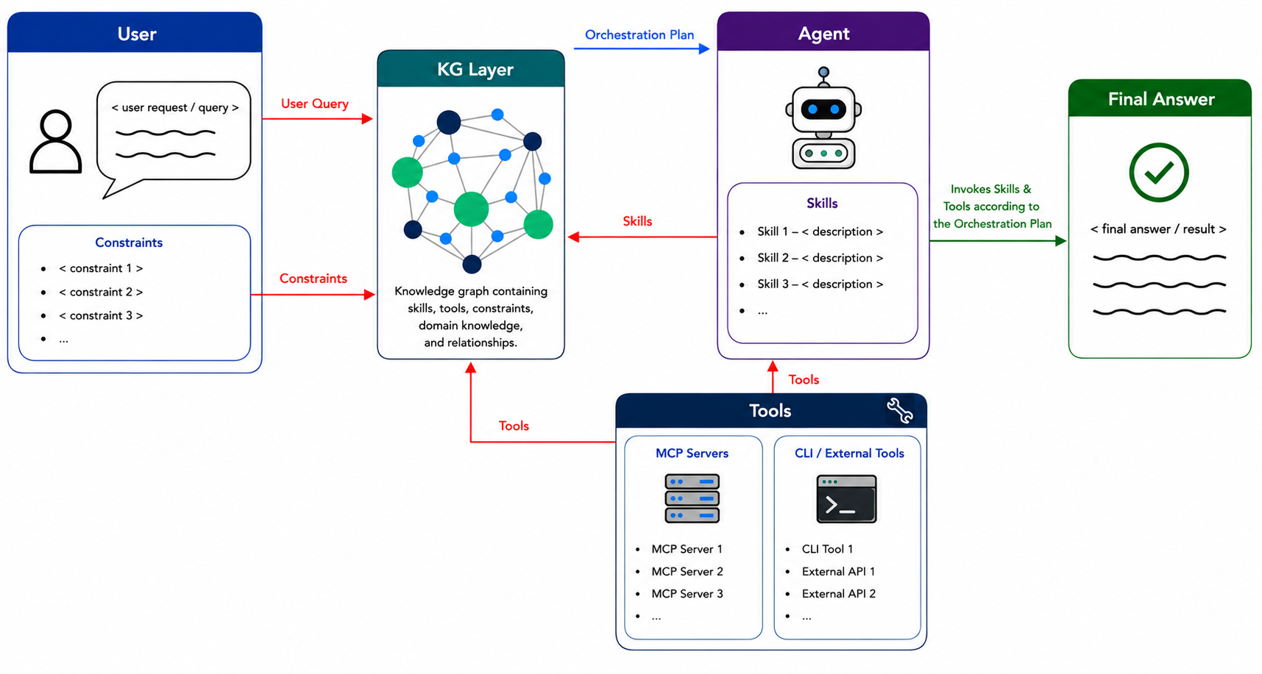
For a specific scope: personalized supplement recommendation

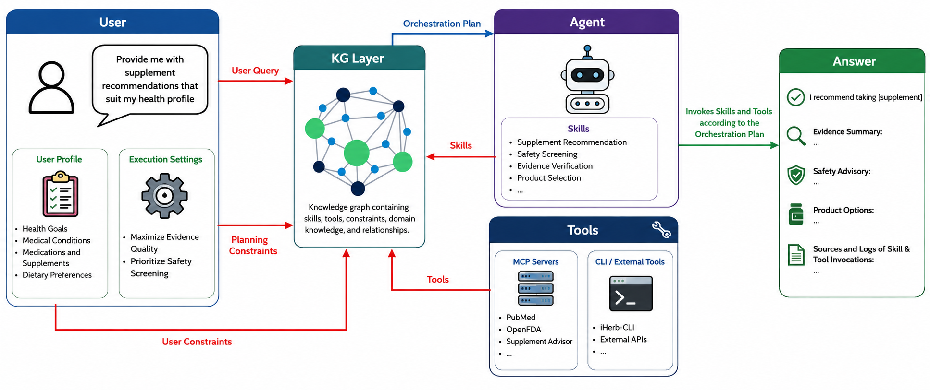

Future work
- Ontology will consider user-aware personalized constraints

