I. Use Case Description
Use Case Name | Reasoning About Action Feasibility from Physical Properties
Use Case Identifier | UC-ActionFeasibility-01
Source | LACAI Lab, Department of Computer Science, Rensselaer Polytechnic Institute
Point of Contact | Hyejin Park, Department of Computer Science, Rensselaer Polytechnic Institute, parkh12@rpi.edu  Xiye Fan, Department of Cognitive Science, Rensselaer Polytechnic Institute, fanx4@rpi.edu  Liangliang Zhang, Department of Computer Science, Rensselaer Polytechnic Institute Zhangl41@rpi.edu  Alex Clark, Department of Electrical, Computer & Systems Engineering, Rensselaer Polytechnic Institute, clarka14@rpi.edu
Creation / Revision Date | September 18, 2026
Associated Documents | Nothing at this stage

II. Use Case Summary
Goal | Develop an extensible ontology that represents how physical properties of objects and object parts, individually or in combination, satisfy or conflict with the physical requirements of actions. Given an object's known physical properties, an ontology-based reasoning system will use the represented property relationships and action requirements to infer and explain action feasibility independently of the object's name or conventional function. The initial course implementation focuses on CUT, providing a foundation for future extensions to additional actions.
Requirements | The ontology should represent Object, ObjectPart, Action, PhysicalProperty, and ActionRequirement, together with the relations connecting them. It should represent relationships among physical properties, including combinations of properties that may jointly satisfy an action requirement and alternative property configurations that may support the same action.  An ontology-based reasoning system should compare the known properties of an object or object part with these represented relationships and requirements to infer whether a specified action is physically feasible under the given conditions. It should also support property-based explanations and the retrieval of alternative objects that satisfy the relevant requirements. The system must distinguish explicitly incompatible properties from insufficient information.  Physical properties are assumed to be known and provided as structured input. The system does not recognize objects, estimate properties from images, or infer properties from object names or conventional functions.
Scope | The broader ontology is intended to represent property–action relationships across different physical actions. For the initial course implementation, the scope is limited to CUT in everyday kitchen contexts, assuming an ordinary human actor and food items commonly found in a kitchen. A carrot is used as one illustrative target in the competency questions; it is not the only intended target.  CUT is treated as a physical action that may be supported by different mechanisms and property configurations, rather than as an action associated exclusively with knives or a single cutting method. The initial ontology will represent a limited set of CUT-relevant properties and requirements, while its structure is intended to accommodate additional mechanisms, actions, and target contexts in future extensions.  The system assumes that physical properties are already known and provided as structured data. Object recognition, visual property estimation, safety, convenience, and social appropriateness are outside the scope of the project.
Priority | High — representing action feasibility from physical properties is central to the intended reasoning task and provides the foundation for later extensions of the ontology.
Stakeholders | Primary stakeholders are researchers in knowledge representation, affordance reasoning, robotics, and embodied AI who study how physical properties support action feasibility. Secondary stakeholders include developers of intelligent systems that require explainable reasoning about non-conventional object use.
Description | The broader ontology is intended to represent property–action relationships across different physical actions. For the initial course implementation, the scope is limited to CUT in everyday kitchen contexts, assuming an ordinary human actor and food items commonly found in a kitchen. A carrot is used as one illustrative target in the competency questions; it is not the only intended target.  CUT is treated as a physical action that may be supported by different mechanisms and property configurations, rather than as an action associated exclusively with knives or a single cutting method. The initial ontology will represent a limited set of CUT-relevant properties and requirements, while its structure is intended to accommodate additional mechanisms, actions, and target contexts in future extensions.  The system assumes that physical properties are already known and provided as structured data. Object recognition, visual property estimation, safety, convenience, and social appropriateness are outside the scope of the project.
Actors / Interfaces | Primary Actor – Researcher:  Submits queries to the ontology-based reasoning system about whether a specific object can support the action Cut, or which available objects could satisfy the physical requirements for cutting. The researcher receives the resulting feasibility judgment, candidate objects, and property-based explanations.  Reference Actor – Ordinary Human Actor:  Represents the assumed physical capabilities of the person who would perform the action. Feasibility judgments are made with respect to whether an ordinary human actor could manipulate the represented object and use its relevant part to perform cutting. This actor does not directly interact with the reasoning system.  System – Ontology-Based Reasoning System:  Uses the ontology to retrieve the requirements associated with Cut, identify relevant object parts and their represented physical properties, and reason about whether those properties satisfy or conflict with the action requirements.  Secondary Actor / Interface – Knowledge Base / Data Sources:  Supplies structured information used to populate or support the ontology, including objects, object parts, physical properties, and evidence used to define or refine cutting requirements.
Pre-conditions | The CUT ontology and its associated knowledge base have been loaded, and the query and reasoning functions are available. The knowledge base contains the represented physical requirements for CUT and structured descriptions of the relevant objects, object parts, and their known physical properties.  Physical properties are supplied as input data; the system does not estimate them. Some information required for a feasibility judgment may be missing, in which case the system returns an insufficient-information result rather than assuming infeasibility.
Post-conditions | The system returns a feasibility judgment for the specified object or a set of candidate objects that satisfy the represented CUT requirements. The result includes a property-based explanation identifying the relevant object parts, known physical properties, and action requirements.  If the available information is insufficient, the system identifies the missing information without classifying the object as infeasible. The query does not modify the underlying knowledge base.
Triggers | The use case is triggered when a researcher submits either (1) a query asking whether a specific object can support Cut under the represented conditions, or (2) a query asking which objects from a provided set of available objects satisfy the represented physical requirements for cutting.
Performance Requirements | No specific runtime performance requirement is imposed for the course prototype. Priority is given to correctness, traceability, and explainability of ontology-based reasoning rather than response speed.
Assumptions | Feasibility judgments assume an ordinary human actor operating in an everyday kitchen environment. The physical properties of objects and object parts are assumed to be known and provided as structured input. The ontology does not recognize objects or estimate their physical properties from images or object names. Feasibility is evaluated under the specified target and context conditions.
Open Issues | The main open issue is how to formally represent relationships among physical properties and between those properties and action requirements. This includes determining how combinations of properties satisfy or conflict with the requirements for CUT, which existing ontology relations can be reused, and which project-specific relations need to be introduced. Another issue is how to distinguish explicit physical incompatibility from insufficient information without assuming that missing properties indicate infeasibility.  A further issue is how to represent alternative property configurations and combinations of requirements without treating provisional relationships as universally necessary or sufficient conditions for CUT.

III. Usage Scenarios

Scenario 1— Feasibility Verification and Explanation
A researcher studying physical affordance reasoning wants to evaluate whether an ontology-based system can infer action feasibility from known physical properties and their relationships to action requirements. The researcher is interested in whether this approach can account for unconventional objects and different ways of performing an action without relying on conventional object–function associations.
For an initial CUT evaluation, the researcher selects a kitchen scenario involving a rigid plastic card and a carrot. The relevant object-part properties and target conditions are already represented as structured data. The researcher does not provide the feasibility conclusion as part of the query. Instead, the system compares the known properties with the represented requirements for the applicable cutting configuration and derives a feasible, infeasible, or insufficient-information judgment. It returns an explanation identifying the property relationships that support the result.
Scenario 2 — Goal-Driven Alternative Object Discovery Under Constraints
A researcher investigating unconventional object use wants to examine whether an ontology-based system can identify alternative objects for a specified action. The research question is whether objects can be retrieved based on physical compatibility rather than their conventional categories or functions.
For an initial CUT scenario, the researcher considers a kitchen situation in which the conventional cutting tool is unavailable. A predefined set of available objects includes a rigid plastic card, a rolling pin, and a kitchen sponge. Their relevant parts and physical properties are already represented in the knowledge base. The researcher asks which of these objects satisfy the modeled requirements for cutting a carrot under the specified conditions.
The system compares the available objects' known properties with the applicable CUT requirements, identifies candidates supported by the represented relationships, and explains any explicit incompatibilities or missing information. The scenario illustrates how the same property-based reasoning approach could eventually support alternative object discovery for additional actions.
Scenario 3 — Comparing Alternative Physical Configurations for the Same Action
A researcher studying physical affordance reasoning wants to investigate whether different combinations of physical properties can support the same action. Rather than assuming that CUT requires one fixed set of properties, the researcher examines how different object parts and their property configurations may satisfy the action's physical requirements.
For an initial kitchen evaluation, the researcher compares two cutting configurations: a knife with a single cutting edge and a pair of scissors with two interacting blades. Their relevant parts, known physical properties, and operating conditions are provided as structured data. The researcher queries the system to determine whether each configuration satisfies its applicable requirements for CUT and which property–requirement relationships support the results.
The system evaluates each configuration against the requirements represented in the ontology and returns the supported feasibility judgments with property-based explanations. This scenario demonstrates how different physical configurations could be represented within the same action ontology without treating any single cutting mechanism as the universal definition of CUT.

IV. Basic Flow of Events

Basic Flow Narrative — Scenario 1: Feasibility Verification and Explanation
The researcher submits a query about whether a specified object can support CUT under given target and context conditions. The object's relevant parts and physical properties are already represented in the knowledge base. The reasoning system retrieves the applicable CUT requirements and the represented relationships among physical properties. It then determines whether the known properties satisfy a supported configuration of requirements or explicitly conflict with the relevant conditions. The system returns a feasibility judgment together with an explanation of the property relationships used in the inference. The query does not modify the knowledge base.

Basic / Normal Flow of Events
Step | Actor (Person) | Actor (System) | Description
1 | Researcher |  | Submits a query asking whether a rigid plastic card can cut a carrot under the specified conditions.
2 |  | Ontology-Based Reasoning System | Retrieves the applicable physical requirements and represented property relationships for CUT under the specified conditions.
3 |  | Ontology-Based Reasoning System | Retrieves the relevant ObjectParts and their known PhysicalProperties from the knowledge base.
4 |  | Ontology-Based Reasoning System | Evaluates the known properties against the represented requirements, including applicable property combinations and alternative configurations.
5 |  | Ontology-Based Reasoning System | Derives a feasible or explicitly infeasible judgment when the represented knowledge supports one. Otherwise, follows the insufficient-information alternate flow.
6 |  | Ontology-Based Reasoning System | Generates an explanation identifying the property–requirement relationships supporting the judgment and returns the result to the researcher.
7 | Researcher |  | Receives the judgment and explanation.

V. Alternate Flow of Events
Alternate Flow Narrative — Insufficient Property Information
This alternate flow begins during Step 5 of the Basic Flow when the reasoning system determines that one or more physical properties required to evaluate a cutting requirement are not represented for the relevant object part. Missing information is not treated as evidence that the object is infeasible. For a feasibility-verification query, the system returns an insufficient-information result and identifies the missing property information. For an alternative-object search query, the affected object is marked as unresolved rather than excluded as infeasible, and the system continues evaluating the remaining candidate objects. If the researcher later provides sufficient additional information, the system updates or retrieves the relevant property information and resumes the Basic Flow.

Alternate Flow of Events
Step | Actor (Person) | Actor (System) | Description
A1 |  | Ontology-Based Reasoning System | During Basic Flow Step 5, detects that one or more physical properties needed to evaluate a represented cutting requirement are missing for the relevant object part.
A2 |  | Ontology-Based Reasoning System | Identifies the missing property information and does not interpret the absence of that information as evidence of infeasibility.
A3 |  | Ontology-Based Reasoning System | For a feasibility-verification query, returns an insufficient-information result and identifies which property information is required to complete the judgment.
A4 |  | Ontology-Based Reasoning System | For an alternative-object search query, marks the affected candidate as unresolved and continues evaluating the remaining available objects.
A5 | Researcher |  | May provide additional property information, choose another object for evaluation, or end the query.
A6 |  | Ontology-Based Reasoning System | If sufficient new information becomes available, updates or retrieves the relevant property representation and resumes the Basic Flow at Step 4, followed by reevaluation at Step 5.

VI. Use Case and Activity Diagram(s)

The following diagrams illustrate the actors, system components, and reasoning activities involved in the two usage scenarios. The use case diagram summarizes the primary interactions with the ontology-based reasoning system, while the architecture diagram shows where the ontology is used within the overall system. Two activity diagrams then show the detailed flows for (1) feasibility verification and explanation and (2) goal-driven alternative object discovery.

Diagram 1 — High-Level Architecture / Overview
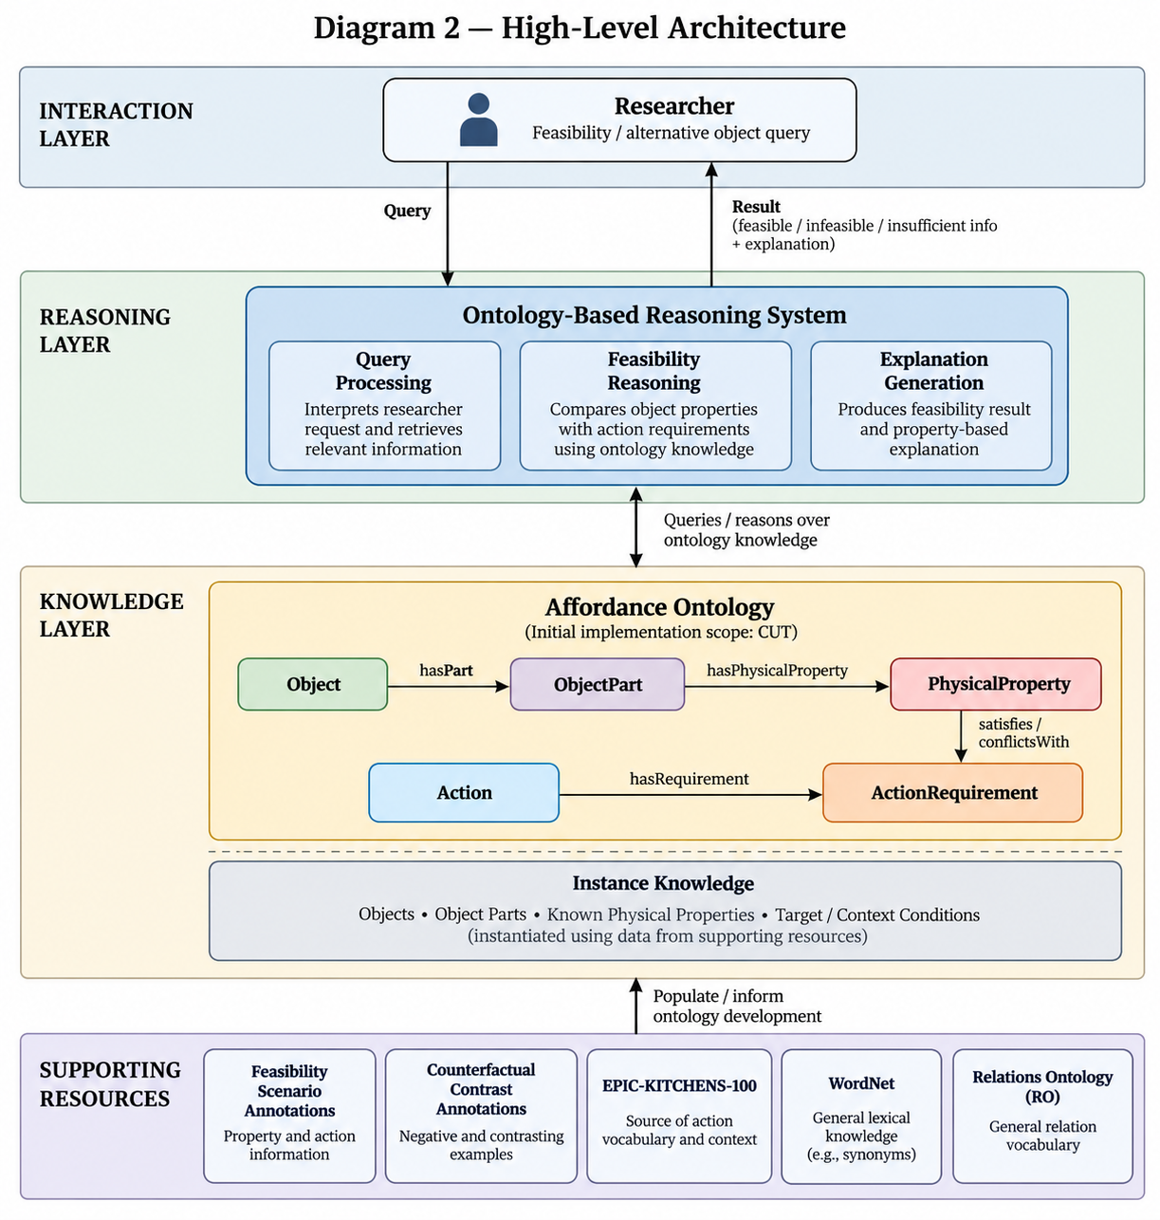

Diagram 2 — Activity Diagram: Scenario 1
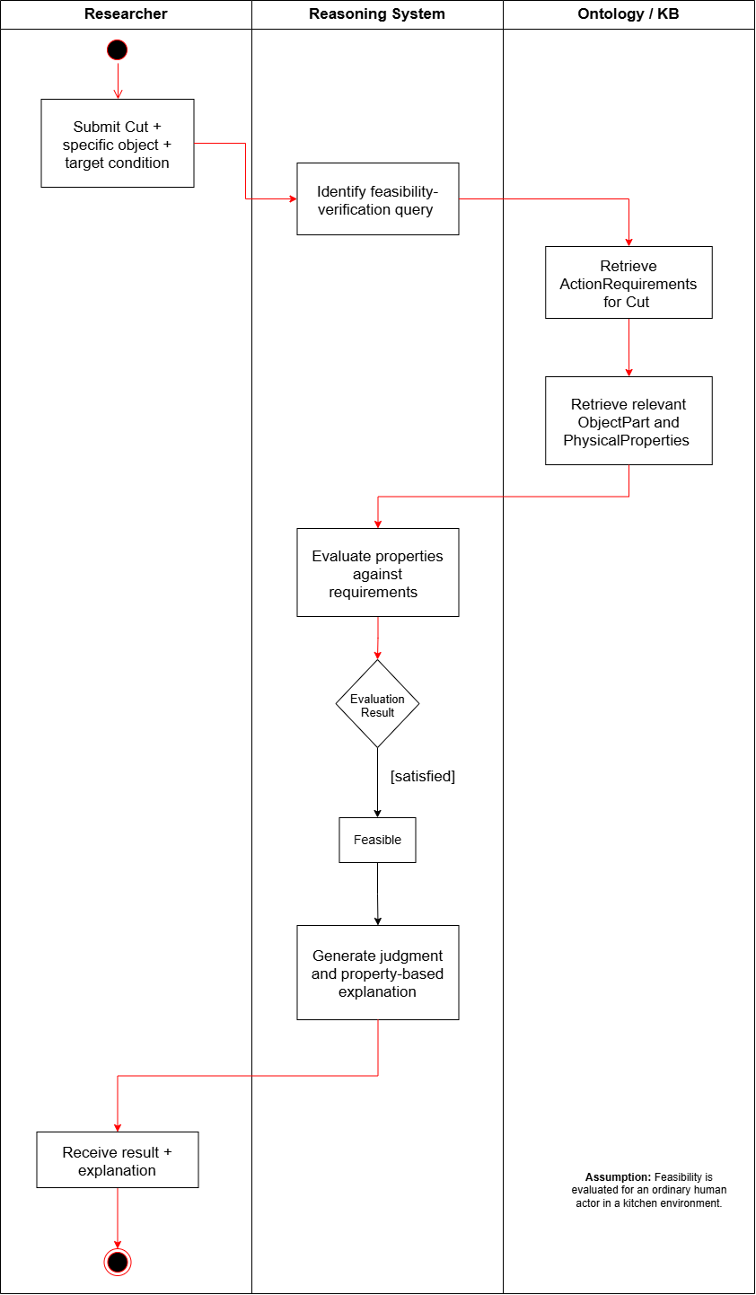

Diagram 3 — Activity Diagram: Scenario 2
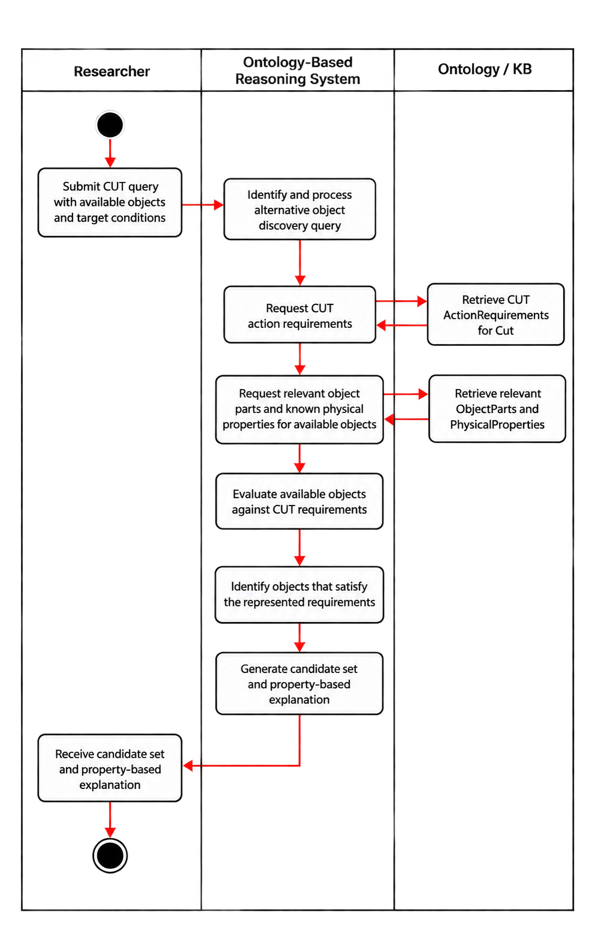

VII. Competency Questions

Resource Note: The competency questions use the CUT-specific Derived Feasibility Scenario Annotations and, where relevant, the Derived Counterfactual Contrast Annotations described in Section VIII. These resources provide structured examples of objects, object parts, physical properties, target contexts, and feasibility outcomes. EPIC-KITCHENS-100 informs the kitchen-domain action vocabulary but does not directly provide the physical-property relationships used in feasibility reasoning. The property configurations described below are illustrative, context-specific modeling candidates for the initial CUT ontology. They will be refined using the available annotations and should not be interpreted as a complete or universally sufficient definition of CUT.

Scenario 1 — Feasibility Verification and Explanation
CQ1.1 — Can a rigid plastic card be used by an ordinary human actor to cut a carrot, and why?

Example Answer: Yes, under the represented conditions. The card's edge is sufficiently thin and rigid to satisfy the modeled requirements for cutting the carrot.
Ontology Approach: The knowledge base contains a rigid plastic card as an Object, its edge as an ObjectPart, and the edge's known PhysicalProperties, including thin edge geometry and sufficient rigidity. It also contains the ActionRequirements represented for CUT under the specified carrot-cutting conditions. These include an edge geometry suitable for initiating a cut and sufficient rigidity to maintain the edge under applied force. The reasoning system determines that the card edge satisfies the modeled requirements for this cutting configuration and classifies the situation as feasible under the represented conditions. Its explanation identifies the card's edge and the specific property–requirement relationships supporting the judgment.
CQ1.2 — Can a typical kitchen sponge be used to cut a carrot, and why or why not?
Example Answer: No, under the represented conditions. The sponge's deformable contact edge does not provide the rigidity required to cut the carrot.
Ontology Approach: The knowledge base represents the kitchen sponge and its candidate contact edge, including the known properties of low rigidity and deformability. The CUT requirements for the specified carrot-cutting conditions include sufficient rigidity to maintain an effective cutting edge under applied force. The sponge's represented properties explicitly conflict with this requirement. The reasoning system therefore classifies the cutting situation as infeasible and explains that the sponge's contact edge does not meet the modeled rigidity requirement.

Scenario 2 — Goal-Driven Alternative Object Discovery Under Constraints
CQ2.1 — If a conventional cutting tool is unavailable, which of the following available objects could satisfy the represented physical requirements for cutting a carrot: a rigid plastic card, a rolling pin, or a kitchen sponge?
Example Answer: Under the represented conditions, the rigid plastic card is returned as a candidate because its edge satisfies the modeled geometry and rigidity requirements. The rolling pin and kitchen sponge are excluded because their represented properties conflict with different cutting requirements.
Ontology Approach: The researcher provides a known set of available Objects: a rigid plastic card, a rolling pin, and a kitchen sponge. The knowledge base already contains their relevant ObjectParts and known PhysicalProperties. The reasoning system retrieves the ActionRequirements for CUT under the specified carrot-cutting conditions and evaluates the candidates against them. The card's thin, rigid edge satisfies the modeled requirements. The rolling pin lacks an appropriately shaped cutting edge, while the sponge's deformable contact edge does not meet the rigidity requirement. Under the modeled conditions for this cutting scenario, the system returns the card as a candidate, excludes the two objects with explicitly incompatible properties, and provides a property-based explanation for each judgment.
CQ2.2 — Why can a rigid plastic card be returned as a candidate for cutting a carrot while a kitchen sponge is excluded?
Example Answer: The card's edge satisfies the represented edge-geometry and rigidity requirements, whereas the sponge's deformable contact edge fails to meet the rigidity requirement for cutting the carrot.
Ontology Approach: The reasoning system compares the known properties of the card's edge and the sponge's candidate contact edge against the same ActionRequirements for CUT. The card's represented edge geometry and rigidity satisfy the modeled requirements, while the sponge's low rigidity conflicts with the requirement to maintain an effective cutting edge under applied force. The system traces these different property–requirement relationships to explain why the card is returned as a candidate and the sponge is excluded.

Scenario 3 — Comparing Alternative Physical Configurations for the Same Action
CQ3.1 — Can a knife and a pair of scissors both support CUT under their respective operating conditions, despite having different physical configurations?
Example Answer: Yes, under the modeled conditions, both configurations may support CUT. A knife can use a single cutting edge with sufficient structural support, while scissors can use two interacting blades to apply opposing cutting forces. Their relevant parts and property configurations differ, but each may satisfy the requirements represented for its cutting mechanism.
Ontology Approach: The knowledge base contains structured descriptions of the knife's cutting edge and the scissors' two blades, including their known physical properties and relationships. The ontology represents the applicable CUT requirements for each configuration, including the relevant edge geometry, structural support, and interaction between parts. The reasoning system evaluates whether each configuration satisfies its modeled requirements and derives the corresponding feasibility judgments. It then explains which property–requirement relationships support CUT in each case, without relying on the objects' conventional names or functions.

VIII. Resources

Data Availability
EPIC-KITCHENS-100 is publicly available and provides the source kitchen-domain action vocabulary from which Cut was selected for the initial ontology scope. However, EPIC-KITCHENS does not directly provide the physical properties, object-part descriptions, or action-requirement relations needed for the proposed feasibility reasoning. These are supplied by a small curated subset of feasibility and counterfactual annotations generated as part of ongoing affordance-reasoning research. For the course project, only data relevant to Cut and the competency questions defined in Section VII will be used.

Knowledge Bases, Repositories, or other Data Sources
Data | Type | Characteristics | Description | Owner | Source | Access Policies & Usage
EPIC-KITCHENS-100 | Remote dataset / repository | Egocentric kitchen videos with annotated manipulation actions and object interactions | Provides the source kitchen-domain action vocabulary and human-object interaction context from which Cut is selected for the initial ontology scope. It does not directly provide the physical-property or action-requirement knowledge used for feasibility reasoning. | EPIC-KITCHENS / University of Bristol and collaborators | EPIC-KITCHENS dataset website / annotation repository  Link (full dataset): https://epic-kitchens.github.io/  Link (annotation dataset): https://github.com/epic-kitchens/epic-kitchens-100-annotations | CC BY-NC 4.0. Non-commercial use is permitted with appropriate attribution, a link to the license, and an indication of any changes. The dataset is used to establish the source action vocabulary and is not queried directly during ontology reasoning.  License: https://github.com/epic-kitchens/epic-kitchens-100-annotations/blob/master/license.txt
Derived Feasibility Scenario Annotations | Local / experimentally generated dataset | A curated set of feasible and infeasible examples for the action Cut, including the relevant object, object part, physical properties, target context, and feasibility outcome. The resource provides instance-level evidence used to populate and test the course ontology and to support the competency questions in Section VII. | Provides the instance-level evidence used to populate the course ontology with examples of objects, object parts, relevant physical properties, and feasible or infeasible outcomes. Only the Cut-specific subset will be used for this course project. | Hyejin Park / LACAI Lab | nternal project resource; no public URL available at this stage. | Internal research resource; not publicly available. A curated CUT-specific subset will be shared with the course team for ontology development and evaluation. Redistribution outside the project is not authorized at this stage. No public license has been assigned.
Derived Counterfactual Contrast Annotations | Local / experimentally generated dataset | Paired examples in which changes to an object property or relevant part are associated with changes in action feasibility | Paired or contrastive examples in which a change to a relevant object part or physical property is associated with a change in cutting feasibility. The resource is used as supporting evidence when identifying or refining which properties are relevant to the ActionRequirements for Cut | Hyejin Park / LACAI Lab | Generated through ongoing affordance-reasoning experiments | Internal research resource; not publicly available. A limited CUT-specific subset may be shared with the course team as supporting evidence for identifying and refining property–requirement relationships. No public license has been assigned. Any further sharing is subject to the research project's data-use policy.

External Ontologies, Vocabularies, or other Model Services
Resource | Language | Description | Owner | Source | Describes/Uses | Access Policies & Usage
WordNet | English | Supports terminology normalization and sense distinction for action and object terms used in the ontology. It is not used to determine physical feasibility. | Princeton University | Princeton WordNet  Link: https://wordnet.princeton.edu/ | Action and object terminology derived from EPIC-KITCHENS and the experimental annotations | Princeton WordNet License. Use, modification, and distribution are permitted without a fee, subject to retaining the required copyright notice and license statements. Used as an optional terminology resource, not for determining physical feasibility.  License: https://wordnet.princeton.edu/license-and-commercial-use
Relations Ontology (RO) | OWL / OBO | Provides standardized relation types intended for reuse across ontologies. It will be reviewed to determine whether general relations needed in this project, such as part-whole relations, can reuse existing semantics before new project-specific relations are introduced. | OBO Relations Ontology community / OBO Foundry | Official Website Link: https://obofoundry.org/ontology/ro.html | Relations among ontology entities, particularly reusable general-purpose relations such as part-whole relations. | CC0 1.0 Universal (Public Domain Dedication). RO is available for reuse and adaptation. The original ontology and term identifiers should be retained when reusing existing relations, and the source should be cited. Used as an optional reference for relation reuse and ontology-design decisions.  License: https://github.com/oborel/obo-relations/blob/master/LICENSE.txt

Other Resources, Service, or Triggers (e.g., event notification services, application services, etc.)
Resource | Type | Description | Owner | Source | Access Policies & Usage
(sensor or external service name) |  | Include a description of the resource as well as availability, if applicable | Primary owner of the service | Application or service URL; if subscription based, include subscription and any subscription owner

IX. References and Bibliography

- EPIC-KITCHENS-100. Egocentric kitchen video dataset and action annotation repository. https://epic-kitchens.github.io/
- EPIC-KITCHENS-100 Annotations. https://github.com/epic-kitchens/epic-kitchens-100-annotations
- Princeton WordNet. Princeton University. https://wordnet.princeton.edu/
- Relations Ontology (RO). OBO Foundry. https://obofoundry.org/ontology/ro.html
- Object Management Group (OMG). Unified Modeling Language (UML), Version 2.5.1. https://www.omg.org/spec/UML/2.5.1/
- Chemero, A. (2003), An Outline of a Theory of Affordances
- Jiang, Y., Yang, M., Li, Z., & Pujara, J. (2026). AFFORDANCE20Q: Evaluating Affordance Reasoning from Physical Properties. arXiv:2606.14240v2.
- Wang et al., Affordance-R1 (2026), p. 1, Introduction; p. 2, §2.1; Xie et al., RelationLMM (2025), p. 3515, Introduction; p. 3519, §IV-A/Table II
- Xie et al., RelationLMM (2025), p. 3515, Introduction; p. 3519, §IV-A
- "B. Barati and E. Karana, ""Affordances as Materials Potential: What Design Can Do for Materials Development,"" International Journal of Design, vol. 13, no. 3, pp. 105–123, 2019.
- M. Qu et al., ""RIO: A Benchmark for Reasoning Intention-Oriented Objects in Open Environments,"" in Advances in Neural Information Processing Systems (NeurIPS), Datasets and Benchmarks Track, 2023.
- Z. Wang, Y. Zhong, J. Fu, H. I. Christensen, and J. Gao, ""AFUN: Towards an Affordance Foundation Model for Functionality Understanding,"" arXiv:2606.02551, 2026. https://arxiv.org/abs/2606.02551"
- J. Mccusker et al., ‘ARCLIGHT: Automated Clustering and Curriculum Learning Guided by Human Training’. Accessed: Sep. 22, 2026. [Online]. Available: https://dspace.rpi.edu/server/api/core/bitstreams/793857db-ca6a-46a6-af17-045c00505de2/content
- "A. Myers, C. L. Teo, C. Fermüller and Y. Aloimonos, ""Affordance detection of tool parts from geometric features,"" 2015 IEEE International Conference on Robotics and Automation (ICRA), Seattle, WA, USA, 2015, pp. 1374-1381, doi: 10.1109/ICRA.2015.7139369.

X. Notes

There is always some piece of information that is required that has no other place to go. This is the place for that information.

