Revision from Assignment 5
The conceptual model was substantially revised after Assignment 5 to reflect instructor and mentor feedback and to align the diagrams with the ontology implemented in Protégé. In particular, the model now uses PhysicalFeature rather than PhysicalProperty, distinguishes feature types from their represented values through FeatureValue and FeatureLevel, and introduces Assessment as the context connecting a candidate, target, and action. RequirementMapping was also introduced to represent how target conditions determine required feature levels for CUT. Concepts that were no longer necessary for the current scope, such as ObjectRegion, were removed, and relevant part structure is represented using ObjectPart, hasPart, and interactsWith. The revised diagrams therefore describe the implemented ontology rather than the earlier preliminary conceptual structure.
How to Read the Diagrams
The conceptual model is divided into two complementary views. Diagram 1 shows class inheritance. In these UML-style hierarchy diagrams, the open triangular arrowhead points from a subclass toward its superclass. For readability, the larger PhysicalFeature and ActionRequirement hierarchies are divided into multiple panels; repeated top-level classes indicate that the panels are continuations of the same hierarchy rather than separate models.
Diagram 2 shows object-property relationships rather than subclass relationships. In this diagram, a directed arrow points from the domain class toward the range class, and the label on the arrow identifies the object property connecting them. The two diagrams should therefore be read together: Diagram 1 shows what kinds of entities exist and how they are classified, while Diagram 2 shows how instances of those classes can be semantically connected.

Diagram 1 — Class Hierarchy
Diagram 1 presents the main class hierarchies of the CUT affordance ontology. PhysicalEntity distinguishes whole objects from their parts through WholeObject and ObjectPart. PhysicalFeature organizes the physical characteristics used to describe candidates and targets, while ActionRequirement organizes the corresponding conditions relevant to CUT feasibility. FeasibilityJudgment represents the possible outcome categories of an assessment.
The feature and requirement hierarchies are intentionally parallel in several areas, including geometric, mechanical, structural, surface, and material characteristics. These hierarchies provide the vocabulary needed to describe the physical information used in the three competency questions. For readability, the larger PhysicalFeature and ActionRequirement hierarchies are divided across multiple panels while preserving the same superclass/subclass structure.
Diagram 1 — Class Hierarch
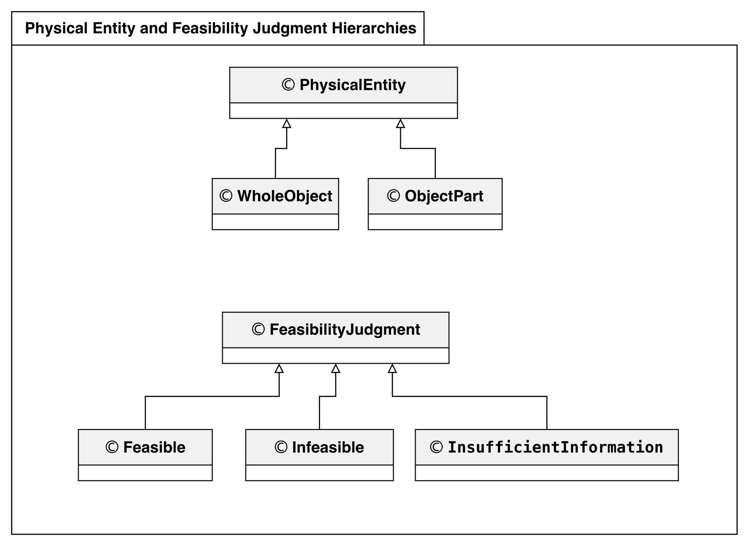

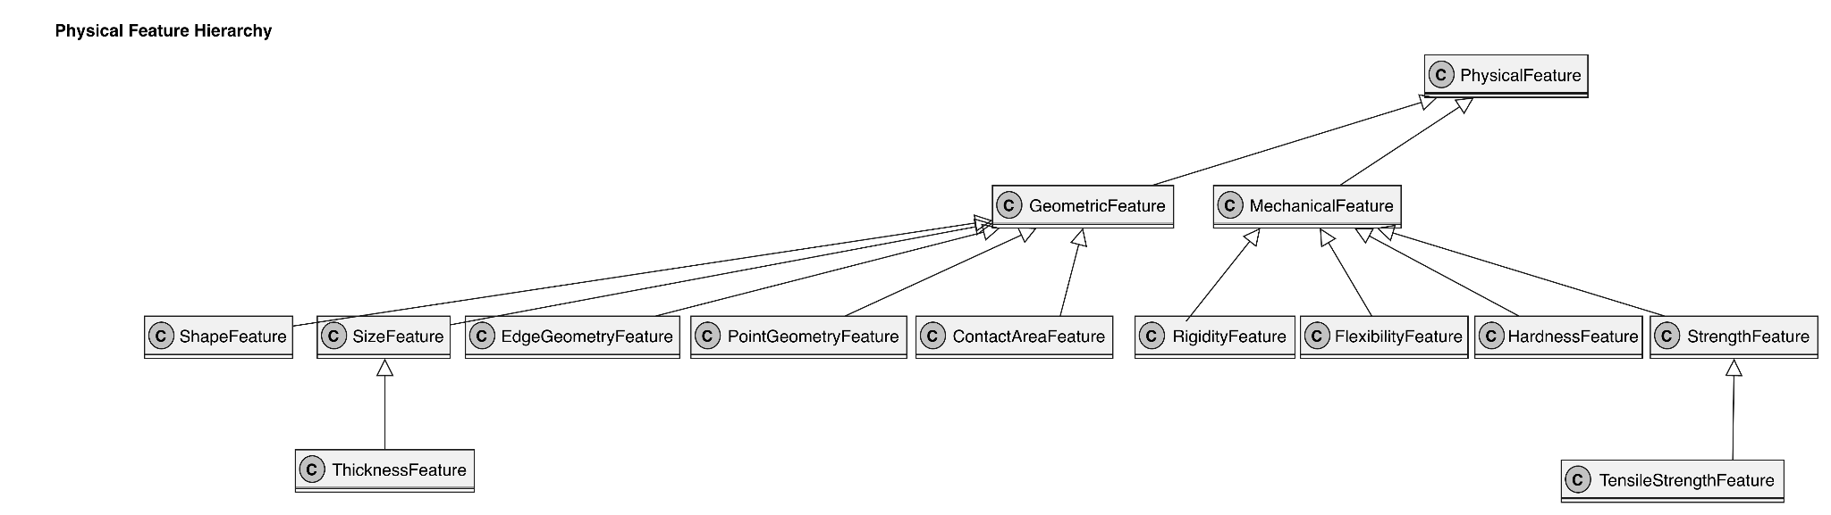
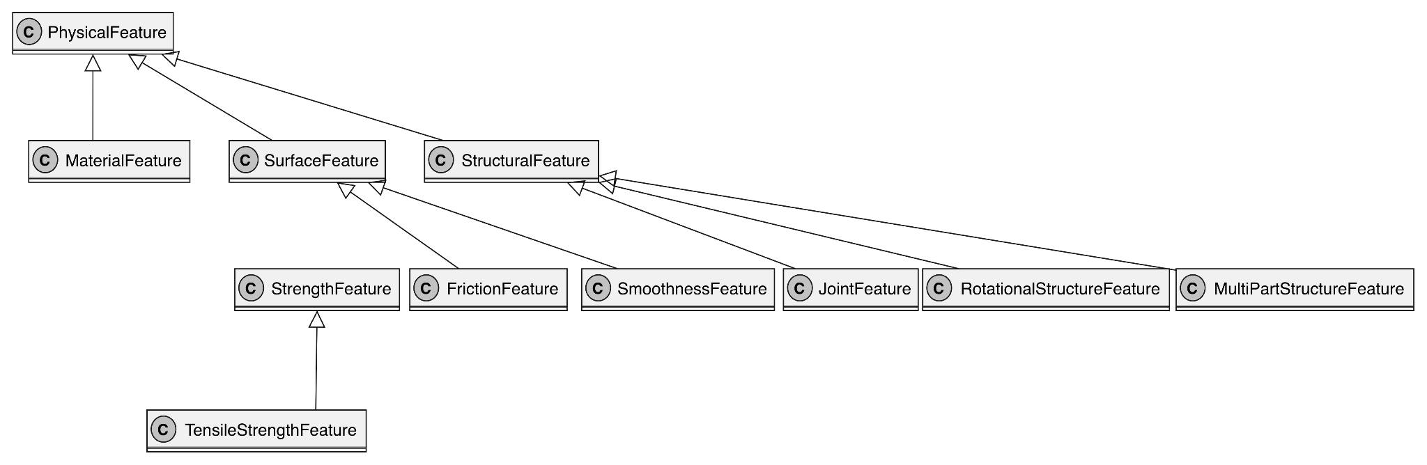

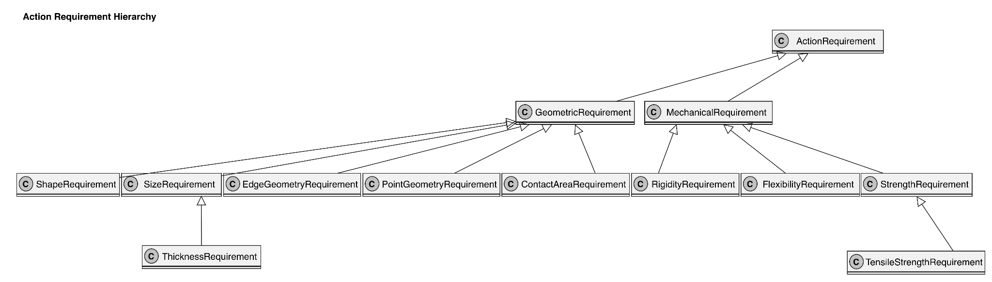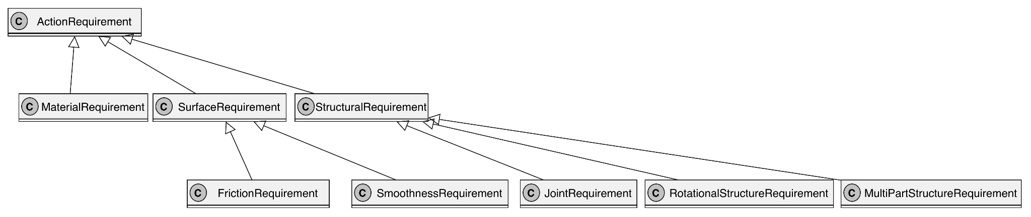
Diagram 2 — Object property Relationships
Diagram 2 shows how the major ontology classes are connected through object properties. An Assessment provides the evaluation context by linking a candidate, target, and action. A PhysicalEntity is associated with FeatureValue instances, which connect a PhysicalFeature to a categorical FeatureLevel. An Action is associated with its ActionRequirement instances, and each requirement identifies the feature it concerns. RequirementMapping represents how a target feature condition can determine the feature level required for a particular action requirement. Part-based configurations are represented through hasPart and interactsWith.
These relationships provide the structural basis for the three competency questions. CQ1 uses them to represent and evaluate one candidate-target CUT configuration. CQ2 reuses the same structure across multiple candidates for comparison. CQ3 additionally uses ObjectPart, hasPart, and interactsWith to represent differences in part structure, such as the relationship between the two blades of scissors.
Cardinality constraints in Diagram 2 reflect the OWL restrictions implemented in Protégé. The whole object properties `satisfiesRequirement` and `conflictsWithRequirement` are disjoint, meaning that the same assessment cannot both satisfy and conflict with the same requirement. No datatype properties are currently used; physical feature types and categorical levels are represented as individuals connected through object properties.

Diagram 2 — whole object propertiy Relationships
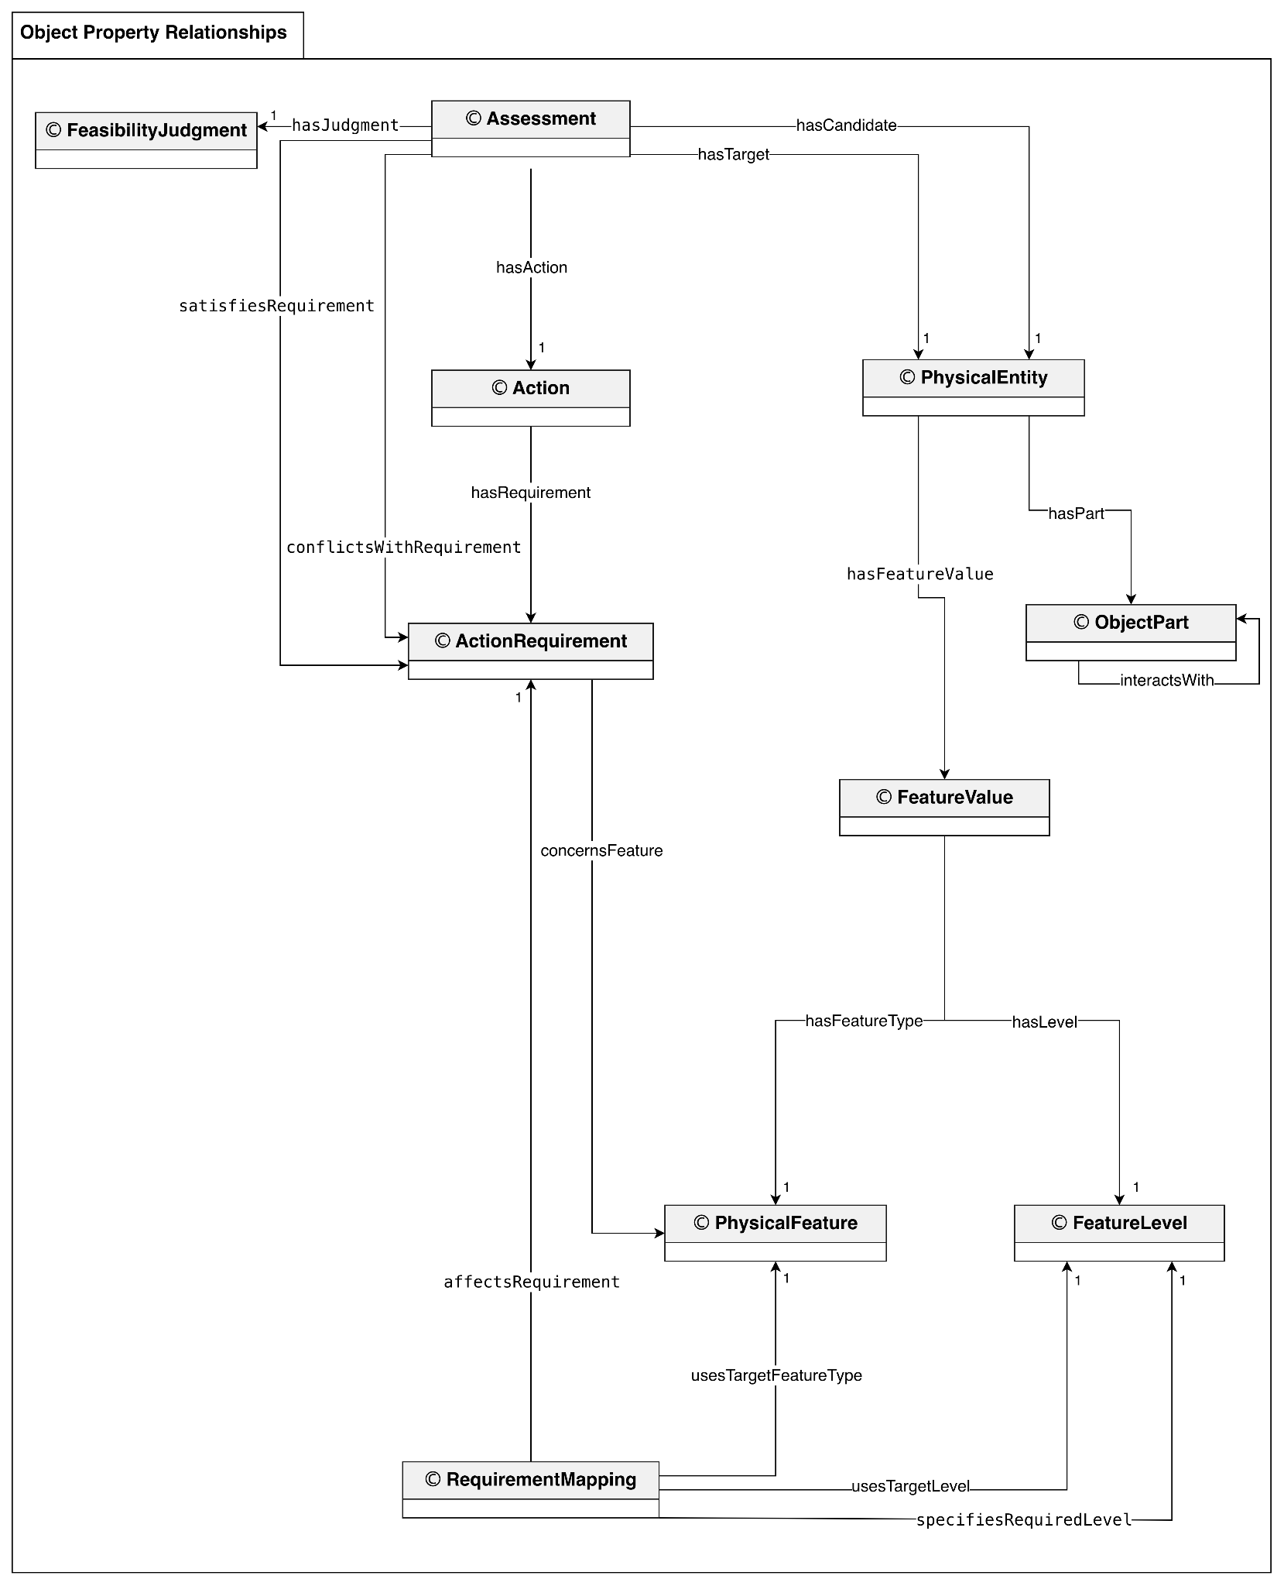
*Note: WholeObject is a subclass of PhysicalEntity. Candidate and target individuals are represented as WholeObject instances; object parts are represented as ObjectPart instances when applicable. Multiplicity 1 indicates exactly one related instance of the specified class, consistent with the OWL cardinality restrictions.

