I. Use Case Description
Use Case Name | Reasoning About Action Feasibility from Physical Properties
Use Case Identifier | UC-ActionFeasibility-01
Source | LACAI Lab, Department of Computer Science, Rensselaer Polytechnic Institute
Point of Contact | Hyejin Park, Department of Computer Science, Rensselaer Polytechnic Institute, parkh12@rpi.edu  Xiye Fan, Department of Cognitive Science, Rensselaer Polytechnic Institute, fanx4@rpi.edu  Liangliang Zhang, Department of Computer Science, Rensselaer Polytechnic Institute Zhangl41@rpi.edu  Alex Clark, Department of Electrical, Computer & Systems Engineering, Rensselaer Polytechnic Institute, clarka14@rpi.edu
Creation / Revision Date | September 18, 2026
Associated Documents | Nothing at this stage

II. Use Case Summary
Goal | Develop an extensible ontology that supports machine-interpretable and explainable reasoning about physical action feasibility. The ontology represents how physical features of objects and object parts, together with relevant structural relationships and target conditions, relate to the physical requirements of actions. This representation is intended to support affordance reasoning in situations where object category or conventional function alone is not sufficient to determine what actions are physically possible. The current implementation focuses on the physical action CUT in everyday kitchen contexts.
Requirements | The ontology should represent physical entities, object parts, physical features and feature values, actions, action requirements, assessment contexts, and the semantic relationships that connect them. It should support representations in which a candidate, target, and action are evaluated together, including cases where target conditions affect the requirements applied to a candidate.  Feasibility judgments should be grounded in explicitly represented physical information, including candidate and target features, relevant object parts and part relationships, and their relationships to action requirements. Object category, lexical name, or conventional function should not by itself determine feasibility. Named object individuals may be used internally as stable references for organizing candidate and target descriptions and for connecting their features, parts, and assessment roles. These identifiers are representational conveniences rather than evidence for feasibility reasoning.  Physical features are assumed to be available as structured information. The ontology is not responsible for object recognition or for estimating physical features from images or object names. The reasoning system should also distinguish explicit incompatibility from insufficient information and support explanations that identify the physical evidence relevant to a judgment.
Scope | CUT is treated as a physical action that can be supported by different combinations of physical features, relevant object parts, part relationships, and target conditions, rather than as an action associated exclusively with a particular object category or cutting method. The ontology represents candidate and target physical features, object-part structure, action requirements, and requirement mappings that describe how relevant physical conditions relate to CUT feasibility. The current implementation is situated in everyday kitchen contexts and assumes the physical capabilities of an ordinary human actor. Physical features are treated as structured information available to the reasoning system rather than information that must be estimated by the ontology itself. Object recognition, visual feature estimation, safety, convenience, and social appropriateness are outside the intended reasoning task. The modeling approach is designed so that it can later be extended to additional actions, physical features, and interaction contexts.
Priority | High — representing action feasibility from physical properties is central to the intended reasoning task and provides the foundation for later extensions of the ontology.
Stakeholders | Primary stakeholders include researchers in knowledge representation, affordance reasoning, robotics, and embodied AI who study how physical characteristics and object structure support action feasibility. Secondary stakeholders include developers of intelligent systems that require explainable reasoning about unfamiliar, modified, or non-conventional object use.
Description | The ontology is intended to support affordance reasoning based on represented physical evidence rather than conventional object–function associations. This is particularly relevant to intelligent systems that may encounter unfamiliar objects, non-conventional tool use, or different physical realizations of the same action.  CUT in an everyday kitchen context is used as the initial domain for developing and evaluating this representation. The examples used in the scenarios are intentionally simple and interpretable so that the reasoning process can be examined clearly. Their purpose is not to provide obvious advice to a human user, but to evaluate whether the system reaches and explains a feasibility judgment using the intended physical evidence.  Candidates and targets may be represented internally as named ontology individuals so that their features, parts, structural relationships, and assessment roles can be explicitly connected. However, their lexical names, object categories, and conventional functions are not treated as feasibility evidence. Reasoning is instead grounded in explicitly represented candidate and target features, relevant part structure and relationships, and their relationships to the requirements for CUT.  This is being developed also because embodied AI systems, such as household robots and robot task planners driven by large language models, usually decide what an object can be used for from its category label (for example, “knife → cut”). This approach breaks down when the conventional tool is unavailable, when an object is unfamiliar or modified, or when the system must justify its choice. A person makes these judgments intuitively, but an automated agent cannot do so reliably, and current models cannot show which physical evidence their answers depend on [7], [8], [12]. The ontology addresses this by providing an explicit, machine-readable link between the physical features of objects and object parts, the conditions of the target, and the requirements of an action. With it, an automated agent can (1) check whether a candidate object can physically perform an action, (2) select a substitute when the usual tool is missing, and (3) give an explanation that a developer can inspect and verify. In the longer term, the ontology is intended as a reusable knowledge component for robot task planning, for grounding and checking the affordance claims of language models, and for benchmarking affordance reasoning. CUT is the first action modeled.  Why it is being developed. Robots and AI agents, such as household robots or task planners built on large language models, usually decide what an object can do from its name or category (for example, “knife → cut”). This fails when the usual tool is missing or the object is unfamiliar, and these systems cannot explain which physical evidence their decision is based on [7], [8], [12]. A person rarely needs help with these judgments; the ontology is intended for automated agents that cannot make them reliably on their own.  What problem it solves. The ontology gives such systems an explicit, machine-readable link between the physical features of objects and object parts, the condition of the target, and the requirements of an action. With it, a system can check whether an object can physically perform an action, choose a substitute when the usual tool is unavailable, and give an explanation that a developer can verify.  Future use. The ontology is intended as a reusable knowledge component for robot task planning, for checking the affordance claims made by language models, and for benchmarking affordance reasoning. CUT is the first action modeled; further actions can be added using the same structure.
Actors / Interfaces | Primary Actor – Researcher:  Uses the ontology-based reasoning system to investigate and evaluate physical action feasibility. The researcher may submit or query structured descriptions of one or more candidates and a target, including relevant physical features, object-part information, and part relationships. Human-readable object labels may be included for clarity, but feasibility reasoning is based on the represented physical information rather than object category or conventional function. The researcher receives feasibility judgments and property-based explanations.  Reference Benchmark – Ordinary Human Actor  Represents the assumed physical capabilities against which feasibility is evaluated. The ordinary human actor does not interact directly with the reasoning system and is not the system user.  System – Ontology-Based Reasoning System:  Uses the ontology to retrieve the requirements associated with CUT, access the represented physical features and part structure of candidates and targets, identify relevant requirement mappings, and evaluate how the represented information satisfies or conflicts with the applicable action requirements.  Secondary Actor / Interface – Knowledge Base / Data Sources:  Supplies structured physical-feature descriptions, object-part structure, part relationships, target conditions, and other represented information used to populate and refine the ontology.
Pre-conditions | The ontology and its associated knowledge base have been loaded, and the query and reasoning functions are available. The knowledge base contains the represented requirements for CUT, relevant requirement mappings, and the structured candidate and target information needed for the assessment. Physical features and part information are assumed to be supplied or already represented rather than estimated by the ontology.
Post-conditions | The system returns the appropriate response to the query. The query does not add, remove, or modify information in the underlying knowledge base, and the system remains available for subsequent queries.  I
Triggers | The use case is triggered when a researcher submits a query asking whether a represented candidate can support CUT with respect to a target, which candidates from a provided set satisfy the represented requirements, or how alternative candidate structures support the same action.
Performance Requirements | No specific runtime performance requirement is imposed. Priority is given to correctness, traceability, and explainability of ontology-based reasoning rather than response speed.
Assumptions | Feasibility judgments assume the physical capabilities of an ordinary human actor operating in an everyday kitchen environment. The ordinary human actor is a modeling decision, not an actor of the system: it sets the physical capabilities (for example, the grip and hand force of an ordinary adult using the candidate by hand) against which requirement levels are interpreted. It does not interact with the reasoning system. Relevant candidate and target physical features, object-part information, and part relationships are assumed to be available as structured information. The ontology does not recognize objects or estimate their physical properties from images, lexical names, or conventional functions. The current representation focuses on qualitative physical features and relationships rather than comprehensive quantitative physical simulation.
Open Issues | A main open issue is how to formalize the reasoning that connects represented candidate and target feature conditions to action requirements and feasibility judgments. The current model includes requirement mappings that represent how target conditions can affect required candidate feature levels, while additional restrictions, rules, or axioms may be needed to support automated inference. Another issue is how to distinguish explicit incompatibility from insufficient information under open-world semantics. A further challenge is representing multiple alternative part structures and physical realizations of CUT without treating the currently modeled examples as universally necessary or sufficient conditions.

III. Usage Scenarios

Usage Scenario Framing
The following scenarios are controlled examples used to examine whether an ontology-based system can reason about CUT feasibility from represented physical evidence rather than from conventional object–function associations. Candidates and targets may be represented internally as named ontology individuals so that their physical features, parts, and assessment roles can be linked explicitly. However, their lexical names, object categories, and conventional functions are not treated as evidence of feasibility. The scenarios differ in the reasoning task being examined: evaluating a single candidate, comparing multiple candidates, and comparing alternative part structures. These scenarios are not intended to help a person decide something they already know. The intended consumer of the ontology is an automated agent, such as a robot or a language-model-based planner, that does not reliably have this physical common sense. The researcher uses simple, easy-to-check cases so that it is clear whether the ontology leads such an agent to the correct judgment and explanation.

Scenario 1— Feasibility Verification and Explanation
A researcher studying physical affordance reasoning wants to evaluate whether an ontology-based system can determine and explain CUT feasibility from explicitly represented physical information. The researcher is particularly interested in whether the system can make the same kind of assessment for conventional and non-conventional candidates without relying on object–function associations. As a controlled example, the researcher evaluates a candidate represented by a rigid plastic card and a target represented by a carrot. The candidate and target are represented through their relevant physical features and, where applicable, part information. Their names are retained as human-readable references, but they are not themselves used as evidence for feasibility.
The system evaluates the candidate features in relation to the represented target condition and applicable CUT requirements. It then returns a feasible, infeasible, or insufficient-information judgment together with an explanation identifying the physical features and requirement relationships that support the result. .
Scenario 2 — Goal-Driven Alternative Candidate Identification
A researcher wants to evaluate whether the ontology-based system can identify which candidates in a given set satisfy the represented physical requirements for CUT. This tests whether candidate selection can be based on physical characteristics rather than on whether an object is conventionally categorized as a cutting tool. The researcher provides several candidate descriptions with contrasting physical characteristics, illustrated by a rigid plastic card, a rolling pin, and a kitchen sponge, together with a represented target such as a carrot. Each candidate is represented through its relevant physical features and part information, while the target contributes the physical conditions relevant to determining the applicable CUT requirements. The system evaluates each candidate against the same target-dependent CUT requirements. Candidates whose represented physical features satisfy the applicable requirements are returned as qualifying candidates; candidates with explicitly conflicting features are distinguished from those for which the available information is insufficient. The system also provides a physical-property-based explanation for each result.
Scenario 3 — Comparing Alternative Part Structures for the Same Action
A researcher wants to evaluate whether the ontology can represent and compare different physical realizations of the same action. In particular, the researcher examines whether candidates with different relevant part structures and part relationships can both support CUT when their represented physical characteristics satisfy the applicable requirements. As controlled examples, the researcher compares a knife with a single relevant cutting part and a pair of scissors with two interacting blade parts. The candidate names are used as human-readable references, while the reasoning is based on the represented parts, their physical features, and relationships such as interactions between parts. The same target context is used so that the two candidate structures can be compared under the same CUT conditions.
The system evaluates each candidate independently against the applicable CUT requirements and then compares the physical evidence supporting each assessment. This allows the ontology to represent multiple structural realizations of CUT without assuming that a single canonical object structure is required for the action.

IV. Basic Flow of Events
Shared evaluation rule
The system evaluates each relevant modeled configuration separately. A configuration is supported when supplied properties and part relations jointly satisfy all its represented requirements; it is blocked when known evidence explicitly conflicts with a required condition; otherwise it is unresolved. A candidate is feasible if at least one configuration is supported. It is infeasible within the evaluated configurations only when that set is nonempty and every configuration is explicitly blocked. All other cases, including missing model coverage, return insufficient information. Failure of one configuration does not rule out an alternative.

Basic Flow Narrative — Scenario 1: Feasibility Verification and Explanation
The researcher submits a query about whether a candidate object described by supplied physical properties and relevant part information can support CUT. In this scenario, the candidate is the card and the target is the carrot.. The reasoning system retrieves the applicable CUT requirements and compares them with the supplied physical properties and part structure of the candidate. It then determines whether the represented information satisfies a supported cutting configuration, explicitly conflicts with the applicable requirements, or is insufficient for a judgment. The system returns a feasibility result together with a property-based explanation identifying the relationships that support the inference.
Basic / Normal Flow of Events
Step | Actor (Person) | Actor (System) | Description
1 | Researcher |  | Submits a query asking whether the card candidate can cut the carrot target.
2 |  | Ontology-Based Reasoning System | Retrieves the applicable ActionRequirements and represented property relationships for CUT.
3 |  | Ontology-Based Reasoning System | Retrieves the supplied physical properties, relevant part structure, and any represented part relationships for the candidate description.
4 |  | Ontology-Based Reasoning System | Compares the supplied properties and part structure against the applicable CUT requirements, including relevant property combinations and supported alternative candidates .
5 |  | Ontology-Based Reasoning System | Derives a feasible or explicitly infeasible judgment when supported by the represented information; otherwise, follows the insufficient-information alternate flow.
6 |  | Ontology-Based Reasoning System | Generates an explanation identifying the physical properties, part relationships, and requirement relationships supporting the judgment.
7 | Researcher |  | Receives the judgment and explanation.

Basic Flow Narrative — Scenario 2: Goal-Driven Alternative Object Discovery Under Constraints
The researcher submits a query asking which candidates from a supplied set of physical descriptions can support CUT. A rigid plastic card, rolling pin, and kitchen sponge are used as illustrative labels for the candidates. For each candidate, the supplied physical description includes the relevant part structure, known physical properties, and any represented part relationships. The reasoning system retrieves the applicable CUT requirements and evaluates each candidate description against the same requirements. It identifies candidates whose supplied physical properties, relevant part structure, and represented part relationships satisfy the applicable CUT requirements, distinguishes candidates with explicitly incompatible properties, and marks candidates with insufficient information as unresolved. The system returns the qualifying candidates together with property-based explanations for the resulting judgments.

Step | Actor (Person) | Actor (System) | Description
1 | Researcher |  | Submits a set of candidate physical descriptions, illustrated by a rigid plastic card, rolling pin, and kitchen sponge, and asks which candidates can support CUT.
2 |  | Ontology-Based Reasoning System | Retrieves the applicable ActionRequirements and represented property relationships for CUT.
3 |  | Ontology-Based Reasoning System | Retrieves the supplied part structure, known PhysicalProperties, and any represented part relationships for each candidate description.
4 |  | Ontology-Based Reasoning System | Evaluates each candidate description against the same CUT requirements, including relevant property combinations and supported alternative candidates..
5 |  | Ontology-Based Reasoning System | Identifies candidates whose supplied physical descriptions satisfy a supported set of CUT requirements, distinguishes candidates with explicitly incompatible properties, and marks candidates with insufficient information as unresolved.
6 |  | Ontology-Based Reasoning System | generates property-based explanations identifying the physical properties, part relationships, and requirement relationships supporting each judgment, and returns the qualifying candidate set to the researcher.
7 | Researcher |  | Receives the qualifying candidates and their associated property-based explanations.

Basic Flow Narrative — Scenario 3: Comparing Alternative Part Structures for the Same Action
The researcher submits a query asking whether two candidates with different relevant part structures can each support CUT. A knife with a single cutting edge and a pair of scissors with two interacting blades are used as illustrative examples. For each candidate description, the physical property description provides the relevant part structure, known physical properties, and any required relationships between parts. The reasoning system retrieves the applicable CUT requirements and evaluates each candidate description independently. It determines whether the supplied properties and part relationships for each candidate description satisfy a supported set of CUT requirements, and then compares how the two candidate descriptions support the same action through different physical structures. The system returns a feasibility judgment and property-based explanation for each candidate description.

Step | Actor (Person) | Actor (System) | Description
1 | Researcher |  | Submits two supplied physical candidate descriptions, illustrated by a knife and scissors, and asks whether each can support CUT.
2 |  | Ontology-Based Reasoning System | Retrieves the applicable ActionRequirements and represented property relationships for CUT.
3 |  | Ontology-Based Reasoning System | Retrieves the supplied part structure, known PhysicalProperties, and any represented relationships between parts for each candidate description.
4 |  | Ontology-Based Reasoning System | Evaluates the first physical candidate description against the applicable CUT requirements.
5 |  | Ontology-Based Reasoning System | Evaluates the second physical candidate description against the applicable CUT requirements, including any required interaction between multiple parts.
6 |  | Ontology-Based Reasoning System | Compares how the two supplied candidate descriptions satisfy CUT through different property combinations, part structures, or part interactions
7 |  | Ontology-Based Reasoning System | Generates a feasibility judgment and property-based explanation for each candidate description.
8 | Researcher |  | Receives the judgments and explanations for both candidate descriptions.

V. Alternate Flow of Events
Alternate Flow Narrative — Insufficient Property or candidate description Information
This alternate flow may occur during any of the three Basic Flows when the reasoning system determines that one or more pieces of information required to evaluate an applicable CUT requirement are not available in the supplied candidate description or represented knowledge. The missing information may concern a relevant physical property, part structure, or relationship between parts. Missing information is not treated as evidence of infeasibility. The three scenarios are not handled in sequence; they all use the same single step. The system marks the affected result (the queried candidate, one candidate in a set, or one configuration) as insufficient information rather than infeasible, finishes evaluating anything else that has enough information, and returns the results to the researcher with the missing information identified.If sufficient additional information is later provided, the system resumes evaluation.

Alternate Flow of Events
Step | Actor (Person) | Actor (System) | Description
A1 |  | Ontology-Based Reasoning System | Detects that information required to evaluate an applicable CUT requirement is missing from the supplied candidate description or represented knowledge..
A2 |  | Ontology-Based Reasoning System | Identifies the missing physical property, part structure, or part relationship and does not treat its absence as evidence of infeasibility. .
A3 |  | Ontology-Based Reasoning System | Marks the affected result (queried candidate, one candidate in a set, or one configuration) as insufficient information, finishes evaluating any remaining candidates or configurations with enough information, and returns the results to the researcher with the missing information identified.
A4 | Researcher |  | May provide additional physical-property or part information, select another candidate, or end the query..
A5 |  | Ontology-Based Reasoning System | If sufficient information becomes available, resumes evaluation at the appropriate step of the corresponding Basic Flow.

VI. Use Case and Activity Diagram(s)

The following diagrams illustrate the actors, system components, and reasoning activities involved in the three usage scenarios. The use case diagram summarizes the primary interactions with the ontology-based reasoning system, while the architecture diagram shows where the ontology is used within the overall system.Three activity diagrams then show the detailed flows for (1) feasibility verification and explanation, (2) goal-driven alternative candidate identification, and (3) comparison of alternative part structures and property relationships.

Diagram 1 — High-Level Architecture / Overview
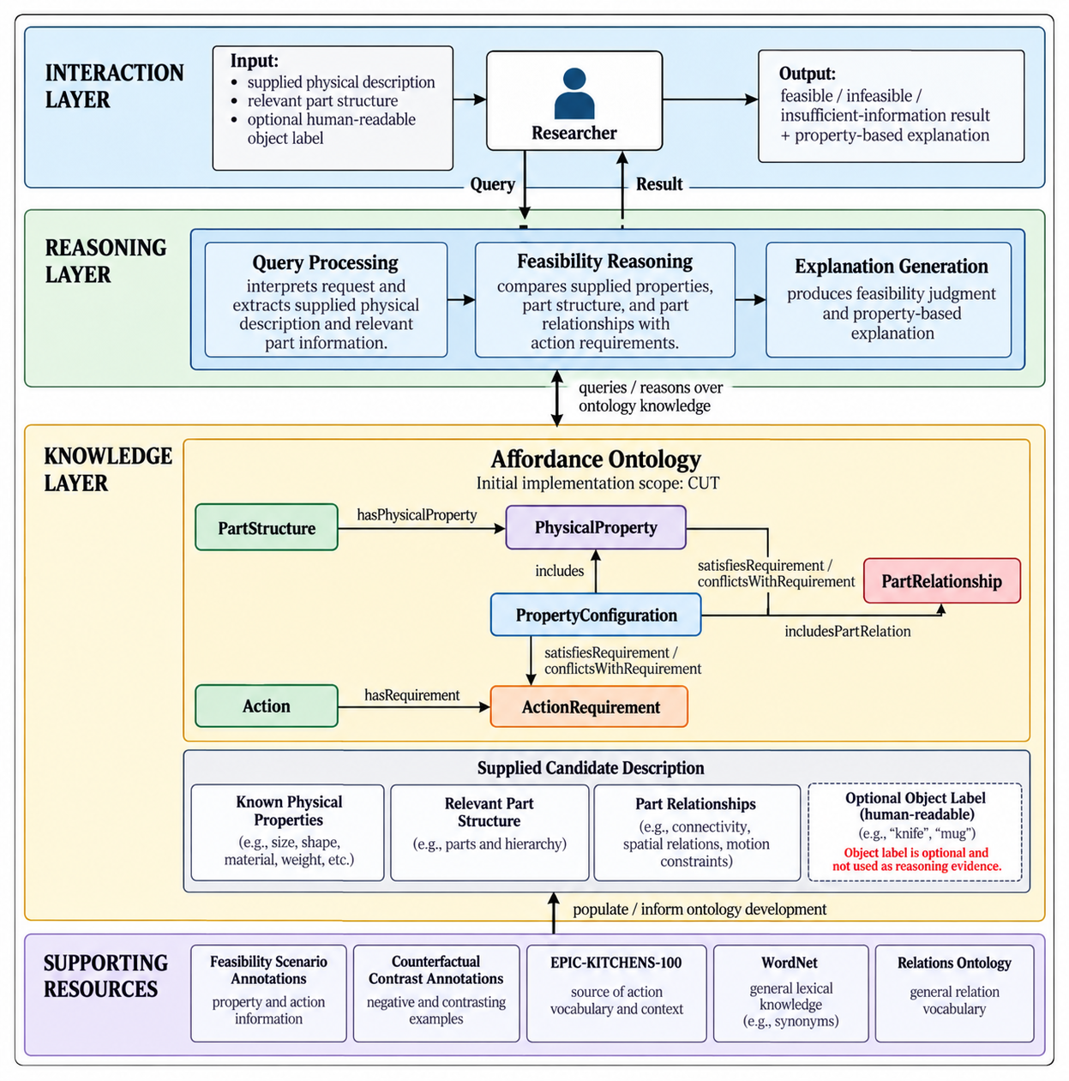

Diagram 2 — Use Case Diagram

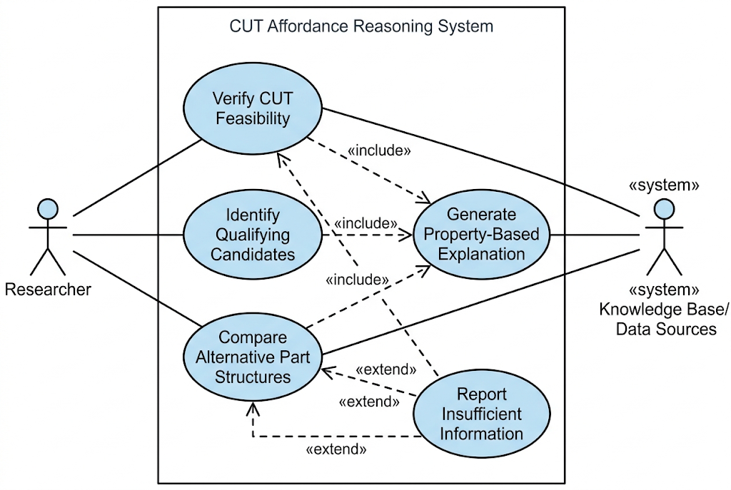

Diagram 3 — Activity Diagram: Scenario 1
Scenario 1 branches according to the shared evaluation rule in Section IV. Support for one configuration is sufficient for a feasible result. An infeasible result requires a nonempty evaluated set in which every configuration is explicitly blocked. Otherwise the result is insufficient information. The merge joins alternative outcomes before the explanation is returned. This flow supports CQ1.1–CQ1.3.

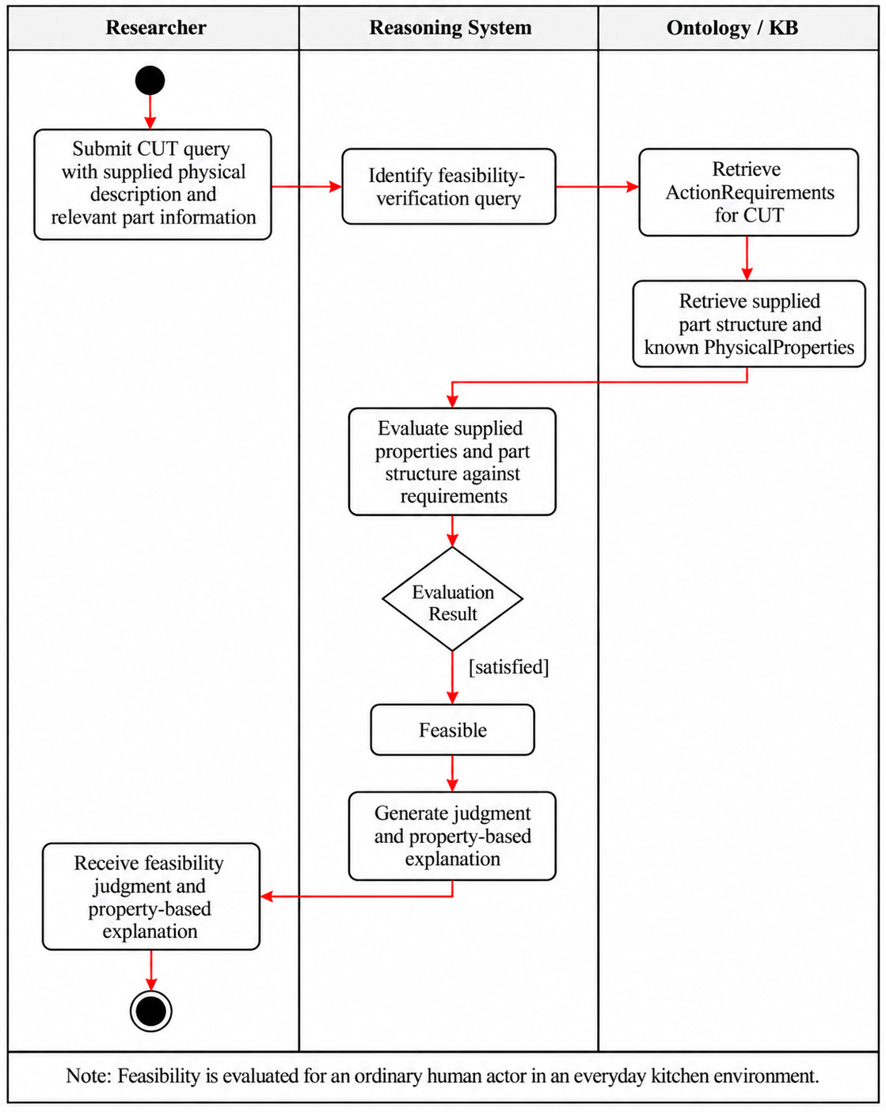

Diagram 4 — Activity Diagram: Scenario 2
Scenario 2 evaluates every supplied candidate and records its judgment before continuing the loop. An unresolved candidate does not stop the search and is not placed in the infeasible group. The shared evaluation behavior is the system-side requirement evaluation and classification shown in Diagram 3. This flow supports CQ2.1–CQ2.3.

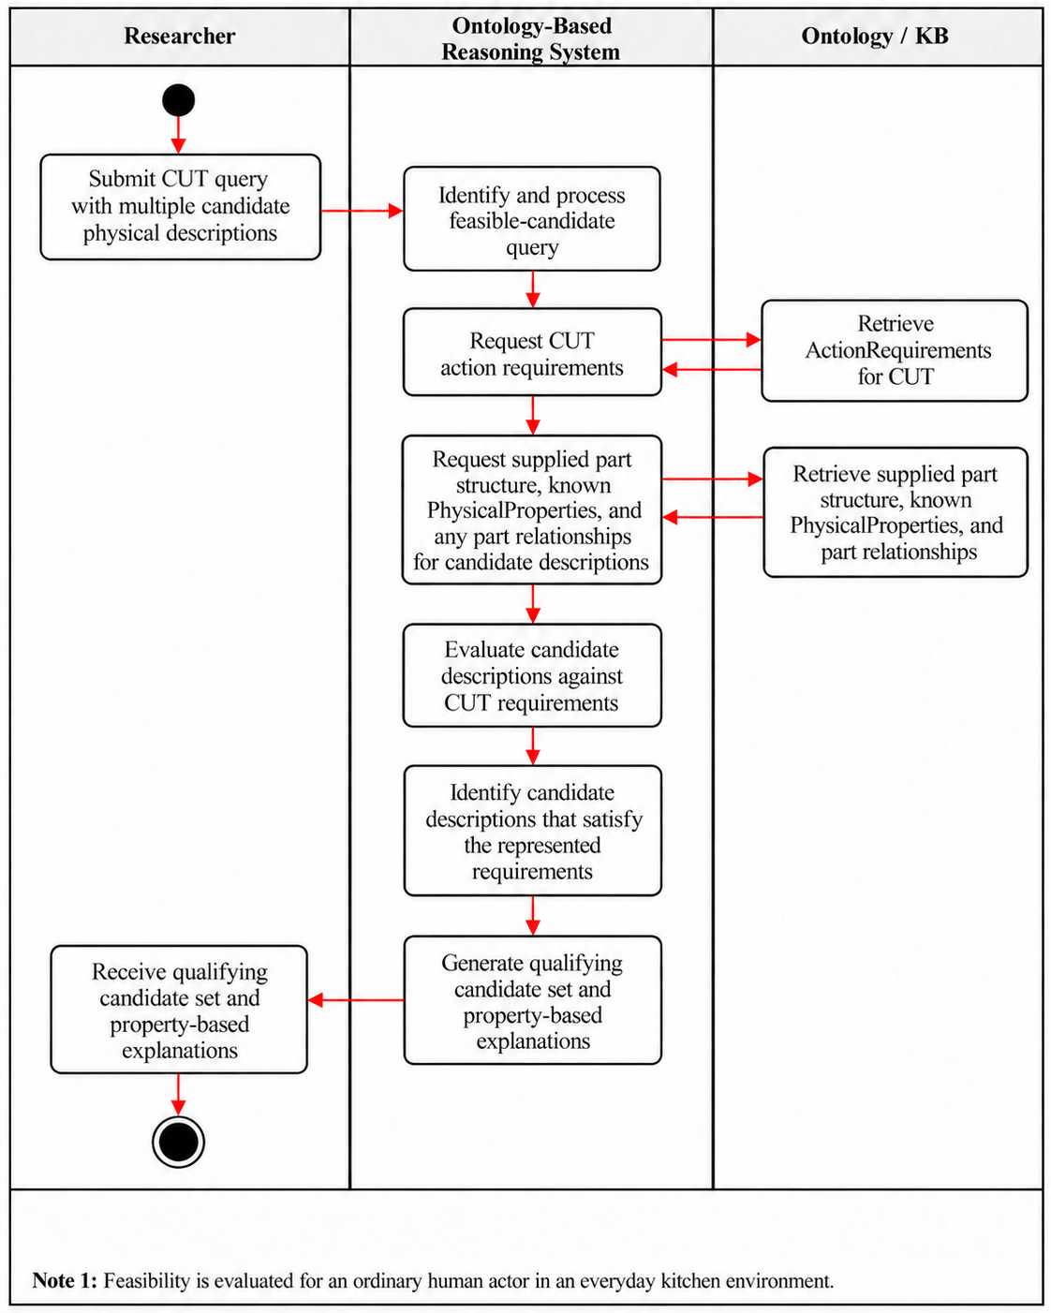
Diagram 5 — Activity Diagram: Scenario 3

Scenario 3 uses the same evaluation behavior for each configuration independently. It compares the resulting evidence, including any interaction required between parts, and preserves uncertainty for either configuration. The comparison does not assume both configurations are feasible. This flow supports CQ3.1–CQ3.2.

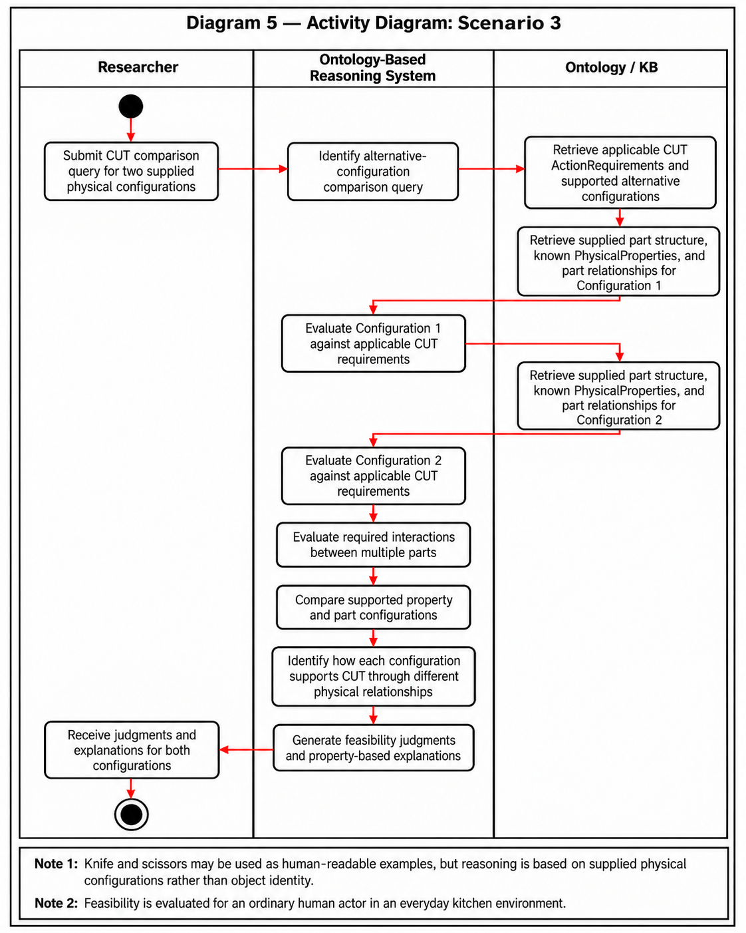

VII. Competency Questions

The following three competency questions evaluate complementary aspects of physical affordance reasoning represented in the ontology: evaluating a single candidate–target assessment, identifying qualifying candidates from a set, and comparing candidates with different part structures. The examples are controlled and interpretable test cases used to examine whether feasibility can be evaluated from explicitly represented physical evidence rather than from conventional object–function associations.
Candidates and targets are represented internally as named ontology individuals so that their physical features, parts, and assessment roles can be linked explicitly. Their lexical names, object categories, and conventional functions are not treated as feasibility evidence. Instead, the ontology represents candidate and target physical features, relevant part structure and relationships, action requirements, and requirement mappings. The current RDF provides the representational structure needed for these reasoning steps; further restrictions or rules may be added to automate the derivation of requirement satisfaction and feasibility judgments.

Resource Note: EPIC-KITCHENS-100 provides the kitchen-domain action vocabulary from which CUT is selected, but it does not directly provide the physical-feature, object-part, or action-requirement assertions used for feasibility reasoning. CUT-specific feasibility and counterfactual annotations described in Section VIII provide example-level physical information used to populate and evaluate the ontology. Object names in these examples serve as human-readable references rather than reasoning evidence. Candidate and target conditions used in the competency questions are represented explicitly in the ontology rather than inferred from those object names.

CQ1.1 — Can a rigid plastic card be used by an ordinary human actor to cut a carrot, and why?

Sample Answer from Ontology: YUnder the represented conditions, the card candidate supports the modeled CUT requirements. The candidate has low edge thickness and high rigidity, while the carrot target has high hardness. For a target with high hardness, the represented requirement mappings specify a low required edge-thickness level and a high required rigidity level. The card candidate therefore matches the represented feature levels required for this assessment.
Terms Used from Ontology
Assessment, Object, Action, PhysicalFeature, FeatureValue, FeatureLevel, ActionRequirement, RequirementMapping, hasCandidate, hasTarget, hasAction, hasFeatureValue, hasFeatureType, hasLevel, hasRequirement, concernsFeature, usesTargetFeatureType, usesTargetLevel, affectsRequirement, specifiesRequiredLevel
Semantic Processes Involved
Retrieve the candidate, target, and action associated with the assessment; retrieve the explicitly represented physical features of the candidate and target; identify requirement mappings whose target conditions match the represented target features; retrieve the corresponding required candidate feature levels; and compare the candidate's represented feature levels with those requirements. The resulting evidence can then support a feasibility judgment and a traceable explanation.
Usage Scenario Covered
Scenario 1 — Feasibility Verification and Explanation
Description + Ontology Usage
The card and carrot are represented as named individuals so that their roles and physical features can be connected within an Assessment. The name “card” does not cause the system to infer that the candidate can or cannot cut. Instead, the relevant evidence consists of explicitly represented feature values such as edge thickness and rigidity for the candidate and hardness for the target. RequirementMapping connects the represented target condition to the feature levels required of the candidate for CUT. This allows the assessment to be explained in terms of physical evidence rather than conventional object identity.

CQ2 — Given the same target, which of the following candidates satisfy the represented physical requirements for CUT: a rigid plastic card, a rolling pin, or a kitchen sponge?
Sample Answer from Ontology
Under the represented conditions, the card candidate matches the required feature levels, while the rolling-pin and sponge candidates contain represented feature values that conflict with at least one of the modeled requirements. The card has low edge thickness and high rigidity. The rolling pin has high rigidity but high edge thickness, while the sponge has high edge thickness and low rigidity. All candidates are evaluated with respect to the same carrot target, which is represented with high hardness.
Terms Used from Ontology
Assessment, Object, PhysicalFeature, FeatureValue, FeatureLevel, ActionRequirement, RequirementMapping, hasCandidate, hasTarget, hasAction, hasFeatureValue, hasFeatureType, hasLevel, hasRequirement, affectsRequirement, usesTargetFeatureType, usesTargetLevel, specifiesRequiredLevel
Semantic Processes Involved
Retrieve the assessments associated with the candidate set and common target; determine the applicable CUT requirements from the represented target condition; compare each candidate's explicitly represented feature levels against the same required levels; and distinguish candidates whose evidence supports the requirements from candidates with explicitly conflicting or insufficient information.
Usage Scenario Covered
Scenario 2 — Goal-Driven Alternative Candidate Identification
Description + Ontology Usage
Each candidate is represented as an individual so that its physical description can be referenced and compared consistently, but candidate names and conventional functions are not used as evidence. Each candidate has a separate Assessment linked to the same target and action. This allows the system to compare multiple candidates under the same target-dependent requirements and explain differences using their represented physical features.
Deformability is not modeled as a separate feature; a deformable part is represented by a low rigidity level. The sponge’s contact part has rigidity = low and edge thickness = high, while the carrot’s high hardness requires rigidity = high and edge thickness = low. Because low and high are distinct feature levels, the sponge explicitly conflicts with both requirements rather than lacking information.

CQ2.2 — Why can a rigid plastic card be returned as a candidate for cutting a carrot while a kitchen sponge is excluded?
Example Answer: The card's edge satisfies the represented edge-geometry and rigidity requirements, whereas the sponge's deformable contact edge fails to meet the rigidity requirement for cutting the carrot.
Ontology Approach: The two candidates are described by their known PhysicalProperties and relevant part information. The reasoning system compares both candidate descriptions against the same applicable ActionRequirements for CUT. The card candidate includes a relevant edge whose geometry and rigidity satisfy the applicable CUT requirements, while the sponge candidate includes a deformable contact region whose low rigidity explicitly conflicts with the structural-support requirement. The system traces these different property–requirement relationships to explain why the card is returned as a qualifying candidate and the sponge is excluded.

CQ3 — Can a knife and a pair of scissors support the represented CUT requirements under the same target conditions despite having different relevant part structures, and how are those structural differences represented?
Sample Answer from Ontology
Under the represented feature values, both candidates contain relevant blade parts with low edge thickness and high rigidity, matching the feature levels specified by the current CUT requirement mappings for the represented target condition. Their part structures differ: the knife candidate has one represented blade part, whereas the scissors candidate has two blade parts that are explicitly related through interactsWith.

Terms Used from Ontology
Assessment, Object, ObjectPart, PhysicalFeature, FeatureValue, FeatureLevel, ActionRequirement, RequirementMapping, hasPart, interactsWith, hasFeatureValue, hasFeatureType, hasLevel, hasCandidate, hasTarget, hasAction
Semantic Processes Involved
Retrieve the relevant object parts and their explicitly represented feature values; evaluate those feature values against the same target-dependent CUT requirements; retrieve the represented part relationships; and compare how the two candidate descriptions differ structurally while supporting the same action requirements.
Usage Scenario Covered
Scenario 3 — Comparing Alternative Part Structures for the Same Action
Description + Ontology Usage
The names “knife” and “scissors” identify example individuals but do not provide the evidence for CUT feasibility. The knife candidate is represented through a single blade part, while the scissors candidate is represented through two blade parts and explicit interactsWith relationships. Physical features are attached to the relevant parts rather than inferred from the object names. This allows the ontology to represent and compare different structural realizations of candidates under the same target and action conditions. In the current preliminary ontology, the part interaction is represented explicitly but is not yet encoded as a necessary CUT requirement. Further formalization could determine when particular structural relationships contribute directly to requirement satisfaction.

VIII. Resources

Data Availability
EPIC-KITCHENS-100 is publicly available and provides the source kitchen-domain action vocabulary from which Cut was selected for the initial ontology scope. However, EPIC-KITCHENS does not directly provide the physical properties, object-part descriptions, or action-requirement relations needed for the proposed feasibility reasoning. These are supplied by a small curated subset of feasibility and counterfactual annotations generated as part of ongoing affordance-reasoning research. For the course project, only data relevant to Cut and the competency questions defined in Section VII will be used.

Knowledge Bases, Repositories, or other Data Sources
Data | Type | Characteristics | Description | Owner | Source | Access Policies & Usage
EPIC-KITCHENS-100 | Remote dataset / repository | Egocentric kitchen videos with annotated manipulation actions and object interactions | Provides the source kitchen-domain action vocabulary and human-object interaction context from which Cut is selected for the initial ontology scope. It does not directly provide the physical-property or action-requirement knowledge used for feasibility reasoning. | EPIC-KITCHENS / University of Bristol and collaborators | EPIC-KITCHENS dataset website / annotation repository  Link (full dataset): https://epic-kitchens.github.io/  Link (annotation dataset): https://github.com/epic-kitchens/epic-kitchens-100-annotations | CC BY-NC 4.0. Non-commercial use is permitted with appropriate attribution, a link to the license, and an indication of any changes. The dataset is used to establish the source action vocabulary and is not queried directly during ontology reasoning.  License: https://github.com/epic-kitchens/epic-kitchens-100-annotations/blob/master/license.txt
Derived Feasibility Scenario Annotations | Local / experimentally generated dataset | A curated set of feasible and infeasible examples for the action Cut, including the relevant object, object part, physical properties, target context, and feasibility outcome. The resource provides instance-level evidence used to populate and test the course ontology and to support the competency questions in Section VII. | Provides the instance-level evidence used to populate the course ontology with examples of objects, object parts, relevant physical properties, and feasible or infeasible outcomes. Only the Cut-specific subset will be used for this course project. | Hyejin Park / LACAI Lab | nternal project resource; no public URL available at this stage. | Internal research resource; not publicly available. A curated CUT-specific subset will be shared with the course team for ontology development and evaluation. Redistribution outside the project is not authorized at this stage. No public license has been assigned.
Derived Counterfactual Contrast Annotations | Local / experimentally generated dataset | Paired examples in which changes to an object property or relevant part are associated with changes in action feasibility | Paired or contrastive examples in which a change to a relevant object part or physical property is associated with a change in cutting feasibility. The resource is used as supporting evidence when identifying or refining which properties are relevant to the ActionRequirements for Cut | Hyejin Park / LACAI Lab | Generated through ongoing affordance-reasoning experiments | Internal research resource; not publicly available. A limited CUT-specific subset may be shared with the course team as supporting evidence for identifying and refining property–requirement relationships. No public license has been assigned. Any further sharing is subject to the research project's data-use policy.

External Ontologies, Vocabularies, or other Model Services
Resource | Language | Description | Owner | Source | Describes/Uses | Access Policies & Usage
WordNet | English | Supports terminology normalization and sense distinction for action and object terms used in the ontology. It is not used to determine physical feasibility. | Princeton University | Princeton WordNet  Link: https://wordnet.princeton.edu/ | Action and object terminology derived from EPIC-KITCHENS and the experimental annotations | Princeton WordNet License. Use, modification, and distribution are permitted without a fee, subject to retaining the required copyright notice and license statements. Used as an optional terminology resource, not for determining physical feasibility.  License: https://wordnet.princeton.edu/license-and-commercial-use
Relations Ontology (RO) | OWL / OBO | Provides standardized relation types intended for reuse across ontologies. It will be reviewed to determine whether general relations needed in this project, such as part-whole relations, can reuse existing semantics before new project-specific relations are introduced. | OBO Relations Ontology community / OBO Foundry | Official Website Link: https://obofoundry.org/ontology/ro.html | Relations among ontology entities, particularly reusable general-purpose relations such as part-whole relations. | CC0 1.0 Universal (Public Domain Dedication). RO is available for reuse and adaptation. The original ontology and term identifiers should be retained when reusing existing relations, and the source should be cited. Used as an optional reference for relation reuse and ontology-design decisions.  License: https://github.com/oborel/obo-relations/blob/master/LICENSE.txt

Other Resources, Service, or Triggers (e.g., event notification services, application services, etc.)
Resource | Type | Description | Owner | Source | Access Policies & Usage
(sensor or external service name) |  | Include a description of the resource as well as availability, if applicable | Primary owner of the service | Application or service URL; if subscription based, include subscription and any subscription owner

IX. References and Bibliography

[1] EPIC-KITCHENS, “EPIC-KITCHENS dataset.” Accessed: Oct. 14, 2026. [Online]. Available: https://epic-kitchens.github.io/
[2] EPIC-KITCHENS, “EPIC-KITCHENS-100 annotations,” GitHub repository. Accessed: Oct. 14, 2026. [Online]. Available: https://github.com/epic-kitchens/epic-kitchens-100-annotations
[3] Princeton University, “WordNet.” Accessed: Oct. 14, 2026. [Online]. Available: https://wordnet.princeton.edu/
[4] OBO Foundry, “Relations Ontology.” Accessed: Oct. 14, 2026. [Online]. Available: https://obofoundry.org/ontology/ro.html
[5] Object Management Group, “OMG Unified Modeling Language (OMG UML), version 2.5.1,” Dec. 2017. Accessed: Oct. 14, 2026. [Online]. Available: https://www.omg.org/spec/UML/2.5.1/
[6] A. Chemero, “An outline of a theory of affordances,” Ecological Psychology, vol. 15, no. 2, pp. 181–195, 2003, doi: 10.1207/S15326969ECO1502_5.
[7] Y. Jiang, M. Yang, Z. Li, and J. Pujara, “AFFORDANCE20Q: Evaluating affordance reasoning from physical properties,” arXiv:2606.14240v2, 2026. [Online]. Available: https://arxiv.org/abs/2606.14240v2
[8] H. Wang et al., “Affordance-R1: Reinforcement learning for generalizable affordance reasoning in multimodal large language models,” Proceedings of the AAAI Conference on Artificial Intelligence, vol. 40, no. 12, pp. 9738–9746, 2026, doi: 10.1609/aaai.v40i12.37937.
[9] C. Xie et al., “RelationLMM: Large multimodal model as open and versatile visual relationship generalist,” IEEE Transactions on Pattern Analysis and Machine Intelligence, vol. 47, no. 5, pp. 3515–3529, May 2025, doi: 10.1109/TPAMI.2025.3531452.
[10] B. Barati and E. Karana, “Affordances as materials potential: What design can do for materials development,” International Journal of Design, vol. 13, no. 3, pp. 105–123, 2019.
[11] M. Qu et al., “RIO: A benchmark for reasoning intention-oriented objects in open environments,” in Advances in Neural Information Processing Systems, vol. 36, 2023. [Online]. Available: https://proceedings.neurips.cc/paper_files/paper/2023/hash/8644353f7d307baaf29bc1e56fe8e0ec-Abstract-Datasets_and_Benchmarks.html
[12] Z. Wang, Y. Zhong, J. Fu, H. I. Christensen, and J. Gao, “AFUN: Towards an affordance foundation model for functionality understanding,” arXiv:2606.02551, 2026. [Online]. Available: https://arxiv.org/abs/2606.02551
[13] J. McCusker et al., “ARCLIGHT: Automated clustering and curriculum learning guided by human training,” in Proceedings of the Special Session on Harmonising Generative AI and Semantic Web Technologies (HGAIS 2024), CEUR Workshop Proceedings, vol. 3953, 2025. [Online]. Available: https://ceur-ws.org/Vol-3953/366.pdf
[14] A. Myers, C. L. Teo, C. Fermüller, and Y. Aloimonos, “Affordance detection of tool parts from geometric features,” in Proceedings of the IEEE International Conference on Robotics and Automation (ICRA), Seattle, WA, USA, 2015, pp. 1374–1381, doi: 10.1109/ICRA.2015.7139369.

X. Notes

There is always some piece of information that is required that has no other place to go. This is the place for that information.

