Collective judgment formation conceptual model
  - OE Week 9 | Team CJF | November 1 2026
This model connects conversation moves to transcript evidence, speakers, relationships, and current and historical states. The ten figures below support the six competency questions in the Week 9 use case and match the current website gallery. Diagram class labels are abbreviated; the RDF schema defines the full identifiers and executable axioms.

1 Provenance
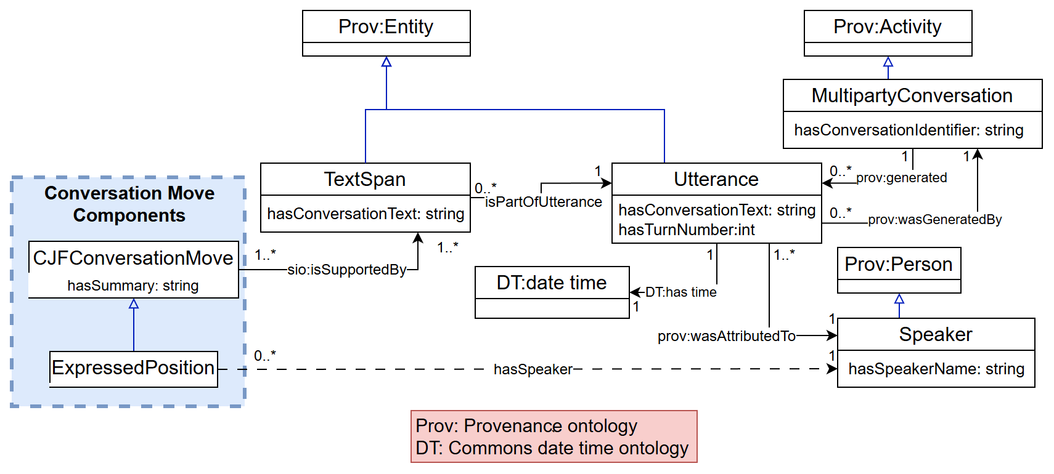
Figure 1. Transcript evidence and speaker provenance for conversation moves.
Each conversation move is supported by a TextSpan within an Utterance. The utterance records its text, turn number, conversation, and attributed Speaker. A property chain infers hasSpeaker through the evidence and utterance links. These connections let CQs 5 and 6 retrieve the original text, source turn, and person responsible for a contribution. Conversation moves also carry hasSummary; speakers and conversations carry their names and identifiers.

2 Conversation Moves with States
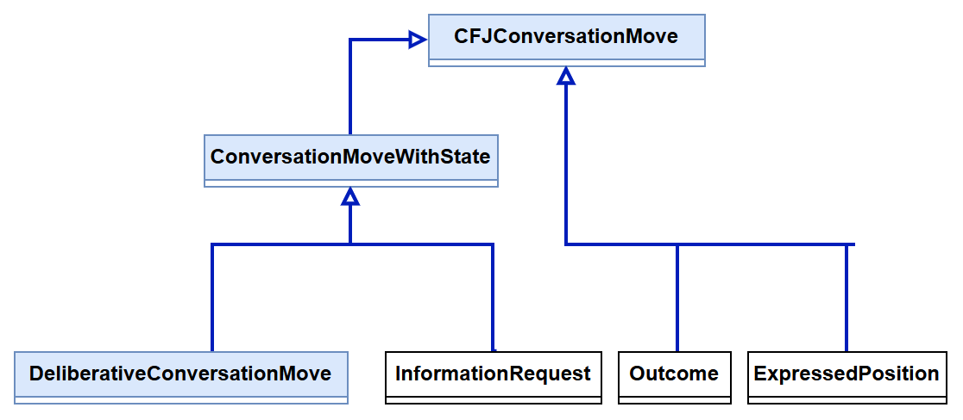
Figure 2. Conversation move taxonomy and the branch for moves with states.
ConversationMoveWithState groups DeliberativeConversationMove and InformationRequest. Outcome and ExpressedPosition remain directly under the general conversation move class. This distinction supports CQ1: every relevant move can be retrieved, while state information is included where it applies.

3 Deliberative Conversation Moves
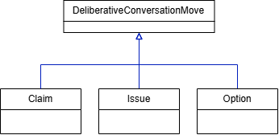
Figure 3. Claim, Issue, and Option as deliberative conversation moves.
Claim, Issue, and Option introduce or develop the substance of the group's reasoning. Each is a DeliberativeConversationMove and therefore a ConversationMoveWithState. Grouping these classes allows common relationships and state history patterns to be represented consistently.

4 State Taxonomy
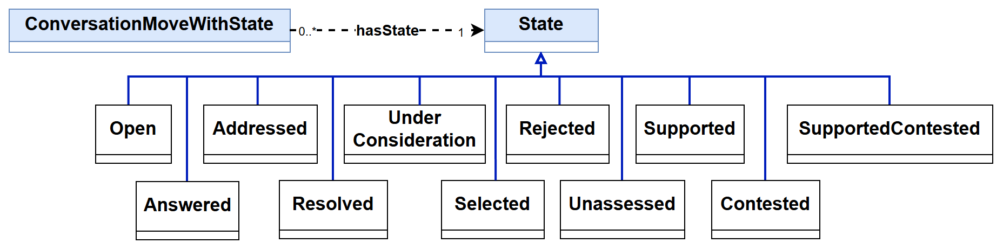
Figure 4. State taxonomy and its association with conversation moves.

5 State Assignment History
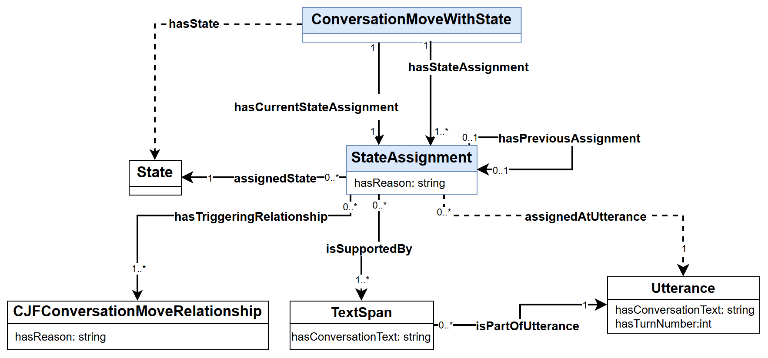
Figure 5. Current and historical state assignments with evidence and triggering relationships.
A StateAssignment connects a move to its assigned State, the Utterance at which it applies, its evidence TextSpan, and optionally the preceding assignment for the same move. An initial assignment has no predecessor. hasStateAssignment retains the full history; its subproperty hasCurrentStateAssignment identifies the terminal assignment. The reasoner derives hasState through that assignment's assignedState link. Rule-based transitions record the relevant relationship through hasTriggeringRelationship. Both StateAssignment and relationship records use hasReason for their explanations.

6 Expressed Positions
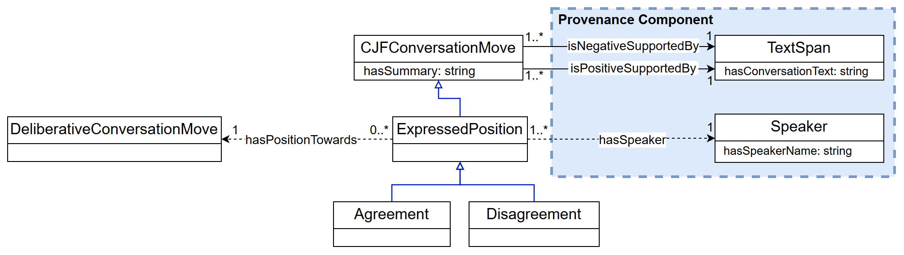
Figure 6. Expressed positions, polarity evidence, and speaker attribution.
Agreement and Disagreement specialize ExpressedPosition. The reasoner infers these classes from isPositiveSupportedBy and isNegativeSupportedBy evidence links. hasPositionTowards identifies the target move and hasSpeaker identifies the speaker. Together with source turns, these links support CQ5 about agreement with the selected option and CQ6 about a participant's positions throughout the conversation.

7 Relationships between Conversation Moves
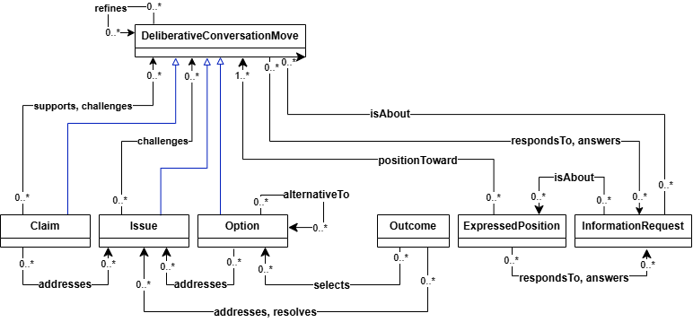
Figure 7. Semantic relationships among the conversation move types.
The model connects claims, issues, options, outcomes, positions, and information requests through relationships such as supports, challenges, answers, addresses, resolves, and selects. These links expose the structure of the group's reasoning. Their evidence also contributes to state interpretation and to retrieving the contributions relevant to a particular option or issue.

8 Property Hierarchy
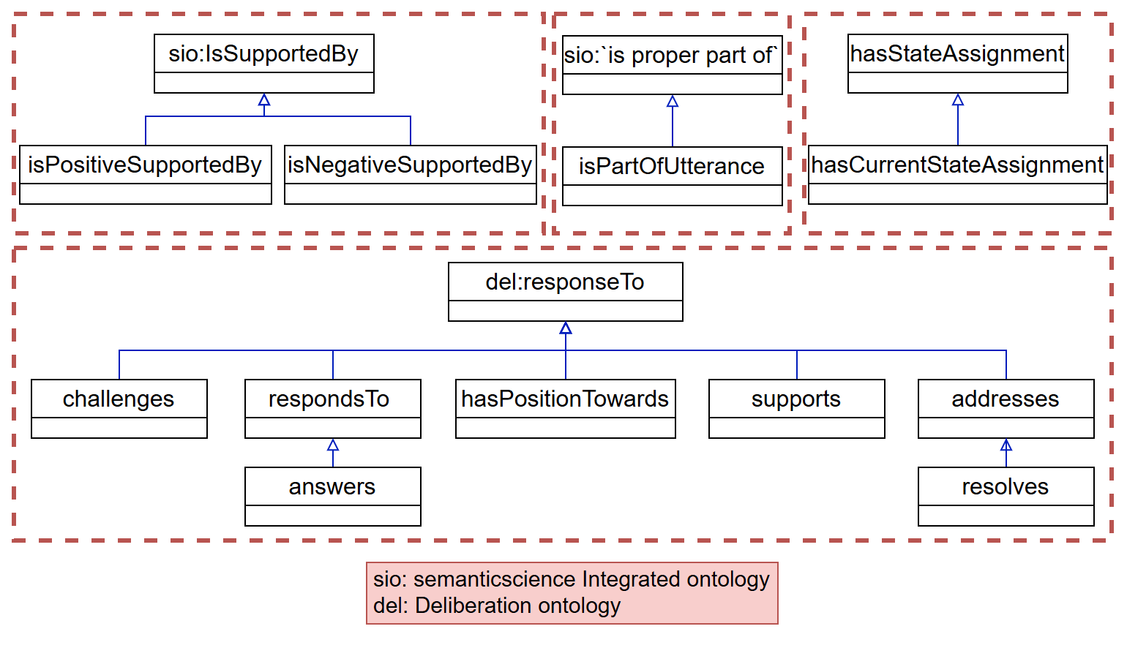
Figure 8. Subproperty relationships and reused vocabulary.
The four segments group evidence properties, text containment, state assignment properties, and conversational responses. Positive and negative support specialize the evidence relationship. hasCurrentStateAssignment specializes hasStateAssignment; resolves specializes addresses; and answers specializes respondsTo. addresses belongs under the Deliberation Ontology's responseTo property alongside the other response properties. The diagram also identifies reused SIO vocabulary.

9 Relationship Class Taxonomy
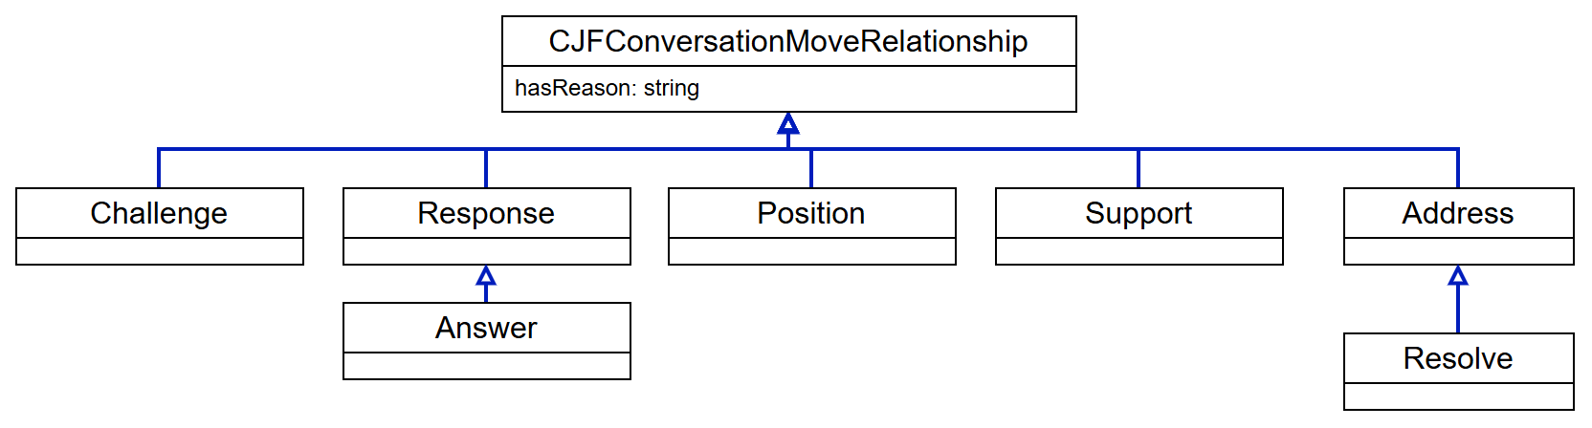
Figure 9. Class hierarchy for reified conversation move relationships.
Relationships can be represented as individuals of CollectiveJudgmentFormationConversationMoveRelationship. Its specialized classes include Challenge, Response, Position, Support, and Address. Answer specializes Response, and Resolve specializes Address. Giving relationships their own individuals allows evidence and contextual information to be attached to the connection itself. Their hasReason field records an explanation; hasSummary is reserved for conversation moves.

10 Relationship Reification
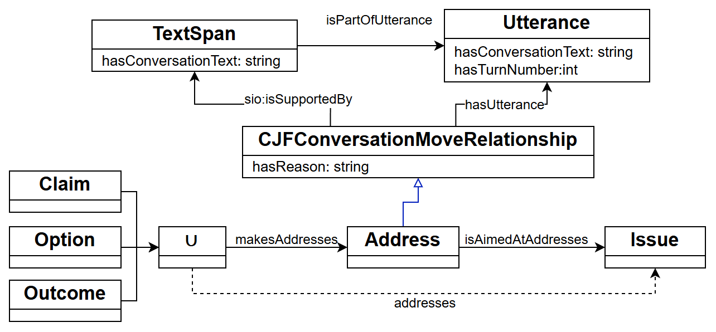
Figure 10. Reifying an Address relationship and retaining its evidence.
A source conversation move connects to an Address individual through makesAddresses, and the relationship identifies the target Issue through isAimedAtAddresses. The relationship individual records hasReason and is supported by a TextSpan in an Utterance. A property chain derives the direct addresses relationship from these two links. The same pattern lets queries retrieve both how two moves are connected and the text and turn that justify the connection.

References
M. Dumontier et al. The Semanticscience Integrated Ontology (SIO) for biomedical research and knowledge discovery. Journal of Biomedical Semantics 5, 14 (2014). https://doi.org/10.1186/2041-1480-5-14
S. Vagnoni. Deliberation Knowledge Graph. Accessed October 13 2026. https://dkg.svagnoni.linkeddata.es/
T. Lebo, S. Sahoo, and D. McGuinness, editors. PROV-O: The PROV Ontology. W3C Recommendation, April 30 2013. https://www.w3.org/TR/prov-o/

