OE9 — Conceptual Model of Property-Grounded CUT Feasibility

1. Modeling Scope and Design Rationale
The conceptual model represents a property-grounded approach to evaluating the feasibility of the CUT action in an everyday kitchen environment, assuming an ordinary human actor. Rather than relying on object names, categories, or conventional functions, the ontology evaluates candidate–target configurations using explicitly represented physical features, categorical feature levels, relevant part structures, and CUT requirements. The model distinguishes physical entities from their feature descriptions and separates the physical characteristics of a candidate from the requirements of an action. An Assessment provides the context connecting a candidate, a target, and the CUT action. ActionRequirement represents the physical conditions relevant to performing CUT, while RequirementMapping connects target conditions to required candidate feature levels. Together, these structures support property-based reasoning about whether a supplied configuration satisfies or conflicts with the modeled requirements.
Assignment 9 extends the earlier model through additional controlled assessment cases, explicit representation of unspecified feature information, part-based configurations, and SWRL reasoning rules. These additions support the evaluation of feasible, infeasible, and insufficient-information cases without treating object identity as reasoning evidence.

2. Diagram Conventions and Interpretation
The conceptual model is presented through complementary class-structure and object-property views. In the class hierarchy diagrams, an open triangular arrowhead points from a subclass toward its superclass. Figures 1–4 present explicitly asserted subclass relationships, whereas Figure 5 illustrates selected subclass relationships that follow logically from OWL equivalent-class definitions. These two forms of classification should be distinguished. An asserted subclass relationship explicitly establishes that one class is included in another. An OWL equivalent-class definition specifies necessary and sufficient conditions for class membership, allowing a reasoner to classify individuals when the required conditions are established.
In the object-property diagram, directed arrows connect domain and range classes, with labels indicating the corresponding properties. Cardinality annotations are included where they reflect implemented OWL restrictions. The diagrams represent the conceptual and logical organization of the ontology; SWRL-based feasibility judgments are explained separately from OWL class classification.

3. Class Structure and OWL-Defined Classification

3.1 Asserted Class Hierarchies
The ontology organizes its main concepts into several class hierarchies, separating physical entities, physical features, action requirements, and feasibility judgments. PhysicalEntity distinguishes complete objects and their constituent parts through WholeObject and ObjectPart. PhysicalFeature organizes the characteristics used to describe candidates and targets, including geometric, mechanical, material, surface, and structural features. The corresponding ActionRequirement hierarchy represents the physical characteristics relevant to determining whether CUT requirements can be met. Although PhysicalFeature and ActionRequirement contain related categories, they serve different purposes. PhysicalFeature describes what is represented about an entity, whereas ActionRequirement describes what is needed for an action. Keeping these concepts separate allows candidate and target characteristics to be evaluated against action-specific requirements. The FeasibilityJudgment hierarchy distinguishes Feasible, Infeasible, and InsufficientInformation outcomes. Additional asserted subclass relationships include TwoCUTRequirementsSatisfiedAssessment, a specialization of Assessment, and HighHardnessRigidityMapping, a specialization of RequirementMapping. These classes support the representation and evaluation of specific conditions within the CUT model.

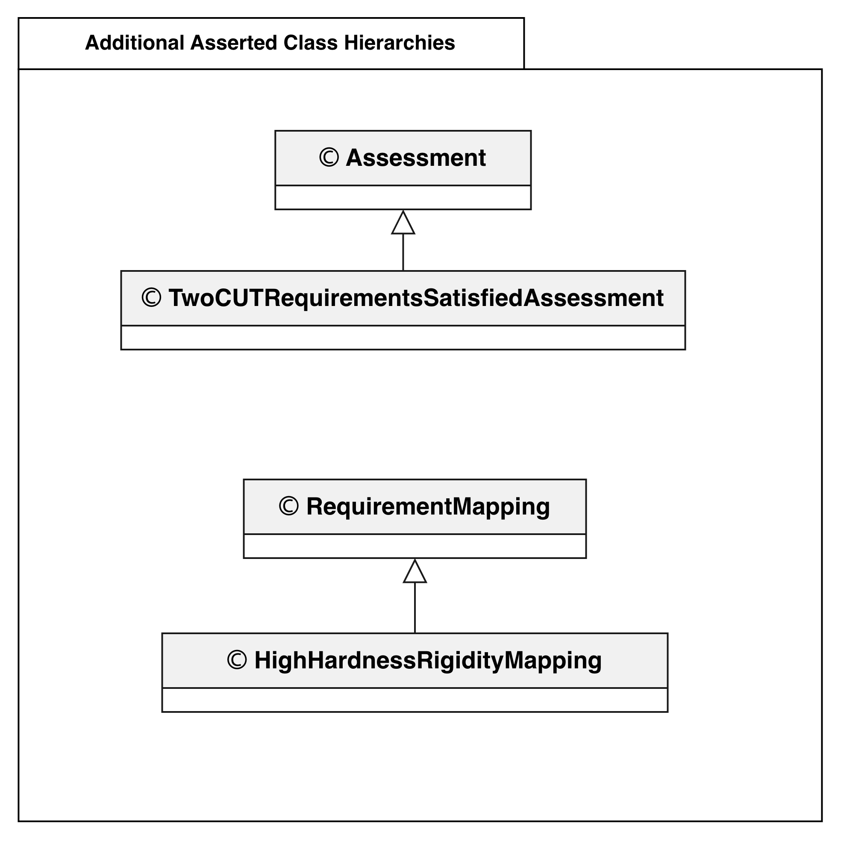
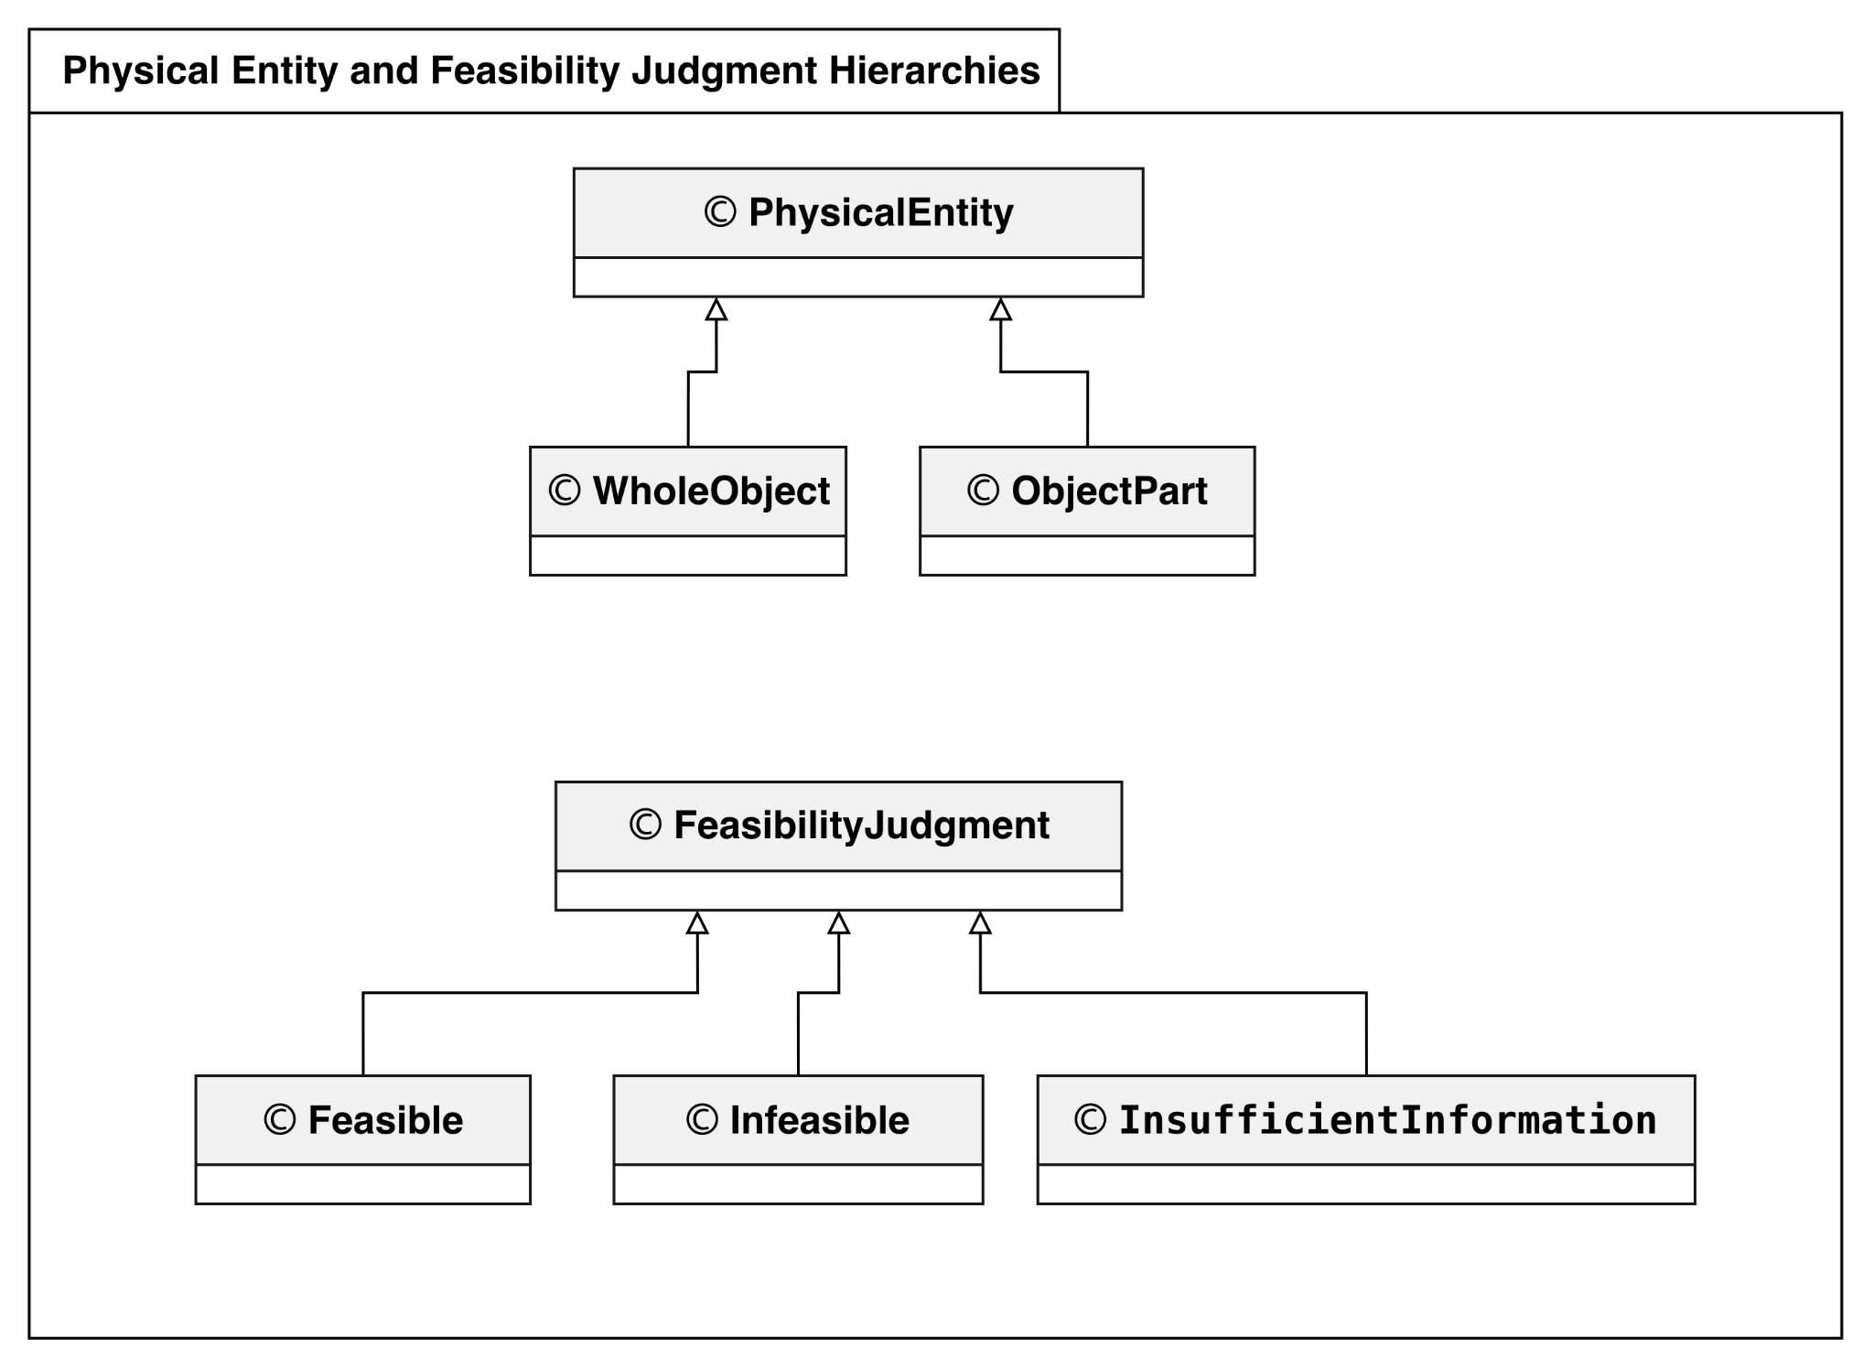
Figure 1. Physical Entity and Feasibility Judgment Hierarchies.
Figure 2. Additional Asserted Class Hierarchies.

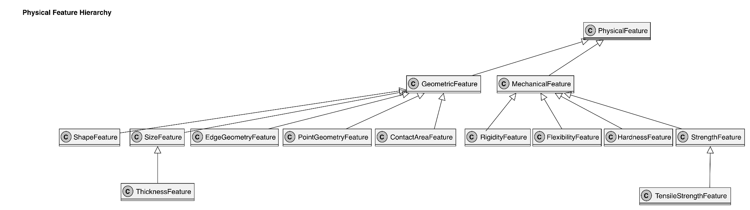
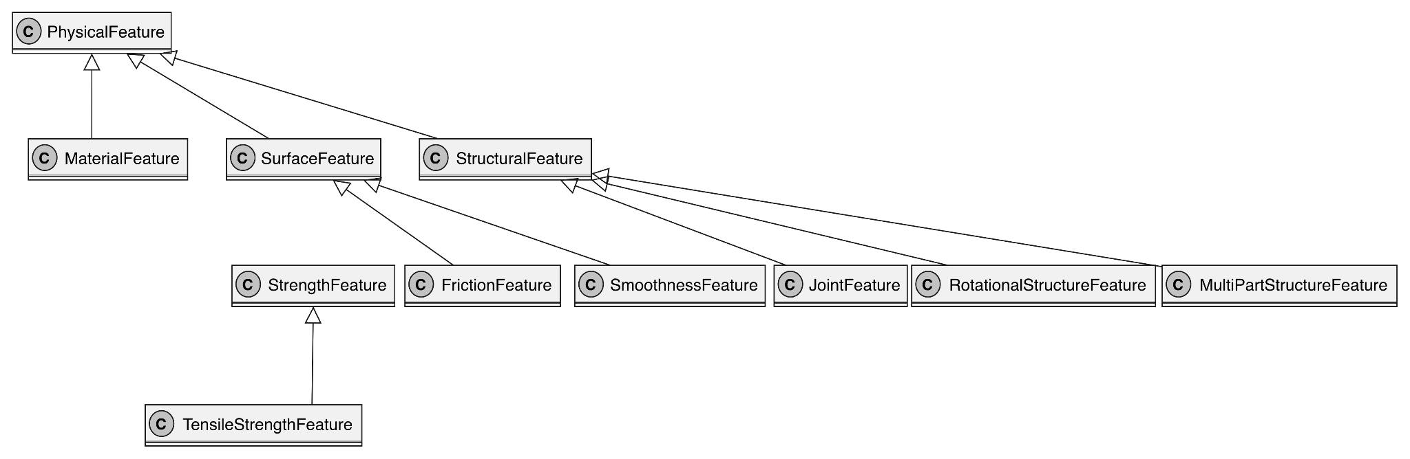

Figure 3. Physical Feature Hierarchy
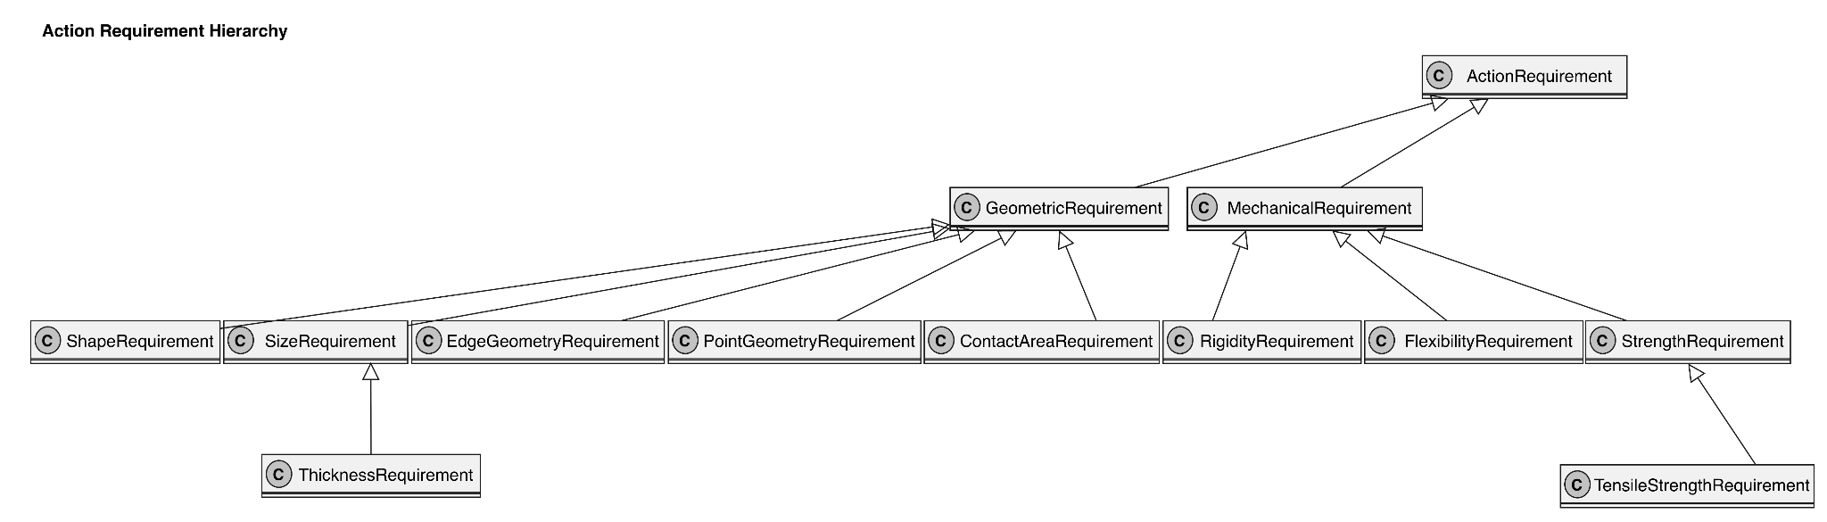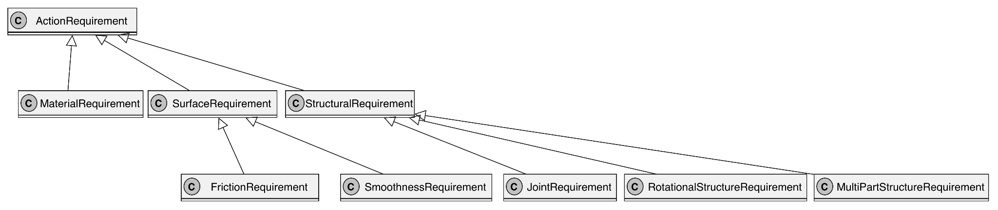
Figure 4. Action Requirement Hierarchy.

3.2 OWL-Defined Classification Patterns
In addition to explicitly asserted subclass relationships, the ontology includes classes defined through OWL equivalence axioms. These definitions allow class membership to be determined from represented relationships and restrictions rather than only from manually assigned class types. For example, InteractingPart is defined as an ObjectPart that interacts with at least one other ObjectPart. Consequently, an individual satisfying these conditions can be classified as InteractingPart through OWL reasoning. Similarly, PartBearingObject, SinglePartObject, MultiPartObject, InteractingPartObject, and PairedInteractingObject describe whole objects through restrictions on their part structures. DescribedObject captures whole objects with represented physical descriptions or parts. These patterns are particularly relevant to the ontology's treatment of part-based configurations. They provide a formal way to identify structural characteristics from explicit relationships, supporting the representation of configurations such as those used in the alternative-candidate CUT assessments.
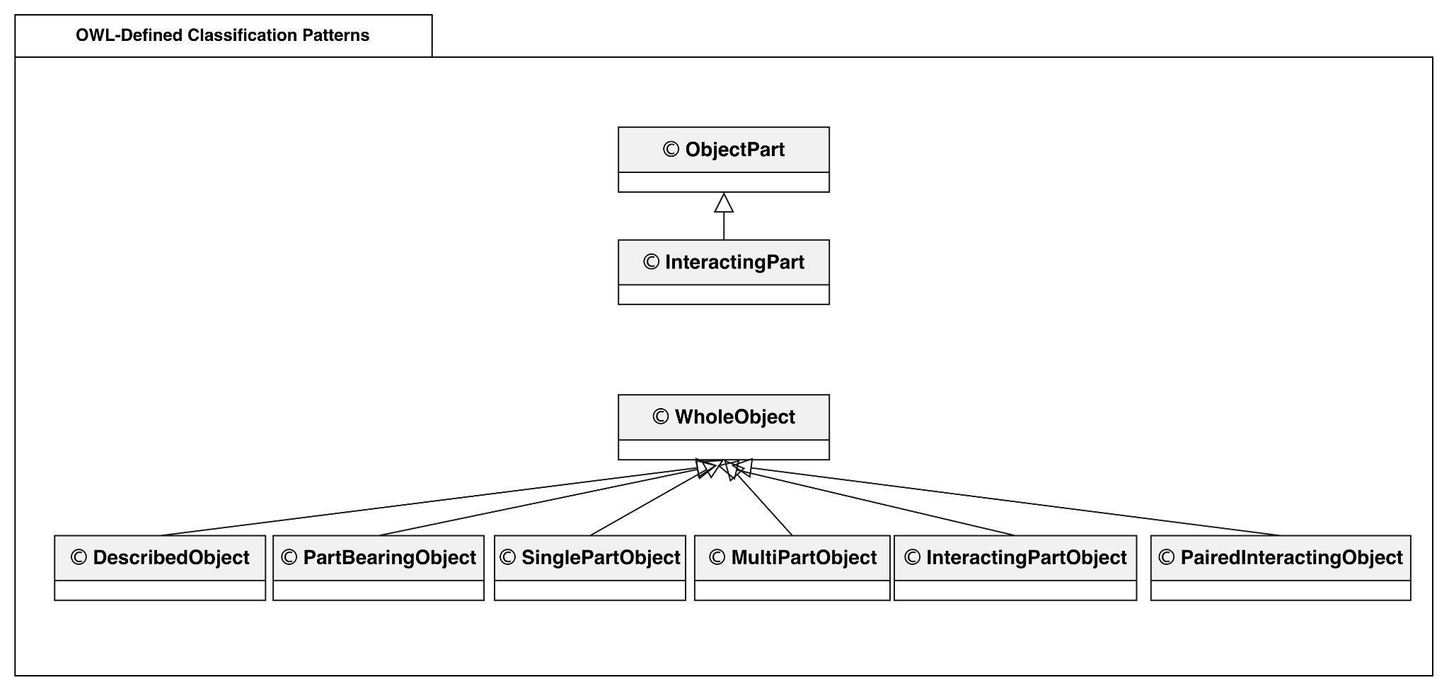
Figure 5. Selected OWL-Defined Classification Patterns.
Note: The subclass relationships shown in Figure 5 are entailed by OWL equivalent-class definitions rather than directly asserted through rdfs:subClassOf. These definitions specify necessary and sufficient conditions for class membership. The diagram presents selected classification relationships rather than the complete inferred hierarchy.
The distinction between Figures 1-4 and 5 highlights two complementary aspects of the ontology: explicit conceptual organization and logically defined classification. OWL reasoning supports structural classification, while the SWRL rules used for CUT assessment support the evaluation of action requirements and feasibility judgments.

4. Property-Grounded CUT Assessment Model
The central assessment model connects an Assessment to its candidate, target, action, and feasibility judgment through the properties hasCandidate, hasTarget, hasAction, and hasJudgment. Candidate and target are modeled as PhysicalEntity instances, with their roles determined by their relationships to the assessment rather than by separate object categories. Physical characteristics are represented using FeatureValue, which connects a PhysicalFeature to a categorical FeatureLevel. This structure allows an entity to carry explicit information about its physical characteristics without deriving those characteristics from its name or conventional function. An Action is linked to its ActionRequirement instances through hasRequirement, and each requirement identifies the relevant feature through concernsFeature. RequirementMapping connects target feature conditions to the levels required for the corresponding action requirement. This allows CUT evaluation to account for both candidate characteristics and relevant target conditions. The model also uses hasUnspecifiedFeatureType to explicitly represent a feature type for which a value has not been supplied. This is important for distinguishing insufficient information from an explicitly conflicting feature value. Missing assertions alone are not treated as evidence of infeasibility.
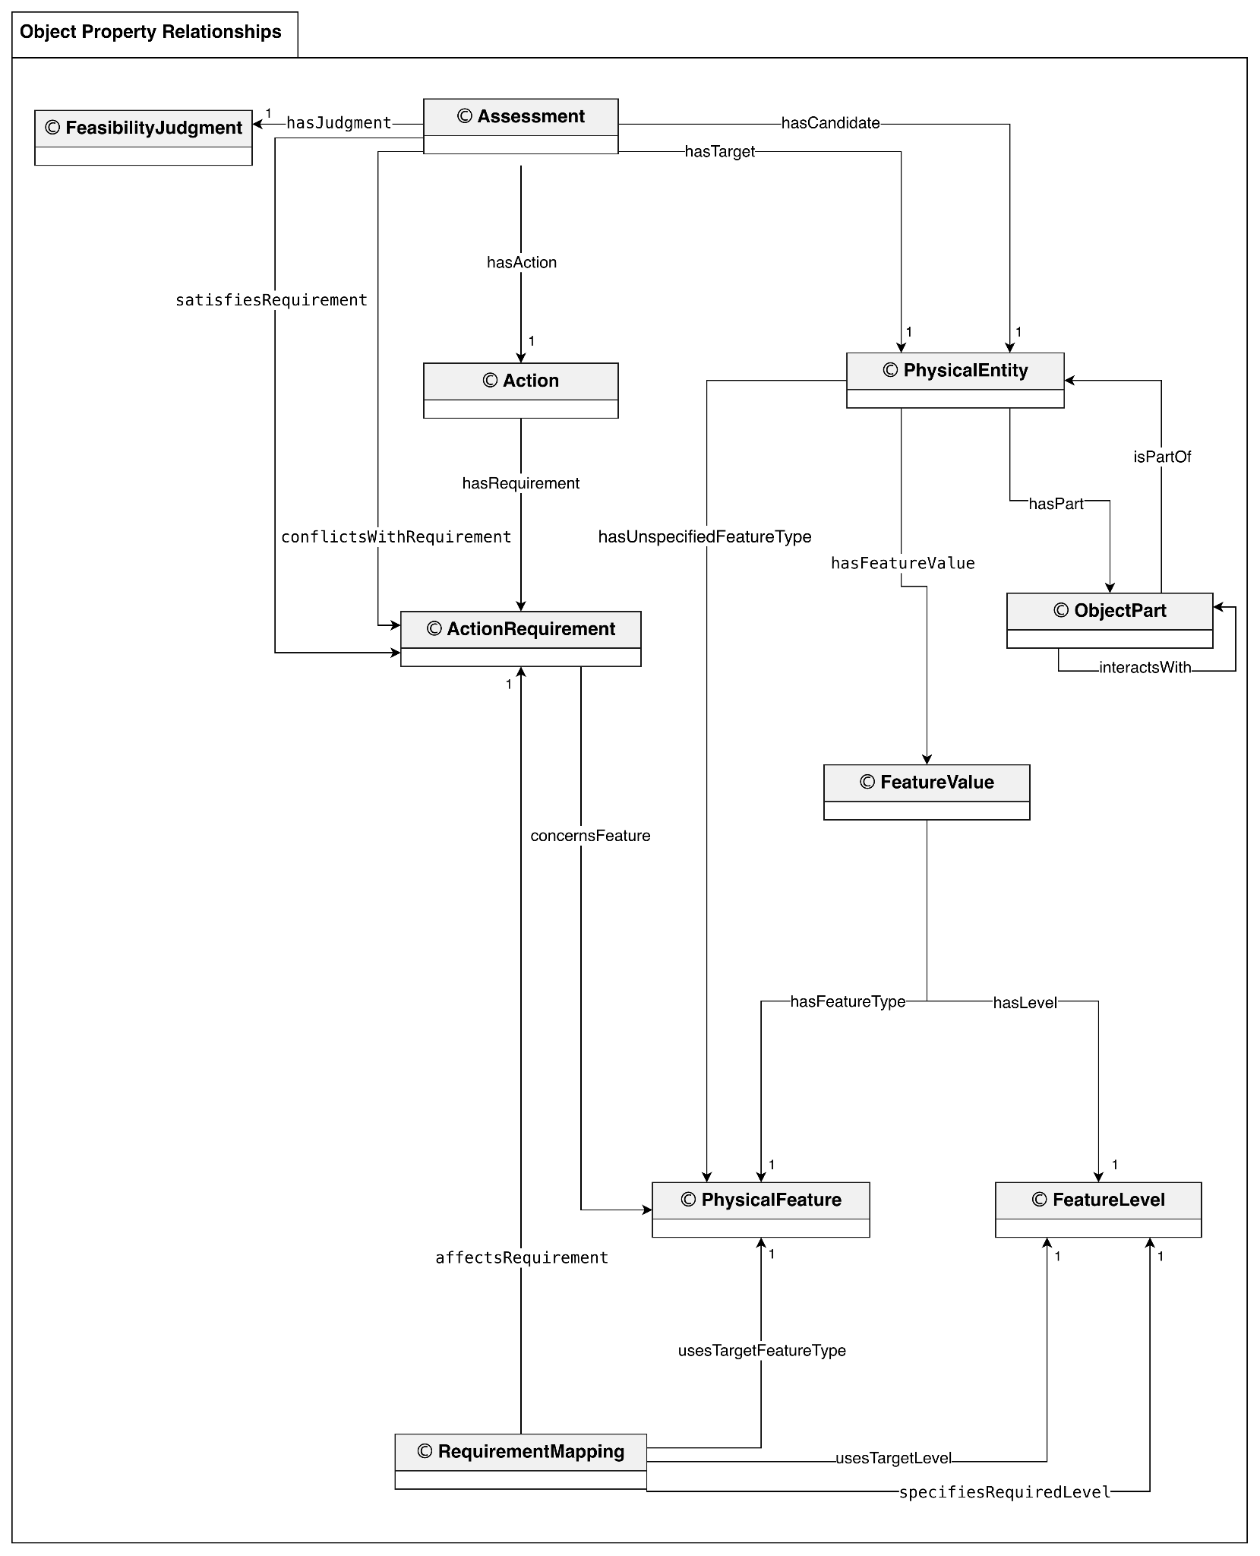
Figure 6. Object-Property Relationships Supporting Property-Grounded CUT Assessment.
Together, these relationships provide the structural basis for evaluating whether a configuration satisfies or conflicts with the modeled CUT requirements. SWRL rules can use these represented conditions to infer requirement-evaluation relationships and feasibility judgments. The inferred results must be made available to the query environment when they are retrieved through SPARQL.

5. Part-Based Configuration Model
Some CUT configurations depend not only on whole-object characteristics but also on the physical features and relationships of their constituent parts. As shown in Figure 6, the ontology represents part–whole relationships through hasPart and isPartOf, and interactions between object parts through interactsWith. Because ObjectPart is a subclass of PhysicalEntity, individual parts can also have their own FeatureValue descriptions. These relationships support the representation and evaluation of alternative CUT configurations, including knife and scissors assessments, without using conventional object functions as reasoning evidence. The OWL-defined classes shown in Figure 5 further support structural classification based on explicitly represented part relationships.

6. Alignment with Competency Questions
The conceptual model is designed to support the three competency-question scenarios through a shared assessment structure.
Competency Question | Relevant Model Components | Evaluation Focus
CQ1 — Single Configuration Feasibility | Assessment, FeatureValue, ActionRequirement, RequirementMapping | Evaluate one candidate–target configuration and explain the judgment through represented physical conditions
CQ2 — Candidate Identification and Comparison | Multiple Assessments, FeatureValue, requirement satisfaction and conflict relations | Identify and compare candidates under the modeled constraints
CQ3 — Alternative Configuration Comparison | ObjectPart, hasPart, isPartOf, interactsWith, part-level FeatureValue | Compare configurations involving different part structures and physical characteristics
The Assignment 9 assessment cases additionally support the evaluation of different judgment outcomes. For example, the controlled Test A, Test B, and Test C configurations distinguish satisfied requirements, conflicting requirements, and explicitly unspecified required features. Across these scenarios, the ontology uses object individuals as references for organizing the assessment data, while feasibility reasoning remains grounded in explicitly represented physical features, part relationships, and requirement mappings. The resulting judgments apply within the modeled CUT requirements and do not establish universal physical feasibility across all possible contexts.

