Assignment 9 — SPARQL Query Development & Revised Ontology Report
Team contributions and scope
Team Member | Ontology Modeling | Additional Responsibilities
Alex (D) | Added and validated testCandidate3/4 and their distinct parts, then integrated the updated Individuals RDF into Drive. Reviewed part-based CUT reasoning and open-world limits without changing the schema or rules. | Developed and verified CQ3 queries Q3.1–Q3.7; tested asserted and inferred results in Protégé; captured Q3.4/Q3.6 evidence; documented report Sections 2.3, 3.4, and 4.4.Use Case document revisions for CQ3 and clarifications in open issues
Hyejin (A) | Led the revision and integration of the OE9 ontology, building on the ActionRequirement and RequirementMapping structures, OWL restrictions, and SWRL reasoning developed in previous assignments.  - Extended the SWRL reasoning framework from 2 to 9 rules to support requirement satisfaction, explicit requirement conflicts, feasibility judgments, insufficient-information cases, and part-based CUT assessments.  - Added hasUnspecifiedFeatureType and the controlled Test C individuals to represent missing edge-thickness information explicitly and support an InsufficientInformation judgment.  - Maintained and validated the existing candidate–target assessments, including Test A/B, card, rolling pin, sponge, knife, and scissors configurations.  - Reviewed class definitions, object-property relationships, OWL restrictions, and SWRL rules for consistency with the competency questions.  - Integrated and validated the main ontology and separate Individuals ontology, checking RDF structure, imports, reasoning behavior, and serialization consistency. | Coordinated the team's division of responsibilities (Roles A–D), deadlines, ontology integration, and artifact preparation. Managed ontology merging and validation, including HermiT/Drools reasoning checks and RDF serializer/hygiene checks. Revised the curated terminology and conceptual model, coordinated related website/report/presentation updates, and reviewed modeling issues identified during teammates' SPARQL evaluations.
Xiye (B) | Validated the CQ1 individuals and SPARQL Query. Reported a current uncertainty with SPARQL+SWRL. | CQ1 SPARQL Query, CQ1 slide, Report 2.1, 3.2, 4.2.
Lia (C) | Validated the CQ2 individuals and the SWRL inferences with HermiT. Reported the testCandidateC namespace issue and the level-specific conflict rules (S5/S6) to Role A. | CQ2 SPARQL queries Q2.1-Q2.4 (including the entailment query); created the shared SPARQL queries file; CQ2 use-case update; report sections 2.2, 3.3 and 4.3; CQ2 slide.

1. Ontology Modifications and Validation

1.1 Ontology Modifications
Assignment 9 focused on extending and validating the existing property-grounded CUT affordance ontology rather than fundamentally redesigning its conceptual structure. The revised ontology maintains the separation between physical entities, physical features, action requirements, requirement mappings, and assessments. The current implementation contains 64 named classes, 19 object properties, and 61 named individuals across the main ontology and individuals files, including the six CQ3 structural regression individuals.
The ontology revision extended the evaluation coverage of existing controlled assessment cases while introducing Test C to examine incomplete physical information. Test candidates A and B, together with the previously modeled card, rolling pin, sponge, knife, and scissors configurations, were retained and reused to validate the expanded SWRL reasoning framework. The hasUnspecifiedFeatureType property explicitly identifies a physical feature whose value has not been supplied, supporting an insufficient-information judgment without treating missing assertions as negative evidence. The ontology also represents part-based CUT configurations, including knife and scissors assessments. These configurations use hasPart and part-level FeatureValue descriptions so that relevant physical characteristics can be evaluated at the component level rather than inferred from conventional object functions. The implementation includes nine SWRL rules distributed across the main ontology and individuals files. These rules support requirement satisfaction, requirement conflicts, structural classification of assessments, and feasibility judgments. In particular, the reasoning distinguishes Feasible, Infeasible, and InsufficientInformation outcomes under the currently modeled CUT requirements.
Purpose of the Controlled Test Cases. The controlled test cases were designed to evaluate whether CUT feasibility reasoning depends on explicitly represented physical properties rather than object names or conventional functions. Test A and Test B use neutral candidate names and controlled physical descriptions to examine whether changes in relevant feature levels lead to different feasibility judgments. They also allow comparisons with named object examples that have equivalent physical conditions, providing a check that object identity is not used as reasoning evidence. Test C extends this evaluation by explicitly marking edge thickness as unspecified, testing whether the ontology distinguishes insufficient information from a known requirement conflict. Together, these cases provide systematic evidence of the reasoning behavior under the modeled CUT requirements, rather than serving merely as additional example individuals.
CQ3 structural validation (Role D). Six named individuals were added to the OE9 Individuals file: testCandidate3, testCandidate4, and two distinct ObjectPart individuals for each. Candidate4 alone has an asserted interaction. The additions preserve all existing axioms and rules and support the regression results in Section 2.3. After local validation, the updated individuals were incorporated into the shared Drive file.

1.2 Reasoner and Hygiene Validation

Validation focused on ontology consistency, OWL restrictions, SWRL reasoning, and RDF serialization. The main ontology and individuals file were examined together to verify that the classes, object properties, and assessment instances were connected as intended. The ontology includes 24 OWL restriction expressions, including qualified cardinality restrictions for Assessment, FeatureValue, and RequirementMapping. During team evaluation, the merged ontology was checked using HermiT, and the reported result was consistent with no unsatisfiable classes. The team also evaluated the competency-question cases against the available reasoning results, including requirement satisfaction, requirement conflicts, and final feasibility judgments. The serialized RDF files contain the SWRL rules but do not explicitly store the inferred satisfiesRequirement, conflictsWithRequirement, or hasJudgment assertions. Consequently, SPARQL queries that require these relationships must be executed in an environment where the relevant inferences are available. The CQ2 evaluation confirmed the difference between querying the asserted graph and querying inferred results through an entailment-enabled environment.
Known Limitations and Planned Revisions. Validation identified several issues that require further refinement. First, three Test C individuals (testCandidateC, testCAssessment, and testCRigidityValue) were serialized under a different namespace from the other assessment individuals. Although the current tests can still reference these individuals, this inconsistency may cause problems when queries assume a uniform namespace. In the next revision, we plan to normalize their IRIs and revalidate the affected assertions and queries.
Second, the categorical feature levels (high, medium, and low) have not been explicitly declared mutually distinct using owl:AllDifferent. Consequently, the current SWRL conflict rules handle specific level combinations rather than providing a general comparison mechanism. In the next revision, we plan to declare the feature levels as distinct individuals, generalize the conflict-detection rules, and introduce additional test cases involving previously untested level combinations.
These issues were identified during the final validation stage. To preserve the tested OE9 baseline and avoid introducing changes without sufficient regression testing, we deferred their correction to the next ontology revision. The current evaluation results are therefore reported within the scope of the implemented and tested configurations, rather than as evidence of complete generalization across all physical conditions.

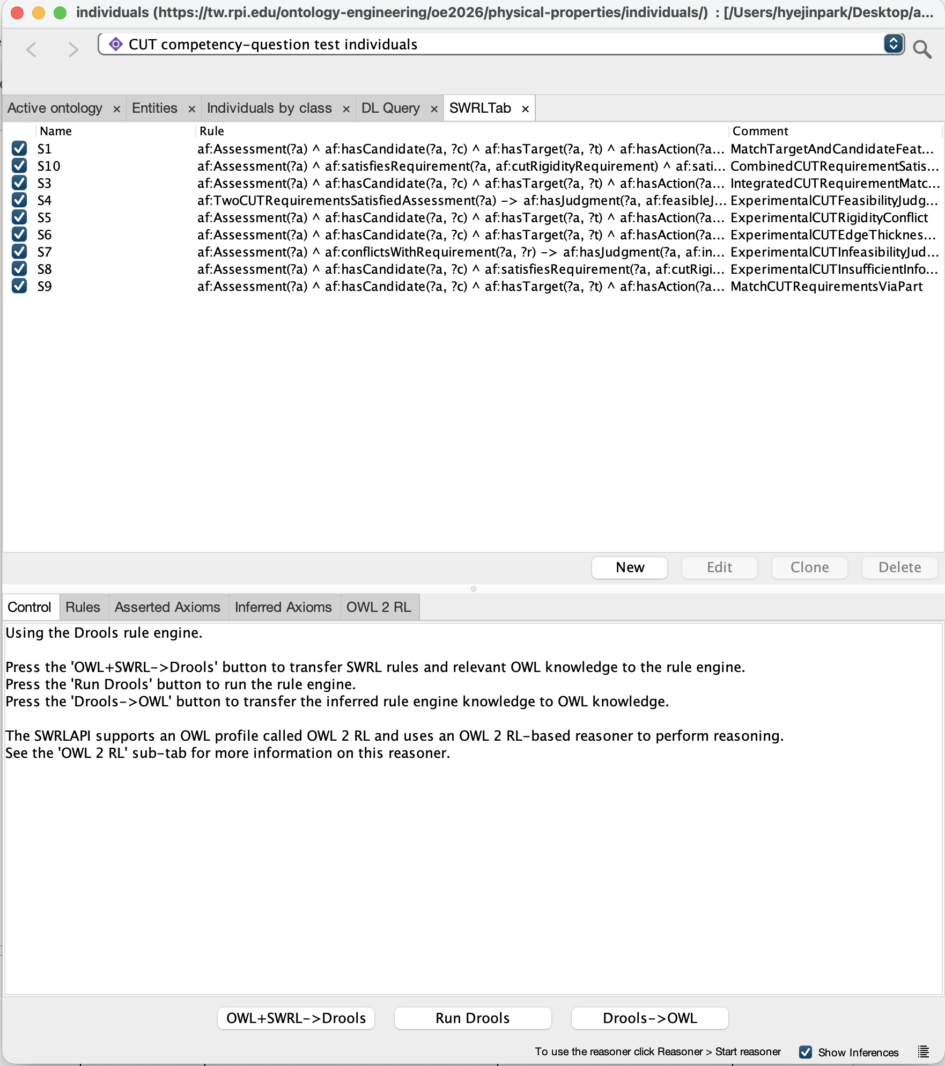
Figure A1. SWRL Rules Used in the Revised CUT Ontology.
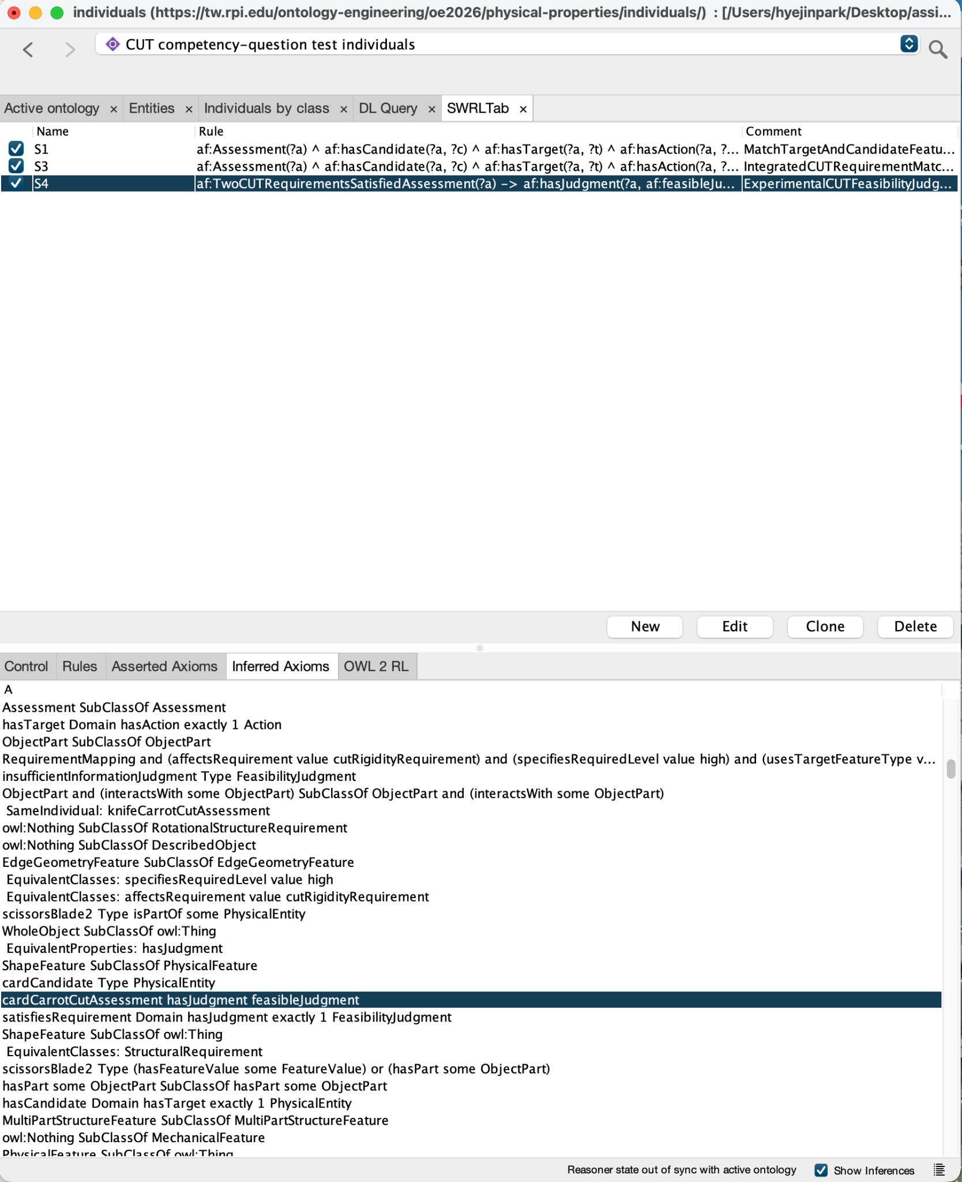
Figure A2. SWRL/Drools Inference Results for CUT Feasibility.

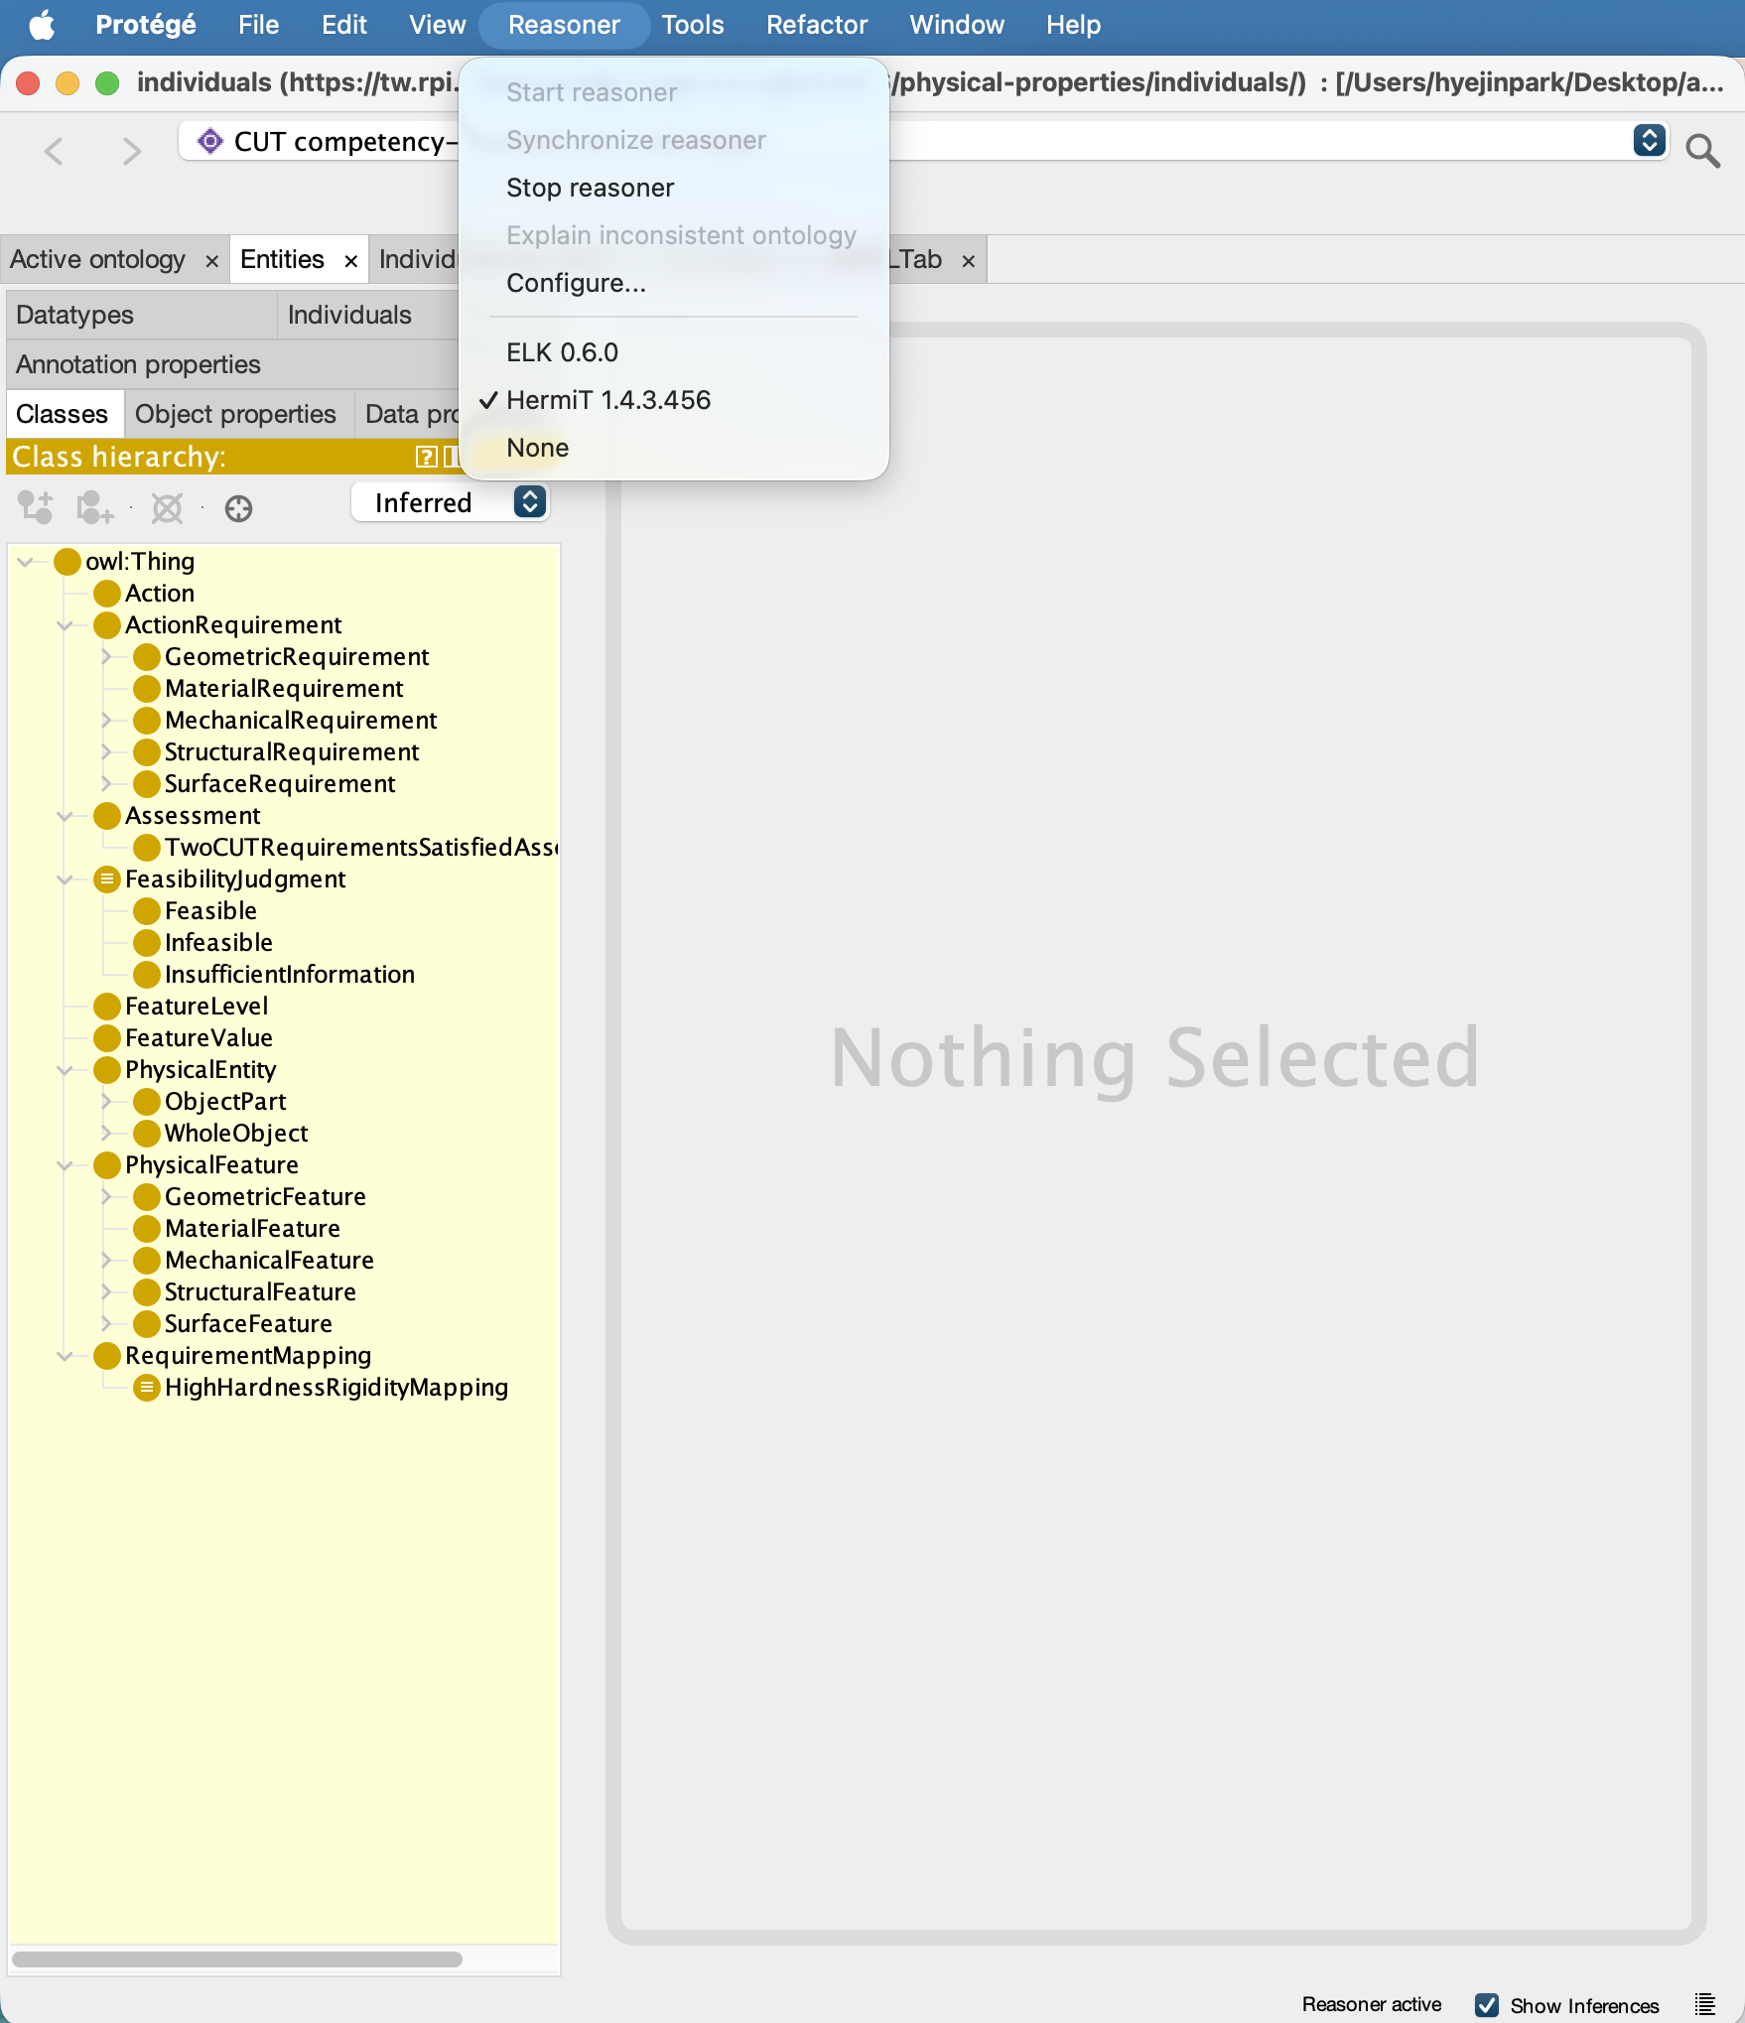Figure A3. HermiT Reasoner and Inferred Class Hierarchy in Protégé.

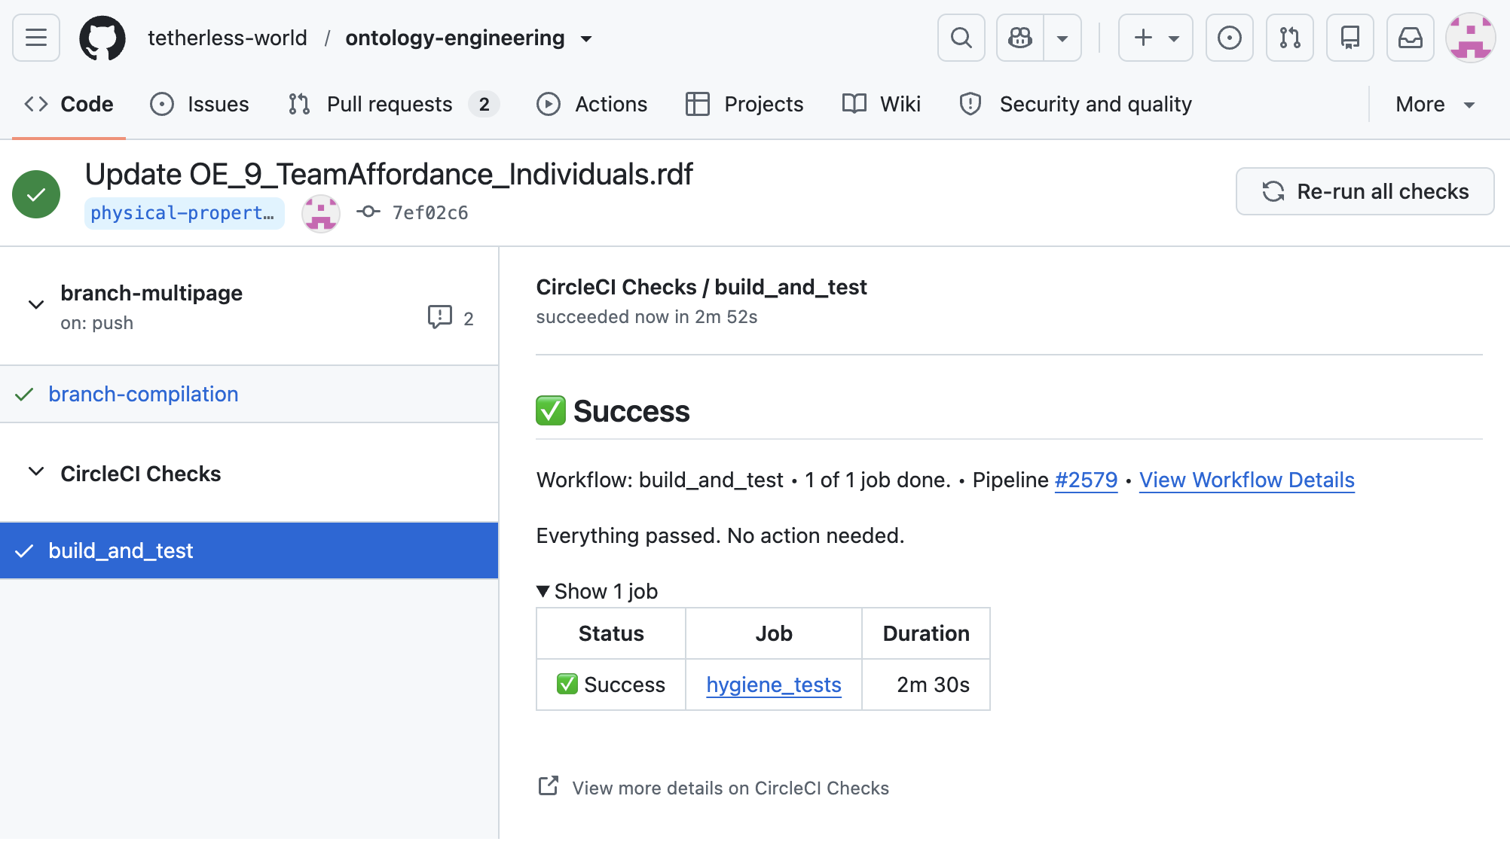
Figure A4. Successful CI Build and Test for the Revised Ontology Files.

2. SPARQL Competency Question Evaluation

2.1 CQ1 — Single Configuration Feasibility Evaluation

Responsible: Role B

Competency Question: Can a rigid plastic card be used by an ordinary human actor to cut a carrot, and why? The objective is to determine whether the card candidate satisfies the modeled CUT requirements based on its physical features and the target's physical conditions, rather than conventional object functions.

Individuals Used:

Assessment: cardCarrotCutAssessment

Candidate and Target: cardCandidate, carrotTarget

Action: cut

Feature Values: cardEdgeThicknessValue, cardRigidityValue, carrotHardnessValue

Requirements: cutEdgeThicknessRequirement, cutRigidityRequirement

Requirement Mappings: cutEdgeThicknessMapping, cutRigidityMapping

Physical Features and Levels: edgeThickness, rigidity, hardness, low, high

SPARQL Query: See CQ1 in OE_9_TeamAffordance_SPARQLQuery.txt.

Reasoning Requirements / Plugin:
  - Reasoning: RDF graph pattern matching and SPARQL 1.1 expressions (VALUES, OPTIONAL, BIND, IF, and BOUND). No OWL or SWRL inference is required for this query.
  - Plugin: Standard Protégé SPARQL Query tab, with OE_9_TeamAffordance_Individuals.rdf and its imported main ontology loaded.

Expected Results: requiredLevel and candidateLevel for edgeThickness are low; requiredLevel and candidateLevel for rigidity are high.

Actual Results: Matched with expected results.

Evaluation and Limitations:
  - The query successfully demonstrates property-based reasoning by matching the candidate's physical features with target-dependent CUT requirements. It provides a traceable explanation showing that the card's low edge thickness and high rigidity satisfy the two modeled requirements for the carrot.
  - Limitation: As reported to Role A, we potentially need SWRL or DL Query in SPARQL Query to convert a matched individual result to a Feasibility Judgment. The current existing properties don’t support such a feature. We plan to consult our project mentor for a solution.

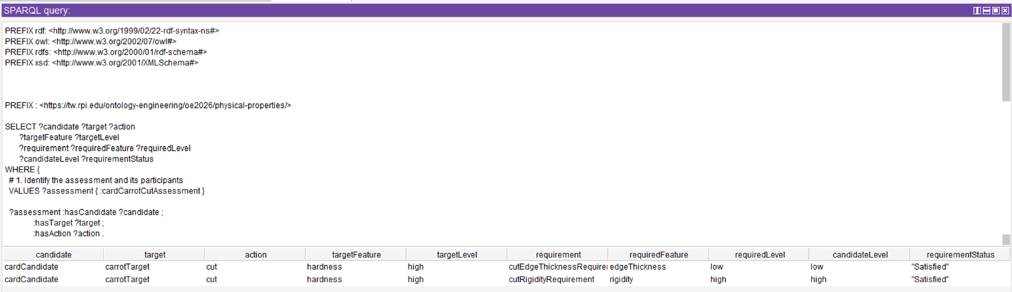

2.2 CQ2 — Alternative Candidate Identification
Responsible: Role C — Entailment Required
- Competency Question: CQ2 (Priority 2, Use Case Scenario 2). Given the same carrot, which of a rigid plastic card, a rolling pin, and a kitchen sponge satisfy the CUT requirements? Expected answer from the use case: only the card.
- Individuals Used: carrotTarget (with carrotHardnessValue = hardness/high); cardCandidate, rollingPinCandidate and spongeCandidate, each with a rigidity FeatureValue and an edge-thickness FeatureValue; one Assessment per candidate (cardCarrotCutAssessment, rollingPinCarrotCutAssessment, spongeCarrotCutAssessment), all with the same target (carrotTarget) and action (cut); and the judgment individuals feasibleJudgment and infeasibleJudgment. From the main ontology: cut, cutRigidityRequirement, cutEdgeThicknessRequirement, cutRigidityMapping, cutEdgeThicknessMapping, and the levels high and low. No new individuals were needed: the Assignment 8 individuals were sufficient. The change from Assignment 8 is that CQ2 is now answered for the card, the rolling pin and the sponge named in the question (the grader noted that Assignment 8 had tested only testCandidateA/B). The neutral-name test individuals are kept as a regression check (Q2.4).
- SPARQL Query: four queries in OE_9_TeamAffordance_SPARQLQueries.txt. Q2.1 (main, shown below) returns the inferred judgment for each candidate. Q2.2 returns the requirements each candidate satisfies or conflicts with (the explanation). Q2.3 is a cross-check that runs without a reasoner. Q2.4 is a regression check over every assessment of the carrot.
- Entailment / Reasoning Method and Plugin: OWL 2 DL entailment including the ontology's SWRL rules. Run in Protégé 5.6 with the Snap SPARQL Query plugin and HermiT 1.4.x started (Pellet gives the same answers). This query is our team's entailment query. None of the triples it matches on (satisfiesRequirement, conflictsWithRequirement, hasJudgment) is asserted. They are all inferred:
  - S1 matches the carrot's hardness to each requirement mapping's target condition and infers satisfiesRequirement when the candidate's level equals the required level.
  - S5 and S6 infer conflictsWithRequirement when the candidate has low rigidity or high edge thickness and the mapping requires the opposite level.
  - S10 classifies an assessment that satisfies both requirements as a TwoCUTRequirementsSatisfiedAssessment.
  - S4 infers hasJudgment feasibleJudgment for that class, and S7 infers hasJudgment infeasibleJudgment for any assessment with a conflict.
- In the standard SPARQL Query tab (asserted triples only), Q2.1, Q2.2 and Q2.4 return 0 rows. Q2.3 needs only simple entailment (graph matching with OPTIONAL / BIND / GROUP BY) and runs in the standard tab.
- Expected Results: card: feasible (satisfies both requirements). Rolling pin: infeasible (rigidity satisfied, edge thickness in conflict). Sponge: infeasible (both requirements in conflict).
- Actual Results: as expected, in all four queries (tables below). We validated the results by merging the two RDF files, checking consistency with HermiT (consistent, no unsatisfiable classes), and evaluating every query over the inferred closure and over the asserted-only graph.
- Evaluation and Limitations: see the notes after the tables.
Q2.1 — main CQ2 query (OWL 2 DL + SWRL entailment; Snap SPARQL + HermiT)
PREFIX rdf: <http://www.w3.org/1999/02/22-rdf-syntax-ns#>
PREFIX af: <https://tw.rpi.edu/ontology-engineering/oe2026/physical-properties/>
SELECT ?candidate ?judgment
WHERE {
?assessment rdf:type af:Assessment .
?assessment af:hasTarget af:carrotTarget .
?assessment af:hasAction af:cut .
?assessment af:hasCandidate ?candidate .
?assessment af:hasJudgment ?judgment .
FILTER (?candidate = af:cardCandidate || ?candidate = af:rollingPinCandidate || ?candidate = af:spongeCandidate)
}
ORDER BY ?candidate
Results: Q2.1 (judgment) and Q2.2 (explanation), with reasoning compared to the asserted graph only
Candidate | Rigidity / edge thickness (asserted) | Inferred satisfiesRequirement | Inferred conflictsWithRequirement | Inferred hasJudgment (Q2.1) | Without reasoner
cardCandidate | high / low | cutRigidityRequirement, cutEdgeThicknessRequirement | none | feasibleJudgment | 0 rows
rollingPinCandidate | high / high | cutRigidityRequirement | cutEdgeThicknessRequirement | infeasibleJudgment | 0 rows
spongeCandidate | low / high | none | cutRigidityRequirement, cutEdgeThicknessRequirement | infeasibleJudgment | 0 rows
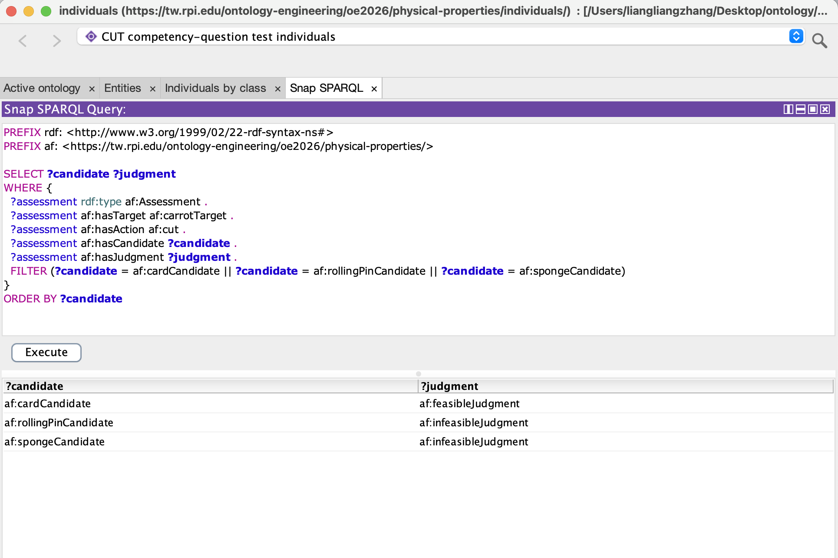
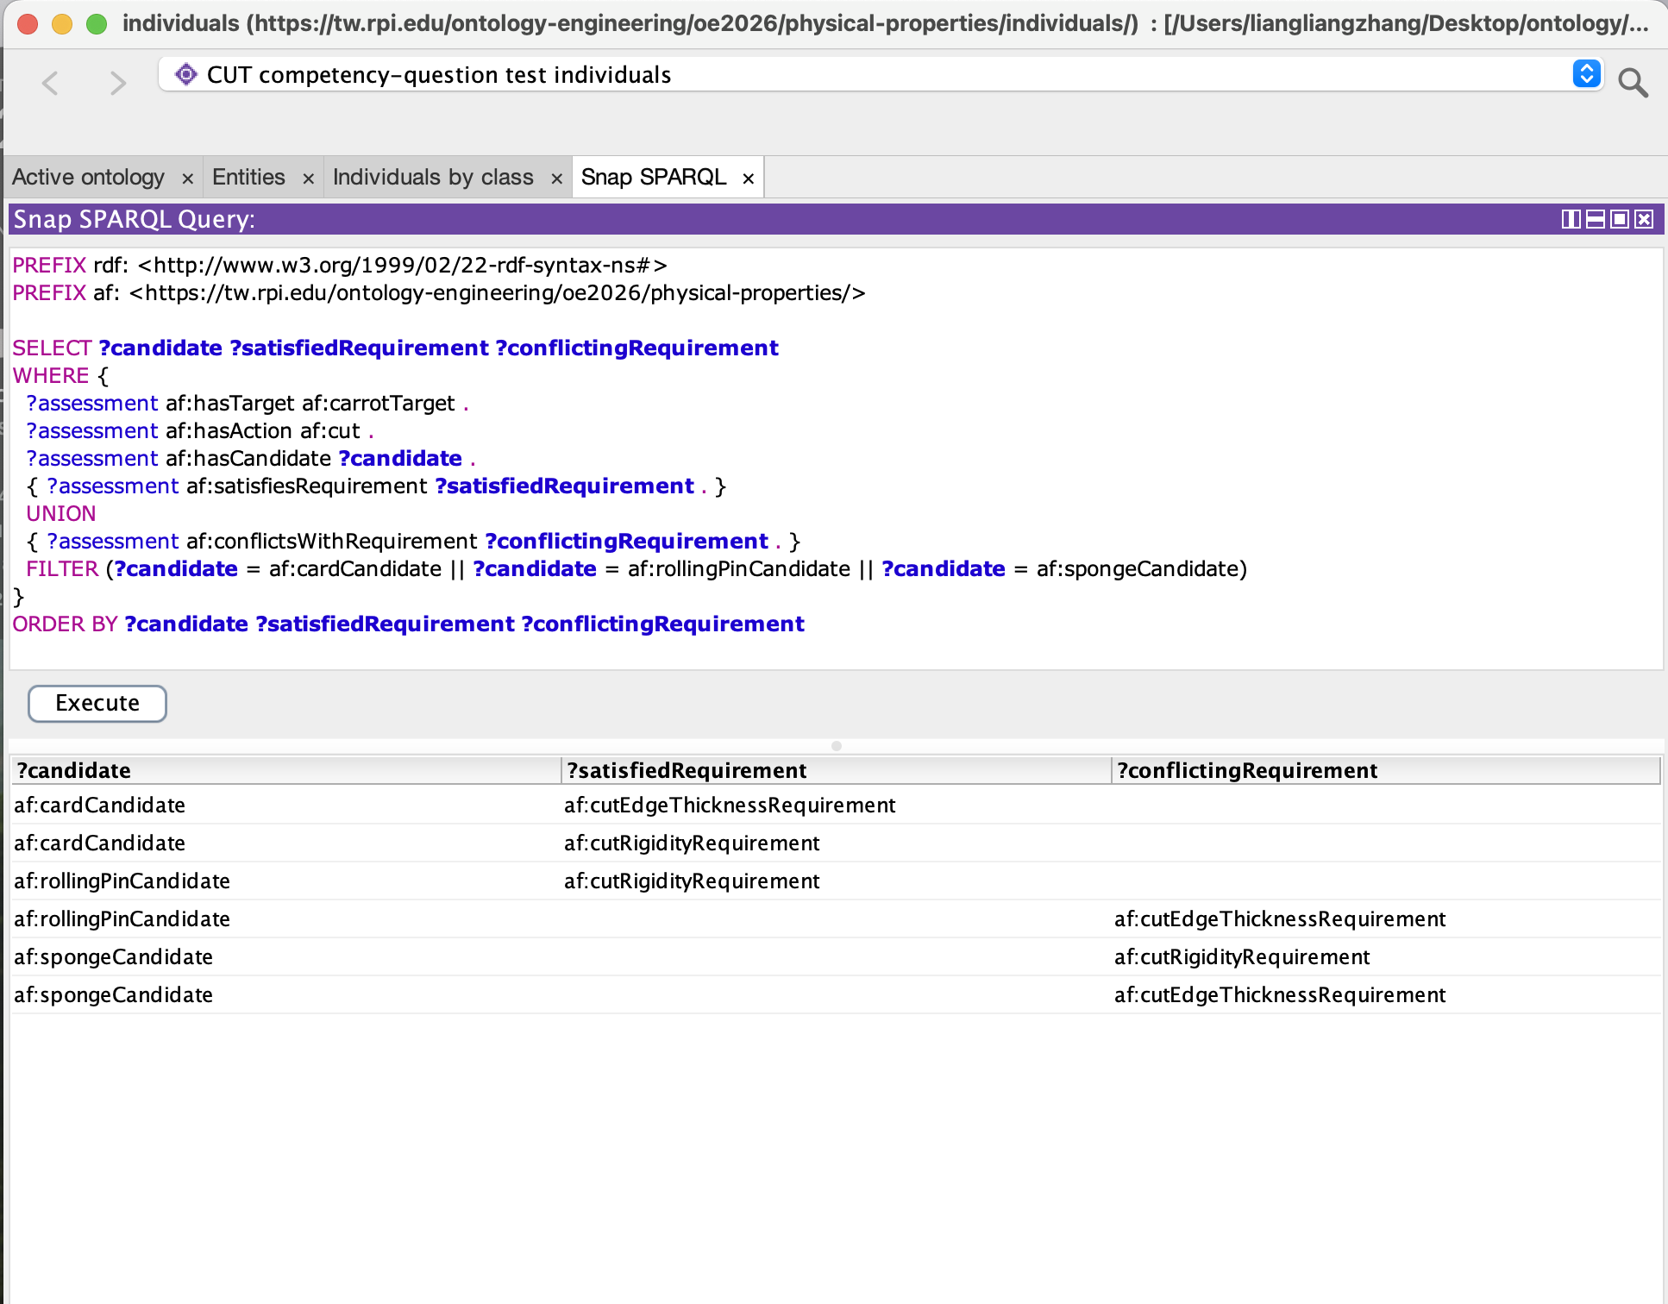
Q2.3 (no reasoner) returns the same three verdicts (FEASIBLE / INFEASIBLE / INFEASIBLE), each with a per-feature explanation such as "edgeThickness: required low, has high (conflict) | rigidity: required high, has high (satisfied)" for the rolling pin. So the answer computed from the asserted data agrees with the answer the rules infer.
Q2.4 (individuals regression, entailment) returns 8 rows and covers all three output groups of Scenario 2:
- Feasible: card, knife, scissors, testCandidateA. Knife and scissors are feasible through rule S9, which reads features from their blade parts.
- Infeasible: rolling pin, sponge, testCandidateB.
- Insufficient information: testCandidateC (edge thickness not supplied, rule S8).
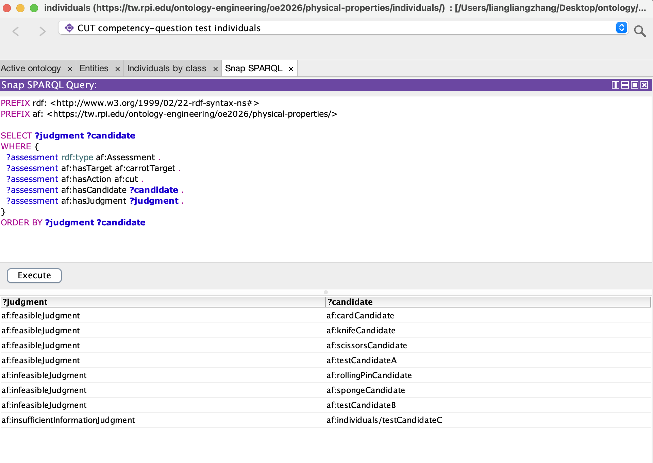
Test candidates A and B have the same feature levels as the card and the rolling pin under neutral names, and they get the same judgments. This confirms that the result depends on physical features, not on object names.
Evaluation and limitations
- CQ2 is answered for the individuals named in the question, and every result traces back to asserted feature levels through a named rule.
- Conflict rules S5 and S6 are written for specific levels (low rigidity, high edge thickness). They do not test "level differs from the required level", because high, medium and low are not declared mutually different. Without that declaration a SWRL differentFrom test cannot fire. As a result, a candidate with medium edge thickness would get no conflict and no judgment, instead of being judged infeasible.
Planned revision (Role A): Declare the categorical feature levels as mutually distinct and generalize the SWRL conflict rules. The changes will be implemented and regression-tested in the next ontology revision.
- Under open-world semantics, a missing feature value cannot be detected by inference. Insufficient information therefore depends on an explicit hasUnspecifiedFeatureType assertion (rule S8), and an assessment with no value and no such assertion simply gets no judgment.
- Because Assessment allows exactly one hasJudgment and Feasible is disjoint from Infeasible, an assessment that received both judgments would make the ontology inconsistent. HermiT reported no inconsistency, so no assessment received two contradictory judgments.
- The requirement mappings cover only high-hardness targets, so CQ2 cannot yet be asked for a soft target.
- Hygiene item passed to Role A: testCandidateC, testCAssessment and testCRigidityValue were serialized in the namespace …/physical-properties/individuals/ instead of …/physical-properties/.
This inconsistency has been documented and is scheduled for correction in the next ontology revision.

2.3 CQ3 — Alternative Cutting Configuration Comparison
Responsible: Alex Clark — Role D
Competency question: Can a knife and a pair of scissors both meet the CUT requirements for the same carrot, and how does the ontology represent the difference in their part structures?
Individuals used. The comparison uses knifeCandidate with knifeBlade; scissorsCandidate with the explicitly distinct scissorsBlade1 and scissorsBlade2; knifeCarrotCutAssessment and scissorsCarrotCutAssessment; and the shared carrotTarget and cut action. Blade FeatureValue individuals represent high rigidity and low edge thickness. The applicable mappings are cutRigidityMapping and cutEdgeThicknessMapping, with cutRigidityRequirement, cutEdgeThicknessRequirement, and feasibleJudgment.
Structural regression additions. The OE9 Individuals ontology was extended with testCandidate3 and testCandidate4, each typed WholeObject and linked by hasPart to two named ObjectPart individuals. Each pair is explicitly distinguished with owl:differentFrom. Only testCandidate4 has an asserted interactsWith link between its parts; the reverse follows from symmetry. Labels and definitions were supplied for all six new individuals. No structural result classes were asserted, and no schema axioms or SWRL rules were changed. These controls test structure only; they have no CUT assessments or feature values.
Queries and execution. Seven self-contained queries, Q3.1–Q3.7, were developed locally in OE_9_TeamAffordance_CQ3_VerificationQueries.txt and incorporated into the CQ3 section of the shared OE_9_TeamAffordance_SPARQLQueries.txt file without changing CQ1 or CQ2. They were tested in Protégé 5.6.9 using the standard SPARQL Query view for asserted data and Snap SPARQL 6.0.0 with HermiT for inferred results. In Snap, the reasoner was active and Show Inferences was checked. The ontology's local main schema import must be resolved. The standard view does not automatically expose HermiT's inferred class and property assertions.
Expected and actual results. All seven checks returned the expected results in the appropriate views:
Q3.1 — Parts: 7 candidate–part rows: knifeBlade; scissorsBlade1/2; testCandidate3Part1/2; and testCandidate4Part1/2.
Q3.2 — Distinctness: 3 unordered part pairs, belonging to scissorsCandidate, testCandidate3, and testCandidate4.
Q3.3 — Interaction: 3 asserted directed rows and 4 total rows with inference. Both scissors directions are already asserted; symmetry adds the reverse interaction for testCandidate4. Neither knifeCandidate nor testCandidate3 is returned.
Q3.4 — Structural classification: 5 inferred rows. scissorsCandidate and testCandidate4 each belong to MultiPartObject and InteractingPartObject; testCandidate3 belongs to MultiPartObject. knifeCandidate is not returned. The asserted-only graph returns 0 rows.
Q3.5 — Inverse relationships: 7 inferred rows confirming isPartOf for the represented parts; the asserted-only graph returns 0 rows.
Q3.6 — CUT feasibility: 4 inferred rows. knifeCandidate and scissorsCandidate each satisfy cutRigidityRequirement and cutEdgeThicknessRequirement, and each assessment has feasibleJudgment. The asserted-only graph returns 0 rows.
Q3.7 — Supporting features: 6 matching rows from asserted data. knifeBlade and each scissors blade supply high rigidity and low edge thickness, matching the mappings for the high-hardness carrot.
Reasoning explanation. S9 derives satisfiesRequirement from part-level feature matches to the applicable target-dependent mappings. S10 combines satisfaction of the two CUT requirements at assessment level, and S4 assigns feasibleJudgment. Separately, the OWL class definitions classify a WholeObject with at least two distinct ObjectPart fillers as MultiPartObject and a whole with an InteractingPart as InteractingPartObject. These structural inferences do not depend on tool names.
Evaluation and limitations. Both tools meet the two modeled CUT requirements for the same carrot, while the scissors additionally receive the multipart and interacting-part classifications. The knife is not inferred to belong to either structural class; this does not prove nonmembership or exactly one part. Likewise, no interaction asserted for testCandidate3 does not prove noninteraction. S9 evaluates requirements separately and S10 combines their results: neither every part nor the same part must satisfy both requirements. Interaction is not currently a CUT prerequisite. The current scissors data happen to give both required features to both blades.
The structural additions passed RDF/XML parsing, preservation checks for every original assertion, and HermiT consistency and inference checks before the queries were tested in Protégé. The validated Individuals RDF and CQ3 queries were subsequently incorporated into their existing shared Drive files, preserving the original file links. The main schema and all SWRL rules were left unchanged. The possible mismatch between the judgment policy and rule conditions is reserved for team discussion; no judgment-policy or blade-condition rule changes were made.
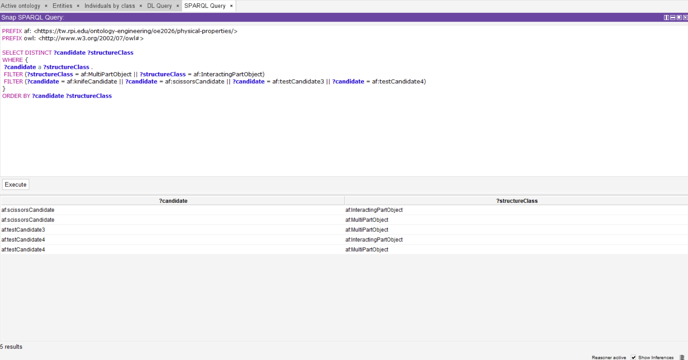
Figure D1. Q3.4 in Snap SPARQL: five inferred structural classification rows, with the reasoner active and Show Inferences checked.
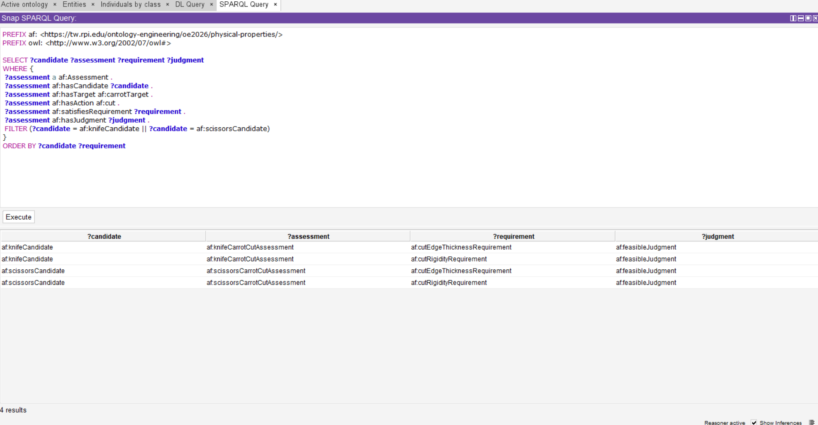
Figure D2. Q3.6 in Snap SPARQL: four rows showing both CUT requirements satisfied and feasibleJudgment for the knife and scissors assessments.

3. What We Learned and Challenges

3.1 Ontology Modeling and Validation — Role A
One of the main lessons from this assignment was the importance of distinguishing ontology structure, logical inference, and query execution. Defining classes and object properties establishes how knowledge is represented, while OWL and SWRL reasoning derive additional relationships or classifications from the asserted information. SPARQL then retrieves information from the graph available to its execution environment. A successful reasoning result does not necessarily mean that the inferred assertion has been stored in the serialized RDF or is accessible through every SPARQL interface.
Another important challenge was representing insufficient information under open-world semantics. A missing feature value does not establish that the feature is absent or that the configuration is infeasible. Explicitly representing an unspecified feature type allowed us to distinguish incomplete information from conflicting physical evidence within the controlled tests.
The controlled test cases also helped us evaluate whether the ontology's reasoning behavior was genuinely property-grounded. By comparing neutral-name candidates with named object examples under equivalent physical conditions, we could check whether the same properties produced the same judgments. Varying selected feature levels while holding the evaluation context constant also made it easier to identify which represented conditions influenced the results. This demonstrated the value of controlled test cases for validating reasoning assumptions, rather than relying only on realistic object examples.
The validation process also highlighted the importance of namespace consistency, explicit assumptions about categorical feature levels, and coordination between ontology modeling and SPARQL development. In particular, teammates' query evaluations helped identify issues that were not immediately apparent during ontology construction. Although these issues did not prevent the current controlled test cases from producing their expected results, they revealed limitations in namespace consistency and the generalizability of the current reasoning rules. Rather than making untested structural and rule changes immediately before submission, we documented these limitations and established them as priorities for the next revision. This experience reinforced the importance of iterative ontology development, regression testing, and communication between ontology modeling and competency-question evaluation.

3.2 CQ1 SPARQL Implementation — Role B
Through implementing and testing the SPARQL query for CQ1.1, I gained a better understanding of how SPARQL retrieves and connects RDF triples to support ontology-based reasoning. In particular, I learned how variables and shared relationships link an assessment to its candidate, target, physical features, and applicable action requirements. I also explored how OPTIONAL, BIND, and IF can be used to distinguish satisfied requirements, conflicting feature levels, and missing information.
One challenge was understanding the differences between SPARQL implementations in Protégé. Initially, the Snap SPARQL plugin rejected the VALUES expression, preventing the query from executing. After switching to the standard SPARQL Query tab, I successfully retrieved the expected results.
Another important lesson was distinguishing SPARQL-based feature comparison from OWL and SWRL inference. Although the query confirmed that both modeled CUT requirements were satisfied, this result alone does not establish a complete feasibility judgment. This highlighted the importance of separating evidence retrieval, requirement evaluation, and final feasibility reasoning.
In addition, Role A and I are currently exploring how to make the SWRL inference results available to SPARQL. After that is completed and after future revisions of the query, we should be able to receive the feasibility judgment by executing the query.

3.3 CQ2 SPARQL and Entailment — Role C
What we learned. The clearest lesson from CQ2 was what entailment adds to a SPARQL query. Q2.1 returns 0 rows in the standard SPARQL Query tab and the correct three judgments in Snap SPARQL with HermiT. The query does not change; what changes is whether the reasoner has derived satisfiesRequirement, conflictsWithRequirement and hasJudgment from the SWRL rules. Writing the query against these inferred properties keeps it short and leaves the evaluation logic in the ontology, where every CQ can reuse it. The no-reasoner version (Q2.3) had to re-implement the use-case evaluation rule inside SPARQL. That made it a useful independent cross-check, but it also showed how easily the logic gets duplicated when the ontology does not carry it. We also saw the difference between open-world and closed-world reasoning in practice. SPARQL's OPTIONAL / !BOUND can detect a missing feature value directly in the graph, while OWL and SWRL cannot infer the absence of a value. So the insufficient-information result depends on an explicit hasUnspecifiedFeatureType assertion (rule S8).
Challenges.
- Choosing the execution environment. The standard Protégé SPARQL tab does not use the reasoner, and Snap SPARQL supports a narrower SPARQL syntax. We therefore kept the entailment queries to basic graph patterns with UNION, FILTER and ORDER BY, and used VALUES, BIND, GROUP BY and aggregates only in the no-reasoner cross-check.
- Comparing feature levels. SWRL cannot conclude "the level differs from the required level" unless the levels are declared distinct individuals. The conflict rules are therefore level-specific (S5 for low rigidity, S6 for high edge thickness), and we reported the generic version to Role A as a follow-up.
- Deciding what counts as the answer. "Which candidates satisfy the CUT requirements?" can be answered at the level of individual requirements or as a final judgment. We provide both: Q2.1 gives the judgment, and Q2.2 gives the requirement-level explanation that Scenario 2 needs.
- Team coordination. All three CQs share one individuals file and one SPARQL file. Validating the merged files is how we found test individuals serialized under a different namespace, which had to go back to Role A rather than be patched locally.

3.4 CQ3 SPARQL Implementation — Role D
I learned that representing parts and reasoning about them are separate steps. Two differently named parts do not automatically establish two distinct individuals in OWL; explicit owl:differentFrom assertions support the minimum-cardinality inference used by MultiPartObject. The neutral structural controls made this visible: testCandidate3 demonstrated multipart classification without a represented interaction, while testCandidate4 reproduced the scissors' multipart and interacting-part classifications.
Open-world semantics also changed how I described the results. A missing class or interaction row is not proof that the relationship is false. I therefore report that the knife is not inferred to be multipart or interacting, and that candidate3 has no asserted or inferred interaction, rather than claiming either has been proved incapable of those structures.
A practical challenge was making inference available to SPARQL. Running HermiT did not populate inference-dependent results in the standard query view. Using Snap SPARQL with the reasoner active and Show Inferences checked allowed me to retrieve the expected structural classes, inverse part relationships, and feasibility judgments. Comparing asserted and inferred results helped distinguish a query-environment issue from an ontology modeling problem.
Reviewing S9 and S10 clarified another assumption: requirements are matched separately and combined at assessment level, so different parts can supply different required features. Both scissors blades currently carry both features, but this is not a general rule requiring every blade to satisfy every CUT condition. I left the rules unchanged and identified the judgment-policy mismatch for later discussion with the team.

4. AI Assistance

4.1 Role A — Ontology and Artifacts
I used ChatGPT to help review ontology modeling decisions, interpret OWL restrictions and SWRL rules, investigate RDF serialization and validation issues, and improve the clarity of the conceptual-model documentation and report. AI assistance was also used to discuss the distinction between asserted and inferred relationships and how these affect SPARQL query results.
The resulting suggestions were evaluated against the implemented RDF files, the ontology's intended competency questions, and available Protégé reasoning and validation results. AI-generated explanations and recommendations were not treated as independent evidence of ontology correctness.

4.2 Role B — CQ1
I used ChatGPT to help construct and understand SPARQL queries for CQ1, interpret RDF relationships, and troubleshoot syntax errors in Protégé. ChatGPT also helped explain query results, SPARQL syntax, generate SPARQL exercises for understanding, identify reasoning limitations, and organize the evaluation report. The generated queries were manually reviewed, tested, and validated against the ontology in Protégé.

4.3 Role C — CQ2
I used Claude to revise the SPARQL.

4.4 Role D — CQ3
I used ChatGPT and Codex to inspect the RDF schema and SWRL rules, clarify open-world semantics and part-based requirement satisfaction, develop the seven CQ3 SPARQL queries, and add the missing structural regression individuals locally. AI assistance also helped troubleshoot the standard SPARQL plugin and install the compatible Snap SPARQL plugin.
Codex ran RDF parsing, preservation checks, HermiT reasoning, and automated query checks against asserted and inferred data. I then ran all seven queries in Protégé using the standard and Snap SPARQL views, checked the expected results, and captured screenshots for Q3.4 and Q3.6. These executions provided the evidence for the reported results. I also corrected an earlier AI explanation that incorrectly suggested every part had to satisfy both CUT requirements. AI recommendations to change the rules were not applied; the policy question was deferred for team review.

