I. Use Case Description
Use Case Name | Tracking Collective Judgment Formation in Multiparty Dialogue
Use Case Identifier | CJF-TRACKING
Source | Ontology Engineering 2026 course project
Point of Contact | Tiziana Hernandez, hernat@rpi.edu  Devin De Silva, desild@rpi.edu  Srihari Sridharan, sridhs3@rpi.edu  Lausev, Matthew A, lausem@rpi.edu
Creation / Revision Date | Created Sept. 3rd, 2026  Last Revised: Sept 18th, 2026
Associated Documents | Requirements documentation, traceability matrix if applicable  None

II. Use Case Summary
Goal | The goal of this use case is to represent the evolving state of collective judgment formation in multiparty dialogue. This representation allows a human user or researcher to query a group’s developing reasoning, including what reasoning has been introduced, how contributions relate to one another, and what remains unresolved as a conversation unfolds.
Requirements | State any requirement(s)specific to this use case, including any capabilities from a business architecture or process model that the use case supports, any metrics or other reporting requirements, etc., including any reference identifier for the requirement(s), as applicable  - The ontology must be able to represent CJF milestones in group reasoning, including information requests, issues, options, claims, expressed positions, and outcomes  - Represent relationships between milestones, such as supports, challenges, answers, addresses, resolves, refines, isAbout  - Associate milestones with speakers and conversation turns  - Represent how milestone states change over time, such as whether an issue is open, addressed, resolved, etc  - Allow a single utterance to express zero, one, or multiple CJF milestones. When different parts of an utterance perform distinct reasoning functions, each milestone must be represented separately and linked to the utterance and relevant text span. For example, in the utterance “I disagree because it does not require an annual license,” “I disagree” is represented as an Expressed Position, while “it does not require an annual license” is represented as Claim. Both milestones are linked to the same utterance. If the same text span could fit multiple milestone categories, choose the best-fitting category based on its function in context.  - Support direct user queries that determine which milestones have occurred, how they are connected, and which remain unresolved.  - Support semantic reasoning over milestone types, relationships, and states so that some higher-level CJF information can be inferred from explicitly represented conversational evidence.  - Require positive conversational evidence for inferred state changes. For example, the absence of additional objections should not by itself be treated as evidence that an issue has been resolved.
Scope | This use case is limited to representing and querying the evolving CJF state of a multiparty conversation, focusing on reasoning CJF milestones, their relationships, the speakers and conversation turns associated with them, and their changing states over the course of the dialogue. It will not address generating agent interventions or deciding whether a group judgment is correct.  The ontology itself will not assume a fixed conversation length, but for the class project implementation, the ontology will be tested using a subset of no more than 150 consecutive turns from each of four multiparty conversations from the Albany MPC Dialogue Chat Corpus, rather than attempting to process an entire large corpus.  The multiparty transcript should also come with prelabeled speakers corresponding to utterances. Determining the speaker and transcribing are out of the scope of this project.  The ontology represents all utterances as conversation turns to preserve the source and sequence of the full dialogue. CJF milestones are created only for utterances that contribute to the group’s reasoning, and semantic relationships are represented primarily between those milestones. Utterances without a CJF milestone remain part of the conversation record but do not require milestone-level relationships.  For the class implementation, a manageable subset of conversation segments will be annotated before they are loaded into the ontology (estimated 75-150 consecutive turns per conversation). A fixed LLM-assisted workflow will be given the annotation objective, the initial CJF milestone and relationship categories as seed candidates, and a required structured output linking each candidate annotation to its source turn and supporting evidence. The model may flag contributions that do not fit the initial categories for human review, but it will not automatically define or modify the ontology. A human reviewer will verify and correct the candidate annotations before they are represented in the ontology. Developing or training a new annotation system is outside the scope of this use case.
Priority | Identify the priority of the use case (with respect to other use cases for the project)
Stakeholders | Identify all known stakeholders for the use case  Stakeholders include researchers studying CJF or group deliberation, and developers of systems that support collaborative decision-making. Researchers can use the ontology to examine how group reasoning develops, while developers can use its representation as a basis for systems that monitor or analyze collaborative reasoning.
Description | Summarize the use case, capturing the essential objectives (no longer than a page), including a quick overview, restated goals, and principal actor(s).  This use case focuses on representing the evolving state of collective judgment formation (CJF) in multiparty dialogue. CJF is important whenever a group must combine information, consider different perspectives, compare possible actions, and arrive at a shared judgment. Researchers studying group reasoning need ways to examine how this process develops, while developers of collaborative systems need representations that allow their systems to recognize and support it.  The ontology supports this process by representing the group’s reasoning as it develops across multiple speakers and conversation turns. As group members raise issues, propose options, provide claims, and reach outcomes, the ontology represents these CJF milestones, the relationships between them, and their changing states. A human user or researcher can directly query the populated ontology to identify unresolved issues, examine the Claims surrounding an option, or understand what the group has considered.  The initial application domain is small-group collaborative judgment and decision-making in synchronous online chat. For the class implementation, the ontology will be developed and tested using four conversations from the Albany MPC Dialogue Chat Corpus. These conversations involve groups evaluating alternatives, sharing claims, raising concerns, expressing positions, and working toward a group outcome. The four discussions cover different topics, including selecting an Olympic host city, choosing a dormitory resident assistant, deciding which public service should receive tax funding, and identifying the most influential person of the previous decade. This variation provides a concrete setting for testing whether the same CJF milestone types, relationships, and states can represent group reasoning across different subject matters. The ontology is therefore not intended to be specific to the MPC corpus or any one discussion topic; the selected conversations provide the development and evaluation setting rather than defining the scope of the ontology.  The CJF milestone types and relationships used in this project are based on an aggregation of concepts from argumentation, dialogue-move, discourse-analysis, deliberation, and collaborative decision-making literature. Related concepts from these areas were compared and consolidated into a working framework for representing general features of CJF.  CJF information extracted from the dialogue is used to populate the ontology with explicit conversational evidence. For example, the system may identify that one contribution raises an Issue, a later Option addresses that Issue, and an Outcome eventually resolves it. The ontology can use these milestones and relationships to infer that the Issue moved from Open to Addressed and then to Resolved. Each state and transition can also be linked to the conversation turns that provide its supporting evidence.  The structured representation of the group’s developing reasoning could later provide an MPCA with information needed to determine when/how to intervene to support group reasoning, although designing or generating MPCA interventions is outside the scope of this project.
Actors / Interfaces | List actors: people, systems, knowledge bases, repositories, and other data resources, services, sensors, or other “things” outside the system that either act on the system (primary actors) or are acted on by the system (secondary actors). Primary actors are those that invoke the use case and benefit from the result. Identify the primary actor and briefly describe role.  Primary: A human user or researcher who directly queries the ontology to understand the current state of the group’s reasoning.  Secondary: The conversation participants or a dialogue/transcript data source that produces the dialogue that is represented in the ontology.  Also, a CJF annotation or extraction component (an LLM, for example) that identifies CJF milestones and relevant conversational evidence, including milestone types, relationships, and evidence of responses, agreement, disagreement, or other state-changing events. Speakers and turns are already associated with each utterance. This information is used to populate or update the ontology, where semantic reasoning can be used to derive additional information about milestone states when supported by the represented evidence.  Any actor that is external to or outside the control of the use case owner should be further described under Resources, below.
Pre-conditions | Identify any assumptions about the state of the system that must be met for the trigger (below) to initiate the use case. Any assumptions about the state of other related systems can also be stated here. List all preconditions.  A multi-party conversation must be available with identified speakers and conversation turns.  The conversation must be processed before the use case begins. Relevant CJF milestones, relationships, speakers, turns, and supporting conversational evidence must be identified through a separate annotation or extraction process.  The resulting CJF information must be represented in the ontology/KG using the required classes and properties. The ontology must contain the semantic definitions and rules needed to reason over the represented information, and a compatible reasoner must be available to evaluate those rules when the query is processed.  The human user or researcher must have access to the populated ontology/KG through a query interface.
Post-conditions | Provide any conditions that will be true of the state of the system after the use case has been completed.  The user receives an answer based on the explicit and inferred CJF information represented in the ontology, including supporting conversation turns when available. The ontology remains available for additional questions about the same conversation.
Triggers | Describe in detail the event or events that initiate the execution of this use case. Triggers can be external, temporal, or internal. They can be single events or a complex event that indicates that some set of conditions has been met.  The use case is triggered when a human user or researcher submits a query about the reasoning represented in a multiparty conversation, such as what issues remain open, what claims support a proposed option, or how a milestone’s current state was determined.
Performance Requirements | List any known performance-specific requirements – timing and sizing (volume, frequency, etc.), maintainability, reusability, other “-ilities”, etc.
Assumptions | The ontology assumes that utterances can be interpreted according to their function in context and represented using a consistent set of CJF milestone types, relationships, and states.  The selected conversations or conversation segments have an identifiable task, decision, or topic boundary so that milestones can be connected within the correct discussion context.  The working definitions are based on concepts aggregated from argumentation, dialogue-move, discourse-analysis, deliberation, and collaborative decision-making literature. Since these concepts may be defined differently across sources, the ontology uses operational definitions developed specifically for this project.  It also assumes that sufficient conversational context is available to determine how contributions relate and whether the conditions for a state change have been met.
Open Issues | The initial set of CJF milestone types, relationships, and states is still being refined as part of my ongoing research. However, the project will begin with the initial working set. Milestone types include information requests, issues, options, claims, expressed positions, and outcomes. Initial relationships include respondsTo  answers, partiallyAnswers, supports, challenges, positionToward, alternativeTo, addresses, partiallyAddresses, resolves, selects, isAbout, and  refines. States include Open, Partially Answered, Answered, Deferred, Partially Addressed, Addressed, Resolved, Under Consideration, Selected, Rejected, Unassessed, Accepted, and Contested.  The exact semantic conditions for some state transitions also still need to be refined. For example, this project will need to define what conversational evidence is sufficient to infer that an issue has moved from open to addressed or resolved. The working definitions and transition conditions would ideally be reviewed by a subject-matter expert. Since SME review is not available within the scope of this class project, they will be refined through their application to example annotations. The lack of expert validation will be treated as a limitation. However, the state-transition rules will be documented separately from conversation instances so that their conditions can be revised without changing the recorded milestones and evidence  The method used to extract or annotate CJF information from dialogue is not the main focus of this use case, but will affect the quality of the representation.

III. Usage Scenarios
Provide at least two usage scenarios that flesh out the requirements outlined in the summary, including identification of requirements specific to any envisioned ontology or semantically-driven service or application. Scenarios should be described as narrative, with supporting diagrams as appropriate. In an Agile process, every user story relevant to the use case should be included and elaborated/rolled up into one or more usage scenarios, with a clear mapping from the user story to the scenario it is integrated in or mapped to.

Scenario 1: Determine the Conversation-Wide State of the Group’s Reasoning
Maya is a researcher studying how groups form judgments during collaborative decision-making. She is reviewing a meeting in which four team members are deciding which software platform to adopt for a new project. The participants propose options, provide supporting Claims, raise concerns, and respond to one another. Maya wants to understand how the group’s reasoning developed over the discussion.
Maya queries the populated CJF ontology to identify which reasoning milestones occurred in the selected conversation, how they are connected, and which issues remain open or have been addressed. The ontology retrieves relevant milestones, such as issues, options, claims, and outcomes, along with relationships such as supports, challenges, answers, addresses, and resolves. It also links each milestone to the speaker and conversation turn where it occurred. When the required evidence is present, semantic rules are applied to infer additional state information of milestones. For example, rules will be used to determine whether each Issue is Open, Addressed, or Resolved based on the available evidence. Maya receives a conversation-wide summary showing what the group considered, how the contributions are connected, and which issues remain open or have been addressed.

Scenario 2: Examine the Subgraph Around a Specific Option
Daniel is a technical lead reviewing the same meeting in which four team members are deciding which software platform to adopt for a new project. The participants propose options, provide supporting Claims, raise concerns, and respond to one another. He wants to examine the Claims specifically related to Platform A, including the reasons given for and against it and the concerns that remain open.
Unlike Scenario 1, which retrieves information across the selected conversation, this scenario begins with one specific Option. Daniel queries the populated CJF ontology for Platform A. The ontology retrieves the claims, issues, expressed positions, and outcomes connected to Platform A, along with their supporting conversation turns. It applies semantic rules to determine the supported states of milestones related to Platform A, including whether associated Issues are Open, Addressed, or Resolved. Daniel receives an option-centered summary showing the Claims for and against Platform A, the issues associated with it, and whether those issues have been addressed.

Scenario 3:
Daniel, the team lead, is reviewing the same meeting about the software platform selection. During the conversation, several speakers express positions toward the available Options, and some of these positions change as the discussion progresses. For example, at Turn 5, Diluc expresses that he prefers Platform B because it is less costly. This contribution expresses a position toward Platform B and includes a cost Claim. Later, at Turn 7, Kaeya presents a revised cost comparison that includes training costs and says she favors Platform A. . This new information leads Diluc to change his position at turn 8 and explicitly vote for Platform A. The group later reaches an Outcome that selects Platform A.
Daniel wants to determine which speakers explicitly voted for the selected Option, which speakers changed their positions during the conversation, and what conversational contributions preceded those changes. Daniel queries the populated CJF ontology for the conversation's Outcome and the Option selected by that Outcome. He then queries the ontology for the Expressed Positions toward both Platform A and B, along with their source utterances and turns. By examining a speaker's Expressed Positions across multiple turns, Daniel can determine how that speaker's position toward an Option changed during the conversation and identify the conversational evidence associated with that change.

IV. Basic Flow of Events
Narrative: Often referred to as the primary scenario or course of events, the basic flow defines the process/data/work flow that would be followed if the use case were to follow its main plot from start to end. Error states or alternate states that might occur as a matter of course in fulfilling the use case should be included under Alternate Flow of Events, below. The basic flow should provide any reviewer a quick overview of how an implementation is intended to work.

A summary paragraph should be included that provides such an overview (which can include lists, conversational analysis that captures stakeholder interview information, etc.), followed by more detail expressed via the table structure.

In cases where the user scenarios are sufficiently different from one another, it may be helpful to describe the flow for each scenario independently, and then merge them together in a composite flow.

The normal flow begins when a human user or researcher submits a query about a group’s reasoning. The query uses the ontology’s CJF milestone classes, relationships, states, and provenance properties to retrieve relevant information. Semantic reasoning may also use combinations of represented milestones and relationships to infer state information, such as whether an issue has been addressed or resolved. The answer includes the relevant milestones, their explicitly represented or inferred states, and the conversation turns that provide supporting evidence.
Basic / Normal Flow of Events
Step | Actor (Person) | Actor (System) | Description
1 | User/Researcher |  | The user wants to know about the group’s reasoning. For example, the user may ask for the current state of the discussion, for the Claims associated with a particular option, or which issues remain open.
2 | User/Researcher |  | The user forms and submits a query. The query uses the available ontology class terminology, such as Issues, Options, Claims, and Outcomes, relationships such as supports, challenges, and addresses, and relevant states to identify the requested information.
3 |  | CJF Ontology/KG | The ontology retrieves the relevant CJF milestone instances and their relationships. It also retrieves associated speakers and conversation turns using the ontology’s provenance properties.
4 |  | CJF Ontology/KG/Reasoner | The ontology uses its semantic definitions and reasoning rules to determine whether additional state information can be inferred. For example, an Issue is initially Open, becomes Addressed when an Option addresses it, and becomes Resolved when an Outcome resolves it. The supporting conversation turns are retained as evidence for each inferred state.  Other transition rules may determine whether an Information Request has been answered, or whether an Option has been selected or rejected.
5 |  | Ontology Query Interface | The system constructs an answer containing the relevant milestones, their explicitly represented or inferred states, their relationships, and the conversation turns that support the answer.
6 | User/Researcher |  | The user may ask another question about the same conversation. Steps 2-5 repeat without requiring the conversation data to be reloaded/processed.

V. Alternate Flow of Events
Narrative: The alternate flow defines the process/data/work flow that would be followed if the use case enters an error or alternate state from the basic flow defined above. A summary paragraph should be included that provides an overview of each alternate flow, followed by more detail expressed via the table structure.

The alternate flow occurs when the user asks whether a milestone has changed state or whether an Issue has been resolved, but the ontology does not contain enough positive evidence to support that conclusion. The ontology returns the milestone’s current supported state and the available evidence without inferring an unsupported state change or relationship.

Alternate Flow of Events
Step | Actor (Person) | Actor (System) | Description
1 | User / Researcher |  | The user asks a question that requires determining a milestone’s state, such as, “Has Issue X been resolved?”
2 |  | CJF Ontology / KG | The ontology retrieves Issue X, its current state, related milestones, relationships, and supporting conversation turns.
3 |  | CJF Ontology / KG | Issue X is currently represented as Open. The ontology does not find an Option that addresses Issue X or an Outcome that resolves it.
4 |  | CJF Ontology / KG | The ontology returns Issue X’s current state as Open and identifies the available evidence. Since the required evidence is not present to support a state change, the ontology does not infer that Issue X is Addressed or Resolved.
5 | User / Researcher |  | The user receives the qualified answer: “Issue X is currently Open. No addressing Option or Outcome that resolves the Issue is represented in the ontology.” The user may then ask another question about the conversation.

This alternate flow occurs when a user asks about a concern that has no matching Issue in the populated ontology for the selected conversation. The system returns the related Issues and supporting turns it can find, along with a qualified answer explaining that it cannot determine the requested concern’s state. It does not infer that the concern was never raised or assign a state to an Issue that is not represented.

Alternate Flow of Events
Step | Actor (Person) | Actor (System) | Description
1 | User / Researcher |  | The user asks a question that requires determining a milestone’s state, such as, “Has the security concern about Platform A been resolved? ”
2 |  | CJF Ontology / KG | The interface maps Platform A to an Option and the requested concern to an Issue. It queries the ontology for Issues connected to that Option, using represented relationships such as challenges.
3 |  | CJF Ontology / KG | The ontology retrieves Platform A and its connected Issue instances, including their descriptions and links to supporting conversation turns. No Issue matching the security concern is found in the selected annotated conversation data.
4 |  | CJF Ontology / KG | Because there is no matching Issue instance, the reasoner cannot determine whether that Issue is Open, Addressed, or Resolved. It also does not treat the missing instance as proof that the concern was never raised.
 |  | Ontology Query Interface | The interface returns a qualified answer: “No security concern about Platform A is represented in the selected conversation data, so I cannot determine whether it was resolved.” It can also show the Issues that were found and their supporting turns.
5 | User / Researcher |  | The user reviews the recorded Issues and may select one of them or revise his question.

VI. Use Case and Activity Diagram(s)

Provide the primary use case diagram, including actors, and a high-level activity diagram to show the flow of primary events that include/surround the use case. Subordinate diagrams that map the flow for each usage scenario should be included as appropriate

Use Case Diagram:
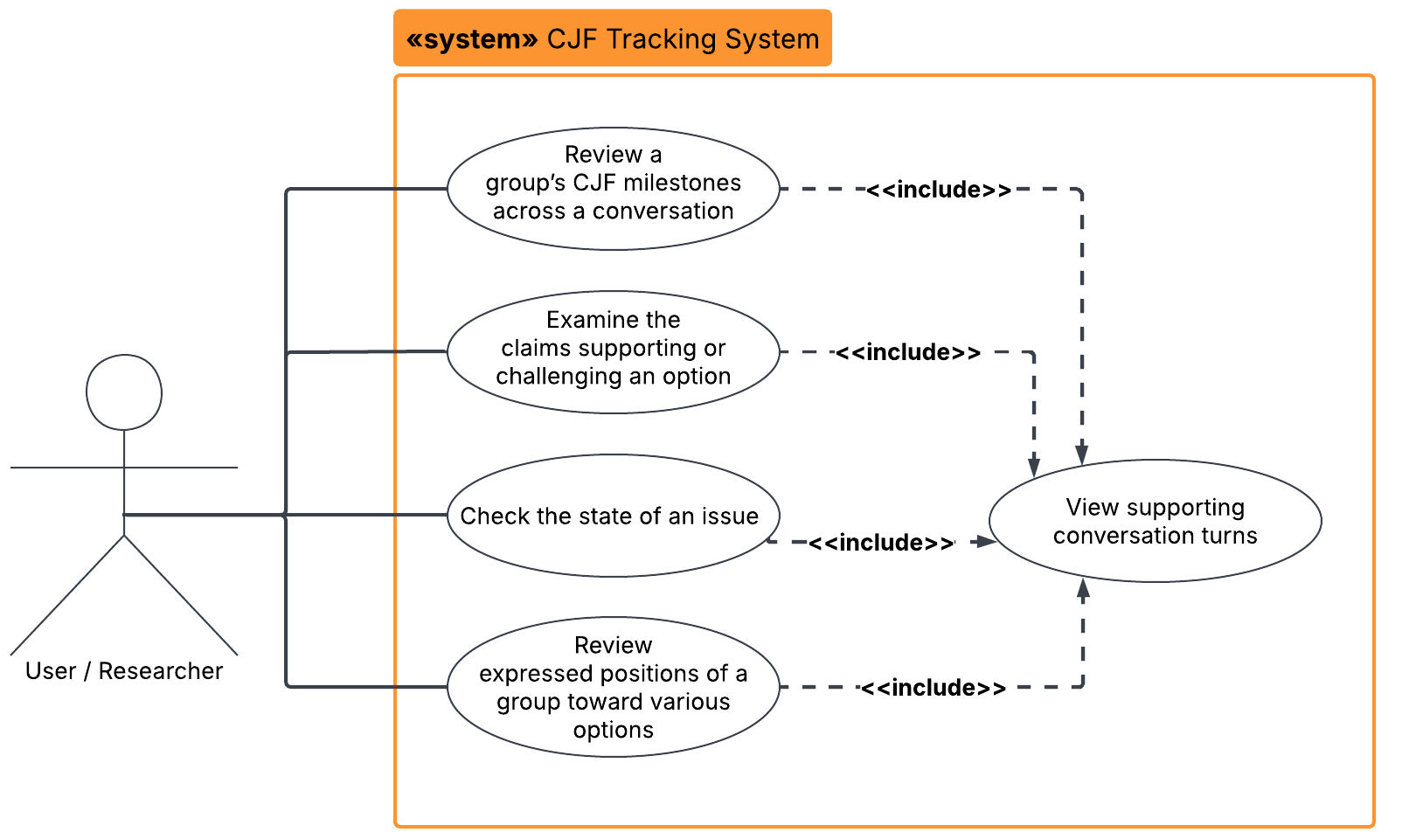

High Level Overview (Component Diagram)

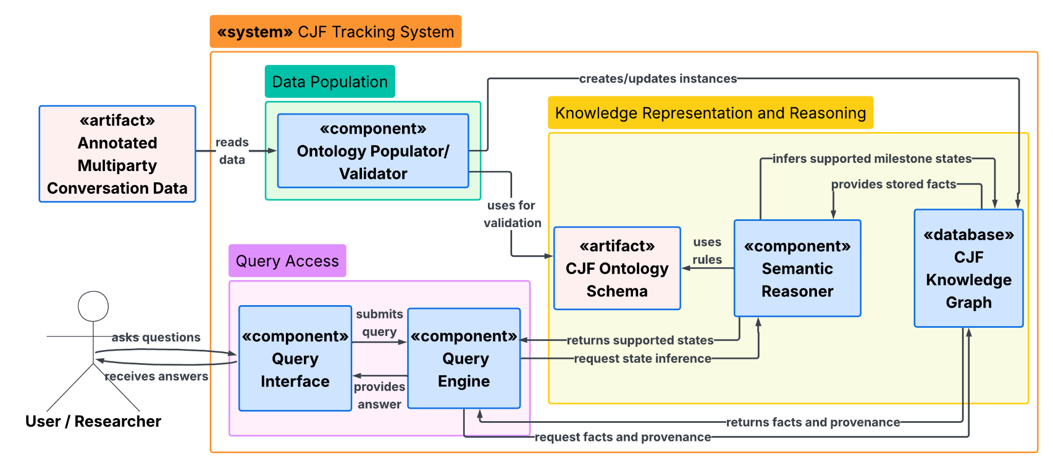Basic Flow Usage Scenario 1 Diagram:

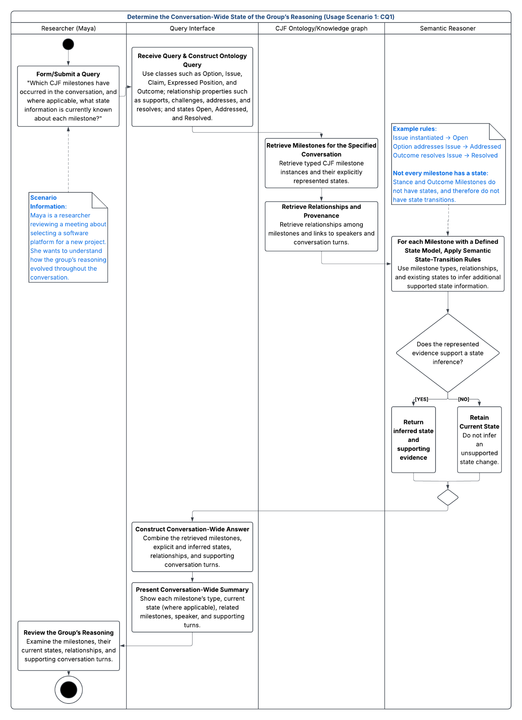
Alternative Flow Activity Diagram:
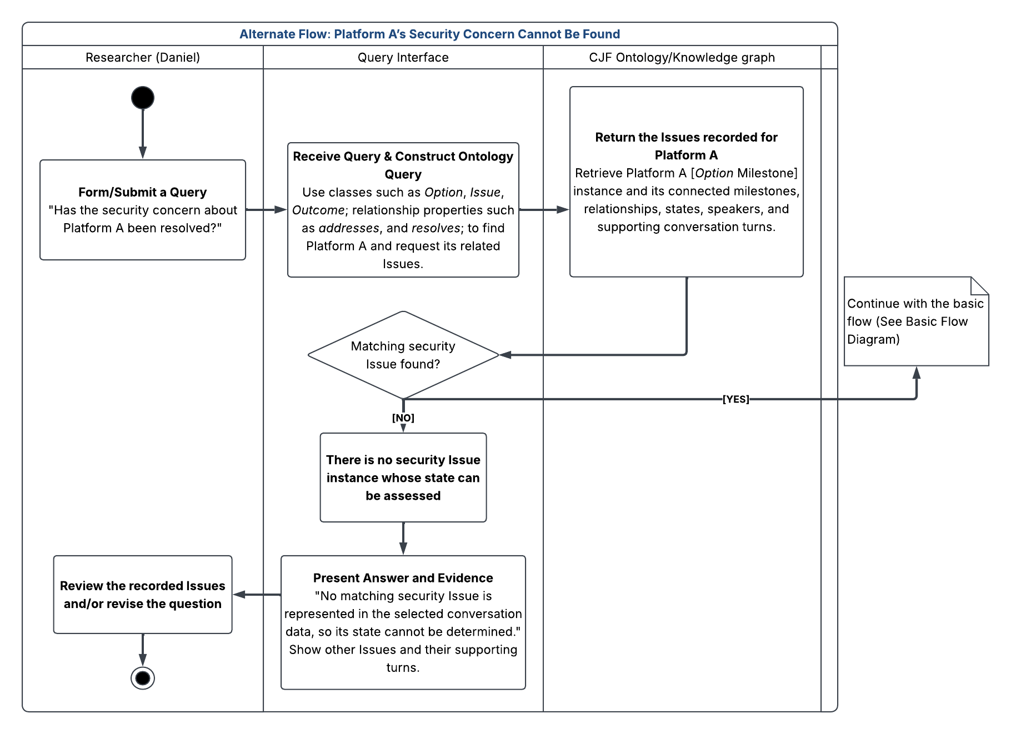

VII. Competency Questions

Provide at least 2 competency questions that you will ask of the vocabulary/ontology/knowledge base to implement this use case, including example answers to the questions.
- at least 2 competency questions per scenario

Describe at least one way you expect to use the semantics and/or provenance to propose an answer to the questions. Include an initial description of why the semantics and/or provenance representation and reasoning provides an advantage over other obvious approaches to the problem. (optional – depending on the use case and need for supporting business case).

Scenario 1: Determine the Conversation-Wide State of the Group’s Reasoning

Question 1: Which CJF milestones have occurred in the conversation, and where applicable, what state information is currently known about each milestone where a state applies?

Let's say a team is discussing which software platform to adopt for a new project:
Example Answer:
- Option 1: Use Platform A - Under Consideration. Speaker A proposes Platform A at Turn 2.
- Issue 1: Concern about the cost of Platform A - Open. Speaker B raises this concern at Turn 5.
- Option 2: Use Platform B instead - Under Consideration. Speaker C proposes Platform B as an alternative at Turn 9.
- Claim 1: Platform B has a lower expected cost - Unassessed. Speaker C makes this Claim at Turn 10; it supports Option 2.
- Issue 2: Concern about implementation time for Platform B - Open. Speaker D raises this concern at Turn 11.

How the ontology would support the answer:
The ontology could include a general CJF Milestone class with more specific milestone types such as Issue, Option, Claim, and Outcome. The query retrieves the milestones linked to the selected conversation, their types, current recorded states, and source turns. It identifies Platforms A and B as Options linked by alternativeTo. Issue 1 is linked to Option 1 through isAbout, Issue 2 is linked to Option 2 through isAbout, and Claim 1 is linked to Option 2 through supports. These relationships show which concern or claim belongs to which Option, even when the contributions occur in different turns.
The ontology returns Under Consideration for both Options, Open for both Issues, and Unassessed for the Claim, based on the state information represented for them. If later turns provide evidence for a state change, the ontology can use the relevant milestones and relationships to update the state information based on state transition rules. This question is primarily a retrieval question. The user can query the milestones represented in the ontology and get returned state information that is explicitly known or has been inferred from conversational evidence.

Question 2: Which Issues raised during the conversation are currently Addressed or Resolved, and what conversational evidence supports each Issue’s current state?

Example Answer:
Cost concern for Platform A - resolved.

- At turn 15, speaker A proposes, “We can reallocate funds from another part of the budget to cover this purchase.” This contribution is represented as an Option that addresses the cost Issue. Based on this relationship, the Issue moves from Open to Addressed.

- At turn 18, speaker C says, “Let’s do that.” In this context, the contribution is represented as a group Outcome that resolves the cost Issue. Based on this relationship, the Issue moves from Addressed to Resolved.

Training concern for Platform A - addressed
- At Turn 20, speaker A proposes a training plan by stating, “Training can be done on Monday’s break from 5-6.” This contribution is represented as an Option that addresses the training Issue. Based on this relationship, the Issue moves from Open to Addressed.
- No later Outcome with a resolves relationship to the training Issue is represented in the ontology. Therefore, its current supported state remains Addressed.

How the ontology would support the answer:
Conversational evidence refers to the specific transcript turns and text spans that support an annotation or state inference. This evidence includes the speaker, turn number, relevant utterance quotation, milestone type, and semantic relationships that support the inference.
Before the use case begins, the annotation or extraction component identifies the relevant milestones and relationships and links them to their source turns. In this example, it identifies:
- An Issue representing the cost concern.
- An Option at Turn 15 that addresses the cost Issue.
- An Outcome at Turn 18 that resolves the cost Issue.
- An Issue representing the training concern.
- An Option at Turn 20 that addresses the training Issue.
The ontology then applies the following state-transition rules:
- When an Issue is instantiated → Open
- Option addresses Issue → Addressed
- Outcome resolves Issue → Resolved
The query returns each Issue’s inferred current state together with the evidence path that supports it. For example, the cost Issue is returned as Resolved because the ontology can trace it from the Issue to the addressing Option at Turn 15 and then to the resolving Outcome at Turn 18. The training Issue is returned as Addressed because an addressing Option is represented at turn 20, but the query does not find an Outcome that resolves the Issue.
Under the open world assumption, missing evidence is not treated as evidence of resolution. Therefore, the ontology reports that no resolving Outcome was found rather than assuming that the training Issue was resolved.

--------------------
Scenario 2: Examine the Subgraph Around a Specific Option

Question 3: What claims or issues support or challenge Platform A?

Let's again say team is discussing which software platform to adopt for a new project:
Example Answer:
Platform A is supported by two Claims:

- At Turn 4, Speaker A says, “Platform A could simplify implementation.” This Claim supports the Platform A Option.

- At Turn 8, Speaker C says, “Platform A integrates well with our existing systems.” This Claim also supports the Platform A Option.

Platform A is challenged by two Issues:

- At Turn 5, Speaker B raises a cost concern: “I’m concerned Platform A will cost more than we can afford.” This Issue challenges the Platform A Option.

- At Turn 7, Speaker D raises a training concern: “I’m worried employees will need additional training for Platform A.” This Issue also challenges the Platform A Option.

How the ontology would support the answer:
Before the query, the contributions are represented as CJF milestones linked to their speakers, turns, and relevant text spans. Platform A is represented as an Option. The statements at Turns 4 and 8 are represented as Claims with supports relationships to that Option. The concerns at Turns 5 and 7 are represented as Issues with challenges relationships to the Option.

Unlike CQ2, this query starts at Platform A rather than looking at the entire conversation. The query starts with the Platform A Option and follows its incoming supports and challenges relationships. It retrieves each connected milestone, speaker, and source turn. The answer groups the Claims under “supports” and the Issues under “challenges,” with the quotations showing the conversational evidence for each link. This question uses the relationships already represented in the ontology; it does not require a state-transition rule to determine whether a Claim is Accepted or an Issue is Resolved.

Question 4: Which issues are associated with Platform A, and can they be inferred to be addressed or resolved?

Example Answer:
Employee training concern - Addressed.
- At Turn 7, Speaker D raises an Issue about the additional training Platform A may require. This Issue challenges Platform A.
- At Turn 20, Speaker A proposes, “Training can be done on Monday’s break from 5-6.” This Option addresses the training Issue, moving it from Open to Addressed.

Cost concern - Resolved.
- At Turn 5, Speaker B raises an Issue about Platform A’s cost. This Issue challenges Platform A.
- At Turn 15, Speaker A proposes, “We can reallocate funds from another part of the budget to cover this purchase.” This Option addresses the cost Issue, moving it from Open to Addressed.
- At Turn 18, following group agreement, Speaker C says, “Let’s do that.” In this context, the turn records an Outcome that selects the funding Option and resolves the cost Issue, moving the Issue to Resolved.

How the ontology would support the answer:
The ontology could represent the concerns as Issue milestones connected to Platform A through relationships such as challenges or isAbout. A query for Platform A retrieves those Issues and the conversation turns where they were raised. Later Options can be connected to the Issues through addresses, while an Outcome can select an Option and be connected to an Issue through resolves.
Semantic reasoning can use combinations of these relationships to infer state information. For example, a later Option that addresses an Issue can support a transition from Open to Addressed. If an Outcome selects that addressing Option and also resolves the Issue, the Issue can be inferred to be Resolved In the cost example, the query follows the Issue to the addressing Option at Turn 15 and the resolving Outcome at Turn 18. In the training example, it finds the addressing Option at Turn 20, so Addressed is the latest supported state. No resolving Outcome is represented for the training Issue in the selected data.
The state annotation produced by an LLM or human annotator can be kept separately as a reference label. It does not need to be used as the input for the reasoning rule. This allows the inferred ontology state to later be compared with the annotated state to evaluate whether the semantic rules produce the expected result.

—-----------------
Resources needed: These questions require multiparty conversation data with identified speakers and turns, such as DeliData or transcribed chatroom discussions. AIF and AIFdb may help inform the representation of argumentative relationships, while PROV-O may support links between milestones, and their source turns and speakers. These resources are described in Section VIII.
The CJF milestone types and relationships used in this project are based on an aggregation of concepts from argumentation, dialogue-move, discourse-analysis, deliberation, and collaborative decision-making literature. These resources are included in section IX, References and Bibliography.

---------------------
Semantic representation provides two different capabilities in these competency questions. First, it gives explicit meaning to the relationships between milestones across different speakers and conversation turns. For example, the ontology can distinguish that one contribution supports an option, another challenges it, and another addresses a previously raised issue.
Second, semantic reasoning can use combinations of these represented relationships as evidence for higher-level CJF states. Rather than requiring the annotation system to directly assign every current state, the ontology can infer some states from the structure of the represented conversation. For example, an Issue with an addressing Option may be inferred to be Addressed. If an Outcome selects or adopts that Option and has a resolves relationship to the Issue, the Issue may be inferred to be Resolved.
Annotated state labels can still be retained as part of the CJF annotation data, but they can serve as reference labels rather than the only source of state information. This creates a separation between the conversational evidence used for semantic reasoning and the annotated state used to evaluate the result.
Provenance can also link milestones and inferred states back to the conversation turns that provide their supporting evidence. This allows a user to determine not only that an Issue was inferred to be resolved, but also which contributions supported that inference.

Question 5: Which speakers explicitly expressed that they voted for the Option ultimately selected by the group in the conversation?

Example Answer:

- At turn 7 Kaeya says she favors Platform A
- At turn 8 Diluc vote for Platform A

How the ontology would support the answer:

CQ5 and CQ6 are focused on Use case 3 where we look at the conversation from the angle of speaker position on the outcome option. Before the query, relevant contributions are represented as CJF milestones linked to their speakers, conversation turns, and supporting text spans. Platform A is represented as an Option, and the group's final decision is represented as an Outcome that selects Platform A. To answer the query, the ontology first retrieves the Option selected by the Outcome and then retrieves the Position milestones associated with that Option. These milestones are linked through provenance to the corresponding speaker, conversation turn, and text span, allowing the query to identify which speakers explicitly expressed a vote for the Option selected by the group. This distinguishes individual expressed positions from the group-level Outcome.

Question 6: What positions did Diluc express toward Platform A and B throughout the conversation?
Example Answer:

- Turn 5: Diluc expressed an implied positive position toward Platform B, stating that he preferred Platform B because it was less costly.
- Turn 8: Diluc expressed an explicit positive position toward Platform A by voting for Platform A.

How the ontology would support the answer:

The stored information used for this CQ is similar to CQ5, but the query is centered on a particular speaker rather than on the selected Outcome. The ontology retrieves all Position milestones associated with Diluc in the conversation and follows their positionTowards relationships to identify the Options toward which those positions were expressed. Each position is linked through provenance to its source utterance and conversation turn. By ordering these milestones according to their turns, the query can show that Diluc first expressed a positive position toward Platform B at Turn 5 and later expressed a positive position toward Platform A at Turn 8. Related contributions from intervening turns can also be retrieved to provide the conversational evidence that preceded the change in position.

Question 7: Which Claims supporting or challenging Platform A or Platform B were introduced between Diluc’s preference for Platform B and his later vote for Platform A, and who introduced them?

Example answer:

Using Scenario 3 example,
- Turn 5: Diluc (earlier position): expresses a preference for Platform B because he considers it less costly.
- Turn 7: Kaeya (intervening Claim): presents a revised cost comparison that includes training costs. In this illustrative example, the comparison shows that Platform A has a lower total cost. This Claim supports Platform A and is returned by the query.
- Turn 8: Diluc (later position): explicitly votes for Platform A.

How the ontology supports the answer:

The query retrieves Diluc’s two Expressed Position milestones and their source turns. It then finds Claim milestones introduced between those turns whose recorded supports or challenges relationships connect them to either Option. Each result includes the Claim, its relationship to the Option, its speaker, and its supporting turn and text span.

VIII. Resources
In order to support the capabilities described in this Use Case, a set of resources must be available and/or configured. These resources include the set of actors listed above, with additional detail, and any other ancillary systems, sensors, or services that are relevant to the problem/use case.

This use case requires multiparty dialogue data with identified speakers and conversation turns. The Albany MPC Dialogue Chat Corpus is the primary data source selected for the class implementation. DeliData and AMI are optional alternatives. AIF and AIFdb provide structured argument representations that could be used to examine and test argumentative relationships.
Knowledge Bases, Repositories, or other Data Sources

Data | Type | Characteristics | Description | Owner | Source | Access Policies & Usage
(dataset or repository name) | (remote, local/in situ, etc.) | e.g. – no cloud cover | Short description of the dataset, possibly including rationale of the usage characteristics |  | Source (possibly a system, or remote site) for discovery and access
Albany MPC Dialogue Chat Corpus | Restricted-access multiparty dialogue corpus; selected XML files stored locally for the project | contains 35 synchronous multiparty chat discussion. Each conversation contains ordered turns with speaker identifiers, timestamps, and utterance text. | We will use four selected conversations: Feb19 GroupA, concerning which city should host the Olympics; Mar07 GroupB, concerning the selection of a dormitory resident assistant; Mar11 GroupB, concerning which public service should receive tax funding; and Mar14 GroupA, concerning the most influential person of the previous decade. These conversations will be annotated or reviewed for CJF milestones, relationships, states, and supporting conversational evidence before modeling | Copyright Research Foundation of the State University of New York.  Corpus contact: Tomek Strzalkowski. | Available from the dataset provider or through the Linguistic Data Consortium. Corpus documentation: https://aclanthology.org/L10-1050/ | Available for research and noncommercial use with required attribution. The license contact, Tomek, gave the project permission to use the selected conversations as described and publish the ontology to the web. A small project subset may be included with the public ontology implementation, but the complete corpus cannot be openly redistributed.  Required as the primary data source for the class implementation.
DeliData | Multiparty deliberation dialogue dataset | Annotated group problem-solving conversations | DeliData contains multiparty problem-solving conversations with utterance-level annotations for deliberative behaviors such as reasoning, solutions, agreement, disagreement, and probing. It can provide dialogue examples that CJF milestones and their relationships can be represented from in the ontology. | Karadzhov, Stafford, and Vlachos | https://huggingface.co/datasets/gkaradzhov/DeliData | Publicly available  Optional / candidate data source
AMI Corpus | Multiparty meeting dialogue dataset | Group meetings with multiple speakers, transcripts, and dialogue annotations | The AMI Meeting Corpus contains multiparty meeting conversations that follow groups working together on a product design task, where participants discuss ideas and make decisions throughout the project. It can provide dialogue examples that CJF milestones and their relationships can be represented from in the ontology. | AMI Consortium | https://groups.inf.ed.ac.uk/ami/corpus/overview.shtml | Publicly available under a Creative Commons Attribution 4.0 license.  This is an optional candidate data source- it could provide additional conversations for testing how the ontology represents evolving group reasoning.
AIFdb / Argument Web | Argument knowledge base / repository | Online repository of structured argument data represented using AIF | AIFdb provides access to corpora of analyzed arguments represented as structured nodes and relationships using the Argument Interchange Format (AIF). It could provide examples for examining how argumentative relationships might be represented/mapped to relationships between CJF milestones. | Centre for Argument Technology (ARG-tech) | http://aifdb.org/search  https://corpora.aifdb.org/ | ARG-tech states that its argument corpora are free for academic use.  AIFdb is optional as a candidate knowledge source for examining and testing representations of argumentative relationships.

External Ontologies, Vocabularies, or other Model Services

Resource | Language | Description | Owner | Source | Describes/Uses | Access Policies & Usage
(ontology, vocabulary, or model name) | (ontology language and syntactic form, e.g., RDFS - N3) | If the service is one that runs a given ontology or model-based application at a given frequency, state that in addition to the basic description |  | Source (link to the registry or directly to the ontology, vocabulary, or model where that model is maintained, if available) | List of one or more data sources described by and/or used by the model
Argument Interchange Format (AIF) | OWL-DL, RDF-S and SQL, and many more formats  RDFS – RDF/XML | AIF is a semantic representation for argument structures and relationships. It could provide existing concepts or modeling patterns for representing how reasoning supports/conflicts with other reasoning. The CJF ontology would extend beyond argument structure to represent CJF milestone types, speakers, conversation turns, and changing states. | AIF community / ARG-tech | ARG-tech AIF specification:  https://www.arg.tech/index.php/research/contributing-to-the-argument-interchange-format/ | DialAM (listed in my references below) represents its dialogue and argumentative relations as AIF nodes and edges. In this use case, AIF could help describe argumentative relationships extracted from multiparty dialogue | Publicly described and used in argumentation research. Specific implementations and datasets may have their own licenses.  Optional Resource
PROV-O | OWL 2 – Turtle (also available in RDF/XML, and XSD) | PROV-O is an ontology for representing provenance: where information came from, who/what was responsible for it, and how it was generated/derived. It could be reused to represent provenance for CJF milestones, such as the conversation turn a milestone was extracted from and the annotation/extraction process that produced it. | W3C Provenance Working Group | https://www.w3.org/TR/prov-o/ | Not tied to a specific data source; designed to describe provenance information generated by different systems.  In this use case, it could be used to describe the provenance of milestones, states, speakers, turns, and the extraction process used to generate them. | Public W3C Recommendation; available for reuse.  Optional Resource

Other Resources, Service, or Triggers (e.g., event notification services, application services, etc.)
Resource | Type | Description | Owner | Source | Access Policies & Usage
(sensor or external service name) |  | Include a description of the resource as well as availability, if applicable | Primary owner of the service | Application or service URL; if subscription based, include subscription and any subscription owner
Fixed LLM-assisted annotation workflow | Model / annotation support | Uses the initial CJF milestone and relationship categories as seed candidates to generate structured candidate annotations. The output identifies the milestone type, source turn or text span, related milestones, relationship type, supporting evidence, and an optional uncertainty flag. Any utterance that does not fit the initial categories may be flagged for human review. | Depends on the Model used | Exact model and version to be determined and documented before annotation begins | Access and usage depend on the selected model or service. I can use an open source model and GPUs from my lab’s server.  One fixed model and workflow will be required to prepare candidate annotations for a small conversation subset.  A human reviewer will verify and correct the output before it is loaded into the ontology. Model comparison and LLM performance evaluation are outside the project scope

IX. References and Bibliography

List all reference documents – policy documents, regulations, standards, de-facto standards, glossaries, dictionaries and thesauri, taxonomies, and any other reference materials considered relevant to the use case

Multiparty Conversation Datasets:
Georgi Karadzhov, Tom Stafford, and Andreas Vlachos. 2023. DeliData: A Dataset for Deliberation in Multi-party Problem Solving. Proc. ACM Hum.-Comput. Interact. 7, CSCW2, Article 265 (October 2023), 25 pages. https://doi.org/10.1145/3610056
-------------------
Jean Carletta, Simone Ashby, Sebastien Bourban, Mike Flynn, Mael Guillemot, Thomas Hain, Jaroslav Kadlec, Vasilis Karaiskos, Wessel Kraaij, Melissa Kronenthal, Guillaume Lathoud, Mike Lincoln, Agnes Lisowska, Iain McCowan, Wilfried Post, Dennis Reidsma, and Pierre Wellner. 2005. The AMI meeting corpus: a pre-announcement. In Proceedings of the Second international conference on Machine Learning for Multimodal Interaction (MLMI'05). Springer-Verlag, Berlin, Heidelberg, 28–39. https://doi.org/10.1007/11677482_3
--------------------------------------------------------------------------------------------------------------------------------

CJF Theoretical Basis/Definition:
Mallick, R., Paletz, S. B. F., Kane, A. A., Do, K., Porter, A., Diep, M., & Fabian, C. A. (2026). Model of Collective Judgment Formation for Sequential Teams in Information-Dense Scenarios. Proceedings of the Human Factors and Ergonomics Society Annual Meeting, 0(0). https://doi.org/10.1177/10711813261475151

This paper gives the theoretical basis for CJF as something that develops over time, rather than just a final decision. It describes CJF as a dynamic process where information is interpreted and integrated as the team's judgment develops.
---------------------------------------------------------------------------------------------------------------------------------

External Vocabularies/Ontology Resources:
Lawrence, John and Chris Reed. “AIFdb Corpora.” Comma (2014).
—----------------
Rahwan, Iyad & Reed, Chris. (2009). The Argument Interchange Format. 10.1007/978-0-387-98197-0_19.
—----------------
Lebo, Timothy & Sahoo, Satya & Mcguinness, Deborah & Belhajjame, Khalid & Cheney, James & Corsar, David & Garijo, Daniel & Soiland-Reyes, Stian & Zednik, Stephan & Zhao, Jun. (2013). PROV-O: The PROV Ontology.
—------------------------------------------------------------------------------------------------------------------------------
Terminology list references:

[1] J. Kim, J. Li, and T. Kim, “Towards identifying unresolved discussions in student online forums,” in Proc. NAACL HLT 2010 Fifth Workshop on Innovative Use of NLP for Building Educational Applications, Los Angeles, CA, USA, 2010, pp. 84–91. [Online]. Available: https://aclanthology.org/W10-1012/

[2] V. Pallotta and R. Delmonte, “Automatic argumentative analysis for interaction mining,” Argument & Computation, vol. 2, nos. 2–3, pp. 77–106, 2011, doi: 10.1080/19462166.2011.608225.

[3] N. Asher, J. Hunter, M. Morey, F. Benamara, and S. Afantenos, “Discourse structure and dialogue acts in multiparty dialogue: The STAC corpus,” in Proc. 10th International Conference on Language Resources and Evaluation (LREC’16), Portorož, Slovenia, 2016, pp. 2721–2727. [Online]. Available: https://aclanthology.org/L16-1432/

[4] V. M. Karan et al., “LEDA: A large-organization email-based decision-dialogue-act analysis dataset,” in Findings of the Association for Computational Linguistics: ACL 2023, Toronto, Canada, 2023, pp. 6080–6089, doi: 10.18653/v1/2023.findings-acl.378.

[5] C. Roberts, “Information structure in discourse: Towards an integrated formal theory of pragmatics,” in OSU Working Papers in Linguistics, vol. 49, J. H. Yoon and A. Kathol, Eds. Columbus, OH, USA: Ohio State University, 1996, pp. 91–136.

[6] R. T. Kasper, P. C. Davis, and C. Roberts, “An integrated approach to reference and presupposition resolution,” in The Relation of Discourse/Dialogue Structure and Reference, 1999. [Online]. Available: https://aclanthology.org/W99-0101/

[7] R. Ruiz-Dolz, J. Lawrence, E. Schad, and C. Reed, “Overview of DialAM-2024: Argument mining in natural language dialogues,” in Proc. 11th Workshop on Argument Mining (ArgMining 2024), Bangkok, Thailand, 2024, pp. 83–92, doi: 10.18653/v1/2024.argmining-1.8.

[8] V. D. Lai, D. N. Pham, J. Steinberg, J. Mikeska, and T. H. Nguyen, “CAMAL: A novel dataset for multi-label conversational argument move analysis,” in Proc. 2024 Joint International Conference on Computational Linguistics, Language Resources and Evaluation (LREC-COLING 2024), Torino, Italy, 2024, pp. 2673–2682. [Online]. Available: https://aclanthology.org/2024.lrec-main.239/

[9] C. Olshefski, L. Lugini, R. Singh, D. Litman, and A. Godley, “The Discussion Tracker corpus of collaborative argumentation,” in Proc. 12th Language Resources and Evaluation Conference, Marseille, France, 2020, pp. 1033–1043. [Online]. Available: https://aclanthology.org/2020.lrec-1.130/

[10] C. S. C. Asterhan and B. B. Schwarz, “Argumentation and explanation in conceptual change: Indications from protocol analyses of peer-to-peer dialog,” Cognitive Science, vol. 33, no. 3, pp. 374–400, 2009, doi: 10.1111/j.1551-6709.2009.01017.x.

[11] D. Noble and H. W. J. Rittel, “Issue-based information systems for design,” in Computing in Design Education: ACADIA Conference Proceedings, Ann Arbor, MI, USA, 1988, pp. 275–286.

[12] G. Karadzhov, T. Stafford, and A. Vlachos, “DeliData: A dataset for deliberation in multi-party problem solving,” Proceedings of the ACM on Human-Computer Interaction, vol. 7, no. CSCW2, Art. no. 265, pp. 1–25, Oct. 2023, doi: 10.1145/3610056.

[13] R. Fernández, M. Frampton, P. Ehlen, M. Purver, and S. Peters, “Modelling and detecting decisions in multi-party dialogue,” in Proc. 9th SIGdial Workshop on Discourse and Dialogue, Columbus, OH, USA, 2008, pp. 156–163. [Online]. Available: https://aclanthology.org/W08-0125/

[14] M. G. Core and J. F. Allen, “Coding dialogs with the DAMSL annotation scheme,” in Working Notes of the AAAI Fall Symposium on Communicative Action in Humans and Machines, 1997, pp. 28–35. [Online]. Available: https://markcore.github.io/papers/97.Core-Allen.AAAI.pdf

[15] F. Niu, M. Yang, A. Li, B. Zhang, X. Peng, and B. Zhang, “A challenge dataset and effective models for conversational stance detection,” in Proc. 2024 Joint International Conference on Computational Linguistics, Language Resources and Evaluation (LREC-COLING 2024), Torino, Italy, 2024, pp. 122–132. [Online]. Available: https://aclanthology.org/2024.lrec-main.11/

[16] P. Baroni, M. Romano, F. Toni, M. Aurisicchio, and G. Bertanza, “Automatic evaluation of design alternatives with quantitative argumentation,” Argument & Computation, vol. 6, no. 1, pp. 24–49, 2015, doi: 10.1080/19462166.2014.1001791.

[17] D. Walton, “Types of dialogue and burdens of proof,” in Computational Models of Argument: Proceedings of COMMA 2010, P. Baroni, F. Cerutti, M. Giacomin, and G. R. Simari, Eds. Amsterdam, The Netherlands: IOS Press, 2010, pp. 13–24, doi: 10.3233/978-1-60750-619-5-13.

[18] P. Nowara, “Decision-O: The decision ontology,” ver. 1.0, 2017. Accessed: Sep. 23, 2026. [Online]. Available: https://github.com/nicholascar/do-on

[19] F. Vitali and S. Peroni, “The Argument Model Ontology (AMO),” ver. 1.0, 2011. Accessed: Sep. 23, 2026. [Online]. Available: https://sparontologies.github.io/amo/current/amo.html

[20] Centre for Argument Technology, “A quick start guide to Inference Anchoring Theory (IAT),” Sep. 10, 2017. Accessed: Sep. 23, 2026. [Online]. Available: https://arg.tech/~chris/acl2019tut/IAT-guidelines.pdf

[21] Tiziana Hernandez, “Conversation Labels from Literature (States_of_milestones)” working spreadsheet, 2026.

[22] Tiziana Hernandez, “Conversation Labels from Literature (Relationships_Between_Milestones)” working spreadsheet, 2026.

[23] Tiziana Hernandez, "Conversation Labels from Literature (Milestone_Taxonomy)," working spreadsheet, 2026.

[24] T. Hernandez, D. Y. De Silva, S. Sridharan, and M. A. Lausev, “Tracking Collective Judgment Formation in Multiparty Dialogue,” Ontology Engineering 2026 Course Project, Rensselaer Polytechnic Institute, Troy, NY, USA, Sep. 2026

X. Notes

There is always some piece of information that is required that has no other place to go. This is the place for that information.

