**Beer Advisor - A beer ontology**

**Lucas Standaert1, Anna Yaroslaski2, Marcelo de Castro3**

Rensselaer Polytechnic Institute1,2,3  
[standl@rpi.edu](mailto:standl@rpi.edu)1, [yarosa2@rpi.edu](mailto:yarosa2@rpi.edu)2, [decasm3@rpi.edu](mailto:decasm3@rpi.edu)3

**Abstract**

Due to the wide variety of beers with different flavor profiles and styles, choosing a beer is not a simple task. The goal of the application introduced in this paper is to provide users with contextualized beer recommendations, thereby simplifying the selection process. By matching their preferences with attributes of commercially available beer, we can provide users a collection of beers they will likely enjoy. In order to do this, we have designed an ontology with a series of semantic rules to assist our application. Inside of our ontology, beers are classified based on defined characteristics, helping us to infer a beer’s style, season, and other important characteristics. In addition to this, we have designed user profiles that allow users to store their preferences towards certain qualities of a beer. By combining these two features, we can infer different beers a user will enjoy, as well as similarities between users. There are a number of existing ontologies and accompanying applications that serve a similar function, but fail to take into account the importance of a consumer and their biases. Therefore, the current work aims to show how a beer ontology focused on providing recommendations can be implemented and used in an application. This current report also presents the technical challenges related to the implementation of such an ontology. The ontology is then evaluated using a set of competency questions and results are going to be presented.

**Introduction/Motivation***[1]*

Beer is said to be one of the oldest alcoholic drinks created by humans. In fact, we have been creating different types of beers for millennia. Due to the wide variety of beers with different flavor profiles and styles, choosing a beer is not always a simple matter. In addition, a number of craft breweries have emerged that have contributed a wide assortment of quality beers. This mass quantity of beers has led to conflicting style guidelines that label beers incorrectly. A consumer's preferences towards certain styles and brands of beer can also have a major impact on what beer they buy. Providing them with choices made by users with similar preferences can help to expand their list of potential beers. Overall knowledge of beer is another factor that can influence a consumer. While amateur beer drinkers may simply judge based upon style, beer aficionados have a much higher standard and may wish to narrow their search further. Our goal is to create an ontology that will help to resolve these discrepancies between databases, style guidelines, and marketing materials, and an application that can assist both experienced and inexperienced beer drinkers.

**Use Case**

The ontology-enabled application developed in this work aims at providing users with beer recommendations that match their preferences with attributes of commercially available beers, including local craft beers. The application combines information from different databases in order to find listings of beers that can then be organized by the beer ontology and information can be retrieved using SPARQL queries. The users might specify different sets of characteristics that they want to find in a beer. The first set is related to beer intrinsic characteristics, which include alcohol content, measured by Alcohol By Volume (ABV), bitterness. determined by the International Bitterness Unit (IBU), sweetness, measured using Original Gravity (OG) and color, using the Standard Reference Method (SRM). Ingredients are also features that belong to this set of intrinsic characteristics. The second set is related to extrinsic characteristics of beers such as its name and the brewery that produced it.

Hence, it is clear that this application has mainly two types of stakeholders that will have roles as actors. The first type of stakeholders are the primary actors that effectively use the ontology-enabled application looking for a beer. Examples of these actors include a beer drinker customer, a beer store, a bar and a beer distributor. The second main type of stakeholders will play a secondary role in the application by providing the beer data that will be organized by the ontology. Beer databases such as OpenBeerDB and beer.db are examples of this set of actors. In addition to that, breweries are important stakeholders that might not perform any action in the application.

In order to illustrate how the application can be used, three different usage scenarios of the beer recommender application are presented next.

**Scenario 1:** A person has just moved to a new town and they are looking for local beers as they want to support microbreweries that are located in that town. The person then selects a type of beer, say India Pale Ales (IPAs), and selects the town. The application should return the specified type of beer produced by breweries located in that town.

**Scenario 2:** A bar in Pittsburgh is looking for expanding its selection of beers by adding a local beer to it. However, they want winter beers, which are usually dark-colored, that have a maximum of 7% ABV. The owner can then ask for beers that are made from breweries located in Pittsburgh which have their alcohol content in the previously established ABV limit.

**Scenario 3:** A Beer Advisor user has already found a nice list of beers using the application. However, they feel that they have limited their list too much due to characteristics that might be too specific. Therefore, they expand their beer list by checking out what beers appear in other user's search history.

More details on usage scenarios and general information about our use case can be found through the link below. <https://beer-advisor--rpi-ontology-engineering.netlify.app/oe2020/beer-advisor/usecase>.

**Technical Approach**

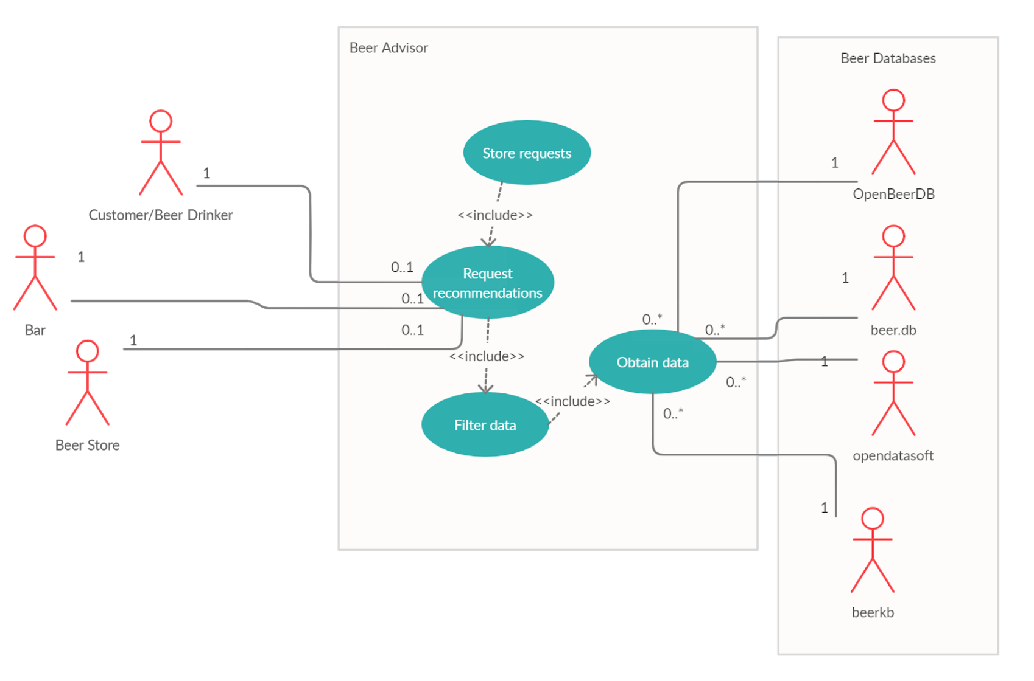

We first start with a look at the overall architecture of our application. We plan to have our application draw from several broad sources in order to populate our database. From here, these individuals will be classified utilizing inference rules in our ontology. Users will then be able to make requests to the application which will utilize our ontology to filter the data and return the results to our users. These searches will be stored for later use. Users can also be recommended beers based on their preferences and the preferences of other users.

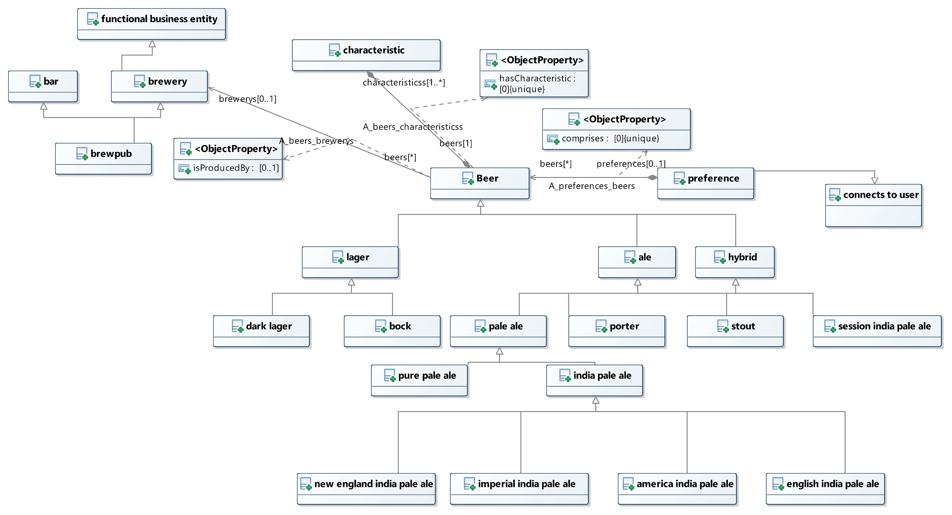

Now we introduce our beer class. Each beer has a specific alcohol content, bitterness unit, color, original gravity, and some ingredients. Beer associated with specific breweries, allowing us to ask questions based upon location. This includes both major and local breweries. The ontology then sorts beers into their specific styles utilizing the different ranges and ingredients. To help distinguish each individual style from their siblings, we have made them disjoint.

Breweries are not only classified by name and location, but also based upon whether they are a brewpub and if they serve food. Breweries are also linked to the beers they produce. This allows us to query for certain breweries based on location, specific beers made by a brewery, and a combination of the two.

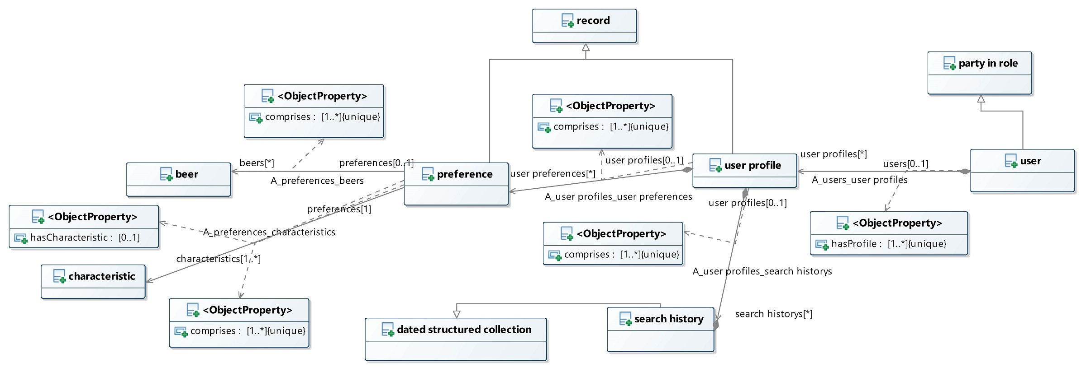

In addition to the beer and brewery class, we also describe users and their preferences.. Each user contains a user profile, which includes their preferences towards certain beers and specific characteristics. We also include their search history, which provides hints related to preferences. The search history is a dated collection, which allows us to search for more recent queries from users. Each user preference is a combination of beers and characteristics, which allows us to query and compare users based on both their search history and preferences.

Individual preferences specify specific characteristics and encode the range of values that the user claims to like.. For example, a preference towards a sweet flavor profile includes beers that have an original gravity above 1.100. This allows us to also easily compare users as this set of preferences is shared amongst them. This will also assist us in a rating system we have planned, where users will be able to provide beers with a specific rating.

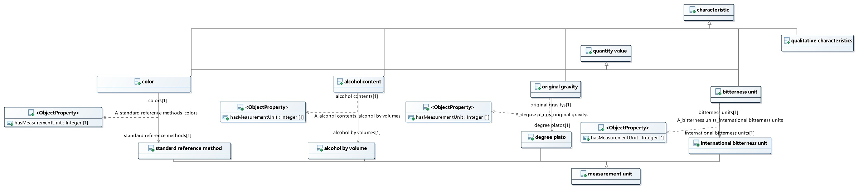

Finally, we have modeled a number of common characteristics of beer that we use for classification and comparison purposes. The four main characteristics are the original gravity, alcohol content, bitterness unit, and color. We then model a range of quantity values for each characteristic. Each value can be associated with a name for ease in querying, and given the relevant unit of measure. Beer styles are modeled based upon the appropriate range for each characteristic, and this can also be applied to individual beers. This allows us to draw and classify beers from a variety of sources using this set of characteristics, providing a standard way to classify them independent of how they are labeled.

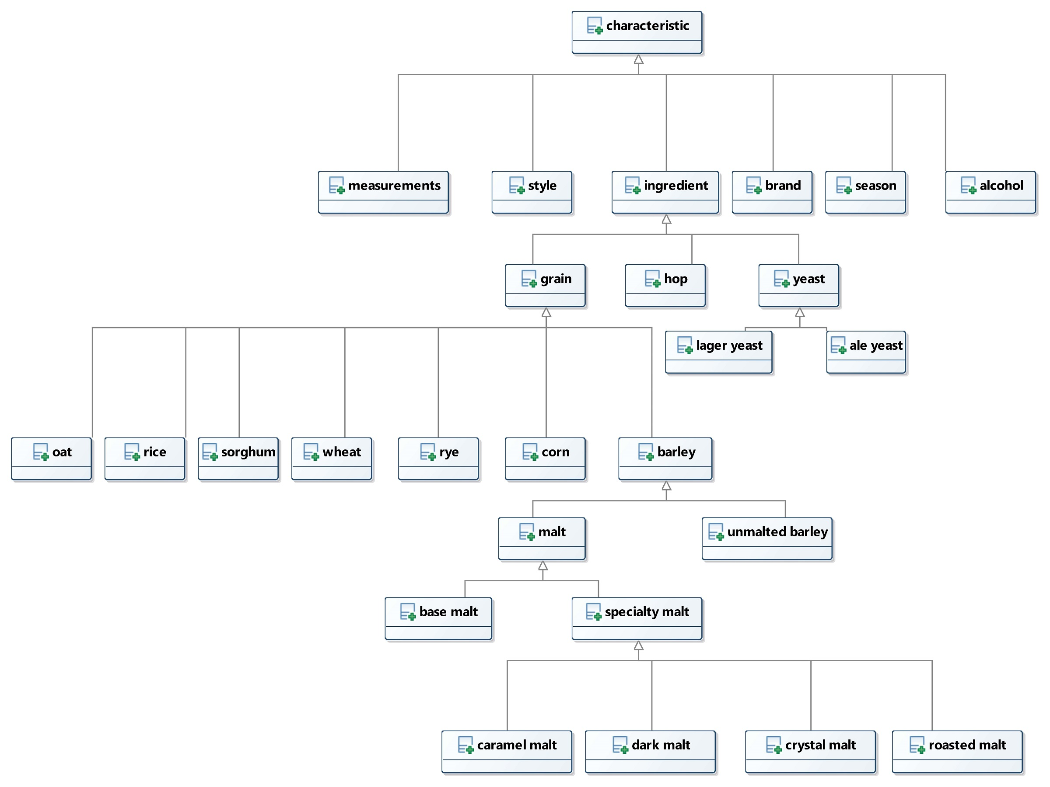

In addition to this, beers also have a wide assortment of other characteristics, including ingredients. These are more qualitative characteristics, so we decided not to focus too heavily upon them, as the above characteristics were readily available.

For more details about the structure and our conceptual models, they can be found using the link below.

<https://beer-advisor--rpi-ontology-engineering.netlify.app/oe2020/beer-advisor/ontology>

**Related Work**

The development of semantic web bolstered the number of ontology-enabled applications for recommendations of services, products and actions. Therefore, it is not surprising to find many ontologies related to classifying and recommending different types of food and beverages. These ontologies are often used as a tool that enables an application rather than the end use of a project [1]. This is because there is plenty of information on the web stored in different databases that needs to be structured. This information can then be classified and interlinked using proper classes and relations that are provided by an ontology. Applications can then leverage these ontologies to provide accurate recommendations such as for specific beverages.

In fact, one of the most well-known ontologies is the wine and food ontology presented in [2, 3]. It provides ways of classifying wines and of suggesting proper meals that accompany a particular wine. Hence, an application that leverages such an ontology could be used in different scenarios; a restaurant that wishes to list the wines that will properly accompany a new dish in the menu could use such application. Or, in addition, a wine aficionado could look for the perfect wine that will match his favorite steak dish. The ontology differentiates wine based on a number of characteristics, including color, and specifies that red, white and rose are disjoint wine classes. Wine characteristics are then used to classify a wide range of wines. For instance, Wine has subclass Red wine that has a child class Red Bordeaux that can be, for example, a Graves [2]. This type of classification approach was used as a basis for classifying beers in the ontology presented in this current report, where some overarching classes were used to comprise even more specific subclasses.

However, the wine and food ontology, as one would expect, covers only wines as beverages. On the other hand, Bevon, a beverage ontology, can be used to classify many other drinks, including beers [4]. The ontology contains classes for different types of beers such as Irish Red and Pilsner and it tries to organize its beers by using two overarching classes: Lagers and Ales. These two types of beers are not considered disjoint in Bevon. In addition to that, our current ontology has also a third overarching class: Hybrid beers. Therefore, beers that do not fit exactly into Ales or Lagers can be classified as Hybrids, such as Lambics or even Session beers. Bevon, on the other hand, would need to be extended in order to address this type of issue. Moreover, Bevon has two characteristics that are attributed to beer: color (via SRM) and bitterness (via IBU). This was also adopted in our ontology but other characteristics such as ABV and sweetness were also added. Bevon also presents a property that can represent a brewery as a characteristic of a beer. This simple solution to link a beer to its brewery, however, does not allow the representation of more information about the brewery, such as its location. Although Bevon has many interesting attributes to beers, the ontology has had its development stalled since 2015 and, therefore, it presents many limitations such as the lack of ingredients from which beer is brewed.

Ontologies such as the ones presented in [5] and [6] address this problem by adding properties that link beers to specific ingredients such as hops, malts and yeasts which can be classified into different types. The ontology in [5] is organized in a suitable way for classifying beers into many different styles and its ingredients. It also presents a characteristic that allows awards to be linked to beer individuals. However, it does not present any beer attributes that can be used to add characteristics to beers. In addition to that, the classes of beers are not very coherent since Lager and Pilsner are considered different classes without any relation between them but, in reality, a Pilsner should be considered a child class of a Lager. The ontology in [6], on the other hand, presents a set of attributes that allows alcoholic content and sweetness to be represented. In addition, [6], as the ontology presented in [4], also allows beers to be linked to breweries. In [6], however, breweries belong to a dedicated class and, therefore, more information can be attributed to it.

It is easy to see that many ontologies related to beverages were developed in the last years and that a few are especially concerned with beers. However, none of them fully address a complete classification of beer characteristics, for example. Furthermore, none of them allow the representation of beer classes that do not particularly fit the overarching classes Lagers and Ales. We can cite Lambics or even Session beers as examples of such beers that are hard to classify. None of those ontologies approached the idea of a user that could be interpreted as a beer drinker and that might have a set of beers that are preferred.

In this context, our beer ontology is developed to address all these issues, setting more characteristics to beers that are classified in a more coherent manner. For example, a beer can be connected to a list of ingredients and characteristics such as bitterness, sweetness, color and alcohol content can be attributed to beer individuals. Moreover, the ontology presented here also allows the representation of breweries which can be linked to its produced beers. The ontology presented here also allows the representation of a user class. This class is focused on the possibility that the ontology can be used in an application. The user can have preferences linked to its profile and, therefore, this information is also available to be queried. Furthermore, it is really important to highlight that our ontology has a property that helps link beer styles due to similarity. This property allows answers to be provided to queries even when there's no beer satisfying all the conditions specified by the user. This similarity property could be later extended to be inferred, instead of being explicitly declared, and to cover not only beer styles but also ingredients, users and beer-individuals.

**Evaluation**

During the course of working on this project we utilized a variety of different tools to evaluate our ontology. To check for logical inconsistencies, we employed Protege with the Pellet reasoner, the W3 RDF validator, and an RDF serializer. These were used to make sure our ontology was consistent with our design and to make sure there weren’t any syntax errors. In addition to this, we used external tools such as hygiene tests in CircleCI and Oops to perform best practice review.

Additionally, we have identified five questions that we can use to evaluate the functionality and completeness of our application. The questions and their implementation stage are as follows:

1. What are types of winter beers that are under 8% alcohol content? (Supplementary)

This is a basic lookup problem inside of our ontology. This question is currently supplementary as we were focused upon the 2nd, 3d, and 4th competency questions as our main focus. However, we would like to note that a level of complexity could be added to the solution for this question through the implementation of semantic categorization of beers into seasons. This concept, as well as our ability to semantically classify beers into styles, is covered in more detail in our discussion.

1. What is a brewery in Pennsylvania that makes IPAs under 8%? (Active)

Due to confusion surrounding our first competency question, this question targets the lookup ability of our ontology. Utilizing our query below, the ontology should return Helltown brewery.

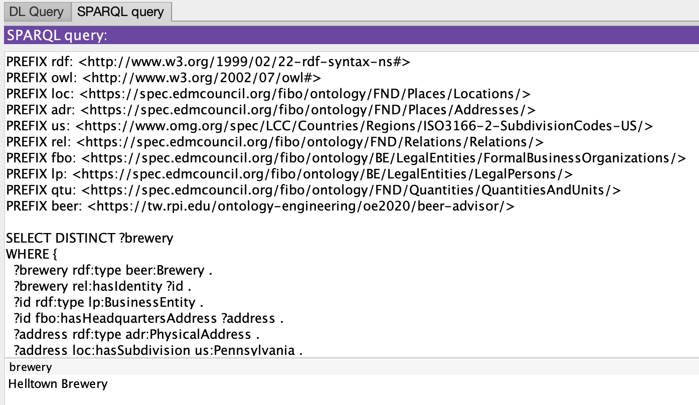

If we examine the results of this query, we find that we do obtain our expected results.



1. What is an IPA that is 5% ABV or below? (Active)

The goal of this question is to evaluate the ontology’s ability to classify beers as “similar” to each other . The application will begin by calling the following initial query:

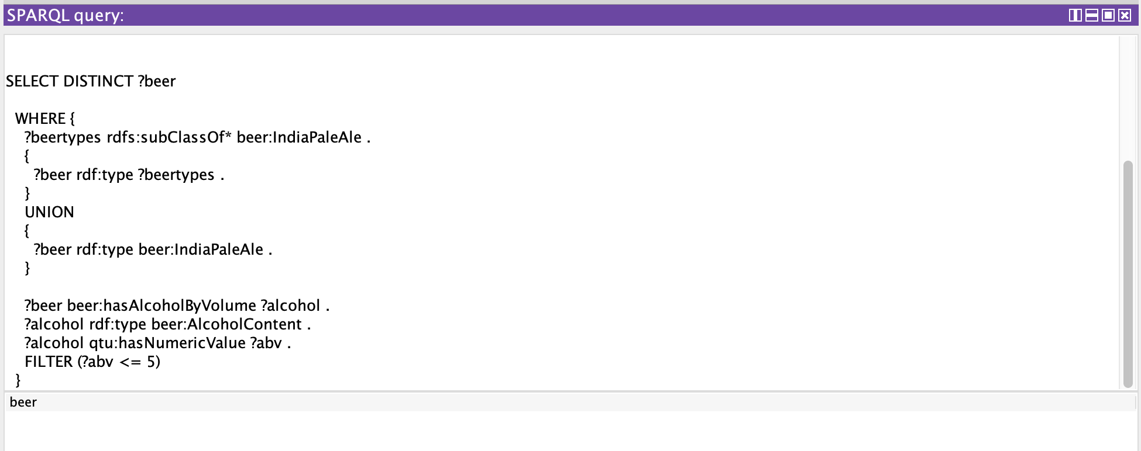

However, there are no IPAs that have an ABV of 5% or less, so this query would return no results. Rather than simply returning no results, we would like to point the user toward beers that are similar to the one that they requested. As such, whenever the query returns no results, the application should call a secondary query which is as follows:

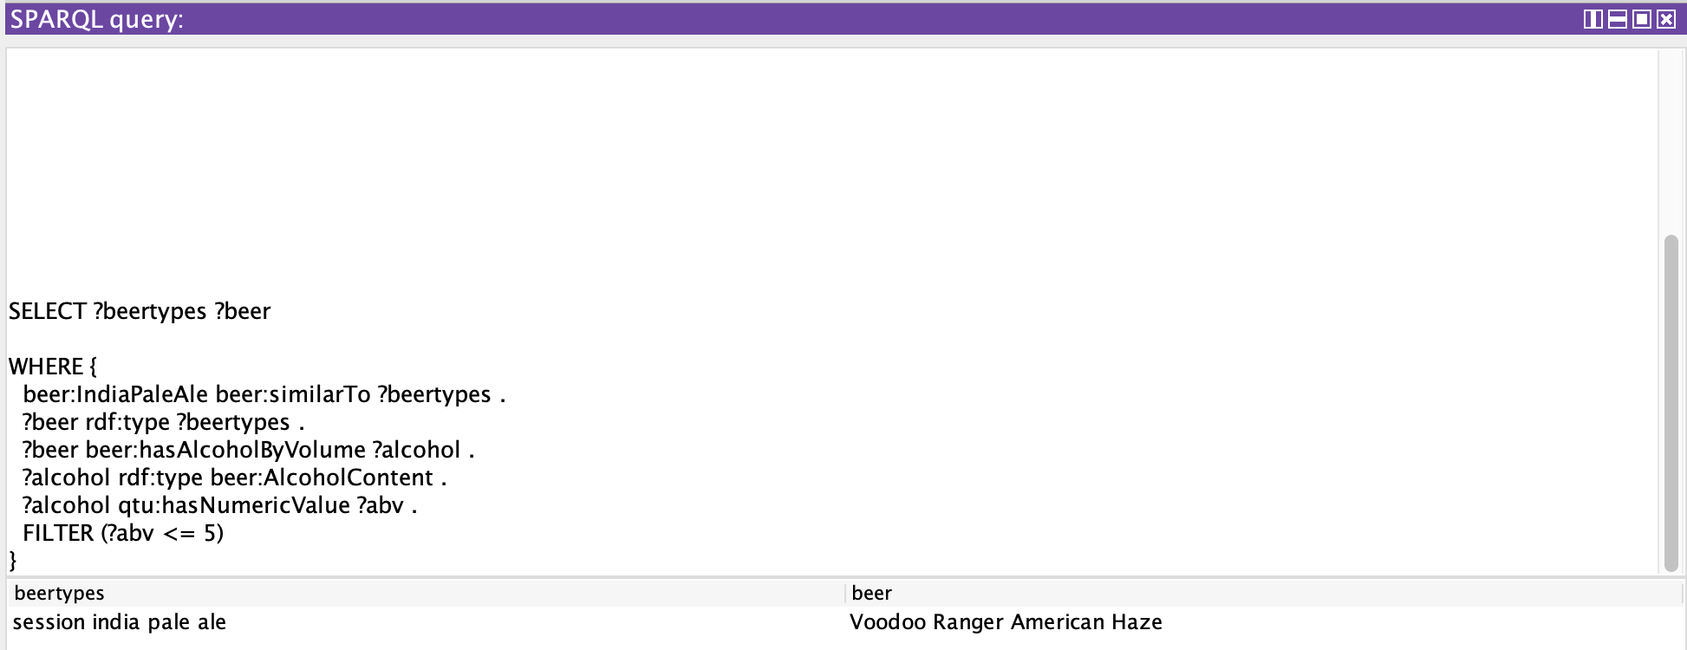

1. I really like New Belgium’s IPA’s, what other beers have people searched for from New Belgium? (Active)

This question is our baseline for evaluating our ability to semantically determine similarity between users. In this scenario, the ontology will compare different users' search histories and return beers from the New Belgium brewery that are found in others search histories. Utilizing our current ontologies, the results should be the Glutiny Pale Ale, the Fat Tire Belgian White, the Fat Tire Amber Ale, and the Voodoo Ranger American Haze. If we utilize the query below and compare it with the results beneath it, we find that it does match up.

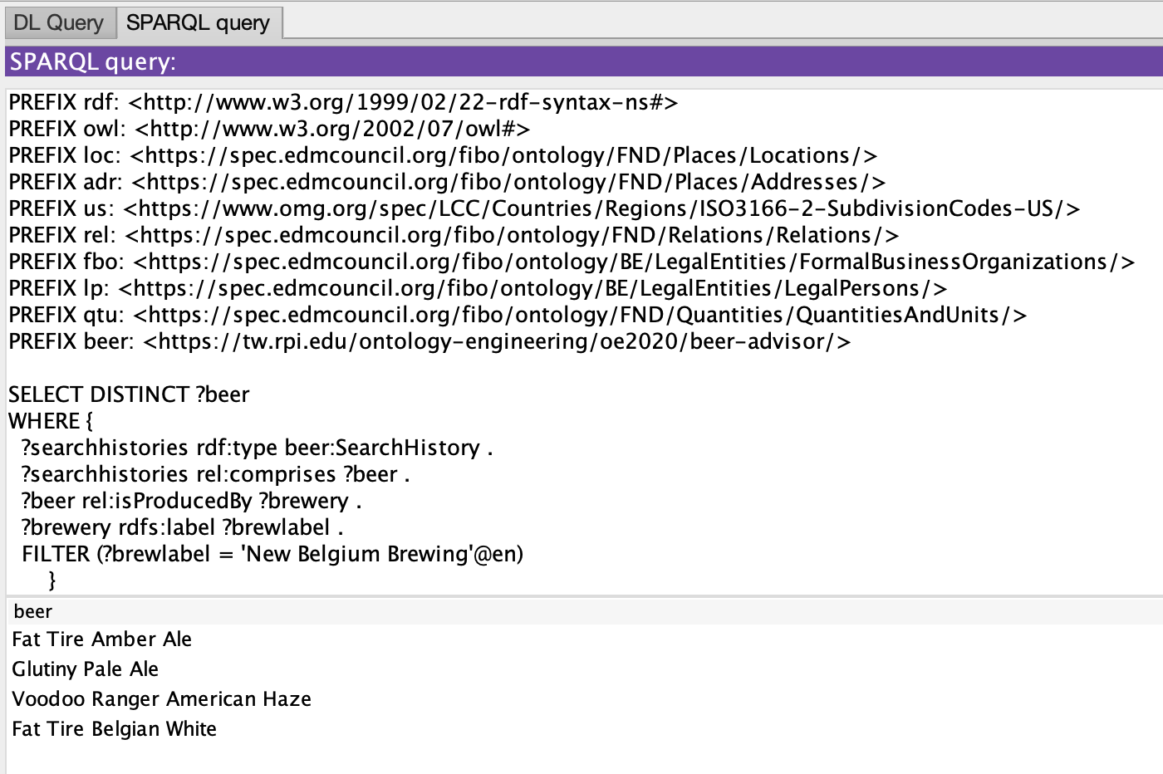

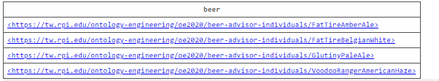

1. Is there a stout made by a local brewery in Idyllwild, California? (Future)

Due to time constraints, we decided not to focus upon this query as it would bring up a variety of different issues through location. However, in the future, this is something we plan to implement.

These five competency questions can be found in their entirety through the following link: <https://beer-advisor--rpi-ontology-engineering.netlify.app/oe2020/beer-advisor/usecase>.

To further ensure the quality and effectiveness of our ontology, we need to add additional measures. In order to do this, we’ve come up with a set metrics to help us gauge this. First we’ll look at the ontologies effectiveness in inference beer styles based upon the criteria it is given. Using smaller sample sizes, we utilize this preset data and test to see if our ontology can accurately access what style of beer each individual is. By comparing the number of correct answers to the number of incorrect answers, we can tell where the ontology may have difficulty ascertaining the style and fine tune the ontology to fix this.

The second metric we will be looking at will be in relation to our *similarTo* property. Currently this property is in its very early stages due to time constraints and we are simply tagging related beer styles. In the future we would like to expand this metric to include brewery, location, original gravity, and other important characteristics. We hope to assign scores to these beers and return a ranked list back to the user. To measure this, we will manually compute scores of beers before they enter the ontology. After this, we will compare these scores to those in the ontology to confirm they are correct, keeping track of which scores are not.

**Discussion**

The semantics in our ontology provide us a method by which we can properly categorize beers and look for similarities between both beers and users. Beers come in many different styles and are sometimes labeled incorrectly due to conflicting definitions. By providing semantics to categorize them, we can solve these inconsistencies while also leveraging this for our own means, such as providing seasonal beers. As mentioned, semantics also provide us a means to look for similarities between beers and users. By looking for overlapping characteristics in beers, we can help recommend users new beers when queries return subpar results. Similar logic can be applied to user preferences, allowing us to provide recommendations based off of other users.

**Value of Semantics**

While there are existing ontologies and concurring applications that similarly define and recommend alcoholic beverages, none focus on only beer. Choosing a beer can be a complicated process, and we believe the claims we have made in this paper will help to simplify that process. In this section we aim to provide evidence to support these claims. The first of our claims is that we will be able to categorize beers into different styles even if their style is not explicitly stated. Each style of beer has numerical ranges corresponding to our four primary attributes: alcohol by volume, international bitterness unit, color, and original gravity. By entering these values for the beer we wish to categorize we will be able to semantically determine which style the beer is. This may leave some room for possible overlap and incorrect classification. As such, although not currently implemented, we aim to add ingredients as another factor for identification, helping further the distinction between the different styles of beer. Similar to the categorization of beers into different styles, we can use semantics to determine the season of beers. The season that beers are popular is determined by their characteristics. While there is some overlap between the popular beers for each season, no two seasons have identical favored characteristics. By identifying the characteristics of the different styles of beers, we will then be able to semantically determine their season.

Our second claim is we will be able to classify beers as “similar” to each other. For our ontology, similarity is currently explicitly determined by us, based on which beers we know to be similar (e.g. Session IPAs are similar to IPAs as a Session IPA is technically a type of IPA but cannot be classified as such in our ontology due to an incompatible ABV range). As mentioned previously different styles of beer have different characteristics. This provides us with another way of defining similarity between beers that our ontology supports. We can compare the ingredients, alcohol contents, etc. of different beers and semantically categorize them as similar to each other.

Our third claim is we will be able to provide users with recommendations based on the searches of other users judged to be “similar to” the active user. All users of our application will have a profile. This profile holds information such as that user’s preferences in characteristics and styles of beer, as well as their search history. As the name would suggest, the search histories of each profile contain the list of searches the given user has made. By comparing the characteristics identified in both the active search and the search history of others we can identify the appropriate recommendations. In time we aim to add prioritization of recommendations based on the user’s preferences. This can be accomplished once again by determining similarity. As mentioned above a user’s profile contains their preferences regarding ingredients, styles, alcohol content, etc. Similarity between two users can be semantically determined by comparing their favored characteristics. Once similarity between users is determined we will be able to prioritize the favored characteristics in the search by prioritizing users that have been identified as similar.

See our project page for more information: <https://beer-advisor--rpi-ontology-engineering.netlify.app/oe2020/beer-advisor/>.

**Limitations**

There are a few limitations regarding our semantics. The first limitation is in regards to missing data. If an individual beer is missing some characteristics, it will be difficult for the ontology to correctly categorize the beer. While we are currently adding more characteristics to help and remedy this problem, there are certain characteristics that form the backbone of our ontologies categorization. These include ABV, original gravity, IBU, and color. If a database is missing one of these characteristics, it will be increasingly difficult to properly label the beer.

This limitation can further affect our similarities. If a beer is missing data, categorization can help to fill in the missing data. However, in the case of critical data being absent the ontology may label the beer incorrectly. This would give the beer incorrect values, which may cause it to show up in unrelated searches.

Finally, in a similar vein to the above limitation, there is also the issue of there being an excessive amount of overlaps between styles. If two styles are incredibly similar it can be difficult to differentiate between the two. In these cases, the beer may be labeled as belonging to both. We are trying to remedy this through the addition of more characteristics, but this may be inevitable. This becomes an even greater issue if combined with missing data.

**Future Work**

Looking towards the future, we still have a few things we will need to work on. The first is general expansion within our individuals RDF and our beer styles inside of our main RDF. We want to expand our main styles of beer to include a multitude of different beers, as this would allow us to further specify different styles of beer. We also plan to supplement our individuals with beer from existing databases, at both the local and national scale. We will also allow our users to input new beers not found in the ontology. This would allow us to return better and more accurate results to our users.

Our next plan is to incorporate a hierarchy for ranking. Currently our system looks for relatively basic similarities, utilizing styles as similarities. We want to create a much better representation for the similarities between users so the main goal here is to create a ranking system that allows us to do this. In order to do this, we will implement a series of beers inside of our individual ontology, similar to our preferences. From here, we will utilize these to make comparisons between users and different styles of beer, based upon the users criteria. Finally, we want to launch our application to the public and maintain it. This will be done after a significant period of testing to make sure that our ontology is returning the proper results. After this, we will open the app to the public for future testing and maintenance.

**Conclusion**

In this paper we introduced Beer Advisor, an ontology centered around assisting consumers select new beers to drink. Through the use of inference rules, semantics, and reasoners, the ontology can accurately provide users with new beer styles based upon queries, user preferences, and search history. The ontology also provides a way in which conflicts between style guidelines surrounding beer can be resolved. As we move into the future, we plan to expand the ontology to include more styles and continue to expand its functionality within it’s domain.

**Acknowledgements**

The authors would like to thank Elisa Kendall, Sam Stouffer, Sabbir Rashid, Shruthi Chari, and Prof. Deborah McGuiness, for their continuing support in technical matters during the development of this ontology. The authors would also like to thank Evan Wallace and Pete Rivett for providing important insights and expertise that greatly assisted this project.

**References**

[1] N. F. Noy and D. L. McGuinness, "Ontology development 101: A guide to creating your first ontology", Technical report, Stanford Knowledge Systems Laboratory, May, 2001.

[2] "Wine Ontology: an Example OWL Ontology" [Online]. Available: <http://www.daml.org/ontologies/76.html> [Accessed on 28-Nov-2020]

[3] E. I. Hsu and D. L. McGuiness, "Wine Agent: Semantic Web Testbed Application", In the *Proceedings of the Workshop on Description Logics,* Rome, Italy, 2003.

[4] "BEVON: Beverage Ontology" [Online]. Available: <http://rdfs.co/bevon/latest/html> [Accessed on 28-Nov-2020].

[5] "Beer Ontology 1.0" [Online]. Available: <https://www.cs.umd.edu/projects/plus/SHOE/onts/beer1.0.html> [Accessed on 28-Nov-2020].

[6] "Beer Ontology, OWL Lite" [Online]. Available: <https://dbs.uni-leipzig.de/files/coma/sources/fd/beer.owl> [Accessed on 28-Nov-2020].

1. Copyright © 2021, Association for the Advancement of Artificial Intelligence (www.aaai.org). All rights reserved.