| I. Use Case Description | |
| --- | --- |
| Use Case Name | *FitMe* |
| Use Case Identifier | *FM-001* |
| Source | *Ontology Engineering Class* |
| Point of Contact | *Johnny Sun Anirban Acharya*  *Dominick Iadevaia*  *Abhirup Dasgupta* |
| Creation / Revision Date | *November 1, 2024* |
| Associated Documents | *See References* |

| II. Use Case Summary | |
| --- | --- |
| Goal | *Assist people to find workouts and recipes that are all meant to better their physical health based on their current body goals.* |
| Requirements | *Recommendation must have an overall body goal, any and/or all disabilities/injuries that may affect their ROM(range of motion) or ROI(Risk of Injury), biometrics like weight, height, BMI, age, gender, and race, and any dietary restrictions. Calories Burned is Optional and will make the food recommendation much more precise.* |
| Scope | *This use case will recommend the best exercises and great recipes for the user, however will not take into account the individual's current nutritional status. The recommended exercises are common exercises that are defined by the Ontology of Physical Exercise. The recommended meals are common meals that are recommended based on their nutrient makeup. The recommended meals are pulled from a recipe database (see sources below). To determine the user’s caloric intake, we use a standardized formula that considers their age, weight, height, sex.The recommendations will either suggest specific movements for a targeted area that the user inputs and/or recipes for the user if they ask. If they do not specify, it will give movements for all body parts and recipes.*  *Preferences/Dislikes of exercises and recipes should be a part of a different use case and is not covered in this one. The system will take into account the safety of certain exercises when recommending workouts.*  *Workouts will be recommended as a cycle. (push, pull, cardio, repeat)* |
| Priority | *N/A(Only Use Case Right Now)* |
| Stakeholders | *Stakeholders could be anyone ranging from experts to non-experts in the health and wellness field. Experts may find that the system is helpful but their expertise in the area is more reliable than our use case with a limited scope.*  *Stakeholders could include but are not limited to the following:*  *Health Junkies, Amateur Gym goers, Bodybuilders, Powerlifters, Athletes, Coaches, such as those who train elite bodybuilders.* |
| Description | *Many people want to start their gym journey for their own specific goal, whether it be to lose weight, put on muscle, live a healthier lifestyle, or be more explosive for sports, but most people don’t know how to start. While there are coaching services, many beginners don’t want to spend money on something they might not want to pursue and end up quitting the gym after not seeing progress for a month doing exercises that are not efficient for their goal. This use case covers a part of this problem and will recommend efficient workout and recipes for all skill levels as well as what to avoid based on dietary restrictions, past injuries, and genetic disabilities.* |
| Actors / Interfaces | *A primary actor for this use case would be someone interested in going to the gym, who may have a physical limit factor, who wants to see an efficient workout plan and recommended healthy recipes that will help them achieve their target body goal.*  *Secondary actors for this use case include the databases/ontologies that are referenced by our use case. These references are listed in the reference section below.* |
| Pre-conditions | *Accessibility to all resources needed for data.*  *Accessibility to a local gym with the necessary machinery.(Precondition for the actor)* |
| Post-conditions | *Once the user is done seeing their recommendation, the server does nothing. Maybe another use case will add what was liked/disliked about the recommendations and can be saved.* |
| Triggers | *User wants to see their recommendations after inputting their data.* |
| Performance Requirements | *Should be relatively quick, although there is no rush* |
| Assumptions | *User has a gym that has the machinery needed*  *User can afford/acquire the food we recommend* |
| Open Issues | How to take in user information and cache it for each user. Login system? Cached to device? |

Health Goals(Dropdown(can select multiple)):

* Increase Cardiovascular Fitness
* Recovery(Injuries)
* Lose Fat
* Lose Weight
* Gain Muscle
* Gain Weight
* Gain Flexibility
* Gain Strength
* Gain Explosiveness
* Functional Training

### **Usage Scenario 1: Tailored Recommendations for Post-Injury Recovery Using Ontology Concepts**

**Persona:**

* **Name: John**
* **Age: 34**
* **Gender: Male**
* **Health Goal: Recovery (Injuries) while maintaining Cardiovascular Fitness**
* **Existing Conditions: Recent Injury to the shoulder, mild hypertension**
* **Dietary Restrictions: Lactose intolerant**

**Scenario:  
John, a 34-year-old male, recently injured his shoulder during a Weight Lifting session. He is seeking ways to recover from his shoulder Injury while maintaining his overall fitness. He signs up for the system and inputs his BMI, height, weight, age, and the details of his shoulder Injury. The system analyzes his data and recommends personalized plans targeting Recovery (Injuries) and maintaining High Cardiovascular Fitness.**

### **Workout Recommendations:**

* **Low-impact exercises such as Cycling, Stationary Cycling, or Walking are recommended to maintain Increase Cardiovascular Fitness without straining his injured shoulder.**
* **Strength-building Functional Training for lower body and core, using Calisthenics exercises like Pushups or Pullups that don't aggravate his shoulder, helping to Gain Strength in other areas while he recovers.**
* **Suggested shoulder mobility exercises focusing on Recovery (Injuries) once he is cleared for rehabilitation, including resistance band work to gradually improve flexibility and strength in the shoulder.**
* **Recommendations on workout intensity and duration, designed to balance Injury Recovery with Increasing Cardiovascular Fitness and Gain Flexibility in the shoulder.**

### **Nutrition Recommendations:**

* **The system suggests increasing Protein and omega-3 fatty acids intake to help with muscle repair and reduce inflammation, supporting his Injury Recovery.**
* **Dairy-free meals are recommended due to his lactose intolerance, while ensuring adequate intake of Calcium and Vitamin D to support bone and muscle health.**
* **A balanced diet with high Nutrition Density is suggested to support Gain Strength and prevent muscle loss during the recovery process.**

### **Key Outcomes:**

* **Recovery (Injuries): John’s workout and nutrition plans are customized to accelerate his shoulder recovery while avoiding further injury.**
* **Increase Cardiovascular Fitness: John maintains his cardiovascular fitness through low-impact exercises that don’t stress his injured shoulder, allowing him to stay active while recovering.**
* **Gain Strength: The system recommends strength-building exercises targeting the lower body and core, allowing John to stay fit and Gain Strength in areas unaffected by his injury.**
* **Gain Flexibility: Shoulder mobility exercises help John improve flexibility and strength in his shoulder, contributing to a full recovery.**

### **How the ontology is used:**

### **Once the system is queried by the user, it will reference the physical exercise ontology with the fact that the user has a shoulder injury and will generate an exercise plan that includes workouts that are safe for someone with the user’s condition. Since the user has a shoulder injury, the system would look for light shoulder exercises to recommend and recommend normal lower body workouts. All strenuous shoulder exercises will be put in the DO NOT section. This will be taken from the Ontology of Physical Exercises.**

### **Usage Scenario 2: Marathon Training Using Ontology Concepts**

**Persona:**

* **Name: Sophia**
* **Age: 28**
* **Occupation: Marketing Specialist**
* **Fitness Level: Intermediate (training for a marathon)**
* **Health Goal: Increase Cardiovascular Fitness for marathon training**
* **Dietary Preferences: No specific restrictions**
* **Concerns: Needs to optimize hydration and stamina, balance energy levels for long-distance running**

**Scenario:  
Sophia is preparing for an upcoming marathon and is looking to Increase Cardiovascular Fitness. She inputs her body data (weight, height) and daily water intake into the system. Additionally, Sophia specifies her goal of completing a marathon and sustaining energy for long-distance Running.**

**Input:  
Sophia provides her height and weight and hydration levels. She identifies her goal of Increasing Cardiovascular Fitness and building endurance for marathon training.**

### **Workout Recommendations:**

* **The system generates a weekly Running schedule designed to Increase Cardiovascular Fitness, focusing on a combination of long-distance runs and interval training to improve speed and endurance.**
* **Cross-training with exercises like Cycling, Stationary Cycling, and Swimming to prevent overuse of specific Musculoskeletal System Parts while maintaining overall fitness.**
* **Functional Training recommendations, such as Calisthenics (e.g., Pushups, Pullups) to improve core strength and support full-body fitness.**

### **Nutrition Recommendations:**

* **Based on her training intensity, the system suggests increasing Carbohydrate intake, emphasizing complex carbs like quinoa and whole grains to fuel long runs.**
* **Recommends meals high in Iron and Vitamin B12 to enhance oxygen transportation and support her muscles during endurance training.**
* **Ensures a balanced intake of Protein to help in muscle recovery and fuel her intense workout regimen.**

### **Key Outcomes:**

* **Optimized Hydration: Sophia maintains better hydration through electrolyte and water intake recommendations, tailored to her body weight and activity level.**
* **Increase Cardiovascular Fitness: The personalized training plan helps Sophia build stamina for long-distance running, while reducing the risk of Injury through appropriate recovery protocols.**
* **Balanced Nutrition: The system ensures Sophia’s body is well-nourished with the necessary Carbohydrates, Protein, and Iron, optimizing her performance, endurance, and recovery during her marathon training journey.**

### **How the ontology is used:**

### **Once the system is queried by the user, it will reference the physical exercise ontology with the fact that the user is trying to improve their running ability. Since the user has no injuries, the system would recommend all reasonable workouts. This will be taken from the Ontology of Physical Exercises The system will reference the daily caloric intake calculation(simple equation) and the daily value dataset to determine the users caloric intake/macronutrient goals for each day. With these values and the fact that the user does not have any dietary restrictions, the system will then determine a preferred food item for the user. With the preferred food item, the system will then reference the database containing recipe information and generate recipe recommendations and ensure the user does not go over their caloric goals.**

### 

### Usage Scenario 3: Tailored Training for Explosiveness and Flexibility

Persona:

* Name: Alex
* Age: 26
* Gender: Male
* Occupation: Software Developer
* Fitness Level: Advanced
* Health Goal: Gain Explosiveness and Gain Flexibility for improved athletic performance
* Existing Conditions: Occasional lower back pain from long hours of sitting
* Dietary Preferences: High-protein, low-carb diet

### Scenario:

Alex, a 26-year-old male, is an advanced-level fitness enthusiast who wants to Gain Explosiveness and Gain Flexibility to improve his overall athletic performance. He’s dealing with occasional lower back pain due to prolonged sitting at work and is seeking workouts that not only enhance his athletic performance but also relieve stress in his lower back.

Alex inputs his BMI, height, weight, fitness level, and details about his lower back pain. The system evaluates his data and provides personalized workout and nutrition plans to achieve his goals.

### Input:

Alex provides his body metrics (weight, height), current fitness level (advanced), diet preferences, and details about his lower back pain.

### Workout Recommendations:

#### Explosiveness Training:

* Plyometrics:
  + Jumping Rope: High-intensity Jumping Rope intervals to improve explosive leg power, coordination, and stamina.
  + Box Jumps: High box jumps to build leg explosiveness and enhance vertical power.
  + Clap Pushups: To develop explosive upper body strength, targeting the Chest and Triceps muscles.
* Weight Lifting (Explosive Movements):
  + Power Cleans: Full-body movement to develop explosive power in the Hamstrings, Glutes, and Back.
  + Kettlebell Swings: Explosive hip thrusts to improve core and lower back strength while enhancing explosiveness.

#### Flexibility Training:

* Dynamic Stretches:
  + Hamstring and Abdominal Muscle stretches to alleviate lower back pain and increase overall flexibility.
* Yoga for Flexibility:
  + Functional Training using yoga to improve flexibility in Hip Flexors, Hamstrings, and Lower Back.
  + Cat-Cow Pose and Cobra Pose to relieve stress in the lower back and improve overall spinal flexibility.

#### Cardiovascular and Core Work:

* Running:
  + Short sprints to develop explosiveness and improve cardiovascular health.
* Calisthenics:
  + Pullups and Pushups for core strength development, flexibility, and overall fitness.

### Nutrition Recommendations:

* To support Gain Explosiveness, the system suggests increasing Protein intake to fuel muscle growth and recovery after intense plyometric and strength workouts.
* The system recommends Carbohydrate cycling, emphasizing complex carbs like sweet potatoes and quinoa on intense workout days for added energy.
* Meals rich in Dietary Fat and Protein to support explosive strength, especially through omega-3 sources like Fish to reduce inflammation from high-intensity workouts.
* A focus on iron-rich foods (like spinach) and Water intake to prevent cramping and maintain muscle performance.

### Key Outcomes:

* Gain Explosiveness: Alex's plyometric and powerlifting exercises improve his ability to generate force quickly, enhancing his athletic performance.
* Gain Flexibility: The dynamic stretching and yoga routines increase flexibility in his lower back, Hamstrings, and Abdominal Muscles, reducing pain from long sitting hours.
* Optimized Nutrition: A high-protein, complex-carbohydrate diet ensures Alex is fueled for intense training, promoting both muscle growth and recovery.

### How the ontology is used:

### Once the system is queried by the user, it will reference the physical exercise ontology with the fact that the user is trying to relieve some stress on their lower back. Since the user has no injuries, the system would recommend all reasonable workouts with priority on exercises/stretches that aid in lower back health. This will be taken from the Ontology of Physical Exercises The system will reference the daily caloric intake calculation(simple equation) and the daily value dataset to determine the users caloric intake/macronutrient goals for each day. With these values and the fact that the user does not have any dietary restrictions, the system will then determine a preferred food item for the user. With the preferred food item, the system will then reference the database containing recipe information and generate recipe recommendations and ensure the user does not go over their caloric goals.

**IV. Basic Flow of Events**

Narrative: *Often referred to as the primary scenario or course of events, the basic flow defines the process/data/workflow that would be followed if the use case were to follow its main plot from start to end. Error states or alternate states that might occur as a matter of course in fulfilling the use case should be included under Alternate Flow of Events, below. The basic flow should provide any reviewer a quick overview of how an implementation is intended to work. A summary paragraph should be included that provides such an overview (which can include lists, conversational analysis that captures stakeholder interview information, etc.), followed by more detail expressed via the table structure.*

*In cases where the user scenarios are sufficiently different from one another, it may be helpful to describe the flow for each scenario independently, and then merge them together in a composite flow.*

| Basic / Normal Flow of Events | | | |
| --- | --- | --- | --- |
| Step | **Actor (Person)** | **Actor (System)** | **Description** |
| 0 | **User** | **~** | **User will open application** |
| 1 | **~** | **Application** | **System prompts user for physical data** |
| 2 | **User** | **~** | **User inputs physical data** |
| 3 | **~** | **Application** | **System prompts user for fitness goals** |
| 4 | **User** | **~** | **User inputs physical goals** |
| 5 | **~** | **System** | **System references user’s physical goals and users physical data and references data/ontology to get process users physical goals and physical data** |
| 6 | **~** | **System** | **From above step, system will check if users physical goals and physical data align - meaning it is safe to proceed with moving toward the goal** |
| 7 | **~** | **System** | **System determines that it is safe to proceed with the users goal.** |
| 8 | **~** | **System** | **System will analyze users fitness level, nutritional balance, and general diet health based on the users input.** |
| 9 | **~** | **System** | **System will take fitness level, user goal, and user physical data and reference exercise ontology listed above to generate a tailored workout plan for the user** |
|  | **~** |  |  |
| 10 | **~** | **System** | **System will analyse users health data, and the generated workout plan and generate food recommendations.** |
| **11** | **~** | **User** | **User accepts or denies recommendation** |

**V. Alternate Flow of Events**

Narrative: *The alternate flow defines the process/data/work flow that would be followed if the use case enters an error or alternate state from the basic flow defined, above. A summary paragraph should be included that provides an overview of each alternate flow, followed by more detail expressed via the table structure.*

| Alternate Flow of Events | | | |
| --- | --- | --- | --- |
| Step | **Actor (Person)** | **Actor (System)** | **Description** |
| 1 | **~** | **Application** | **System prompts user for physical data** |
| 2 | **User** | **~** | **User inputs physical data** |
| 3 | **~** | **Application** | **System prompts user for fitness goals** |
| 4 | **User** | **~** | **User inputs physical goals** |
| 5 | **~** | **System** | **System references user’s physical goals and users physical data and references data/ontology to get process users physical goals and physical data** |
| 6 | **~** | **System** | **From above step, system will check if users physical goals and physical data (injuries/weaknesses - can be found in exercise ontology ) align - meaning it is safe to proceed with moving toward the goal** |
| 7 | **~** | **System** | **System determines that it is unsafe to proceed with the users goal** |
| 8 | **~** | **System** | **System will warn the user that their fitness goal conflict with their physical condition (any potential injuries)** |
| 9 | **~** | **System** | **System prompts user to accept current fitness goal or modify it** |
| 10 | **User** | **~** | **User either enters yes or no to system’s prompt** |
| 11 | **~** | **System** | **IF USER ENTERED NO:**  **Return to step 1 (User will presumably alter their goals to proceed with using the system)**  **IF USER ENTERED YES:**  **Proceed to step 8 in normal flow** |

**VI. Use Case and Activity Diagram(s)**

Overview Diagram:

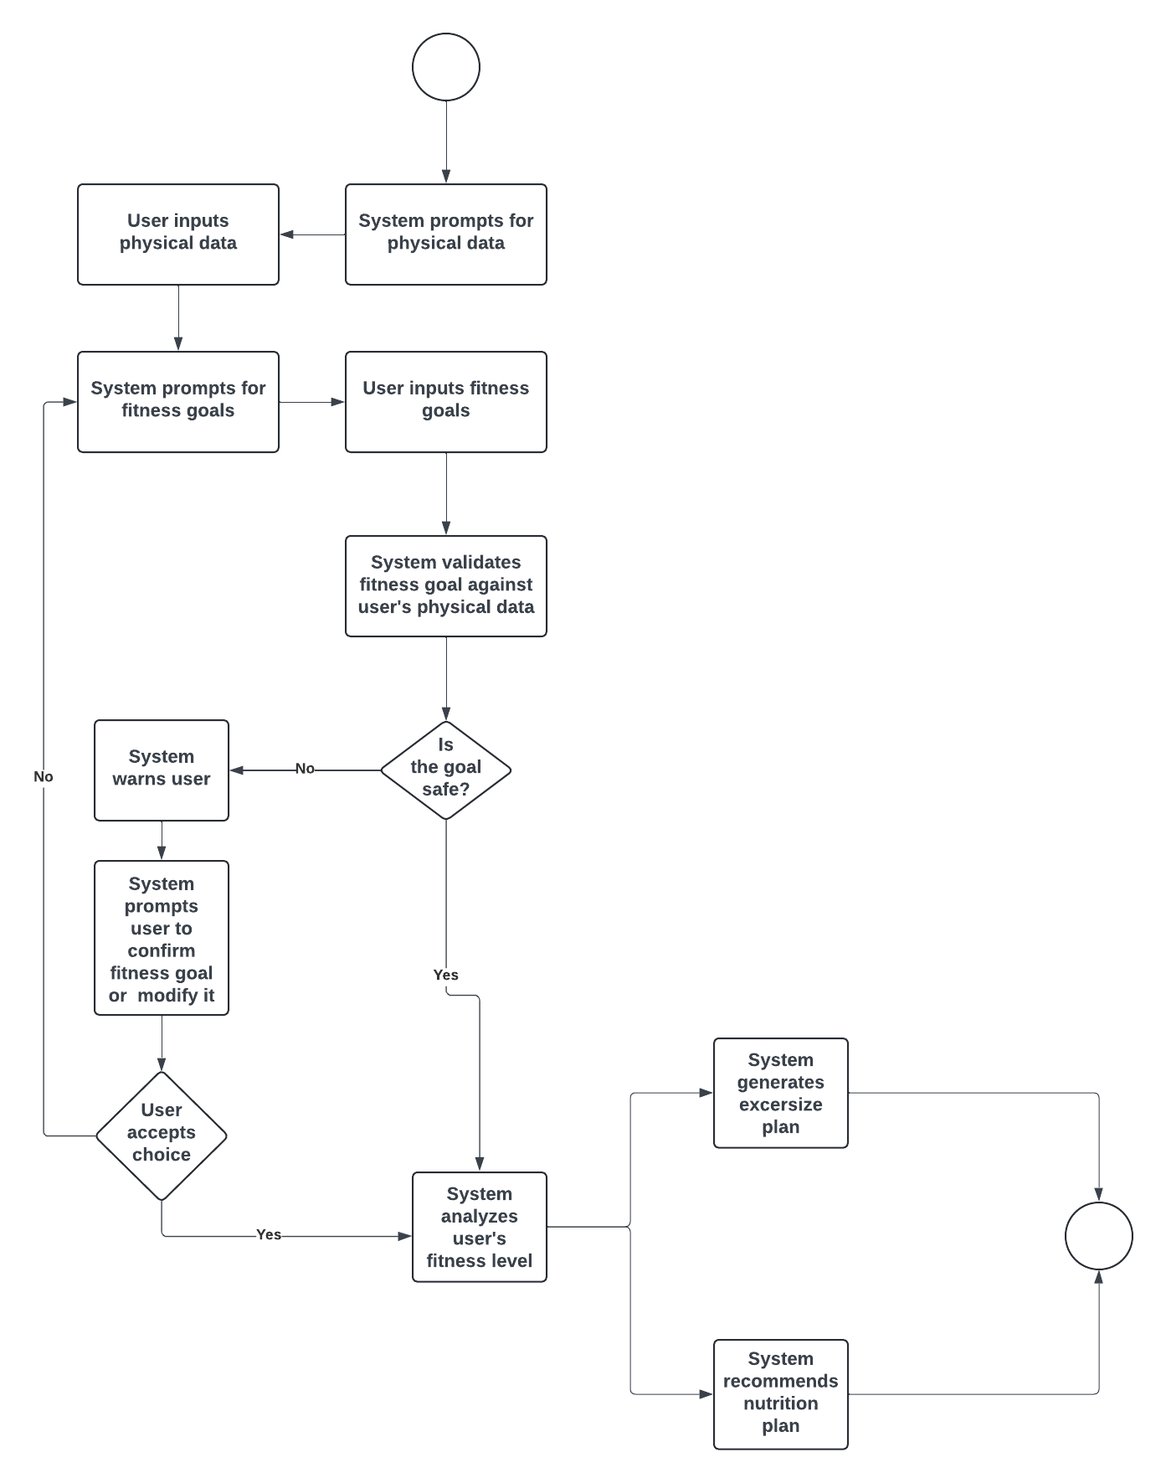

Activity Diagram 1: Normal Flow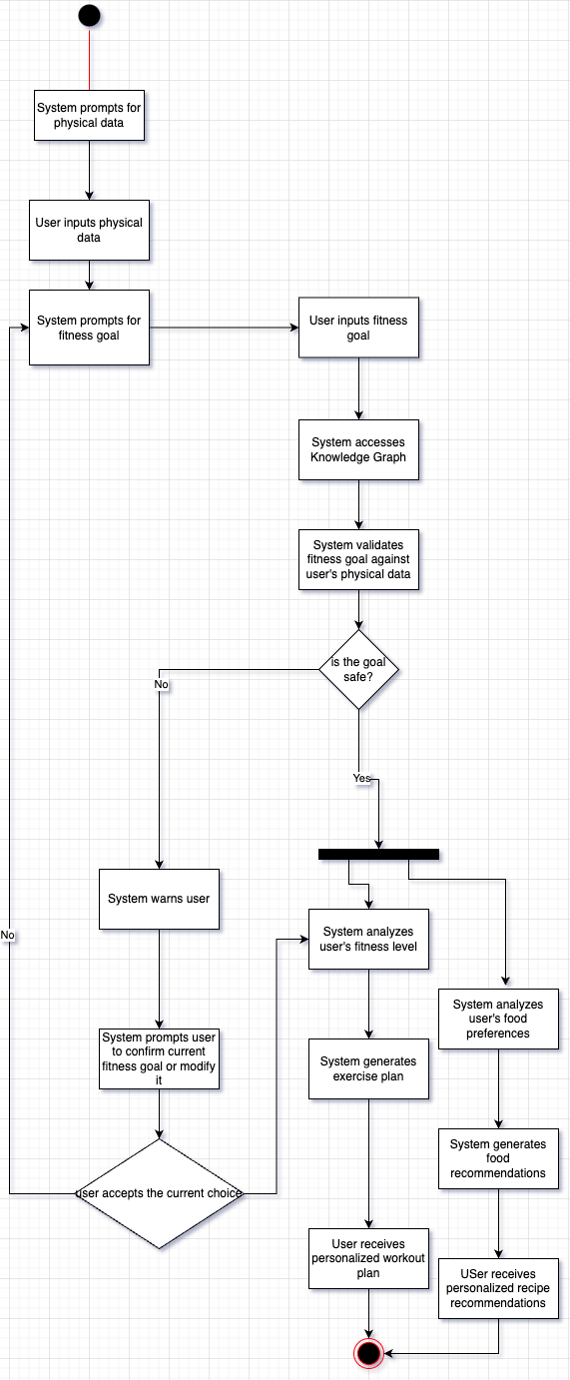

System architecture diagram:

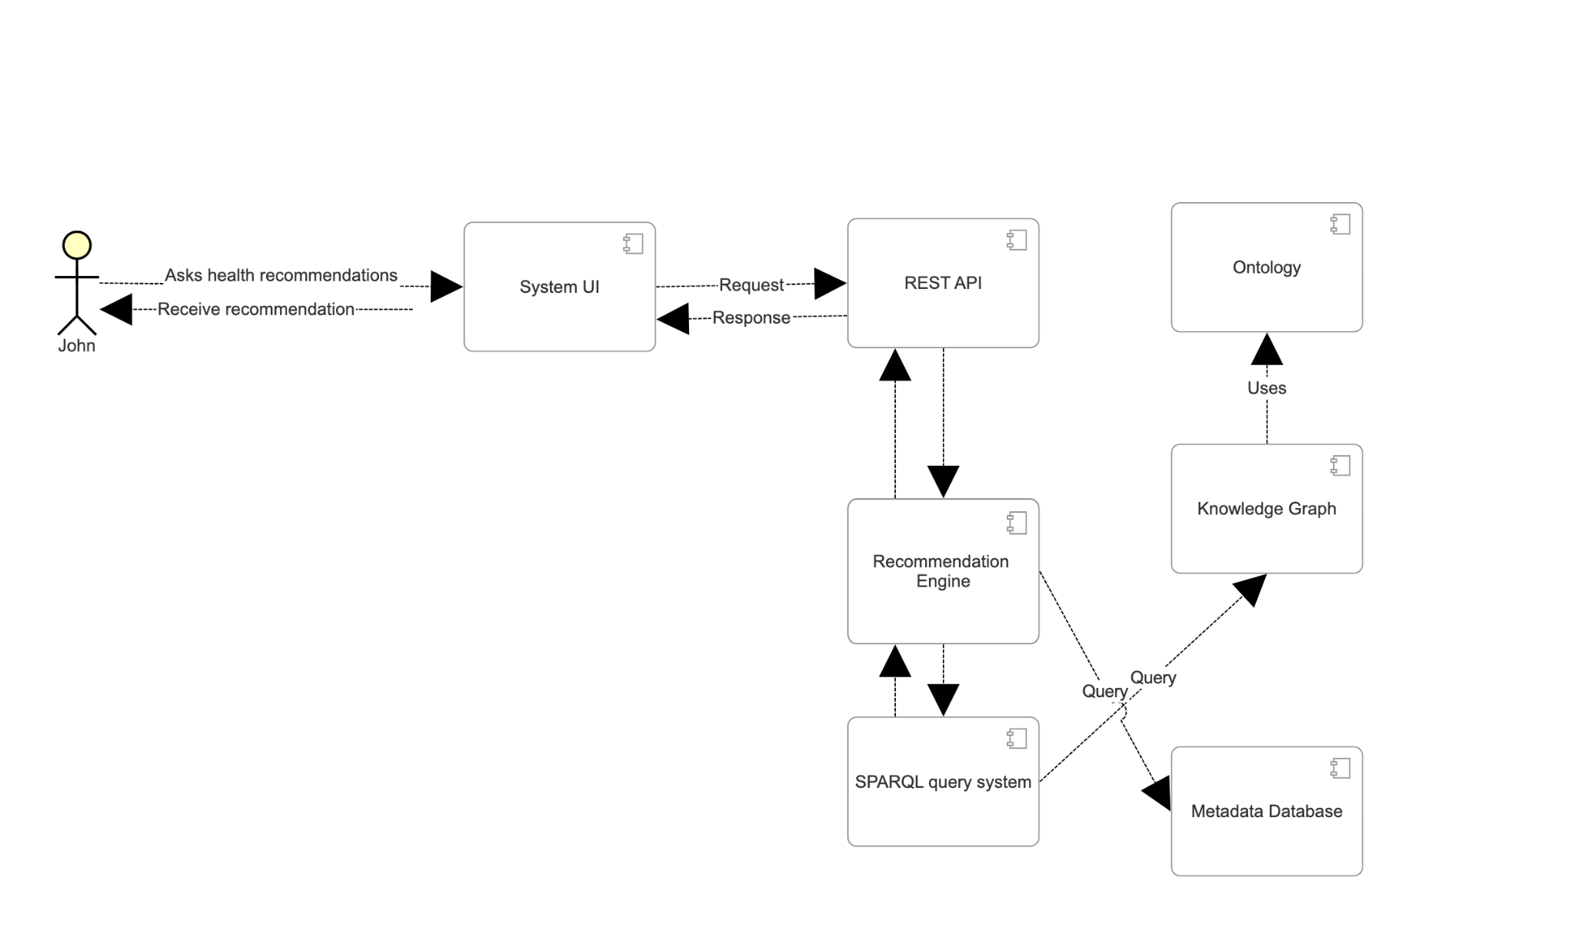

**VII. Competency Questions**

**Note: Competency questions highlighted in blue denote questions we will be focusing on.**

Q:What is a good workout routine I can follow if I want to lose fat and gain muscle given that I have a knee injury? (Users will enter their age, weight, height, sex, physical condition, etc.. - for more info see scope above. The goal will be selected from a drop down menu.)

A: [The system will recommend a workout cycle and meals for the user to do, see below for an example.]

**Workout Plan:**

**Upper Body Push**

Bench Press

Overhead Shoulder Press

Lateral Raises

Tricep Pushdowns

Core: Seated Ab Crunches

**Core and Low-Impact Lower Body**

Planks

Seated Leg Extensions

Bodyweight Glute Bridges

Upper Body Finisher: Push-Ups

Mobility Work: Gentle knee stretches

**Upper Body Pull**

Lat Pulldown

Seated Rows

Bicep Curls

Face Pulls

Core: Russian Twists

**Active Recovery/Low Impact Cardio**

Swimming or Stationary Cycling

Stretching and Mobility Work

**DO NOT:**   
 Deadlift

Heavy Front Squats

RDL’s

Bulgarian Split Squats

**How the ontology is used:**

Once the system is queried by the user, it will reference the physical exercise ontology with the fact that the user has a knee injury and will generate an exercise plan that includes workouts that are safe for someone with the user’s condition. Since the user has a knee injury, the system would look for light leg exercises to recommend and all upper body workouts will be fine. All strenuous leg exercises will be put in the DO NOT section. This will be taken from the Ontology of Physical Exercises. This is the generic cycle generated for all other body parts and targets the most areas. However, it takes into account that there is an injury to consider and avoids all strenuous leg exercises.

**Q:** What are the best workouts for beginners at the gym looking to build strength?

(Users will enter their age, weight, height, sex, physical condition, etc.. - for more info see scope above)

**A: [The system will recommend a workout cycle for the user to do see below for an example]**

**Workout Plan:**

**Upper Body Push**

Bench Press

Overhead Shoulder Press

Incline Dumbbell Press

Tricep Dips

Core: Plank Variations

**Core and Lower Body Strength**

Deadlifts

Barbell Squats

Lunges (weighted if possible)

Leg Press

Core: Hanging Leg Raises

**Upper Body Pull**

Pull-Ups or Assisted Pull-Ups

Bent-Over Rows

Seated Cable Rows

Face Pulls

Core: Ab Wheel Rollouts

**Full Body Compound Day**

Barbell Clean and Press

Kettlebell Swings

Farmer's Walk

Push Press

Core: Plank to Push-Up

**How the ontology is used:**

Once the system is queried by the user, it will reference the physical exercise ontology with the fact that the user has no inhibiting physical conditions and will generate a basic exercise plan for the user. Since the user has no physical limitations, but the user wants strength, the system would look for any good exercise recommendations for all body parts, with mainly strenuous or moderate exercises. This will be taken from the Ontology of Physical Exercises. The DO NOT section will not show since there is no physical limitation.

**Q:** I’m looking to start working out and lose fat. Provide me with a workout cycle and meals.

(User has already stated that they have a nut allergy. System knows about this condition. Users will enter their age, weight, height, sex, physical condition, etc.. - for more info see scope above)

**A:** [The system will recommend a workout cycle and meals for the user to do see below for an example]

**Workout Plan:**

**Upper Body Push**

Bench Press

Overhead Shoulder Press

Incline Dumbbell Press

Tricep Dips

Core: Plank Variations

**Core and Lower Body Strength**

Deadlifts

Barbell Squats

Lunges (weighted if possible)

Leg Press

Core: Hanging Leg Raises

**Upper Body Pull**

Pull-Ups or Assisted Pull-Ups

Bent-Over Rows

Seated Cable Rows

Face Pulls

Core: Ab Wheel Rollouts

**Full Body Compound Day**

Barbell Clean and Press

Kettlebell Swings

Farmer's Walk

Push Press

Core: Plank to Push-Up

**Recommended Meals:**

**Greek Yogurt Parfait**

Greek yogurt (plain or flavored)

Sliced strawberries and kiwi

Chia seeds

Drizzle of maple syrup

Toasted oats for crunch

**Quinoa and Black Bean Salad**

Cooked quinoa

Black beans (canned or cooked)

Diced avocado

Cherry tomatoes

Cilantro and lime dressing (olive oil, lime juice, garlic, salt)

**Banana Oat Muffins**

Rolled oats

Mashed bananas

Eggs

Greek yogurt

Baking powder

Vanilla extract

**Baked Cod with Roasted Sweet Potatoes**

Cod filets

Roasted sweet potatoes

Olive oil

Lemon zest

Fresh parsley and garlic seasoning

**How the Ontology is Used:**

Once the system is queried by the user, it will reference the physical exercise ontology with the fact that the user has a nut allergy and will generate an exercise and meal plan that includes workouts that are safe for someone with the user’s condition. Since the user has no physical limitations, the system would look for any good exercise recommendations for all body parts, with a mix of strenuous, moderate, and light exercises. This will be taken from the Ontology of Physical Exercises. The DO NOT section will not show since there is no physical limitation. The system will reference the daily caloric intake calculation(simple equation) and the daily value dataset to determine an ideal caloric intake/macronutrient goals for each day to place the user in a reasonable calorie deficit while still getting in required nutrients. With these values and the fact that the user has a nut allergy, the system will then determine a preferred food item for the user. With the preferred food item, the system will then reference the database containing recipe information and generate recipe recommendations and ensure that we do not exceed their caloric goals.

**Q:** I’m looking into strengthening my back. Can you provide me with a back workout? (User has already stated that they have **scoliosis** when creating their profile. System knows that the user has this condition.

Users will enter their age, weight, height, sex, physical condition, etc.. - for more info see scope above).

**A:** [The system will recommend a back workout for the user that works around their condition.]

**Workout Plan:**

**Upper Body Pull 1**

Lat Pulldown

Seated Rows

Bicep Curls

Face Pulls

**Upper Body Pull 2**

Pull ups

Superman

Dumbbell Row

Wall Angels

**DO NOT:**  
 Deadlift

Overhead Press

Barbell Back Squats

Bent over row

**How Ontology is Used:**

Once the system is queried by the user, it will reference the physical exercise ontology with the fact that the user has scoliosis and will generate an exercise plan that includes workouts that are safe for someone with the user’s condition. Since the user has scoliosis, the system would look for lightly strenuous back exercises that avoid rotation (from the exercise ontology) which are safer for those with back conditions. When all terms are mapped, we will find exercises that have “rotation” or any synonym in the workout name and add it in the DO NOT section. Also, strenuous back exercises will be put in the DO NOT section. This will be taken from the Ontology of Physical Exercises. Only the back was specified by the user so two variations will be provided. Since the user only requested back workouts, the system will not provide meal recommendations to the user.

**Q:** I have already begun working out and want to lose weight. Can you provide me with a set of meals given that I am vegetarian but eat eggs?

(Users will enter their age, weight, height, sex, physical condition, etc.. - for more info see scope above)

**A:** [The system will recommend meals for the user to see below for an example]

**Recommended Meals:**

**Greek Yogurt Parfait**

Greek yogurt (plain or flavored)

Sliced strawberries and kiwi

Chia seeds

Drizzle of maple syrup

Toasted oats for crunch

**Cottage Cheese and Fruit Bowl**

Cottage cheese

Sliced peaches or pineapple

Almonds or walnuts

Cinnamon

Drizzle of honey

**Roasted Veggie Medley**

A variety of vegetables (carrots, zucchini, bell peppers, broccoli, and sweet potatoes)

Olive oil

Herbs and spices (salt, pepper, garlic powder, or Italian seasoning)

**Egg and Vegetable Scramble**

Eggs or egg whites

A mix of vegetables (spinach, tomatoes, bell peppers, mushrooms, onions)

Cheese (optional)

Salt and pepper

**How the ontology is used:**

Since the user didn’t specify workout plans, no exercise plan will appear. Once the system is queried by the user and the user inputs their data, the system will reference the daily caloric intake calculation(simple equation) and the daily value dataset to determine the users caloric intake/macronutrient goals for each day this recommendation will be displayed to the user this recommendation will be displayed to the user. With these values and the fact that the user is vegetarian but eats eggs, the system will then determine a preferred vegetarian/egg based food item for the user. With the preferred food item, the system will then reference the database containing recipe information and generate recipe recommendations that will not exceed the caloric goals.

**Q:** I’m looking to develop strong legs. Can you provide me with a leg workout? (User has already stated that they have a mild leg strain when creating their profile. The system knows that the user has this condition. Users will enter their age, weight, height, sex, physical condition, etc. - for more info see scope above).

**A:** [The system will recommend a leg workout for the user that works around their condition.]

**Error:** Please change your goal since there are no available exercises

[Re-enter Goal] [Show Anyways]

(These are buttons, highlighted shows what was clicked)

**Workout Plan:**

**Lower Body 1**

Seated Leg Extensions (light weight)

Glute Bridges (with minimal resistance)

Standing Calf Raises (with support)

Modified Bodyweight Step-Ups (low height)

**Lower Body 2**

Side-Lying Leg Lifts (gentle)

Wall Sits (short duration)

Resistance Band Leg Press (light resistance)

Gentle Hamstring Stretches

**How Ontology is Used:**

Once the system is queried by the user, it will reference the physical exercise ontology with the fact that the user has a mild leg strain (light leg exercises) and will look at their goal of stronger legs (moderate to strenuous exercises) and will come up with no exercises. The system will give a prompt to the user to change their goals since there are no available exercises that work well for their goal and their current injuries/conditions. If they still want to see exercises, they can click show anyways, which will prioritize their goals over their current issues. Since the user doesn’t want to change their goal, we will show leg workouts assuming they have no leg issues. Therefore, we will look for moderate to strenuous exercises. This will be taken from the Ontology of Physical Exercises. Only the legs were specified by the user, so two variations will be provided. Since the user only requested leg workouts, the system will not provide meal recommendations to the user.

**VIII. Resources**

*In order to support the capabilities described in this Use Case, a set of resources must be available and/or configured. These resources include the set of actors listed above, with additional detail, and any other ancillary systems, sensors, or services that are relevant to the problem/use case.*

**Knowledge Bases, Repositories, or other Data Sources**

| Data | Type | Characteristics | Description | Owner | Source | Access Policies & Usage |
| --- | --- | --- | --- | --- | --- | --- |
| *Calories Burned During Exercise and Activities* | *downloadable as metadata exported as croissant* | *Has information on how much calories is burned for 248 basic exercises(This is more than enough since this planner will not give incredibly specific exercises that haven’t been tested for its efficiency)* | *This dataset contains the number of calories burned by a person while performing some activity/exercise.*  *It currently contains 248 activities and exercises ranging from running, cycling, calisthenics, etc.* | *Aadhav Vignesh* | [*https://www.kaggle.com/datasets/aadhavvignesh/calories-burned-during-exercise-and-activities*](https://www.kaggle.com/datasets/aadhavvignesh/calories-burned-during-exercise-and-activities) | *open* |
| *Nutritional Facts for most common foods* | *Downloadable as a CSV file* | *Gives macros of basic foods(over 300 listed)* | *The dataset contains a csv file with more than 300 foods each with the amount of Calories, Fats, Proteins, Saturated Fats, Carbohydrates, Fibers labeled for each food. Also, the foods are also categorized into various groups like Desserts, Vegetables, Fruits etc.* | *Niharika Pandit* | [*https://www.kaggle.com/datasets/niharika41298/nutrition-details-for-most-common-foods*](https://www.kaggle.com/datasets/niharika41298/nutrition-details-for-most-common-foods) | *open* |
|  |  |  | *use case* |  |  |  |
| *Nutrient Recommendation Database* | *Table in webpage. Easily scrapable.* | *Provides recommended daily values.* | *Provides recommended daily values of elements, vitamins, nutrients,*  *And water.* | *NIH* | [*https://ods.od.nih.gov/HealthInformation/nutrientrecommendations.aspx*](https://ods.od.nih.gov/HealthInformation/nutrientrecommendations.aspx) | *open* |
| *FoodSubs* | *Website easily scrapable* | *Provides substitutions/synonyms for food items* | *Includes ingredient substitutions and ingredient synonyms* | *Foodsubs* | *https://foodsubs.com/* | *Open* |

**External Ontologies, Vocabularies, or other Model Services**

| Resource | Language | Description | Owner | Source | Describes/Uses | Access Policies & Usage |
| --- | --- | --- | --- | --- | --- | --- |
| *Ontology of Physical Exercises* | *OWL*  *CSV*  *RDF/ XML*  *Diff* | *The Ontology of Physical Exercises (OPE) provides a reference for describing an exercise in terms of functional movements, engaged musculoskeletal system parts, related equipment or monitoring devices, intended health outcomes, as well as target ailments for which the exercise might be employed as a treatment or preventative measure.* | *BioPortal* | [*https://bioportal.bioontology.org/ontologies/OPE?p=summary*](https://bioportal.bioontology.org/ontologies/OPE?p=summary) | *N/A* | *open* |
| *FoodOn* | OWL, CSV, YML, XML | Ontology that name and reference food products and their components throughout the food supply chain | N/A | <https://github.com/FoodOntology/foodon/blob/master/README.Md> | N/A | Open |
| Recipe | CSV | A website of recipes for data to be scrapped from | [U.S. Department of Agriculture](https://www.usda.gov/) | https://www.nutrition.gov/recipes/search |  | open |