| I. Use Case Description | |
| --- | --- |
| Use Case Name | *Personalized Depression Treatment Ontology* |
| Use Case Identifier |  |
| Source |  |
| Point of Contact | *Cole Feuer, Nancy Zhang, Gunnar Eastman* |
| Creation / Revision Date | 11/4*/24* |
| Associated Documents |  |

| II. Use Case Summary | |
| --- | --- |
| Goal | *To create an ontology that can improve the personalization of depression treatment by mapping relationships between patient demographics, treatment types, and outcomes.* |
| Requirements | *The system must integrate data from clinical trials, genetic studies, and patient-reported outcomes.*  *It must have practical use in supporting clinicians in creating the best treatment plan for patients.* |
| Scope | *Focus on integrating genetic, demographic, and treatment outcome data to help clinicians identify more effective treatment strategies for depression patients. The system will utilize genetic and demographic data, as well as prior treatment outcomes, while excluding other personalized health information such as blood test results, and lifestyle factors. The reasoning will be based on patterns observed in similar patients and the avoidance of previously unsuccessful treatments, without delving into direct biochemistry analysis. Output recommendations will be limited to pharmacological options, such as antidepressants and related drugs, and cognitive behavioural therapies while excluding dietary, hormonal, or lifestyle interventions.* |
| Priority | *High, as improving the speed and accuracy of mental health treatments has important social and medical implications.* |
| Stakeholders | *Primary stakeholders: Clinicians, mental health researchers, and patients.*  *Secondary stakeholders: Hospitals, mental health organizations, and pharmaceutical companies.* |
| Description | *This use case focuses on creating a personalized depression treatment ontology to improve the efficiency and accuracy of mental health treatment. The ontology will integrate diverse data sources, including patient demographics, genetic data, clinical trials, and patient-reported outcomes. The system will assist clinicians in formulating personalized treatment plans, reducing the trial-and-error approach often associated with mental health care.*  *Principal Actors:*  *Clinicians: Use the system to recommend personalized depression treatments based on patient data.*  *Patients: Provide data on treatment outcomes, allowing the ontology to evolve with real-world experiences.*  *Researchers: Input clinical trial and genetic data into the system to enhance its accuracy.*  *Genetic Counselors: Utilize genetic data to offer tailored treatment recommendations for patients.*  *Restated Goals:*  *Provide clinicians with personalized treatment recommendations for depression based on patient-specific data.*  *Minimize the trial-and-error approach in mental health treatment, leading to faster and more accurate care.*  *Integrate ongoing patient-reported outcomes and clinical trial data to continuously improve treatment recommendations.* |
| Actors / Interfaces | *Primary Actors:*   * *Clinicians: Use the ontology for recommending treatments.* * *Patients: Provide patient-reported outcome data.* * *Researchers: Input and analyze clinical and genetic data.*   *Systems:*   * *Clinical trials databases* * *Genetic databases* * *Ontology management system* * *Electronic medical records systems.* |
| Pre-conditions | *A clinician or researcher is logged into the system.*  *The system has access to clinical, genetic, and patient-reported outcome datasets.* |
| Post-conditions | *A treatment plan with a predicted success rate is recommended for the patient.*  *Data from the current treatment experience is fed back into the ontology to improve future predictions.* |
| Triggers | *The clinician inputs a patient's demographic and genetic information into the system.*  *The need for treatment recommendations triggers the use of the ontology.* |
| Performance Requirements | *Response time: needs to provide treatment recommendations reasonably quickly*  *Scalability: needs to scale with data imputed and new research*  *Concurrency: needs to be accessible to multiple clinicians and researchers at a time.*  *Updatability: needs to adapt to new research and update suggestions accordingly* |
| Assumptions | *The patient’s demographic data is available and able to be inputted.*  *The data sources that we pull medical and drug information from are well-credited and accurate.*  *No protected health information or identifying information will be necessary.* |
| Open Issues |  |

**III. Usage Scenarios**

**Scenario 1: Clinician Seeking Treatment for a New Patient**

A clinician is meeting with a new patient who has been diagnosed with depression. The patient has not previously received treatment for depression, and the clinician wants to recommend the most effective treatment option while minimizing the trial-and-error approach that is commonly used in mental health care. The clinician uses the ontology-based system to provide personalized treatment recommendations based on the patient's demographics and genetic data.

**Scenario 2: Person Exploring Treatment Options for Comorbid Conditions**

*A patient with both depression and anxiety desires treatment. They have not received treatment before and would like to learn more about their options and what treatments are available. The ontology-based system, leveraging data on comorbid conditions, suggests MBCT, which has been shown to effectively treat both conditions based on prior clinical outcomes.*

**Scenario 3: Psychiatrist Adjusting Medication for a Patient with Anxiety Disorder**

A psychiatrist is treating a patient with generalized anxiety disorder (GAD) who has experienced limited success with current medication and has reported side effects. The psychiatrist uses the ontology-based system to refine treatment options by considering the patient’s medical history, genetic markers, and past medication responses. The system provides personalized recommendations for alternative medications or dosages that are more likely to be effective while minimizing side effects based on the patient’s specific profile.

**IV. Basic Flow of Events**

| Basic Flow I | | | |
| --- | --- | --- | --- |
| Step | **Actor (Person)** | **Actor (System)** | **Description** |
| 1 | **Clinician** | **Treatment ontology recommendation system** | **The clinician logs into the treatment recommendation system.** |
| 2 | **Clinician** | **Treatment ontology recommendation system** | **The clinician enters patient information (age, gender, genetic data).** |
| 3 | **N/A** | **Treatment ontology recommendation system** | **The system searches through the ontology to find relevant treatments based on similar cases.** |
| 4 | **N/A** | **Treatment ontology recommendation system** | **The system suggests potential treatments with predicted effectiveness.** |
| 5 | **Clinician** | **Treatment ontology recommendation system** | **The clinician selects a treatment and provides it to the patient.** |
| 6 | **Clinician** | **Treatment ontology recommendation system** | **The clinician logs treatment outcomes into the system for future analysis.** |

| Basic Flow II | | | |
| --- | --- | --- | --- |
| Step | **Actor (Person)** | **Actor (System)** | **Description** |
| 1 | **Clinician** | **Treatment ontology recommendation system** | **The clinician logs into the treatment recommendation system.** |
| 2 | **Clinician** | **Treatment ontology recommendation system** | **The clinician enters incomplete patient data (age, gender) but also provides medical history (previous medications taken, etc.)** |
| 3 | **N/A** | **Treatment ontology recommendation system** | **The system searches through the ontology to find relevant treatments based on similar cases, avoiding the previously taken medications, and medications similar to those already taken by the patient.** |
| 4 | **N/A** | **Treatment ontology recommendation system** | **The system suggests potential treatments with predicted effectiveness.** |
| 5 | **Clinician** | **Treatment ontology recommendation system** | **The clinician selects a treatment and provides it to the patient.** |
| 6 | **Clinician** | **Treatment ontology recommendation system** | **The clinician logs treatment outcomes into the system for future analysis.** |

**V. Alternate Flow of Events**

| Alternate Flow of Events | | | |
| --- | --- | --- | --- |
| Step | **Actor (Person)** | **Actor (System)** | **Description** |
| 1  2  3 | **Clinician**  **Clinician**  **Clinician** | **Treatment ontology recommendation system**  **​​Treatment ontology recommendation system**  **Treatment ontology recommendation system** | **The clinician enters patient data, but the ontology finds insufficient data for an accurate prediction (e.g., for rare genetic conditions).**  **The system requests additional clinical trial or research data related to the case.**  **The clinician is provided with a generic recommendation based on broad population data rather than personalized data.** |

**VI. Use Case and Activity Diagram(s)**

**Overview Diagram**

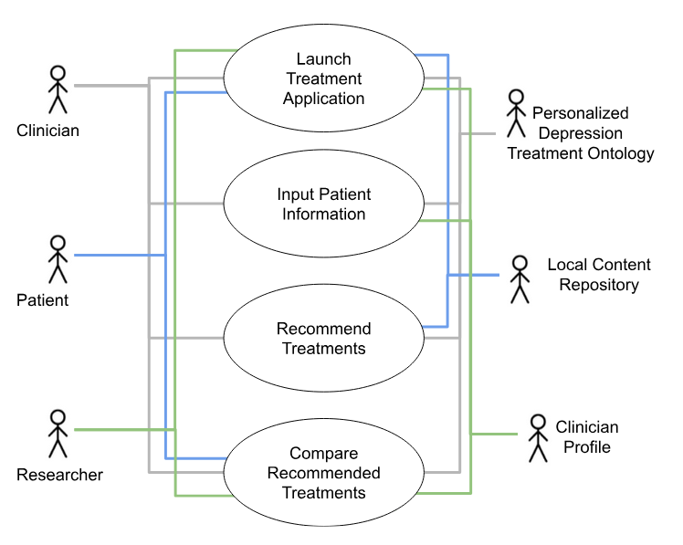

**Launch Treatment Recommendation System Diagram**

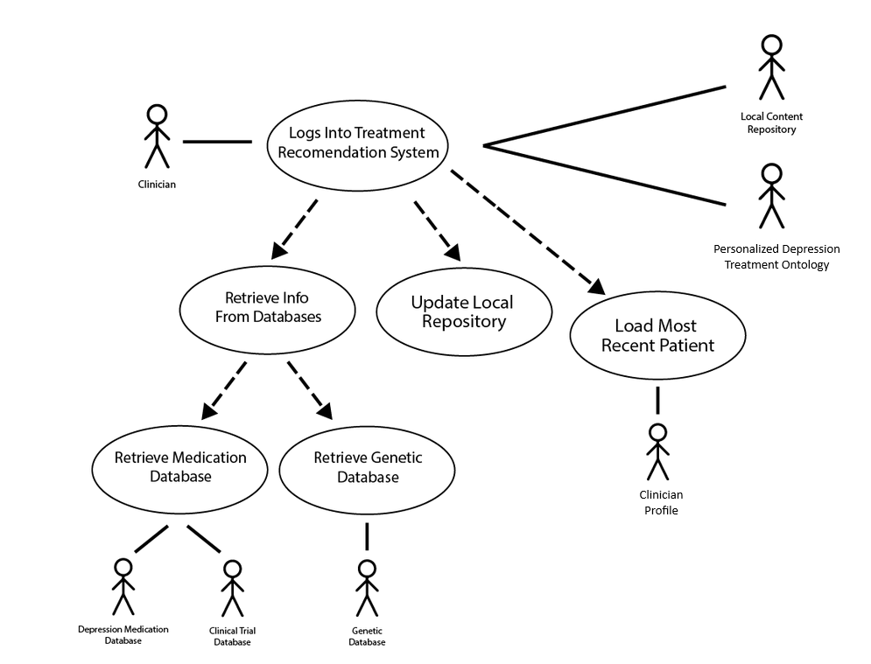

**Recommend Treatment Diagram**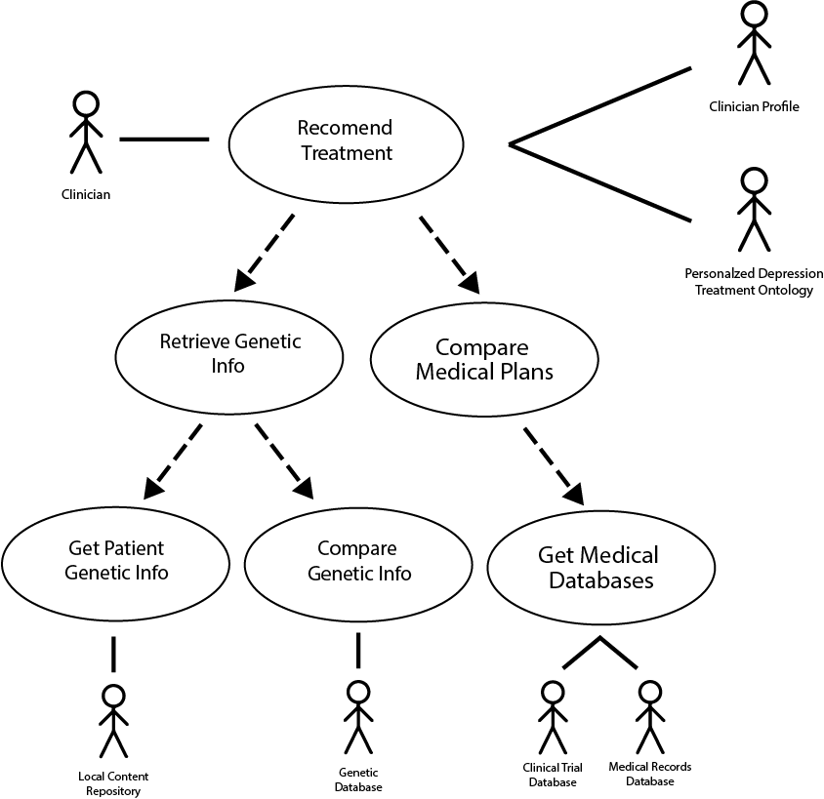

**VII. Competency Questions**

**Competency Question 1:**

*What is the most effective treatment for patients with specific genetic markers associated with depression?*

*Example Answer: The system identifies that patients with a particular genetic marker (e.g., serotonin transporter gene polymorphisms) have shown a higher response rate to selective serotonin reuptake inhibitors (SSRIs). Based on this, the ontology suggests SSRIs as the recommended treatment with a success prediction of 75%, supported by clinical trial data and patient outcomes from similar cases.*

*Which treatment options have the highest success rates for patients aged 30-45 with treatment-resistant depression? In this case, patients demographic includes age 30-45, genetic marker is chromosome 3p25-26 that is often exhibited by families with multiple members that are diagnosed with Major Depressive Disorder. Treatment type will be medication, specifically SSRIs, with the treatment outcome hopefully being remission.*

*How Ontology Was Used: The ontology utilizes relationships between entities such as “patient demographics,” "genetic markers," “treatment types” and “treatment outcomes.” These relationships allow the system to infer connections between a patient's genetic data and the most relevant treatment options, even when some information may be missing or incomplete. By organizing knowledge in a structured and interconnected way, the ontology enables more accurate predictions than simple rule-based systems. For example, if we only had simple rule-based systems, we would not be personalizing treatments based on patients and only fitting them in “if… else” statements basically. By utilizing ontologies and an inference model, it can help go through a database that has a bunch of medications and with each relationship it has connected from “patient demographics," "genetic markers," "treatment types," and "treatment outcomes", it will be able to give a couple personalized treatment plans with high accuracy success outcomes.*

*Competency Question 2:*

*How does age impact the effectiveness of certain treatments for depression?*

*Example Answer: For patients aged 30-45, the ontology suggests that a combination of cognitive behavioral therapy (CBT) and ketamine has shown a 60% improvement rate in cases of treatment-resistant depression. This recommendation is supported by aggregated data from clinical trials and patient-reported outcomes.*

*How Ontology Was Used: The ontology integrates clinical trial data and patient-reported outcomes categorized by demographic factors, such as age. It mapped the success rates of various treatments for specific age groups, identifying that for patients aged 30-45, a combination of cognitive behavioral therapy (CBT) and ketamine resulted in a 60% improvement rate in treatment-resistant cases. This information was drawn from an aggregated analysis of clinical trials that tested these treatments on patients within this age range, allowing the ontology to infer the most effective strategies for similar future patients.*

*Competency Question 3:*

*What alternative treatments are recommended for patients with genetic markers indicating poor response to SSRIs?*

*Sample Answer from Ontology*

*The system identifies norepinephrine-dopamine reuptake inhibitors (NDRIs) as a more effective treatment for patients with genetic markers that indicate a poor response to selective serotonin reuptake inhibitors (SSRIs). This recommendation is based on genetic data and patient-reported outcomes from similar cases.*

*Terms Used from Ontology*

* *Genetic markers (e.g., SLC6A4 gene polymorphism)*
* *Treatment (NDRIs, SSRIs)*
* *Treatment outcomes*

*Semantic Processes Involved*

* *Inferencing: The ontology links genetic markers with treatment efficacy by comparing outcomes of similar patients.*
* *Data integration: Genetic and treatment response data are aggregated to support personalized recommendations.*

*Usage Scenario Covered*

*A genetic counselor, specializing in the treatment of mental health conditions, is meeting with a patient who has struggled with depression and has not responded well to traditional antidepressants. The counselor uses the ontology-based system to recommend personalized treatment options based on the patient’s genetic profile and demographic information.*

*Description + Ontology Usage*

*The ontology connects genetic markers with treatment outcomes by using relationships between “genetic markers,” “treatment types,” and “treatment outcomes.” The system identifies alternative treatments, such as NDRIs, when it detects poor response markers for SSRIs, ensuring a more personalized and effective treatment recommendation.*

*Competency Question 4:*

*How can treatment recommendations be adapted for patients with comorbid conditions such as anxiety or chronic pain along with depression?*

*Sample Answer from Ontology*

*The system recommends mindfulness-based cognitive therapy (MBCT) for patients with both depression and anxiety. This suggestion is drawn from clinical trials showing that MBCT effectively treats both conditions, improving patient outcomes by 65%.*

*Terms Used from Ontology*

*•* *Illness (depression, anxiety, chronic pain)*

*•* *Treatment (MBCT is contained under Treatment)*

*•* *Patient (has properties that cover demographic information)*

*Semantic Processes Involved*

*•* *Reasoning: Treatments in the ontology are given a list of illnesses that they can treat. When searching for treatments for comorbid patients, the system can find treatments that treat all of the provided illnesses, or the largest subset, if no treatment treats all of the listed conditions.*

*•* *Data integration: Clinical trial and patient-reported outcome data are linked to identify effective treatments for patients with multiple conditions.*

*Usage Scenario Covered*

*A patient with both depression and anxiety seeks treatment. The ontology-based system, leveraging data on comorbid conditions, suggests MBCT, which has been shown to effectively treat both conditions based on prior clinical outcomes.*

*Description + Ontology Usage*

*The ontology integrates clinical trial data related to comorbid conditions such as anxiety and depression to provide personalized recommendations. This enables the system to recommend MBCT as an effective treatment for patients with both conditions, improving outcomes for complex cases.*

*Competency Question 5:*

*What is the most effective treatment option for patients with both depression and genetic markers linked to bipolar disorder?*

*Sample Answer from Ontology*

*The system recommends mood stabilizers like lithium combined with cognitive-behavioural therapy (CBT) as the most effective treatment for patients with genetic markers linked to bipolar disorder. Clinical data indicates a 70% success rate in reducing depressive episodes for these patients.*

*Terms Used from Ontology*

*•* *Genetic markers (associated with bipolar disorder)*

*•* *Treatment (lithium, CBT)*

*•* *Patient (has properties that cover demographic information)*

*Semantic Processes Involved*

*•* *Inferencing: The ontology cross-references genetic markers with treatment outcomes to suggest the best options for patients with both depression and bipolar disorder.*

*•* *Predictive analysis: The system uses historical clinical data to predict treatment success rates based on genetic markers.*

*Usage Scenario Covered*

*A clinician is treating a patient with depression who also shows genetic markers linked to bipolar disorder. The ontology suggests lithium combined with CBT as the best treatment option, using data from similar cases to support this recommendation.*

*Description + Ontology Usage*

*The ontology integrates genetic data and clinical trial outcomes to identify lithium combined with CBT as the most effective treatment for patients with depression and bipolar disorder markers, ensuring personalized care based on genetic profiles and historical success rates.*

*These revisions incorporate the required structuring while clearly highlighting how the ontology supports answering each competency question.*

**VIII. Resources**

**Knowledge Bases, Repositories, or other Data Sources**

| Data | Type | Characteristics | Description | Owner | Source | Access Policies & Usage |
| --- | --- | --- | --- | --- | --- | --- |
| *(dataset or repository name)* | *(remote, local/in situ, etc.)* | *e.g. – no cloud cover* | *Short description of the dataset, possibly including rationale of the usage characteristics* |  | *Source (possibly a system, or remote site) for discovery and access* |  |
| *GENDEP (Genome-Based Therapeutic Drugs for Depression) Dataset*  *STAR D (Sequenced Treatment Alternatives to Relieve Depression) Dataset*  *UK Biobank*  *PsychENCODE Consortium Data*  *NIMH Data Archive (NDA)* | *Genetic and Clinical Data*  *Clinical Trial Data*  *Genetic, Demographic, and Health Data*  *Genetic and Epigenetic Data*  *Mental health data* | *Combines genetic data with clinical outcomes from antidepressant treatment trials*  *Large-scale, longitudinal, real-world study of depression treatment*  *Large cohort with comprehensive genetic, demographic, and health-related data.*  *Multi-omic data combining genetic, epigenetic, and transcriptomic information*  *Mental health data from various clinical and observational studies.* | *The GENDEP project focuses on the genetic determinants of antidepressant response, making it highly relevant for an ontology that aims to personalize treatments based on genetic profiles.*  *one of the largest and most comprehensive studies of depression treatment. It tracks patients across several levels of antidepressant treatment, detailing effectiveness, side effects, and patient-reported measures over time.*  *The UK Biobank includes both genetic and health data from over 500,000 participants. It provides great data on depression diagnoses, symptoms, and genetic factors, which can be integrated into the ontology to provide personalized treatment insights.*  *The PsychENCODE project provides detailed genetic and epigenetic data, offering insights into how gene expression impacts depression and mental health. This is valuable for understanding the biological mechanisms that might influence treatment responses.*  *The NIMH Data Archive contains data from large-scale clinical studies and trials, focusing on mental health conditions, including depression. It includes data on different treatments, such as Cognitive Behavioral Therapy (CBT), and their patient outcomes, providing valuable insights into treatment efficacy.* | *NIH*  *NIH*  *UK Biobank*  *NIH*  *NIH* | *Publicly available (European Genome-phenome Archive)*  *Publicly available*  *(European Genome-phenome Archive)*  *UK Biobank (need to apply)*  *PsychENCODE Consortium,(NIH data portals)*  *NIMH Data Archive - accessible through application* |  |

**External Ontologies, Vocabularies, or other Model Services**

| Resource | Language | Description | Owner | Source | Describes/Uses | Access Policies & Usage |
| --- | --- | --- | --- | --- | --- | --- |
| *(ontology, vocabulary, or model name)* | *(ontology language and syntactic form, e.g., RDFS - N3)* | *If the service is one that runs a given ontology or model-based application at a given frequency, state that in addition to the basic description* |  | *Source (link to the registry or directly to the ontology, vocabulary, or model where that model is maintained, if available)* | *List of one or more data sources described by and/or used by the model* |  |
| POEM | OWL | [Psychometric Ontology of Experiences and Measures](https://tetherless-world.github.io/POEM/) | Tetherless World Constellation at RPI | https://tetherless-world.github.io/POEM/ | Mental Health Terminology | open |
| IDMP | OWL | Identification of Medicinal Products | EDM Council | (concepts from IDMP were given to us by Professor Kendall | Medicinal Products |  |

**Other Resources, Service, or Triggers** *(e.g., event notification services, application services, etc.)*

| Resource | Type | Description | Owner | Source | Access Policies & Usage |
| --- | --- | --- | --- | --- | --- |
| *(sensor or external service name)* |  | *Include a description of the resource as well as availability, if applicable* | *Primary owner of the service* | ***Application or service URL****; if subscription-based, include subscription and any subscription owner* |  |
|  |  |  |  |  |  |

**IX. References and Bibliography**

*List all reference documents – policy documents, regulations, standards, de-facto standards, glossaries, dictionaries and thesauri, taxonomies, and any other reference materials considered relevant to the use case*

[1] B. Gaynes and A. Rush, “Treatment Alternatives to Relieve Depression (STAR*D) study The STAR*D study: Treating depression in the real world,” CLEVELAND CLINIC JOURNAL OF MEDICINE, vol. 75, no. 1, 2008, Available: <https://www.ccjm.org/content/ccjom/75/1/57.full.pdf>

[2] “GENOME-BASED THERAPEUTIC DRUGS FOR DEPRESSION (GENDEP),” CORDIS, https://cordis.europa.eu/project/id/503428 (accessed Sep. 26, 2024).

[3] M., et al Li, “Integrative functional genomic analysis of Human Brain Development and Neuropsychiatric Risks | Science,” Science, https://www.science.org/doi/10.1126/science.aat7615 (accessed Sep. 26, 2024).

[4] Kupfer, D. J., Frank, E., & Phillips, M. L. (2012). "Major depressive disorder: New clinical, neurobiological, and treatment perspectives." The Lancet.

**X. Notes**

*There is always some piece of information that is required that has no other place to go. This is the place for that information.*

*Info Gotten From Each Source:*

*M. et al., Li, “Integrative functional genomic analysis of Human Brain Development and Neuropsychiatric Risks | Science”*

Provides a comprehensive look at genetic markers and brain development, linking neuropsychiatric risks to specific treatment outcomes. This research can answer questions involving genetic predisposition and comorbid conditions. The study's functional genomic analysis would be highly relevant to understanding how genetic markers influence treatment efficacy, especially in complex conditions like depression with comorbid bipolar disorder or pharmacoresistance.

B. Gaynes and A. Rush, “Treatment Alternatives to Relieve Depression (STAR*D) study The STAR*D study: Treating depression in the real world,” CLEVELAND CLINIC JOURNAL OF MEDICINE

The STAR*D study is a large-scale investigation into treatment-resistant depression, focusing on various treatment strategies when initial options fail. It provides insights into the effectiveness of different treatments across demographics. The study can also offer data on treatment outcomes for specific genetic markers or age groups, helping answer questions related to treatment efficacy based on age or genetic factors.

GENOME-BASED THERAPEUTIC DRUGS FOR DEPRESSION (GENDEP)

The GENDEP project focuses on the relationship between genetic markers and antidepressant responses, which is crucial for understanding pharmacogenomics in depression treatment. This study links genetic data to treatment efficacy, providing an evidence base for personalized treatment strategies based on genetic variations and pharmacoresistance.

Kupfer, D. J., Frank, E., & Phillips, M. L. (2012). "Major depressive disorder: New clinical, neurobiological, and treatment perspectives." The Lancet.

This comprehensive review focuses on new developments in the understanding and treatment of major depressive disorder (MDD), with an emphasis on the neurobiological mechanisms and treatment options, including newer antidepressants and personalized medicine. This source could provide updated insights into pharmacoresistance and the effectiveness of newer treatments like ketamine or novel antidepressants, especially in various age groups.