| I. Use Case Description | |
| --- | --- |
| Use Case Name | *When To Go Where* |
| Use Case Identifier | *NP-001* |
| Source | *Student In CSCI 4340* |
| Point of Contact | *Benjamin Rodgers, Tyler Layton, Annabelle Choi, Samyuth Sagi* |
| Creation / Revision Date | *September 2024* |
| Associated Documents | *Requirements documentation, traceability matrix if applicable* |

| II. Use Case Summary | |
| --- | --- |
| Goal | *To help explorers and adventurers decide on a national park they wish to go to based on their preferences* |
| Requirements | *Given data points such as the typical weather, terrain, visitation statistics, hike statistics of a particular park the system needs to be able to make a recommendation suited to a particular user. This recommendation should be made based upon certain preferences input by the user.* |
| Scope | *The scope would contain all the national parks in the United States. Based on whatever settings the user would want, this would be a recommender for your novice to experienced adventurer who requires specifics on their hike/camp. The scope should remain national parks and not national forests or sites, this keeps the data within a doable nature.* |
| Priority | *N/A* |
| Stakeholders | *Stakeholders would be novice to experienced adventurers/campers looking to checkout national parks* |
| Description | *Many campers/explorers have experienced quite a bit of nature. I, for example, have seen 40+ states within this beautiful country. When you do such a thing for so long, you develop preferences and desires for what you want to see and experience. When you develop these preferences, they tend to revolve around the people you are hiking with, the temperature to hike in, and the terrain you wish to climb. For example, in 2023 I was at Yellowstone National Park. I experienced the beauty of the park and the great hiking trails. The only problem was the tourists ruining the views. Taking the cheap hiking routes just to get to the bigger picture, clogging up scenic views, and getting in the way. I would like a way to easily pick out when to go to avoid this and so would many others.* |
| Actors / Interfaces | *Actors would mainly include hikers and campers willing to see more with more preferences. Campers who seek to hike and camp when nobody is around at a certain temperature. Anyone who wants specifics influencing their planning. Databases would include weather forecasting data, National Park visitation statistics, and map terrain data.* |
| Pre-conditions | *Ability to access weather forecasting data, National Park visitation statistics, map terrain data, or any other needed source.* |
| Post-conditions | *None, hopefully the actor will be satisfied.* |
| Triggers | *An actor looking for specifics and needing a recommendation.* |
| Performance Requirements |  |
| Assumptions | *The data is acquirable and there is a market for this* |
| Open Issues |  |

**III. Usage Scenarios**

*Provide at least two usage scenarios that flesh out the requirements outlined in the summary, including identification of requirements specific to any envisioned ontology or semantically-driven service or application. Scenarios should be described as narrative, with supporting diagrams as appropriate. In an Agile process, every user story relevant to the use case should be included and elaborated/rolled up into one or more usage scenarios, with a clear mapping from the user story to the scenario it is integrated in or mapped to.*

1. John, an experienced hiker, is looking for something new. He has never been to the true midwest of the United States. He is looking for someplace in South Dakota where the weather is typically around 50 degrees in the Fall, is mostly flat land, and where no people show up. He has looked around but can’t seem to find the correct data to point him where he needs to go. He needs specifics in order to satisfy his quench for adventure.
2. Jeb is fairly new to hiking, his legs are very weak and he can’t go for long distances. He correctly assumes that National Parks with more visitation tend to have easier trails and sights to see, but he also wants something warm, dry, yet mountainous. Jeb also just wants to take pictures for Instagram and Hinge, he figures that seeming like he loves nature is a good way to seem likeable. He needs to find that easy popular place, he wants to follow the people trail.
3. Joe has never seen a moose before and he really wants to see one in his lifetime. He has never been north before, but he knows that moose can be found in some of the northern parks. He wants a park that is not visited a lot because he doesn't like people and also a park with lots of long hikes. He was thinking about going on a trip in the summer, since he has school off.
4. James has never been to a national park before. He has gotten the recommendation to visit national parks but has never followed through because he is concerned about lodging and facilities. He would like to at the bare minimum make sure that he has a room with a bed he can stay in overnight and that he has consistent access to food and water.

**IV. Basic Flow of Events**

Narrative: *Often referred to as the primary scenario or course of events, the basic flow defines the process/data/work flow that would be followed if the use case were to follow its main plot from start to end. Error states or alternate states that might occur as a matter of course in fulfilling the use case should be included under Alternate Flow of Events, below. The basic flow should provide any reviewer a quick overview of how an implementation is intended to work. A summary paragraph should be included that provides such an overview (which can include lists, conversational analysis that captures stakeholder interview information, etc.), followed by more detail expressed via the table structure.*

*In cases where the user scenarios are sufficiently different from one another, it may be helpful to describe the flow for each scenario independently, and then merge them together in a composite flow.*

**Summary:** In the basic flow of events the user would reach out, through a UI, and declare what they’re looking for. For the basis of scope, the plan is to have the user decide what they want based on, selection of states, temperature/weather required, and visitation/population in the park at a given time. Once this selection is made, the computer will take a look at the ontology and pick places that fit all the descriptions needed. Lastly, the computer will return the data to the user and the normal flow.

| Basic / Normal Flow of Events | | | |
| --- | --- | --- | --- |
| Step | **Actor (Person)** | **Actor (System)** | **Description** |
|  |  |  |  |
| Search | **Hiker** | **UI** | The actor is looking for a place to go, he puts in specifics for his search based on descriptions provided by the system. The weight of each item will also be ranked from 1-3. |
|  |  |  |  |
| Find | **Hiker** | **System** | The system will take the queries desire by the hiker and look within its ontology to find characteristics that contain the characteristics and stats the hiker is looking for |
| Gather Queries | **Hiker** | **System** | Once locating the parks that match the given user requests, the system will determine what parks in the list best match the request by comparing the user desired weight of the preferences and determining how many matched results are present. |
| Display | **Hiker** | **System** | When the list is determined, the computer will select the top three listed and display them to the user. |
| Finish | **Hiker** | **System** | After gathering all the weather, visitation, geographic statistics and characteristics for the parks within the given queries and ontologies, the computer narrows down the parks to its top three and reveals them to the hiker along with their statistics that match the queries. |

**V. Alternate Flow of Events**

Narrative: *The alternate flow defines the process/data/work flow that would be followed if the use case enters an error or alternate state from the basic flow defined, above. A summary paragraph should be included that provides an overview of each alternate flow, followed by more detail expressed via the table structure.*

**Summary:** The only difference between this flow and the basic flow is that the computer is/was not able to find a selection of places that fit the required description. In this case, the system would inform the user what part of the query went wrong/causes the issue.

| Alternate Flow of Events | | | |
| --- | --- | --- | --- |
| Step | **Actor (Person)** | **Actor (System)** | **Description** |
|  |  |  |  |
| Search | **Hiker** | **UI** | The actor is looking for a place to go, he puts in specifics for his search based on descriptions provided by the system |
|  |  |  |  |
| Find | **Hiker** | **System** | The system will take the queries desire by the hiker and look within its ontology to find characteristics that contain the characteristics and stats the hiker is looking for |
| Fail Find | **Hiker** | **System** | The system is unable to find a good result/ no result that fits the user’s request. |
| Finish | **Hiker** | **System** | The system informs the hiker that what he is looking for doesn’t exist/ can’t be done. It will let the user know what certain part of its request led to no results. |

**VI. Use Case and Activity Diagram(s)**

*Provide the primary use case diagram, including actors, and a high-level activity diagram to show the flow of primary events that include/surround the use case. Subordinate diagrams that map the flow for each usage scenario should be included as appropriate*



Very General Search Ontology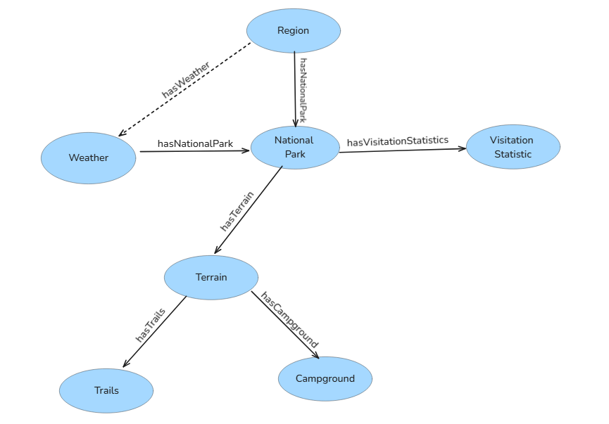

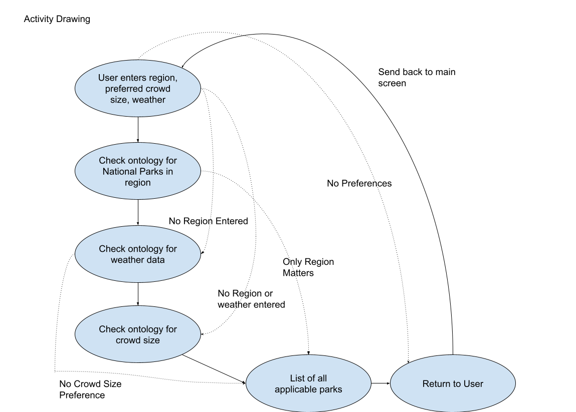

Architecture Diagram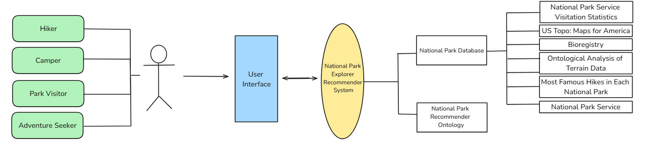

Class Hierarchy:

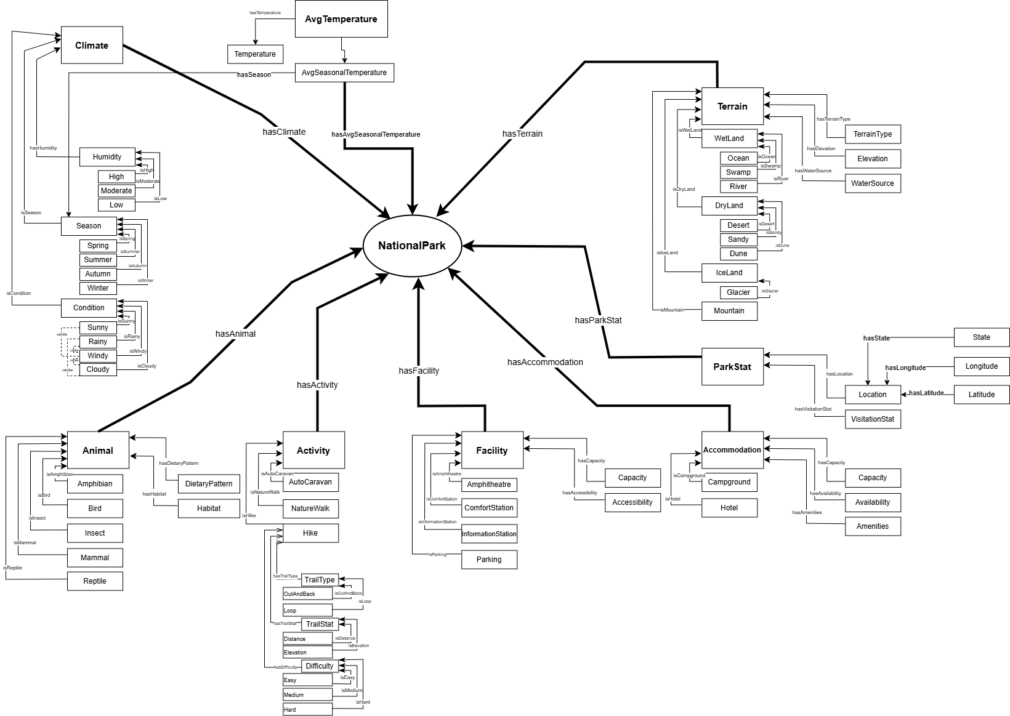

Description:

Above is the UML diagram that shows the classes and properties that the main park class has. The main park class has activities, animals, park stats, terrain, climate, accommodations, and facilities. All of these classes also have their own classes and properties.

**VII. Competency Questions**

**One way to use semantics etc.:**

**Importance:**  I would need to use provenance and semantics to ensure that my data is reliable and my answers are as well. With semantics, this representation allows me to be specific with data related to whatever the user desires.

**For Visitation Stats:** Knowing visitation statistics and using provenance allows us to assume that all the data of people coming to the park is accurate, thus my recommendation to the user is accurate.

**For Weather Data:** Similar to visitation statistics, provenance allows the user to assume that the climate and the source I am getting the information from is accurate and thus my response is accurate.

**Question 1:**

If I want to go to the northernmost park in the United States that is the least visited in Winter, where should I go?

**Answer 1:**

“In order to avoid crowds, visiting Arctic Gates National Park in the winter is the optimal solution.”

Terms used from the Ontology:

Weather, location, park, visitation statistics

Semantic Processes Involved:

Simple search to find north parks checking for the least visited ones

Usage Scenario Covered:

Joe has never seen a moose before and he really wants to see one in his lifetime. He has never been north before, but he knows that moose can be found in some of the northern parks. He wants a park that is not visited a lot because he doesn't like people and also a park with lots of long hikes. He was thinking about going on a trip in the summer, since he has school off.

**How was this determined?:**

The user input their own desires into the system and then the system is able to compare the specific places through a query. Ideally the computer finds the location of the northernmost parks in the United States, once this is done, the computer can compare the visitation statistics for the winter months. The ontology, containing the national parks, is able to easily compare the visitation statistics/month and weather/month, as they will be characteristics attached to the park object.

**Question 2:**

“If I want the coldest temperature park in the midwest during summer, what park should I go to that fits my comfort level?”

**Answer 2:**

“The coldest park during summer in the midwest would be Theodore Roosevelt National Park located in North Dakota”

Terms used from the Ontology:

temperature, location, park

Semantic Processes Involved:

A simple search to find midwest parks checking for the least coldest ones in the summer

Usage Scenario Covered:

John, an experienced hiker, is looking for something new. He has never been to the true midwest of the United States. He is looking for someplace in South Dakota where the weather is typically around 50 degrees in the Fall, is mostly flat land, and where no people show up. He has looked around but can’t find the correct data to point him where to go. He needs specifics to satisfy his quench for adventure.

**How was this determined?:**

Like the first question, the computer would need to find the locations of all the Midwest parks in the United States. After it found these parks, it would need to access the weather data for the Summer months for those states. Once it finds the lowest overall temperature it can narrow it down to a list of parks that work for the user.

**Question 3:**

If I want to see the rare yellow billed loon bird and I want to see if they are native to any national parks.

**Answer 3:**

Unfortunately, this animal is not native to any National Park.

Terms used from the Ontology:

animal, park

Semantic Processes Involved:

Simple search to match the animal to any park

Usage Scenario Covered:

Joe has never seen a moose before and he really wants to see one in his lifetime. He has never been north before, but he knows that moose can be found in some of the northern parks. He wants a park that is not visited a lot because he doesn't like people and also a park with lots of long hikes. He was thinking about going on a trip in the summer, since he has school off.

**How was this determined?:**

The computer iterates through each national park looking at the animals that are native to each of them. When it cannot find the specific animal that the user is looking for, it returns something along the lines of “cannot find animal”.

**Question 4**:

“I am new to hiking. Which national park has cool summer temperatures and offers short hiking trails?”

**Answer 4:**

Try Olympic National Park in Washington. The summer highs are about 70°F, trails like Hoh Rain Forest and Marymere Falls Trails are great for beginners.

Terms used from the Ontology:

Weather, temperature, park, trail statistics

Semantic Processes Involved:

Search to find cool temperatures in the summer with easy trails

Usage Scenario Covered:

Jeb is fairly new to hiking, his legs are very weak and he can’t go for long distances. He correctly assumes that National Parks with more visitation tend to have easier trails and sights to see, but he also wants something warm, dry, yet mountainous. Jeb also just wants to take pictures for Instagram and Hinge, he figures that seeming like he loves nature is a good way to seem likeable. He needs to find that easy popular place, he wants to follow the people trail.

**How was this determined?:**

The program first identifies all the national parks in the U.S. and then gathers the average summer temperatures for each park. After collecting the data it then filters the parks to find those with cooler temperatures. After that it looks for hiking trails in each park looking for shorter trails for beginners and once that is done compiling its results would be Olympic National Park as it meets both temperature and the preferred trail length.

**Question 5:**

I am in California for a week and I am curious as to what the most popular hike is out of all the National Parks here.

**Answer 5:**

The Balconies Cave Trail is the most popular hike out of all of the National Parks in California.

Terms used from the Ontology:

location, park, trail statistics

Semantic Processes Involved:

Search California to find the most popular hike

Usage Scenario Covered:

Jeb is fairly new to hiking, his legs are very weak and he can’t go for long distances. He correctly assumes that National Parks with more visitation tend to have easier trails and sights to see, but he also wants something warm, dry, yet mountainous. Jeb also just wants to take pictures for Instagram and Hinge, he figures that seeming like he loves nature is a good way to seem likeable. He needs to find that easy popular place, he wants to follow the people trail.

**How was this determined?:** The ontology would search through all of the National Parks in California putting all of the most popular hikes from each park in a list. Then it would search through that list again finding the most popular hike in the entire state.

**Question 6:**

I would like to visit Yellowstone National Park and would like to make sure that there are hotels and cafeterias in the park that I can use.

**Answer 6:**

Yellowstone National Park has several hotels and restaurants on premise.

Terms used from the Ontology:

park, accommodations

Semantic Processes Involved:

Simple search to search a park for certain accommodations

Usage Scenario Covered:

James has never been to a national park before. He has gotten the recommendation to visit national parks but has never followed through because he is concerned about lodging and facilities. He would like to at the bare minimum make sure that he has a room with a bed he can stay in overnight and that he has consistent access to food and water.

**How was this determined?:**

The parks in the ontology would be queried to assess if there are accommodations suitable to the users query. Yellowstone National Park has hotels so an answer is given saying that yellowstone national park has this accommodation. For the cafeteria, even if Yellowstone National Park has no ‘cafeteria’, cafeteria is a subclass of establishments that provide food of which a restaurant also belongs and so an answer is provided saying that restaurants are on premises.

**VIII. Resources**

*In order to support the capabilities described in this Use Case, a set of resources must be available and/or configured. These resources include the set of actors listed above, with additional detail, and any other ancillary systems, sensors, or services that are relevant to the problem/use case.*

**Knowledge Bases, Repositories, or other Data Sources**

| Data | Type | Characteristics | Description | Owner | Source | Access Policies & Usage |
| --- | --- | --- | --- | --- | --- | --- |
| *(dataset or repository name)* | *(remote, local/in situ, etc.)* | *e.g. – no cloud cover* | *Short description of the dataset, possibly including rationale of the usage characteristics* |  | *Source (possibly a system, or remote site) for discovery and access* |  |
| *National Park Service Visitation Statistics* | *Potentially downloadable* | *List of all the national parks and their visitation statistics by year by month* | *This can give the visitation statistics of all the national parks.* | *US Government* | *National Park Service, "Summary of Visitor Use By Month and Year (1979 - Last Calendar Year): Knife River Indian Villages National Historic Site," [Online]. Available:* [*https://irma.nps.gov/Stats/SSRSReports/Park%20Specific%20Reports/Summary%20of%20Visitor%20Use%20By%20Month%20and%20Year%20(1979%20-%20Last%20Calendar%20Year)?Park=KNRI*](https://irma.nps.gov/Stats/SSRSReports/Park%20Specific%20Reports/Summary%20of%20Visitor%20Use%20By%20Month%20and%20Year%20(1979%20-%20Last%20Calendar%20Year)?Park=KNRI)*. [Accessed: 03-Oct-2024].* | *Public Access* |
| *Weather in North Dakota by Month* | *Potentially downloadable* | *This will list the weather in a given state by month* | *This will list the weather in a given state by month. The goal would be to find one of these per state or region.* | *Associated Weather Websites* | *“North Dakota Climate, Weather By Month, Average Temperature (United States) - Weather Spark,” weatherspark.com. https://weatherspark.com/countries/US/ND* | *Public* |
| *US Topo: Maps for America* | *Downloadable* | *Terrain mappage for United States* | *This is a topological map of the United States that can be used to get terrain data for a state/area* | *US Government* | *“US Topo: Maps for America | U.S. Geological Survey,” www.usgs.gov. https://www.usgs.gov/programs/national-geospatial-program/us-topo-maps-america* | *Public* |
| *National Park Service Glossary of Terms* | *Downloadable* | *List of terms commonly used in park management* | *With this list we are able to identify terms that are relevant to a recommendation system* | *National Park Service* | *National Park Service, “Glossary of National Park Service Terms.” [Online]. Available: https://npshistory.com/publications/nps-glossary.pdf. [Accessed: 25-Sep-2024].* | *Public* |
| *National Parks Data* | *Data Category* | *National Park Visitation* | *Comprehensive data on U.S. national parks, including climate, terrain types, wildlife, and visitor statistics.* | *National Park Service* | *https://public.tableau.com/app/profile/john.marucci7217/viz/NationalParksData_17089763478400/NationalParksData* | *Public* |
| *Weather Averages for National Parks* | *Data Category* | *Temperature, Precipitation, Seasons* | *Average weather conditions, including temperature and precipitation for various national parks.* | *Destination Parks* | *https://www.destinationparks.com/resource/weather-averages-national-parks.php* | *Public* |
| *Best Hikes in National Parks* | *Data Category* | *Trail Name, Location, Difficulty* | *Highlights the best hiking trails in various national parks, including details on trail location and difficulty level.* | *Condé Nast Traveler* | *https://www.cntraveler.com/gallery/the-best-hike-in-every-national-park* | *Public* |

**External Ontologies, Vocabularies, or other Model Services**

| Resource | Language | Description | Owner | Source | Describes/Uses | Access Policies & Usage |
| --- | --- | --- | --- | --- | --- | --- |
| *(ontology, vocabulary, or model name)* | *(ontology language and syntactic form, e.g., RDFS - N3)* | *If the service is one that runs a given ontology or model-based application at a given frequency, state that in addition to the basic description* |  | *Source (link to the registry or directly to the ontology, vocabulary, or model where that model is maintained, if available)* | *List of one or more data sources described by and/or used by the model* |  |
| *Bioregistry* |  | *“An ontology and inventory of geopolitical entities such as nations and their components (states, provinces, districts, counties) and the actual physical territories over which they have jurisdiction. We thus distinguish and assign different identifiers to the US in "The US declared war on Germany" vs. the US in "The plane entered US airspace".” - From Website* | *geogeo* | *https://bioregistry.io/registry/geogeo* | *Would use this to register states.* | *Public* |
| *Ontological analysis of terrain data* |  | *“ we formalize the properties of each piece of data and its processing history in a geographic ontology, and use declarative Semantic Web Rule Language (SWRL) rules to calculate the errors relative to the real world or to other data. Since the impact of these errors depends on the purpose for which the data is to be used, purpose-dependent requirements are described using an additional task ontology and evaluated by our task analyzer software. The geographic ontology combines knowledge from different areas of expertise, and makes it available for the community to use, critique, and augment.”- From Website* | *Susanne Riehemann, Daniel Elenius* | *https://dl.acm.org/doi/10.1145/1999320.1999330* | *This might have the same use as the previous source, but I believe this can get terrain data.* | *Need to Purchase - $15* |

**Other Resources, Service, or Triggers** *(e.g., event notification services, application services, etc.)*

| Resource | Type | Description | Owner | Source | Access Policies & Usage |
| --- | --- | --- | --- | --- | --- |
| *(sensor or external service name)* |  | *Include a description of the resource as well as availability, if applicable* | *Primary owner of the service* | ***Application or service URL****; if subscription based, include subscription and any subscription owner* |  |
| *most famous hikes in each national park* | *website* | *Includes the most famous hikes in each national park along with information about them* | *STRAVA | FATMAP* | *https://fatmap.com/discover/guidebook/united-states-of-america/washington/alpine-climbing/hiking/the-most-famous-hike-in-every-us-national-park/109220* | *public* |
|  | *website* | *Temperature for each park by season* |  | *https://discord.com/channels/@me/1285354133431386233/1306427467912843276* | *public* |

**IX. References and Bibliography**

*List all reference documents – policy documents, regulations, standards, de-facto standards, glossaries, dictionaries and thesauri, taxonomies, and any other reference materials considered relevant to the use case*

All needed elements, sourced in previous tables

**Domain Reference:**

**National Weather Service, “Glossary of Weather Terms,” Weather.gov. [Online]. Available:** [**https://www.weather.gov/cae/weatherterms.html**](https://www.weather.gov/cae/weatherterms.html)**. [Accessed: 25-Sep-2024].**

**Merriam-Webster, “Merriam-Webster Dictionary.” [Online]. Available:** [**https://www.merriam-webster.com**](https://www.merriam-webster.com)**. [Accessed: 25-Sep-2024].**

**FATMAP, “The Most Famous Hike in Every US National Park,” FATMAP Guidebook. [Online]. Available:** [**https://fatmap.com/discover/guidebook/united-states-of-america/washington/alpine-climbing/hiking/the-most-famous-hike-in-every-us-national-park/109220**](https://fatmap.com/discover/guidebook/united-states-of-america/washington/alpine-climbing/hiking/the-most-famous-hike-in-every-us-national-park/109220)**. [Accessed: 23-Sep-2024].**

**Integrated Taxonomic Information System, “Integrated Taxonomic Information System.” [Online]. Available:** [**https://www.itis.gov/**](https://www.itis.gov/)**. [Accessed: Date you accessed the site].**

**Encyclopedia of Life, “Species Profiles.” [Online]. Available:** [**https://eol.org**](https://eol.org)**. [Accessed: 25-Sep-2024].**

**National Park Service, “Wildlife in National Parks.” [Online]. Available:** [**https://www.nps.gov**](https://www.nps.gov)**. [Accessed: 25-Sep-2024].**

**National Audubon Society, “Bird Guide,” [Online]. Available:** [**https://www.audubon.org/bird-guide**](https://www.audubon.org/bird-guide)**. [Accessed: 25-Sep-2024].**

**Smithsonian Institution, “Animal Information and Conservation Resources.” [Online]. Available:** [**https://www.si.edu**](https://www.si.edu)**. [Accessed: 25-Sep-2024].**

**National Park Service, “Species List (IRMA Portal).” [Online]. Available:** [**https://irma.nps.gov/NPSpecies/Search/SpeciesList**](https://irma.nps.gov/NPSpecies/Search/SpeciesList)**. [Accessed: 25-Sep-2024].**

**National Park Service, “Glossary of National Park Service Terms.” [Online]. Available:** [**https://npshistory.com/publications/nps-glossary.pdf**](https://npshistory.com/publications/nps-glossary.pdf)**. [Accessed: 25-Sep-2024].**