HuffPost News Category Classification Using RoBERTa
Part B Technical Report - Draft

Team Members | [Insert all official team member names]
Course | DX703 O1 Advanced Machine Learning & AI - Spring 2026
Date Submitted | April 27, 2026
Dataset Used | HuffPost News Category Dataset
Final Model | roberta-base with linear classification head

One-sentence summary: This project fine-tunes a transformer-based text classifier to route HuffPost news articles into editorial categories using headline and short-description text.

B.1: Introduction and Problem Definition

B.1.1 Problem Description and Motivation
This project addresses a multi-class text classification problem: predicting the editorial category of a news article from its headline and short description. The problem is realistic for digital publishing platforms, news aggregators, recommendation systems, and content-management systems. In production, editors and product teams often need to route incoming stories into topic pages, personalize news feeds, organize archives, and trigger downstream workflows such as moderation, tagging, search indexing, and recommendation. Manual categorization can be slow and inconsistent when article volume is high, while an automated classifier can provide fast, repeatable first-pass labels.
The task is challenging because HuffPost article text is short, categories overlap semantically, and the dataset is imbalanced. For example, political stories can overlap with world news, media, business, or identity-related topics. Lifestyle categories such as wellness, parenting, food, and travel may be more separable because their headlines often contain distinctive topical words, but ambiguous categories such as miscellaneous, media, education, and environment require stronger contextual understanding. For this reason, the final solution uses a pretrained transformer language model rather than relying only on bag-of-words or recurrent-network representations.

B.1.2 Business and Data-Science Goals
The business goal is to support reliable and scalable topic routing for a digital news platform. A model that predicts article categories accurately can reduce editorial triage time, improve topic-page organization, support more relevant user recommendations, and create a consistent taxonomy across a large archive.
The data-science goal is to learn a supervised classification model that maps article text to one of 23 consolidated editorial categories. The input to the model is a combined text field created from each article headline and short description. The output is a probability distribution over the final category set. Because the dataset is imbalanced, macro-F1 is treated as a primary evaluation metric alongside accuracy and weighted-F1. Accuracy measures the overall share of correctly classified articles, while macro-F1 gives equal weight to all categories and is therefore more sensitive to minority-class performance.

B.1.3 Dataset Description and EDA Summary
The project uses the HuffPost News Category Dataset, which contains approximately 200,000 articles from 2012-2018. Each record includes fields such as headline, short description, category, authors, link, and date. The raw dataset contains 41 categories. During preprocessing, semantically duplicate or overlapping categories were consolidated into 23 canonical classes. Examples include merging WORLDPOST and THE WORLDPOST into WORLD NEWS, combining SCIENCE and TECH into SCIENCE & TECH, grouping several identity-focused categories into IDENTITY, and grouping niche categories such as WEIRD NEWS, GOOD NEWS, IMPACT, and FIFTY into MISCELLANEOUS.
The main input features were headline and short description. These fields were concatenated into a single BERT-style text sequence using the format: headline [SEP] short_description. The combined field captures both the strongest topical signal from the headline and additional context from the short description. The EDA showed several practical data issues: missing short descriptions, a very small number of empty headlines, duplicate combined-text records, class imbalance, and overlapping category semantics. After cleaning and consolidation, the final split contained 160,284 training examples, 20,036 validation examples, and 20,036 test examples across 23 classes.
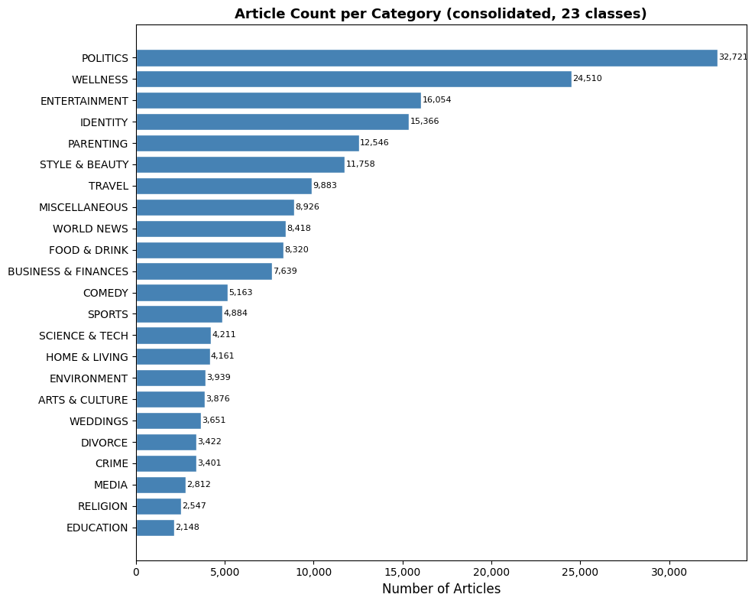
Figure 1. Article count per category after consolidation into 23 classes.
Figure 1 shows that the dataset is strongly imbalanced. POLITICS and WELLNESS are among the largest categories, while EDUCATION, RELIGION, MEDIA, CRIME, and DIVORCE have far fewer examples. This imbalance affects model evaluation because high accuracy can be achieved by performing well on majority classes while still missing minority categories. For that reason, macro-F1 and per-class F1 are especially important for interpreting the final model.

B.2: Methodology

B.2.1 Preprocessing Pipeline
The final preprocessing pipeline was designed to be reproducible and appropriate for transformer-based NLP. The dataset was loaded from Hugging Face rather than from a hard-coded local path. Text fields were cleaned by handling missing values, dropping empty headlines, removing exact duplicate combined-text rows, and lowercasing the combined text. Category consolidation was then applied to reduce the original 41 raw labels to 23 canonical classes. This step reduced redundant labels and made the classification problem more meaningful by aligning the label taxonomy with broader editorial topics.
After cleaning, labels were encoded as integer IDs with a label encoder. A fixed random seed was used for reproducibility. The cleaned dataset was split into training, validation, and test sets using a stratified 80/10/10 split. Stratification was important because several classes were small; without stratification, minority categories could be underrepresented in validation or test data.
For model input, the combined text was tokenized with the RoBERTa tokenizer. The maximum sequence length was set to 64 tokens. This value was chosen because EDA showed that the 95th-percentile combined text length was about 57 words, meaning that max_length=64 covered the vast majority of articles while keeping training computationally efficient. Tokenization produced input IDs and attention masks. These tensors were passed to PyTorch data loaders with a training batch size of 32 and an evaluation batch size of 64.
Pipeline Component | Final Choice
Raw text fields | headline + short_description
Combined text format | headline [SEP] short_description
Raw categories | 41
Final categories | 23 consolidated classes
Cleaning | Drop empty headlines; remove exact combined-text duplicates; handle missing descriptions
Split | Stratified 80% train / 10% validation / 10% test
Tokenizer | RoBERTa tokenizer
Max sequence length | 64 tokens

B.2.2 Model Architecture and Justification
The final model is roberta-base with a linear classification head for 23 output classes. RoBERTa is a pretrained transformer encoder that learns contextual token representations through self-attention. This architecture is well suited for short news text because it can use word order and context to distinguish categories that share vocabulary. For example, the same words may appear in political, business, media, and world-news stories, but transformer attention can help capture the surrounding context that determines the intended category.
The architecture contains approximately 124.7 million parameters. The pretrained encoder provides general language representations, while the classification head maps the pooled representation to the 23 category logits. The model is trained with multi-class cross-entropy loss. Because the label distribution is imbalanced, macro-F1 is used as the primary model-selection metric during validation.
Milestone 2 experiments informed this final architecture. Simpler neural baselines, including an embedding model with global average pooling and BiLSTM variants, improved over trivial baselines but plateaued around the low 60% accuracy range. A BiLSTM with attention reached about 63.3% test accuracy and 0.575 macro-F1. Pretrained transformers performed substantially better: DistilBERT reached about 75.4% accuracy and 0.676 macro-F1, while RoBERTa achieved the best overall performance. The final choice therefore prioritizes RoBERTa because it provides the strongest balance of accuracy, macro-F1, and contextual representation quality for this dataset.
Model | Test Accuracy | Test Macro-F1 | Interpretation
Embedding + GlobalAveragePooling | 59.8% | 0.534 | Baseline neural text model
BiLSTM + Attention + ReduceLR | 63.3% | 0.575 | Best custom RNN model
DistilBERT phased fine-tuning | 75.4% | 0.676 | Efficient pretrained transformer
RoBERTa phased fine-tuning | 76.6% in milestone; 76.23% final notebook | 0.689 in milestone; 0.7236 final notebook | Selected final model

B.2.3 Training Strategy
The final training strategy used phased fine-tuning. This approach starts with a mostly frozen pretrained model and gradually unfreezes more parameters while lowering the learning rate. The purpose is to adapt the classification head first, then carefully adapt higher-level transformer layers, and finally fine-tune the full model without causing large destructive updates to pretrained weights.
The optimizer was AdamW with weight decay. AdamW is appropriate for transformer fine-tuning because it combines adaptive learning rates with decoupled weight decay, which improves regularization compared with standard Adam. Cross-entropy loss was used because the task is single-label multi-class classification. The validation macro-F1 score was monitored to select the best checkpoint.
Phase | Trainable Parameters | Learning Rate | Epochs | Purpose
Phase 1 | Classifier head only | 2e-5 | 5 | Train task-specific head while protecting pretrained encoder
Phase 2 | Top 2 encoder layers + head | 1e-5 | 5 | Adapt higher-level contextual features
Phase 3 | All parameters | 5e-6 | 5 | Full fine-tuning with a conservative learning rate

Hyperparameter / Strategy | Value
Loss function | Multi-class cross-entropy
Optimizer | AdamW
Weight decay | 0.01
Training batch size | 32
Evaluation batch size | 64
Maximum length | 64 tokens
Total epochs | 15
Primary validation metric | Macro-F1
Checkpointing | Save best model based on validation macro-F1

B.2.4 Performance Validation and Leakage Prevention
The validation set was used during training to monitor generalization and choose the best checkpoint. The test set was held out until final evaluation and was not used to tune model architecture or training decisions. Stratified splitting preserved the approximate class distribution across train, validation, and test sets. Duplicates were removed before splitting so that the same combined text would not appear in multiple splits. This step reduced the risk of data leakage and made the test set a more realistic estimate of performance on unseen articles.
The final notebook reports validation progress after each epoch and loads the best checkpoint before running test-set evaluation. This makes the final test metrics correspond to the best validation macro-F1 model rather than simply the last epoch.

B.3: Results and Evaluation

B.3.1 Quantitative Results
The final RoBERTa model achieved strong performance on the held-out test set. Final test accuracy was 76.23%, macro-F1 was 0.7236, and weighted-F1 was 0.7585 across 20,036 test articles and 23 classes. The difference between weighted-F1 and macro-F1 reflects the effect of class imbalance: performance is stronger on high-support categories and weaker on some smaller or more ambiguous categories.
Metric | Value | Meaning
Accuracy | 76.23% | Overall percentage of correct predictions
Macro-F1 | 0.7236 | Primary metric; treats each class equally
Weighted-F1 | 0.7585 | F1 weighted by class support
Test samples | 20,036 | Held-out test set
Number of classes | 23 | Consolidated editorial categories
Best validation macro-F1 | 0.7243 | Best checkpoint selected during training

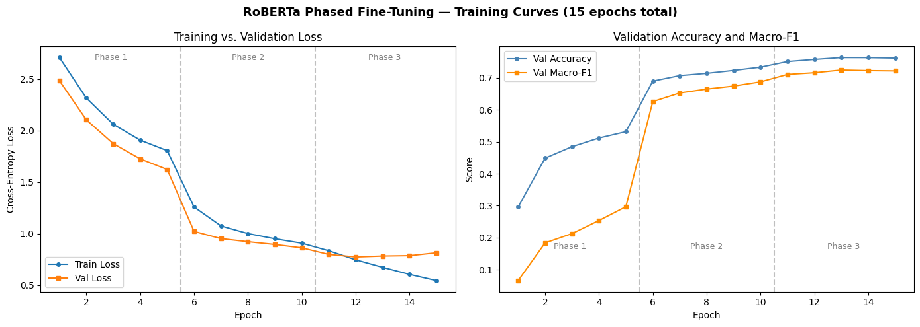
Figure 2. RoBERTa phased fine-tuning curves across 15 epochs.
Figure 2 shows that phased fine-tuning produced large performance gains once transformer layers were unfrozen. During Phase 1, when only the classifier head was trained, validation accuracy and macro-F1 improved but remained limited. Phase 2 produced the largest jump, indicating that the top encoder layers contributed important task-specific adaptation. Phase 3 produced smaller gains and then began to show mild overfitting: training loss continued to decrease while validation loss flattened and increased slightly in later epochs. The best validation macro-F1 occurred at epoch 13, and the final model was loaded from that best checkpoint.

B.3.2 Confusion Matrix Interpretation
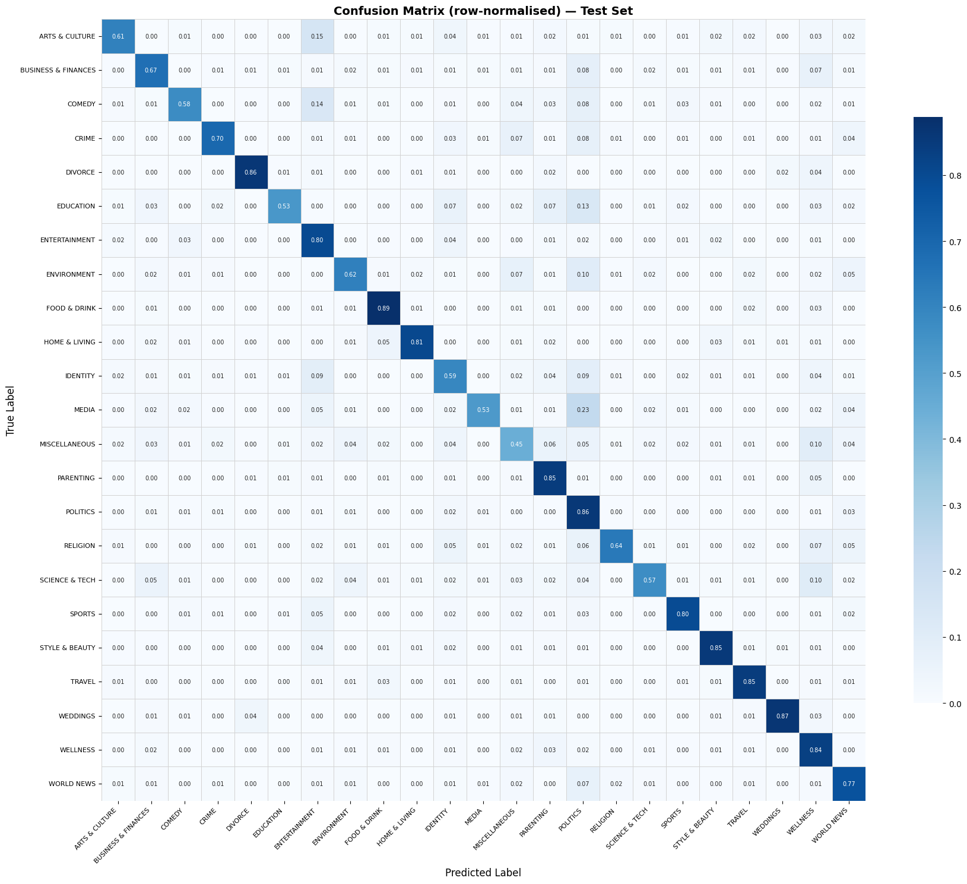
Figure 3. Row-normalized confusion matrix on the test set.
The row-normalized confusion matrix in Figure 3 shows that many categories have strong diagonal values, meaning the model usually predicts the correct label. Categories such as FOOD & DRINK, DIVORCE, WEDDINGS, STYLE & BEAUTY, TRAVEL, WELLNESS, and POLITICS show high recall. These categories likely contain distinctive lexical patterns and clearer editorial boundaries.
The confusion matrix also reveals predictable errors among semantically related categories. MISCELLANEOUS is difficult because it contains several broad niche categories merged into a single label. MEDIA, EDUCATION, ENVIRONMENT, and COMEDY also show lower recall and more confusion with broader classes such as POLITICS, ENTERTAINMENT, WORLD NEWS, or MISCELLANEOUS. These errors are not random; they reflect overlap in real editorial taxonomies. For example, an environmental article may also involve politics, science, or world news. A media story may be categorized as entertainment or politics depending on the article framing.

B.3.3 Per-Class Metrics
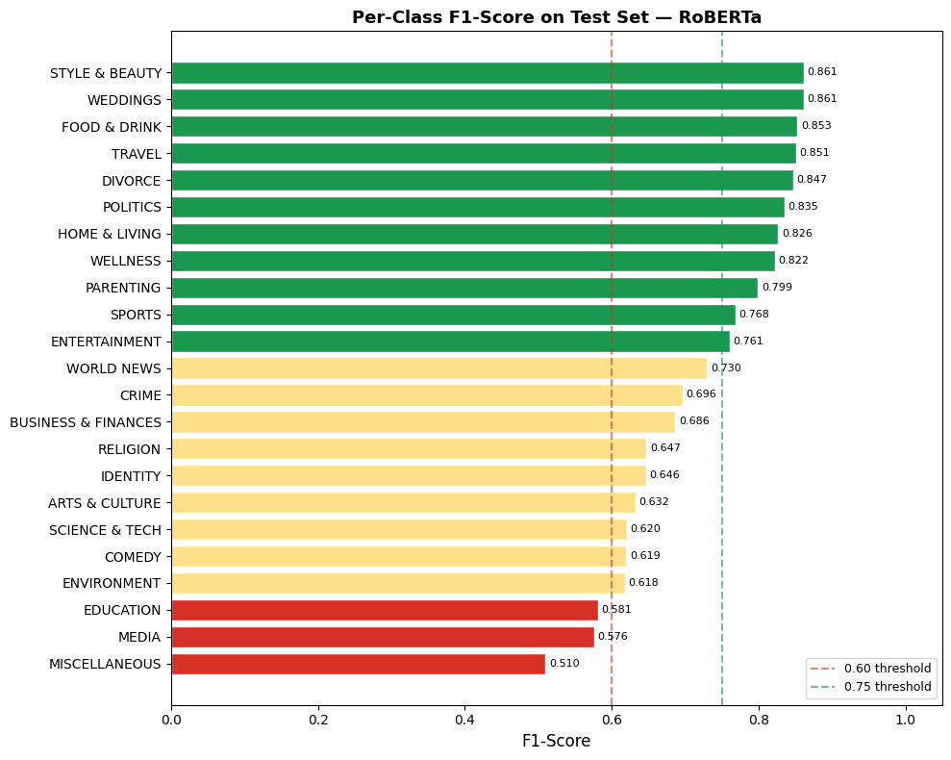
Figure 4. Per-class F1 scores for the final RoBERTa model.
Figure 4 makes the class-level pattern clearer. The strongest classes were STYLE & BEAUTY, WEDDINGS, FOOD & DRINK, TRAVEL, and DIVORCE. These categories all achieved F1 scores above approximately 0.84. Their success suggests that the model learned clear topical signals from short text. For example, wedding and divorce articles often contain direct lexical cues, and food, travel, and style articles often have distinctive vocabulary.
The weakest classes were MISCELLANEOUS, MEDIA, EDUCATION, ENVIRONMENT, and COMEDY. MISCELLANEOUS was the hardest class, with an F1 score of 0.5096. This is expected because it is a deliberately broad class created from heterogeneous raw labels. EDUCATION and MEDIA had relatively low support and can overlap with politics, identity, entertainment, or world news. COMEDY may be especially difficult because humor is not always detectable from short headlines and descriptions, and many comedy articles may also look like entertainment or culture articles.
Class | F1-Score | Support | Interpretation
STYLE & BEAUTY | 0.8611 | 1,176 | Clear topical vocabulary
WEDDINGS | 0.8610 | 365 | Distinctive label-specific language
FOOD & DRINK | 0.8529 | 832 | Strong lexical cues
TRAVEL | 0.8505 | 988 | Geographic and travel-specific terms
DIVORCE | 0.8465 | 342 | Narrow topic boundary
MISCELLANEOUS | 0.5096 | 893 | Broad heterogeneous merged class
MEDIA | 0.5759 | 281 | Overlaps with politics/entertainment
EDUCATION | 0.5808 | 215 | Small support and broad topic scope
ENVIRONMENT | 0.6175 | 394 | Overlaps with politics/science/world news
COMEDY | 0.6194 | 516 | Tone and humor are hard from short text

B.3.4 Summary of Final Model Performance
The final model represents the best solution because it outperformed earlier neural and transformer alternatives and produced the strongest validation and test metrics. The result shows that pretrained contextual representations are highly valuable for short-form news classification. At the same time, the model is not perfect: even a strong transformer struggles with noisy labels, merged categories, minority classes, and ambiguous article topics. The final performance indicates that automated routing would be useful as a first-pass classification system, but a production editorial workflow should still allow human review, especially for low-confidence predictions or categories known to be ambiguous.

B.4: Discussion and Reflection

B.4.1 Limitations and Sources of Error
The first major limitation is class imbalance. The largest category contains far more examples than the smallest categories, so the model has more opportunities to learn majority-class patterns. Macro-F1 helps expose this issue, but it does not eliminate the underlying imbalance. Minority categories such as EDUCATION and MEDIA remain harder to model because the training signal is weaker.
The second limitation is category ambiguity. News taxonomies are not always mutually exclusive. A single article could reasonably belong to politics, world news, business, environment, identity, or media depending on editorial intent. The model is trained to predict only one label even when several categories might be plausible. This creates unavoidable noise in the target labels.
The third limitation comes from short and noisy text. Headlines are optimized for readers, not machine learning models. They may use humor, irony, names, events, or references that require broader world knowledge. Short descriptions help, but some records have missing or limited descriptions. This makes it harder to classify tone-based or context-dependent categories such as COMEDY, MEDIA, and MISCELLANEOUS.
A fourth limitation is the category-consolidation strategy. Merging raw categories improved the label taxonomy, but it also created broad classes. MISCELLANEOUS is the clearest example: it groups several categories that are not semantically identical. This makes the class useful for simplifying the task but difficult for the model to learn cleanly. Finally, model-related limitations remain. RoBERTa is powerful but sensitive to fine-tuning choices such as learning rate, maximum sequence length, batch size, and which layers are unfrozen.

B.4.2 Potential Improvements
If we had more time, the first improvement would be to use class-weighted loss or focal loss during transformer fine-tuning. These methods could force the model to pay more attention to difficult or minority categories, potentially improving macro-F1 even if overall accuracy changes only slightly.
The second improvement would be deeper error analysis and label-taxonomy refinement. For example, MISCELLANEOUS could be split into more coherent subgroups or handled as a fallback class only when the model is uncertain. Similarly, MEDIA, EDUCATION, and ENVIRONMENT errors could be reviewed manually to determine whether some labels are genuinely ambiguous or inconsistently assigned.
The third improvement would be to test stronger or newer pretrained models, such as DeBERTa or a domain-adapted news transformer. RoBERTa already performs well, but a model trained or adapted on news-style text may better capture journalistic phrasing and category boundaries.
The fourth improvement would be to experiment with input length and feature construction. Although max_length=64 covers most examples, some records may benefit from longer context. We could compare 64, 96, and 128 tokens and examine whether minority or ambiguous categories improve. We could also add article date or author metadata if appropriate, but this would require careful leakage analysis because temporal or author patterns might not generalize.
The fifth improvement would be probability calibration and confidence-aware deployment. In a real workflow, the model should not always make a hard automatic decision. Instead, high-confidence predictions could be auto-routed, while low-confidence predictions or categories with known confusion patterns could be flagged for editorial review.

B.4.3 Reflection on Learning
The most important lesson from the project was that representation quality mattered more than small architectural tuning once the task involved short, semantically nuanced text. Custom embedding and RNN models could learn useful patterns, but they did not capture enough context to separate overlapping editorial categories. Pretrained transformers produced a major improvement because they brought strong prior language knowledge to the problem.
We also learned that validation design and metric choice matter. Accuracy alone would overstate performance because the dataset is imbalanced. Macro-F1, per-class F1, and the confusion matrix provided a much more honest view of the model. They showed not only whether the model performed well overall, but also where it failed and why those failures made sense.
The phased fine-tuning process was another important learning point. Fully fine-tuning a large transformer from the start can be unstable, while training only the classification head is not expressive enough. Gradual unfreezing gave the model a stable path from general pretrained language understanding to task-specific category prediction. If we repeated the project, we would spend more time earlier on label design and error analysis, because the hardest remaining problems appear to come from taxonomy ambiguity and data quality rather than from the model architecture alone.

B.5: AI Use Disclosure
AI tools were used as assistive resources during the project. They were helpful for organizing the notebook around the rubric, improving Markdown explanations, drafting technical-report language, checking whether the report addressed all required sections, and debugging or clarifying code structure. AI tools were also useful for turning notebook outputs into clearer narrative interpretations.
AI tools were not used as a substitute for running the model, validating outputs, or making final analytical judgments. The team remained responsible for the dataset choices, model implementation, training results, interpretation of metrics, and final submission. In several cases, AI-generated suggestions required review because they could overstate certainty or produce generic language that did not match the actual results. The most useful approach was to treat AI as a writing and review assistant, while verifying all technical claims against the notebook and project outputs.
Our advice to future students is to use AI tools carefully and transparently. AI can help with organization, debugging, and explanation, but it should not replace understanding the model or checking the evidence. The strongest use of AI is to ask it to align work with the rubric, identify missing pieces, and improve clarity after the student or team has produced real code and results.

References
- HuffPost News Category Dataset. Available through Hugging Face Datasets.
- Liu, Y., Ott, M., Goyal, N., et al. (2019). RoBERTa: A Robustly Optimized BERT Pretraining Approach.
- Devlin, J., Chang, M.-W., Lee, K., & Toutanova, K. (2019). BERT: Pre-training of Deep Bidirectional Transformers for Language Understanding.

Appendix A: Required Figures Checklist
Rubric Requirement | Location | Status
EDA / class distribution | Figure 1 | Included
Training vs. validation loss | Figure 2 | Included
Training/validation performance curve | Figure 2 | Included
Confusion matrix on test set | Figure 3 | Included
Per-class F1 metrics | Figure 4 and Table 7 | Included

