mlr3入門

川田恵介

## おすすめ

* R入門
  + R for Data Science: https://r4ds.had.co.nz/
  + Advanced R: https://adv-r.hadley.nz/
* mlr3入門
  + Package Page: https://mlr3.mlr-org.com/
* 講義に合わせたページ: https://github.com/tetokawata/BookEmiricalSocialML)

## SetUp

library(mlr3verse) # Machine Learning  
library(tidyverse) # PreProcess  
  
Data <- read_csv("ExampleData/Example.csv") # Import Data

## mlr3 EcoSystem

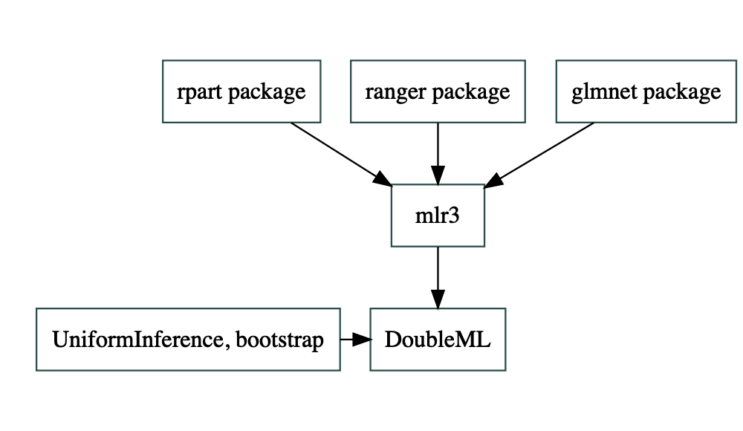

## RoadMap

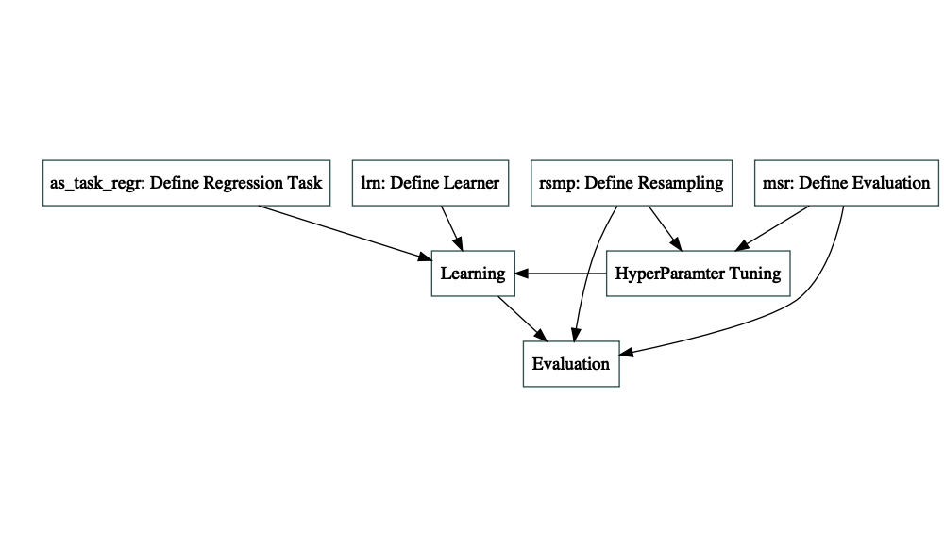

## Define

Tree <- lrn("regr.rpart") # Define Tree Learner  
  
Task <- as_task_regr(Data,  
 target = "Price") # Define Price Prediction Task  
  
R2 <- msr("regr.rsq") # Define R2

## Learning

Tree$train(Task)

## Visualization

rpart.plot::rpart.plot(Tree$model)

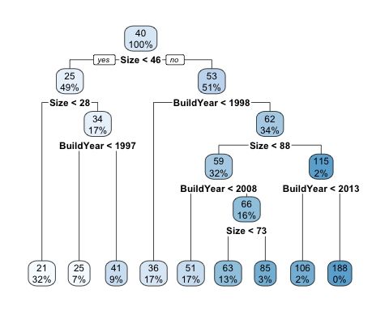

## HyperParameter

Tree$param_set # Check default hyper parameters

<ParamSet>  
 id class lower upper nlevels default value  
 1: cp ParamDbl 0 1 Inf 0.01   
 2: keep_model ParamLgl NA NA 2 FALSE   
 3: maxcompete ParamInt 0 Inf Inf 4   
 4: maxdepth ParamInt 1 30 30 30   
 5: maxsurrogate ParamInt 0 Inf Inf 5   
 6: minbucket ParamInt 1 Inf Inf <NoDefault[3]>   
 7: minsplit ParamInt 1 Inf Inf 20   
 8: surrogatestyle ParamInt 0 1 2 0   
 9: usesurrogate ParamInt 0 2 3 2   
10: xval ParamInt 0 Inf Inf 10 0

## Set NewAlgorithm

ShallowTree <- Tree$clone(deep = TRUE) # Deep copy  
  
ShallowTree$param_set$values$maxdepth <- 2 # Set MaxDepth  
  
ShallowTree$train(Task)  
  
rpart.plot::rpart.plot(ShallowTree$model)

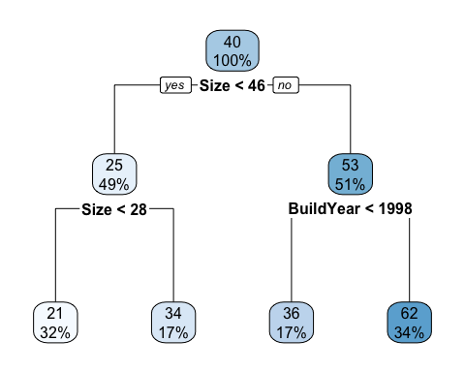

## Prediction

Tree$predict(Task) # 推定に用いたデータへの予想

<PredictionRegr> for 14793 observations:  
 row_ids truth response  
 1 21 25.00514  
 2 98 51.46344  
 3 30 21.05457  
---   
 14791 34 36.39636  
 14792 33 36.39636  
 14793 51 62.58268

## Evaluation

Tree$predict(Task)$score(R2)

regr.rsq   
0.4092182