A New Strategy to Solving Ellipse around Differential Equation

Ramin Edjlal
codesandart@gmail.com
Keywords: Ellipse, Equation, Around, Accurate, Scope

Abstract:
Reaching to ellipse equation in this paper is considered. Differential Equations is a way to reachable equation around of a curve. But because the Ellipse equation is a close curve with symmetry four side we can operate on one side of it and from another because from familiar around curve equation it may we could not get curve around solution we introduce a new strategy in order to find our goal equation. This paper is a way to reaching the exact ellipse equation around.
- Introduction:
The polar equation of an ellipse is shown at the below. The θ in this equation should not be confused with the parameter θ in the parametric equation. In celestial mechanics, the θ in the polar equation is called the true anomaly (sometimes denoted by w), while the parameter is called the eccentric anomaly (sometimes denoted by E). The two constants in the polar equation are the semi-latus rectum p and the eccentricity e. The origin is a focus F of the ellipse. There is a second focus F' symmetrically located on the axis. The point P at which r is a minimum is called perihelion in an orbit about the sun, while A is the aphelion. Hence, 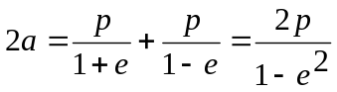
Thus:
(1) 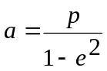

Relating p to the semi-major axis a. p is, of course, the radius when θ = 90°. [1]

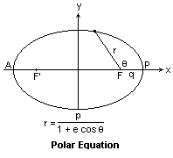
Figure 1-Polar Equation Of Ellipse
Now let c be the distance from the center to either of the foci. Then
(2) 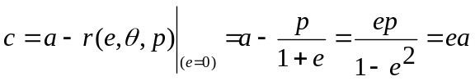
With Replacement equation (1) in equation (2) we reached:
(3) 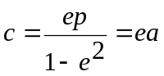
That from (1) and (3) we achieve:
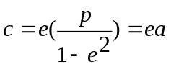
This is the clearest definition of the eccentricity.
(4) 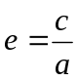.
We see that when e < 1, and e = 0, we reach to a circle. These factors are illustrated in the diagram at the Figure 2. Note especially the right triangle with legs b and c, and hypotenuse a. From this triangle, we can prove that:
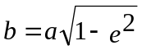
- Lemma 1: In polar coordinate system and at an ellipse we can proof that:

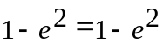
From equation (4):
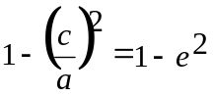
As we know:
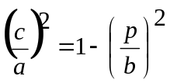
With Replacement:
(5) 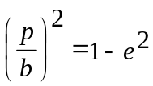
From (1) we have:
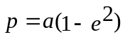
With replacements:
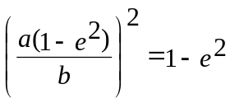
And with arrangement we reached:
(7)
That we achieve to above concept. Below the ellipse is shown the canonical equation of an ellipse, which includes a and b lengths. Two parameters are necessary to specify an ellipse, either a and b or p and e for example
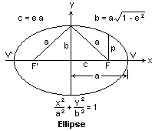
Figure 2-The ellispe description

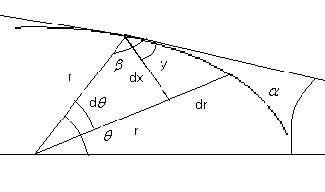
Figure 3-Elements

- Related Works:
Related works about this concept is only approximated works. It means that they estimated the ellipse around at their works. In this paper we try to prepare an exact solution of around ellipse equation. We encountered very tiring problems.
- Hope solution:
We can write that:
(8) 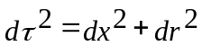
That:
(9) 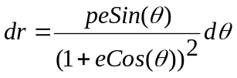
And we know that:
(10) 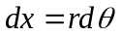
And:
(11) 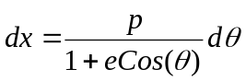
With replacement:
(12) 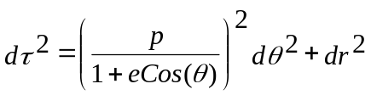
If below first integral variable changing solved it will lead to:

(13) 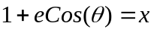
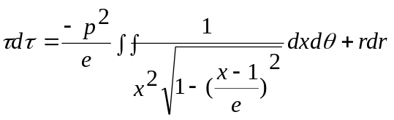
When below variable change is assumed:
(14) 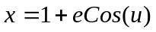
We have:
(15) 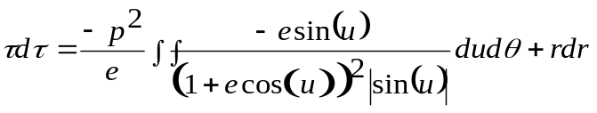
The absolute value should be specified the mark.
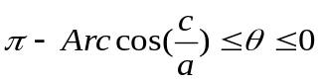
With cosine:
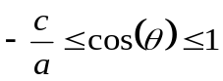
With multiply at e:
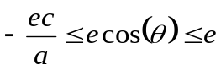
Adding with 1:
(16) 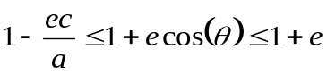
From (13) and (16):
(17) 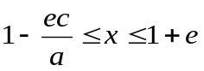
From (14) and (17):
(18) 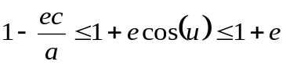
When we return the above steps we see that:
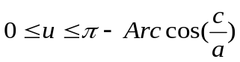
Because the sin(u) in first and second regions is positive thus:

(19) 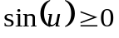
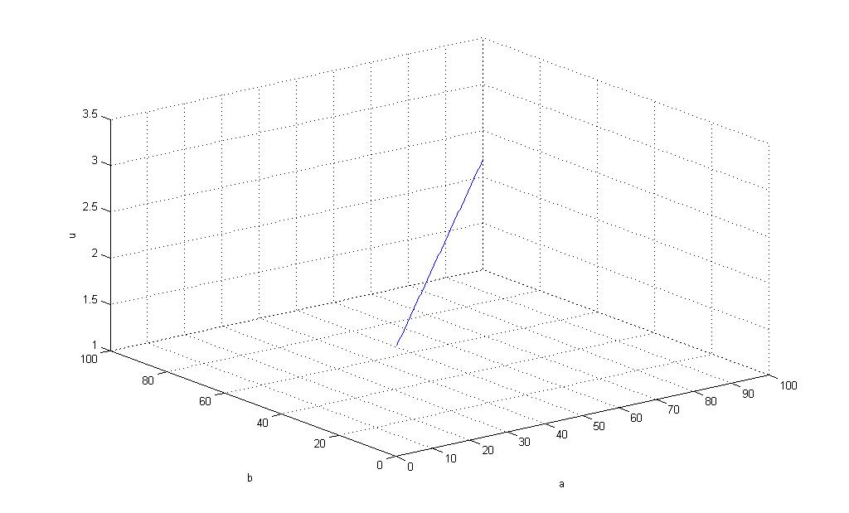
Figure 4-Differencies of a and b vs. u
The differences changes of length a and b versus u is illustrated in figure 4. The code for reaching to the changes is brought in appendix 1. As we see these changes are linear.
Thus form (19) we result from (15) we can write:
(20) 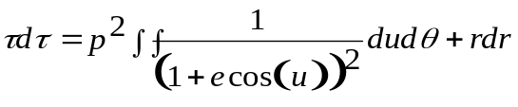
From (11) we can write:
(21) 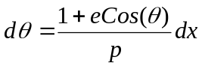
And from (13) we can write:
(22) 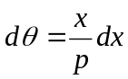
And From (14) we have:
(23) 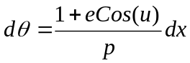
By Derivates (14) we have:
(24) 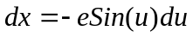
And (23) and (24) we have:
(25) 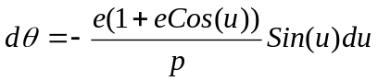
From (20) and (25) we have:
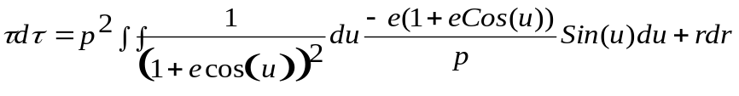
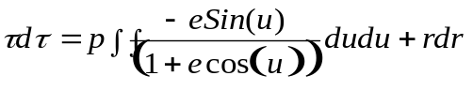
With integrate:
(26) 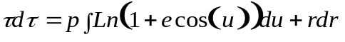

Depend of (34) and (26):

*

With replacement in (26)
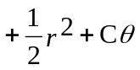

That C is constant.
We transfer this formula to section 11
- Solving Integral of:
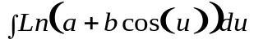
If:
(27) 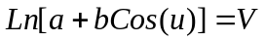

We achieve:
(28) 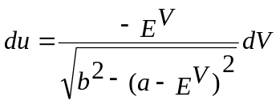
We can write:
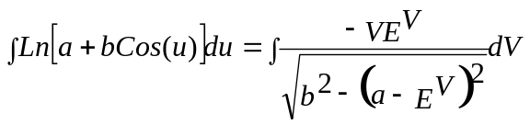
And:
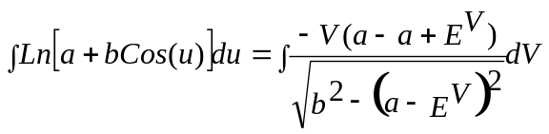
By dispreading:
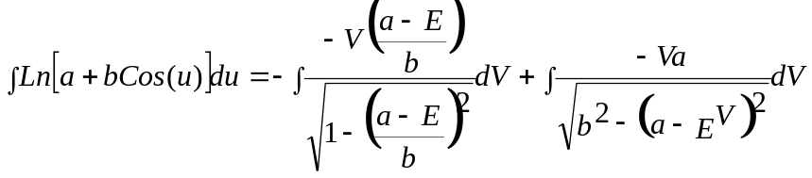
That a is constant and is equal to 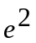at Ellipse Polar Equation and E is Nipper constant.
With part of part integral instruction:

(29) 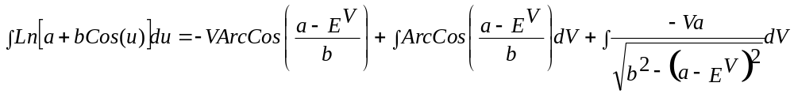
We know that:
(30) 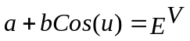
With Derivates of (3) we have:
(31) 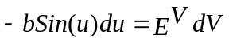
With replacements (30) in (31) we have:
(32) 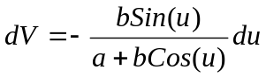
From (29) we have:
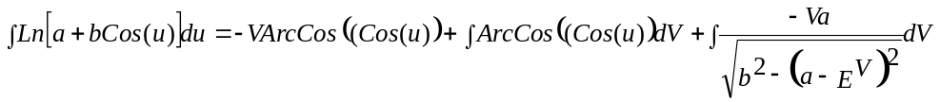
we have and Simplification:

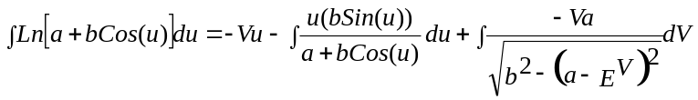
With part of part of first integral:

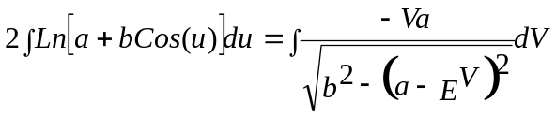
With simplification:
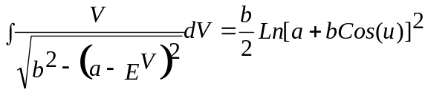
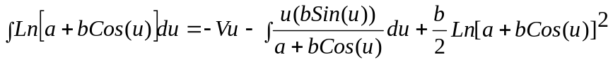
For Integral:
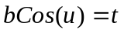
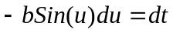
With part of part integral:

- Solving Integral of:
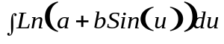
If:
(35) 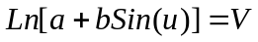

We achieve:
(36) 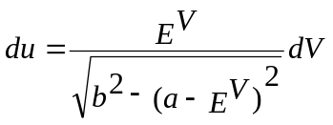
We can write:
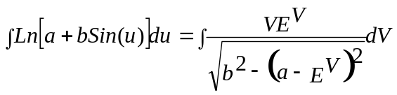

And:
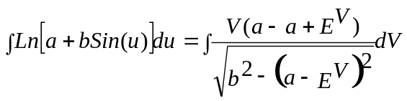
By dispreading:
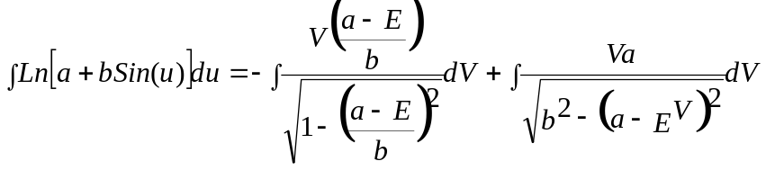
We know that:
(37) 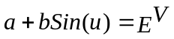
With Derivates of (37) we have:
(38) 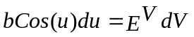
With replacements (37) in (38) we have:
(39) 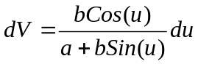
Like before we have:
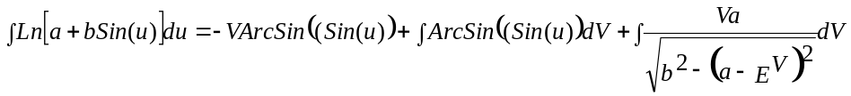
we have and Simplification:

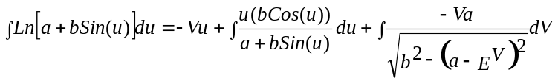
With part of part of first integral:
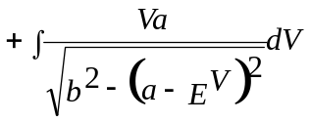
We know:
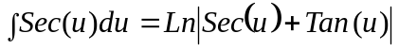
With replacement:
(40)
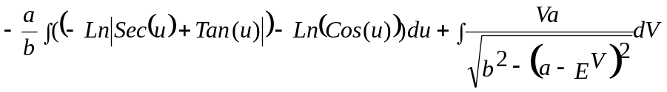

- Solving Integral of:
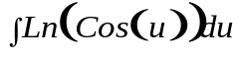
If:
(41) 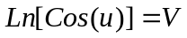

We achieve:
(42) 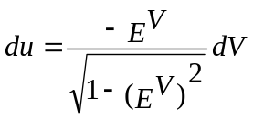
We can write:
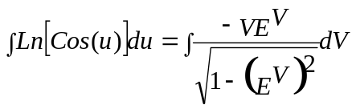
And:
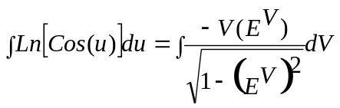
That 'a' is constant and is equal to at Ellipse Polar Equation and E is Nipper constant.
With part of part integral instruction:

(43)
We know that:
(44) 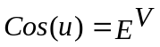
With Derivates of (44) we have:
(45) 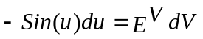
With replacements (44) in (45) we have:
(46) 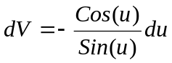
From (43) we have:
we have and Simplification:

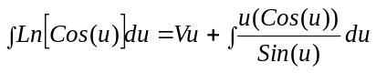
With part of part of first integral:

We know:
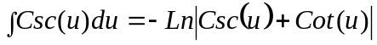
With replacement:
We can write:
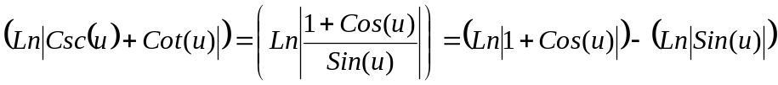
Thus:
And we can write:
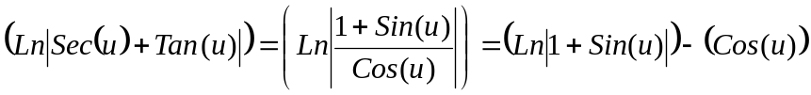

Thus:
Thus:
Thus:
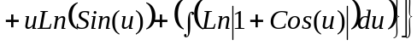

- Solving Integral of:
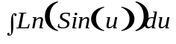
If:
(58) 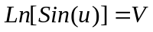

We achieve:
(59) 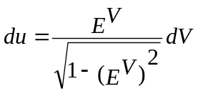
We can write:
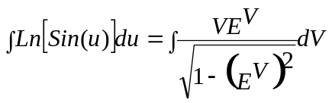

We know that:
(60) 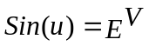
With Derivates of (36) we have:
(61) 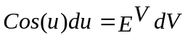
With replacements (36) in (37) we have:
(62) 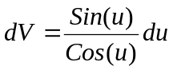

Like before we have:
we have and Simplification:

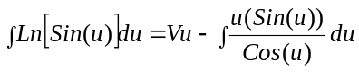
With part of part of first integral:
We know:
With replacement:
(63)
With replacements (52) in (62):
(64)
With arrangement:
(65)
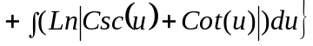
By Division:
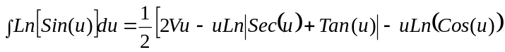
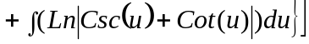
With simplification:
We can write:
Thus:
And we can write:
Thus:
And we have:
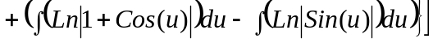

And simplification:
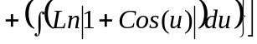

By Division:
(66)
- Solving Integral For Section 4:
From (27) and (32) we have:

(67) 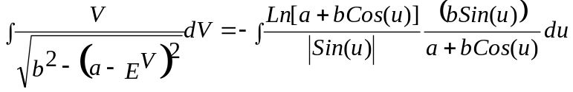
With Simplification:
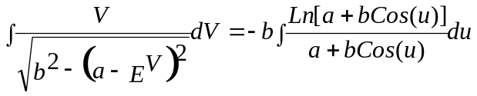

If:
(68) 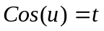
Then:
(69) 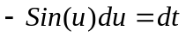
Then:
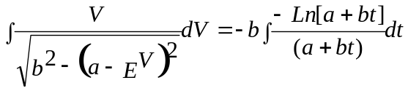
With part of part integral:
From (68):

- Solving Integral For Section 5:
From (35) and (39) we have:

(73) 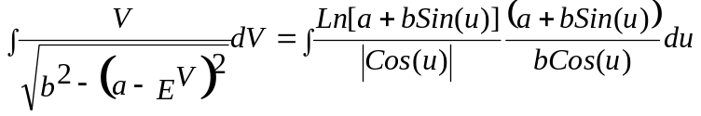
With Simplification:
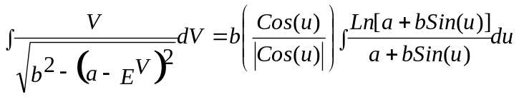

If:
(74) 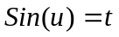
Then:
(75) 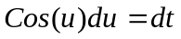
Then:
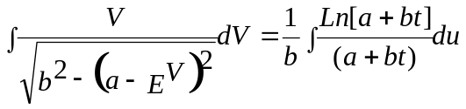
With part of part integral:
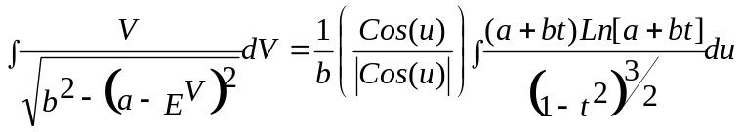
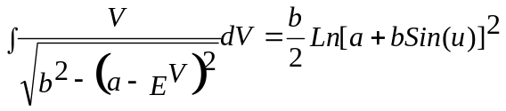
- Reminders:
We know some integrals:
If 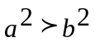:
(79) 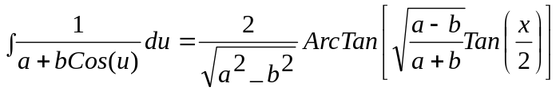
If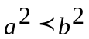:
(80) 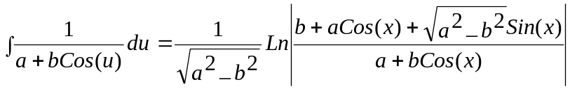
Else :
(81) 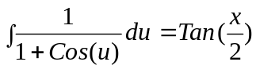
If :
(82) 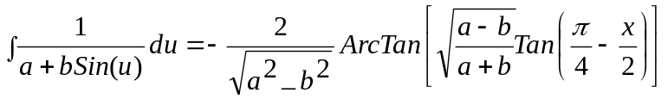
If:
(83) 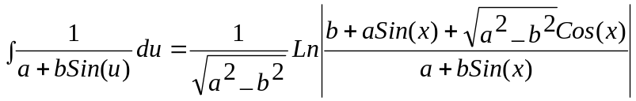
Else:
(84) 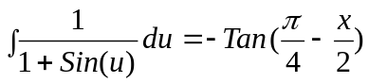

- C founding:
If we square and write:
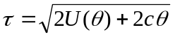
And derive from equation above and arrange we achieve:
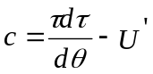
That C =2c.With replacement and arrangement and multiply at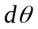:
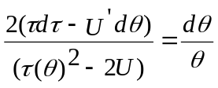
With integrating and arrangement we achieve:
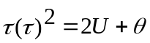
As result C is equal to 0.5.
And From Section 3:

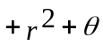

Scope Consideration:
The Scope Consideration is derived from symmetry ellipse property. Ellipse is Symmetry of ellipse center and can be divided to four sections.

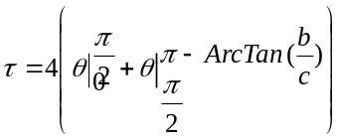
- Simulation Consideration:
Simulation Consideration leads to very usefulness result on weak personal computers. It seems to be used of more fast and occurrence computers. All we need is simulation of subsidiary Integral and Formula in a Computer Program.
- Appendix 1
clear all;
close all;
a=0:100;
b=0:100;
c=sqrt(power(a,2)+power(a,2));
e=zeros(1,101);
teta=zeros(1,101);
x=zeros(1,101);
u=zeros(1,101);
for i=1:101
e(1,i)=c(1,i)/a(1,i);
teta(1,i)=pi-atan(c(1,i)/a(1,i));
x(1,i)=1+e(1,i)*cos(teta(1,i));
u(1,i)=acos((x(1,i)-1)/e(1,i));
end;
plot3(a,b,u);

References:
[1]- http://mysite.du.edu/~jcalvert/math/ellipse.htm
[2]-
Calculus and Analytic Geometry–George B.Thomas,Ross- L.Finney Seventh Edition Addision–Wesely,1988
[3]-http://in.answers.yahoo.com/question/index?qid=20100620001054AAWDFv9
[4]-http://www.wolframalpha.com/input/?i=int+%28+1+%2F+%28+3+%2B+2+cos+x+%29%C2%B2%29+dx

