1. Create a blank repository in GitHub under User A’s account called “GITLAB” with 1 Readme file. https://github.com/tetsu123/GITLABPrint hub status. Both users A and B will use this repository. Add User B as collaborator to this repository.
2. 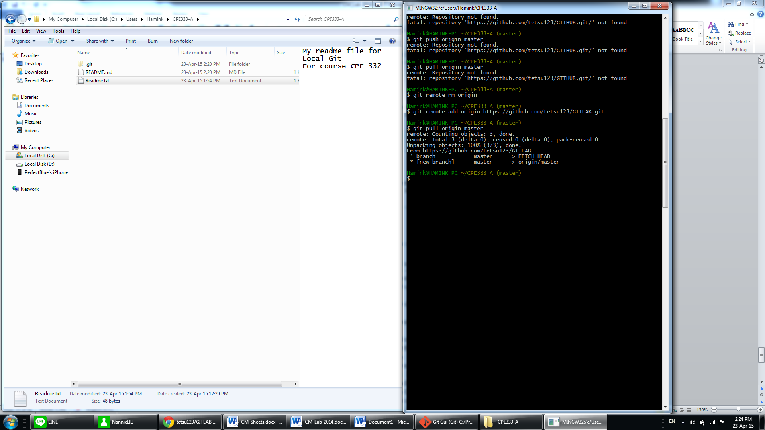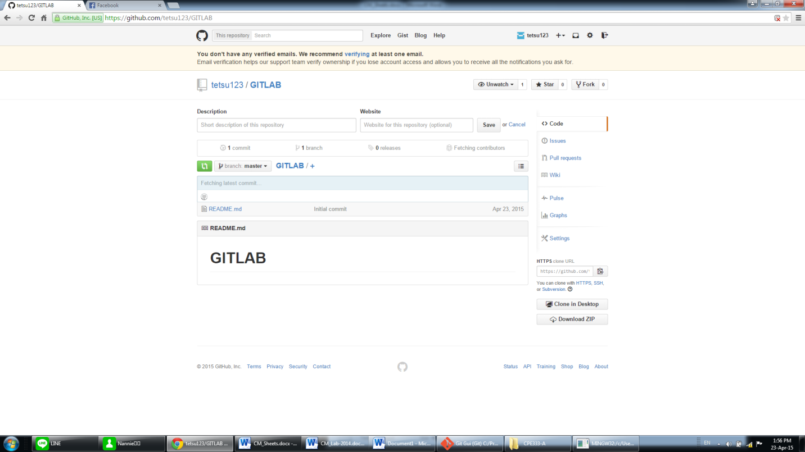In some path create a folder called “CPE333-A” for User A. Make this a git repository and pull data from GitHub. Show status.
3. In some path create a folder called “CPE333-B” for User B. Make this a git repository and pull data from GitHub. Show status.

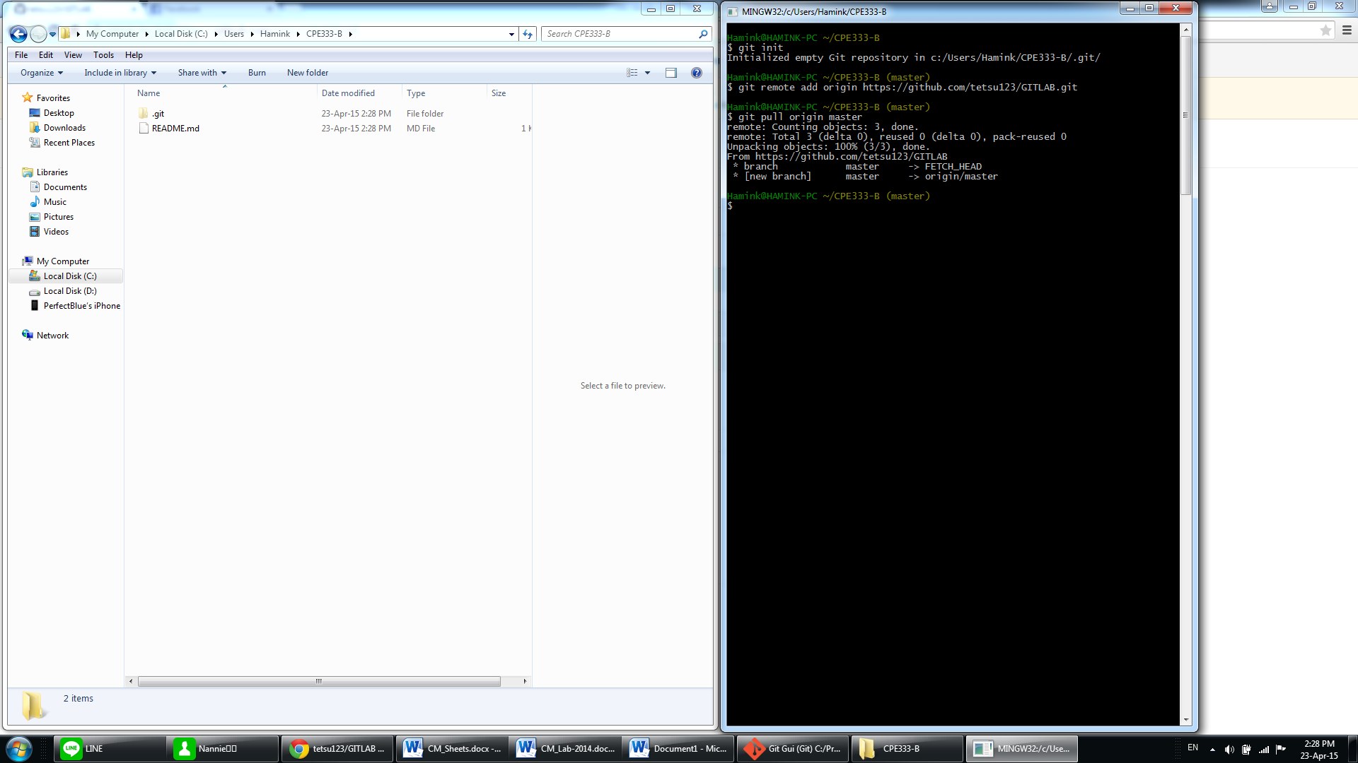

1. User A. Use file manager to put 2 C programs (Program #1 and Program #2), and 1 MS Word document into CPE333-A.



1. User A. Add all files to git. Then commit. Show Status. 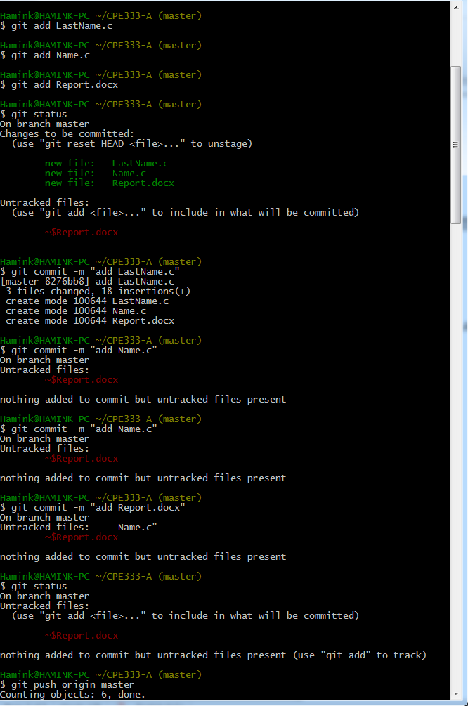

6. User A. Push your local repository to the GitHub repository. Show screen.

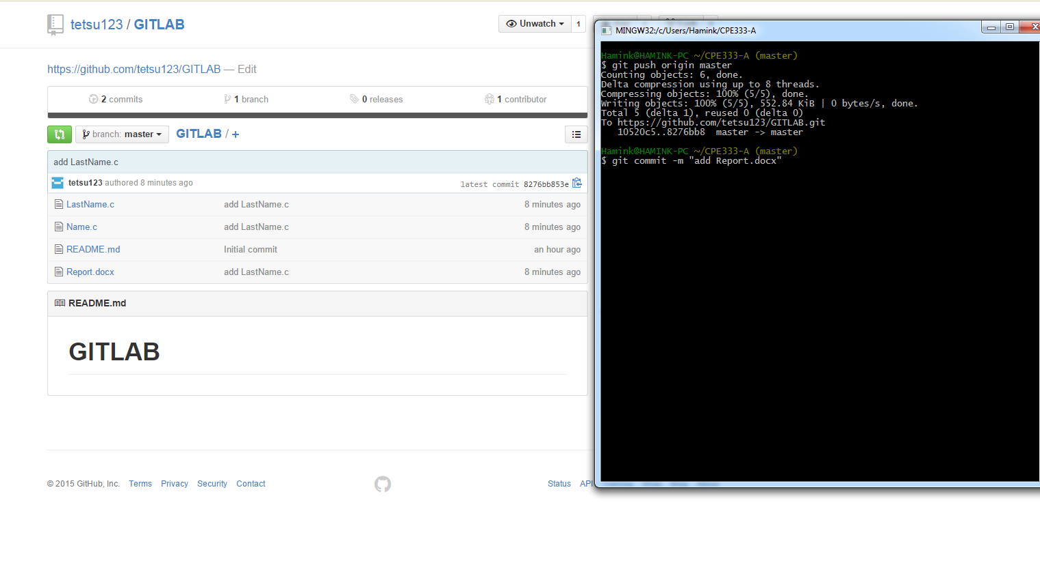

7. User B pulls data from GitHub. Show status. 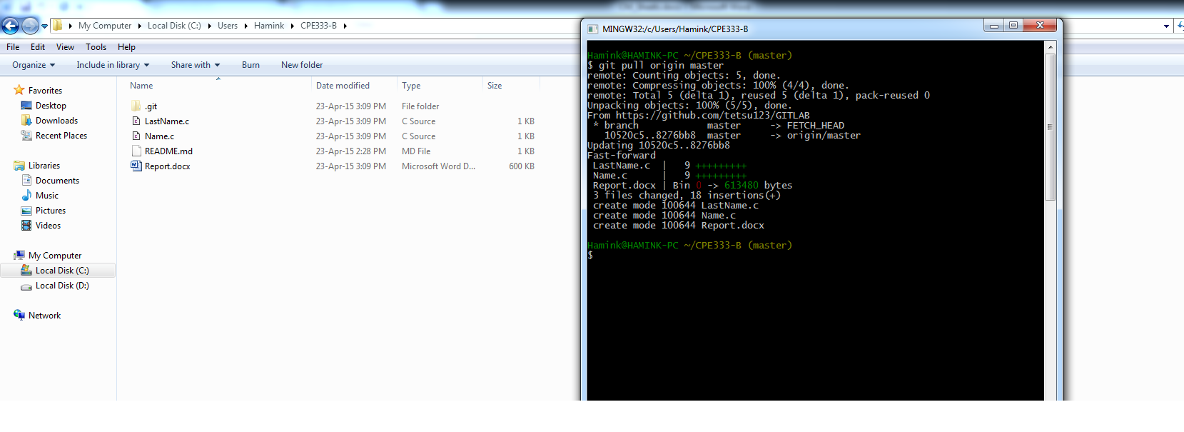

8. User B change 1 function in Program #2. Print local status User B.

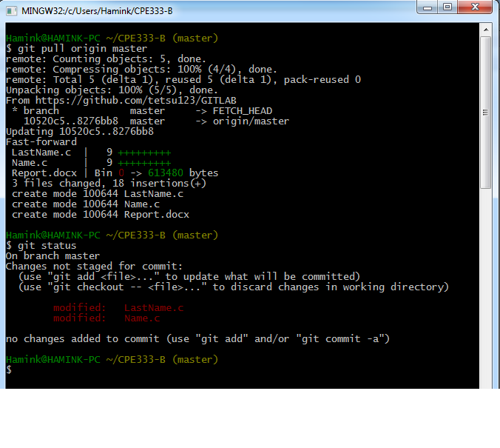

9. User B create a new C program Program #3. Do not put into Git yet. Print local status User B.

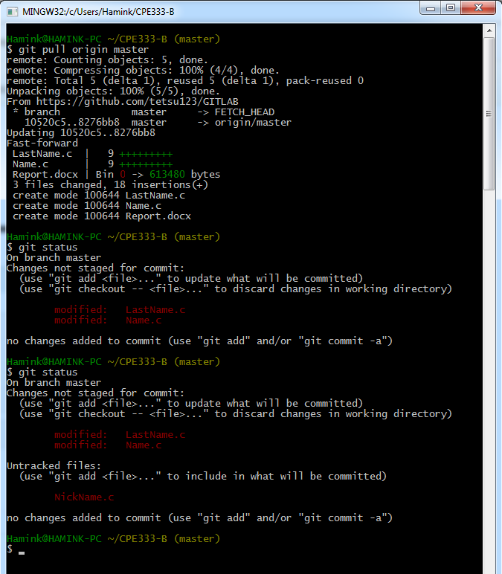

10. User B adds Program #3 to Git control (git add). Print local status User B.

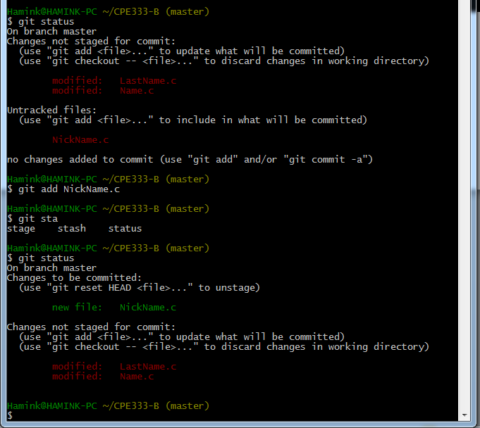

11. User B commits changes. Print local status User B.

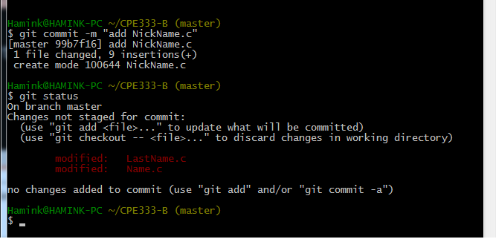

1. User B pushes changes to the GitHub repository. Print hub status. Print User B status.

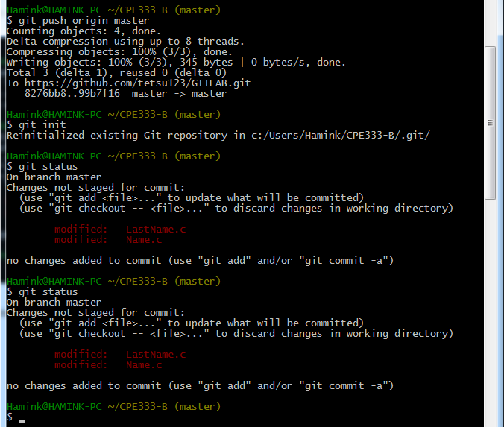

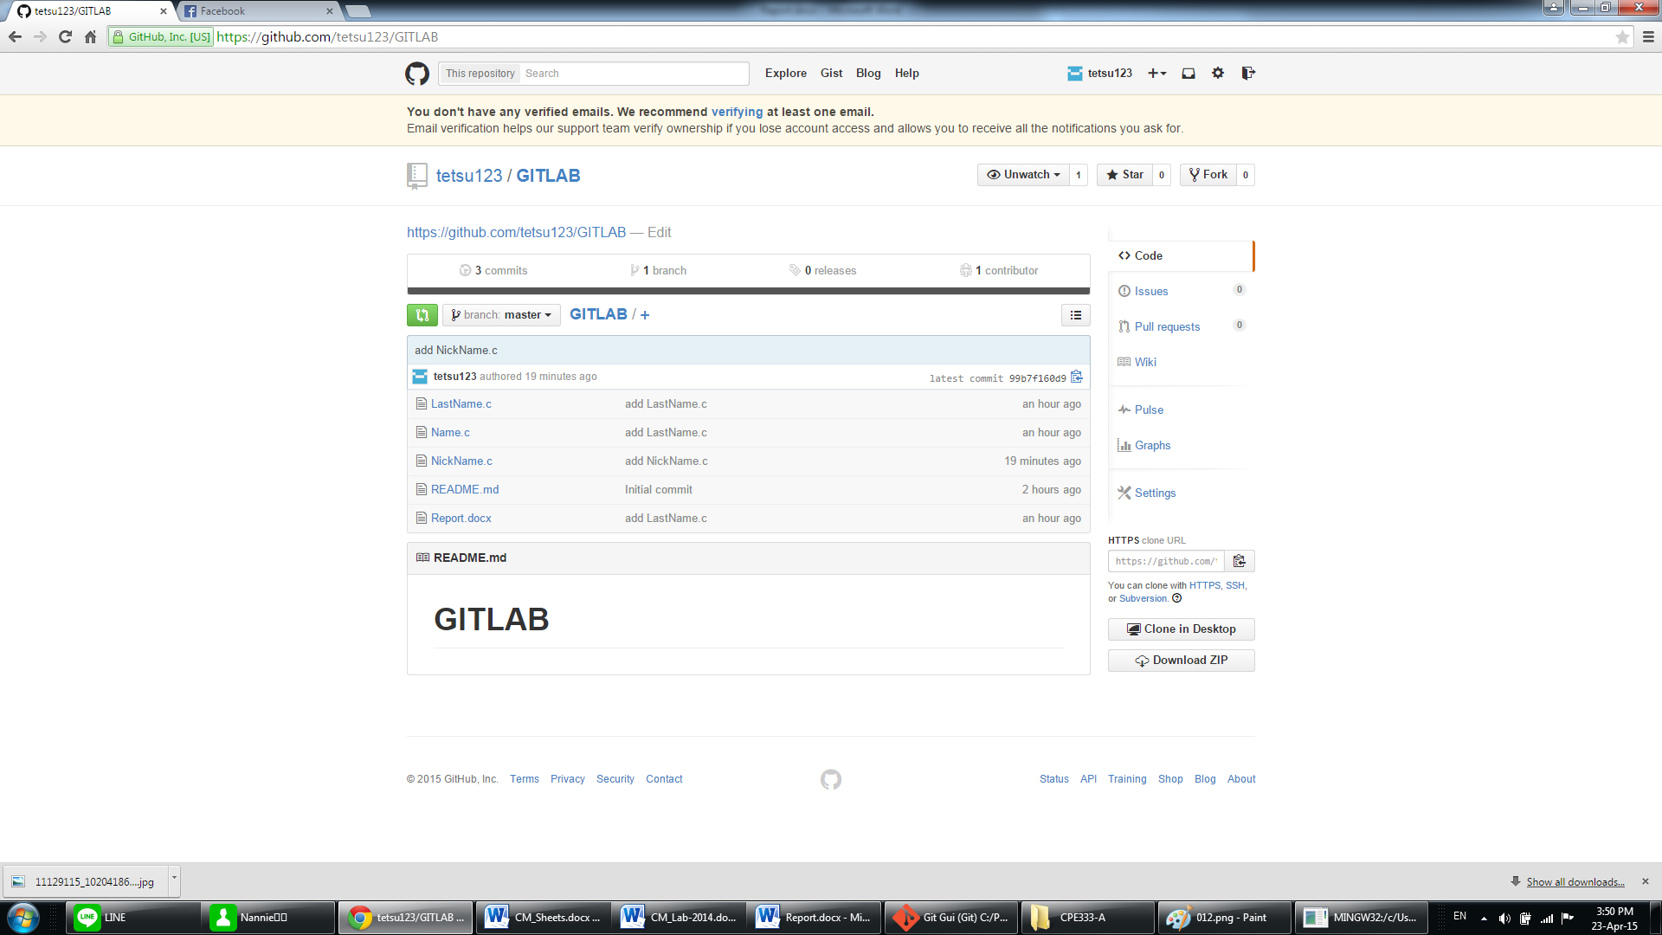

1. User A change something in C Program #1. Print local status User A.

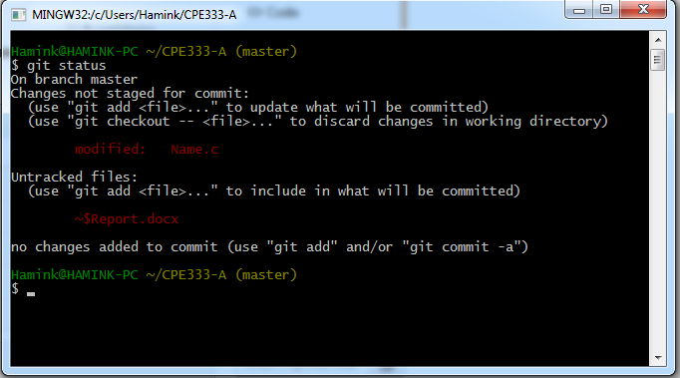

14. User A stages its changes and commits at once. Print local status User A.

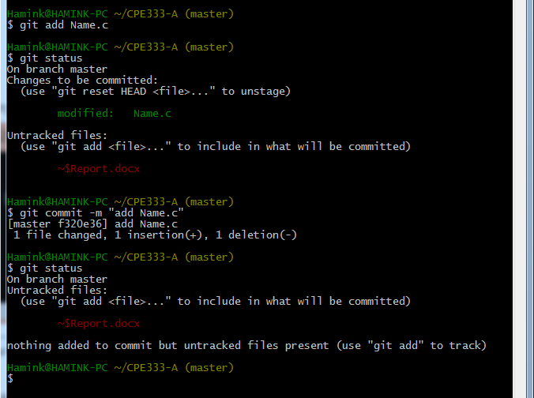

1. User A pulls repository from GitHub.

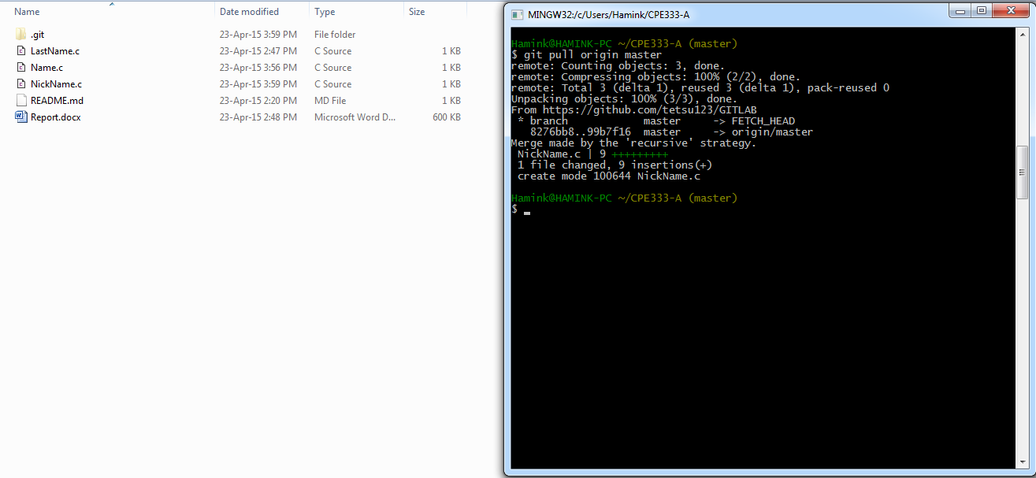

1. User A pushes changes to GitHub repository. Print status User A.

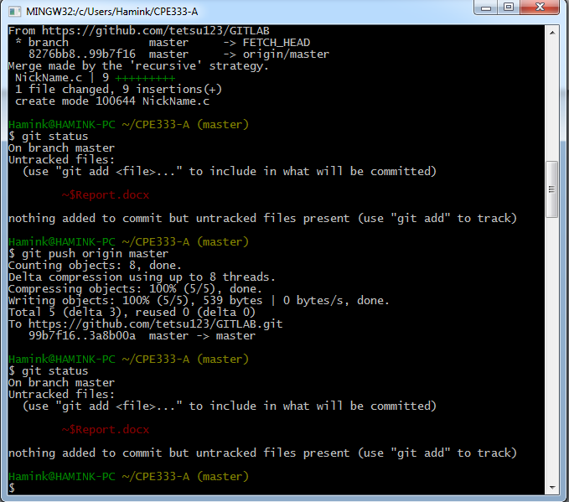

17. User B pulls repository from GitHub.

* All 3 repositories have same copy now.

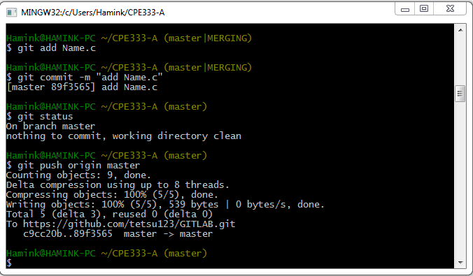

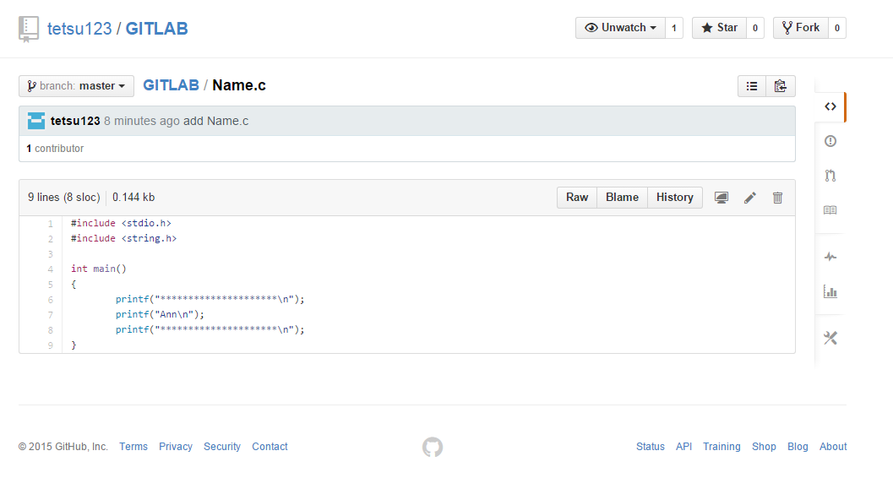

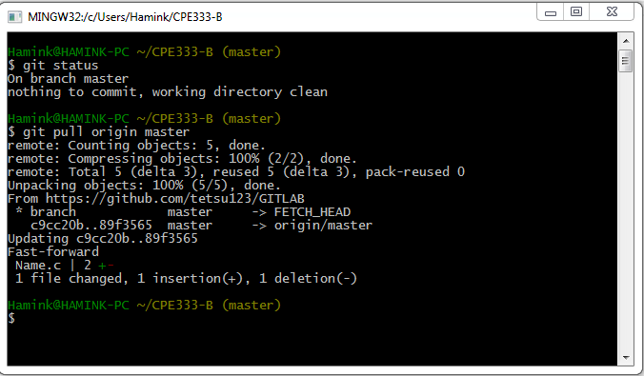

18. Then User A changes Program #1 at 2 places and User B changes same Program #1 at 2 places. Both add and commit changes. Print status of User A and User B.

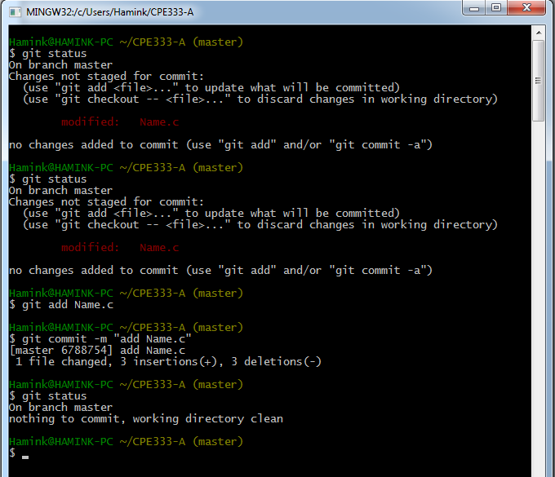

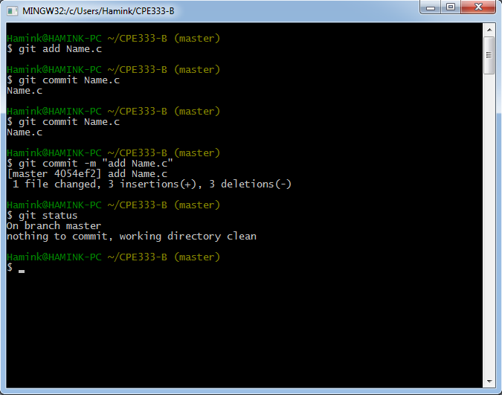

1. User A pulls from GitHub and then pushes to GitHub. User B then pulls and pushes to GitHub, but there’s conflict. Resolve this merge conflict for User B and commit change. Show each step.

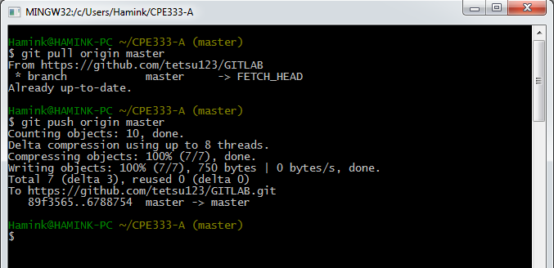

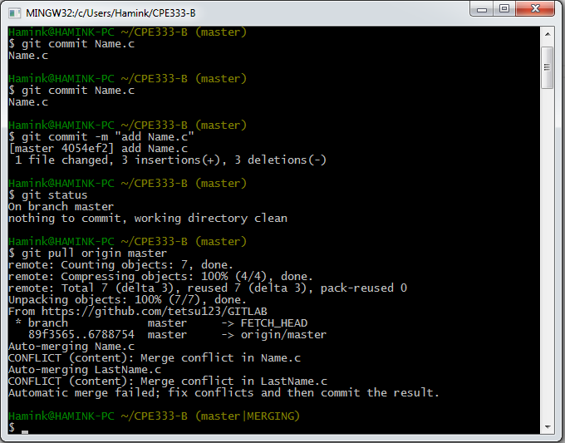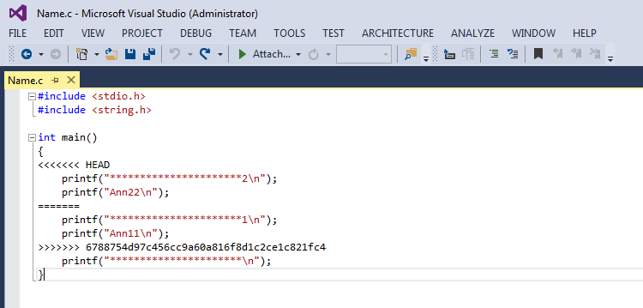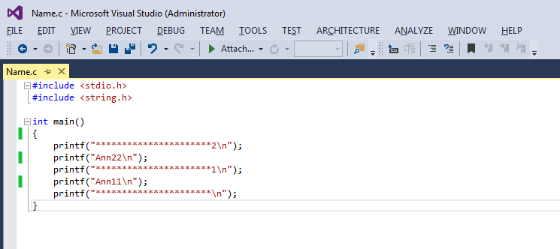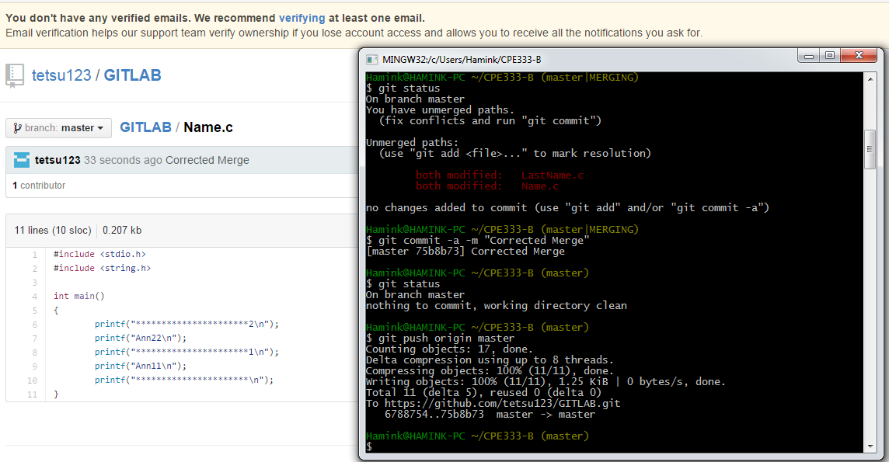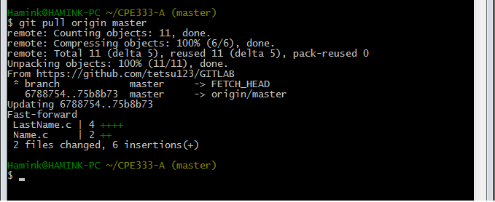20. Then User A pulls the changes. Show the Program#1 for both users that they are now the same.

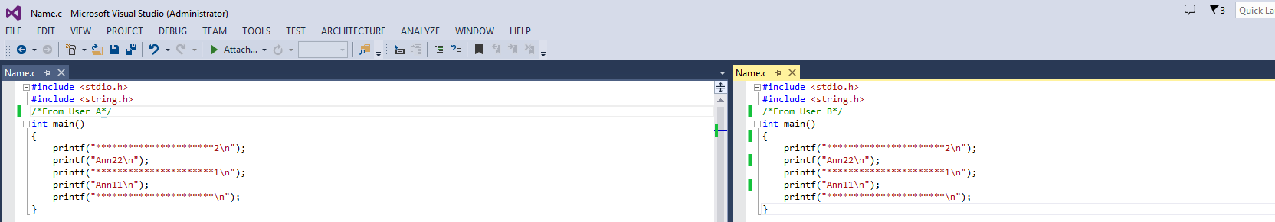

Thanakorn Iempattanasook 55070503415

Vorapol Sathitthanapat 55070503469