U

User Manual

Space Hunt

Duckfunt

Table of Contents

Controls 2

Wii 2

keyboard + mouse 3

# Controls

## Wii

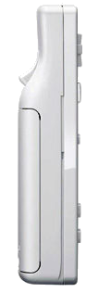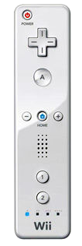

_____________________Power on/off

Shoot_______________

____________Crouch

_____________Menu

Shut down controller 🡪 Power button

Crouch 🡪 A button

Shoot 🡪 B button / Trigger

Return to menu / Pauze 🡪 Home button

## keyboard + mouse

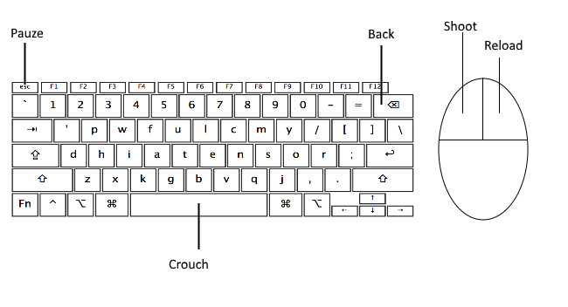

Crouch 🡪 Space bar

Shoot 🡪 Left mouse button

Reload 🡪 Right mouse button

Return to menu / Pauze 🡪 Esc button

Back 🡪 Backspace