Control map

Space hunt

duckfunt

duckfunt  Terheijdenseweg 350A

Contents

Controls Wii 2

Controls keyboard + mouse 3

# Controls Wii

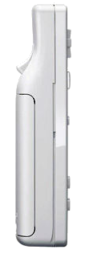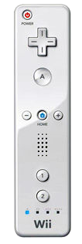

_____________________Power on/off

Shoot_______________

____________Crouch

_____________Menu

Shut down controller 🡪 Power button

Crouch 🡪 A button

Shoot 🡪 B button / Trigger

Return to menu / Pauze 🡪 Home button

# Controls keyboard + mouse

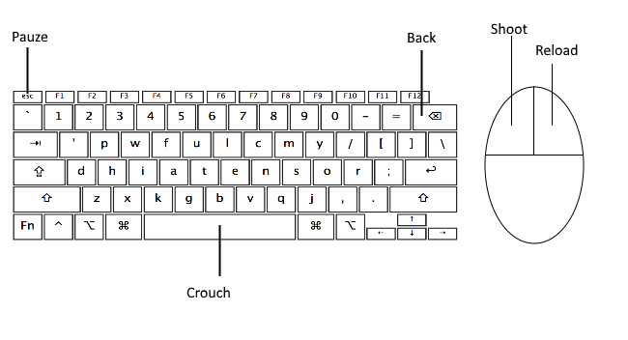

Crouch 🡪 Space bar

Shoot 🡪 Left mouse button

Reload 🡪 Right mouse button

Return to menu / Pauze 🡪 Esc button

Back 🡪 Backspace