U

User Manual

Space Hunt

Duckfunt

Table of Contents

[1. Getting Started 2](#_Toc440969178)

[1.1 Wiimote set-up 2](#_Toc440969179)

[1.2 Controls 3](#_Toc440969180)

[1.3 Starting the game 3](#_Toc440969181)

[2. Content 4](#_Toc440969182)

[2.1 Items 4](#_Toc440969183)

[2.2 Planets 5](#_Toc440969184)

[2.3 Character 5](#_Toc440969185)

[2.4 Enemies 5](#_Toc440969186)

[3. How to play 7](#_Toc440969187)

[The game explained 7](#_Toc440969188)

# Getting Started

## 1.1 Wiimote set-up

**Connecting Your WiiMote**

To find out whether or not your Bluetooth is capable of communication with your Wiimote you will need to attempt to establish a basic connection.

When you’re ready to begin, open Start > Control Panel > Add a device and then hold the 1 and 2 buttons on your Wiimote. Windows should detect the device (as Nintendo RVL-CNT-01) and add it, before asking you to select a pairing option – you don’t need to choose a passcode to pair this type of device, however, so skip this.

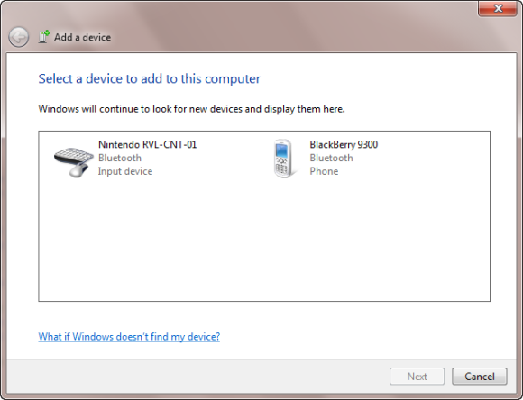

To check that the Wiimote has been connected open Start > Control Panel > View devices and printers, then look for Nintendo RVL-CNT-01 listed under Devices. With the device successfully connected you can then begin configuration!

## wii_MapsControls

**Wiimote:**

**Keyboard** 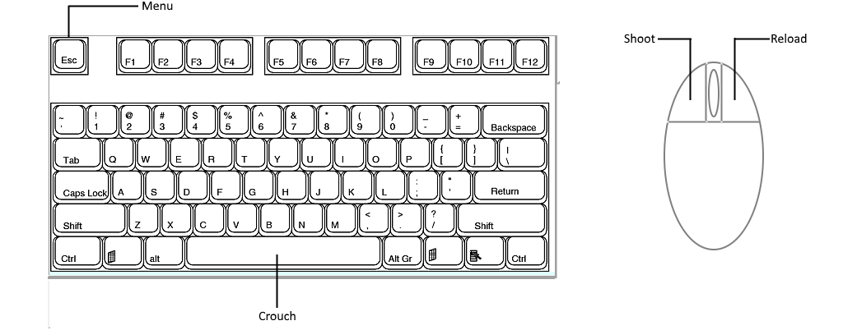

## 1.3 Starting the game

1. Press the “Spacehunt” executable on your Windows desktop.

2. The game will start with an introduction about the story of the game.

3. After the introduction the main menu will pop up.

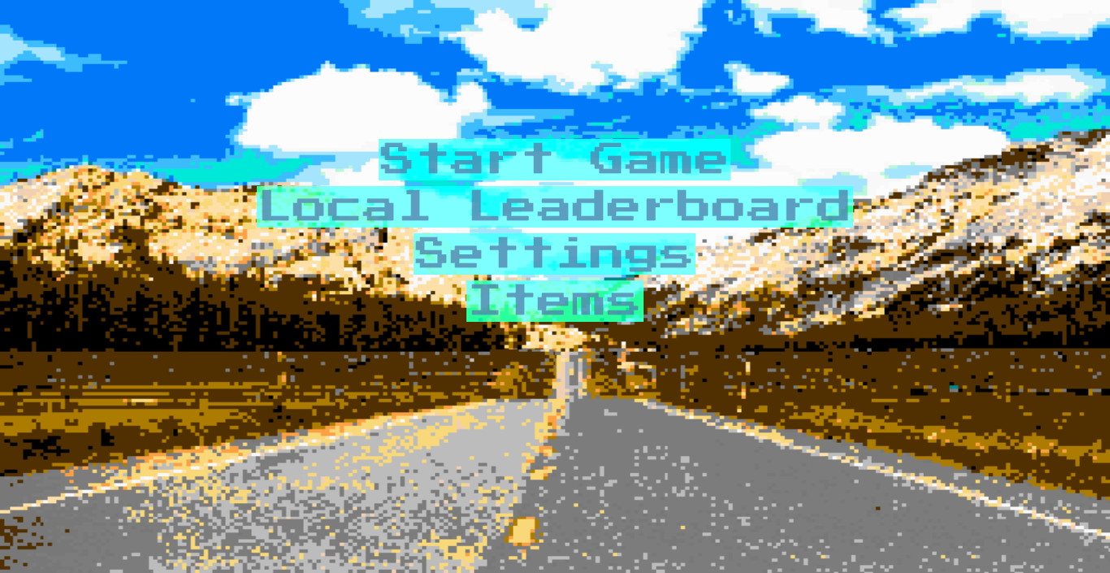

***Main Menu Items:***

**Start Game:** Pressing “Start Game” will lead you to the game menu where you can create a new and load an existing game.

**Local Leaderboard:** Pressing “Local Leaderboard” will lead you to the game’s high scores where you can view the existing high scores of a player.

**Settings:** “Pressing “Settings” will lead you to the settings menu where you can adjust and change the settings of the game to your likings.

# 2. Content

## 2.1 Items

You can buy new weapons and ammo and also upgrade them every time you complete a level, or at the main menu.

|  |  |  |  |
| --- | --- | --- | --- |
| **Weapon** | **Fire mode** | **Magazine capacity** | **Hits needed to destroy UFO** |
| Pistol | Single | 3, 16 bullets | 5 |
| MP5 | Burst | 4, 30 bullets | 4 |
| AK-47 | Burst | 6, 24 bullets | 2 |
| M50 | Single | 4, 5 bullets | 1 |
| RPG 7 | Single | 6, 1 bullet | 2 |
| Minigun | Fully automatic | 4, 1000 bullets | 100 |
| Lasergun | Single | 15, 1 bullet | 0,5 |

## 2.2 Planet

Your mission will be to defend earth from the aliens

|  |  |  |
| --- | --- | --- |
| **Planet** | **Type** | **Colors** |
| Earth | Stone / Water | Blue and Brown |

## 2.3 Character



The hero will be your character through the game.

## 2.4 Enemies

**UFO’s:**

The enemies will fly towards you and try to hit you.  
The second UFO will also shoot with its machinegun on you.  
There’s a 1 on 3 chance that an alien will eject from the UFO and will make it an easy target to shoot which will earn you bonus points.

****

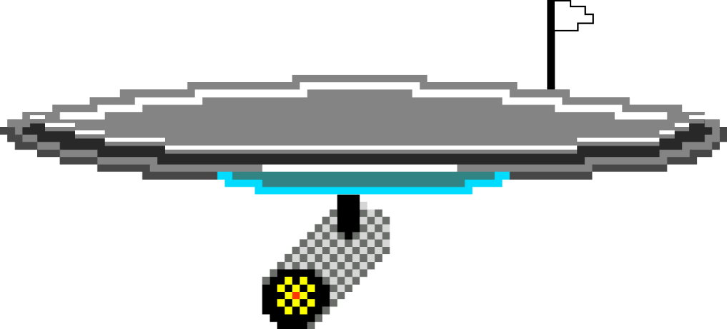

**Bosses:**

Every planet has its own boss which will be the hardest enemy to defeat.

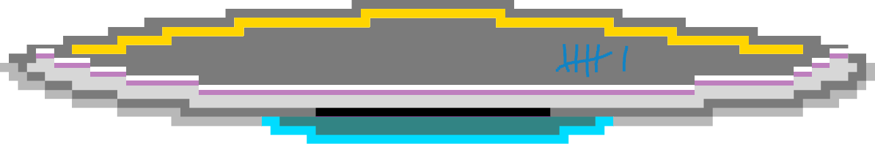



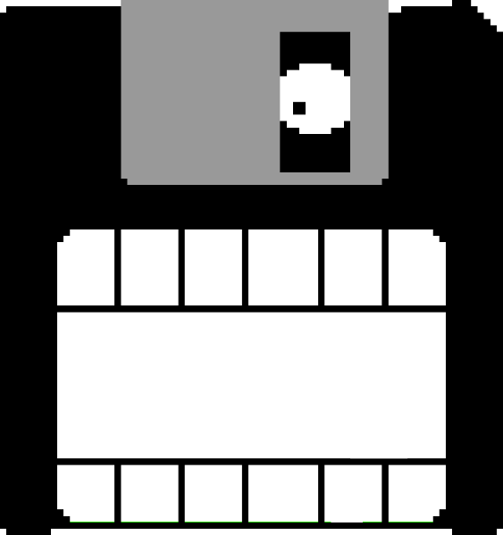

# The game explained

You are stuck on earth while hordes of aliens are approaching.

The only thing you can do at this point is to try and survive as long as possible.

Your skills will be tested the aliens probably won’t retreat any time soon if they will even retreat at all.

Good luck comerad you will surely need it.

Shoot aliens using the B button or the left mouse button before they shoot you.

It’s your task to destroy the UFO’s to save the world from the aliens.

The UFO’s will appear closer and move to any possible position.

The enemies will fly towards you and try to hit you.  
The second UFO will also shoot with its machinegun on you.  
There’s a 1 on 3 chance that an alien will eject from the UFO and will make it an easy target to shoot which will earn you bonus points.