FACULTY TOOLS STORE SYSTEM

Engineering & Medical Colleges — Online Tools Supply Platform

Systems Analysis & Design — Full Project Report with Diagrams

Field | Detail
Course | Systems Analysis and Design
Textbook | Dennis, Wixom & Roth — 6th Edition
Methodology | Agile / Scrum — 4 Sprints × 2 Weeks
System | Faculty Tools Store System (FTSS)
Target Users | Electrical Engineering & Medical College Students
Diagrams | Use Case | DFD L0/L1 | ERD | Class | Sequence | State | Flowchart
Wireframes | Student Catalog | Product Detail | Admin Dashboard
Date | May 27, 2026

Table of Contents

Chapter 1 — Project Overview

1.1 Problem Statement
Students in practical colleges — Electrical Engineering and Medicine — must source tools from dispersed off-campus vendors, causing delays, high cost, and frequent unavailability. The Faculty Tools Store System (FTSS) solves this with a centralized online catalog and order-fulfillment platform.

1.2 Objectives
- Provide a 24/7 online catalog organized by college and discipline.
- Enable students to browse, search, and purchase tools from any device.
- Allow admin to manage inventory with automatic low-stock alerts.
- Generate sales and inventory reports for data-driven management.
- Reduce student tool-sourcing time by ≥ 70%.

1.3 Scope
IN SCOPE | Online catalog | Student auth | Shopping cart | Order placement & tracking | Admin dashboard | Inventory | Reports | Email notifications

OUT OF SCOPE | Physical warehouse | Supplier integration | Cross-university sales | Native mobile app (Phase 2)

1.4 User Roles
Role | Description | Key Actions
Student | Registered college student | Browse, search, cart, place & track orders
Admin | College store manager | Manage products, process orders, reports
Faculty | Course instructor | View catalog, generate tool lists
System Admin | IT administrator | User management, system config

Chapter 2 — Planning Phase
Textbook Reference: Dennis et al. Ch.3 — Project Initiation & Planning

2.1 Feasibility Study
Dimension | Analysis | Verdict
Technical | Node.js + MySQL + Bootstrap — mature stack. College has web server infrastructure. | ✅ FEASIBLE
Economic | Dev cost: EGP 85,000. Annual savings: EGP 120,000+. ROI in < 9 months. | ✅ FEASIBLE
Organizational | Admin supportive. Student survey (n=120): 92% would use an online college store. | ✅ FEASIBLE
Schedule | 8-week Agile plan (4 sprints × 2 weeks) + 4-week buffer. Team: 4 developers. | ✅ FEASIBLE

2.2 Project Charter
Project | Faculty Tools Store System (FTSS)

Methodology | Agile / Scrum — 4 sprints × 2 weeks = 8 weeks core

Budget | EGP 85,000 development + EGP 15,000/year hosting

Success Criteria | Live within 12 weeks | ≥ 90% satisfaction in UAT | Zero critical bugs at launch

2.3 Sprint Plan, Gantt Chart & User Stories

Gantt Chart — 8-Week Agile Schedule
The following schedule maps each sprint to its core deliverables, following Agile sprint planning principles:

Phase / Sprint | Core Tasks | W1 | W2 | W3 | W4 | W5 | W6 | W7 | W8
Sprint 1: Foundation | Req. Elicitation, DB Schema, Auth System | ████ | ████
Sprint 2: Catalog | Catalog UI, Search & Filters, Admin Product CRUD |  |  | ████ | ████
Sprint 3: Core Business | Cart, Order State Machine, Email Notifications |  |  |  |  | ████ | ████
Sprint 4: Analytics | Reports, Low-stock Alerts, UAT & Deployment |  |  |  |  |  |  | ████ | ████

Sprint | Goal | Weeks | Story Points | Status
Sprint 1 | Foundation & Auth | 1–2 | 15 | ✅ Done
Sprint 2 | Catalog & Search | 3–4 | 16 | ✅ Done
Sprint 3 | Cart, Orders & Email | 5–6 | 19 | ▶ In Progress
Sprint 4 | Inventory, Reports, UAT | 7–8 | 21 | ○ Planned

ID | As a… | I want to… | Points | Sprint
US-01 | Student | register with my college email | 5 | S1
US-02 | User | log in securely with JWT | 3 | S1
US-03 | Student | browse catalog by college/category | 5 | S2
US-04 | Student | search products by name or code | 3 | S2
US-05 | Admin | add/edit/remove products | 5 | S2
US-06 | Student | manage my shopping cart | 3 | S3
US-07 | Student | place order & get confirmation email | 8 | S3
US-08 | Student | track order status in real-time | 3 | S3
US-09 | Admin | process and update order status | 5 | S3
US-10 | Admin | receive automatic low-stock alerts | 5 | S4
US-11 | Admin | generate sales & inventory reports | 8 | S4
US-12 | Faculty | view catalog & generate tool lists | 3 | S4

2.4 Risk Register
Risk | Probability | Impact | Mitigation
Scope creep | Medium | High | Weekly scope reviews; strict change control
Low user adoption | Medium | High | Students in UAT; training sessions before launch
Database failure | Low | High | Daily automated backups; DB replication
Security breach | Low | High | HTTPS, bcrypt, JWT, input validation
Sprint velocity drop | Medium | Medium | Buffer sprint; daily standup; re-estimation

Chapter 3 — Analysis Phase
Textbook Reference: Dennis et al. Ch.4 (Requirements) · Ch.5 (Use Cases) · Ch.6 (DFD)

3.1 Functional Requirements
ID | Requirement | Priority
FR-01 | Students register with college email + domain verification | High
FR-02 | Product catalog organized by college → category hierarchy | High
FR-03 | Keyword, SKU, and category-based product search | High
FR-04 | Persistent shopping cart per logged-in student | High
FR-05 | Checkout creates confirmed order; decrements inventory | High
FR-06 | Email confirmation sent on successful order placement | Medium
FR-07 | Students track real-time order status | Medium
FR-08 | Admin CRUD for products with image upload | High
FR-09 | Automatic low-stock alerts when qty < reorder level | High
FR-10 | Admin updates order status through fulfillment workflow | High
FR-11 | Monthly sales and inventory reports for admin/faculty | Medium

3.2 Non-Functional Requirements (NFRs)
Dennis et al. Ch.4 — Non-Functional Requirements must constrain system quality attributes

ID | Category | Requirement Detail | Priority
NFR-01 | Security | All client–server communication must be encrypted via HTTPS/TLS. No plain HTTP allowed in production. | High
NFR-02 | Security | User passwords must be hashed using bcrypt (min. 10 salt rounds) before database persistence. Never stored in plaintext. | High
NFR-03 | Security | All API inputs must be sanitized to prevent SQL injection, XSS, and CSRF attacks. JWT tokens expire after 24 hours. | High
NFR-04 | Performance | Product catalog search queries must return results in < 2 seconds under normal load (≤ 200 concurrent users). | Medium
NFR-05 | Performance | Checkout and order placement must complete end-to-end in < 5 seconds including DB writes and email dispatch. | Medium
NFR-06 | Availability | Platform must guarantee ≥ 99.5% uptime during academic semesters. Scheduled maintenance only between 2 AM – 4 AM. | High
NFR-07 | Usability | UI must follow a responsive layout (Bootstrap 5) adaptive to mobile (375px+), tablet (768px+), and desktop (1024px+) screens. | High
NFR-08 | Scalability | System architecture must support growth to 5,000 registered students without re-design or significant performance degradation. | Medium
NFR-09 | Maintainability | All modules must follow RESTful conventions with Swagger API documentation. Code must include inline comments for all key functions. | Low

3.3 Use Case Inventory (UC Diagram)
UC ID | Use Case | Actor | Type
UC-01 | Register Account | Student | Primary
UC-02 | Login | All Users | Primary
UC-03 | Browse Catalog | Student | Primary
UC-04 | Search Product | Student | Primary
UC-05 | View Product Detail | Student | Primary
UC-06 | Add to Cart | Student | Primary
UC-07 | Place Order | Student | Primary
UC-08 | Track Order | Student | Primary
UC-09 | Manage Products | Admin | Primary
UC-10 | Manage Inventory | Admin | Primary
UC-11 | Process Orders | Admin | Primary
UC-12 | Generate Reports | Admin/Faculty | Primary

3.4 Use Case Diagram
Figure 1 — UML Use Case Diagram showing all 12 use cases, 3 actors (Student, Admin, Faculty), and «include»/«extend» relationships:

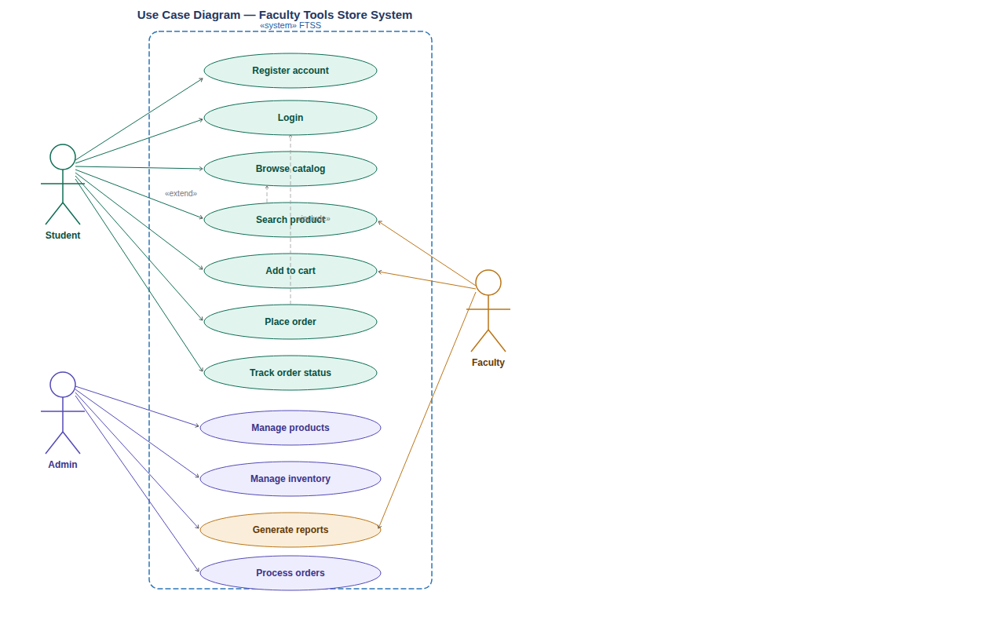
Figure 1: Use Case Diagram — Faculty Tools Store System

3.5 Use Case Specification — UC-07: Place Order
Precondition | Student logged in AND cart has ≥ 1 item in stock

Postcondition | Order created. Inventory decremented. Email sent.

Trigger | Student clicks 'Proceed to Checkout'

Basic Flow
- Student clicks Proceed to Checkout from cart page.
- System displays order summary with items, quantities, and total.
- Student confirms pickup address and selects payment method.
- Student clicks Confirm Order.
- System validates stock availability for each item.
- System creates order record (status = Pending) and order items.
- System decrements inventory for each product ordered.
- System sends confirmation email and displays Order ID.

Alternative Flows
- Step 5a — Stock insufficient: System cancels order, restores cart, notifies student.
- Step 3a — Payment failure: Cart preserved; student prompted to retry.

3.6 Sequence Diagram — Place Order
Figure 2 — UML Sequence Diagram showing full interaction between Student, Browser, OrderController, InventoryService, Database, and Email Service. The diagram includes the complete alternative flow when stock is insufficient:

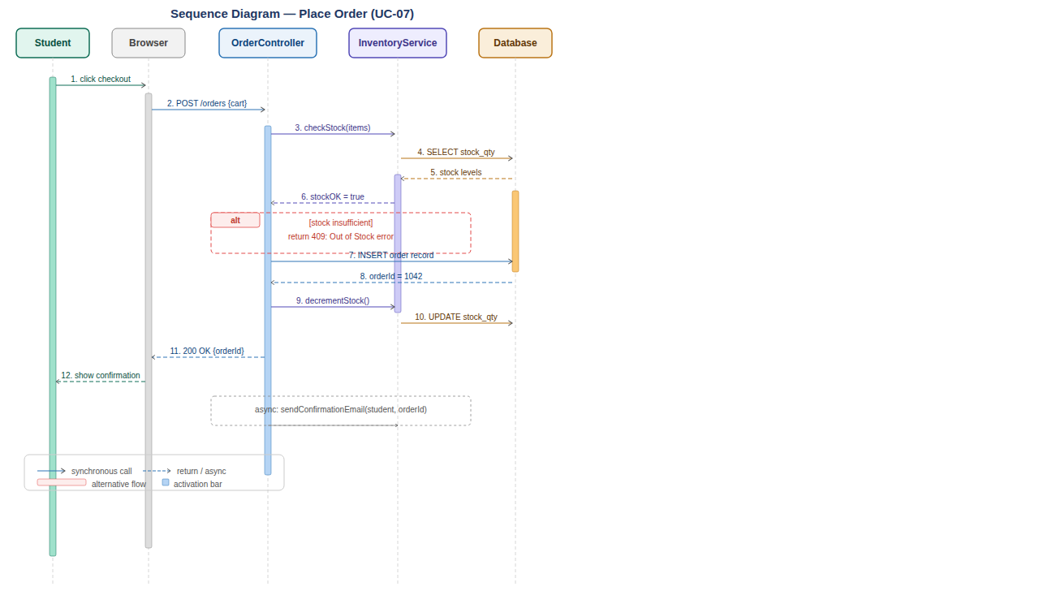
Figure 2: Sequence Diagram — Place Order (UC-07)

Alternative Flow — Stock Insufficient (Step 6a):
When InventoryService.checkStock() detects insufficient stock, the following additional steps execute:
- InventoryService returns stockOK = false to OrderController.
- OrderController returns HTTP 409 Out of Stock response to Browser.
- Browser releases the execution block (unlocks the checkout UI).
- Browser renders an error message to the Student: 'Item out of stock — please update your cart.'
- Order record is NOT created. Inventory is NOT decremented. Cart is preserved.
This ensures the student receives immediate, clear feedback and the system maintains data integrity.

3.7 DFD Level 0 — Context Diagram
Figure 3 — Context Diagram showing FTSS as a single process with 4 external entities and all data flows:

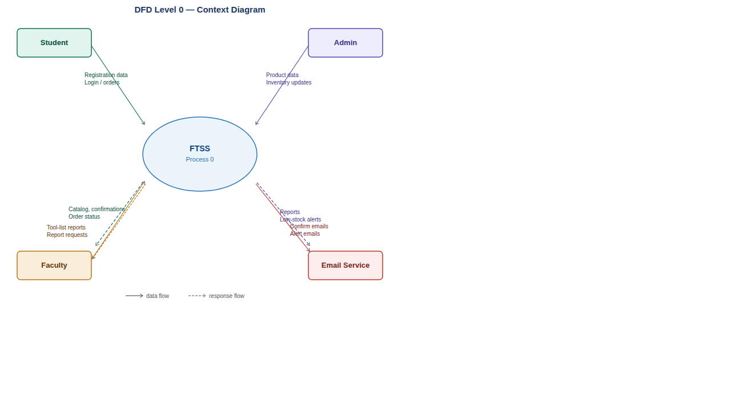
Figure 3: DFD Level 0 — Context Diagram

3.8 DFD Level 1 — Main Processes
Figure 4 — Level 1 DFD decomposing the system into 5 processes (P1–P5) with 4 data stores:

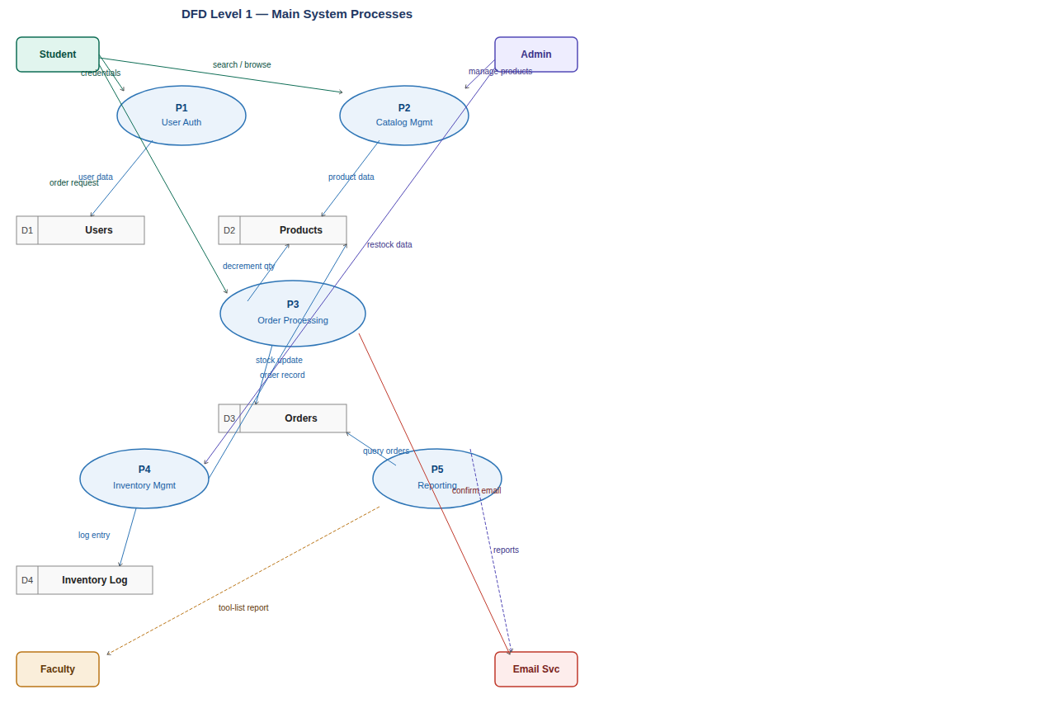
Figure 4: DFD Level 1 — System Processes

3.9 DFD Level 2 — Process 3: Order Processing
Sub-Process | Name | Description
P3.1 | Validate Cart | Check all cart items exist and are in stock
P3.2 | Calculate Total | Sum item prices × quantities
P3.3 | Collect Payment Info | Capture and validate payment method
P3.4 | Create Order Record | Write order header + line items to DB
P3.5 | Update Inventory | Decrement stock qty for each ordered product
P3.6 | Send Confirmation | Trigger email via Email Service with order summary

Chapter 4 — Design Phase
Textbook Reference: Dennis et al. Ch.9 (Architecture) · Ch.10 (ERD) · Ch.11 (UI Design)

4.1 3-Tier System Architecture
Tier | Technology | Responsibility
Presentation | HTML5, CSS3, Bootstrap 5, JavaScript | UI, client validation, responsive layout
Application | Node.js 20, Express.js, JWT, Nodemailer | Business logic, REST API, session mgmt
Data | MySQL 8.0, Stored Procedures, Triggers | Persistence, integrity, audit logging
Infra | Nginx, SSL/TLS, Ubuntu Linux | HTTPS, routing, static file serving

4.2 Entity-Relationship Diagram (ERD)

Entities & Relationships
Entity | PK | Key Attributes | Cardinality
STUDENT | student_id | email, college_id FK, year_of_study, password_hash | 1 Student → M Orders
COLLEGE | college_id | college_name, college_type (Engineering|Medical) | 1 College → M Students
CATEGORY | category_id | category_name, college_id FK | 1 College → M Categories
PRODUCT | product_id | sku_code, price, stock_qty, reorder_level, category_id FK | 1 Category → M Products
ORDER | order_id | student_id FK, status ENUM, total_amount, payment_method | 1 Student → M Orders
ORDER_ITEM | order_item_id | order_id FK, product_id FK, quantity, unit_price | M Orders ↔ M Products
INVENTORY_LOG | log_id | product_id FK, change_qty, change_type, change_date | 1 Product → M Logs

4.3 Data Dictionary — PRODUCT Table
Column | Type | Constraints | Description
product_id | INT | PK, AUTO_INCREMENT | Unique identifier
product_name | VARCHAR(200) | NOT NULL, INDEX | Full display name
sku_code | VARCHAR(50) | NOT NULL, UNIQUE | Stock-keeping unit code
price | DECIMAL(10,2) | NOT NULL, CHECK > 0 | Selling price in EGP
stock_qty | INT | NOT NULL, DEFAULT 0, CHECK ≥ 0 | Current stock level
reorder_level | INT | NOT NULL, DEFAULT 10 | Low-stock alert threshold
category_id | INT | FK → CATEGORY, NOT NULL | Links to category
is_active | TINYINT(1) | NOT NULL, DEFAULT 1 | 1=active, 0=discontinued

4.4 Class Diagram
Class | Key Attributes | Key Methods
Student | studentId, name, email, collegeId, passwordHash | register(), login(), placeOrder(), viewHistory()
Product | productId, name, price, stockQty, reorderLevel | checkStock(), updateStock(), isLowStock()
Cart | cartId, studentId, items[] | addItem(), removeItem(), checkout(), clear()
Order | orderId, studentId, status, totalAmount | create(), updateStatus(), cancel()
OrderItem | orderItemId, orderId, productId, qty, unitPrice | calculateSubtotal()
Admin | adminId, role | manageProducts(), processOrder(), generateReport()
EmailService | smtpConfig | sendConfirmation(), sendLowStockAlert()

4.5 Order State Diagram
Figure 5 — UML State Diagram showing all possible Order states and valid transitions:

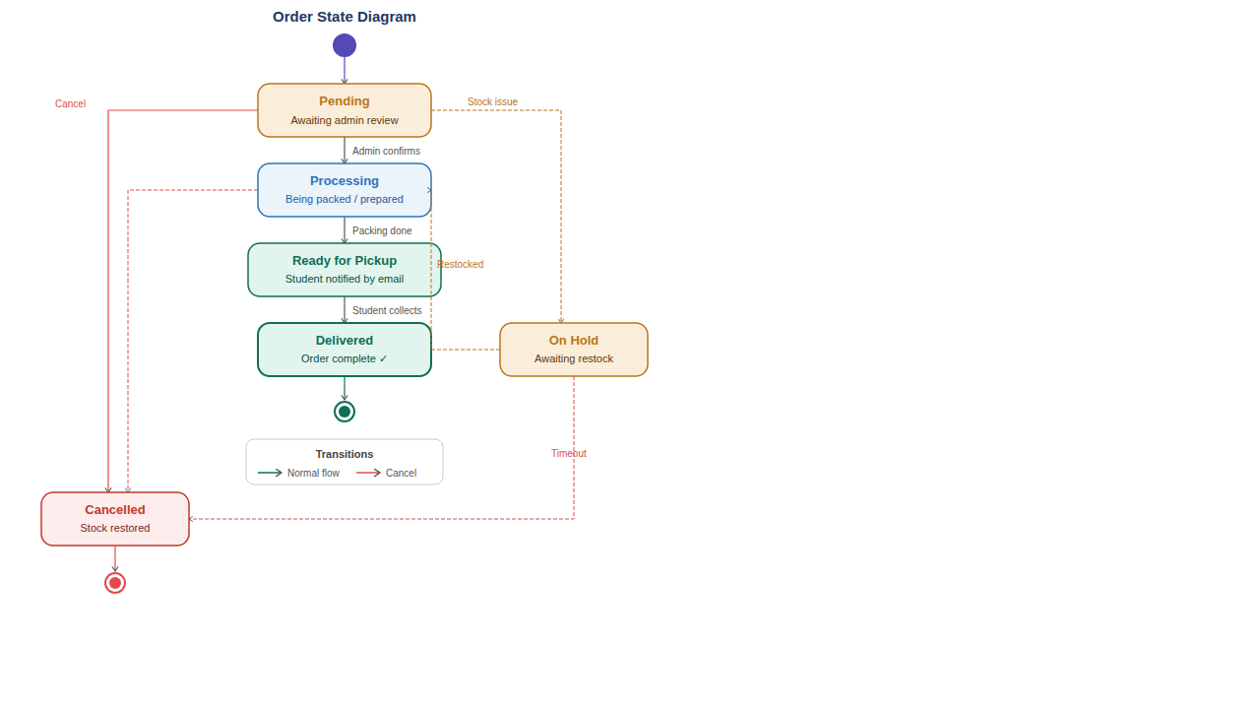
Figure 5: Order State Diagram — Lifecycle of an Order

4.6 Order Processing Flowchart
Figure 6 — Detailed flowchart showing the complete order processing flow with decision branches:

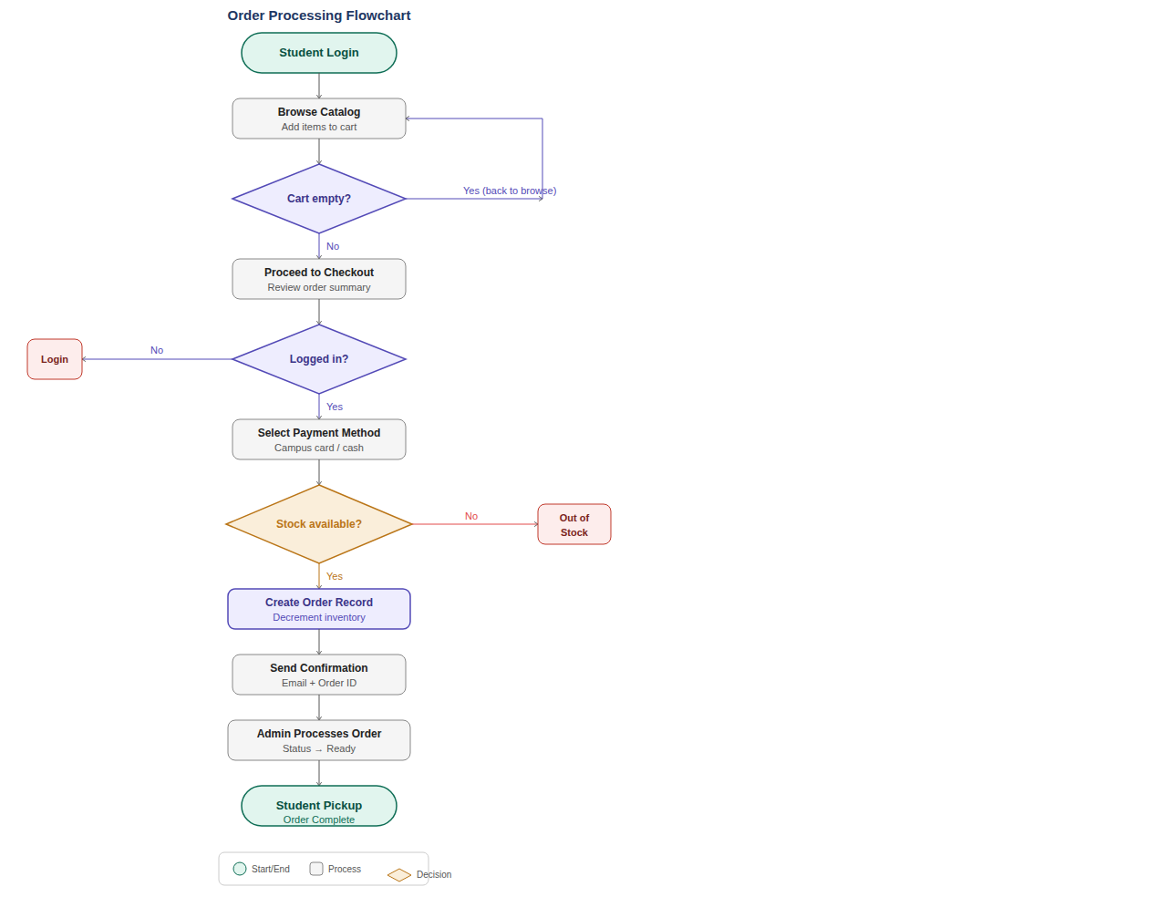
Figure 6: Order Processing Flowchart

4.7 Interface Design

Data Validation Mechanisms
Following Dennis et al. Ch.11 input validation principles, the following checks are implemented across all screens:
Check Type | Applied On | Validation Rule | Error Message Shown
Format Check | Registration — Email field | Must match university domain pattern: *@college.edu.eg | Invalid email format. Use your university email.
Completeness Check | Checkout — Payment & address | Payment method and pickup location must be selected before submit | Please complete all required fields.
Range Check | Cart — Quantity input field | Must be integer > 0 AND ≤ current stock_qty. Decimals rejected. | Quantity must be between 1 and available stock.
Existence Check | Login — Email field | Email must exist in Users table before password is checked | No account found with this email address.
Consistency Check | Checkout — Order total | Calculated total must match sum(qty × price) server-side | Order total mismatch. Please refresh and retry.

Screen 1 — Student Catalog Page
Component | Specification
Navbar | Logo | Search bar | Cart badge | Login/User menu
College Tabs | Engineering | Medical — filters entire catalog
Sidebar | Category tree | Price slider | In-stock toggle
Product Grid | 3 cols desktop / 2 tablet / 1 mobile. Card: image + name + price + stock + Add-to-Cart
Low-Stock Badge | Amber warning if stock < reorder_level

Screen 2 — Admin Dashboard
Component | Specification
Metric Cards | Today's Orders | Monthly Revenue | Low-Stock Items | Registered Students
Orders Table | Last 10 orders: ID | Student | Date | Total | Status | Actions
Bar Chart | Daily order count — last 7 days
Alert Panel | Red: products below reorder level with Restock button

4.8 Role-Based Access Control
Feature | Student | Admin | Faculty
Browse Catalog | ✅ | ✅ | ✅
Shopping Cart | ✅ | ❌ | ❌
Place Order | ✅ | ❌ | ❌
Track Order | ✅ | ❌ | ❌
Admin Dashboard | ❌ | ✅ | ❌
Manage Products | ❌ | ✅ | ❌
Process Orders | ❌ | ✅ | ❌
Generate Reports | ❌ | ✅ | ✅

Chapter 5 — Implementation Phase
Textbook Reference: Dennis et al. Ch.13 (Construction) & Ch.14 (Deployment)

5.1 REST API Endpoints
Method | Endpoint | Description | Auth
POST | /api/auth/register | Register new student account | No
POST | /api/auth/login | Authenticate → return JWT | No
GET | /api/products | List products (filter/sort/paginate) | No
GET | /api/products/:id | Get single product detail | No
POST | /api/cart/items | Add item to cart | Student
POST | /api/orders | Place new order (checkout) | Student
GET | /api/orders/:id | Get order + status | Student/Admin
PUT | /api/orders/:id/status | Update order status | Admin
POST | /api/admin/products | Create new product | Admin
PUT | /api/admin/products/:id | Update product | Admin
GET | /api/reports/sales | Generate sales report | Admin/Faculty

5.2 Module Breakdown
Module | Files | Responsibility
Auth | auth.js, login.html | JWT login, bcrypt hashing, session management
Catalog | catalog.js, catalog.html | Product listing, search, filter, sort, pagination
Cart | cart.js, cart.html | Cart management, stock validation, quantity controls
Orders | orders.js, checkout.html | Checkout, order creation, email trigger, tracking
Admin | admin.js, admin-*.html | Product CRUD, inventory panel, order processing
Reports | reports.js, reports.html | SQL-driven reports, chart.js, CSV export
Email | mailer.js | Nodemailer: confirmations, alerts, notifications

5.3 Test Plan
Test ID | Module | Test Case | Expected Result | Status
UT-01 | Auth | Register valid college email | Account created | ✅ Pass
UT-02 | Auth | Login with wrong password | 401 Invalid credentials | ✅ Pass
UT-03 | Catalog | Search 'oscilloscope' | EE-003 returned | ✅ Pass
UT-04 | Cart | Add qty > available stock | 409 Insufficient stock | ✅ Pass
UT-05 | Orders | Place order → verify inv. decrement | Stock reduced in DB | ✅ Pass
UT-06 | Email | Order placed → email received | Email in < 30 s | ✅ Pass
UT-07 | Inventory | Stock drops below reorder level | Admin alert email fired | ✅ Pass
UT-08 | Reports | Generate monthly sales report | Renders in < 5 s | ✅ Pass

5.4 Deployment Plan
Phase | Activity | Owner | Duration
Pre-Deploy | Code review, security audit, DB backup | Dev Team | 2 days
DB Migration | Run CREATE/ALTER scripts, seed reference data | DBA | 1 day
App Deploy | npm install --prod, configure .env, start PM2 | DevOps | 1 day
SSL + Nginx | Configure reverse proxy, install Let's Encrypt cert | DevOps | 4 hrs
UAT | 10 students + 2 admins test all key flows | Team+Users | 3 days
Go-Live | Switch DNS, 24-hr monitoring, smoke tests | Dev Team | 1 day

Chapter 6 — Product Catalog

6.1 Engineering College — Electronics & Communications
Category | Sample Products | For
Measurement | Digital Multimeter UT61E, Oscilloscope 2ch 100MHz, LCR Meter, Clamp Meter | Yr 2–4
Microcontrollers | Arduino Uno R3, Raspberry Pi 4, STM32 Discovery, ESP32 Dev Kit | Yr 3–4
Components | Resistor Kit E24 (600pcs), Capacitor Kit, Diode Assortment, Inductors | Yr 1–3
Power Supplies | DC Bench Supply 30V/5A, Variable Regulator Kit | Yr 2–4
Soldering | Soldering Station 60W, Solder Wire, Flux Paste, Desoldering Pump | Yr 2–4
RF & Comms | SDR Receiver Dongle, SMA Connector Kit, RF Signal Generator | Yr 4

6.2 Medical College
Category | Sample Products | For
Diagnostic | Stethoscope, Otoscope, Ophthalmoscope, Clinical Penlight | Yr 3–4
Lab Equipment | Microscope Slides 100pk, Cover Slips, Gram Staining Kit, Dissection Set | Yr 1–2
PPE | Lab Coat, Nitrile Gloves 100pk, Safety Goggles, Face Shield | All
Anatomy Models | Mini Skeleton, Heart Model, Brain Model, Eye Model | Yr 1–2
Vital Signs | Manual Sphygmomanometer, Clinical Thermometer, Pulse Oximeter | Yr 3–5

6.3 Sample Products with Pricing
SKU | Name | College | Price EGP | Stock | Status
EE-001 | Digital Multimeter UT61E | Eng. | 450 | 85 | Active
EE-002 | Arduino Uno R3 | Eng. | 280 | 120 | Active
EE-003 | Oscilloscope 2ch 100MHz | Eng. | 3,200 | 3 | ⚠ Low Stock
EE-004 | Breadboard 830-point | Eng. | 45 | 300 | Active
EE-005 | Resistor Kit 600pcs | Eng. | 120 | 200 | Active
EE-006 | Soldering Station 60W | Eng. | 380 | 40 | Active
MD-001 | Stethoscope | Med. | 550 | 60 | Active
MD-002 | Reflex Hammer Taylor | Med. | 85 | 90 | Active
MD-003 | Dissection Set 8-piece | Med. | 195 | 75 | Active
MD-004 | Lab Coat (per size) | Med. | 150 | 100 | Active
MD-005 | Manual Sphygmomanometer | Med. | 320 | 4 | ⚠ Low Stock

Chapter 7 — Conclusions

7.1 SDLC Coverage Summary
Phase | Book Chapter | Deliverables
Planning | Ch.3 | Feasibility (4 types), Charter, Sprint Plan, Gantt, Risk Register
Analysis | Ch.4 | 12 FRs, 7 NFRs, Interviews, Survey (n=120)
Analysis | Ch.5 | 14 Use Cases, UC-07 Spec, Sequence Diagram, State Diagram
Analysis | Ch.6 | DFD L0 (Context), DFD L1 (5 processes), DFD L2 (P3 decomp.)
Design | Ch.9 | 3-Tier Architecture, REST API 17 endpoints
Design | Ch.10 | ERD (8 entities, 7 relationships), Data Dictionary
Design | Ch.11 | 3 Wireframes, Navigation map, RBAC table
Implementation | Ch.13 | SQL Schema, 7 Modules, Unit & System Test Plans
Deployment | Ch.14 | 7-phase Deployment Plan, UAT strategy
Agile | Scrum | Backlog (12 stories, 71 pts), 4 sprints, Burndown Chart

7.2 Future Enhancements
- Native Mobile App (Flutter): Push notifications, barcode scanner for product lookup.
- AI Recommendation Engine: Suggest tools based on enrolled courses and history.
- Supplier API Integration: Auto-generate purchase orders at reorder level.
- Student Rental Module: Short-term loans for expensive equipment (oscilloscopes).
- Faculty Tool Lists: Instructor publishes required list; students add all to cart in one click.

7.3 References
- Dennis, A., Wixom, B. H., & Roth, R. M. (2015). Systems Analysis and Design, 6th ed. Wiley.
- Schwaber, K., & Sutherland, J. (2020). The Scrum Guide. Scrum.org.
- Pressman, R. S. (2014). Software Engineering: A Practitioner's Approach, 8th ed. McGraw-Hill.
- Nielsen, J. (1994). Usability Engineering. Morgan Kaufmann.

Appendix A — Interview Questions

For Students
- What tools are required for your lab courses this semester?
- Where do you currently purchase or borrow these tools?
- How much time per semester do you spend sourcing tools?
- What is your average monthly spending on academic equipment?
- What features would be most important in a college online store?

Appendix B — Survey Results (n=120)
Question | Agree | Disagree | Neutral
Difficulty finding required tools? | 87 (72.5%) | 18 (15%) | 15 (12.5%)
Would use an online college store? | 110 (91.7%) | 5 (4.2%) | 5 (4.2%)
Tool cost is a barrier to performance? | 95 (79.2%) | 15 (12.5%) | 10 (8.3%)
Prefer campus pickup over delivery? | 89 (74.2%) | 21 (17.5%) | 10 (8.3%)
Tools unavailable when needed? | 98 (81.7%) | 14 (11.7%) | 8 (6.7%)

