AL-ALAMY

System Analysis and Design Document
Project Name: Al-Alamy
Project Type: Digital Business Transformation and Freelancer Management Platform
Document Type: System Analysis and System Design
Version: 1.0
Status: Analysis and Design Phase
Team Size: 5 Members

1. Document Control
Item | Description
Project Name | Al-Alamy
Project Type | Digital Business Transformation Platform
Document | System Analysis and Design
Version | 1.0
Status | Draft for Analysis and Design
Team Size | 5
Primary Users | Clients, Freelancers, Al-Alamy Team
Main Interface Language | Arabic / English
Design Direction | Professional Business Platform
Primary Color | Blue
Secondary Colors | White and Neutral Gray

2. Executive Summary
Al-Alamy is a digital business transformation and online management platform designed to help businesses establish and develop their online presence.
The platform connects business owners with a managed digital service environment where website development social media management paid advertising and customized digital requirements can be requested and managed through one system.
The platform does not operate as a traditional freelancer marketplace where clients directly select freelancers.
Instead Al-Alamy acts as the central management layer between the client and the professionals responsible for completing the required work.
The client communicates with Al-Alamy.
The Al-Alamy team analyzes the requirements.
The requirements are converted into projects and tasks.
Each task is classified according to a professional track.
Eligible freelancers receive the appropriate task opportunity.
The first eligible freelancer who successfully accepts an available task receives the assignment.
The freelancer completes the task and submits the result to Al-Alamy.
The Al-Alamy team reviews the submitted work.
Approved work is integrated into the client project.
The client receives the final result and project progress through the platform.
This model creates a controlled workflow that separates client management from internal task execution.

3. Project Vision
The vision of Al-Alamy is to create a structured digital environment that allows businesses to move from traditional offline operations toward a professional online presence.
At the same time the platform creates continuous work opportunities for freelancers who have specific professional skills.
The name Al-Alamy represents two connected journeys.
The first journey belongs to the business owner who wants to take the business toward a wider digital presence.
The second journey belongs to the freelancer who wants to develop professional experience and gain continuous work opportunities.
The two sides operate through the same platform while maintaining a controlled professional workflow.

4. Problem Statement
Many small and medium businesses need websites social media management advertising and digital content.
However business owners often need to deal with different individuals or companies for different services.
This creates several problems.
Requirements may become unclear.
Communication may become fragmented.
Project progress may be difficult to track.
Business owners may not know which specialist they need.
Freelancers may also struggle to find continuous professional opportunities.
There is also a management problem when several freelancers work on different parts of the same project.
Al-Alamy addresses these problems by introducing one managed platform that receives business requirements analyzes them and distributes the required work through structured internal tasks.

5. Proposed Solution
Al-Alamy provides one central environment for requesting managing and delivering digital services.
The main services include:
- Website Development
- Social Media Management
- Paid Advertising
- Digital Content
- Video Production
- Video Editing
- Custom Digital Requirements
The platform manages the complete lifecycle of each request.
The lifecycle starts when the client submits a requirement.
The lifecycle ends when the approved result is delivered to the client.

6. Business Concept
The business model contains three main parties.

6.1 Client
The client is a business owner or organization that requests digital services.
The client can:
- Create an account
- Add business information
- Browse services
- View website templates
- Request a website
- Request social media management
- Request paid advertising
- Submit custom requirements
- Request meetings
- Track project progress
- View approved deliverables
- Communicate with Al-Alamy

6.2 Freelancer
The freelancer is a professional who belongs to a specific professional track.
The freelancer does not directly manage the client.
The freelancer receives tasks through the Al-Alamy system.
The freelancer can:
- Create an account
- Build a professional profile
- Select a professional track
- Add skills
- Add portfolio items
- View available tasks
- View task requirements
- Accept tasks
- Work on tasks
- Submit work
- Receive review feedback
- Revise work
- Resubmit work
- View task history

6.3 Al-Alamy Team
The Al-Alamy team represents the management layer between clients and freelancers.
The team is responsible for:
- Managing clients
- Managing freelancers
- Reviewing client requests
- Understanding requirements
- Creating projects
- Creating tasks
- Classifying tasks
- Monitoring task progress
- Reviewing submissions
- Requesting revisions
- Approving completed work
- Integrating approved work
- Delivering results to clients

7. Target Market
The platform is designed primarily for:
- Small businesses
- Medium businesses
- Restaurants
- Cafés
- Retail stores
- Local brands
- Service providers
- Startups
- Companies
- Other businesses that need digital transformation

8. Stakeholder Analysis
Stakeholder | Responsibility
Client | Requests and receives services
Freelancer | Executes assigned tasks
Al-Alamy Team | Manages projects and tasks
System Administrator | Controls platform configuration
Payment Provider | Processes payments
Social Media Platforms | Support social media operations
Hosting Provider | Supports website deployment
Domain Provider | Supports domain registration
Notification Provider | Sends system notifications

9. System Scope

9.1 In Scope
The first version of the system includes:
- Authentication
- Role management
- Client profiles
- Business profiles
- Service browsing
- Website template browsing
- Service requests
- Meeting requests
- Project management
- Task management
- Track classification
- Freelancer profiles
- Freelancer task opportunities
- Task acceptance
- Task submission
- Task review
- Revision management
- Project progress
- Notifications
- Deliverable management
- Basic reporting

10. Future Scope
Future versions may include:
- Advanced analytics
- Automated freelancer matching
- Official social media API integrations
- Automated publishing
- Advanced advertising integrations
- AI-assisted requirement analysis
- AI-assisted task classification
- Mobile applications
- Advanced payment subscriptions
- Automated invoices
- Performance analytics
- Freelancer ratings
- Skill verification
- Advanced reporting
- Multi-language expansion
- Multi-country expansion

11. System Actors
The primary actors are:
- Client
- Freelancer
- Al-Alamy Team / Administrator
- Payment Gateway
- Social Media Platforms
- Hosting / Domain Provider
- Notification Service

12. System Context Diagram

Diagram 01 — System Context Diagram
STATUS: COMPLETED
Al-Alamy System Context Diagram
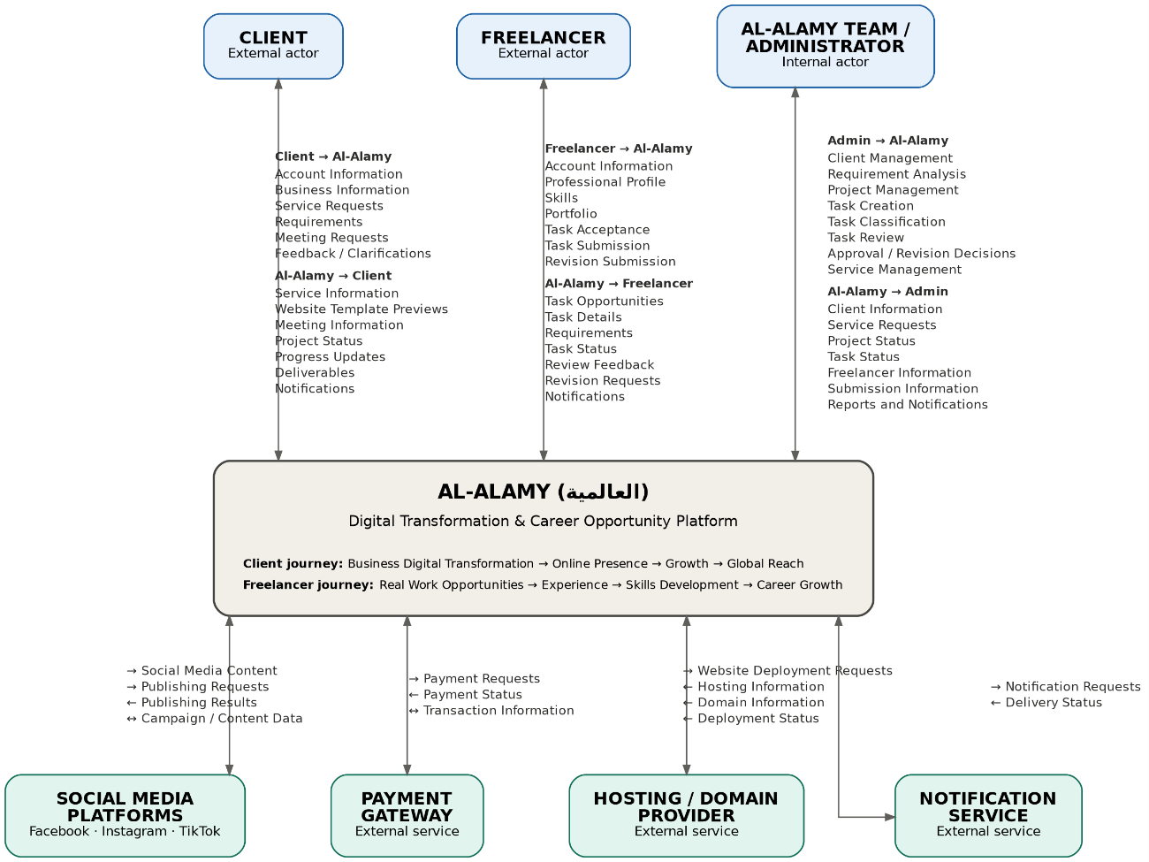
The diagram should represent Al-Alamy as one central system surrounded by its main external actors and external services.

13. High-Level Use Case Diagram

Diagram 02 — High-Level Use Case Diagram
STATUS: COMPLETED
Al-Alamy High-Level Use Case Diagram
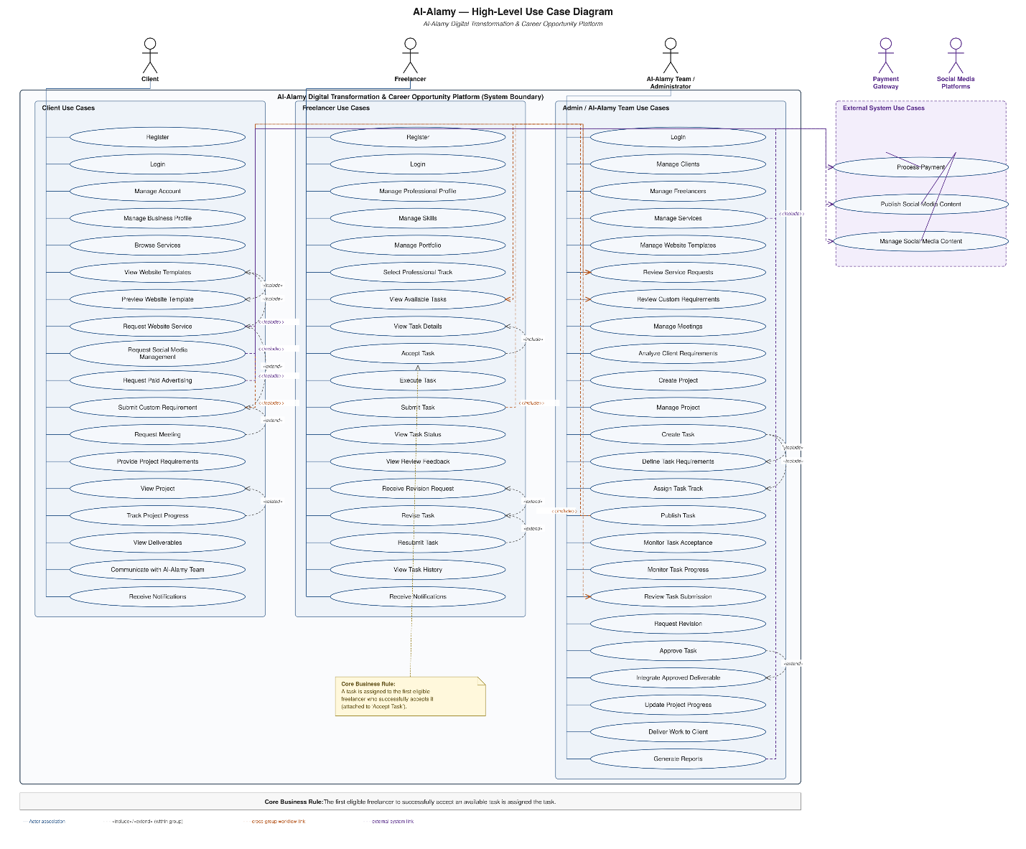
The diagram represents the major interactions between Client Freelancer Al-Alamy Team and external systems.

14. Detailed Client Use Case Diagram
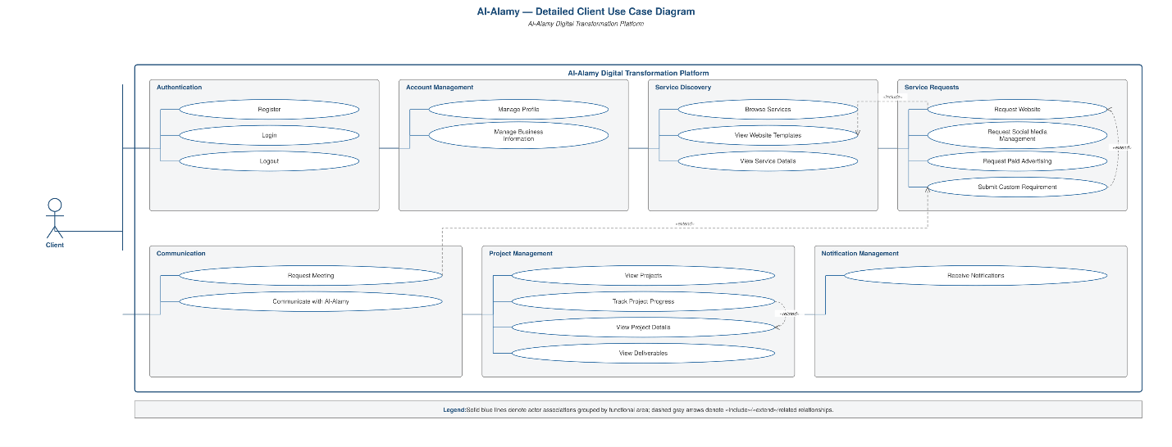

15. Detailed Freelancer Use Case Diagram 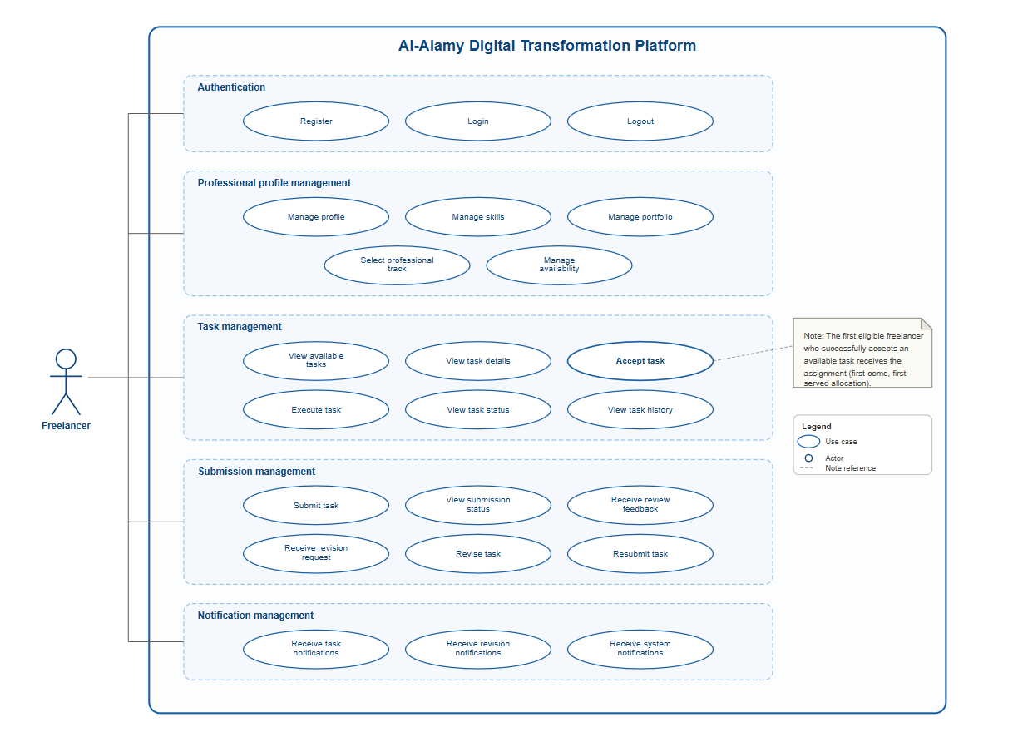

16. Detailed Admin Use Case Diagram
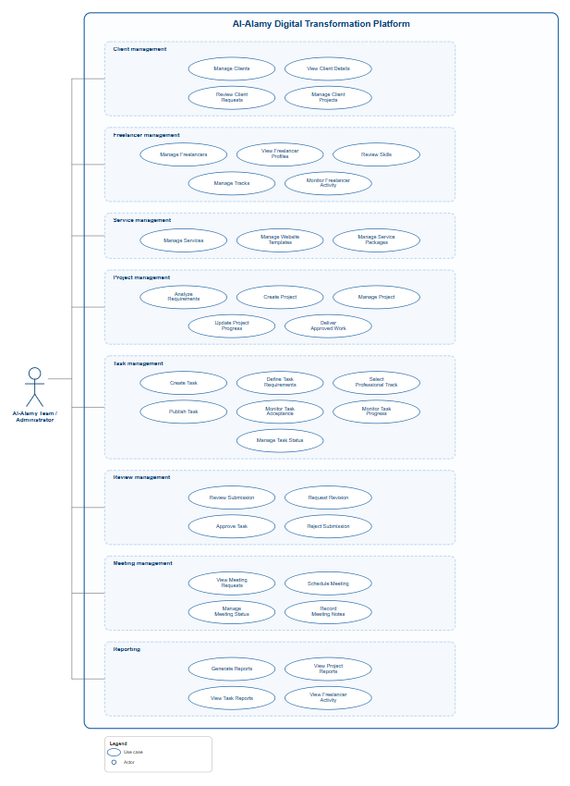

17. Client Activity Diagram — Service Request
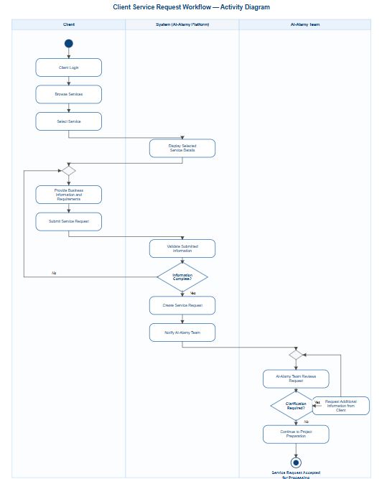

18. Activity Diagram — Meeting and Requirements Analysis
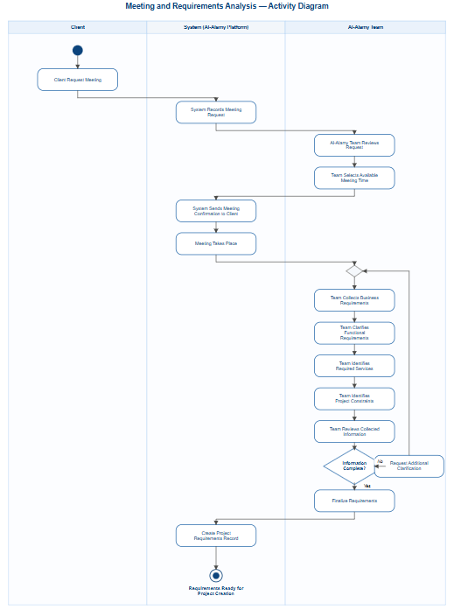

19. Activity Diagram — Project and Task Creation
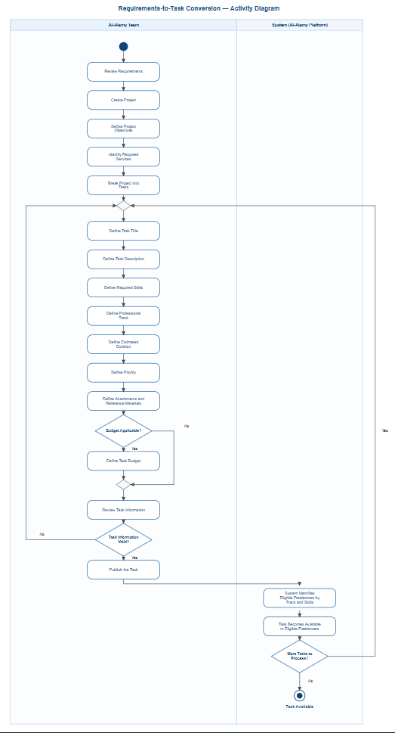

20. Activity Diagram — Freelancer Task Lifecycle
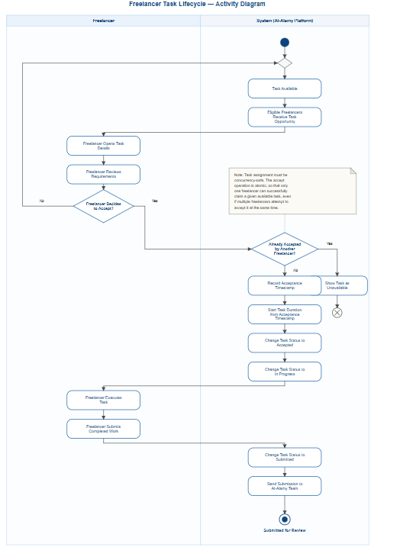

21. Activity Diagram — Task Review and Approval
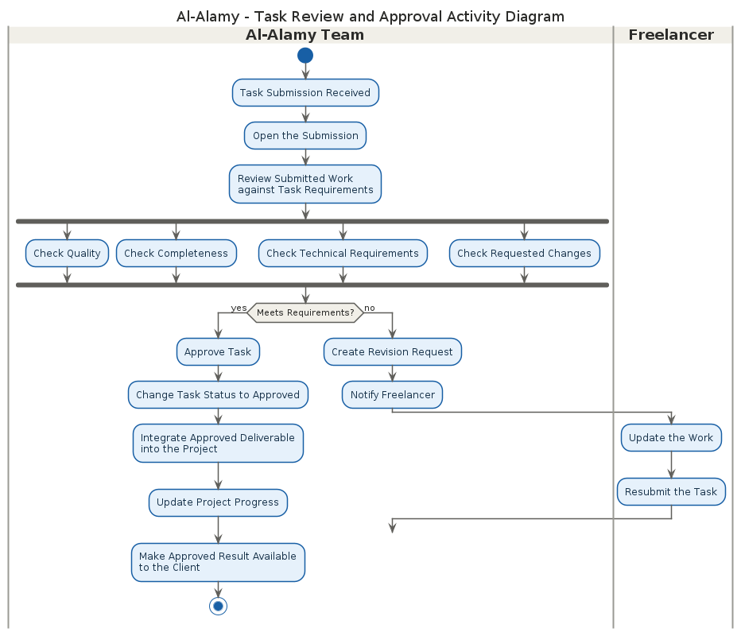

22. Sequence Diagram — Client Service Request
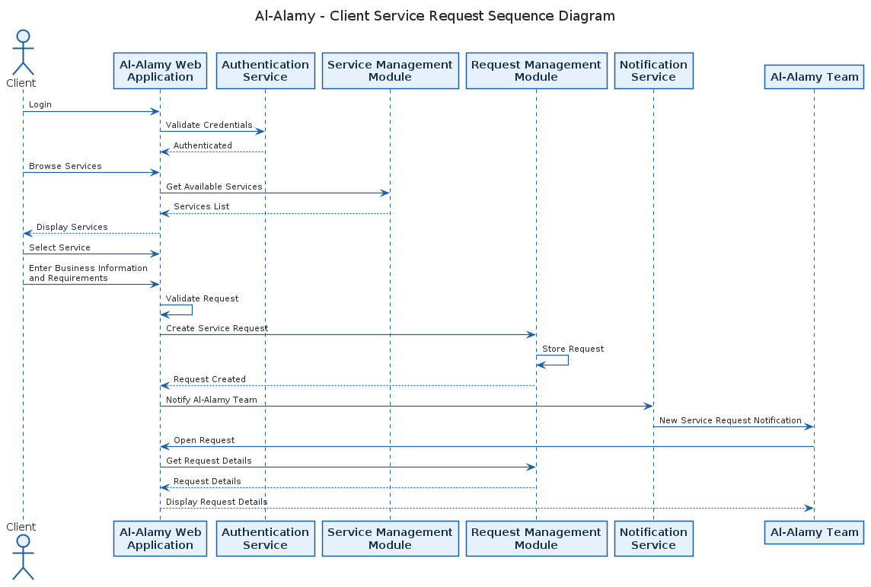

23. Sequence Diagram — Meeting Request
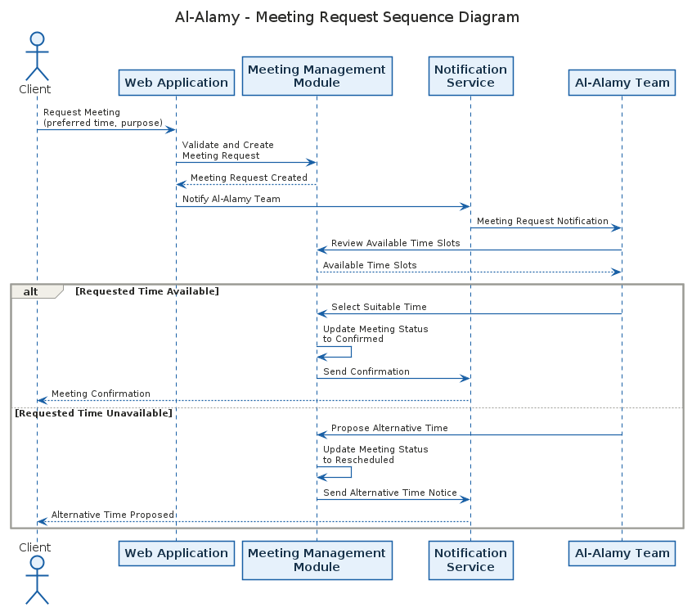

24. Sequence Diagram — First Freelancer Acceptance
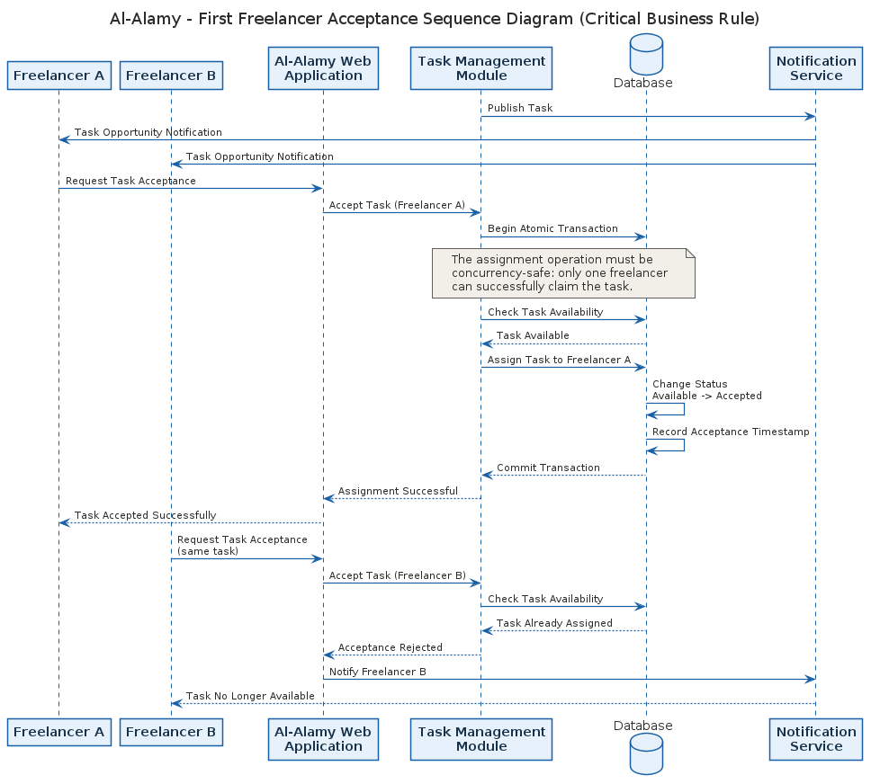

25. Sequence Diagram — Freelancer Submission and Review
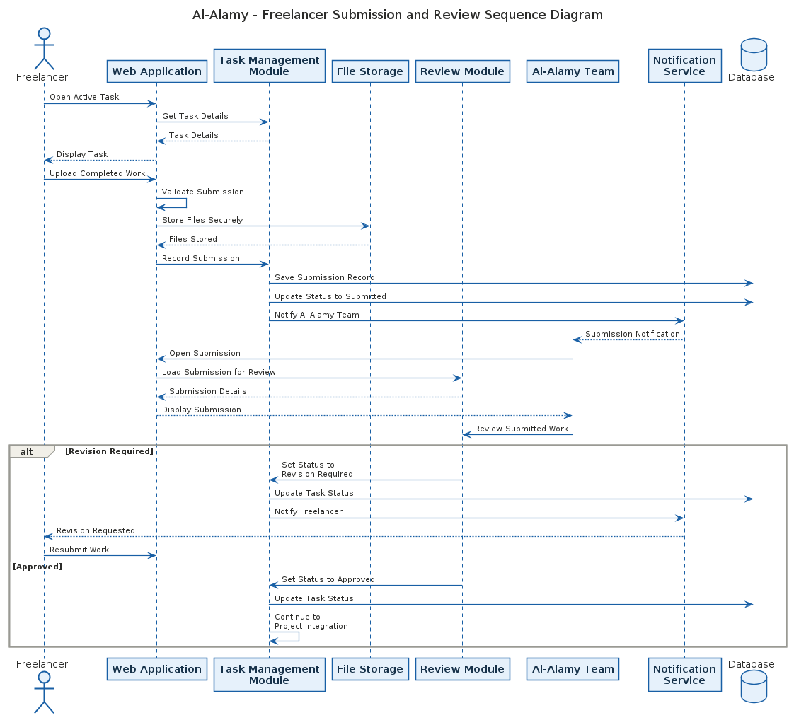

26. Sequence Diagram — Approved Deliverable to Client
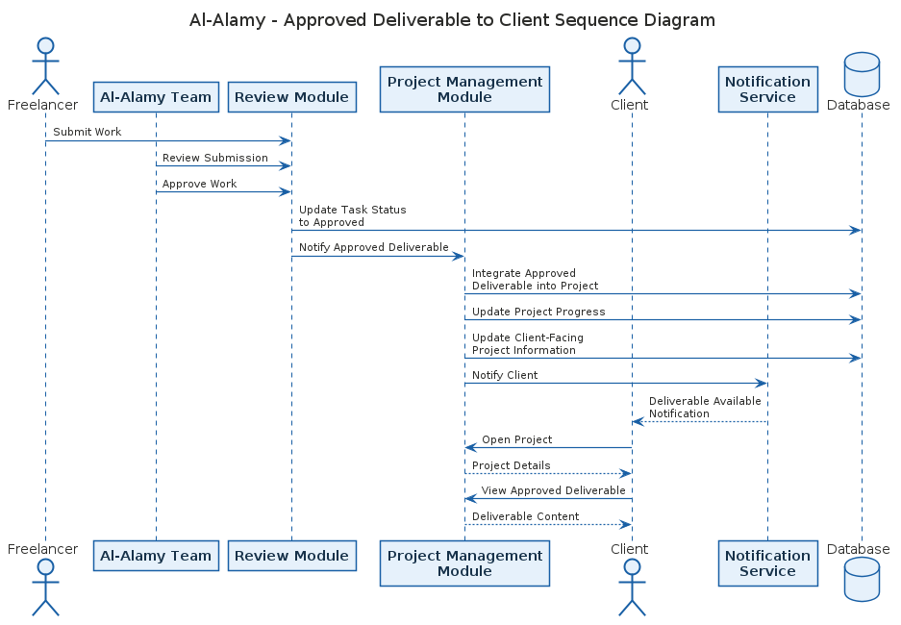

27. DFD Level 0
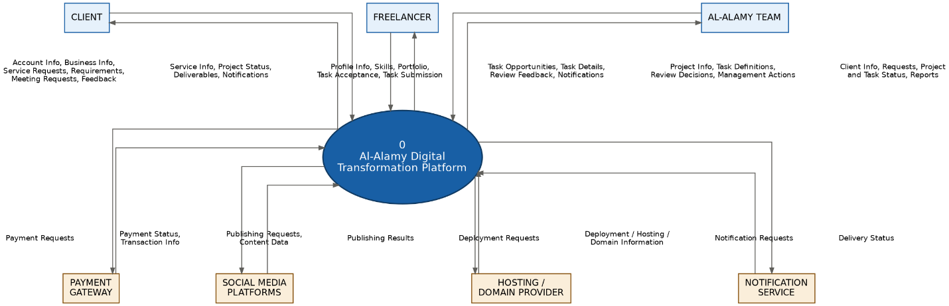

28. DFD Level 1 — Task Management
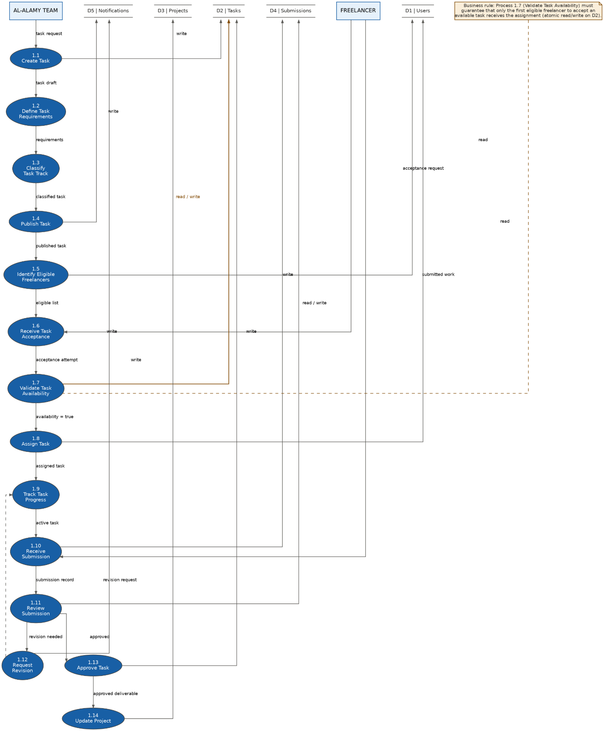

29. Domain Model and Class Diagram
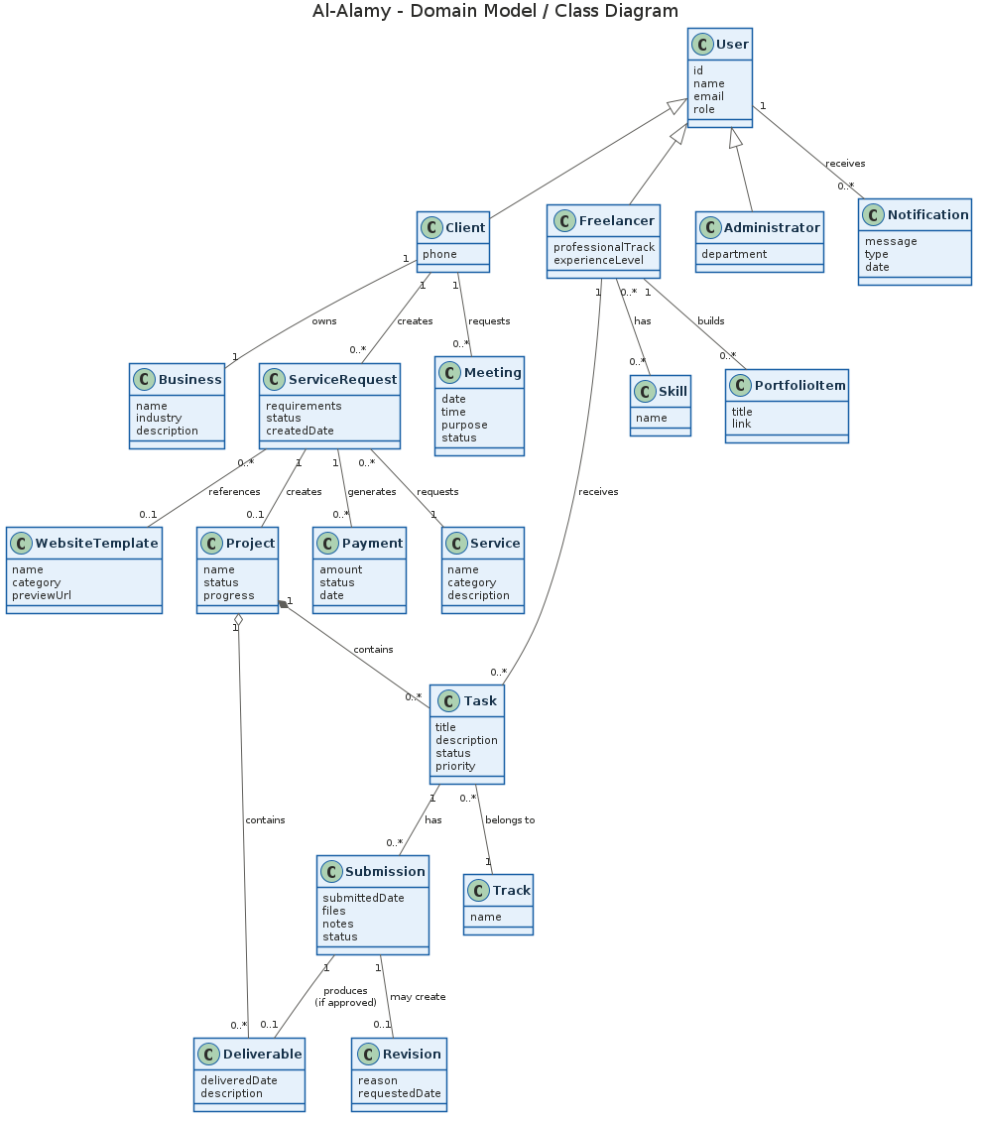

30. Conceptual ERD
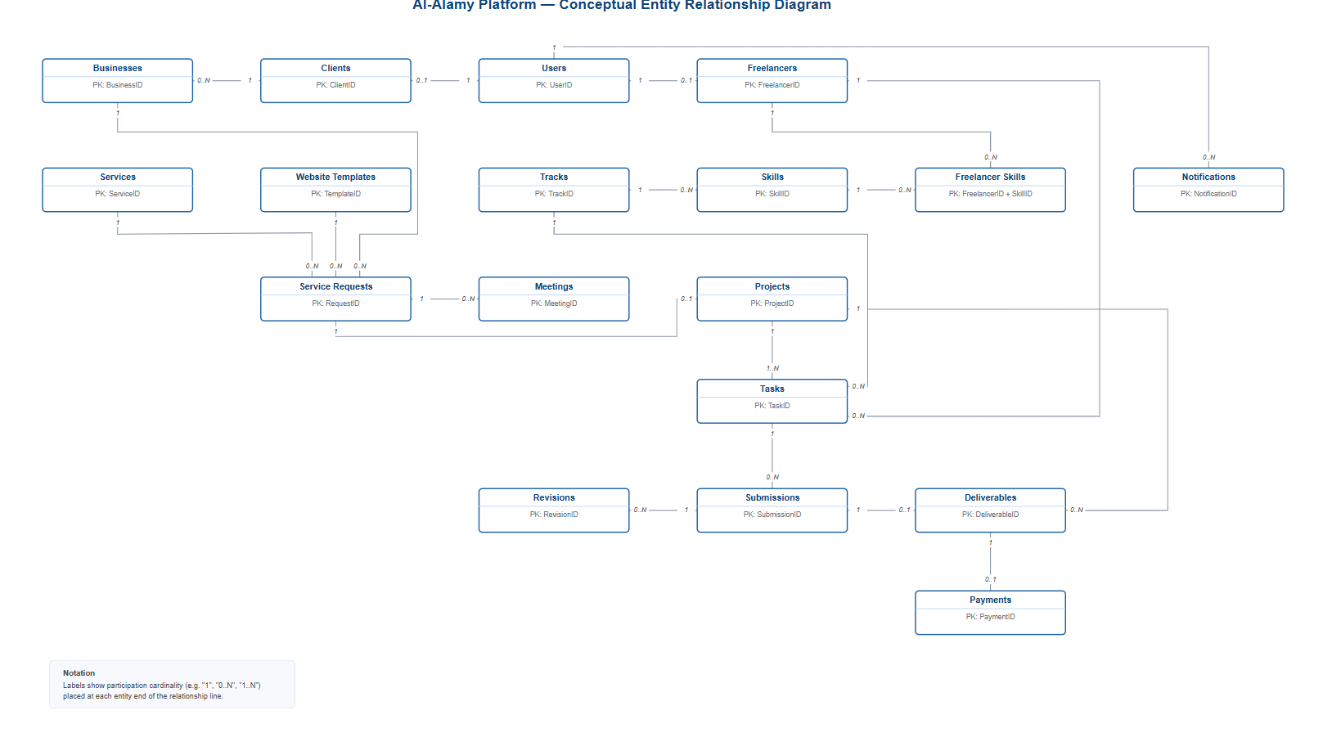

31. System Architecture Diagram

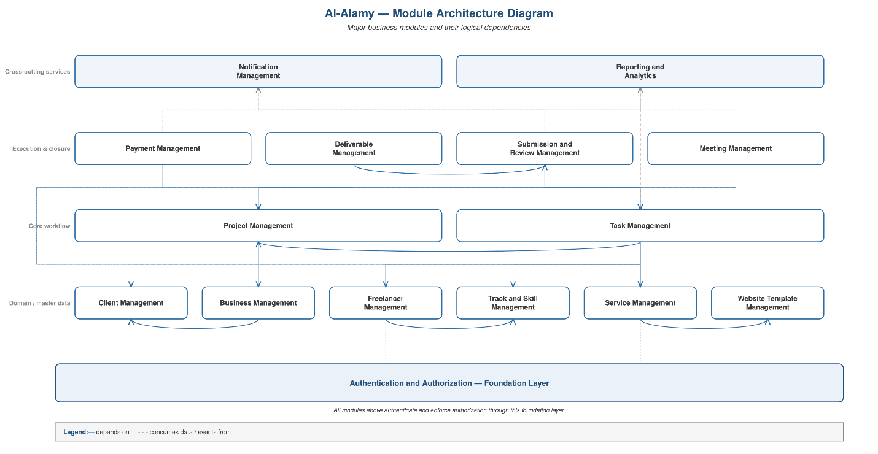

32. Module Architecture

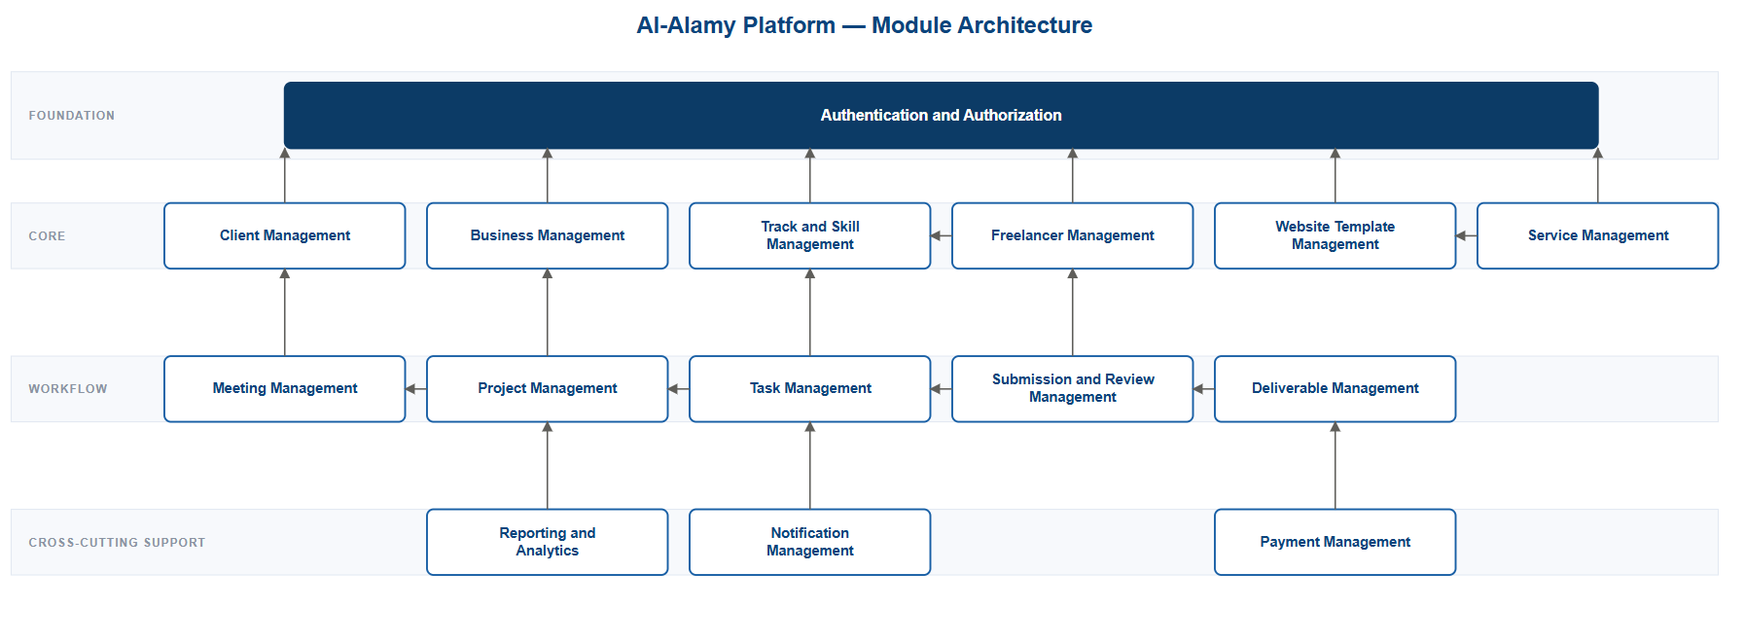

33. Deployment Diagram
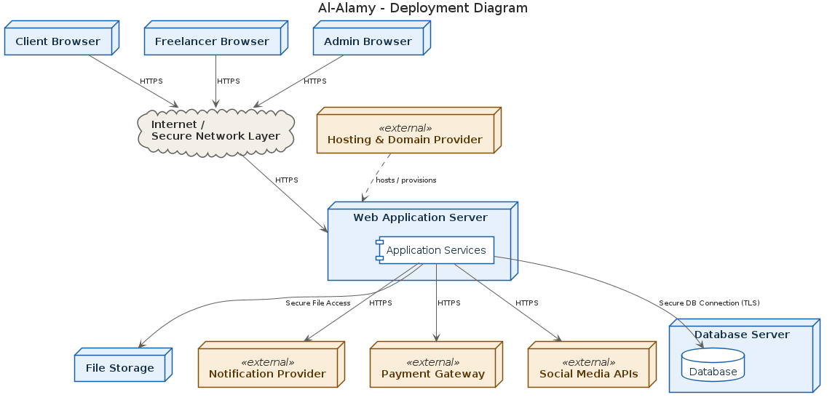

34. Information Architecture
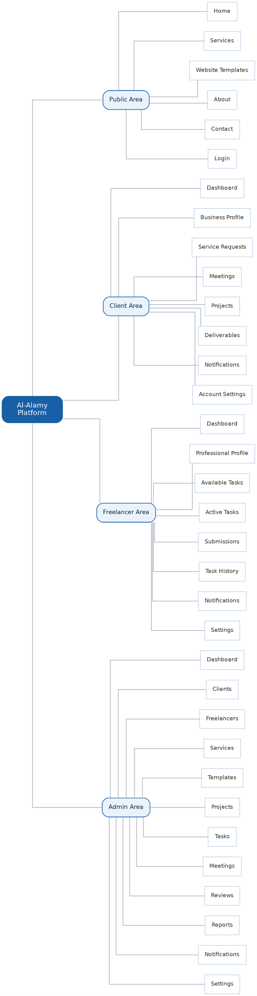

35. Client Dashboard UI

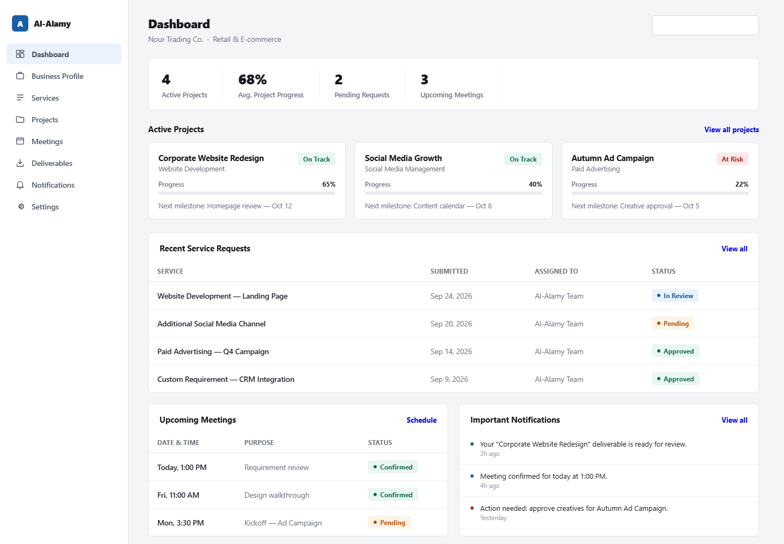

36. Freelancer Dashboard UI
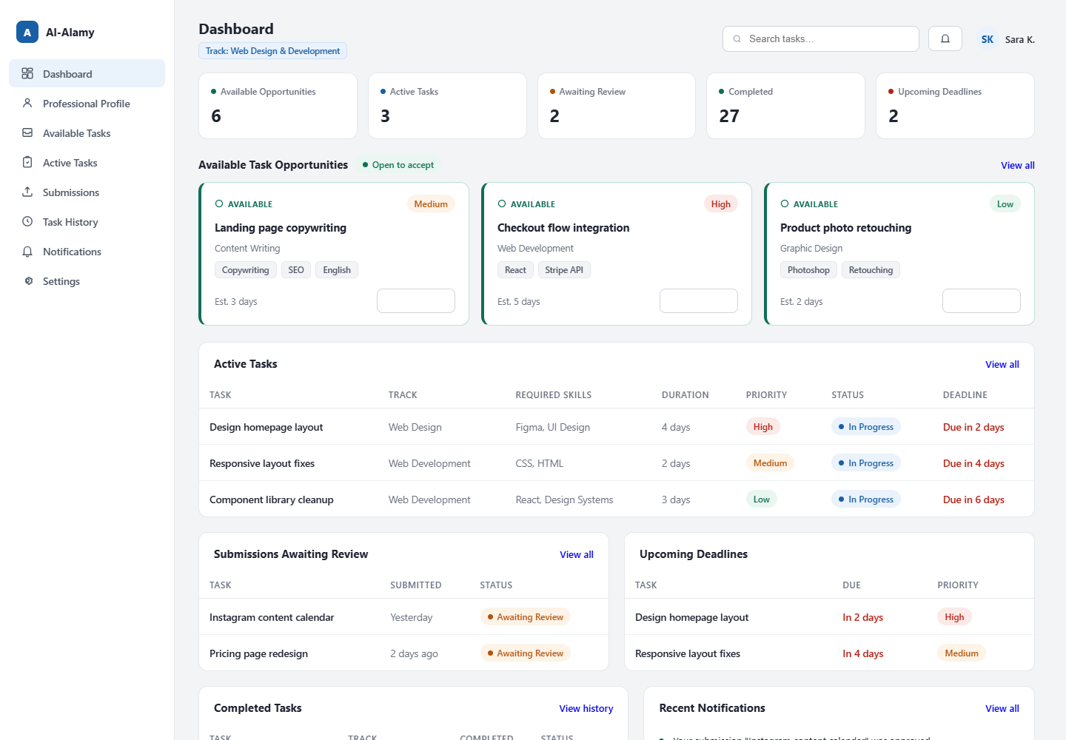

37. Admin Dashboard UI
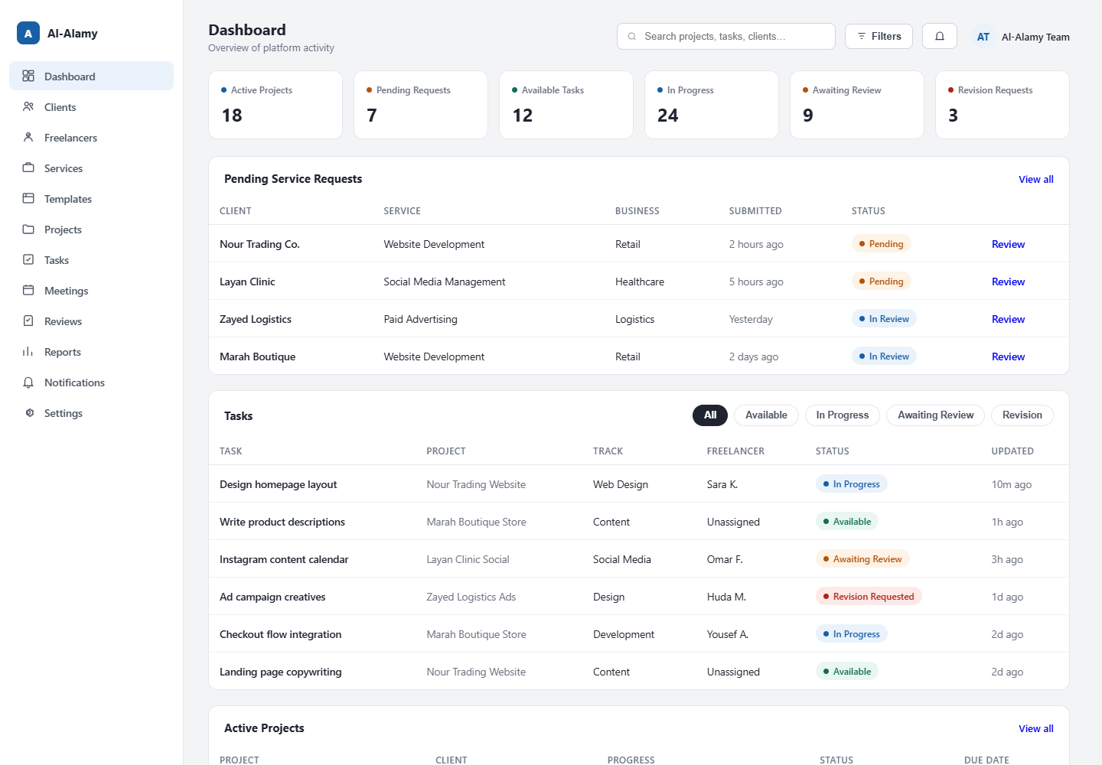

38. Website Template Gallery UI

39. Website Template Preview UI

40. Freelancer Available Tasks UI

41. Freelancer Task Details UI

42. Freelancer Task Submission UI

43. Admin Task Management UI

44. Task Review UI

45. Project Management UI

46. Meeting Management UI

47. Notification Center UI

48. Al-Alamy Design System

49. Requirements Traceability Matrix
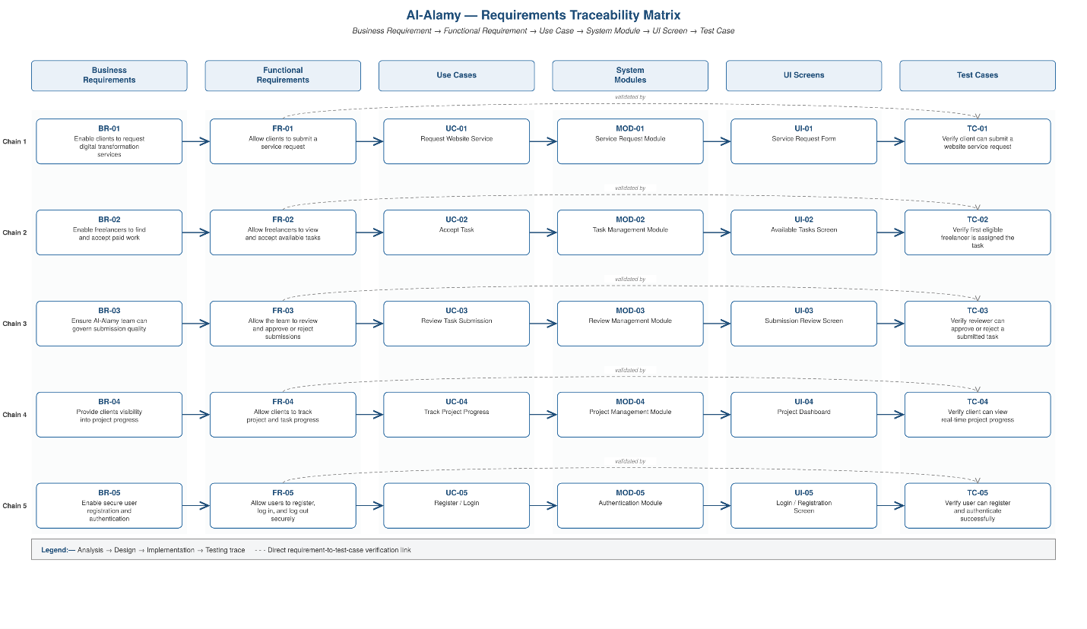

50. Overall Project Workflow
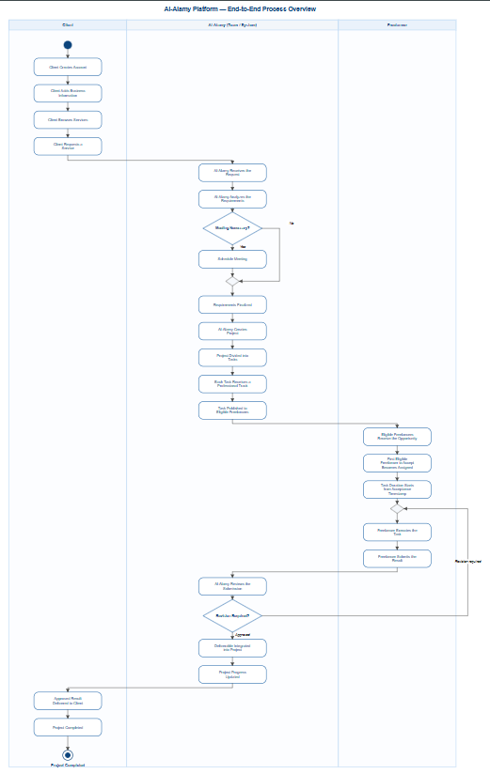

51. Functional Requirements

FR-01 Authentication
The system shall allow users to register and authenticate securely.

FR-02 Role Management
The system shall distinguish between Client Freelancer and Administrator roles.

FR-03 Client Profile
The system shall allow clients to manage their personal and business information.

FR-04 Service Browsing
The system shall allow clients to browse available services.

FR-05 Website Template Preview
The system shall allow clients to view available website templates.

FR-06 Service Request
The system shall allow clients to submit service requests.

FR-07 Custom Requirement
The system shall allow clients to submit customized requirements.

FR-08 Meeting Request
The system shall allow clients to request meetings with the Al-Alamy Team.

FR-09 Project Management
The system shall allow the Al-Alamy Team to create and manage projects.

FR-10 Task Creation
The system shall allow administrators to create tasks.

FR-11 Track Classification
Every task shall belong to a professional track.

FR-12 Task Distribution
The system shall make tasks available to eligible freelancers.

FR-13 First Acceptance
The system shall assign an available task to the first eligible freelancer who successfully accepts it.

FR-14 Task Timing
The system shall calculate the task deadline from the acceptance timestamp.

FR-15 Task Submission
The system shall allow freelancers to submit completed work.

FR-16 Review
The system shall allow the Al-Alamy Team to review submitted work.

FR-17 Revision
The system shall allow the team to request revisions.

FR-18 Project Progress
The system shall update project progress based on task states.

FR-19 Deliverables
The system shall provide approved deliverables to the client.

FR-20 Notifications
The system shall provide notifications for important workflow events.

52. Non-Functional Requirements

Security
The system must protect user accounts data files and business information.

Performance
The platform should respond efficiently under normal operating conditions.

Reliability
The system should preserve data integrity during normal operations and unexpected failures.

Concurrency
The task acceptance mechanism must prevent multiple freelancers from receiving the same task.

Usability
The system should provide a clear and understandable interface for each user role.

Maintainability
The system should be modular and maintainable.

Scalability
The architecture should support increasing numbers of users projects tasks and files.

Availability
The platform should remain accessible during normal service periods.

Auditability
Important actions should be recorded for accountability and troubleshooting.

Privacy
Users should only access information permitted by their role.

53. Core Business Rules
BR-01
Clients interact with Al-Alamy rather than directly managing freelancers.
BR-02
A project may contain multiple tasks.
BR-03
Every task belongs to a professional track.
BR-04
Only eligible freelancers should receive or see a task.
BR-05
The first eligible freelancer who successfully accepts an available task receives the assignment.
BR-06
Once assigned the task becomes unavailable to other freelancers.
BR-07
The task duration starts from the acceptance timestamp.
BR-08
Freelancers submit completed work to Al-Alamy.
BR-09
Al-Alamy reviews submitted work before integration.
BR-10
A task may require one or more revisions.
BR-11
Only approved work can be integrated into the client project.
BR-12
Client-facing progress should hide unnecessary internal freelancer operations.

54. Critical Use Cases

UC-01 Request Service
Actor: Client
Goal: Request a digital service.
Precondition: Client is authenticated.
Main Flow:
Client opens Services.
Client selects a service.
Client reviews service information.
Client provides business information.
Client provides requirements.
Client submits the request.
System validates the request.
System creates the service request.
Al-Alamy Team receives notification.
Alternative Flow:
If required information is missing the system requests additional information.

UC-02 Request Meeting
Actor: Client
Goal: Request a meeting with the Al-Alamy Team.
Main Flow:
Client opens Meeting Request.
Client selects preferred time.
Client provides meeting purpose.
Client submits request.
System creates meeting request.
Al-Alamy Team receives notification.
Team confirms or reschedules the meeting.
Client receives confirmation.

UC-03 Create Task
Actor: Al-Alamy Team
Goal: Convert project requirements into an executable task.
Main Flow:
Team opens project.
Team identifies required work.
Team creates task.
Team defines requirements.
Team selects professional track.
Team defines required skills.
Team defines estimated duration.
Team defines priority.
Team publishes task.
Eligible freelancers receive the task opportunity.

UC-04 Accept Task
Actor: Freelancer
Goal: Accept an available task.
Main Flow:
Freelancer opens available tasks.
Freelancer selects task.
Freelancer reviews requirements.
Freelancer selects Accept.
System verifies that the task is still available.
System assigns the task.
System records acceptance timestamp.
System calculates deadline.
System changes task status.
Other freelancers can no longer accept the task.

UC-05 Submit Task
Actor: Freelancer
Goal: Submit completed work.
Main Flow:
Freelancer opens active task.
Freelancer uploads required files.
Freelancer adds links or notes.
Freelancer submits work.
System validates the submission.
System stores the submission.
System changes status to Submitted.
Al-Alamy Team receives notification.

UC-06 Review Task
Actor: Al-Alamy Team
Goal: Validate submitted work.
Main Flow:
Team opens submission.
Team reviews requirements.
Team reviews submitted work.
Team decides whether revision is required.
If revision is required the system sends feedback to the freelancer.
If approved the task becomes Approved.

UC-07 Deliver Approved Work
Actor: Al-Alamy Team
Goal: Deliver approved work to the client.
Main Flow:
Team approves submission.
System updates task status.
Approved deliverable is integrated into the project.
Project progress is updated.
Client receives notification.
Client opens project.
Client views approved deliverable.

55. Security Requirements
The system shall use secure authentication.
Passwords must be securely hashed.
Role-based authorization must be enforced.
Administrative functions must be protected.
Files must be protected against unauthorized access.
Uploaded files should be validated.
Business rules must be validated on the server side.
Task acceptance must be protected against race conditions.
Important actions should be logged.
The platform should not request or store social media passwords.
Future social media integrations should use official APIs and OAuth-based authorization.

56. Privacy Requirements
Client business information should only be visible to authorized users.
Freelancer personal information should be protected.
Internal task information should not expose unnecessary client data.
Client-facing interfaces should not expose internal freelancer management details.
Administrative information should remain restricted to authorized team members.

57. Subscription Model
Al-Alamy may provide service packages based on recurring subscriptions.
A subscription may contain:
- Website service
- Social media management
- Advertising management
- Content services
- Support
- Reporting
The final pricing structure should be defined during the business planning phase.
The system should allow future subscription expansion without redesigning the core architecture.

58. Social Media Management
The social media management service may cover:
- Facebook
- Instagram
- TikTok
Possible internal tasks include:
- Content planning
- Post creation
- Video production
- Video editing
- Publishing
- Promotional content
- Product announcements
- Customer communication
- Community management
The platform should not require clients to provide social media passwords.
Future integration should use official platform APIs and authorization mechanisms.

59. Payment Management
The payment subsystem may support:
- Service payments
- Subscription payments
- Payment confirmation
- Payment status
- Transaction records
- Payment notifications
The actual payment provider can be selected during implementation.

60. Website Management
Website projects may include:
- Template selection
- Template customization
- Frontend development
- Backend development
- Database configuration
- Domain setup
- Hosting
- Deployment
- Content management
The website service should support both predefined templates and customized requirements.

61. Task Track Structure
Possible professional tracks include:
- Frontend Development
- Backend Development
- Full Stack Development
- Database
- Data Analysis
- UI/UX Design
- Graphic Design
- Video Production
- Video Editing
- Social Media Management
- Community Management
- Digital Marketing
- Paid Advertising
- Content Writing
- SEO
- Other Specialized Tracks
The track structure should remain configurable through the Admin Panel.

62. Freelancer Profile Structure
A freelancer profile may contain:
- Full Name
- Profile Picture
- Email
- Phone
- Country
- City
- Professional Track
- Specialization
- Years of Experience
- Skills
- Portfolio
- Previous Work
- Education
- Certifications
- Languages
- Availability
- Rate
- External Links
- CV
- Professional Bio

63. Task Data Structure
Each task should contain:
- Task ID
- Task Title
- Description
- Project
- Track
- Required Skills
- Estimated Duration
- Priority
- Budget
- Attachments
- Created Date
- Published Date
- Status
- Assigned Freelancer
- Acceptance Timestamp
- Deadline
- Submission Timestamp
- Review Status
- Revision Count

64. Task Status Lifecycle
The recommended lifecycle is:
Available
↓
Accepted
↓
In Progress
↓
Submitted
↓
Under Review
↓
Approved
or
Revision Required
↓
Revised
↓
Resubmitted
↓
Under Review
↓
Approved

65. Project Lifecycle
The project lifecycle is:
Client Request
↓
Requirement Analysis
↓
Requirement Confirmation
↓
Project Creation
↓
Task Breakdown
↓
Task Classification
↓
Task Publication
↓
Task Execution
↓
Task Submission
↓
Task Review
↓
Revision if Required
↓
Approval
↓
Integration
↓
Client Delivery
↓
Project Completion

66. Screen Inventory

Public
- Home
- Services
- Website Templates
- Template Preview
- About
- Contact
- Login
- Registration

Client
- Dashboard
- Business Profile
- Services
- Service Request
- Meeting Request
- Projects
- Project Details
- Deliverables
- Notifications
- Account Settings

Freelancer
- Dashboard
- Professional Profile
- Available Tasks
- Task Details
- Active Task
- Submit Work
- Task History
- Notifications
- Settings

Admin
- Dashboard
- Clients
- Freelancers
- Services
- Website Templates
- Projects
- Tasks
- Task Review
- Meetings
- Reports
- Notifications
- Settings

67. Testing Strategy
Testing should cover both functional and non-functional requirements.

Functional Testing
Authentication.
Authorization.
Service requests.
Meeting requests.
Project creation.
Task creation.
Task distribution.
Task acceptance.
Task submission.
Review.
Revision.
Approval.
Deliverable management.
Notifications.

Concurrency Testing
The first freelancer acceptance mechanism must be tested with multiple simultaneous requests.
The system must guarantee that only one freelancer can successfully claim an available task.

Security Testing
Authentication testing.
Authorization testing.
Input validation.
File upload validation.
Access control testing.
Session security testing.
Audit logging testing.

Usability Testing
Client workflows should be tested with users representing business owners.
Freelancer workflows should be tested with users representing task performers.
Admin workflows should be tested with users representing internal team members.

68. Risks and Constraints

Risk 01
Multiple freelancers may attempt to accept the same task simultaneously.
Mitigation: Use atomic transaction handling and concurrency control.

Risk 02
Client requirements may be unclear.
Mitigation: Use structured requirement forms and meeting workflows.

Risk 03
Freelancer submissions may not meet requirements.
Mitigation: Use review and revision workflows.

Risk 04
Large files may increase storage requirements.
Mitigation: Use controlled file storage and upload validation.

Risk 05
External APIs may change.
Mitigation: Keep integrations modular.

Risk 06
The platform may grow beyond the original architecture.
Mitigation: Use modular architecture and clear service boundaries.

69. Team Responsibilities
The five-person team can be divided into functional responsibilities.

Member 1
Project Analysis.
Requirements.
Business Rules.
Documentation.

Member 2
Backend Development.
Authentication.
Business Logic.
APIs.

Member 3
Frontend Development.
Client Interface.
Freelancer Interface.
Admin Interface.

Member 4
Database.
ERD.
Database Implementation.
Data Integrity.

Member 5
UI/UX.
Figma.
Design System.
Usability.
Testing Support.
The final distribution should be adjusted according to each member's actual skills.

70. Recommended Development Order
The implementation should not begin with random screens.
The recommended order is:
- Finalize requirements.
- Finalize business rules.
- Finalize use cases.
- Finalize activity diagrams.
- Finalize sequence diagrams.
- Finalize DFD.
- Finalize domain model.
- Finalize ERD.
- Finalize architecture.
- Finalize UI information architecture.
- Build the design system.
- Design the main screens.
- Implement authentication.
- Implement user roles.
- Implement client workflow.
- Implement project management.
- Implement task management.
- Implement freelancer workflow.
- Implement review workflow.
- Implement notifications.
- Implement payment integration.
- Implement external integrations.
- Perform testing.
- Perform security review.
- Deploy the system.

71. Final Analysis and Design Deliverables
The final System Analysis and Design package should contain:
- Project Vision
- Problem Statement
- Proposed Solution
- Stakeholder Analysis
- Actor Analysis
- System Scope
- Functional Requirements
- Non-Functional Requirements
- Business Rules
- System Context Diagram
- High-Level Use Case Diagram
- Detailed Client Use Case Diagram
- Detailed Freelancer Use Case Diagram
- Detailed Admin Use Case Diagram
- Activity Diagrams
- Sequence Diagrams
- DFD Level 0
- DFD Level 1
- Domain Model
- Class Diagram
- Conceptual ERD
- System Architecture
- Module Architecture
- Deployment Diagram
- Information Architecture
- UI/UX Design System
- Client Dashboard
- Freelancer Dashboard
- Admin Dashboard
- Template Gallery
- Template Preview
- Task Management Screens
- Review Screens
- Meeting Screens
- Requirements Traceability Matrix
- Testing Strategy
- Risk Analysis
- Implementation Plan

72. Project Quality Standards
All diagrams should use consistent terminology.
The same actor names should be used throughout the document.
The same entity names should be used between Use Cases Domain Model and ERD.
Business rules should be reflected in the activity and sequence diagrams.
Functional requirements should map to use cases.
Use cases should map to system modules.
System modules should map to UI screens.
UI screens should map back to functional requirements.
This creates traceability between analysis design implementation and testing.

73. Important Architectural Principle
The platform should be designed around the business workflow rather than individual screens.
The correct relationship is:
Client
↓
Al-Alamy
↓
Project
↓
Task
↓
Professional Track
↓
Eligible Freelancers
↓
First Successful Acceptance
↓
Execution
↓
Submission
↓
Al-Alamy Review
↓
Approval or Revision
↓
Integration
↓
Client Delivery
This workflow represents the core business logic of the platform.

74. Final System Concept
Al-Alamy is not simply a website for connecting clients with freelancers.
It is a managed digital transformation platform.
The client does not need to understand which specialist is required.
The client explains the business need.
Al-Alamy analyzes the need.
The platform transforms the requirement into structured work.
The work is distributed according to professional tracks.
Freelancers execute the internal tasks.
Al-Alamy controls the review process.
The approved results are integrated into the project.
The client receives the final service through one centralized relationship.
This structure allows Al-Alamy to operate as a controlled digital service organization while creating a structured work environment for freelancers.

75. Appendix — Diagram Prompt Index
ID | Diagram / Design | Status
D01 | System Context Diagram | Completed
D02 | High-Level Use Case Diagram | Completed
D03 | Client Use Case Diagram | Prompt Ready
D04 | Freelancer Use Case Diagram | Prompt Ready
D05 | Admin Use Case Diagram | Prompt Ready
D06 | Client Service Request Activity | Prompt Ready
D07 | Meeting Activity | Prompt Ready
D08 | Project and Task Creation Activity | Prompt Ready
D09 | Freelancer Task Lifecycle Activity | Prompt Ready
D10 | Task Review Activity | Prompt Ready
D11 | Client Service Request Sequence | Prompt Ready
D12 | Meeting Sequence | Prompt Ready
D13 | First Freelancer Acceptance Sequence | Prompt Ready
D14 | Submission and Review Sequence | Prompt Ready
D15 | Approved Deliverable Sequence | Prompt Ready
D16 | DFD Level 0 | Prompt Ready
D17 | DFD Level 1 | Prompt Ready
D18 | Domain Model / Class Diagram | Prompt Ready
D19 | Conceptual ERD | Prompt Ready
D20 | System Architecture | Prompt Ready
D21 | Module Architecture | Prompt Ready
D22 | Deployment Diagram | Prompt Ready
D23 | Information Architecture | Prompt Ready
D24 | Client Dashboard | Prompt Ready
D25 | Freelancer Dashboard | Prompt Ready
D26 | Admin Dashboard | Prompt Ready
D27 | Template Gallery | Prompt Ready
D28 | Template Preview | Prompt Ready
D29 | Freelancer Task Management | Prompt Ready
D30 | Freelancer Submission | Prompt Ready
D31 | Admin Task Management | Prompt Ready
D32 | Task Review | Prompt Ready
D33 | Project Management | Prompt Ready
D34 | Meeting Management | Prompt Ready
D35 | Notification Center | Prompt Ready
D36 | Al-Alamy Design System | Prompt Ready
D37 | Requirements Traceability Matrix | Prompt Ready
D38 | Overall Project Workflow | Prompt Ready

76. Appendix — Core Terminology
Client: The business owner or organization requesting digital services.
Freelancer: A professional responsible for executing internal tasks.
Al-Alamy Team: The internal team responsible for managing client projects and freelancer tasks.
Track: A professional classification used to identify the type of work required.
Skill: A specific capability associated with a freelancer.
Project: A collection of tasks created to fulfill a client requirement.
Task: A specific unit of work assigned to a freelancer.
Submission: Work submitted by a freelancer for review.
Revision: Additional work requested after review.
Deliverable: Approved work that can be integrated into the client project.
Service Request: A request submitted by a client for one of the platform services.
Meeting Request: A request from a client to communicate with the Al-Alamy Team.

77. Final Note
This document represents the master System Analysis and Design baseline for the Al-Alamy project.
Any implementation decision should be evaluated against the requirements business rules workflows and architecture defined in this document.
Changes introduced during development should be documented and reflected in the relevant diagrams requirements and design sections.
The purpose of this document is to make the project understandable before implementation begins and to ensure that all team members work from the same system definition.
End of Document

