BGU Progress Report

# Tasks

* Theory development of efficient quantum pair sources on a chip in ppKTP
* Building the numerical simulator in ppKTP for 775-1550nm and 0.5Mcps/mW

# Studied waveguide architecture

## Initial simulated architecture

Initially we simulated double track waveguide schematically shown in Figure 1.

crystal axis

KTP crystal

*h*

gap

Figure 1 Initially simulated double track waveguide layout

$${\hat{n}}_{track}$$

$${\hat{n}}_{0}$$

w

Due to lack of experimental data, we initially assumed isotropic negative modification of the refractive index (RI) in tracks

$${\hat{n}}_{track}= \left(\begin{matrix}n_{0x}-Δn & 0 & 0 \\ 0 & n_{0y}-Δn & 0 \\ 0 & 0 & n_{0z}-Δn\end{matrix}\right),$$

with bulk index ${\hat{n}}_{0}$ defined by Sellmeier equation [1]

$$n_{0i}^{2}=A_{i}+\frac{B_{1i}}{λ^{2}-C_{1i}}+\frac{B_{2i}}{λ^{2}-C_{2i}}, i=x,y,z.$$

We have simulated the modes of the structure shown in Figure 1 and found this structure supports **no guided modes** which means that one needs to additionally take into account RI modifications outside the track.

In the real double track waveguides wave guiding stems from the interplay of mechanical stresses induced during track formation. Due to the stresses the actual RI distribution appears more complex and involves zones with anisotropic positive and negative refractive index modifications.

To accurately model such modifications one needs either to retrieve the actual RI distribution from measurements or to involve modelling of defects formation by femtosecond laser pulses  [2–4]. However, reliable physical model of this effect, particularly, for KTP is yet lacking. The alternative is to perform heuristic modelling and/or fitting of the experimental data [4].

## Architecture with assumed stress-induced refractive index modification outside the tracks

To achieve wave guiding in the simulated waveguides we imposed certain assumptions. Namely, we assumed that increased index zones (which we call halos) appear around the tracks with the positive RI modification similarly to the result reported in  [5] for double track waveguides in fluoride glass. The halos were assumed to have a circular shape and Gaussian profile of RI. As for the tracks, the RI modification was taken to be isotropic

$${\hat{n}}_{halo}= \left(\begin{matrix}n_{0x}+Δn_{halo} & 0 & 0 \\ 0 & n_{0y}+Δn_{halo} & 0 \\ 0 & 0 & n_{0z}+Δn_{halo}\end{matrix}\right)$$

with

$$Δn_{halo}=\frac{Δn}{4}\exp\left(-r^{2}/r_{halo}^{2}\right),$$

where $r$ is the distance from the halo center, $r_{halo }=2h$ and the amplitude $Δn/4$ was chosen to in accordance with the data reported in the literature [5,6]. The obtained structure is schematically shown in Figure 2.

*w*

crystal axis

KTP crystal

*h*

gap

Figure 2 Double track waveguide layout with stress-induced increased index zones (“halos”) around tracks

$${\hat{n}}_{track}$$

$${\hat{n}}_{0}$$

$${\hat{n}}_{halo}$$

# Estimation of the down-conversion efficiency

## Theory

Following  [7] we define the down-converted signal power $P_{s}^{WG}$ in the waveguide in a frequency interval as

$$P_{s}^{WG}=\int_{ω_{0}-Δω/2}^{ω_{0}+Δω/2}{\frac{ℏd^{2}ω_{s}^{2}ω_{i}L^{2}{{η_{spd}η}_{s}η_{p}P}_{p}}{πc^{3}ε_{0}n_{s}n_{i}n_{p}A_{I}}{sinc}^{2}\left(\frac{ΔkL}{2}\right)dω_{s}} (1)$$

with $Δk=β_{p}-β_{s}-β_{i}-\frac{2π}{Λ}$ and interaction effective area

$$A_{I}={\left[\int_{A}{dxdy} U_{p}U_{i}^{*}U_{s}^{*}\right]}^{-2},$$

$U_{p}, U_{i}, U_{s}$ are the normalized mode field profiles of the pump, signal, and idler modes. The modal profiles are normalized so that $\int_{A}{dxdy}{\left|U_{p,s,i}\right|}^{2}=1$ which implies that $U_{p,s,i}$ have dimensionality of the inverse of a length.

Photon-pair source efficiency in photon counts/s per mW is obtained by

$E=η_{col}\frac{P_{s}^{WG}}{ℏω_{s}}$,

where pump power $P_{p}$ is taken as 1 mW.

Our assumptions on parameters are provided in Table 1

Table 1 Relevant parameters and assumptions

|  |  |  |  |  |
| --- | --- | --- | --- | --- |
| **Parameter** | **Description** | **Formula** | **Value** | **Units** |
| $$η_{s,i}$$ | Collection efficiency of the signal photons to the detection system |  | 0.2 |  |
| $$P_{p}$$ | Pump power |  | 1 | mW |
| $$λ_{s,i}$$ | Wavelength of signal and idler photons |  | 810 | nm |
| $$λ_{0}$$ | Central wavelength of the pump filter |  | 405 | nm |
| $$Δλ$$ | Passband of the pump filter |  | 1 | nm |
| $$d_{24}$$ | Relevant nonlinear coefficient |  | 7.6 | pW/V |
| $$d$$ | Effective nonlinear coefficient | $$2d_{24}/π$$ | 4.8 | pW/V |
| $$L$$ | Length of the waveguide |  | 10 | mm |

## Calculation of the eigenmodes

For estimation of interaction effective area as well as poling period we have identified eigenmodes with a finite-difference mode solver.

We have identified that the waveguide supports guided modes provided that $Δn≥2×{10}^{-3}$.

To find the waveguide parameters with the best down-conversion efficiency we have performed a multiparameter sweep calculating $A_{I}$ for each waveguide. The table below shows the swept parameters with the corresponding sweep ranges:

|  |  |
| --- | --- |
| **Parameter** | **Range** |
| $$w$$ | 1-3 um |
| $$h$$ | 10-24 um |
| $$gap$$ | 6-24 um |
| $$Δn$$ | $$2×{10}^{-3}-8×{10}^{-3}$$ |

Example mode profiles of the calculated signal, idler, and pump modes are shown in Figure 3. Dashed lines in plots designate $1/e^{2}$ intensity contours

.

Figure 3 Signal, idler, and pump modes of a double-track waveguide

Using the obtained modal profiles, we have calculated interaction effective area $A_{I}$ for each configuration and identified the minimum $A_{I}$ among configurations with different $Δn$.

Figure 4 shows $A_{I}$ of the best waveguide configurations for different values of RI modification $Δn$ and the poling period $Λ$ obtained for those configurations. The corresponding optimal waveguide parameters (track width, height and gap between the tracks) are shown in Figure 5.

Figure 6 shows the maximum spectral density at the central pump wavelength and the corresponding photon pair production rate assuming identical experimental setting as in  [7]. For instance, a value of $35$ pW/nm similar to the value reported in  [7] is obtained for $Δn≈0.005$. With the identical assumptions about the losses in experimental setup as in [7] this value corresponds to $2.9×{10}^{6}$ counts/s per mW of transmitted pump and approximately $0.2×{10}^{6}$ counts/s. Respectively, the value of $0.4×{10}^{6}$ counts/s can be achieved by increasing $Δn$ to the maximum value of $8×{10}^{-3}$ used in simulations. We expect that further increase of $Δn$ will lead to the planned efficiency of 0.5Mcounts/s per mW although our assumptions on the RI distribution in case of stronger RI modifications requires validation.

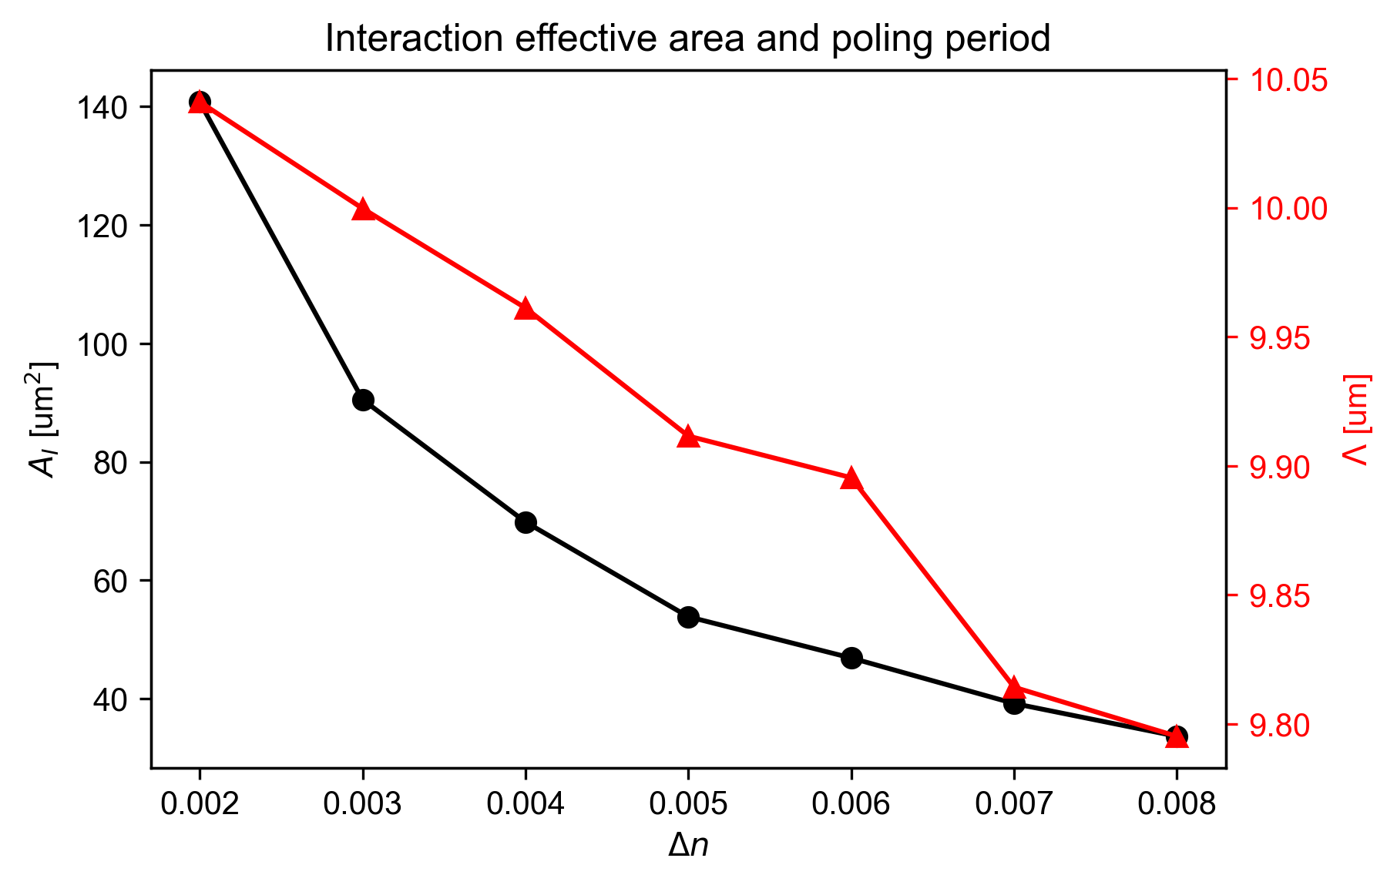

Figure 4 Minimum interaction effective area as function of $Δn$.

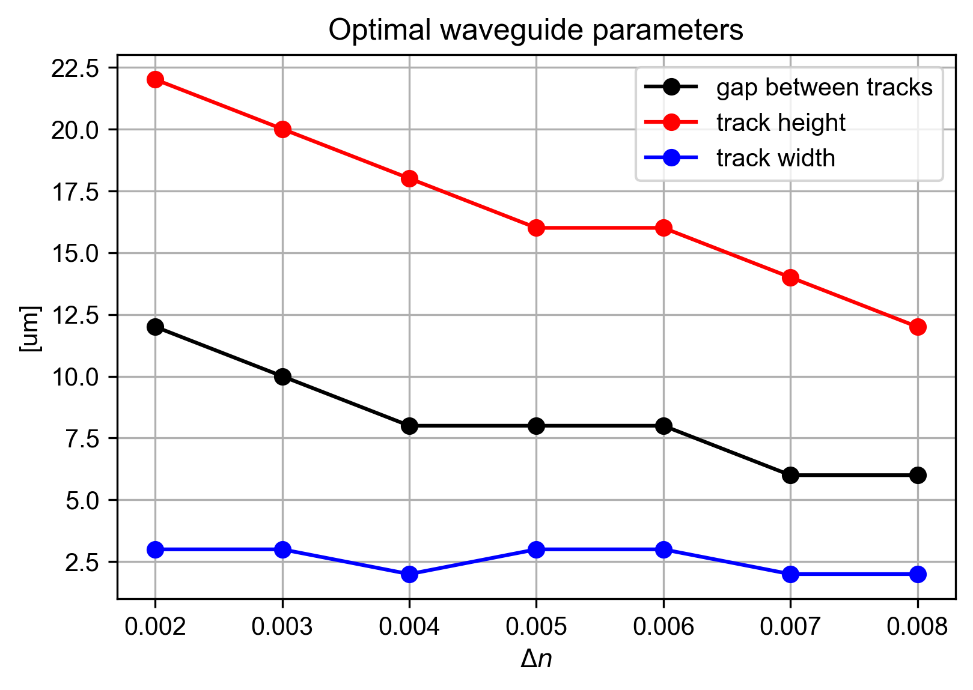

Figure 5 Optimal waveguide parameters as function of $Δn$.

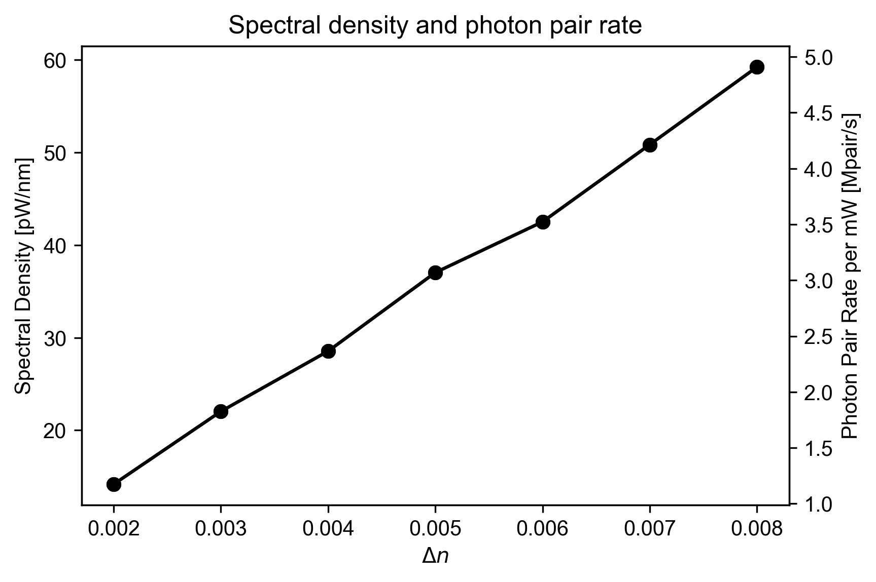

Figure 6 Calculated spectral power density of the signal photons for degenerate type-II SPDC per 1 mW pump power at $λ_{p}=405$ nm, $λ_{s}=λ_{i}=810$ nm and the corresponding photon pair rate.

# Summary

To summarize, we have achieved the two milestones:

* Theory development of efficient quantum pair sources on a chip in ppKTP – ***accomplished***
* Building the numerical simulator in ppKTP for 775-1550nm and 0.5cps/mW– ***accomplished***

# References

[1] K. Kato and E. Takaoka, *Sellmeier and Thermo-Optic Dispersion Formulas for KTP*, Appl. Opt., AO **41**, 5040 (2002).

[2] M. Will, J. Burghoff, S. Nolte, A. Tunnermann, F. Wunderlich, and K. Goetz, *Detailed Investigations on Femtosecond-Induced Modifications in Crystalline Quartz for Integrated Optical Applications*, in *Commercial and Biomedical Applications of Ultrafast Lasers V*, Vol. 5714 (SPIE, 2005), pp. 261–270.

[3] J. Burghoff, S. Nolte, and A. Tünnermann, *Origins of Waveguiding in Femtosecond Laser-Structured LiNbO3*, Appl. Phys. A **89**, 127 (2007).

[4] H.-D. Nguyen, A. Ródenas, J. R. V. de Aldana, J. Martínez, F. Chen, M. Aguiló, M. C. Pujol, and F. Díaz, *Heuristic Modelling of Laser Written Mid-Infrared LiNbO3 Stressed-Cladding Waveguides*, Opt. Express, OE **24**, 7777 (2016).

[5] W. Gebremichael, L. Canioni, Y. Petit, and I. Manek-Hönninger, *Double-Track Waveguides inside Calcium Fluoride Crystals*, Crystals **10**, 109 (13 p.) (2020).

[6] T. Yuan, B. Zhu, H. Tu, Y. Chen, and X. Chen, *Femtosecond Laser Direct Writing Quasi-Phase Matched Type-II Waveguide in Lithium Niobate*, Opt. Mater. Express, OME **13**, 1 (2023).

[7] M. Fiorentino, S. M. Spillane, R. G. Beausoleil, T. D. Roberts, P. Battle, and M. W. Munro, *Spontaneous Parametric Down-Conversion in Periodically Poled KTP Waveguides and Bulk Crystals*, Opt. Express **15**, 7479 (2007).