**T.C.**

**BAHÇEŞEHİR UNIVERSITY**



**FACULTY OF ENGINEERING AND NATURAL SCIENCES**

**CAPSTONE PROJECT PROPOSAL**

**or**

**CAPSTONE FINAL REPORT**

**The TITLE of the project goes here**

**The Names of the Students and their Departments go here,**

**In Alphabetical Order by Surname,**

**Capitalize The First Letters Only**

**Advisors: Your Advisor’s Name Goes Here**

**(e.g. Assist. Prof., Assoc. Prof., Prof. ...) and their departments**

**ISTANBUL, May 2021**

**STUDENT DECLARATION**

By submitting this report, as partial fulfillment of the requirements of the Capstone course, the students promise on penalty of failure of the course that

* they have given credit to and declared (by citation), any work that is not their own (e.g. parts of the report that is copied/pasted from the Internet, design or construction performed by another person, etc.);
* they have not received unpermitted aid for the project design, construction, report or presentation;
* they have not falsely assigned credit for work to another student in the group, and not take credit for work done by another student in the group.

# ABSTRACT

The TITLE of the project goes here

Your Names in alphabetical order by surname

Faculty of Engineering and Natural Sciences

Advisor: Your Adviser Titles and Names

May 2021

Write the abstract here (only necessary for the final report).

**Key Words**: CO2, carbon dioxide, microcontroller, air quality, CO2 meter

# TABLE OF CONTENTS

ABSTRACT iii

TABLE OF CONTENTS iv

LIST OF TABLES v

LIST OF FIGURES v

LIST OF ABBREVIATIONS vi

1. OVERVIEW 1

1.1. Identification of the need 1

1.2. Definition of the problem 1

1.3. Conceptual solutions 1

1.4. Physical architecture 3

2. WORK PLAN 4

2.1. Work Breakdown Structure (WBS) 4

2.2. Responsibility Matrix (RM) 4

2.3. Project Network (PN) 5

2.4. Gantt chart 5

2.5. Costs 7

2.6. Risk assessment 8

3. SUB-SYSTEMS 9

3.1. The name of the sub-system 1 9

3.2. The name of the sub-system 2 10

4. INTEGRATION AND EVALUATION 11

4.1. Integration 11

4.2. Evaluation 11

5. SUMMARY AND CONCLUSION 12

ACKNOWLEDGEMENTS 13

REFERENCES 14

APPENDIX A 15

APPENDIX B 16

# LIST OF TABLES

Table 1. Comparison of the three conceptual solutions. 2

Table 2. Responsibility Matrix for the team 4

Table 3. Gantt chart for the materialisation phase of the project. 6

Table 4. Costs 7

Table 5. Risk matrix 8

Table 6. Risk assessment 8

# LIST OF FIGURES

Figure 1. Path of electrical energy from the power plant to the home. 2

Figure 2. Interface diagram for the system. 3

Figure 3. Process chart for the system 3

Figure 4. Work breakdown structure for the project. 4

Figure 5. The project network. 5

# LIST OF ABBREVIATIONS

IoT Internet of Things

M2M Machine-to-Machine

IEEE The Institute of Electrical and Electronics Engineers

# 1. OVERVIEW

Begin the first paragraph here.

Begin the second paragraph here.

## 1.1. Identification of the need

Begin the first paragraph here.

Begin the second paragraph here.

## 1.2. Definition of the problem

Begin the first paragraph here.

Begin the second paragraph here.

### 1.2.1. Functional requirements

Begin the first paragraph here.

Begin the second paragraph here.

### 1.2.2. Performance requirements

Begin the first paragraph here.

Begin the second paragraph here.

### 1.2.3. Constraints

Begin the first paragraph here.

*Specifically, write about the economic, environmental and social impact of your product. A whole page is dedicated to this in the report guide; please read the guide carefully and write about how these issues apply to your product.*

## 1.3. Conceptual solutions

Begin the first paragraph here.

Begin the second paragraph here.

### 1.3.1. Literature Review

*Include references to other work and data, for example:* Reference [1] states that a base station’s power consumption can be divided into four main parts. Bees are flying insects closely related to wasps and ants [2].

*Below is an example of including a figure. You should always give the figure a number and a caption (make sure that this is including in the LIST OF FIGURES) and refer to the figure in the text.* Figure 1 illustrates the steps electric energy takes from the point of generation to the point of use.

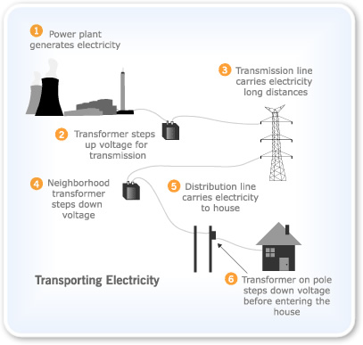

Figure 1. Path of electrical energy from the power plant to the home.

### 1.3.2. Concepts

Begin the first paragraph here.

Begin the second paragraph here.

*Below is an example of including a table. You should always give the table a number and a caption (make sure that this is including in the LIST OF TABLES) and refer to the table in the text. For example:*

Table 1 compares different conceptual solutions with respect to the four most important requirements; Concept 2 is chosen for this project due to it’s low cost and reasonable score in all the other categories.

Table 1. Comparison of the three conceptual solutions.

|  |  |  |  |
| --- | --- | --- | --- |
|  | Concept 1 | Concept 2 | Concept 3 |
| Cost | high | low | medium |
| Complexity | medium | low | medium |
| Performance | High | medium | low |
| Features | high | medium | high |

## 1.4. Physical architecture

Begin the first paragraph here.

Begin the second paragraph here.

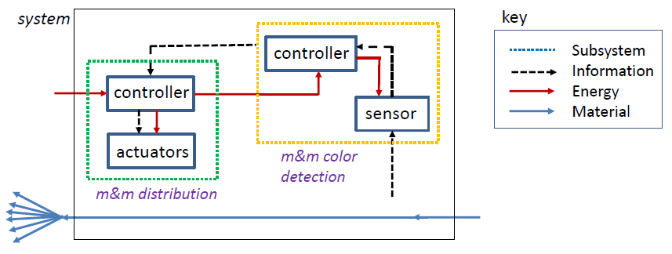

Figure 2. Interface diagram for the system.

Begin the first paragraph here.

Begin the second paragraph here.

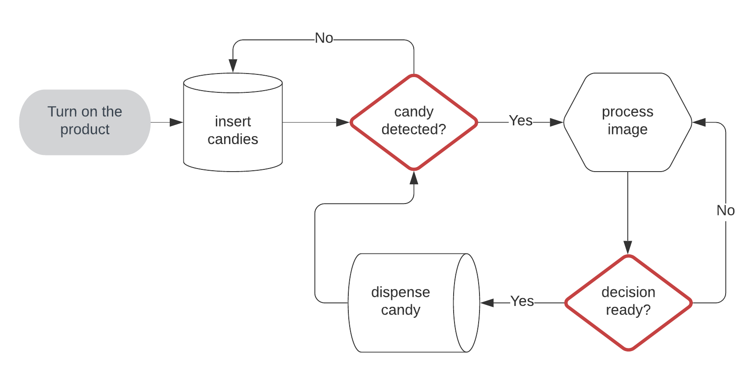

Figure 3. Process chart for the system

# 2. WORK PLAN

Begin the first paragraph here.

Begin the second paragraph here.

## 2.1. Work Breakdown Structure (WBS)

Begin the first paragraph here.

Begin the second paragraph here.

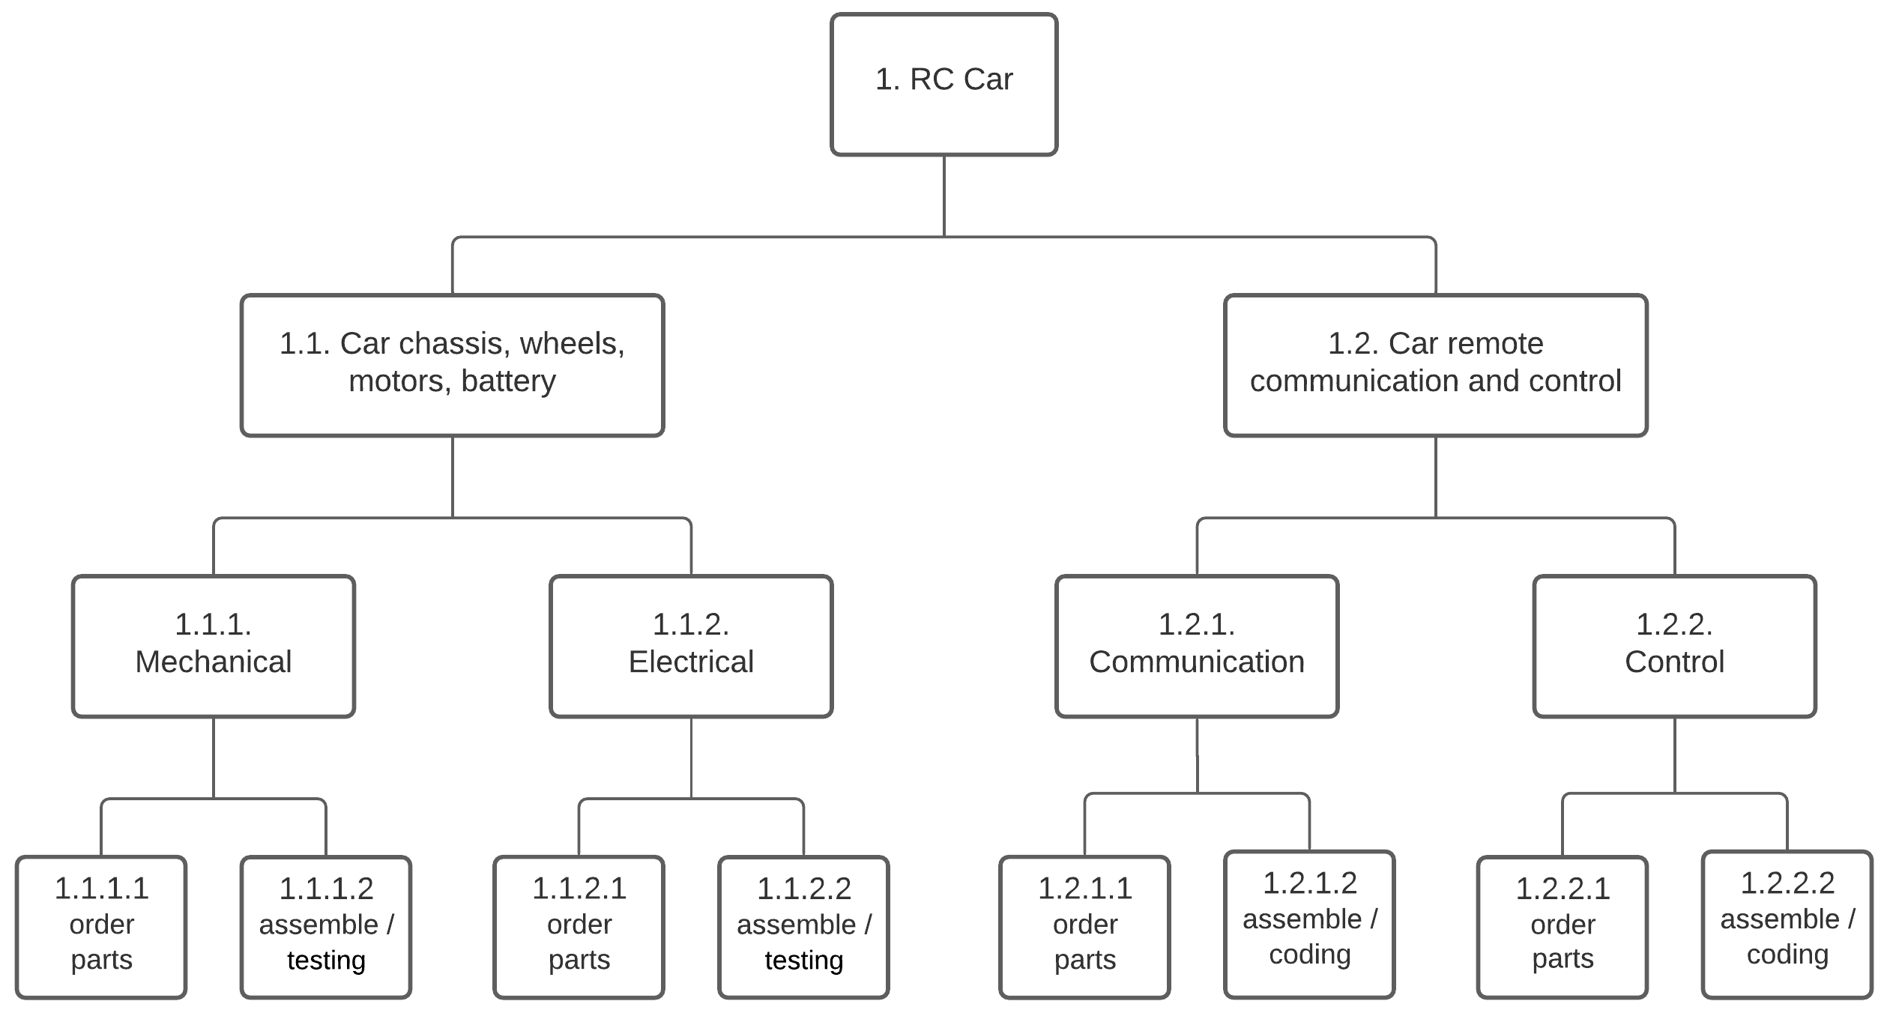

Figure 4. Work breakdown structure for the project.

## 2.2. Responsibility Matrix (RM)

Begin the first paragraph here.

Table 2. Responsibility Matrix for the team

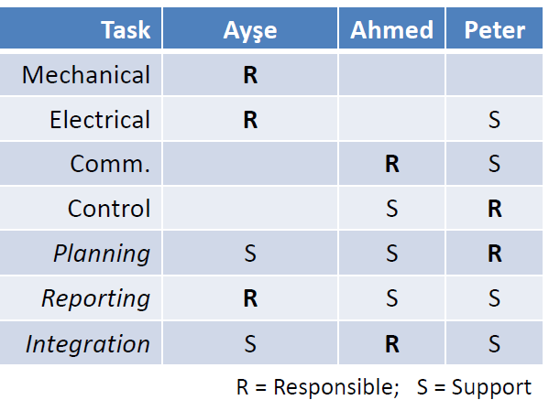

## 2.3. Project Network (PN)

Begin the first paragraph here.

Begin the second paragraph here.

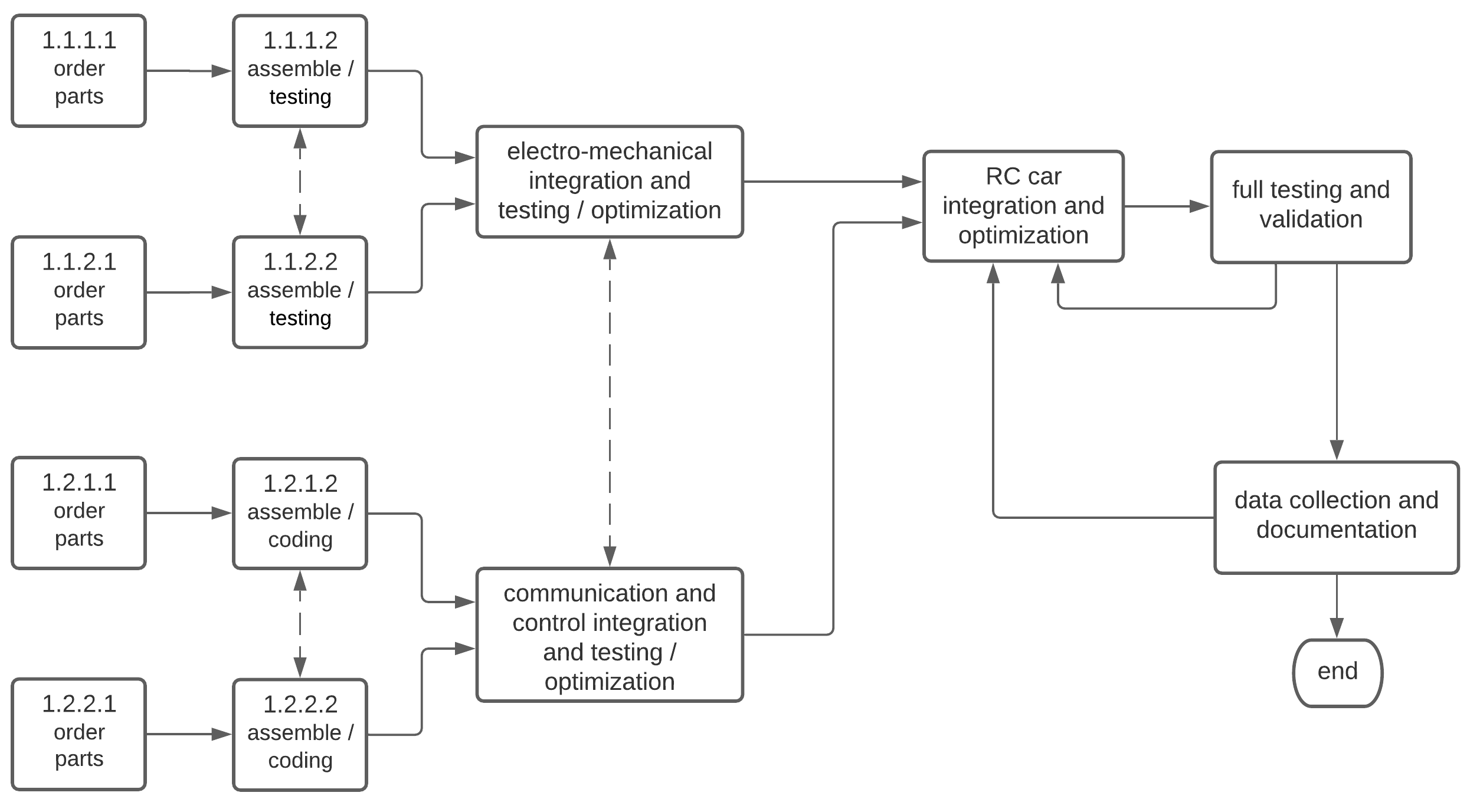

Figure 5. The project network.

## 2.4. Gantt chart

*Since the Gantt chart covers 15 weeks it can be very wide, therefore in this example it is placed on it’s own page and turned sideways. There are various forms for a Gantt chart, choose the form that is suitable for the size and complexity of your project.*

*Discuss the Gantt chart here (refer to the table).*

Begin the first paragraph here.

Begin the second paragraph here.

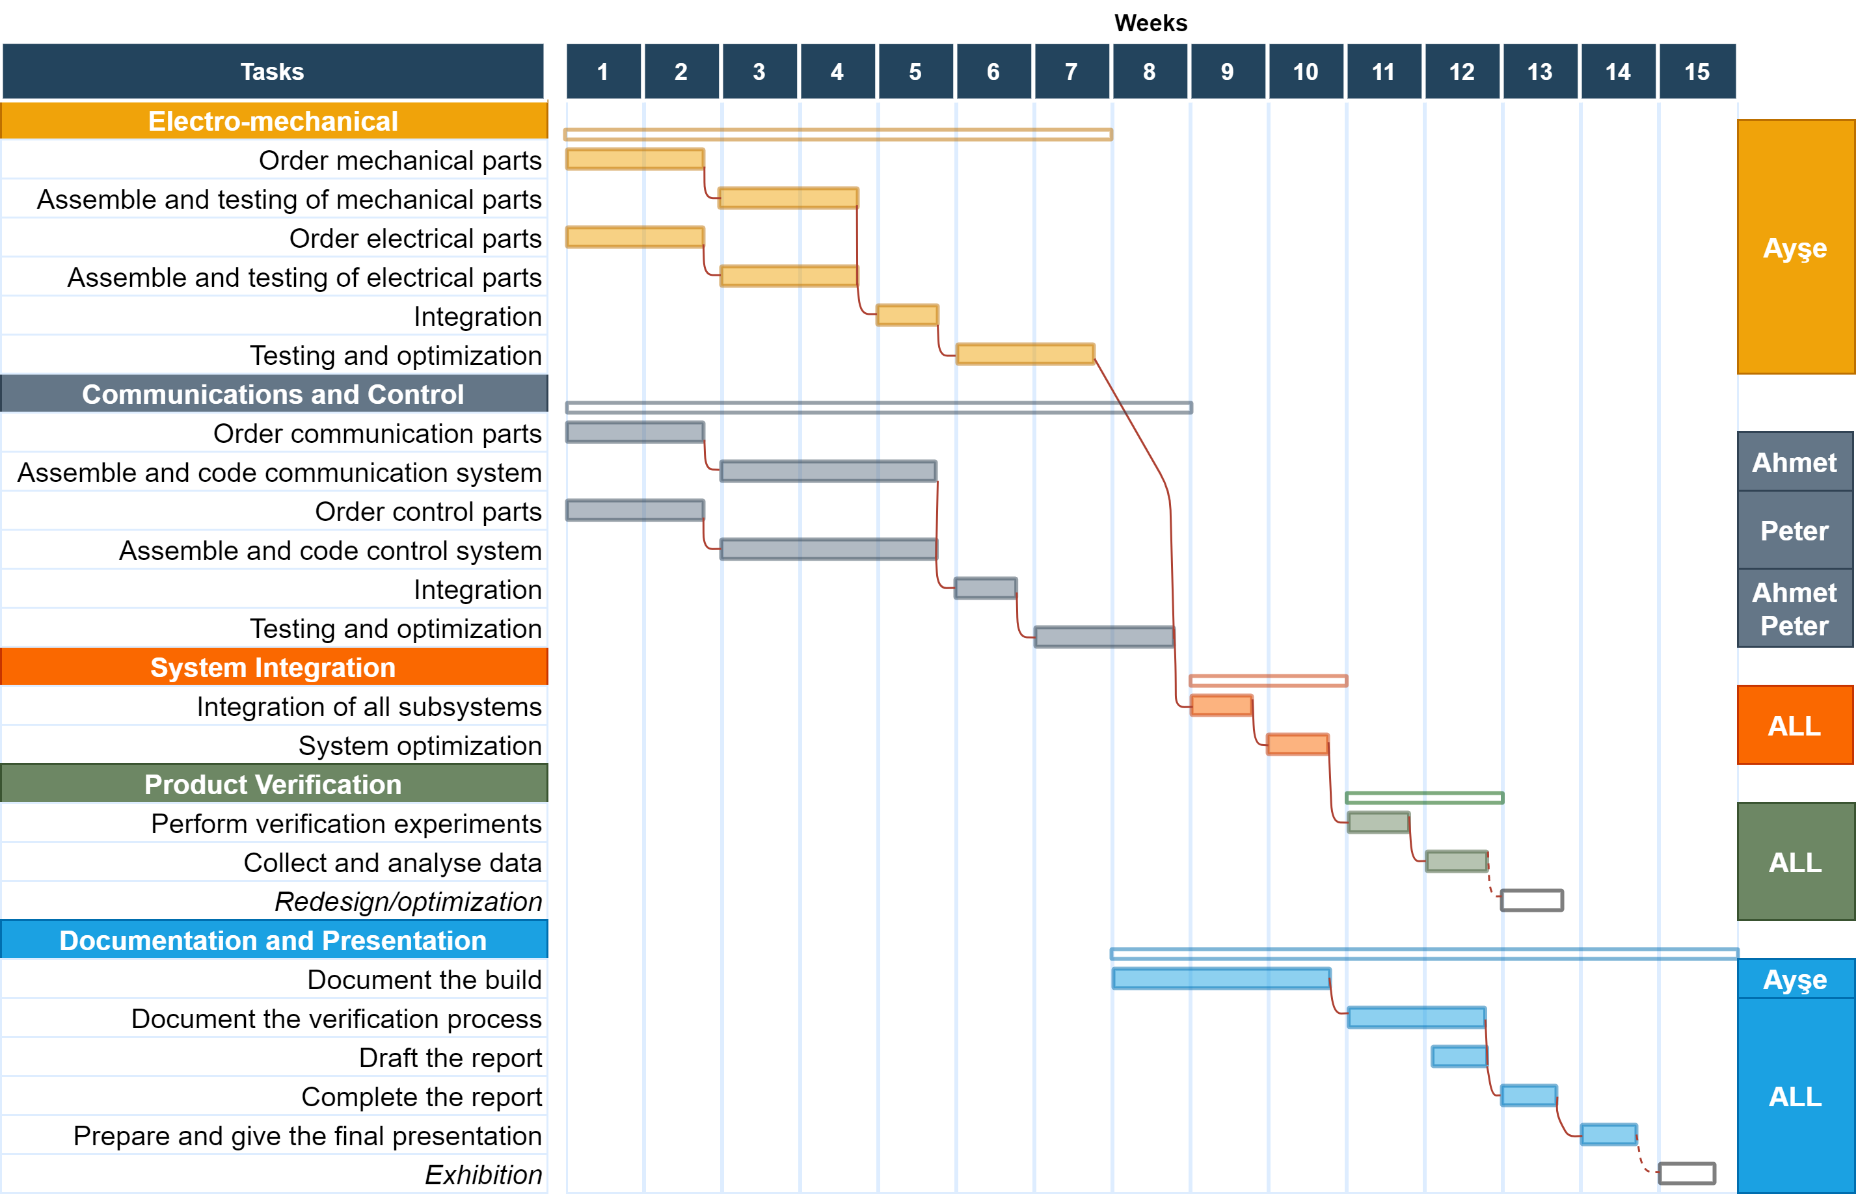

Created at https://app.diagrams.net/

Table 3. Gantt chart for the materialisation phase of the project.

## 2.5. Costs

Begin the first paragraph here.

Table 4. Costs

|  |  |
| --- | --- |
| **Electro-mechanical** | |
| Arduino Uno | 59.90 ₺ |
| SRC-04 sensor | 19.99 ₺ |
| SG90-RC serve-motor | 21.34 ₺ |
| other materials | 26.90 ₺ |
| **Total** | **128.13** ₺ |
|  | |
| **Communications and Control** | |
| Arduino Nano 328 | 55.39 ₺ |
| Arduino joystick shield | 24.23 ₺ |
| HC06 bluetooth-serial module | 28.99 ₺ |
| **Total** | **108.61** ₺ |
|  | |
| **System Total** | **236.74** ₺ |

## 2.6. Risk assessment

*The tables provided below are examples, you can replace one or both with your own.*

Begin the first paragraph here.

Begin the second paragraph here.

Table 5. Risk matrix

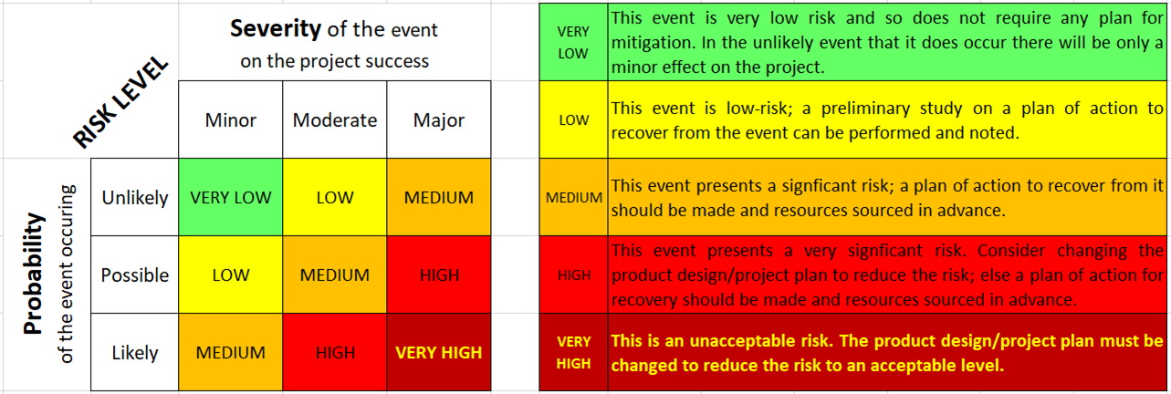

Table 6. Risk assessment

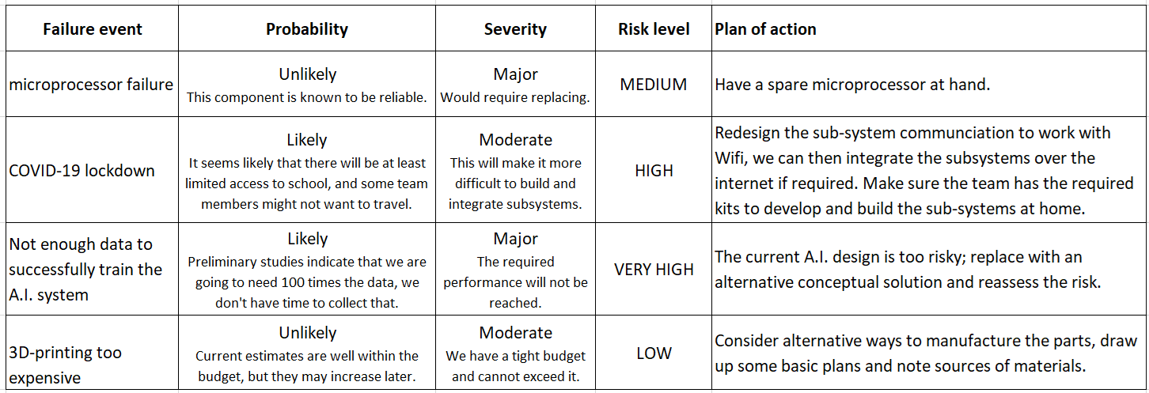

# 3. SUB-SYSTEMS

***There will be at least two sub-systems corresponding to two faculty departments and/or work groups.***

Begin the first paragraph here.

Begin the second paragraph here.

## 3.1. The name of the sub-system 1

Begin the first paragraph here.

Begin the second paragraph here.

### 3.1.1. Requirements

Begin the first paragraph here.

Begin the second paragraph here.

### 3.1.2. Technologies and methods

Begin the first paragraph here.

Begin the second paragraph here.

### 3.1.3. Conceptualization

Begin the first paragraph here.

Begin the second paragraph here.

### 3.1.4. Physical architecture

Begin the first paragraph here.

Begin the second paragraph here.

### 3.1.5. Materialization

Begin the first paragraph here.

Begin the second paragraph here.

### 3.1.6. Evaluation

Begin the first paragraph here.

Begin the second paragraph here.

## 3.2. The name of the sub-system 2

Begin the first paragraph here.

Begin the second paragraph here.

### 3.2.1. Requirements

Begin the first paragraph here.

Begin the second paragraph here.

### 3.2.2. Technologies and methods

Begin the first paragraph here.

Begin the second paragraph here.

### 3.2.3. Conceptualization

Begin the first paragraph here.

Begin the second paragraph here.

### 3.2.4. Physical architecture

Begin the first paragraph here.

Begin the second paragraph here.

### 3.2.5. Materialization

Begin the first paragraph here.

Begin the second paragraph here.

### 3.2.6. Evaluation

Begin the first paragraph here.

Begin the second paragraph here.

# 4. INTEGRATION AND EVALUATION

Begin the first paragraph here.

Begin the second paragraph here.

## 4.1. Integration

Begin the first paragraph here.

Begin the second paragraph here.

## 4.2. Evaluation

Begin the first paragraph here.

Begin the second paragraph here.

# 5. SUMMARY AND CONCLUSION

In summary, ...Begin the first summary paragraph here.

Begin the second paragraph here.

In conclusion, ...Begin the first conclusion paragraph here.

Begin the second paragraph here.

# ACKNOWLEDGEMENTS

We wish to thank our adviser Title Name Surname for ..... . Also acknowledge any other help/support from friends, technicians and other staff etc...

This work was partly/wholly funded by Bahçeşehir University (remove this if are not requesting funding).

# REFERENCES

1. T. G. Conley, and D. W. Galeson, “Nativity and wealth in mid-nineteenth century cities”, *Journal of Economic History*, vol. 58, no. 2, pp. 468-493, June 1998. http://www.jstor.org/stable/2566742.
2. Wikipedia, “Bee”, [Online]. Available: https://en.wikipedia.org/wiki/Bee. [Accessed: February 21, 2016].

Use the **IEEE style** when listing references. Try to add MINIMUM 10 references.

*A good guide can be found here:* <http://libguides.murdoch.edu.au/IEEE/>,

and many examples here: <https://libguides.murdoch.edu.au/IEEE/all>

# APPENDIX A

*Information that does not fit naturally into the main body of the report can be put into an appendix. Typically this would be long sections of software code, product user manuals, large tables of validation results, etc.*

*An example of providing source code is shown in this appendix. Display the source code in a* monospace (fixed-width) *font and single-spaced.*

*Alternatively give a link to an online code repository.*

Code for packing (and unpacking) an occupancy value [0,1] into an unsigned char.

// maximum error = +-0.25% (standard dev. = 0.5/sqrt(12)

// 0% and 100% occupancies are stored exactly.

unsigned char occByte;

if (occ==0.0) { occByte = 254; } // 0% occupancy stored exactly

else if (occ==1.0) { occByte = 255; } // 100% occupancy stored exactly

else { occByte = int(occ*200.0); }

// unpack occupancy

float occFlot;

if (occByte==254) { occFlot = 0.0; }

else if (occByte==255) { occFlot = 1.0; }

else { occFlot = (occByte+0.5)/200.0; }

# APPENDIX B

*Another appendix can go here.*