Solution

-------------------------------------Question1

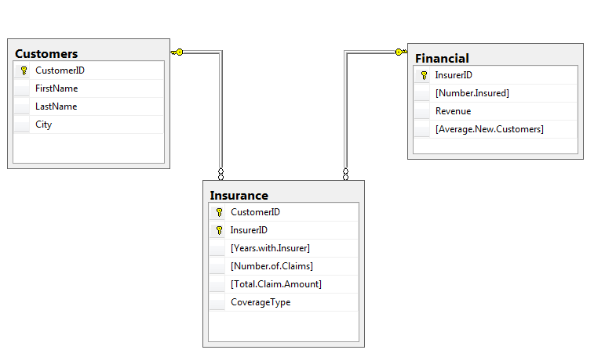

-------------------------------Question2

SELECT \*

FROM Customers

SELECT \*

FROM Insurance

SELECT \*

FROM Financial

--------------------------------Question3

SELECT \*

FROM Insurance

WHERE [Years.with.Insurer] > 15;

----------------------------------Question4

SELECT \*

FROM Insurance

WHERE [Number.of.Claims] > 4;

------------------------------------Question5

SELECT COUNT (DISTINCT CustomerID)

FROM Insurance

WHERE [Years.with.Insurer] > 15

SELECT COUNT (DISTINCT CustomerID)

FROM Insurance

WHERE [Years.with.Insurer] > 4

-----------------------------------------Question6

SELECT CustomerID

FROM Insurance

WHERE InsurerID = 3

--------------------------------------------Question7

SELECT DISTINCT Insurance.InsurerID

FROM Insurance

INNER JOIN Financial

ON Insurance.InsurerID = Financial.InsurerID

WHERE Financial.Revenue = (SELECT MAX (Financial.Revenue) FROM Financial)

SELECT DISTINCT Insurance.InsurerID

FROM Insurance

INNER JOIN Financial

ON Insurance.InsurerID = Financial.InsurerID

WHERE Financial.Revenue = (SELECT MIN (Financial.Revenue) FROM Financial)

-----------------------------------------------------------------------------------Question8

SELECT InsurerID , SUM ( [Total.Claim.Amount] ) AS 'Sum Of Total Claims'

FROM Insurance

GROUP BY InsurerID

--------------------------------------------------------------------------------------Question9

SELECT InsurerID , SUM ( [Number.of.Claims] ) AS 'Sum Of Number Of Claims'

FROM Insurance

GROUP BY InsurerID

----------------------------------------------------------------------------------------Question10

SELECT CoverageType , SUM ( [Total.Claim.Amount] ) AS 'Sum Of Total Claims'

FROM Insurance

GROUP BY CoverageType

SELECT CoverageType , SUM ( [Number.of.Claims] ) AS 'Sum Of Number Of Claims'

FROM Insurance

GROUP BY CoverageType

-----------------------------------------------------------------------------------------Question11

SELECT Customers.CustomerID , Customers.FirstName ,

Customers.LastName , Customers.City ,Insurance.[Years.with.Insurer]

FROM Customers

INNER JOIN Insurance

ON Customers.CustomerID = Insurance.InsurerID

WHERE Insurance.[Years.with.Insurer] > 15

-------------------------------------------------------------------------------------------Question12

SELECT Customers.CustomerID , Customers.FirstName ,

Insurance.[Number.of.Claims],Customers.LastName , Customers.City

FROM Customers

INNER JOIN Insurance

ON Customers.CustomerID = Insurance.InsurerID

WHERE Insurance.[Number.of.Claims] > 4

--------------------------------------------------------------------------------Question13

SELECT \*

FROM Customers

INNER JOIN Insurance

ON Customers.CustomerID = Insurance.InsurerID

WHERE Customers.FirstName LIKE 'T%' OR Customers.FirstName LIKE 'R%';