CS 356 Homework Assignments for Fall 2015.

All problems are from the textbook, and you can find information in the referenced chapter on how to do the assignment. However, the solutions manual is widely available on the Web, so I have changed the data in each assignment.

**Chapter 1 Computer Networks and Internet**

**Homework 1**

1. Propagation Delay and Transmission Delay. Consider two hosts, A and B, connected by a link of rate ***R*** bps. Suppose that the two hosts are separated by ***m*** meters, and suppose the propagation speed along the link is ***s*** meters per second. Host A sends a packet of ***L*** bits to Host B.
2. Express the propagation delay, ***dprop***, in terms of m and s.
3. Determine the transmission time of the packet, ***dtrans***, in terms of ***L*** and ***R***.
4. Ignoring processing and queuing delags, obtain an expression for the end-to-end delay.
5. If host A begins to transmit at time t = 0. At time ***dtrans***, where is the last bit of the packet?
6. Suppose ***dprop*** is greater than ***dtrans.*** At time = ***dtrans***, where is the first bit of the packet?
7. Suppose ***dprop*** is less than ***dtrans.*** At time = ***dtrans***, where is the first bit of the packet?
8. Suppose ***s*** = 200,000,000, ***L*** = 220 bits, and ***R*** = 56 kbps. Find a distance ***m*** so that ***dprop*** equals ***dtrans***.
9. We are sending real-time voice from Host A to Host B over a packet switched network (VoIP) Host A converts analog voice into a digital 64 kbps bit stream on the fly. Host A then groups the bits into 56-byte packets. There is one link between Host A and B. Its transmission rate is 1 Mbps and its propagation delay is 10 msec. As soon as Host A gathers a packet, it sends it to host B. As soon as Host B receives an entire packet, it converts the packets bits into an analog signal. How much time elapses from the time a bit is created (from the original signal at Host A) until the bit is decoded (as part of the analog signal at Host B)?

**Chapter 2 Application Layer**

**Homework 2**

1. Consider the bottlenecked network in Figure 2.12 in the text with the access speed of 15 Mbps on the access link and 100 Mbps on the LAN. Suppose that the average object size is 100,000 bytes (convert to bits) and that the average request rate from the institution’s browsers to the origin servers is 15 requests per second. Also suppose that the average amount of time it takes from when the router on the Internet side of the access link forwards an HTTP request until it receives the response is 3 seconds (See Sec 2.2.5 in text). Model the total average response time as the sum of the average access delay (from Internet Router to Institution Router) and the average Internet delay. Assume ***d*** = average time required to send an object over the access link and ***a*** = the arrival rate of objects to the access link. Compute ***d*** /(1 – (***d*** * ***a***))
2. Find the total average response time
3. Now suppose a cache is installed in the institutional LAN. Suppose the miss rate is 0.45. Find the total response time.

Homework 3

1. Consider distributing a file of ***F*** = 20 Gbits to ***N*** peers. The server has an upload rate of ***us*** = 40 Mbps, and each peer has a download rate of ***di*** = 2 Mbps and an upload rate of ***uc***. For N = 10, 100, and 1000 and u = 500 Kbps and 2 Mbps, prepare a chart giving the minimum distribution time for each of the combinations of N and u for both client-server and peer-to-peer distribution.

**Chapter 3 Transport Layer**

**Homework 4** (Show all work)

1. UDP and TCP use 1s complement for their checksums. Suppose you have the following 3 8-bit bytes. 11011010, 10101000, 11011011. What is the 1s complement of the sum of these 8-bit bytes?
2. Compute the 1s complement of the sum of 10111011 and 11001100.
3. Compute the 1s complement of the sum of 10111011 and 00110101.
4. Compute the 1s complement of the sum of 11110011 and 11000001.
5. Is it possible that a 1 bit error will go undetected with a 1s complement checksum?
6. Give an example of 2 separate 1 bit errors that will not be detected with a 1s complement checksum.

**Chapter 4 Network Layer**

**Homework 5**

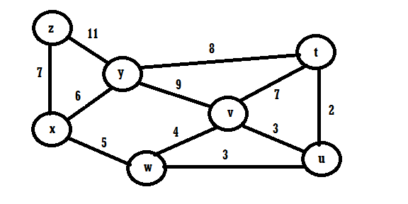

Use Dijkstra’s shortest-path algorithm on the network above to:

1. Compute the shortest path from node t to all nodes.
2. Compute the shortest path from node u to all nodes.
3. Compute the shortest path from node v to all nodes.
4. Compute the shortest path from node w to all nodes.
5. Compute the shortest path from node x to all nodes.
6. Compute the shortest path from node y to all nodes.
7. Compute the shortest path from node z to all nodes.

**Homework 6**

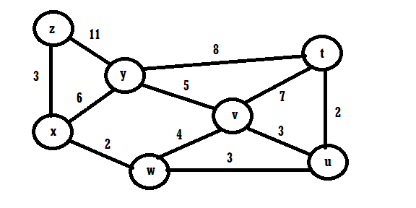

Use the Bellman–Ford Distance Vector algorithm on the network above to:

1. Compute the shortest path from node u to all nodes.
2. Compute the shortest path from node w to all nodes.
3. Compute the shortest path from node z to all nodes.
4. Suppose all the links in the diagram above have unit cost (cost of 1) and the broadcast source is node w. Consider the operation of the Reverse Path Forwarding (RPF) algorithm in Figure 4.44. Using arrows like those shown in that figure indicate links over which packets will and will not be forwarded.

**Chapter 5 Link Layer**

**Homework 7**

Internet Cyclic Redundancy Check: Consider the 5-bit generator, G=10011.

1. If D has the value 10010101101, what is the value of R?
2. If D has the value 10101101010, what is the value of R?
3. If D has the value 0011001101, what is the value of R?
4. If D has the value 1101100100, what is the value of R?

**Homework 8**

Suppose nodes A and B are on opposite ends of a 1000 meter cable, and they each have one frame of 1,500 bits (including all headers and preambles) to send to each other. Both nodes attempt to transmit at time t = 0. Suppose there are three repeaters between A and B, each inserting a 20 bit delay. Assume a transmission rate of 100 Mbps and CSMA/CD with backoff intervals of multiples of 512 bits is used. After the first collision, A draws K = 0 and B draws K = 1 in the exponential backoff protocol. Ignore the Jam signal and the 96 bit time delay.

1. What is the one-way propagation delay (including repeater delays) between A and B in seconds? (Assume a propagation speed of 2*108 meters/second)
2. At what time (in seconds) is A’s packet completely delivered at B?
3. Now suppose that only A has a packet to send and the repeaters are replaced with switches. Suppose that each switch has a 20-bit processing delay in addition to a store and forward delay. At what time, in seconds, is A’s packet fully delivered at B?