**Tevin Jeffrey**

**Chapter 4 Network Layer**

**Homework 5**

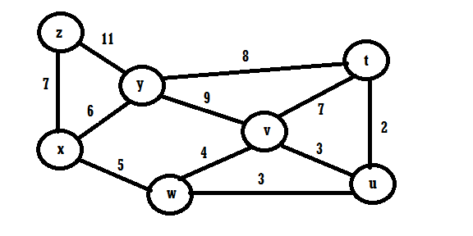

Use Dijkstra’s shortest-path algorithm on the network above to:

1. Compute the shortest path from node t to all nodes.
2. Compute the shortest path from node u to all nodes.
3. Compute the shortest path from node v to all nodes.
4. Compute the shortest path from node w to all nodes.
5. Compute the shortest path from node x to all nodes.
6. Compute the shortest path from node y to all nodes.
7. Compute the shortest path from node z to all nodes.