**Tevin Jeffrey**

**Wireshark Lab 5**

**1. What is the IP address and TCP port number used by the client computer (source) that is transferring the file to gaia.cs.umass.edu?**

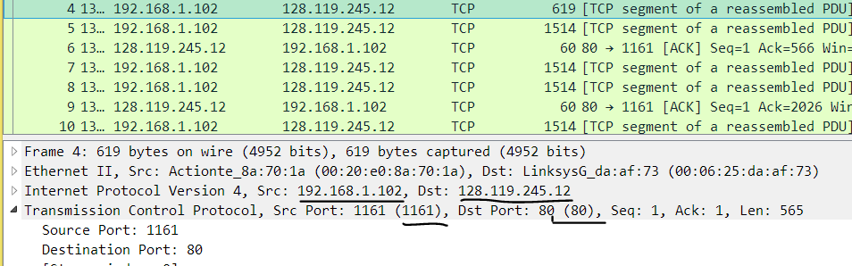

The source IP is 192.168.0.102 and the port is 1161

**2. What is the IP address of gaia.cs.umass.edu? On what port number is it sending and receiving TCP segments for this connection?**

The IP address of gaia.cs.umass.edu is 128.119.245.12 and the port is 80

**3. What is the IP address and TCP port number used by your client computer (source) to transfer the file to gaia.cs.umass.edu?**

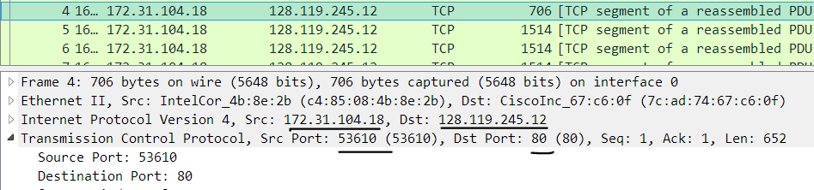

The IP address used by my computer is 172.31.104.118 and the port used is 53610

**4. What is the sequence number of the TCP SYN segment that is used to initiate the TCP connection between the client computer and gaia.cs.umass.edu? What is it in the segment that identifies the segment as a SYN segment?**

The [relative] sequence number used to initiate the TCP connection is 0.

This TCP packet is identified and SYN packet because the SYN bit flag is 1.

**5. What is the sequence number of the SYNACK segment sent by gaia.cs.umass.edu to the client computer in reply to the SYN? What is the value of the ACKnowledgement field in the SYNACK segment? How did gaia.cs.umass.edu determine that value? What is it in the segment that identifies the segment as a SYNACK segment?**

The sequence number of the SYNACK segment is 0.

The acknowledgement number of the segment is 1. The server determined this number by incrementing the segment number of the SYN packet by one.

This packet is identified as a SYN-ACK packet because the SYN and ACK flag bits are 1.

**6. What is the sequence number of the TCP segment containing the HTTP POST command?**

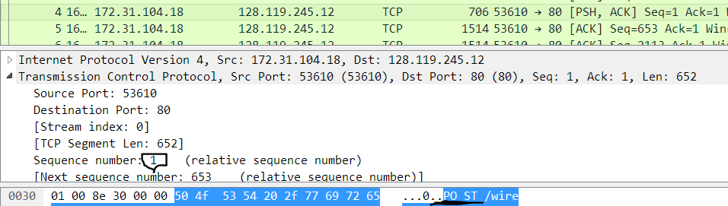

The sequence number of the packet containing the POST request is 1.

**7. Consider the TCP segment containing the HTTP POST as the first segment in the TCP connection. What are the sequence numbers of the first six segments in the TCP connection (including the segment containing the HTTP POST)? At what time was each segment sent? When was the ACK for each segment received? Given the difference between when each TCP segment was sent, and when its acknowledgement was received, what is the RTT value for each of the six segments?**

**8. What is the length of each of the first six TCP segments?**

|  |  |  |  |  |  |  |
| --- | --- | --- | --- | --- | --- | --- |
|  | Sequence# | Length | Time sent | Time ACK received | RTT (seconds) | EstRTT |
| Packet 1 | 1 | 652 | 16:38:19.767523 | 16:38:19.809804 | 0.042281 | 0.042281 |
| Packet 2 | 653 | 1460 | 16:38:19.767774 | 16:38:19.809972 | 0.042198 | 0.042271 |
| Packet 3 | 2113 | 1460 | 16:38:19.767782 | 16:38:19.809972 | 0.042190 | 0.079257 |
| Packet 4 | 3573 | 1460 | 16:38:19.767787 | 16:38:19.809972 | 0.042185 | 0.148606 |
| Packet 5 | 5033 | 1460 | 16:38:19.809856 | 16:38:19.853743 | 0.043887 | 0.278849 |
| Packet 6 | 6473 | 1460 | 16:38:19.810011 | 16:38:19.854889 | 0.044878 | 0.522966 |

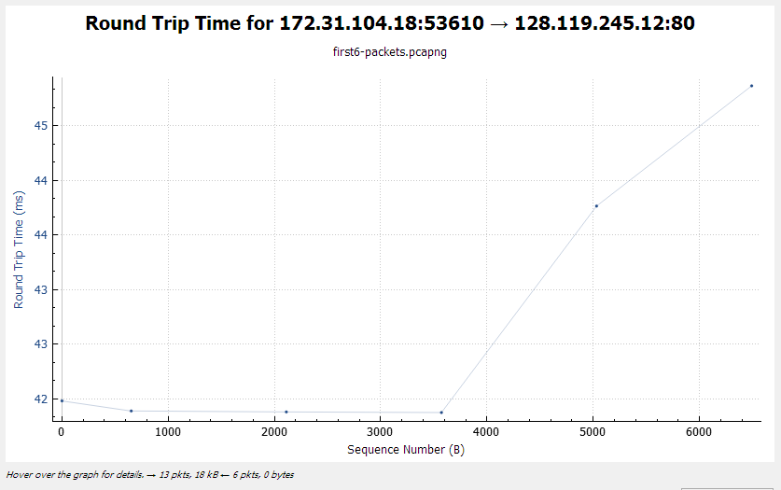

**9. What is the minimum amount of available buffer space advertised at the received for the entire trace? Does the lack of receiver buffer space ever throttle the sender?**

The minimum amount of available buffer space advertised is 256. Yes, when the buffer is too small.

**10. Are there any retransmitted segments in the trace file? What did you check for (in the trace) in order to answer this question?**

No, packet the need to be retransmitted if they don’t receive an ACK within a determined timeout interval.

**11. How much data does the receiver typically acknowledge in an ACK? Can you identify cases where the receiver is ACKing every other received segment (see Table 3.2 on page 257 in the text).**

The receiver is acknowledge just about the length of the received packet which in most areas is 1460

**12. What is the throughput (bytes transferred per unit time) for the TCP connection? Explain how you calculated this value.**

The throughput is about 1460 bytes per unit time. I calculated it length of every TCP packet.

13. Use the Time-Sequence-Graph(Stevens) plotting tool to view the sequence number versus time plot of segments being sent from the client to the gaia.cs.umass.edu server. Can you identify where TCP’s slowstart phase begins and ends, and where congestion avoidance takes over? Comment on ways in which the measured data differs from the idealized behavior of TCP that we’ve studied in the text.

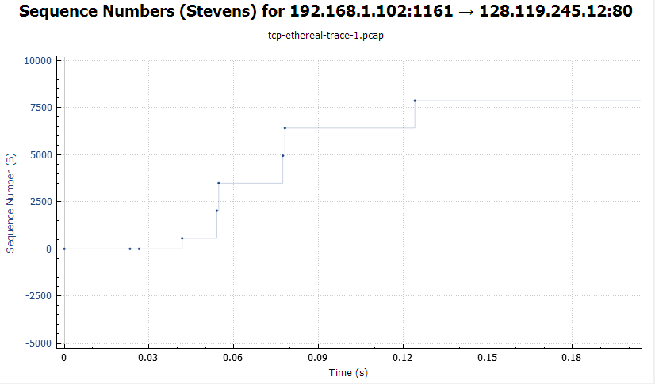

14. Answer each of two questions above for the trace that you have gathered when you transferred a file from your computer to gaia.cs.umass.edu

