Stage 1

Intro to Networking

Tevin Jeffrey

[Year]

Client compiling and running:

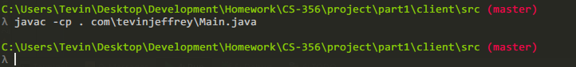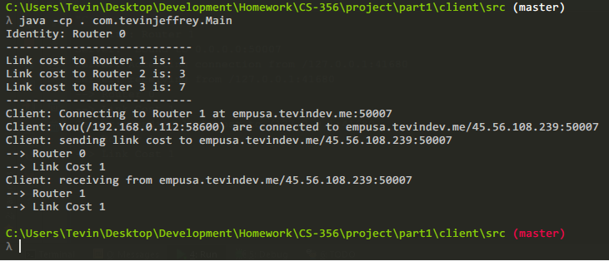

Server compiling and running:

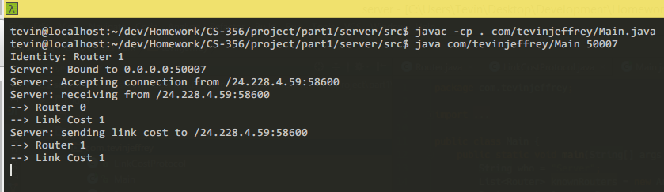

The following is the text output from the terminal of the client and server if these photos are not clear enough.

// Client on home network with Public IP 24.228.4.59 and LAN IP 192.168.0.112

C:\Users\Tevin\Desktop\Development\Homework\CS-356\project\part1\client\src (master)

λ java -cp . com.tevinjeffrey.Main

Identity: Router 0

----------------------------

Link cost to Router 1 is: 1

Link cost to Router 2 is: 3

Link cost to Router 3 is: 7

----------------------------

Client: Connecting to Router 1 at empusa.tevindev.me:50007

Client: You(/192.168.0.112:58600) are connected to empusa.tevindev.me/45.56.108.239:50007

Client: sending link cost to empusa.tevindev.me/45.56.108.239:50007

--> Router 0

--> Link Cost 1

Client: receiving from empusa.tevindev.me/45.56.108.239:50007

--> Router 1

--> Link Cost 1

// Remote Server (empusa.tevindev.me) at 45..56.108.239

tevin@localhost:~/dev/Homework/CS-356/project/part1/server/src$ javac -cp . com/tevinjeffrey/Main.java

tevin@localhost:~/dev/Homework/CS-356/project/part1/server/src$ java com/tevinjeffrey/Main 50007

Identity: Router 1

Server: Bound to 0.0.0.0:50007

Server: Accepting connection from /24.228.4.59:58600

Server: receiving from /24.228.4.59:58600

--> Router 0

--> Link Cost 1

Server: sending link cost to /24.228.4.59:58600

--> Router 1

--> Link Cost 1