**Tevin Jeffrey CS 388: Android Application Development**

**Java Applet** is a small java program compiled to bytecode and executed within the Java Virtual Machine. They can be embedded within a web browser.

import java.applet.*;

import java.awt.*;

public class Main extends Applet{

public void paint(Graphics g){

g.drawString("Welcome in Java Applet.",40,20);

}

}

<HTML>

<HEAD>

</HEAD>

<BODY>

<div >

<APPLET CODE="Main.class" WIDTH="800" HEIGHT="500">

</APPLET>

</div>

</BODY>

</HTML>

The above code will produce this:

Welcome in Java Applet.

**Java Program** is compiled java file with a main method. Usually executed with the command ‘java progName’ in the command line.

public class Program{  
 public static void main(String[] args) {

System.out.println(“Hello World”);

}

}

$ javac Program.java

$ java Program

Hello World

**JavaScript** is a programming language for the web, usually coupled with HTML and CSS.

My personal website (blog.tevindev.me) is an example of a pure HTML CSS JS website.

**AngularJS** aims to extend the HTML by allowing custom HTML tag attributes and provides other extension to allow robust single page websites when data is dynamically loaded.

Netflix and Wikipedia are examples of and AngularJS websites.

A company like Google or Goldman Sachs will choose one other the other depending on the the maturity of the software. This includes the execution speed of the of the program, reliability and security. Java Applets are notorious for its security vulnerably in the browser. Google for example have move more towards JS websites, going so far as to develop their own JS framework and engine (V8).

**How to install Eclipse**

To download Eclipse, goto <https://eclipse.org/downloads/>

Choose you operating system and click Downlaod

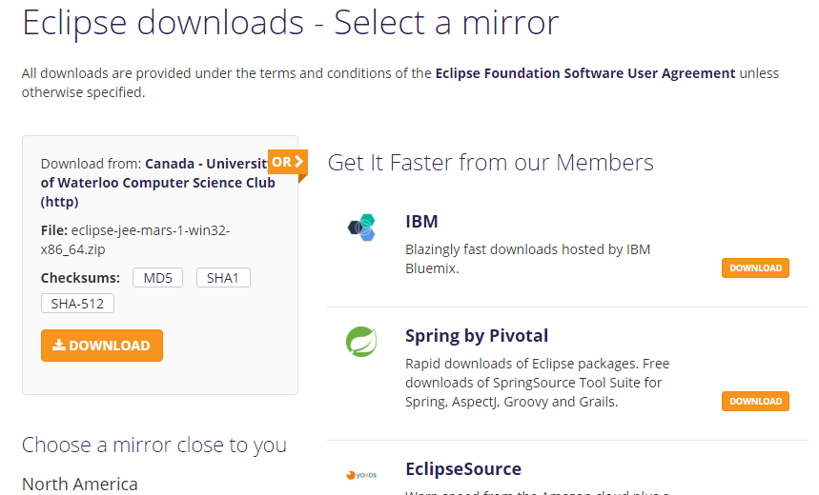

Once the archive is downloaded, extract the containing files.

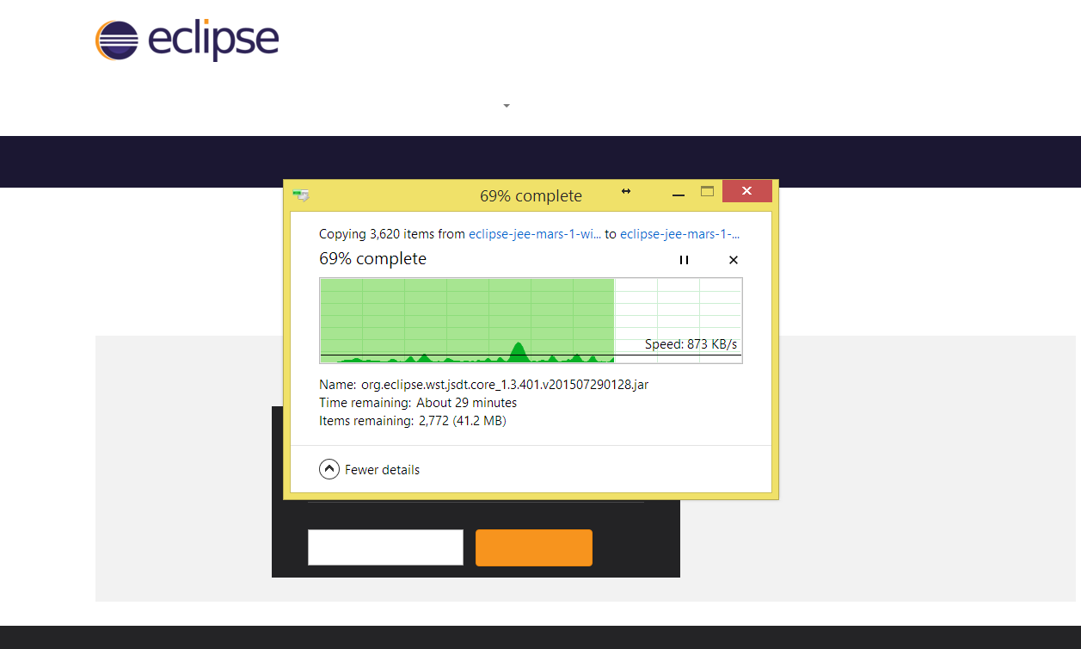

Once extraction is complete execute the eclipse.exe file to launch the program. Congrats you now have Eclipse.

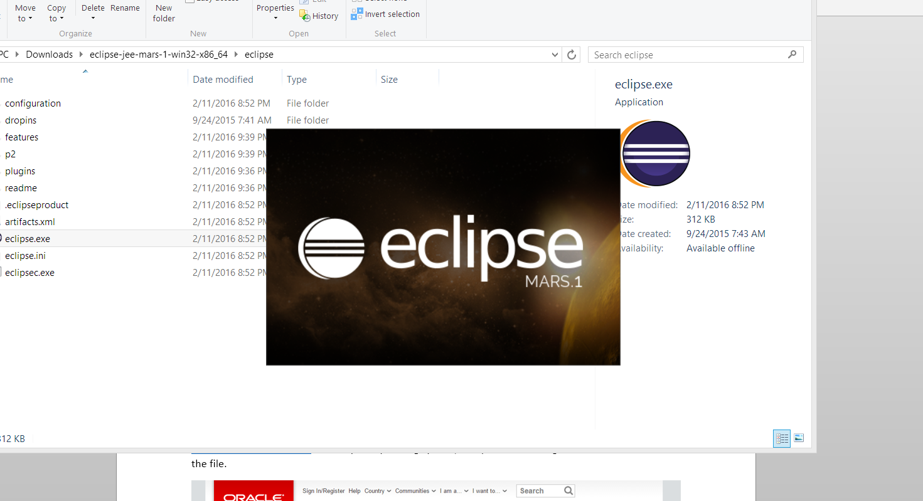

**How to install Java Development Kit (JDK)**

To download the JDK goto <http://www.oracle.com/technetwork/java/javase/downloads/jdk8-downloads-2133151.html> choose your operating system, accept the license agreement and download the file.

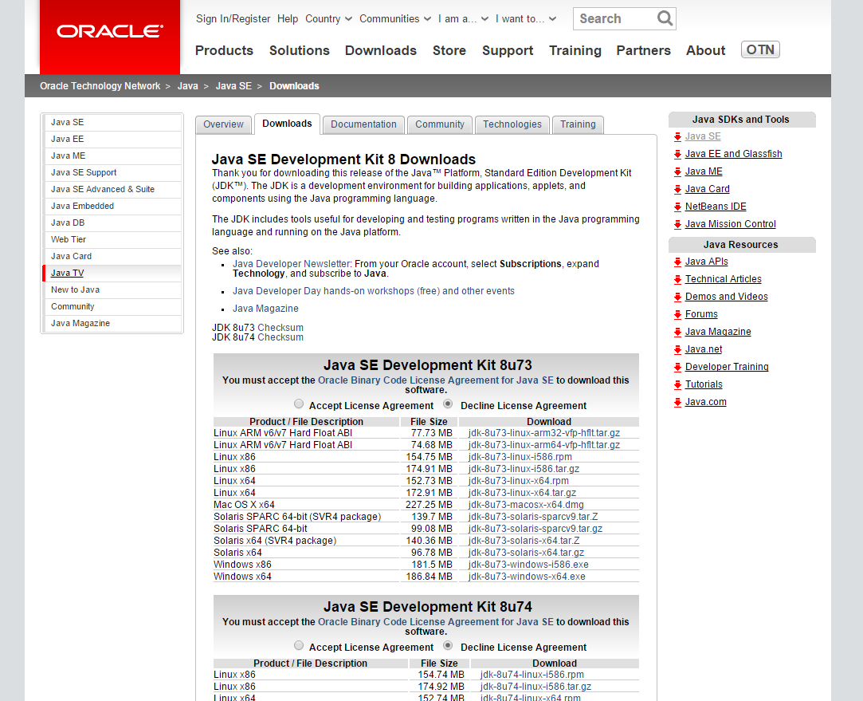

Once downloaded, execute the executable file to install the JDK.

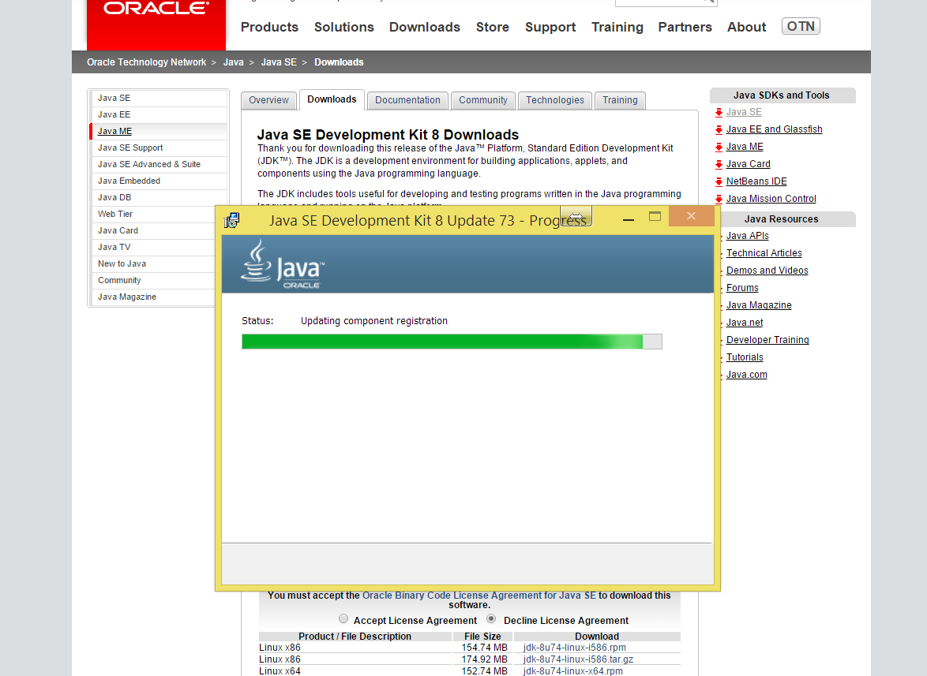

Once installation is complete find the install location and copy the location of the /bin directory. In my case it was located at C:\Program Files\Java\jre1.8.0_40\bin. Once found open control panel and search system environment variable. Add the URL to your PATH variable.

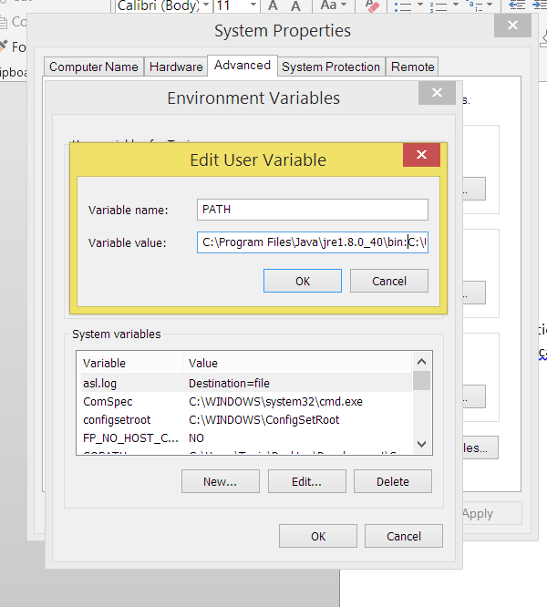

Now can compile and execute Java programs. Open command prompt and run the command

*java –showversion*

