Tevin Jeffrey

CS 388 HW 2

**b. How Figure H.4 works?**

Figure H.4 demonstrates how the retrieve information from an Exception. By calling getStacktrace() on an exception, you can get a list of methods that were called leading up to the exception, including line numbers, the file name and the method name.

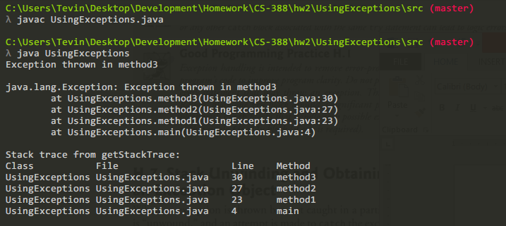e.

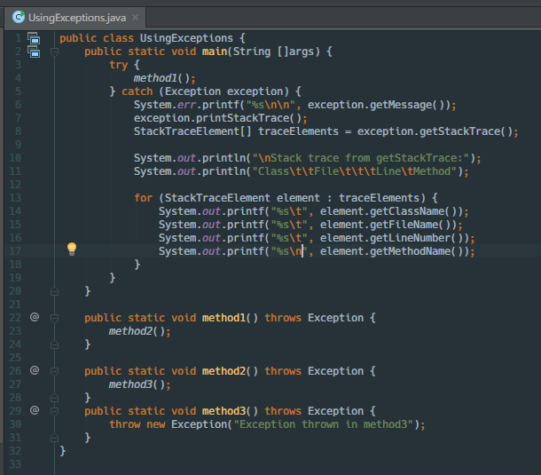

Figure H.4

**How figure I.8 works?**

This the applet loads named files/images from it’s classpath, the combobox frame. The combo bow is a drop down that contains the list of images. A listener is added to the comboboxx, when an item is selected the listener fires and the corresponding image for the item is loaded into a JLabel.

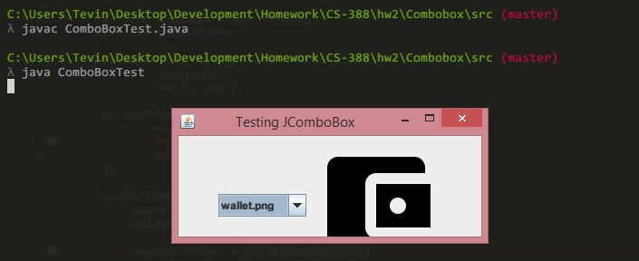

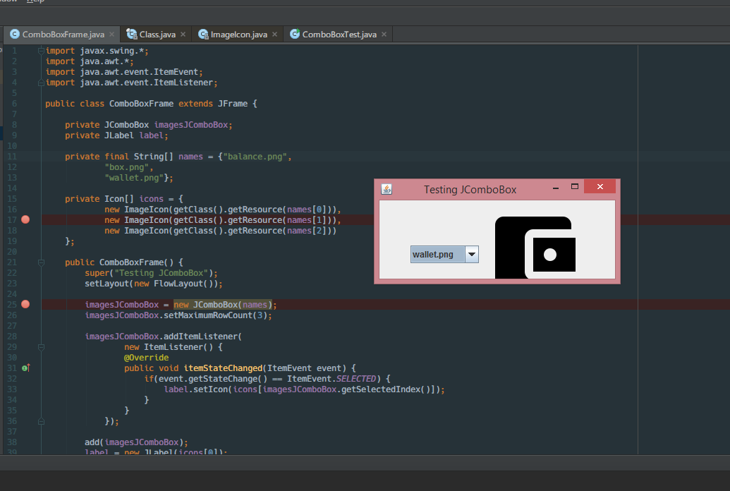

figure I.8

**How figure J.13 works?**

The PrintTask class implement Runnable which contains a single method run() This method sleeps the current tread for a random about of time between 1ms and 5 seconds then prints the how long the thread was asleep for. The TaskExecutor class creates 4 PrintTask objects which are then executed by a executor service.

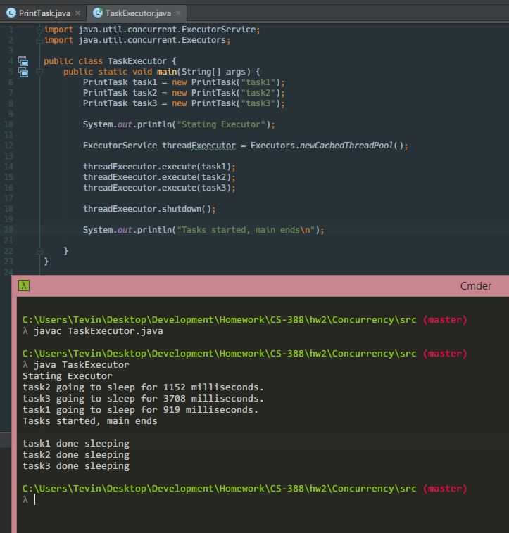

**Name Android Software Development Kit (SDK) all versions, name, features**

|  |  |  |  |
| --- | --- | --- | --- |
|  |  |  |  |
| [Cupcake](https://en.wikipedia.org/wiki/Android_Cupcake) | 1.5 | 3 | **Animated screen transitions, Video recording and playback, Bluetooth stereo support** |
| [Donut](https://en.wikipedia.org/wiki/Android_Donut) | 1.6 | 4 | Multi-lingual speech synthesis engine, support for WVGA resolutions, new GestureBuilder development tool |
| [Eclair](https://en.wikipedia.org/wiki/Android_Eclair) | 2.0–2.1 | 5–7 | Bluetooth 2.1 support, Microsoft Exchange email support, Optimized hardware speed and revamped UI, Support for more screen sizes and resolutions, with better contrast ratio, Improved Google Maps 3.1.2, MotionEvent class enhanced to track multi-touch events, Addition of live wallpapers |
| [Froyo](https://en.wikipedia.org/wiki/Android_Froyo) | 2.2–2.2.3 | 8 | Support for installing applications to the expandable memory, Adobe Flash support, Support for high-PPI displays (up to 320 ppi), such as four-inch 720p screen, USB tethering and Wi-Fi hotspot functionalit |
| [Gingerbread](https://en.wikipedia.org/wiki/Android_Gingerbread) | 2.3–2.3.7 | 9–10 | Concurrent garbage collection for increased performance  Support for WebM/VP8 video playback, and AAC audio encoding  Improved power management with a more active role in managing applications that are keeping the device awake for too long  Enhanced copy/paste functionality, allowing users to select a word by press-hold, copy, and paste |
| [Honeycomb](https://en.wikipedia.org/wiki/Android_Honeycomb) | 3.0–3.2.6 | 11–13 | Optimized tablet support with a new “holographic” user interface, Added System Bar, featuring quick access to notifications, status, and soft navigation buttons, available at the bottom of the screen, Added Action Bar, giving access to contextual options, navigation, widgets, or other types of content at the top of the screen, Simplified multitasking |
| [Ice Cream Sandwich](https://en.wikipedia.org/wiki/Android_Ice_Cream_Sandwich) | 4.0–4.0.4 | 14–15 | Major refinements to the "Holo" interface with new Roboto font family  Soft buttons from Android 3.x are now available for use on phones, Separation of widgets in a new tab, listed in a similar manner to applications, Easier-to-create folders, with a drag-and-drop style, Improved visual voicemail with the ability to speed up or slow down voicemail messages, Pinch-to-zoom functionality in the calendar, Integrated screenshot capture (accomplished by holding down the Power and Volume-Down buttons), Improved error correction on the keyboard, Ability to access applications directly from lock screen, Improved copy and paste functionality |
| [Jelly Bean](https://en.wikipedia.org/wiki/Android_Jelly_Bean) | 4.1–4.3.1 | 16–18 | Bluetooth low energy support, Bluetooth Audio/Video Remote Control Profile (AVRCP) 1.3 support, OpenGL ES 3.0 support, allowing for improved game graphics, SELinux, Premium SMS confirmation, Group Messaging, Native right-to-left, always-on VPN and application verification. A new NFC stack was added at the same time, SELinux enabled by default, 4K resolution support, Added support for five more languages, Changed digital rights management (DRM) APIs, Right-to-left (RTL) languages now supported, Clock in the status bar disappears if clock is selected as lockscreen widget, Native emoji support |
| [KitKat](https://en.wikipedia.org/wiki/Android_KitKat) | 4.4–4.4.4, 4.4W–4.4W.2 | 19–20 | Native infrared blaster API, Verified boot, Enforcing SELinux, Expanded accessibility APIs and system-level closed captioning settings, Android Runtime (ART) introduced as a new experimental application runtime environment, not enabled by default, as a replacement for the Dalvik virtual machine, Bluetooth Message Access Profile |
| [Lollipop](https://en.wikipedia.org/wiki/Android_Lollipop) | 5.0–5.1.1 | 21–22 | Android Runtime (ART) with ahead-of-time (AOT) compilation and improved garbage collection (GC), replacing Dalvik that combines bytecode interpretation with trace-based just-in-time (JIT) compilation. Support for 64-bit CPU, OpenGL ES 3.1 and Android Extension Pack (AEP) on supported GPU configurations, Recent activities screen with tasks instead of applications, up to a configured maximum of tasks per application, Vector drawables, which scale without losing definition, Support for print previews, Material design, bringing a restyled user interface, Refreshed lock screen, no longer supporting widgets,Refreshed notification tray and quick settings pull-down, Project Volta, for battery life improvements |
| [Marshmallow](https://en.wikipedia.org/wiki/Android_Marshmallow) | 6.0–6.0.1 | 23 | Google "Now on Tap" feature, Introduction of Doze mode, which reduces CPU speed while the screen is off in order to save battery life, App Standby feature, Alphabetically accessible vertical application drawer, Application search bar and favorites, Native fingerprint reader support, Direct Share feature for target-specific sharing between apps, Renamed "Priority" mode to "Do Not Disturb" mode, App Linking for faster instinctive opening of links with corresponding applications, Larger Application folders with multiple pages, Post-install/run-time permission requests, USB Type-C support, Demo Mode feature for screenshot-capture usage, Automatic full data backup and restore for apps, 4K display mode for apps, Adoptable External storage to behave like Internal Storage, MIDI support for musical instruments, Experimental multi-window feature, App permissions reintroduced |

**What is Android Studio? Why do you need this for apps development?**

Android Studio is an integrated development environment (IDE) use for writing a code that will be built and packaged for android devices. We need Android Studio for apps development because it comes built in with the tools needed for developing android applications. This includes the build tools that go through the many steps needs for properly assembling the executable for installation on android devices. These steps would include packaging images used in the app, compiling your code to work to a variety of processor types and signing the final executable so that devices can trust the final executable.