Tevin Jeffrey

CS 388 HW 3

1. How Chapter 3 Tip Calculator App works, pps 70-92

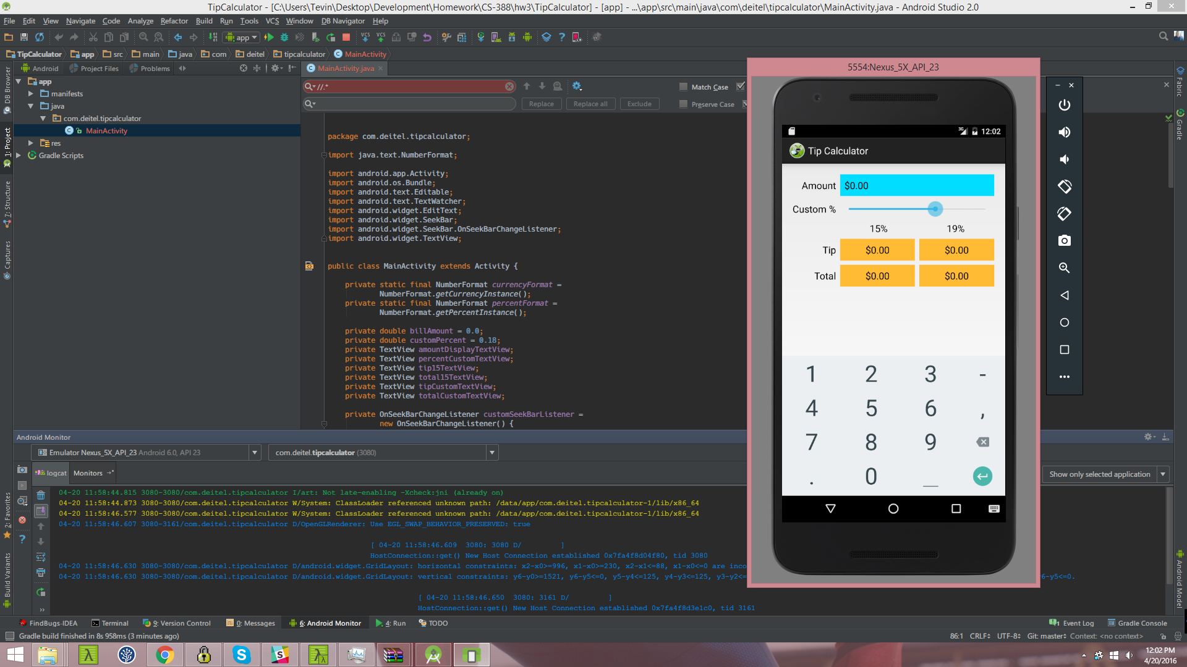

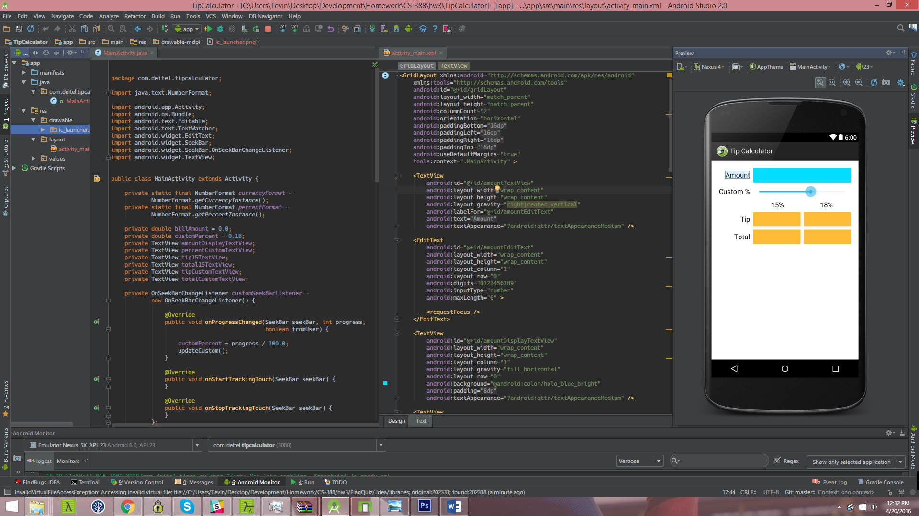

The app starts with a call to OnCreate which instantiates some references to View to be later used. We also attach an *onTextchangeListener* to an EditText and an *onSeekBarChangeListener* to a SeekBar. There are two method that do most of the controlling on of the on screen text. *updateStandard* and *updateCustom*. *UpdateStandard* calculates a tip base on 15% and sets the text accordingly to the textviews. *UpdateCustom* calculates the tip based on the value percentage of of the seekbar and then sets the textviews accordingly.

1. How Flag Quiz App works., pps 137-177

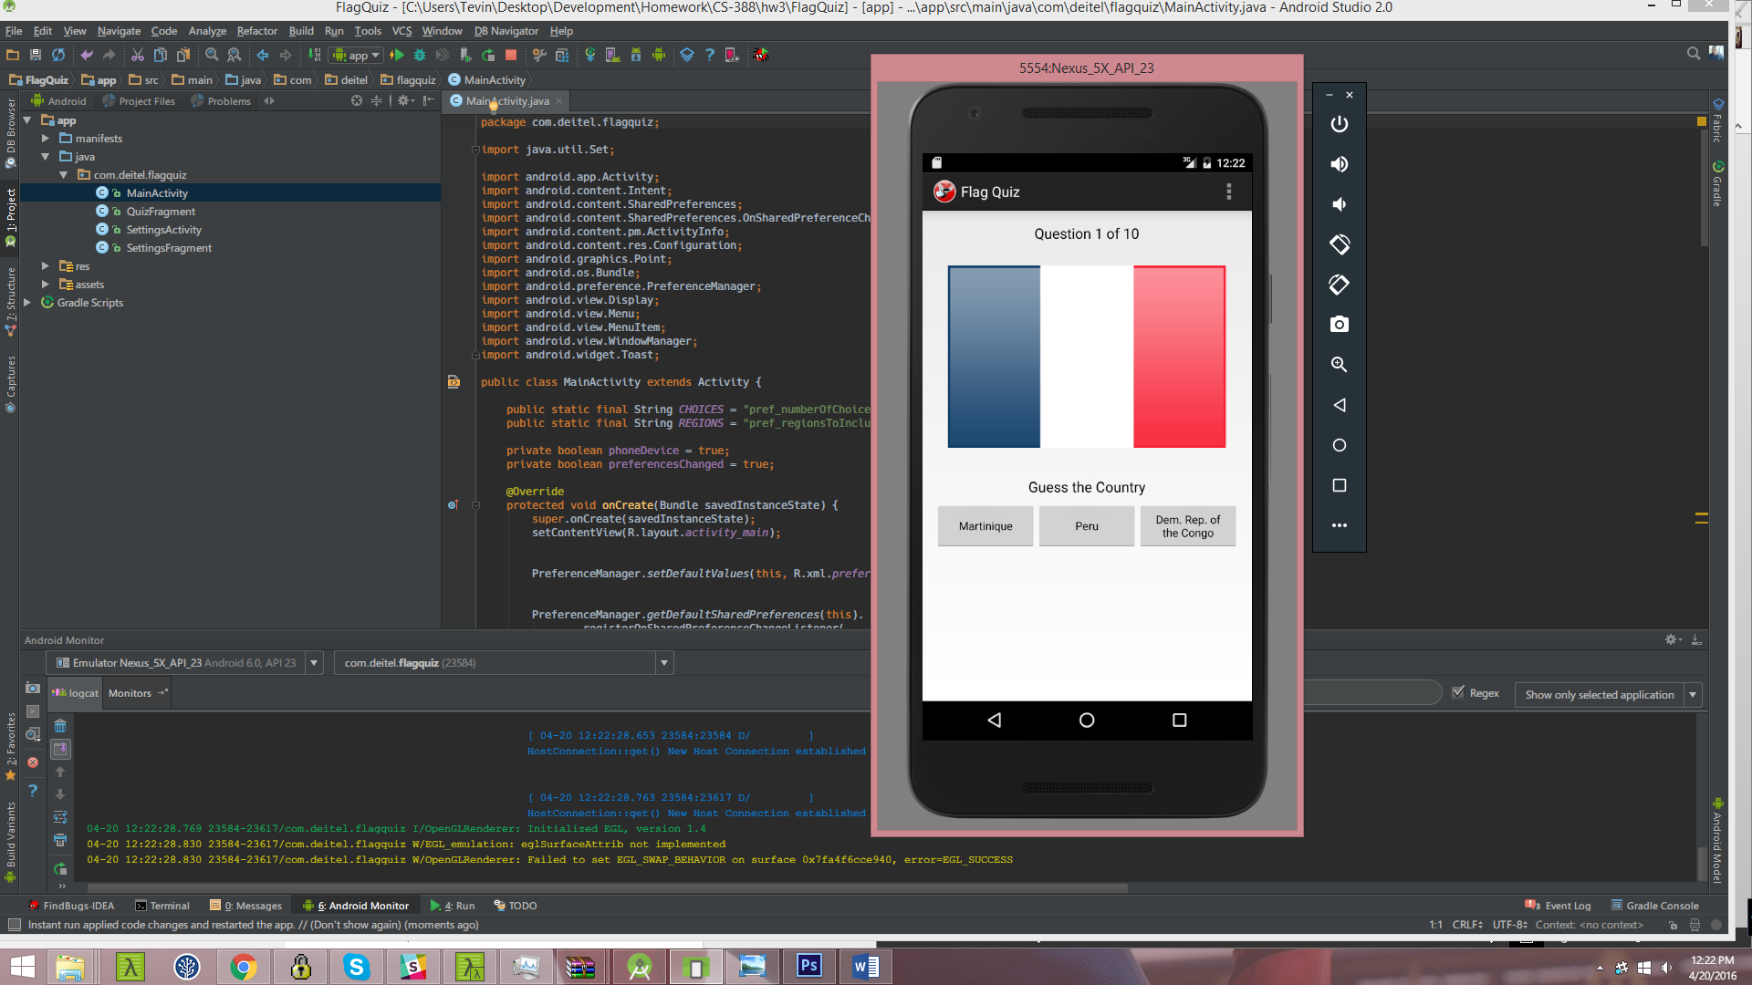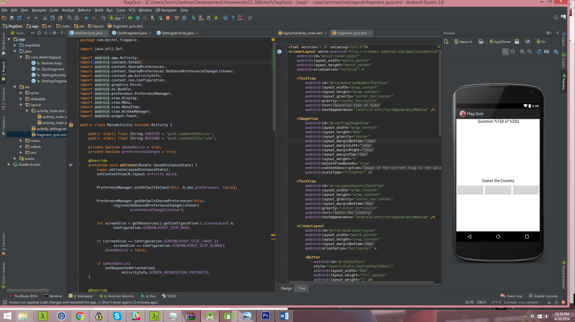

The app starts with a call to on Create and sets the default values to the Preferences to the Preference Manager, then registers an on *preferencechange* listener. The listener listens for changes in the settings for the different continent options with the game as well the default number of guess each flag gets. We then determine if the device is phone or a tablet and the screen orientation accordingly. When onStart is called, we start the *QuizFragment* which begins a new game.

*QuizFragment* is where the game login and the majority of the UI of the game lives. In *onCreateView* it first loads the shake animation that's used for incorrect answers then get references to GUI components. It configures listeners for the guess Buttons. *UpdateGuessRows*, update guessRows based on value in SharedPreferences. *UpdateRegions* updates world regions for quiz based on values in *SharedPreferences*. resetQuiz sets up and starts the next quiz. It uses *AssetManager* to get image file names for enabled regions and adds random flag names for guesses then loads the nextFlag. *loadNextFlag* is called after the user guesses a correct flag, which then loads the next flag. *getcountryName* parses the country flag file name and returns the country name. *guessButtonListener* is called when a guess Button is touched and will start a dialogfragment to display quiz stats and start new quiz when a game finishes. *disableButtons* is a utility method that disables all answer Buttons.

e. How Chapter 7 Doodlz App works, pps 216, 256

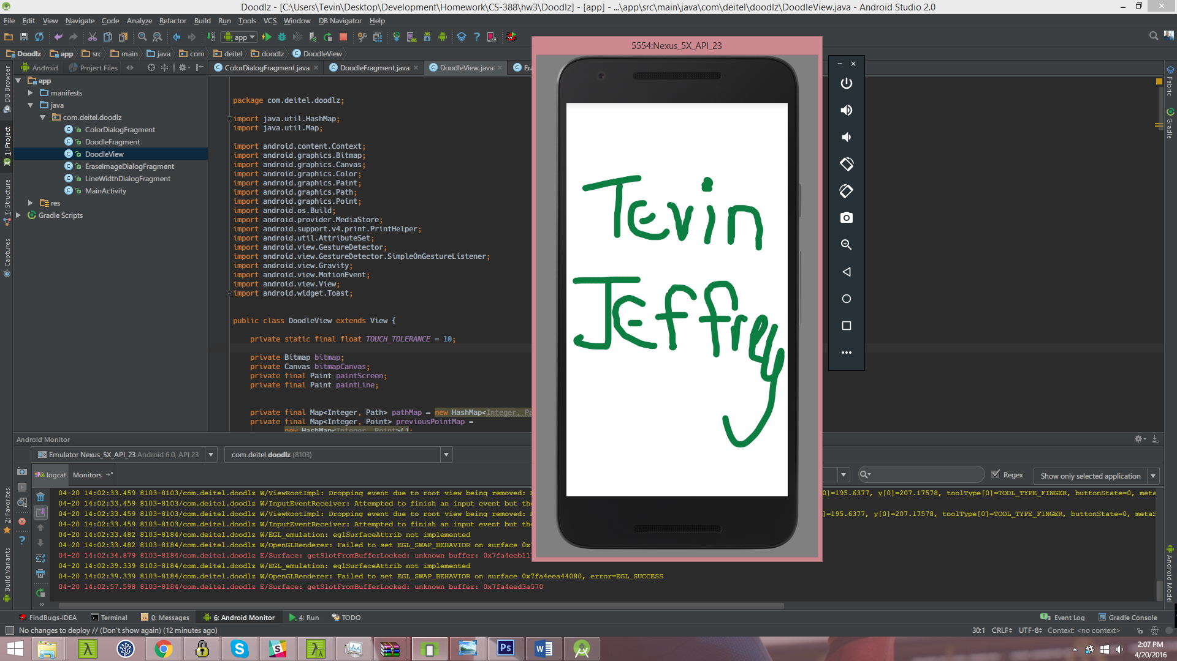

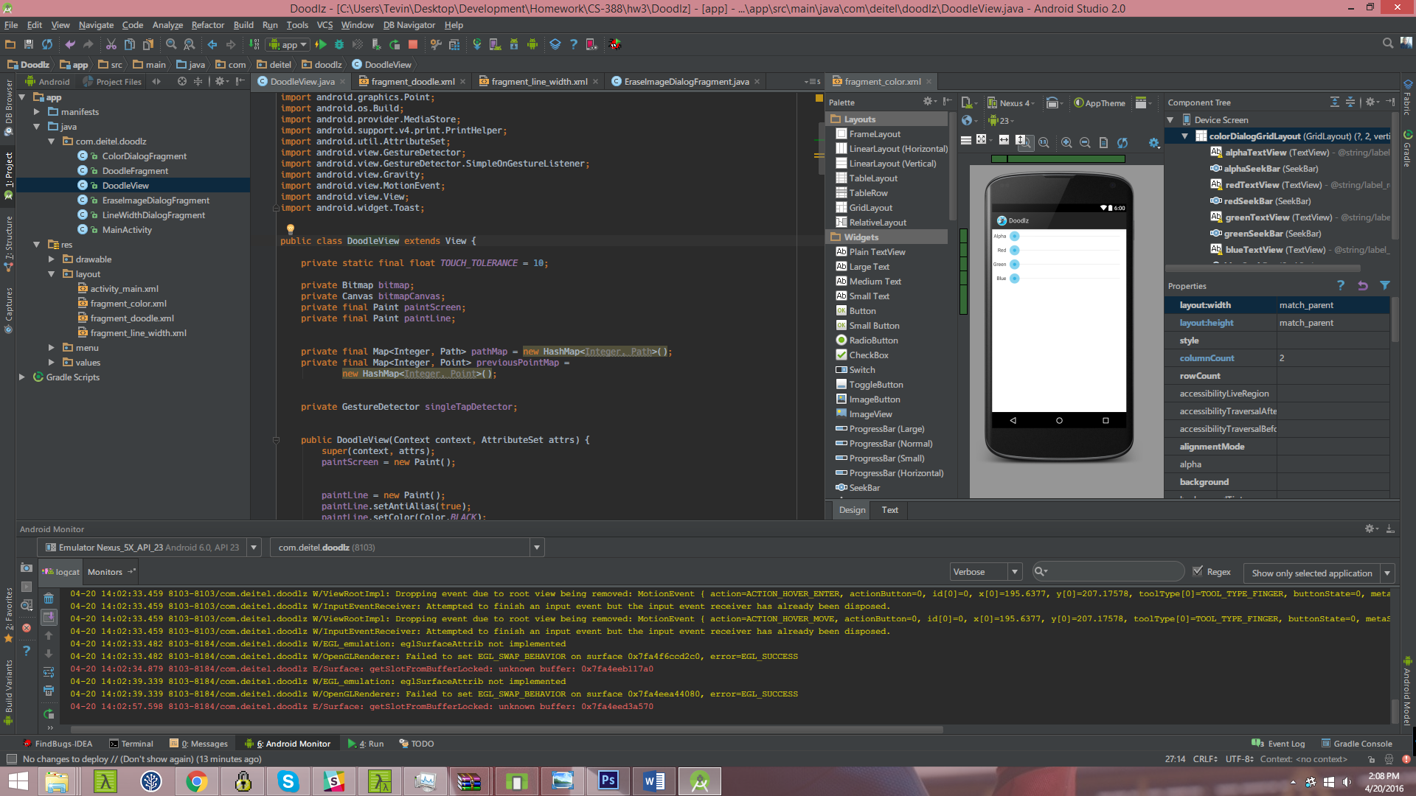

The core of the Doodlz app is a custom view **DoodleView** that extends the View class. This the the view used to paint to the screen. It contains fields for drawing area for display or saving, a canvas to draw on bitmap and two Paints to draw bitmap onto screen and to draw lines onto bitmap. It also contains two maps to hold current Paths being drawn and Points in those Paths. When the view is initialized, it sets the default values to black, solid stroke and default paintline to 5. It contains a method onSizeChanged creates Bitmap and Canvas after app displays. As well as others to set and get the painted line's color and width. onDraw is called 60 times a second called each time this View is drawn. It loops over the maps of paths an redraws them everytime. This class also contains a SimpleOnGestureListener for single tap events to show and hide the status bars. touchStarted is called when the user touches the screen and draws those point those points as the user’s finger moves up and down off the screen.

LineWidthDialogFragment is dialog that pops up to ask the user to choose their desired line width for drawing. I actually uses the DoodleView to give the user a preview of how the line width will look.

ColorDialogFragment is a dialog that pops up to ask the user to choose what color they’d like to use and paints a preview based on the ARGB values choosen from a SeekBar.