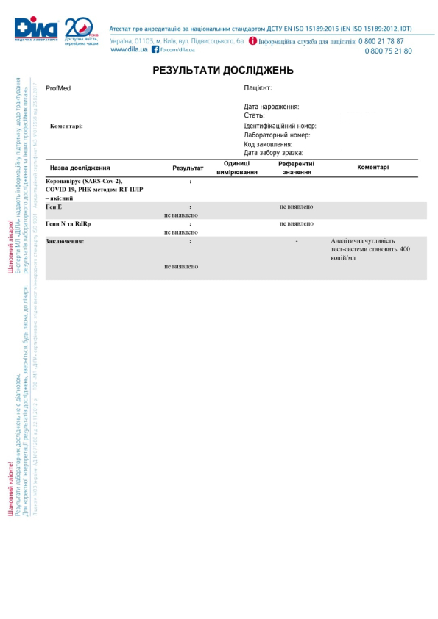

{name}

{date-of-birtht}

{sex}

{number}

{number}

{date} {time}