3.11
/*评：其实可以直接takes与course natural join而不是与section，毕竟都有course_id*/
a.
select distinct student.name
from student natural join takes natural join section,course
where section.course_id = course.course_id and course.dept_name='Comp. Sci.'
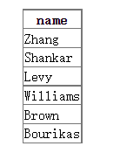
b.
select ID,name
from student natural join takes /*评：此处不需要natural join takes，只需要选所有学生，毕竟后面才是限制*/
except
select ID,name
from student natural join takes
where year<2009
c.
select dept_name,max(salary)
from instructor
group by dept_name
d.
with max_salary_dept(dept_name,max_sal) as 【别忘记with创表时标明名字】
(select dept_name,max(salary) as max_sal 【此时下面就不用重命名】
from instructor
group by dept_name)
select min(max_sal)
from max_salary_dept natural join department 【复杂了】

3.12
1.Insert into course
Values(“CS-001”,’Weekly Seminar’, ‘Comp. Sci.’, 0)
b.
insert into section
values(‘CS-001’, 1, ‘Autumn’, 2009, null, null, null)
c.
insert into takes
(select ID, ‘CS-001’, 1, ‘Autumn’, 2009, null
From student
Where dept_name = ‘Comp. Sci.’)

c. 【这里很严重，where必须出来】
delete from takes
select student.ID, course_id, sec_id, semester, year, grade
from student natural join takes
where name = ‘Chavez’

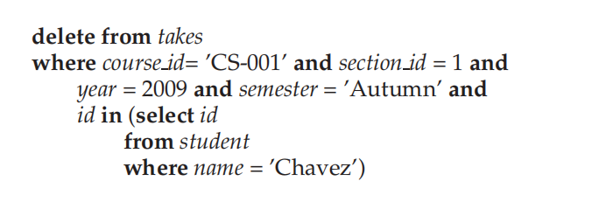
e.【删这门课，就要删掉所有与之相关的地方，还得注意顺序！！！】
Delete from course
Where course_id = ‘CS-001’

f.【此处lower必须写上】
delete from takes
where course_id in (
select course_id
from course
where lower(title) like ‘%database%’)

3.13
Create table person(
Driver_id char(7),
Name varchar(20),
Address varchar(20),
Primary key(driver_id))
Create table car(
license varchar(7),
model varchar(7),
year numeric(4,0),
Primary key(license))

3.14
a.
Select count(*)
From person natural join participated
Where name = ‘John Smith’
b.
update participated
set damage_count=3000
where license =’AABB2000’ and report_number=’AR2197’

3.15
//思路基本正确，但还需要打磨
Select *
From customer as T
Where not exists(
(Select account_number
From account
Where branch_name=’Brooklyn’)
Except
(select account_number
From account natural join depositor natural join (customer as S)
where T.customer_name = S.customer_name))
b.
select branch_name, sum(amounts)
from loan
group by branch_name

3.16
A【多余了】
select employee_name
from employee natural join works
where works.company_name = ‘First Bank Corporation’
b
select employee_name
from employee natural join works, company
where employee.city = company.city and works.company_name=company.company_name
c.
select T.employee_name【少加T可不行】
from employee as T natural join managers, employee as S
where managers.manager_name = S.employee_name
and T.city = S.city
and T.street = S.street
d:
with com_avg_salary(company_name, value) as
(select company_name, avg(salary)
From works
Group by company_name)
Select employee_name
From works natural join com_avg_salary
Where works.salary > com_avg_salary.value
E:
With tot_salary(company_name, value) as
(select company_name, sum(salary)
From works
Group by company_name)
Select company_name
From tot_salary
Where tot_salary.value <= all(
Select value
From tot_salary)

b.
update works as T
set salary = salary * 1.1
where company_name = ‘First xxx’ and
exists (
select *
from managers
where managers.manager_name = T.employee_name)

2.13

