同济大学课程考核试卷（A卷）答案
2006—2007 学年第一学期
命题教师签名： 审核教师签名：
课号：42002301 课名：数据库原理与应用 考试考查：考试
此卷选为：期中考试( )、期终考试( )、重考( ) 试卷

年级 专业 学号 姓名 得分

- Draw an E-R diagram consisting of three entity sets employee, job, and branch, related through the ternary relationship set works-on, supposing that an employee can have at most one job in each branch.
(10 points)

Answer:

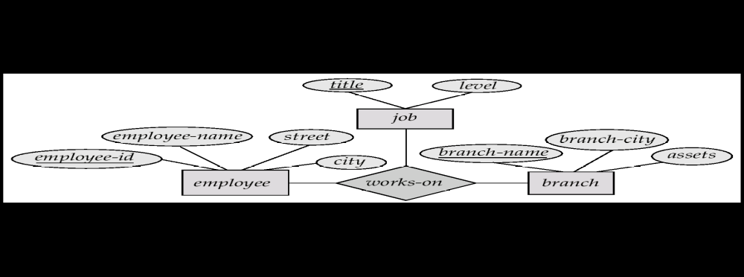

- Write a relational algebra expression to find the names of all customers who have a loan at the Perryridge branch but do not have an account at any branch of the bank.
(10 points)
Answer:

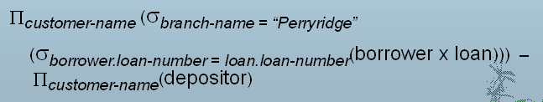

- Find the names of all customers who have an account at all branches located in Brooklyn City, in tuple relational calculus.

(10 points)

Answer:

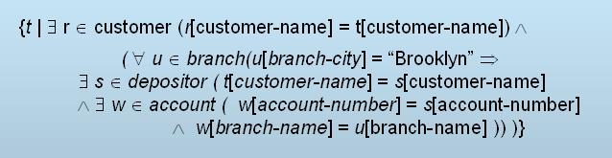

- Is referential integrity checked anywhere in a transaction or just at the end of a transaction? Why? Would you please give an example to illustrate?
(10 points)

Answer:

Referential integrity is only checked at the end of a transaction.

Intermediate steps are allowed to violate referential integrity provided later steps remove the violation.

Otherwise it would be impossible to create some database states, e.g. insert two tuples whose foreign keys point to each other
E.g. spouse attribute of relation
marriedperson(name, address, spouse)

- Let R=(A, B, C, G, H, I),
F={A→B, A→C, CG→H, CG→I, B→H},
Please compute attribute set closure (AG)⁺
Is (AG) a candidate key? Why?
(10 points)

Answer:
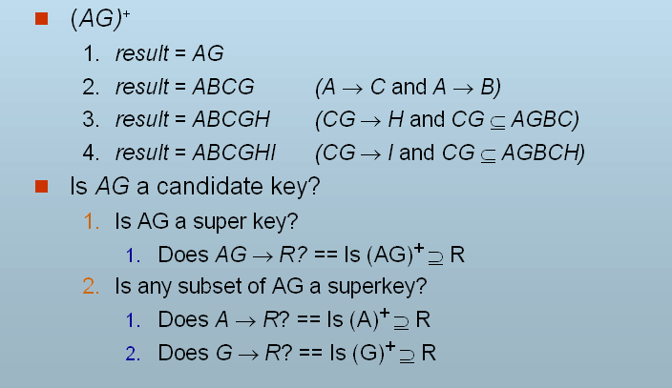
So, (AG) is a candidate key.
- Let R=(branch-name, branch-city, assets, customer-name, loan-number, amount), F={branch-name → assets, branch-city;
loan-number → amount, branch-name}
Key={loan-number, customer-name}
Please decompose R by following the BCNF decomposition algorithm.
(10 points)

Answer:

R1 = (branch-name, branch-city, assets)
R2 = (branch-name, customer-name, loan-number, amount)
R3 = (branch-name, loan-number, amount)
R4 = (customer-name, loan-number)

Final decomposition is: R1, R3, R4

- What is a primary index? What is a secondary index? Is sequential scan using secondary index efficient?
(10 points)

Answer:

- Primary index: in a sequentially ordered file, the index whose search key specifies the sequential order of the file.
- Secondary index: an index whose search key specifies an order different from the sequential order of the file.
- Sequential scan using primary index is efficient, but a sequential scan using a secondary index is expensive.

- The following is a B⁺ tree. Please redraw the new B⁺ tree after insertion of “Clearview”.

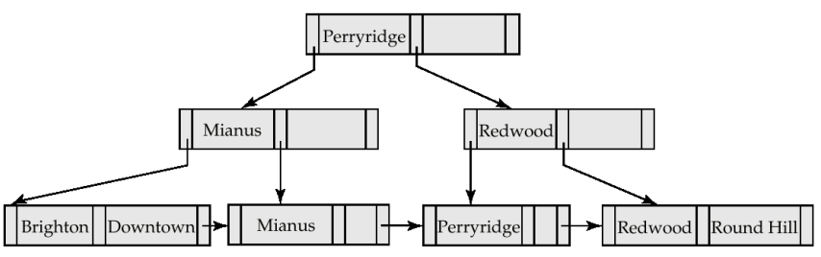

(10 points)

Answer:

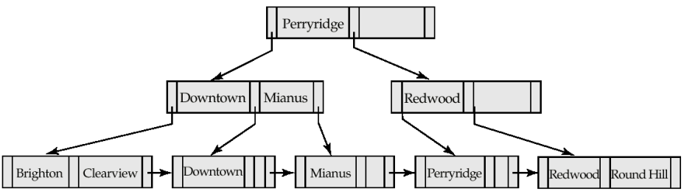

- We say that an ideal hash function is both uniform and random. What does that statement mean? Will you give some example to illustrate these two concepts?
(10 points)

Answer:

- An ideal hash function is uniform, i.e., each bucket is assigned the same number of search-key values from the set of all possible values.
- Ideal hash function is random, so each bucket will have the same number of records assigned to it irrespective of the actual distribution of search-key values in the file.
- Typical hash functions perform computation on the internal binary representation of the search-key.
For example, for a string search-key, the binary representations of all the characters in the string could be added and the sum modulo the number of buckets could be returned.

- For conjunctive selection such as:
We can firstly use corresponding index for each condition, and take intersection of all the obtained sets of record pointers. Then fetch records from file.
If some conditions do not have appropriate indices, we can apply test in memory.

Does this method also work for disjunctive selection such as
?
(10 points)

Answer:

- Applicable if all conditions have available indices. Otherwise we prefer to use linear scan.
- Use corresponding index for each condition, and take union of all the obtained sets of record pointers.
- Then fetch records from file.

