同济大学课程考核试卷（B卷）答案
2006—2007 学年第一学期
命题教师签名： 审核教师签名：
课号：42002301 课名：数据库原理与应用 考试考查：考试
此卷选为：期中考试( )、期终考试( )、重考( ) 试卷

年级 专业 学号 姓名 得分

- What is a weak entity set? What is a strong entity set? Draw an E-R diagram to illustrate that the weak entity set payment depends on the strong entity set loan via the relationship set loan-payment.
(10 points)

Answer:

An entity set that may not have sufficient attributes to form a primary key is called a weak entity set. An entity set that has a primary key is termed a strong entity set.

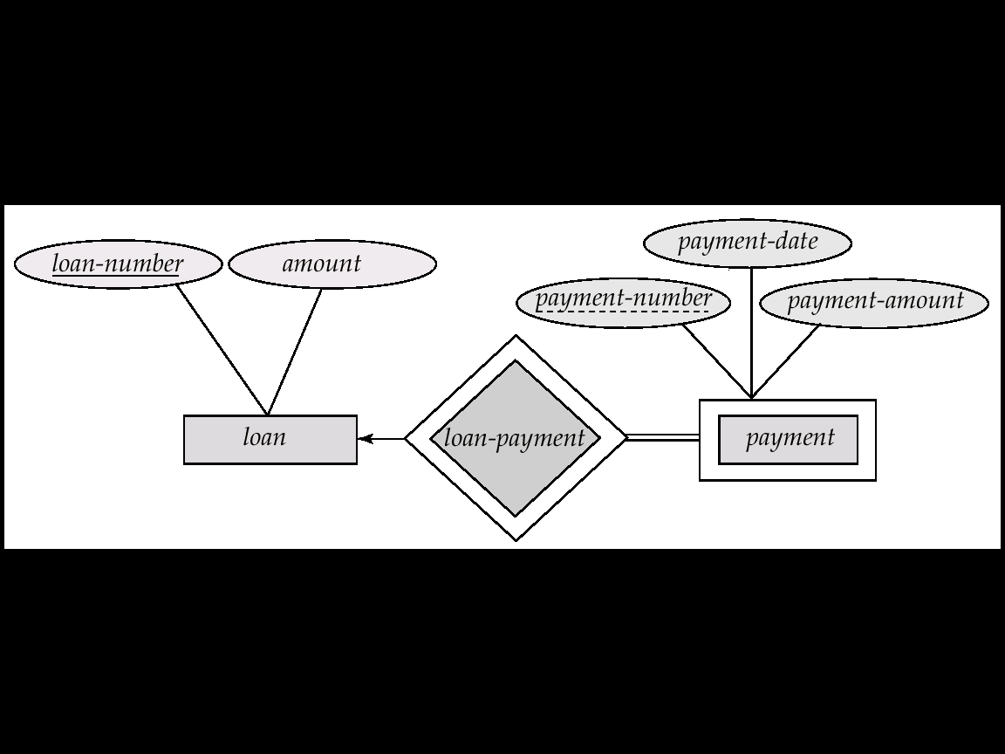

- Please construct a relational algebra expression to find the largest account balance.
(10 points)
Answer:

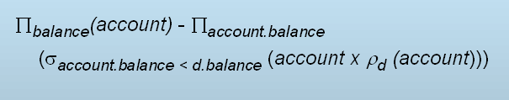

- Write a tuple relational calculus expression to find the names of all customers having a loan from the Perryridge branch, and the cities they live in.
(10 points)

Answer:

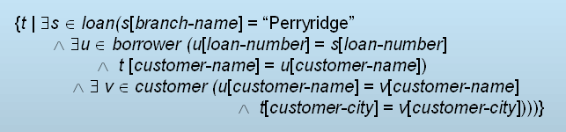

- Read the following assertion. Explain its function and meaning.

create assertion sum-constraint check
(not exists (select * from branch
where (select sum(amount) from loan
where loan.branch-name =
branch.branch-name)
>= (select sum(balance) from account
where account.branch-name =
branch.branch-name)))

(10 points)

Answer:

The sum of all loan amounts for each branch must be less than the sum of all account balances at the branch.

- If R=(A,B,C), F={A→BC, B→C, A→B, AB→C}, Please compute the canonical cover Fc.

(10 points)

Answer:

The canonical cover Fc is: A→B
B→C

- For relation schema:
Banker-info-schema = (branch-name, customer-name, banker-name, office-number)

The functional dependencies for this relation schema are:
banker-name → branch-name office-number
customer-name branch-name → banker-name

The key is: {customer-name, branch-name}

Applying 3NF to decompose this Banker-info-schema.

(10 points)

Answer:

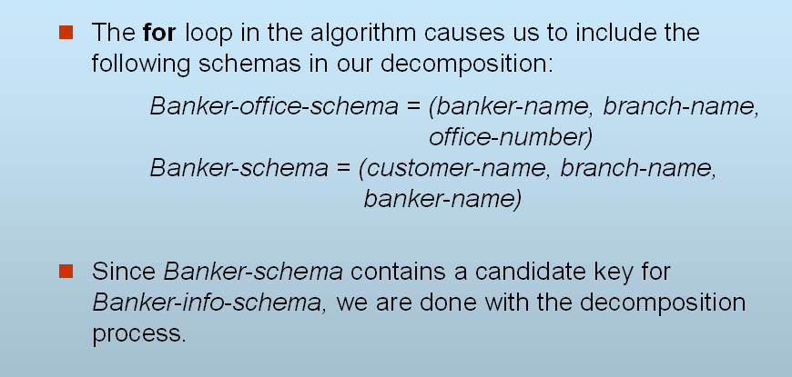

- Please compare dense index and sparse index. Is it meaningful to organize a sparse secondary index?
(10 points)

Answer:

- Dense index — Index record appears for every search-key value in the file.
- Sparse Index — Contains index records for only some search-key values.

- Compared with dense index, sparse index is applicable only when records are sequentially ordered on search-key. Sparse index uses less space and less maintenance overhead for insertions and deletions. And generally, sparse index is slower than dense index for locating records.

- Secondary indices have to be dense.

- Delete “Perryridge” from the following B⁺ tree. Reconstruct it, and draw the new generated B⁺ tree.

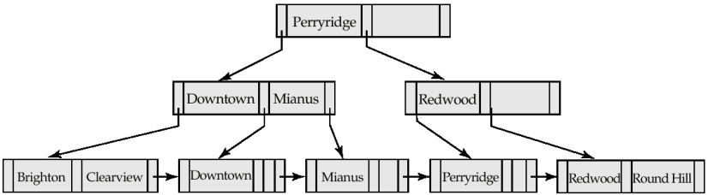

(10 points)

Answer:
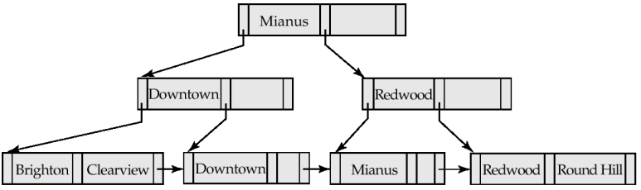

- To preserve integrity of data, database system must ensure the ACID properties of a transaction. What do they mean? Please explain.
(10 points)

Answer:

- Atomicity. Either all operations of the transaction are properly reflected in the database or none are.
- Consistency. Execution of a transaction in isolation preserves the consistency of the database.
- Isolation. Although multiple transactions may execute concurrently, each transaction must be unaware of other concurrently executing transactions. Intermediate transaction results must be hidden from other concurrently executed transactions.
    - That is, for every pair of transactions Ti and Tj, it appears to Ti that either Tj, finished execution before Ti started, or Tj started execution after Ti finished.
- Durability. After a transaction completes successfully, the changes it has made to the database persist, even if there are system failures.

- Multiple transactions are allowed to run concurrently in a database system. Why do we need the concurrency of transactions? What are the advantages?
(10 points)

Answer:

- increased processor and disk utilization, leading to better transaction throughput: one transaction can be using the CPU while another is reading from or writing to the disk

- reduced average response time for transactions: short transactions need not wait behind long ones.

