同济大学课程考核试卷（C卷）答案
2006—2007 学年第一学期
命题教师签名： 审核教师签名：
课号：42002301 课名：数据库原理与应用 考试考查：考试
此卷选为：期中考试( )、期终考试( )、重考( ) 试卷

年级 专业 学号 姓名 得分

- Explain the distinctions among the terms primary key, candidate key, and super key.
(10 points)

Answer:

A superkey is a set of one or more attributes that, taken collectively, allows us to identify uniquely an entity in the entity set. A superkey may contain extraneous attributes. If K is a superkey, then so is any superset of K. A superkey for which no proper subset is also a superkey is called a candidate key. It is possible that several distinct sets of attributes could serve as candidate keys. The primary key is one of the candidate keys that is chosen by the database designer as the principal means of identifying entities within an entity set.

- Find all customers who have an account at all branches located in Brooklyn city in relational algebra expression.
(10 points)

Answer:

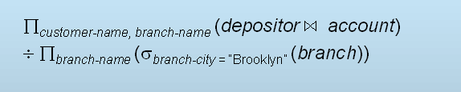

- In tuple relational calculus, please form an expression to find the names of all customers who have a loan at the Perryridge branch, but no account at any branch of the bank.
(10 points)
Answer:

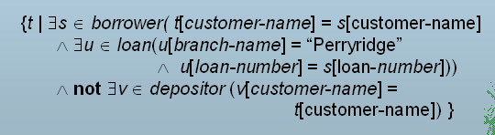

- Analyze the assertion below and describe its purpose.

create assertion balance-constraint check
(not exists (
select * from loan
where not exists (
select *
from borrower, depositor, account
where loan.loan-number = borrower.loan-number
and borrower.customer-name = depositor.customer-name
and depositor.account-number = account.account-number
and account.balance >= 1000)))

(10 points)

Answer:

Every loan has at least one borrower who maintains an account with a minimum balance or $1000.00

- When we decompose a relation schema R with a set of functional dependencies F into R1, R2,….., Rn, we want the decomposition to satisfy three criteria. What are these three criteria? Describe them briefly.
(10 points)

Answer:

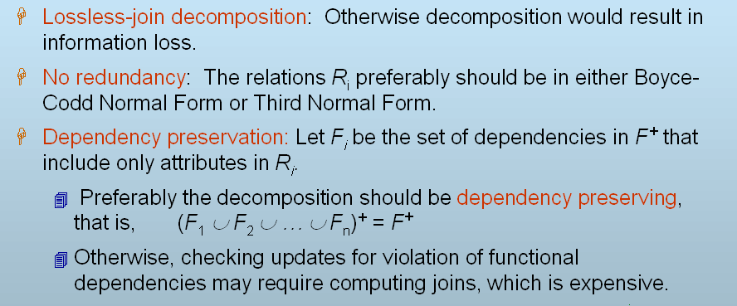

- There exist a relation schema R =(A, B, C, G, H, I), and a set of functional dependencies F ={ A →→ B,
B →→ HI,
CG →→ H }
Is R in 4NF? If it is not, follow the 4NF decomposition algorithm to decompose it.

(10 points)

Answer:

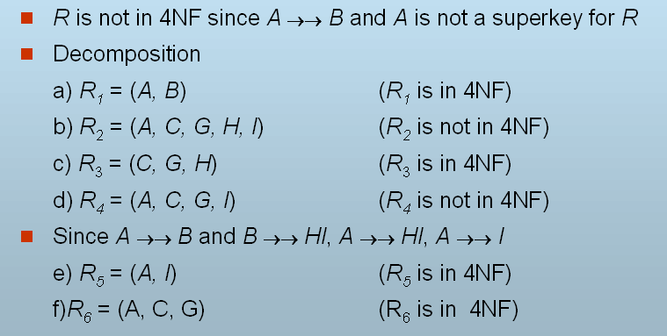

So R is decomposed into R₁, R₃, R₅, R₆.

- Why do we need index mechanism in DBMS? Somebody said that the more the indices, the better the performance. Do you agree with him? Why?
(10 points)

Answer:

- Indices offer substantial benefits when searching for records.

- I don’t agree with him. Because when a file is modified, every index on the file must be updated. Updating indices imposes overhead on database modification.

- Would you please compare B-tree index with B⁺-tree index. What are the advantages and disadvantages of B-tree index? Can we conclude that B-tree index is better than B⁺-tree index?
(10 points)

Answer:

- Advantages of B-Tree indices:
      - May use less tree nodes than a corresponding B+-Tree.
      - Sometimes possible to find search-key value before reaching leaf node.
- Disadvantages of B-Tree indices:
      - Only small fraction of all search-key values are found early
      - Non-leaf nodes are larger, so fan-out is reduced. Thus, B-Trees typically have greater depth than corresponding B+-Tree
      - Insertion and deletion more complicated than in B+-Trees
      - Implementation is harder than B+-Trees.
- Typically, advantages of B-Trees do not out weigh disadvantages.

- There are five transaction states: Active, Partially committed, Failed, Aborted, and Committed. Please draw the state-transformation-diagram and explain all the transformation processes.
(10 points)

Answer:

- Active, the initial state; the transaction stays in this state while it is executing.
- Partially committed, after the final statement has been executed.
- Failed, after the discovery that normal execution can no longer proceed.
- Aborted, after the transaction has been rolled back and the database restored to its state prior to the start of the transaction. Two options after it has been aborted:
    - restart the transaction – only if no internal logical error
    - kill the transaction
- Committed, after successful completion.

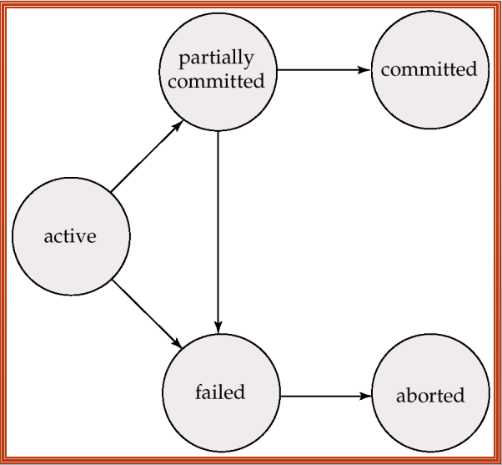

- Is the following schedule conflict serializable? Why?

T3 T4
-----------------------------------
read(Q)
write(Q)
write(Q)
(10 points)

Answer:

It is not conflict serializable. We are unable to swap instructions in the schedule to obtain either the serial schedule < T3, T4 >, or the serial schedule < T4, T3 >.

