同济大学课程考核试卷（A卷）答案
2006—2007 学年第一学期
命题教师签名： 审核教师签名：
课号：42002301 课名：数据库原理与应用 考试考查：考试
此卷选为：期中考试( )、期终考试( )、重考( ) 试卷

年级 专业 学号 姓名 得分

- Draw an E-R diagram consisting of three entity sets employee, job, and branch, related through the ternary relationship set works-on, supposing that an employee can have at most one job in each branch.
(10 points)

Answer:

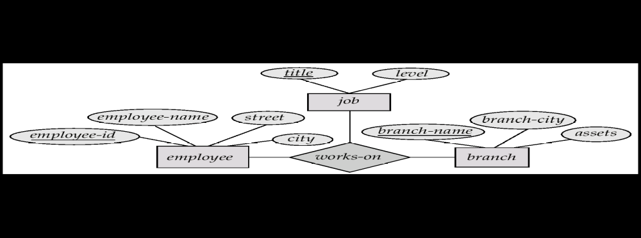

- Let R=(A, B, C, G, H, I),
F={A→B, A→C, CG→H, CG→I, B→H},
Please compute attribute set closure (AG)⁺
Is (AG) a candidate key? Why?
(10 points)

Answer:
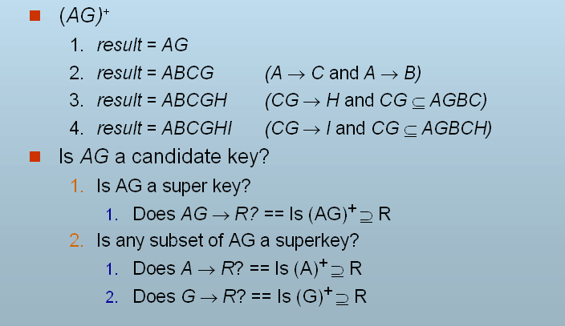
So, (AG) is a candidate key.

- Let R=(branch-name, branch-city, assets, customer-name, loan-number, amount), F={branch-name → assets, branch-city;
loan-number → amount, branch-name}
Key={loan-number, customer-name}
Please decompose R by following the BCNF decomposition algorithm.
(10 points)

Answer:

R1 = (branch-name, branch-city, assets)
R2 = (branch-name, customer-name, loan-number, amount)
R3 = (branch-name, loan-number, amount)
R4 = (customer-name, loan-number)

Final decomposition is: R1, R3, R4

