同济大学课程考核试卷（B卷）答案
2006—2007 学年第一学期
命题教师签名： 审核教师签名：
课号：42002301 课名：数据库原理与应用 考试考查：考试
此卷选为：期中考试( )、期终考试( )、重考( ) 试卷

年级 专业 学号 姓名 得分

- What is a weak entity set? What is a strong entity set? Draw an E-R diagram to illustrate that the weak entity set payment depends on the strong entity set loan via the relationship set loan-payment.
(10 points)

Answer:

An entity set that may not have sufficient attributes to form a primary key is called a weak entity set. An entity set that has a primary key is termed a strong entity set.

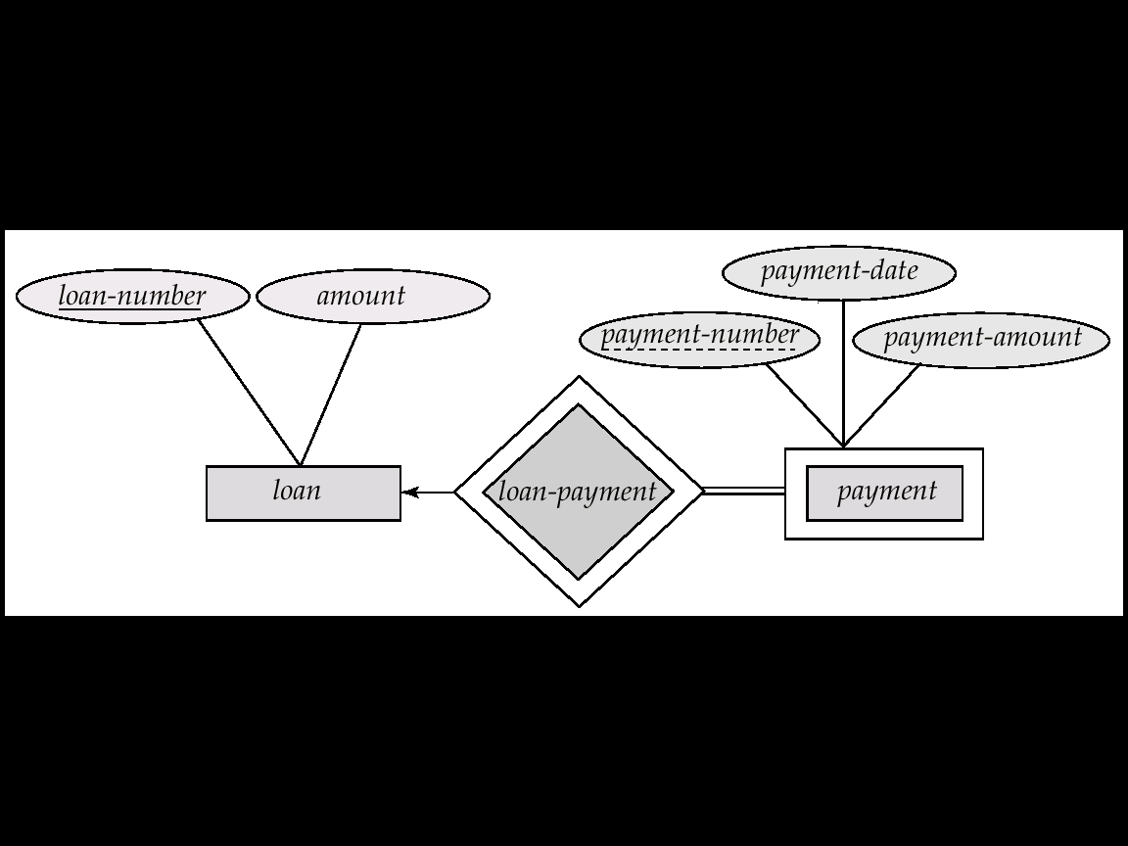

- If R=(A,B,C), F={A→BC, B→C, A→B, AB→C}, Please compute the canonical cover Fc.

(10 points)

Answer:

The canonical cover Fc is: A→B
B→C

- For relation schema:
Banker-info-schema = (branch-name, customer-name, banker-name, office-number)

The functional dependencies for this relation schema are:
banker-name → branch-name office-number
customer-name branch-name → banker-name

The key is: {customer-name, branch-name}

Applying 3NF to decompose this Banker-info-schema.

(10 points)

Answer:

